Information about overhauling
KDI 1903TCR / KDI 1903TCRE5 Workshop manual (Rev. 17.8)


Sommario
1. TITOLO 1 2
1.1. Asdfsdfsdf 2
1.2. Asdfsdfsdfggg 2

Information about overhauling

Recommendations for overhauls and tuning
- The information is laid out in sequence, according to operational requirements, and the intervention methods have been selected, tested and approved by the manufacturer's
technicians.
- This chapter describes procedures for checking, overhauling and tuning units and/or individual components.

NOT E : To easily locate specific topics, the reader should refer to the analytical index or chapter index.

- Before any intervention, the operator should lay out all equipment and tools in such a way as to enable him to carry out operations correctly and safely.
- The operator must comply with the specific measures described in order to avoid errors that might cause damage to the engine.
- Before carrying out any operation, clean the units and/or components thoroughly and eliminate any deposits.
- Do not wash the components with steam or hot water. Use suitable products only.
- Do not use flammable products (petrol, diesel, etc.) to degrease or wash components. Use suitable products only.
- Dry all washed surfaces and components thoroughly with a jet of air or special cloths before reassembling them.
- Apply a layer of lubricant over all surfaces of all disassembled components to protect them against oxidation.
- Check the integrity and state of wear of all disassembled components in order to ensure good working condition of the engine.
- When indicated, some components are to be replaced in pairs or together with other parts (e.g. crankshaft half-bearings/connecting rod, piston complete with rings and gudgeon pin, etc.).
- When indicated, some grinding operations are to be carried out in series (e.g. grinding of cylinders, crankpins, journals, etc.).

Crankcase
8.2.1 Oil line check
Use a pipe cleaner in access points A, B, C, D, E to clean the oil ducts of crankcase G . Use compressed air to eliminate any residues.

Replace and assemble the conical cap in hole B ( B1 if present - tightening torque at 30 Nm ) and caps in holes D , after having performed cleaning operations.

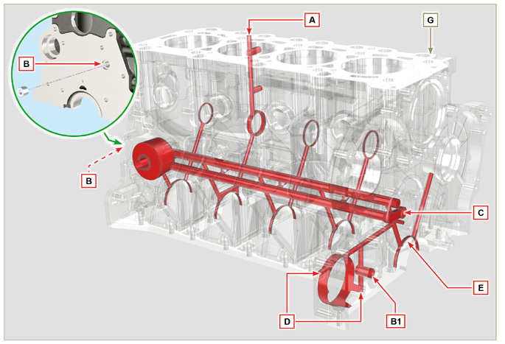
Fig 8.1

8.2.2 Cylinder check
Position crankcase G onto a workbench.

With a dial gauge, measure the diameter in correspondence to points J-M-N (Fig. 8.2) lengthwise and diagonally with regard to axis H of the crankshaft.
If ovalisation or wear detected in a single point in J-M-N is greater than +0.05 mm with regard to the value in Tab. 8.1a , è necessario sostituire il basamento G . *
Refer to Tab. 8.1a

to establish the clearance value of cylinders subjected to grinding operations.
Important

- La rettifica dei cilindri è vietata. *
- Tab. 8.1a details the dimensional values of new components only.
- ⁽¹⁾ The increase of +0.20 mm , may already be present on the engine.
Tab 8.1a Grinding values
PISTON | Ø CILINDER (± 0.007 mm) | Ø PISTON (± 0.007 mm) | CLEARANCE VALUE (mm)
STD | 88.010 | 87.950 | 0.046 - 0.074
+0.20 ⁽¹⁾ | 88.210 | 88.150

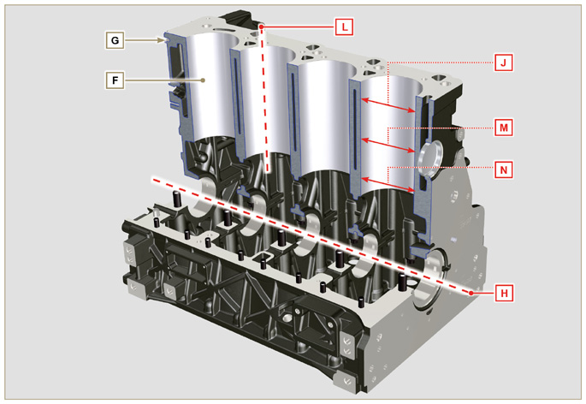
Fig 8.2
N.B.: if removing the Z2 hole closing cap, the new cap must comply with the MAX measurement of 1.5 mm from the surface G1.

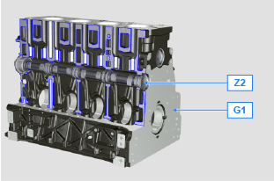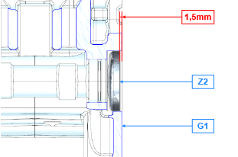
Fig 8.2a

8.2.3 4-cylinder camshaft housing check  The camshaft housings only contain the timing system side bushing Q .  Use an internal dial gauge to measure the diameters of housings X - W - K - Y - Z .  With a micrometer, measure the diameters of gudgeon pins X1 - W1 - K1 - Y1 - Z1 (Fig. 8.4) . According to the values measured, calculate the clearance between the housing and gudgeon, which is to observe the  values in Tab. 8.2a .  The MAX value of wear allowed is 0.120 mm  Important  - Tab. 8.2a details the dimensional values of new components only. | Tab 8.2a Housing and camshaft gudgeon dimensions.  REF. DIMENSIONS (mm) CLEARANCE VALUE (mm)  X 44.000 - 44.025 0.040 - 0.085  X1 43.940 - 43.960  W 43.000 - 43.025 0.060 - 0.105  W1 42.920 - 42.940  K 42.000 - 42.025 0.060 - 0.105  K1 41.920 - 41.940  Y 41.000 - 41.025 0.060 - 0.105  Y1 40.920 - 40.940  Z 36.000 - 36.025 0.060 - 0.105  Z1 35.920 - 35.940
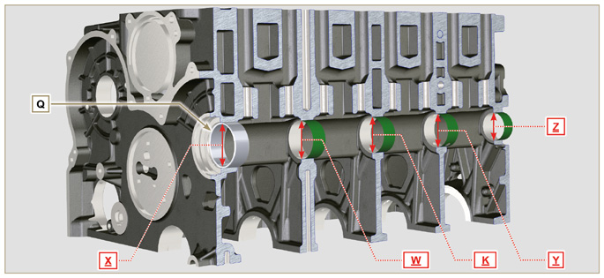
Fig 8.3
8.2.3.1 Block Surface Flatness  Use a dial gauge to check if the cylinder head surface A1 is level.  The MAX value of allowable irregularity of surface A1 is:  - 0.10 mm on the entire area;  - 0.03 mm on an area of 100x100 mm.  Grinding of surface A1 is not permitted | 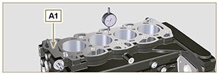  Fig 8.3b

8.2.4 Camshaft control for 4 cylinder engine  With a micrometer, measure the maximum dimensions of intake camshaft R and exhaust camshaft S (Tab. 8.2b) .  The MAX value of wear allowed is 0.1 mm .  Important  - Tab. 8.2b details the dimensional values of new components only. | Tab 8.2b Camshaft dimensions.  REF. DIMENSIONS (mm)  R 32.638 - 32.700  S 32.998 - 32.060
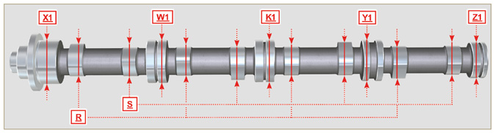
Fig 8.4

8.2.5 3 -cylinder camshaft housing check  The camshaft housings only contain the timing system side bushing Q .  Use an internal dial gauge to measure the diameters of housings X - W - K - Z .  Use an internal dial gauge to measure the diameters of housings X1 - W1 - K1 - Z1 (Fig. 8.5) . According to the values measured, calculate the clearance between the housing and gudgeon, which is to observe the  values in Tab. 8.2a .  The MAX value of wear allowed is 0.120 mm  Important  - Tab. 8.3a details the dimensional values of new components only. | Tab 8.3a Housing and camshaft gudgeon dimensions.  REF. DIMENSIONS (mm) CLEARANCE VALUE (mm)  X 44.000 - 44.025 0.040 - 0.085  X1 43.940 - 43.960  W 43.000 - 43.025 0.060 - 0.105  W1 42.920 - 42.940  K 42.000 - 42.025 0.060 - 0.105  K1 41.920 - 41.940  Z 36.000 - 36.025 0.060 - 0.105  Z1 35.920 - 35.940
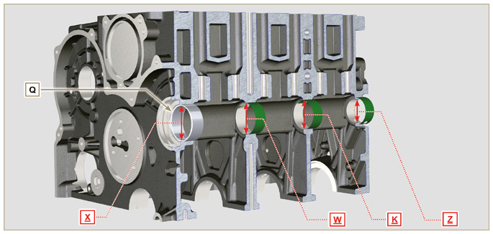
Fig 8.5

8.2.6 Camshaft control for 3 cylinder engine  With a micrometer, measure the maximum dimensions of intake camshaft R and exhaust camshaft S (Tab. 8.3b) .  The MAX value of wear allowed is 0.1 mm .  Important  - Tab. 8.3b details the dimensional values of new components only. | Tab 8.3b Camshaft dimensions  REF. DIMENSIONS (mm)  R 32.834 - 32.896  S 33.335 - 33.397
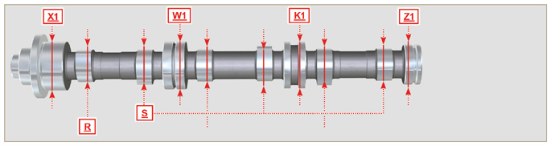
Fig 8.6

Tappets and tappet housings
8.3.1 Tappets check  Use a surface plate and a dial gauge as shown in Fig. 8.7 .  Check the perpendicularity of the plate C , making the tappet D rotate in the direction of the arrow.  The MAX value of wear allowed is 0.02 mm .  With a gauge, check the length of value A and B (Tab. 8.4) . The MAX value of wear allowed is 0.08 mm . | 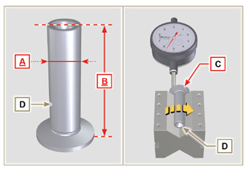  Fig 8.7
8.3.2 Tappet housing check  Use an internal dial gauge to measure the diameter of the tappet housings X .  Use value of A detected (Par. 8.3.1) to calculate the clearance value ( Tab. 8.4 ).  If the clearance values are not observed, replace the worn component.  Important  Tab. 8.4 T appets and t appet housing size.  REF. DIMENSIONS (mm) CLEARANCE VALUE (mm)  A 11.966 - 11.984 0.060 - 0.105  X 12.000 - 12.018  B 46.5 ± 0.2 --- | 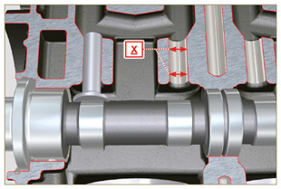  Fig 8.8

Crankshaft
8.4.1 Dimensional check and overhauling

Wash the crankshaft thoroughly using suitable detergent.
Insert the pipe cleaner into all lubrication ducts B and blow compressed air to free them completely from any dirt residues.
Check the state of wear and integrity of journals C and connecting rod D .
Perform the operations described in Par. 9.3.1 , perform the operations described in Par. 9.3.6 - except Points 2, 4, 9 and 10 .
Measure the crank pins A1 with a micrometer, and using a dial gauge measure the internal diameter of the connecting rod half-bearings A2 .
Measure the main journals B1 , with a micrometer, and using a dial gauge measure the internal diameter of the crankshaft half-bearings B2 .
If the values described in Tab. 8.5 do not correspond, proceed with grinding all gudgeon pins A1 and B1 .
Gear A on the crankshaft is timed by a key, assembly of gear A on the shaft occurs after heating at a stabilized temperature of +180° C for 5 mins.

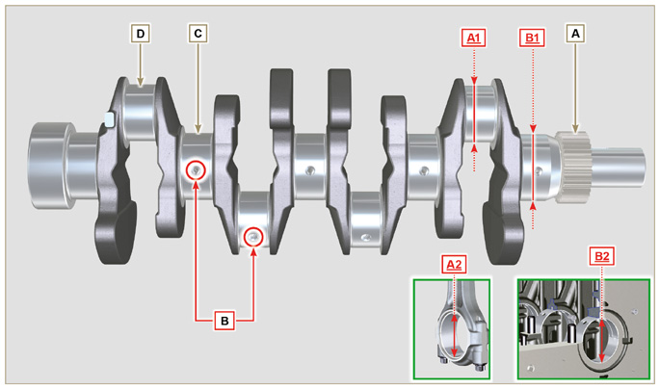
Fig 8.9

Important  - The crankshaft and connecting rod must be replaced every time they are assembled to prevent seizure, as they are made of special lead-free material.  - The MAX allowed value of wear for A1 and A2 is 0.120 mm.  - The MAX allowed value of wear for B1 and B2 is 0.120 mm.  - To grind the crankshaft, a decrease in diameter of the halfbearings and connecting rod is provided for at 0.25 mm and 0.50 mm, to grind gudgeon pins A1 and B1 , measure the values of diameters A2 and B2 by assembling the decreased half-bearings, define the diameter to grind of pins A1 and B1 ,  observing the clearance indicated in Tab. 8.5.  - La Tab. 8.5 riporta i valori dimensionali solo per i componenti nuovi. | Tab 8.5 Connecting rod and journal diameter  REF. DIMENSIONS (mm) CLEARANCE VALUE (mm)  A1 53.981 - 54.000 0.035 - 0.085  A2 54.035 - 54.066  B1 63.981 - 64.000 0.035 - 0.102  B2 64.035 - 64.083
8.4.2 Checking the axial clearance of the crankshaft  Perform the operations described in Par. 9.3.5 and 9.3.6 .  Using a dial gauge, measure the axial shift of crankshaft E .  Axial shift must be a MIN of 0.18 mm and MAX 0.38 mm..  If the values measured do not correspond, replace shoulder rings D . | 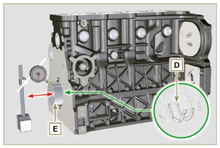  Fig 8.10

Connecting rod - piston assembly
Important

- In case of replacement, the connecting rods and pistons must always be replaced for all cylinders.
8.5.1 Connecting rod dimensions check  Important  - Before assembling the connecting rod and pistons ( Par. 9.3.7 e 9.3.8 ), check that the difference in weight between the complete connecting rod and piston units do not exceed 8 gr to prevent weight imbalances during rotation of the crankshaft and consequent damage.  - Mark some references on the connecting rods, caps Q , pistons and gudgeon pins to prevent unintentionally confusing the components during assembly. Failure to do this may result in engine malfunctions.  - Connecting rod half-bearings S must be there with each assembly.  Check that the contact surfaces are perfectly clean and intact.  Assemble the connecting rod cap Q to the connecting rod with the half-bearings S and tighten capscrews P (tightening torque at 25 Nm ).  With a dial gauge, measure diameters B and D .  The MAX allowed value of wear for B and D is 0.06 mm.  Tab 8.6  REF. DIMENSIONS (mm) CLEARANCE VALUE (mm)  A 169.980 - 170.020  B 30.020 - 30.030 0.025 - 0.030  C 29.995 - 30.000  D 54.035 - 54.066  E 67.700 - 68.000  F 29.750 - 29.790  Important  - Tab. 8.6 details the dimensional values of new components only.  - Check that the connecting rod and crankshaft half-bearings are coupled properly.  - Refer to the warnings in Par. 8.4.1 for value D decreased.  - If the clearance value between B and C is not observed, you are required to replace bearing R (Fig. 8.12) .  Measure value A, C, D, E and F and confront them with those described in Tab.8.6 .  If the measured values do not follow those described in Tab.8.6 , replace connecting rod T . | 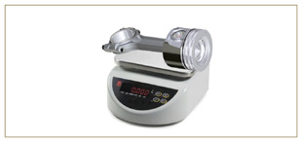  Fig 8.11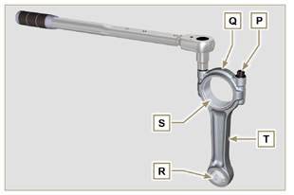  Fig 8.12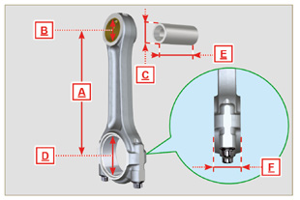  Fig 8.13
8.5.2 Checking the gudgeon pin-pin axes are parallel  Lubricate gudgeon pin A and bearing R (Fig. 8.12) .  Insert the gudgeon pin into bearing R . Use a dial gauge to check the axis parallelism of the connecting rod big end and small end.  Parallel deviation (value V ) measured at the tip of the gudgeonpin, must be a MIN of 0,015 and MAX of 0,030 mm.  If the parallelism values do not comply with the specified ones,replace the connecting rod with a new one.  8.5.3 Piston rings check  Insert ring U into the cylinder, measure value H (distance between the points of ring U ). Repeat for all the seal rings.  If the measured value H does not correspond to the values indicated in the table (Tab. 8.7) , replace the seal rings U .  Important  - Seal rings cannot be replaced separately.  NOTE: refer to Fig. 8.19 to locate the rings.  Tab. 8.7  RINGS H (mm)  U1 0.100 - 0.300  U2 0.250 - 0.500  U3 0.250 - 0.400 | 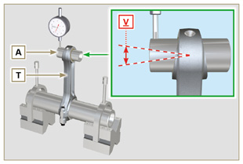  Fig 8.14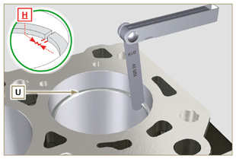  Fig 8.15
8.5.4 Piston dimension check  Clean the piston thoroughly.  Measure the diameter of the piston at 12 mm (quota L ) from the base of the skirt in correspondence with the graphite lubrication windows M .  Refer to Tab. 8.1b to establish the clearance value of the pistons with a decreased diameter.  In correspondence with point W , there are: 3 digits for the STD piston;  3 digits followed by R for a piston with an increased diameter of 0.20 mm; +0.5 for a piston with an increased diameter of 0.50 mm;  +1 for a piston with an increased diameter of 1.00 mm;  If clearance between cylinder and piston is greater than 0,074 mm, the piston and seal rings must be replaced.  Important  - Tab. 8.1b details the dimensional values of new components only.  Tab. 8.1b  PISTON Ø CYLINDERS (± 0.007 mm) Ø PISTON (± 0.007 mm) CLEARANCE VALUE (mm)  STD 88.010 87.950 0.046 + 0.074  +0.20 88.210 88.150  +0.50 88.510 88.450  +1.00 89.010 88.950 | 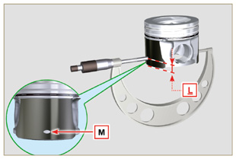  Fig 8.16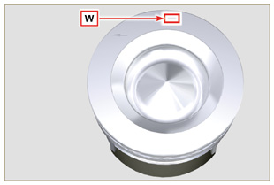  Fig 8.17
Important  - With a feeler gauge, measure the clearance of the seal ring in the respective seat (value L1, L2 e L3 ).  - If the clearance does not comply with the values shown in the Tab. 8.8 , replace the seal rings and the piston.  Tab 8.8  SEAL RINGS CLEARANCE VALUE (mm)  U1 (L1) 0.110 - 0.150  U2 (L2) 0.070 - 0.115  U3 (L3) 0.030 - 0.065 | 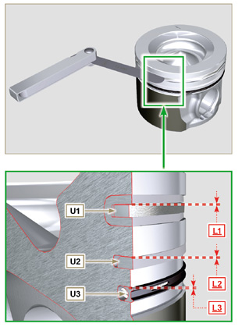  Fig 8.18 e 8.19

Cylinder head
8.6.1 Flatness check  Put the cylinder head on a surface plate and, with a dial gauge, check the flatness of surface C .  The MAX value of allowable irregularity of surface C is 0.10mm.  If the value is not observed, you are required to grind surface C .  The MAX removal allowed is 0.20 mm.  Important  - Grinding is to be performed with sleeves A of the electronic injectors assembled.  - Grinding is prohibited on all engines provided with an EPA name plate (refer to Par. 1.3 ). | 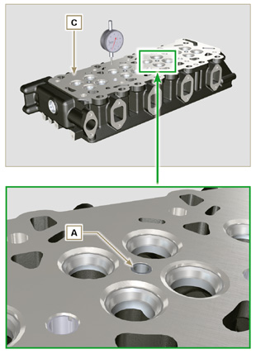  Fig 8.20a - Fig 8.20b
8.6.2 Valve seats check  Measure indentation B of each valve with regard to the cylinder head surface C , which is to be a MIN of 0.60 mm and MAX of 0.85 mm.  The B MAX indentation allowed on worn components is 1.10 mm.  If the measured value does not correspond with the values indicated, replace the worn component.  Important  - The seats must be worked after driving to reach value B , go to a rectification workshop for such operations.  8.6.3 Valve springs  Using a dynamometer, subject the spring to two different forces (in Tab. 8.9) and check that the length of the spring corresponds to the values indicated in the table.  ^{(*1)} The code ED0057551850-S is installed from S/N 4418801760  Tab 8.9  WEIGHT (kg) LENGHT (mm)  ED0057552810-S ED0057551850-S ^{(*1)}  0 0 Z 48.34  13.5 20.4 Z1 30.00  19.5 29.8 Z2 22.00 | 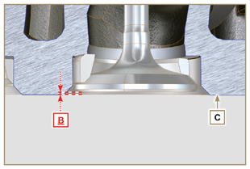  Fig 8.21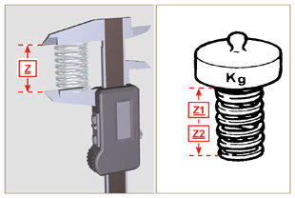  Fig 8.22
8.6.4 Valve guides check  Measure the diameters D and E of the rods and guides valve (Tab. 8.10) .  If the diameters don't correspond to the values indicated, replace the valves or guides.  The MAX allowed value of wear for D and E is 0.10 mm.  Observe values G from surface F when assembling guides H (Tab. 8.10) .  Important  - Carry out the measurements in different points to detect any ovalisation and/or concentrated wear.  - Tab. 8.10 details the dimensional values of new components only.  Tab 8.10 Valve stem - valve guide dimensions  REF. DIMENSIONS (mm) CLEARANCE VALUE (mm)  D 5.978 - 5.990 0.040 - 0.064  E 6.030 - 6.042  G 7.000 - 7.020 | 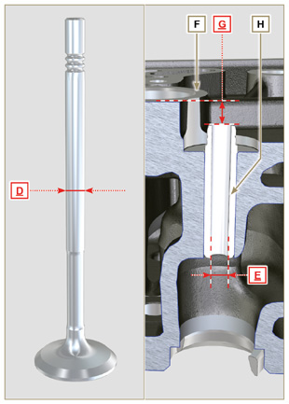  Fig 8.23
8.6.5 Valve guides replacement  The intake and exhaust guides are both made out of grey iron with pearlitic phosphoric matrix and they have the same dimensions.  The guides are press-fit assembled; assembly is possible by cooling the guides with the aid of liquid nitrogen.  Before assembling a new guide, measure value L and M ,calculate the press-fit value, which must observe the values in Tab. 8.11 .  Observe values G from surface F when assembling guides H (Tab. 8.10 - Fig. 8.23) .  Important  - The guides must be worked for value E (Tab. 8.10 - Fig.8.23) after driving. Contact a rectification workshop for such operations.  Tab 8.11 valve guides - housing dimensions  REF. DIMENSIONS (mm) PRESS-FIT VALUE (mm)  L 10.000 - 10.015 0.030 - 0.054  M 10.045 - 10.054 | 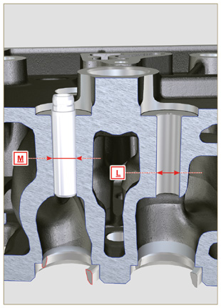  Fig 8.24
8.6.6 Rocker arm check  Measure values W1 in correspondence with holes M located on rocker arm gudgeon L (seen from B in Fig. 8.25 ).  Measure values W2 (Fig. 8.27).  Based on the values measured, calculate the clearance between W1 and W2 , which is to observe the values in Tab. 8.12.  Check that all oil pipes N and M are free from impurities or obstructions.  Tab 8. 12  REF. DIMENSIONS (mm) CLEARANCE VALUE (mm)  W1 19.985 - 20.005 0.035 - 0.076  W2 20.040 - 20.061  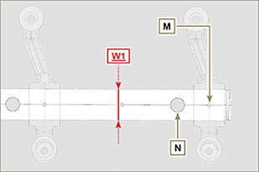  Fig. 8.26 | 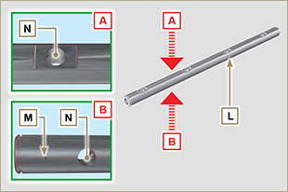  Fig 8.25  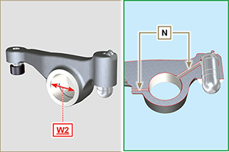  Fig 8.27

Oil pump check
8.7.1 Dimensional and visual check  Perform the operations described in Par.7.8.1 and Par.7.8.4.  Measure clearance value B between the rotor teeth, the value of allowable wear is MAX 0.28 mm.  Clean all the components thoroughly, check that the work surfaces C of the rotors and pump body are not worn.  Important  - Should the results from checks carried out not be in accordance with the conditions described, replace the timing system carter together with the oil pump.  On assembly, references A must be visible. | 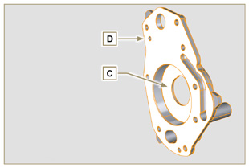  Fig 8.28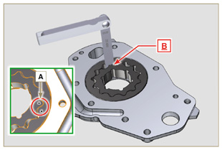  Fig 8.29
8.7.2 R otors clearance check  Important  Replace carter R complete with its oil pump, if there are signs of wear in area P of surface Q (Fig. 8.32 - 8.32a) .  Measure values G and H (Fig. 8.30) .  Measure values L, M and N (Fig. 8.31) .  According to the values measured, calculate the clearance between G and H, L and M and L and N which are to observe the values in Tab. 8. 13 .  For assembly, carry out the operations described from Par. 9.11.3 to Par. 9.11.4 . | 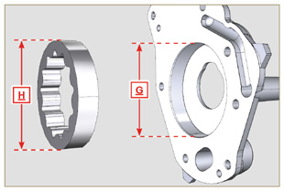  Fig 8.30
Tab 8.13  REF. DIMENSIONS (mm) CLEARANCE VALUE (mm)  G 82.820 - 82.855 0.395 - 0.320  H 82.460 - 82.500  L 17.500 - 17.525 0.036 - 0.086  M 17.464 - 17.439  N | 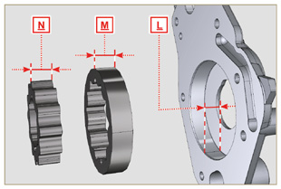  Fig 8.31
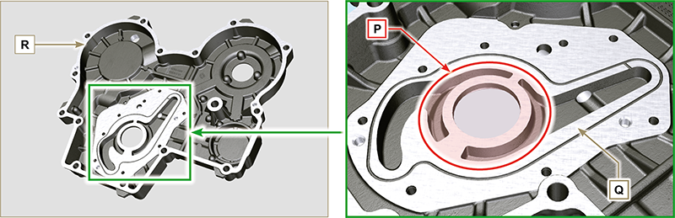
Fig 8.32 - Fig 8.32a
8.7.3 Oil pressure valve check  Measure the free length F of spring D , which must be 47.91 mm .  If the measured value does not correspond to the value indicated, replace spring D .  Tab 8.14  POS DESCRIPTION  B Oil stopper  C Gasket  D Spring  E Piston | 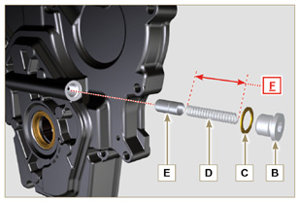  Fig 8.33

