Flashing
Diagnostic tool manual

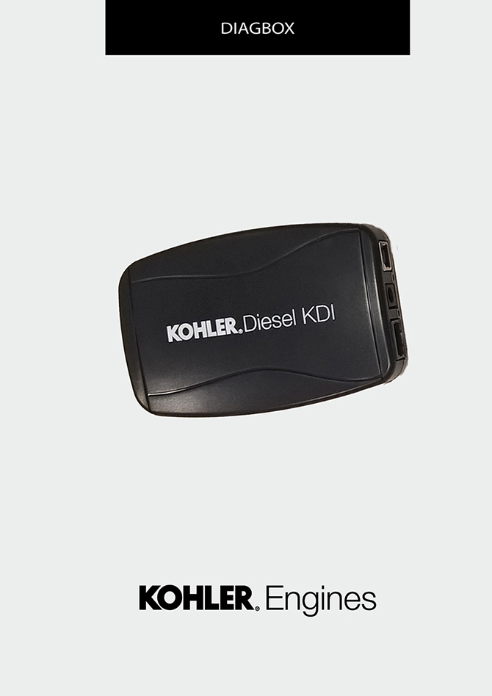
Sommario
1. TITOLO 1 2
1.1. Asdfsdfsdf 2
1.2. Asdfsdfsdfggg 2

Flashing

Map download from the KOHLER server
Go to websiteo "http://iservice.lombardini.it" and click on "KDI KOHLER DIESEL"
Read carefully "PRIVACY" box and click on "I ACCEPT"

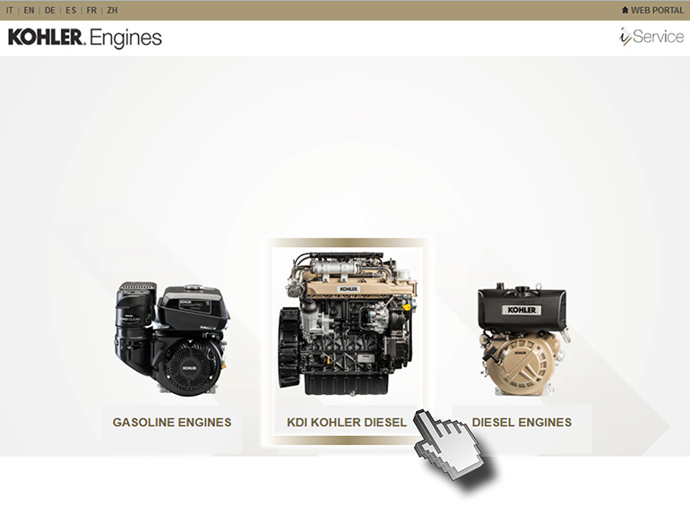
Enter the "Username and Password", flag "I AM NOT A ROBOT" and clicking "Log-in".

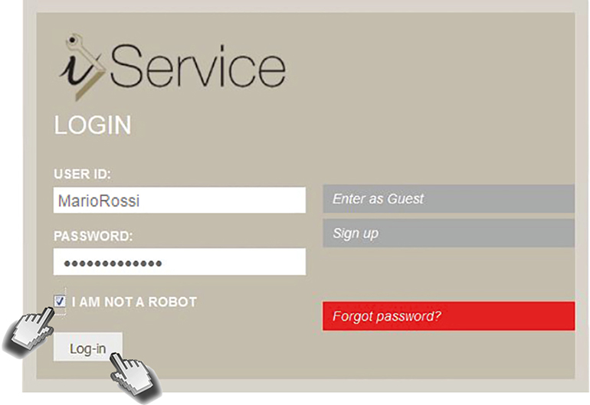

Click on "DIAGNOSIS AND FLASHING"

Click on "FLASHING"

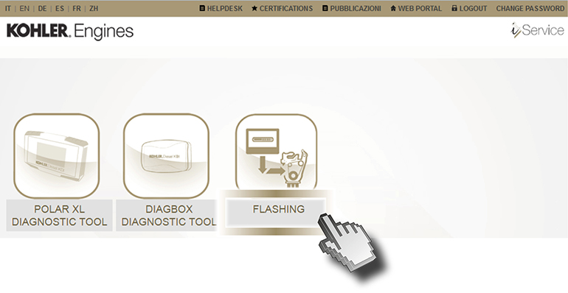
Enter the Username and Password, then click on "Login"

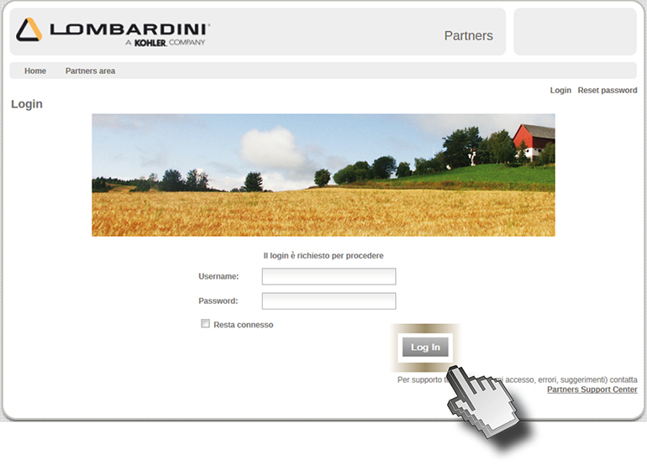

Click on "Flashing ROM"

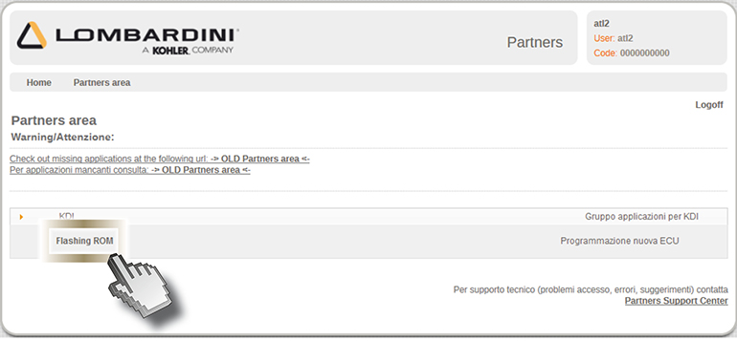

Click on "Obtain MAC address" (1) and then enter the "Serial number" (2). Click on "Search" (3) and then "Download" (4).

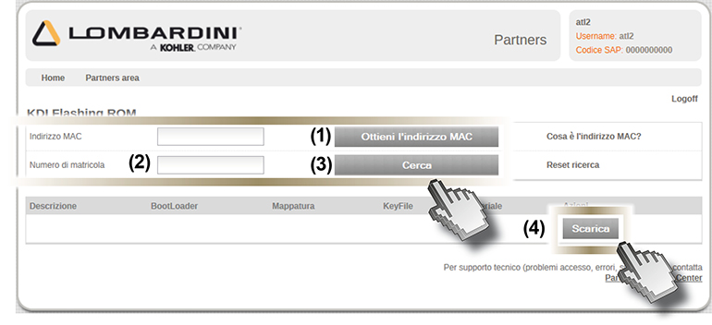

Warning
If the "MAC address" is not detected automatically, perform the following operations:

Click on "START" > "All programs" > Accessories > Command prompt.

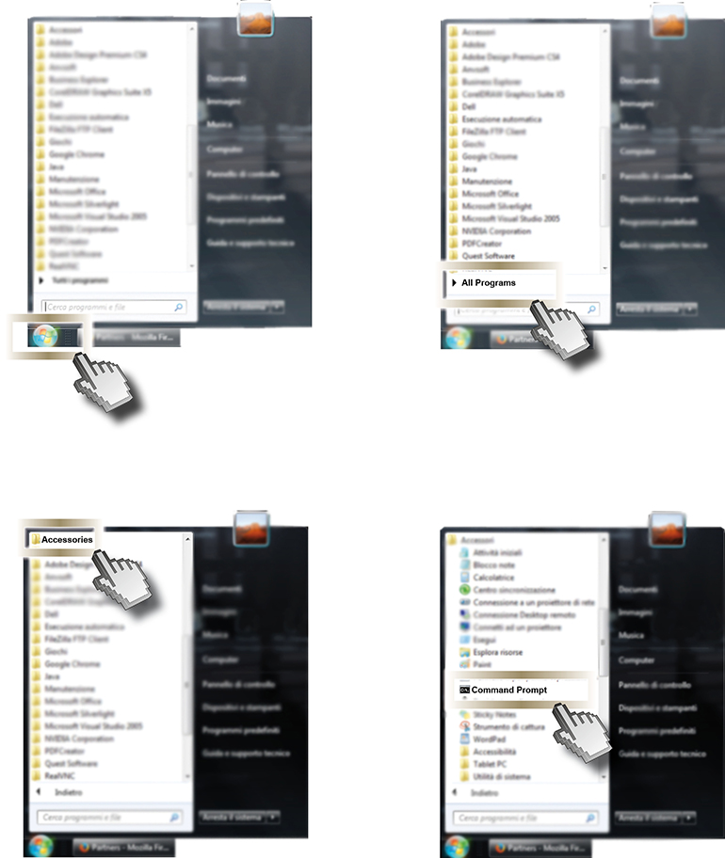

Write: ipconfig/all.

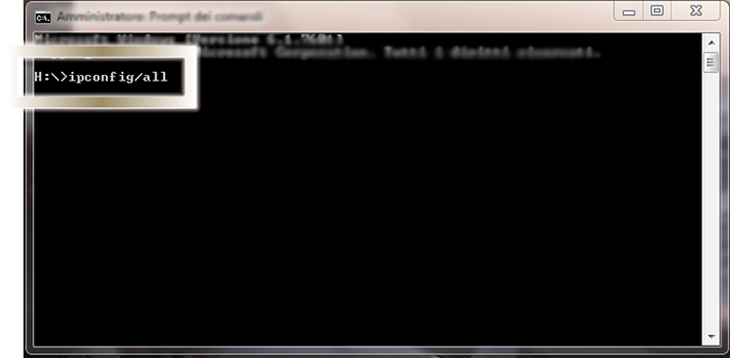

Press enter.

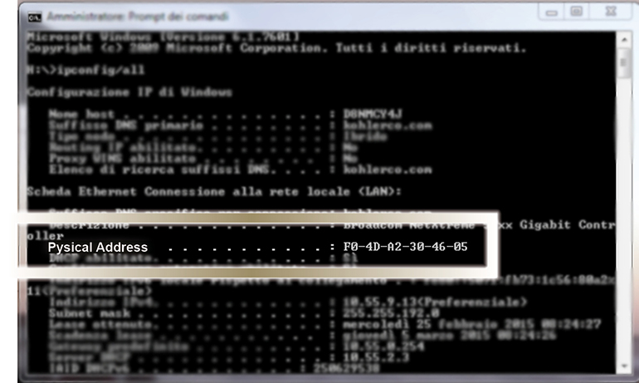

Per i PC portatili, nella scheda "LAN wireless Connessione rete wireless" è indicato il numero dell' "Indirizzo fisico"; per i PC fissi l'indirizzo fisico si trova nella scheda "Ethernet Ethernet".
Each computer has a different number.

Write down the physical address number (1) (separating the numbers with ":" and no longer with "-") in the "MAC address" field of the PC.

Enter the "Serial number" (2) and then click on "Search" (3).

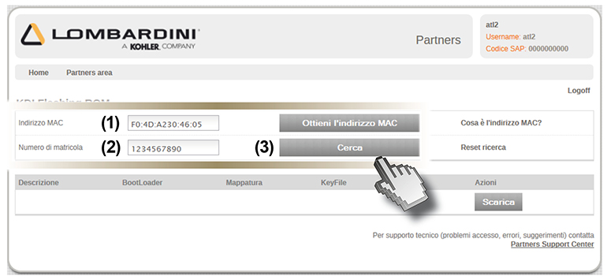

When the search is complete, the name of the file will appear, identified by the engine K of the relevant map.

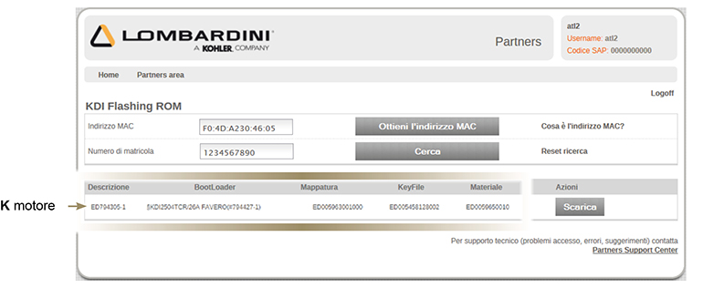

Click on "Download" (4) and click on "Save" (5).

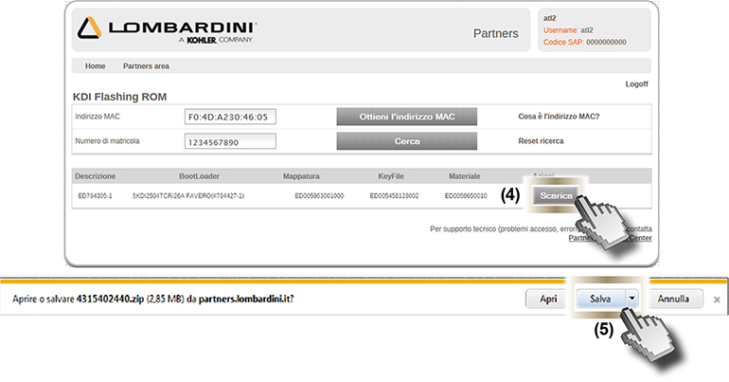

The file will be saved automatically to the "Download" folder of the computer.

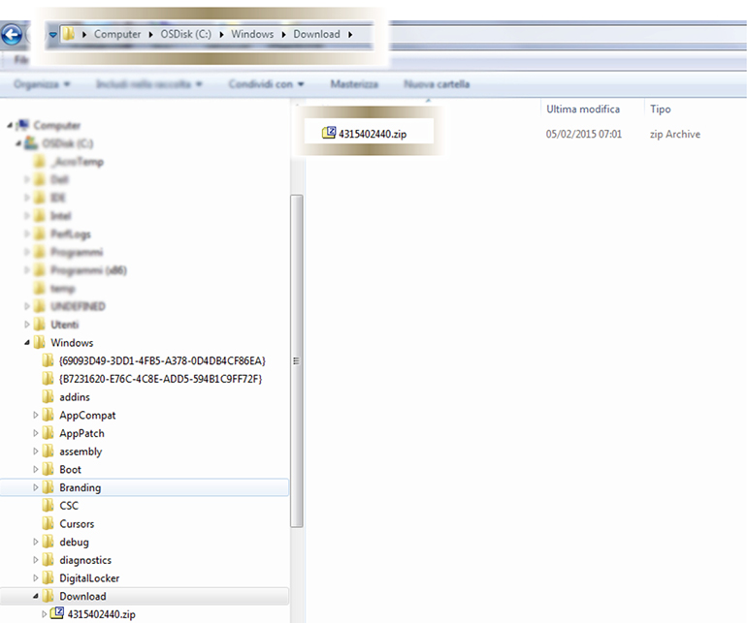

Flashing
Press the "Check" push button to access the "Diagnosis" display screen.

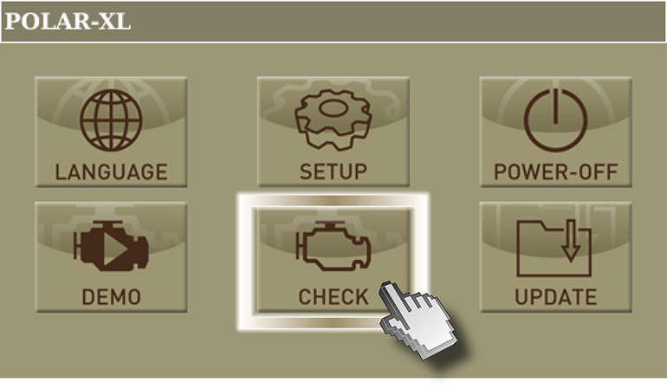

Click on "UPDATE MAPS" and wait some seconds.

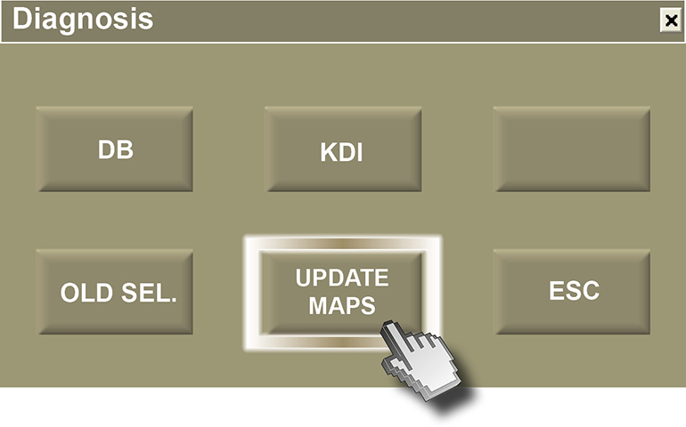
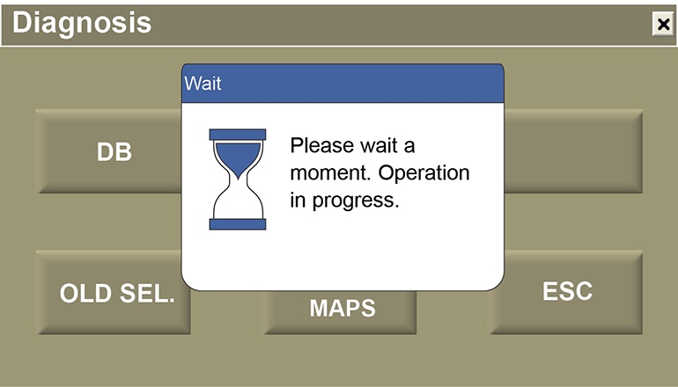

Turn on the panel and press "OK"

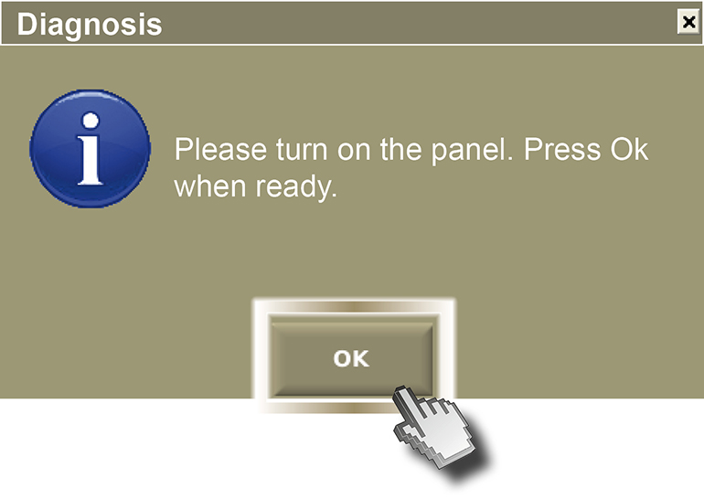
Click on "REP.ECU." (ECU reprogramming).

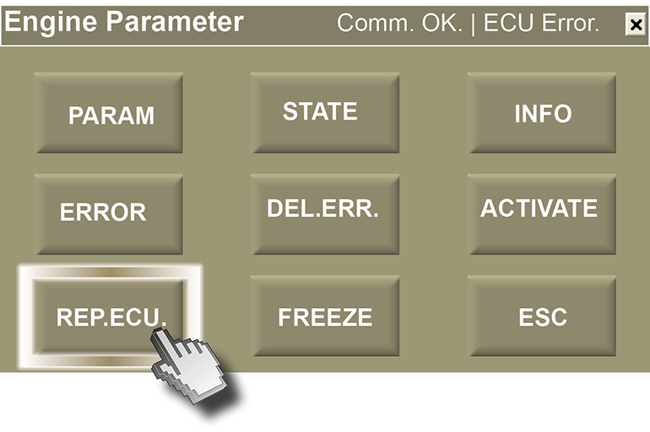

Click on "YES".

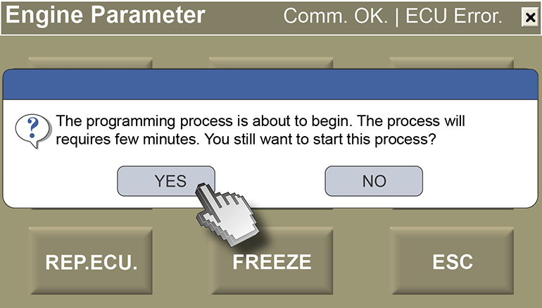

Wait some minutes.

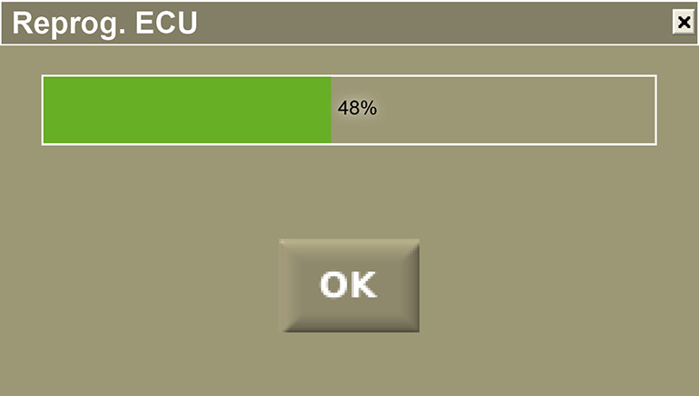

Click on "OK".

