Glossary
KDI 1903 M Workshop manual (Rev_09.6)

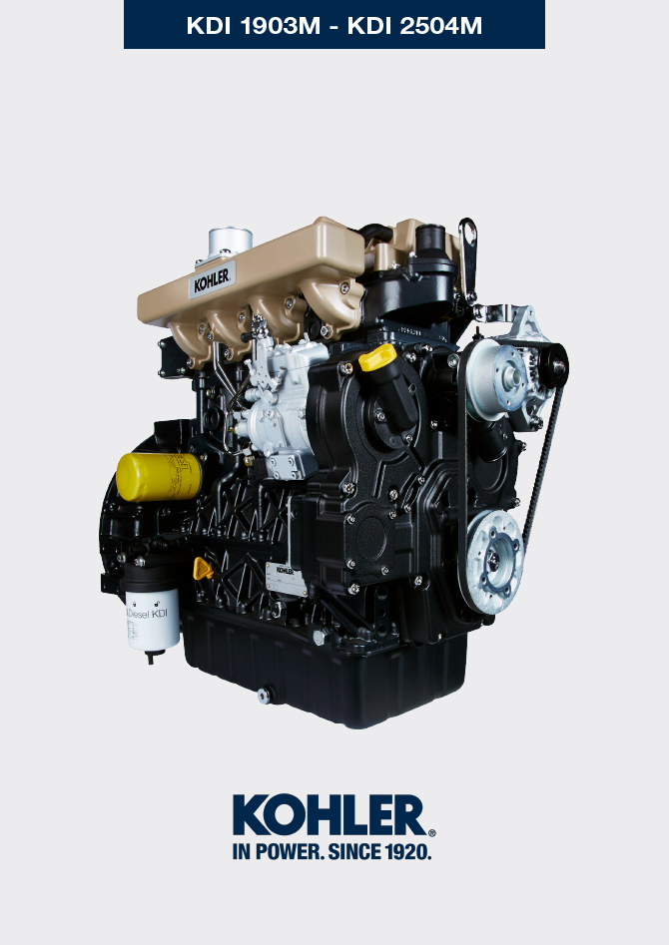
Sommario
1. TITOLO 1 2
1.1. Asdfsdfsdf 2
1.2. Asdfsdfsdfggg 2

Glossary

Glossary
A

Air gap: | Distance to respect between a fixed component and one in movement.
Alternator: | A component that transforms mechanical energy into AC electrical energy.
Authorised service station: | KOHLER authorised workshop.
Authorised workshop: | KOHLER authorised service centre.

B

Balancer device: | A device that reduces vibrations caused by movement of the alternating weights (Crankshaft - Connecting rods - Pistons).
Base configuration: | Engine having components represented in Para. 1.3 - 1.4 .
BDC: | Bottom Dead Centre; a moment in which the piston is at the start of its stroke.
Bore | Internal diameter of the cylinder in combustion engines.

C

Cold Start Advance: | The device provides for advance injection modification to enable advance of the engine at low temperatures.
Combustion: | Chemical reaction of a mixture composed of fuel and fuel (air) inside a combustion chamber.
Crankshaft: | A component that transforms straight operation into rotary operation, and vice-versa.

E

EC: | "European Community".

F

Fig.: | Figure.
Functional units: | Component, or group of main components, able to carry out specific functions on the engine.

G

Galvanised: | Material that has undergone surface protection treatment.
Grinding (valves and seats): | Cleaning operation of the valves and seats carried out with an abrasive paste (refer to an authorised service station for this type of operation).

H

Heater: | A device that heats the intake air by means of an electrical resistor.
Heavy conditions: | Type of extreme condition referred to the work environment in which the engine is used (very dusty - dirty area, or in a contaminated environment due to various types of gas).

I

Idle speed operation: | Operation of a running engine with the vehicle stopped and on idle speed.

K

KDI: | "Kohler Direct Injection"

M

Maintenance - periodic | A group of maintenance actions that have the sole objective to control and replace elements on their expiry, without modifying or improving the functions carried out by the system, neither increasing the value nor improving performance.
MAX: | Maximum.
Methyl ester: | It is a mixture of products by means of a chemical conversion of oils and animal and/or vegetable fat, which is used to produce Biofuel.
Min.: | Minutes.
MIN: | Minimum.
Model: | Model, engine identification plate, which indicates the engine's model.

N

N/C: | Normally Closed, referred to switches (oil-pressure switch).
N/O: | Normally Opened, referred to switches (Coolant temperature sensor)

P

Par.: | Paragraph.
Paraffin.: | Fatty and solid substance that may form inside the diesel.
Pipe cleaner: | An instrument having a metal cylindrical body with bristles that jut outwards. It is similar to a brush and is used to clean areas that are not easily accessible manually (e.g. oil ducts inside an engine).
Power operation: | Operation of the engine at high speeds.
PTO: | Power Take Off - a point provided to take advantage of alternative operation transmission.

R

Ref.: | Reference.
Rpm: | Rounds per minute.

S

s/n: | Serial number (engine identification name plate) indicating the engine identification series/chassis number.
Spec.: | Specification, (engine identification name plate) indicating the engine version.
STD: | (Standard), base configuration of a component, or a group of components.

T

Tab.: | Table.
TDC: | Top Dead Centre; a moment in which the piston is at the end of its stroke.
Thermostatic valve: | A valve that adjusts the flow of coolant liquid; it is able to operate by means of temperature variation.
Torque: | Force applied to an object that rotates on an idler shaft.
Trochoid: | Rounded toothed profile (also known as "lobes").

U

Used oil: | Oil altered by operation or time, which is no longer compliant for correct lubrication of the components.

W

Warning Lamp: | A warning light (usually red) that indicates a serious anomaly during engine operation.

SYMBOLS AND UNITS OF MEASUREMENT
SYMBOL | UNIT OF MEASUREMENT | DESCRIPTION | EXAMPLE
α | degree | Rotation/inclination angle | 1°
cm ² | square centimetre | Area | 1 cm ²
Ø | millimetre | Circumference | Ø 1 mm
Nm | newton-metre | Torque | 1 Nm
mm | millimetre | Length | 1 mm
µm | 1/1000 of a millimetre (micron) |  | 1 µm
H | hour | Time | 1 h
g/kW | grammes per kilowatt per hour | Specific consumption | 1 g/kWh
kg/h | kilogramme per hour | Max. flow rate | 1 kg/h
Lt./min. | litres per minute | Flow rate | 1 Lt./min.
Lt./h | litres per hour |  | 1 Lt./h
ppm | parts per million | Percentage | 1 ppm
N | newton | Force | 1 N
A | Ampere | Intensity of electrical current | 1 A
gr. | gramme | Weight | 1 gr.
kg | kilogramme |  | 1 kg
W | Watt | Power | 1 W.
kW | kiloWatt |  | 1 kW
pa | pascal | Pressure | 1 pa
KPa | Kilopascal |  | 1 KPa
bar | barometric pressure |  | 1 bar
mbar (1/1000 bar) | barometric pressure |  | 1 mbar
R | Resistance | Resistance to electrical current (referred to a component) | 1 Ω
Ω | ohm | Resistance of electrical current | 1 Ω
Rpm | revs per minute | Rotation of an axis | 1 Rpm
Ra | average roughness expressed in microns | Roughness | 1 Ra
°C | degree centigrade | Temperature | 1°C
V | Volt | Electrical voltage | 1 V
 | millimetre | Hex-head capscrew | 1 mm
cm ³ | cubic centimetre | Volume | 1 cm ³
Lt. | litre |  | 1 Lt.

