General Information
KDI 2504 M Owner Manual (Rev_14.2)

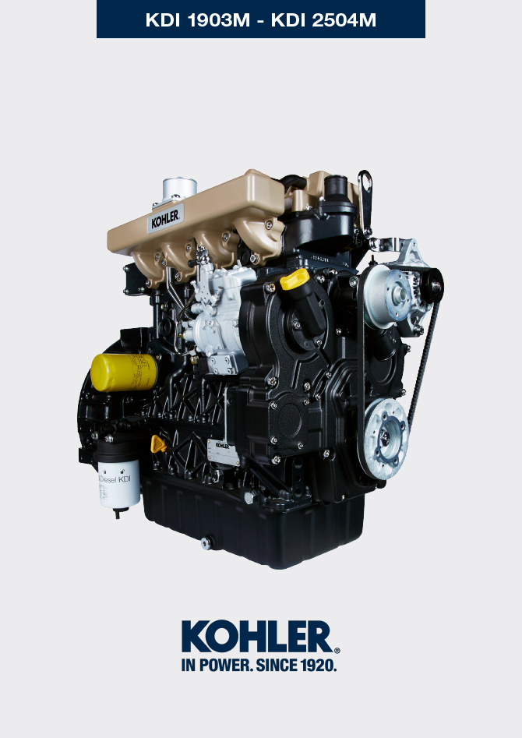
Sommario
1. TITOLO 1 2
1.1. Asdfsdfsdf 2
1.2. Asdfsdfsdfggg 2

null

