Technical information
KSD 1403 Owner Manual

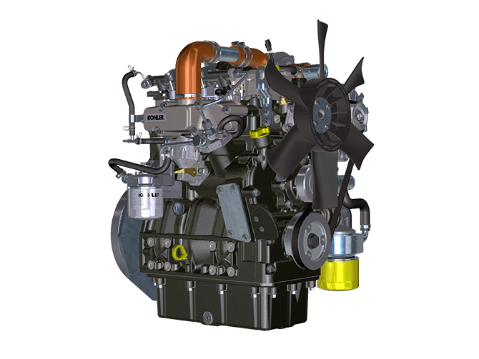
Sommario
1. TITOLO 1 2
1.1. Asdfsdfsdf 2
1.2. Asdfsdfsdfggg 2

Technical information

General description of the engine
- 4-stroke, in-line cylinders Diesel engine; - Liquid-cooling system;

- 2 valves per cylinder;

- Indirect injection.

Engine specifications
2.1
TECHNICAL DATA |  | UNIT OF MEASURE
Engine type |  |  | KSD 1403 NA | KSD 1403 TC
Cylinders |  | n. | 3
Bore |  | mm | 81
Stroke |  | mm | 90
Displacement |  | cm ³ | 1391
MAX INCLINATION DURING OPERATION (even in combined) |  | α | 40° max 30 min.
 |  | α | 45° max 1 min.
OIL CAPACITY (MAX level.) including oil filter | Compact Sump | lt. | 3.72
 | Deep Sump |  | 5.44
DRY WEIGHT |  |  | 121 | 126

Engine dimensions (mm)

KSD 1403 NA | KSD 1403 TC

NOTE : Dimensions vary according to engine configuration.

Oil

Important

- The engine may be damaged if operated with improper oil level.
- Do not exceed the MAX level because a sudden increase in engine rpm could be caused by its combustion.
- Use only the recommended oil to ensure adequate protection, efficiency and service life of the engine.
- The use of lubricants other than recommended may shorten the engine life.
- Viscosity must be appropriate to the ambient temperature to which the engine is to be exposed.

Danger

- Prolonged skin contact with the exhausted engine oil can cause cancer of the skin.
- If contact with oil cannot be avoided, thoroughly wash your hands with soap and water as soon as possible.
- For the exhausted oil disposal, refer to the Par. DISPOSAL and SCRAPPING .
2.4.1 SAE oil classification
- In the SAE classification, oils are identified according to viscosity without considering any other qualitative characteristic.
- The code is composed of two numbers, which indicate, and must correspond to, the ambient temperature in which the engine operates, the first number refers to the viscosity when cold, for use during winter (" W "), while the second number is for viscosity at high temperatures.

2.2
RECCOMENDED OIL
WITH SPECIFICATIONS | API | CJ-4 or better
 | ACEA | E6  E9
VISCOSITY | SAE | 0w-40 (-40°C ÷ +50°C)  5w-30 (-30°C ÷ +40°C)  10w-30 (-25°C ÷ +40°C)  10w-40 (-25°C ÷ +50°C)

Fuel
Important
- Use of other types of fuel could damage the engine. Do not use dirty diesel fuel or mixtures of diesel fuel and water since this will cause serious engine faults.
- Any failures resulting from the use of fuels other than recommended will not be warranted.
Warning
- Clean fuel prevents the fuel injectors from clogging. Immediately clean up any spillage during refuelling.
- Never store diesel fuel in galvanized containers (i.e. coated with zinc). Diesel fuel and the galvanized coating react chemically to each other, producing flaking that quickly clogs filters or causes fuel pump and/or injector failure.

NOTE:
In a warranty case the customer must prove by a certificate from the fuel supplier that an allowed fuel was used.
Do NOT USE vegetable oils. Biofuel contents limit as specified by EN590 and ASTMD975. Any failure resulting from the use of fuel other than recommended will not be warranted.

2.3
no certification | NOTES
NATO F-54 --> | (S = 10 ppm)
NATO F-40 (JP4) --> | Not recommended. JP 4 should be used only in emergency situations. JP 4 severely reduces engine life and potential power due to the lack of lubricity as compared to DF2
NATO F-34 + additives (JP8) --> | 5-12 % reduction in power and up to a 30% reduction in fuel system component and upper cylinder life.
Civil Jet Fuels Jet-A/A1 (kerosene) --> | If 5% oil is added
Civil Jet Fuels Jet B (JP5) --> | 5-12 % reduction in power and up to a 30% reduction in fuel system component and upper cylinder life.
EN 590, DIN 51628 --> | (S=10ppm)
Bio Fuels EN 14214 B20 --> | (up to 20% methyl ester) Max 20% in fuel. Up to 5% reduction in power. Lube oil change and fuel filter change intervals must be shortened. Periodic checks of hoses and seals should be conducted
ASTM D 975 Grade 1-D S15 Diesel artico --> | Recommended fuel type for cold weather operation in ambient temperatures, which would result in DF2 “waxing”. No degradation in performance or engine/ component life
ASTM D 975 Grade 1-D S1500 Diesel artico --> | Recommended fuel type for cold weather operation in ambient temperatures, which would result in DF2 “waxing”. No degradation in performance or engine/ component life
ASTM D 975 Grade 2-D S15 --> | Recommended fuel type for normal ambient operation
ASTM D 975 Grade 2-D S1500 --> | Recommended fuel type for normal ambient operation
Arctic Fuel (EN 590, ASTM D 975) --> | Without adding oil
High Sulphur Fuel S < 5000 ppm (< 0,5%) --> | NOT in USA
High Sulphur Fuel S > 5000 ppm (> 0,5%); < 10000 ppm (<1,0%) --> | NOT in USA
HVO 100%
(EN 15940)

Fuel for low temperatures

- When operating the engine in ambient temperatures lower than 0°C, use suitable low temperature fuel normally available from fuel distributors and corresponding to the specifications of Tab. 2.7.
- These fuels reduce the formation of paraffin in diesel at low temperatures.
- When paraffin forms in the diesel, the fuel filter becomes blocked interrupting the flow of fuel.

It is possible to run the engine at temperatures below 0°C using special winter fuels. These fuels reduce the formation of paraffin in diesel at low temperatures. If paraffin forms in the diesel, the fuel filter becomes clogged interrupting the fuel flow. *

Fuel can be: *
- Summer down to 0°C *
- Winter down to -15°C *
- Arctic below -16°C *

Biodiesel fuel *
- DO NOT USE vegetable oil as a biofuel for this engine. *

Biodiesel blends must be purchased from a BQ-9000 Certified Marketer and meet the American Society for Testing and Materials (ASTM) specifications for biodiesel under ASTM D6751 for North America. In Europe, biodiesel blends must meet the EN14214 standard. *
Biodiesel has a strong cleansing effect; hence initial use will typically result in a collection of deposits from fuel lines and the fuel tank from previous use of diesel at the fuel filter. Therefore, the fuel filter must be changed 30 to 50 hours after changing over from diesel to biodiesel. Shortened fuel filter change intervals are required and fuel dilution of lube oil is possible with the use of biodiesel. Therefore, halved shortened lube oil change intervals must be introduced. Periodic checks of hoses and seals must also be conducted. *
Biodiesel has a high cloud point so heating the fuel is necessary for low ambient temperature operation to avoid waxing or gelling. *
Engine storage with biodiesel longer than 4 to 6 weeks must be avoided. *

Emission control information *
- To be Emission compliant, only ultra low sulfur fuel can be used. *
- “Only ultra low sulfur fuel” label must be attached near the fuel inlet. *

Coolant recommendation
A mixture of 50% demineralized water and 50% low silicate ethylene glycol based coolant liquid must be used. Use a Long Life or Extended Life Heavy Duty OAT coolant free of: silicates, phosphates, borates, nitrites and amines.

The following ethylene-glycol based engine coolant for all models within KDI engine family may be used:

- OAT (Organic Acid Technology) Low Silicate: ASTM D-3306 D-6210
- HOAT (Hybrid Organic Acid Technology) Low Silicate: ASTM D-3306 D-6210

The above coolants in concentrated formulation must be mixed with distilled, deionized, or demineralized water. A pre-mixed formulation (40-60% or 50-50%) can be used directly when available.

Important
- Do not mix ethylene glycol and propylene glycol based coolants. Do not mix OAT and HOAT based coolant. OAT performance life can be drastically reduced if contaminated with nitrite-containing coolants.
- Never use automotive-type coolants. These coolants do not contain the correct additives to protect heavy – duty diesel engines.

OAT coolants are maintenance free up to 6 years or 6000hrs of operation , provided that the cooling system is topped up using the same type of coolant. Do not mix different coolant types. Test the coolant condition annually with coolant test strips.
HOAT are not all maintenance free and it is recommended to have SCA (Supplemental Coolant Additives) added at the first maintenance interval.

Battery recommendation
Battery not supplied by Kohler

Tab. 2.7
RECOMMENDED BATTERIES
AMBIENT TEMPERATURE | BATTERY TYPE
> - 15°C | 12V 100 Ah - 800 CCA/SAE
-15°C ÷ -25°C | 12V 110 Ah - 950 CCA/SAE
< - 25°C | 12V 120 Ah - 1000 CCA/SAE

