Information on adjustments
KDI 3404 TCR-SCR Workshop Manual (Rev. 10.4)

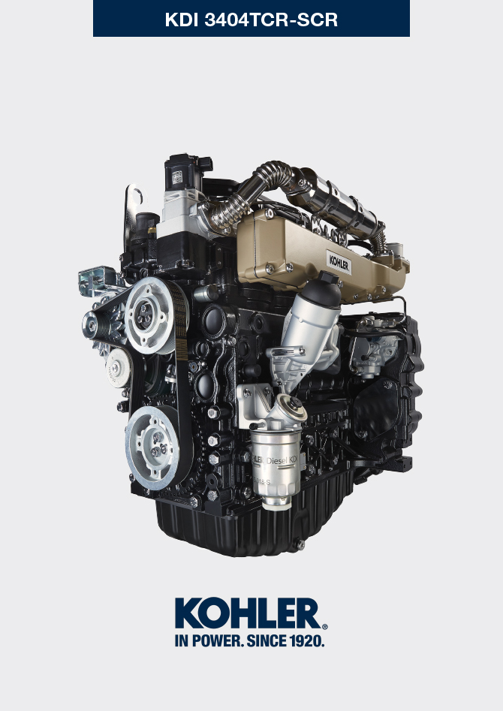
Sommario
1. TITOLO 1 2
1.1. Asdfsdfsdf 2
1.2. Asdfsdfsdfggg 2

Information on adjustments

'Waste Gate' opening valve regulation

Important

- Before proceeding with operation, read Par. 3.3.2 .
- Regulation must not be carried out with the engine running.
- During the procedure in point 5 , pay special attention not to bend rod H .

- Disconnect the hose A from the turbocharger.
- Connect a pressure reducer C to the network of compressed air.
- Position dial gauge D in such a way that feeler F rests onthe Waste Gate rod control valve extremity H (point E ).
- By using gradually the reduction gear C send the air to the Waste Gate actuator control L in order to move rod H forward by 1 mm (value M to check on dial gauge D). Pressure read on gauge B must be: 2500 mbar.
- If pressure is less or more than the indicated value, proceed as follows:
- Remove the retainer cotter pin (point E ) and disconnect rod H from the Waste Gate control lever.
- Tighten (to increase) / or loosen (to decrease) pressure of the ring nut of rod H until reaching the corrected calibration.
- Redo lock nut G .
- Reconnect rod H and assemble the cotter pin point E .

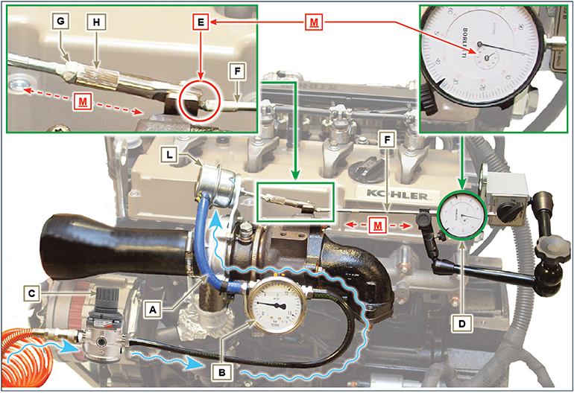
Fig 12.1

Air filter check
NOTE : Component not supplied by KOHLER .

Refer to the technical documentation of the vehicle.

Oil steam separator check
Important

- Before proceeding with operation, read Par. 3.3.2 .
- Loosen clamp B and remove hose C .  - Remove rapid fitting D from separator A .  - Start the engine at idle speed or without a load and check if air comes out from unions A1 and A2 .  NOTE: If what is described in Point 3 does not occur, proceed with cleaning or replacing oil separator A and accurately clean all connecting  hoses, and repeat the operation from Point 3. | 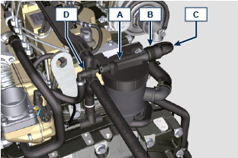  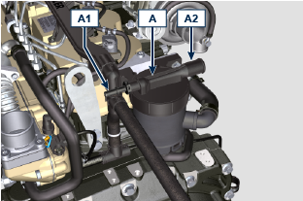

Rubber hoses and manifolds check
Important

- Before proceeding with operation, read Par. 3.3.2 .
The check is carried out by applying slight deflection or bending along the tube/hose and next to the hose clamps.  Components must be replaced if they have clear signs of cracks, tears, cuts, leaks, or do not retain a certain degree of elasticity.  - Check the condition of all rubber hoses A .  - Check whether there are any leakages of air, refrigerant, oil or fuel next to their connections.  NOTE : Refer to the technical documentation of the machine for components that are not shown in the figure. | 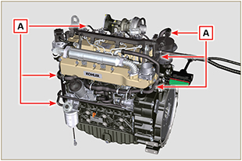  Fig 12.3

Oil leak check
Important

- Before proceeding with operation, read Par. 3.3.2 .
Check that there are no leakages next to area A .  - Start the engine at idle speed or without a load and check whether there are any leakages next to area A.  - It is anyhow necessary to also check the seals of all main components and their surface contact, such as:  - crankcase and gasket (side 1 ª PTO) - oil sump and exhaust caps  - cylinder head and its assembled components  - rocker arm cover  - Timing system carter and gasket (side 2 ª PTO) - oil dipstick housing or rod support tube.  NOTE: Perform the checks described in Points 1 and 2 periodically and during maintenance procedures.  It is also necessary to check for leakages on the components that are not listed.  If necessary, disassemble the components that have a leakage and investigate the possible cause.  The components must be replaced otherwise they do notguarantee their sealing. | 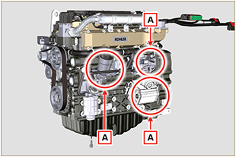  Fig 12.7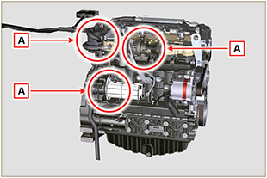  Fig 12.8

Oil pressure check
Important

- Before proceeding with operation, read Par. 3.3.2 .
- Replace the oil dipstick A with a thermocouple B (Fig. 12.6).  - Unscrew and remove the oil pressure switch C and screw on a 10 bar pressure gauge in its seat (Fig. 12.8) .  - Start the engine at idle speed and without a load, check the oil pressure value according to the oil temperature (Fig. 12.7 ).  NOTE : The graph in Fig. 12.7 illustrates the pressure line with speed of 1000 Rpm.  - If the pressure values are below the values indicated in Fig. 12.7 , check to identify the cause of the problem.  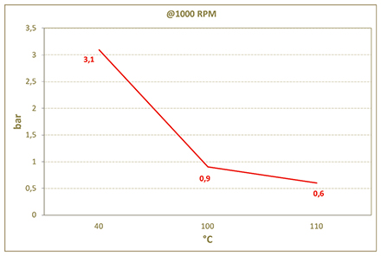  Fig. 12.7 | 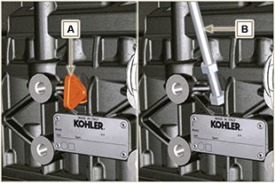  Fig. 12.6  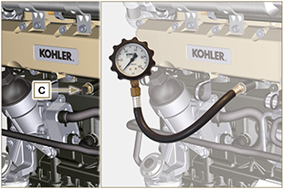  Fig. 12.8

DEF Check
1 - The inspection is carried out with refractometer A . Follow the instructions on the device; the correct value must comply with the values of 1% ± 32.5%.  Warning  Use of the engine with DEF that does not comply with the quality specifications described in point 1 will trigger an error code and result in an inducement strategy (Para. 2.12.3). | 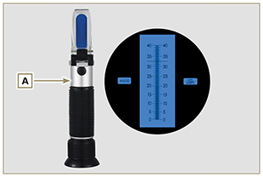  Fig 12.4

DEF tank filter check and cleaning
Warning
- Do not use pressurised air or water.
- Only use hot water for cleaning and lubrication of the gaskets - replace gasket D if damaged.
- The tank and its components cannot be repaired - do not damage the components during cleaning operations.
1 - Turn head A anticlockwise to release tank B.  2 - Remove head A from tank B. | 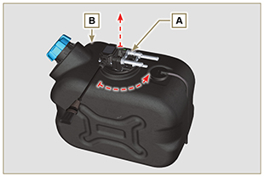  Fig. 12.5
3 - Visually check filter B and proceed to point 4 if there are traces of crystallisation or impurities.  4 - Wash filter C in a basin with hot water .  NOTE: the hot water will dissolve the crystal residues caused by the DEF liquid. It is permitted to use a brush to remove any impurities completely .  5 - Assemble head A by following the instructions in reverse in point 2 and 1.  NOTE: only use water to lubricate gasket D. | 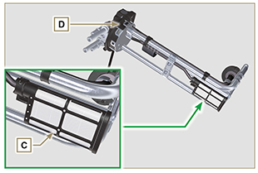  Fig. 12.6

