Technical information
Owner Manual KDW 502 | 702 | 1003 | 1404 (Rev_00)

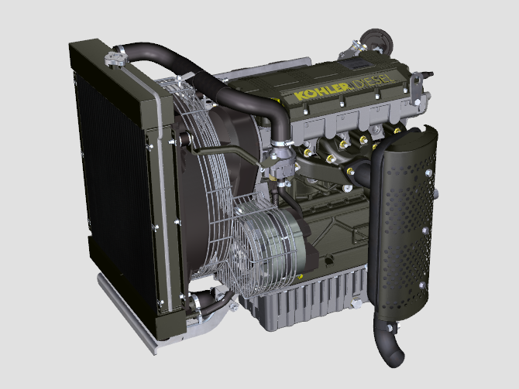
Sommario
1. TITOLO 1 2
1.1. Asdfsdfsdf 2
1.2. Asdfsdfsdfggg 2

Technical information

General description of the engine
- 4-stroke, in-line cylinders Diesel engine; - Liquid-cooling system;

- 2 valves per cylinder;

- Indirect injection.

Engine specifications
Tab. 2.1
TECHNICAL DATA |  | UNIT OF MEASURE | 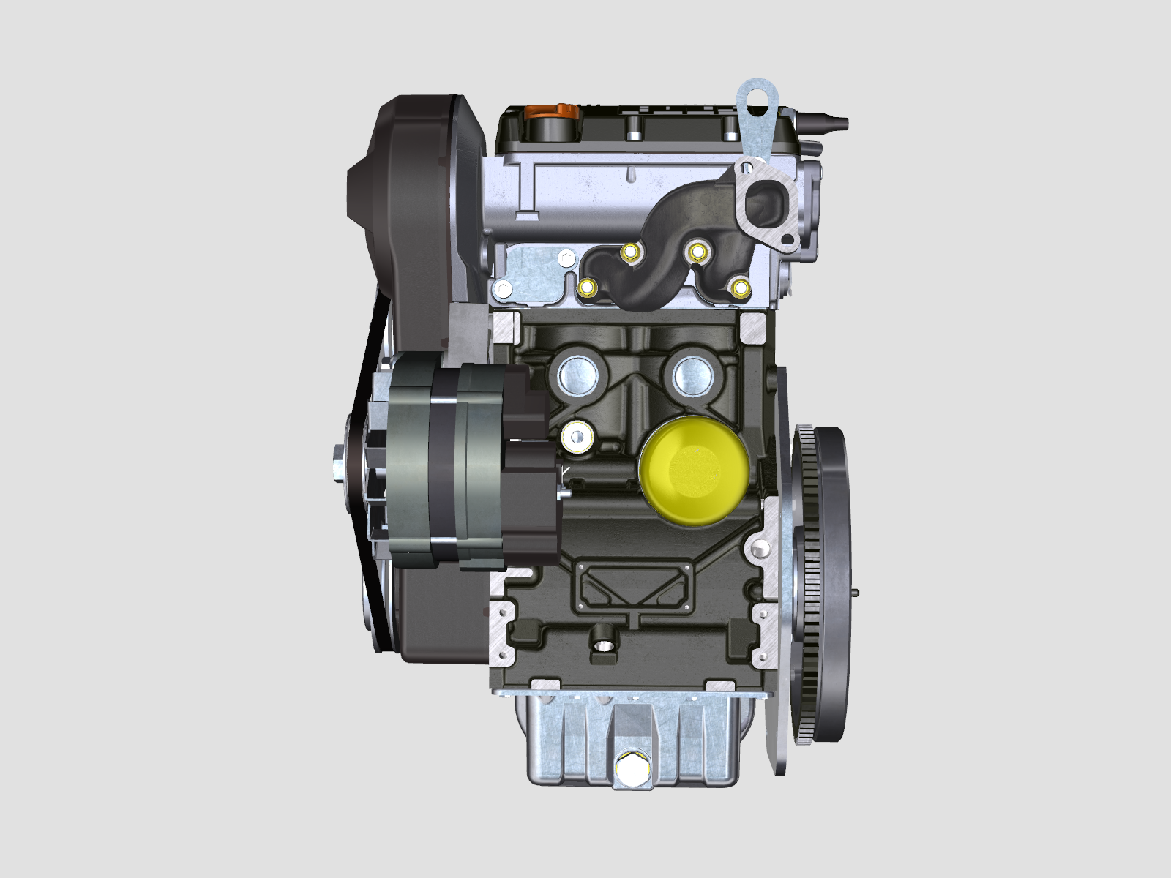 |  | 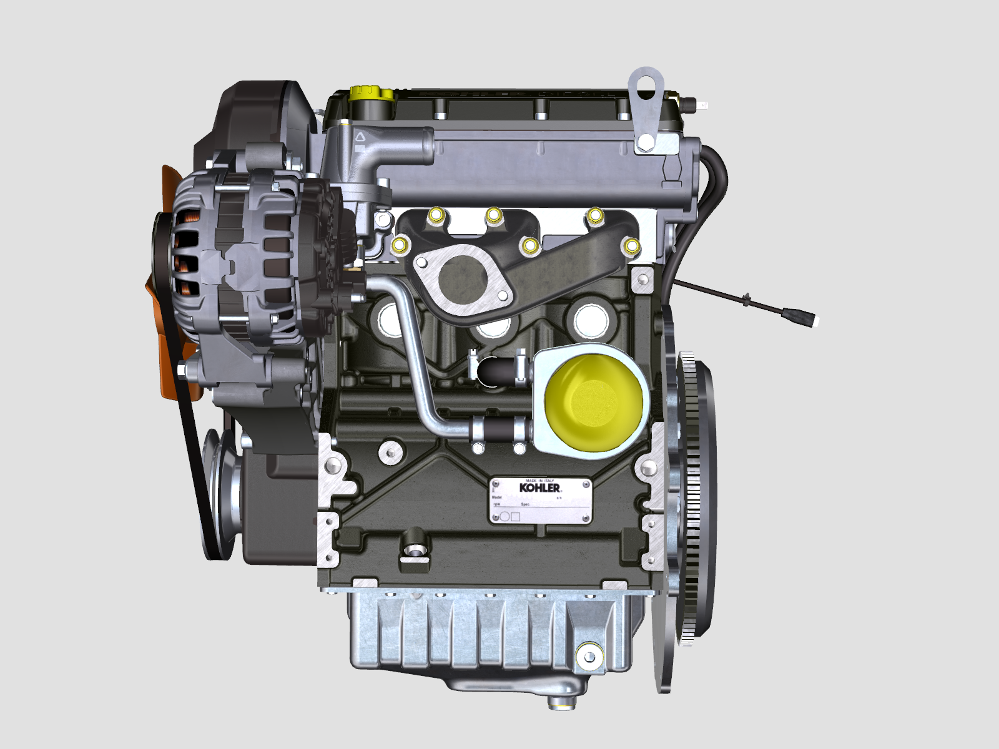 | 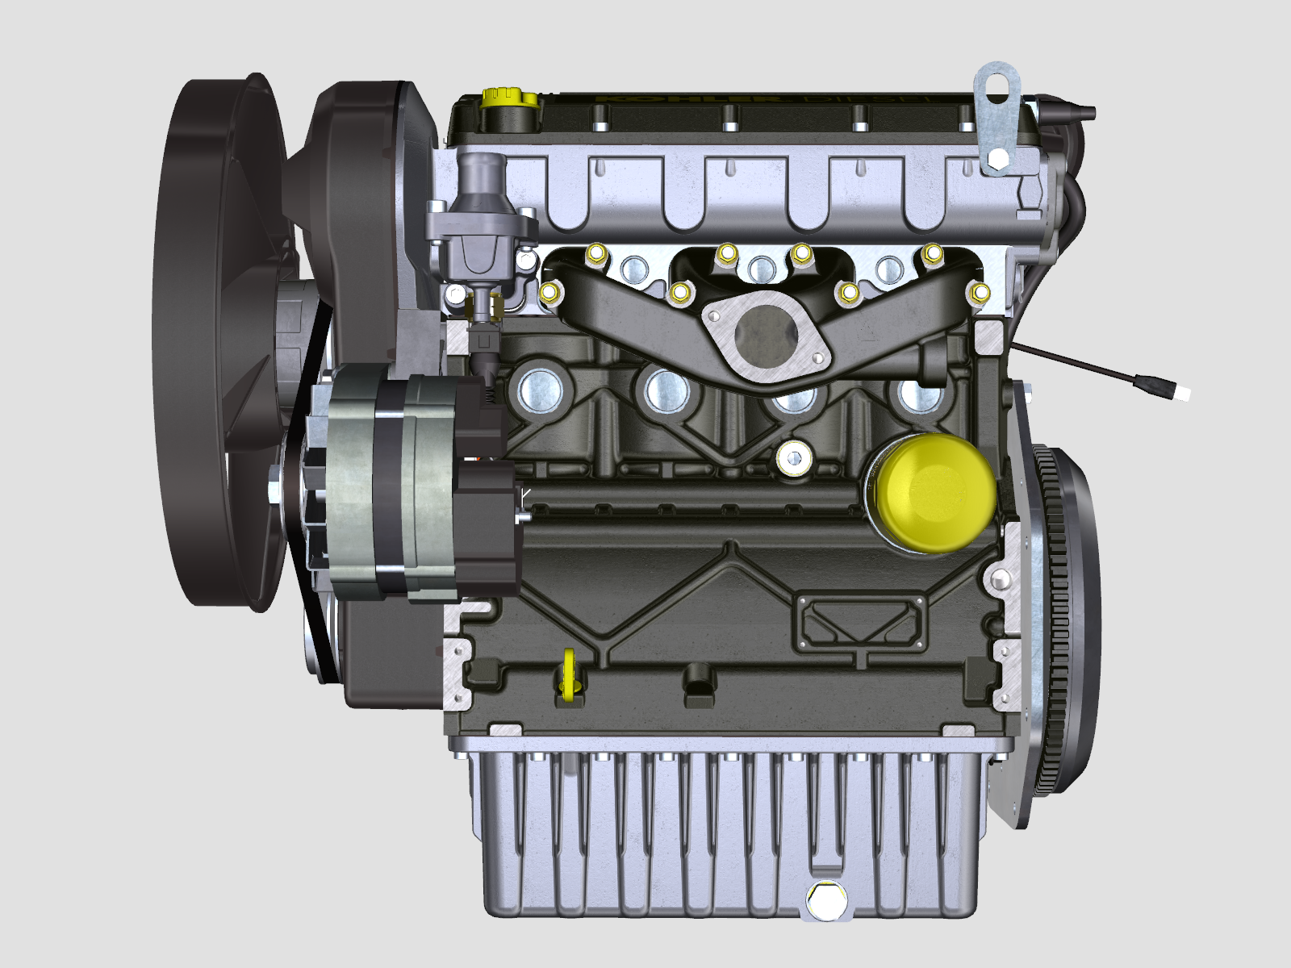
Engine type |  |  | KDW 502 | KDW 702 | KDW 1003 | KDW 1404
Cylinders |  | n. | 2 | 2 | 3 | 4
Bore |  | mm | 72 | 75 | 75 | 75
Stroke |  | mm | 62 | 77.6 | 77.6 | 77.6
Displacement |  | cm ³ | 505 | 686 | 1028 | 1372
MAX INCLINATION DURING OPERATION (even in combined) |  | α | 25° max. 30 min.
 |  | α | 35° max.1 min.
OIL CAPACITY (MAX level.) - filter included | standard oil sump | lt. | 1.5 | 1.6 | 2.4 | 3.2
 | enhanced oil sump | lt. | 2.5 | 2.5 | 3.8 | 5.2
OIL CAPACITY (MAX level.) - without filter | standard oil sump | lt. | 1.4 | 1.5 | 2.3 | 3.0
 | enhanced oil sump | lt. | 2.4 | 2.4 | 3.7 | 5.1
DRY WEIGHT |  | Kg | 60 | 66 | 87 | 98

Engine dimensions (mm)
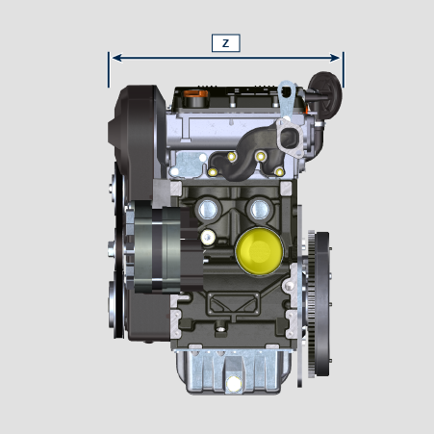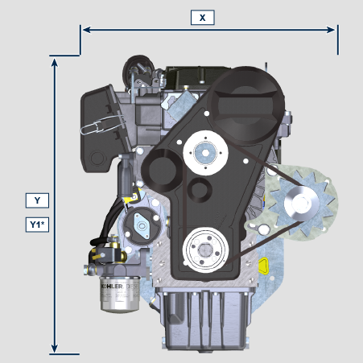
 | KDW 502 | KDW 702 | KDW 1003 | KDW 1404
X | 387 | 412 | 412 | 412
Y | 490 | 516 | 516 | 516
Z | 426 | 421 | 513 | 596
Y1* | 562.35 =(Y+72.35) | 588.35 = (Y+72.35) | 588.35 = (Y+72.35) | 588.35 = (Y+72.35)

*Deep oil sump

NOTE : Dimensions vary according to engine configuration.

Oil

Important

- The engine may be damaged if operated with improper oil level.
- Do not exceed the MAX level because a sudden increase in engine rpm could be caused by its combustion.
- Use only the recommended oil to ensure adequate protection, efficiency and service life of the engine.
- The use of lubricants other than recommended may shorten the engine life.
- Viscosity must be appropriate to the ambient temperature to which the engine is to be exposed.

Danger

- Prolonged skin contact with the exhausted engine oil can cause cancer of the skin.
- If contact with oil cannot be avoided, thoroughly wash your hands with soap and water as soon as possible.
- For the exhausted oil disposal, refer to the Par. DISPOSAL and SCRAPPING .
2.4.1 SAE oil classification
- In the SAE classification, oils are identified according to viscosity without considering any other qualitative characteristic.
- The code is composed of two numbers, which indicate, and must correspond to, the ambient temperature in which the engine operates, the first number refers to the viscosity when cold, for use during winter (" W "), while the second number is for viscosity at high temperatures.

2.2
RECCOMENDED OIL
WITH SPECIFICATIONS | API | SJ/CF 4
 | ACEA | A3-96  B3-96
 | MIL | L-46152 D/E
VISCOSITY | SAE | 5w-40 (-30°C ÷ +40°C)

- Filtration of oils is critical to proper operation and lubrication; always change filters regularly as specified in this manual.

Fuel
Important  - Use of other types of fuel could damage the engine. Do not use dirty diesel fuel or mixtures of diesel fuel and water since this will cause serious engine faults.  - Any failures resulting from the use of fuels other than recommended will not be warranted. | Warning  - Clean fuel prevents the fuel injectors from clogging. Immediately clean up any spillage during refuelling.  - Never store diesel fuel in galvanized containers (i.e. coated with zinc). Diesel fuel and the galvanized coating react chemically to each other, producing flaking that quickly clogs filters or causes fuel pump and/or injector failure.
2.3
Certification --> | Stage 5 |  | Tier IV Final
Fuel Type --> | (EN 590) | HVO 100%  (EN 15940) | Grade 1-D S15 | Grade 2-D S15

2.4
no certification | NOTES
NATO F-54 --> | (S = 10 ppm)
NATO F-40 (JP4) --> | Not recommended. JP 4 should be used only in emergency situations. JP 4 severely reduces engine life and potential power due to the lack of lubricity as compared to DF2
NATO F-34 + additives (JP8) --> | 5-12 % reduction in power and up to a 30% reduction in fuel system component and upper cylinder life.
Civil Jet Fuels Jet-A/A1 (kerosene) --> | If 5% oil is added
Civil Jet Fuels Jet B (JP5) --> | 5-12 % reduction in power and up to a 30% reduction in fuel system component and upper cylinder life.
EN 590, DIN 51628 --> | (S=10ppm)
Bio Fuels EN 14214 B20 --> | (up to 20% methyl ester) Max 20% in fuel. Up to 5% reduction in power. Lube oil change and fuel filter change intervals must be shortened. Periodic checks of hoses and seals should be conducted
ASTM D 975 Grado 1-D S15 Diesel artico --> | Recommended fuel type for cold weather operation in ambient temperatures, which would result in DF2 “waxing”. No degradation in performance or engine/ component life
ASTM D 975 Grado 1-D S1500 Diesel artico --> | Recommended fuel type for cold weather operation in ambient temperatures, which would result in DF2 “waxing”. No degradation in performance or engine/ component life
ASTM D 975 Grado 2-D S15 --> | Recommended fuel type for normal ambient operation
ASTM D 975 Grado 2-D S1500 --> | Recommended fuel type for normal ambient operation
Arctic Fuel (EN 590, ASTM D 975) --> | Without adding oil
High Sulphur Fuel S < 5000 ppm (< 0,5%) --> | NOT in USA
High Sulphur Fuel S > 5000 ppm (> 0,5%); < 10000 ppm (<1,0%) --> | NOT in USA
HVO 100%
(EN 15940)

Coolant recommendation
A mixture of 50% demineralized water and 50% low silicate ethylene glycol based coolant liquid must be used. Use a Long Life or Extended Life Heavy Duty OAT coolant free of: silicates, phosphates, borates, nitrites and amines.

The following ethylene-glycol based engine coolant for all models within KDW engine family may be used:

- OAT (Organic Acid Technology) Low Silicate: ASTM D-3306 D-6210
- HOAT (Hybrid Organic Acid Technology) Low Silicate: ASTM D-3306 D-6210

The above coolants in concentrated formulation must be mixed with distilled, deionized, or demineralized water. A pre-mixed formulation (40-60% or 50-50%) can be used directly when available.

Important
- Do not mix ethylene glycol and propylene glycol based coolants. Do not mix OAT and HOAT based coolant. OAT performance life can be drastically reduced if contaminated with nitrite-containing coolants.
- Never use automotive-type coolants. These coolants do not contain the correct additives to protect heavy – duty diesel engines.

OAT coolants are maintenance free up to 6 years or 6000hrs of operation , provided that the cooling system is topped up using the same type of coolant. Do not mix different coolant types. Test the coolant condition annually with coolant test strips.
HOAT are not all maintenance free and it is recommended to have SCA (Supplemental Coolant Additives) added at the first maintenance interval.

Battery recommendation
Battery not supplied by Kohler

Tab. 2.7
RECOMMENDED BATTERIES
 | IN STANDARD START CONDITIONS | IN HEAVY-DUTY START CONDITIONS
KDW 502 | 12w-44 Ah / 210 A/DIN  12w-44 Ah / 410 A/EN  12w-44 Ah / 400 A/SAE | 12w-55 Ah / 255 A/DIN  12w-55 Ah / 500 A/EN  12w-55 Ah / 485 A/SAE
KDW 702 | 12w-66 Ah / 330 A/DIN  12w-66 Ah / 650 A/EN  12w-66 Ah / 630 A/SAE | 12w-88 Ah / 350 A/DIN  12w-88 Ah / 690 A/EN  12w-88 Ah / 665 A/SAE
KDW 1003-1404 | 12w-70 Ah / 350 A/DIN  12w-70 Ah / 690 A/EN  12w-70 Ah / 665 A/SAE | 12w-92 Ah / 420 A/DIN  12w-92 Ah / 825 A/EN  12w-92 Ah / 800 A/SAE

