Glossary
KDI 2504 M Owner Manual (Rev_14.2)

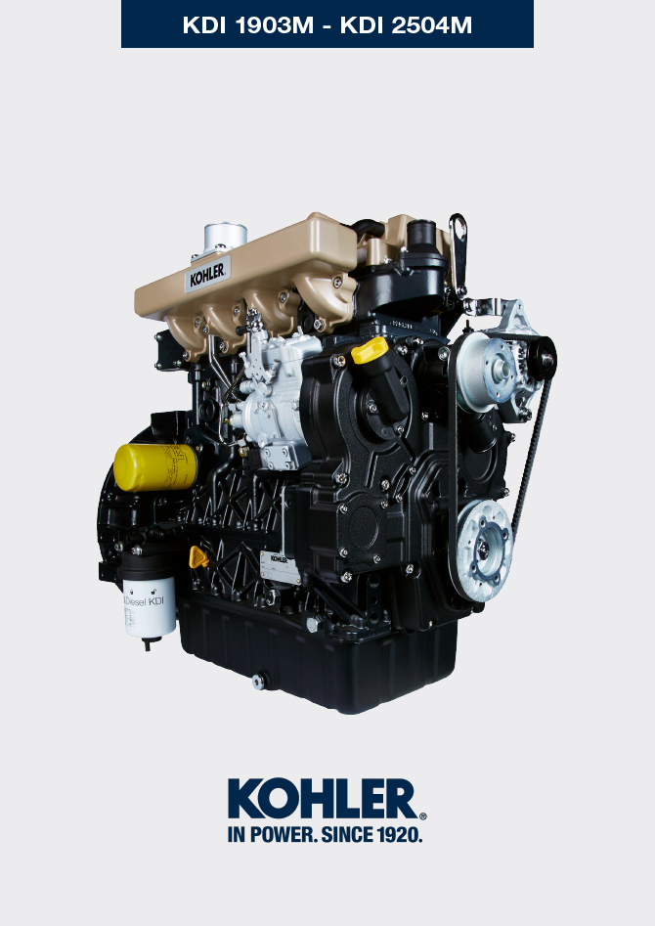
Sommario
1. TITOLO 1 2
1.1. Asdfsdfsdf 2
1.2. Asdfsdfsdfggg 2

Glossary

Glossary and Definitions
A

Alternator | A component that transforms mechanical energy into AC electrical energy.
Authorised workshop | Kohler authorised service centre.

B

Bore | Internal diameter of the cylinder in combustion engines.

C

Catalyst | A device in charge of filtering exhausted gas.
Combustion | Chemical reaction of a mixture composed of fuel and fuel (air) inside a combustion chamber.

E

EC | "European Community".

F

Fig. | Figure.

G

Galvanised | Material that has undergone surface protection treatment.

H

Heavy conditions | Type of extreme condition referred to the work environment in which the engine is used (very dusty - dirty area, or in a contaminated environment due to various types of gas).

K

KDI | Kohler Direct Injection

M

Maintenance - periodic | A group of maintenance actions that have the sole objective to control and replace elements on their expiry, without modifying or improving the functions carried out by the system, neither increasing the value nor improving performance.
Max | Maximum.
Methyl ester | It is a mixture of products by means of a chemical conversion of oils and animal and/or vegetable fat, which is used to produce Biofuel.
Min. | Minutes.
Min | Minimum.
Model | Model, engine identification plate, which indicates the engine's model.

P

Par. | Paragraph.
Paraffin | Fatty and solid substance that may form inside the diesel.

R

Ref. | Reference.

S

s/n | Serial number (engine identification name plate) indicating the engine identification series/chassis number.
Spec. | Specification, (engine identification name plate) indicating the engine version.

T

Tab. | Table.
Tightening torque | A term indicated for installation of threaded components and which is determined by means of a unit of measurement Nm.

U

Used oil | Oil altered by operation or time, which is no longer compliant for correct lubrication of the components.

SYMBOLS AND UNITS OF MEASUREMENT
SYMBOL | UNIT OF MEASUREMENT | DESCRIPTION | EXAMPLE
α | degree | Rotation/inclination angle | 1°
cm ² | square centimetre | Area | 1 cm ²
Ø | millimetre | Circumference | Ø 1 mm
Nm | newton-metre | Torque | 1 Nm
mm | millimetre | Length | 1 mm
µm | 1/1000 of a millimetre (micron) |  | 1 µm
H | hour | Time | 1 h
g/kW | grammes per kilowatt per hour | Specific consumption | 1 g/kWh
kg/h | kilogramme per hour | Max. flow rate | 1 kg/h
Lt./min. | litres per minute | Flow rate | 1 Lt./min.
Lt./h | litres per hour |  | 1 Lt./h
ppm | parts per million | Percentage | 1 ppm
N | newton | Force | 1 N
A | Ampere | Intensity of electrical current | 1 A
gr. | gramme | Weight | 1 gr.
kg | kilogramme |  | 1 kg
W | Watt | Power | 1 W.
kW | kiloWatt |  | 1 kW
pa | pascal | Pressure | 1 pa
KPa | Kilopascal |  | 1 KPa
bar | barometric pressure |  | 1 bar
mbar (1/1000 bar) | barometric pressure |  | 1 mbar
R | Resistance | Resistance to electrical current (referred to a component) | 1 Ω
Ω | ohm | Resistance of electrical current | 1 Ω
Rpm | revs per minute | Rotation of an axis | 1 Rpm
Ra | average roughness expressed in microns | Roughness | 1 Ra
°C | degree centigrade | Temperature | 1°C
V | Volt | Electrical voltage | 1 V
 | millimetre | Hex-head capscrew | 1 mm
cm ³ | cubic centimetre | Volume | 1 cm ³
Lt. | litre |  | 1 Lt.

