Informa?ii pentru demontare
KDI 1903 M Workshop manual (Rev_09.6)

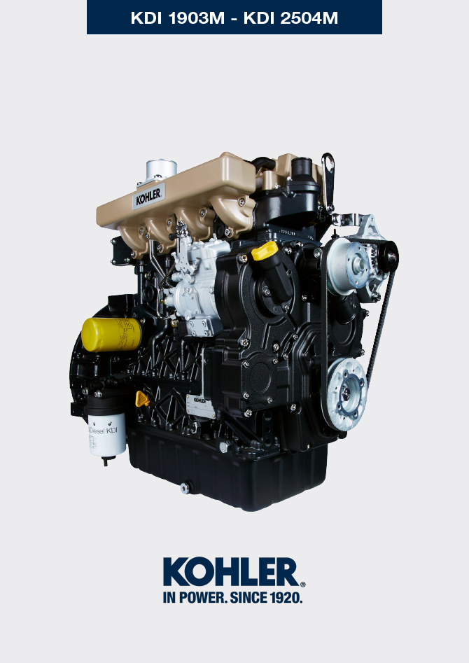
Sommario
1. TITOLO 1 2
1.1. Asdfsdfsdf 2
1.2. Asdfsdfsdfggg 2

Information for disassembly

Recommendations for disassembly

Important

- The mark ( ) after the title of a paragraph, indicates that the procedure is not required in order to disassemble the engine, however the procedures are featured in order to illustrate the disassembly of components.
- The operator should prepare all equipment and tools in order to enable him to carry out the operations correctly and safely.
- Before disassembly, perform the operation described in Chap. 5 .
- Before proceeding with operation, carefully read Chap. 3 .
- In order to operate safely and easily, we recommend positioning the engine on a rotating stand for engine overhauling.
- eal all injection component unions as illustrated in Par. 2.9.7 during assembly.
- Protect all disassembled components and coupling surfaces subject to oxidation with lubricant.
- Where necessary, reference to special tools to use during disassembly operations is indicated (es. ST_05 ), identified in Tab. 13.1 - 13.2 - 13.3 .

Electric components disassembly
7.2.1 Electric wiring

- Disconnect and remove the engine wiring.
NOTE : refer to Par. 2.13.1.3 to disconnect all connectors.
7.2.2 Starter motor  Important  - The motor is not repairable.  - Undo the screws A and remove the starter motor B .  - Mount the tool ST_34 in the seat of the starter motor P and fit it with the two starter motor fixing screws to block the flywheel. | 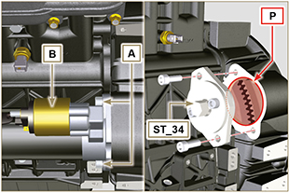  Fig 7.1
7.2.3 Belt and alternator  - Loosen the screws C and D.  - Push the alternator E in the direction of the arrow F .  - Remove the belt G from the pulleys.  Important  - The belt must always be replaced every time it is disassembled, even if it has not reached the scheduled hours for replacement  - Undo the screws C and D and remove the alternator E. | 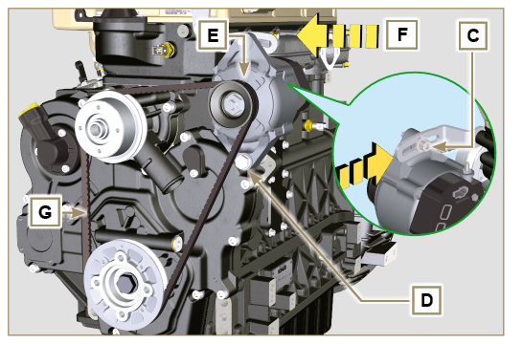  Fig 7.2
7.2.4 Sensors and switches

Important

- After disassembly, protect the sensors suitably against knocks, dampness and any high temperature sources.
- The sensors and switches cannot be repaired, therefore they must be replaced in the event of anomalies.
7.2.4.1 Oil pressure switch disassembly ( )  - Unscrew and remove oil pressure switch H . | 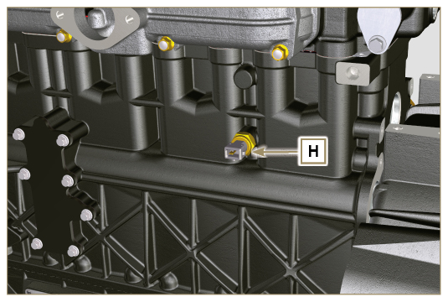  Fig 7.3
7.2.4.2 Coolant temperature sensor ( )  - Unscrew and remove the sensor L . | 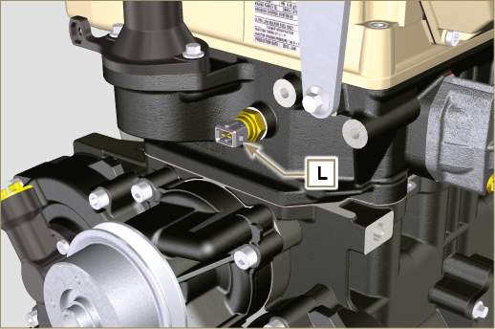  Fig 7.4
7.2.4.3 Fuel filter water detection sensor ( )  Warning  - The fuel filter is not always installed in the engine.  - When disassembling the sensor M, use a suitable container to recover the fuel contained in the cartridge N.  - Unscrew the sensor M from the cartridge N . | 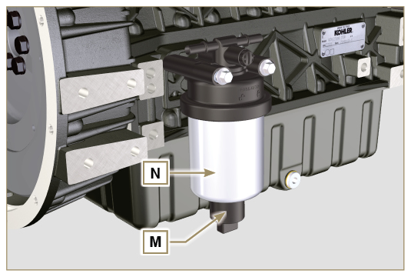  Fig 7.5

Exhaust manifold disassembly
- Undo the nuts A and remove the manifold B and the metallic gaskets C .  - Close the openings and manifolds to prevent foreign bodies from entering. | 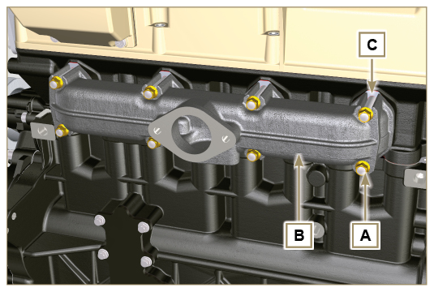  Fig 7.6

Coolant recirculation components disassembly
7.4.1 Coolant recirculation components disassembly  Important  - The pump B is not reparaible  - Undo the screws A and remove the water pump unit B with its gasket C . | 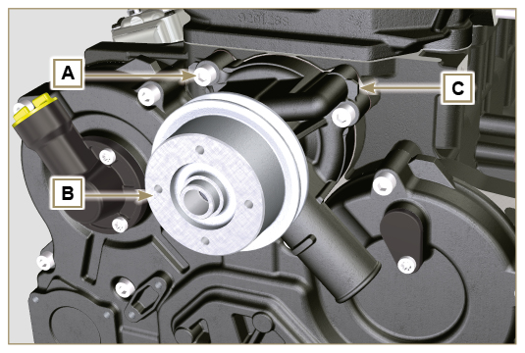  Fig 7.7
7.4.2 Thermostatic valve  - Undo the screws D and remove the thermostatic valve cover E .  - Remove the thermostatic valve F and its gasket.  Important  - Always replace the gasket G every time it is disassembled.  - Check that the air bleeding hole is not clogged or blocked ( Par. 2.11.3 ). | 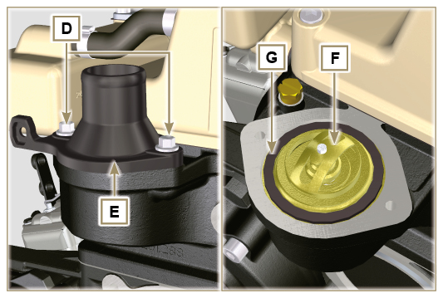  Fig 7.8

Crankshaft pulley disassembly
NOTE: Perform the operations described in Par. 6.1.5 points 2 and 3 .  - Undo the screw A (clockwise - as seen from the timing system side - Ref. A Par. 1.3 ) and remove the pulley B . | 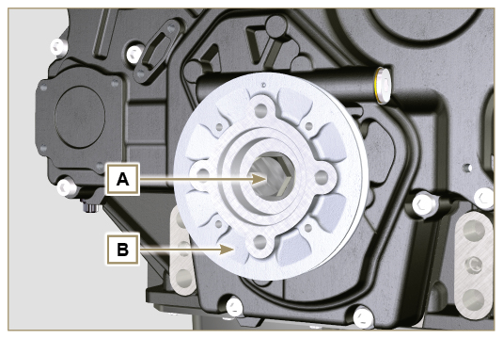  Fig 7.9

Lubrication circuit disassembly
7.6.1 Oil overpressure valve ( )  - Undo the cap A .  - Remove the spring B .  - Remove the valve piston C using a magnet. | 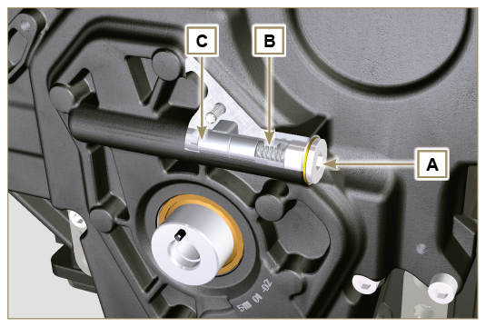  Fig 7.10
7.6.2 Timing system semi-crankcase oil filling flange ( )  - Undo the screws G and remove the oil filling flange E ( ST_06 ) .  - Remove the gasket F . | 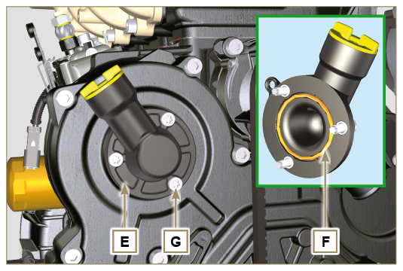  Fig 7.11
7.6.3 Timing system  - Make sure that the crankshaft with the 1st cylinder is at TDC.  - Undo the screws X .  - Remove the timing system crankcase H . | 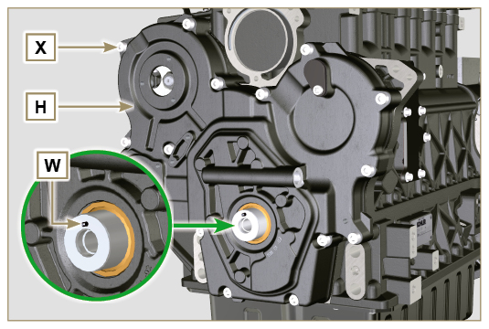  Fig 7.12
7.6.4 Oil pump  Important  - The oil pump is not repairable.  - Undo the screws M and remove the pump crankcase N from the crankcase D ( ST_06 ) . | 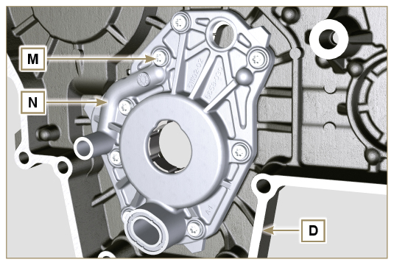  Fig 7.13
- Remove the rotors P and Q. | 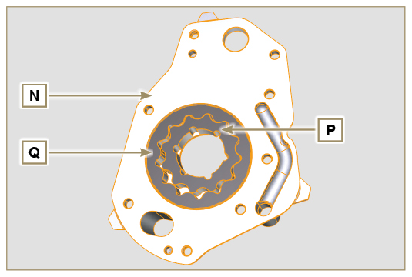  Fig 7.14
7.6.5 Oil filter  - Unscrew and remove the cartridge R .  Warning  - Use a suitable container to recover any residue oil. | 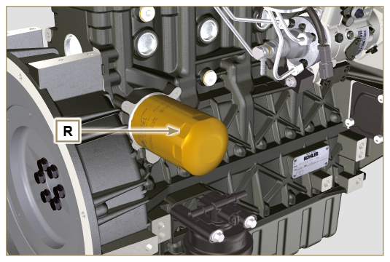  Fig 7.15

Intake manifold disassembly
- Loosen clamp A and disconnect hose B . | 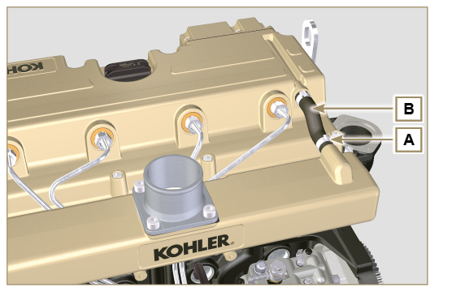  Fig 7.16
- Undo the screws C and remove the manifold D together with the washer E . | 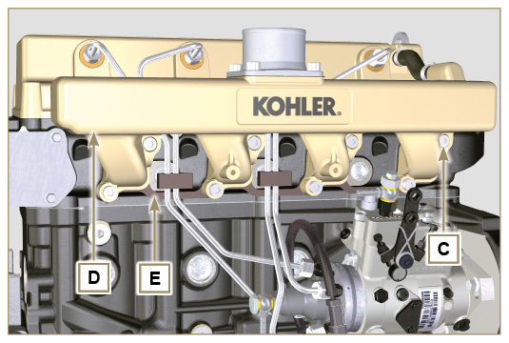  Fig 7.17

Fuel system disassembly
Important
- Seal all injection component unions as illustrated in Par. 2.9.7 .
- The fuel injection circuit undergoes high pressure, use safety protections as described in Par 3.4.3 .
7.8.1 Fuel injection pipes  - Remove loking clips A from pipes B .  - Loose nuts C and D and remove pipes B . | 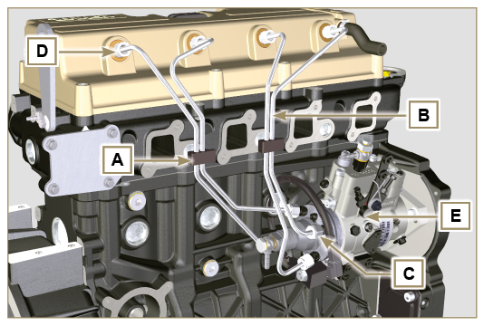  Fig 7.18
7.8.2 Rocker arm cover  - Undo the screws F and remove the rocker arm cap G . | 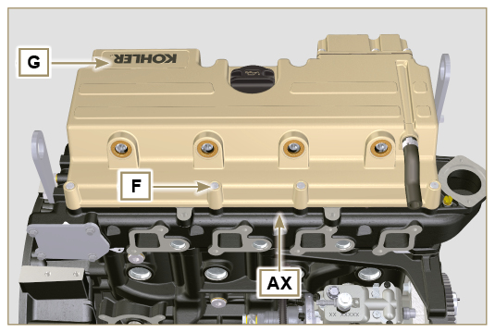  Fig 7.19
7.8.3 Fuel return pipes  - Undo the screws L and remove hose H. | 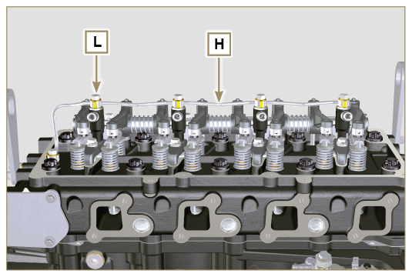  Fig 7.20
7.8.4 Injector  - Undo the screws P and remove the washers Q and the brackets M .  - Pull out the injectors N.  NOTE : Should you be unable to remove the injector (acting only on point BC ), use an open-ended spanner ( ∅ 11 mm ), by applying small rotations to unblock the component. If the washer K is not found on the injector N , recover it from inside the injector sleeve J . | 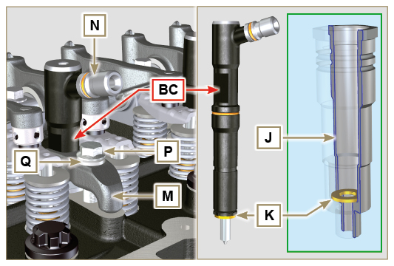  Fig 7.21
7.8.5 Injection pump  Important  - Before disassembling, carefully read Par. 2.17 .  - The injector pump cannot be repaired.  - Carry on operations described in steps 1-13 Par. 6.1.5 .  - Undo the nut S and remove it together with the washer.  - Screw the unit ST_04 on the gear R . | 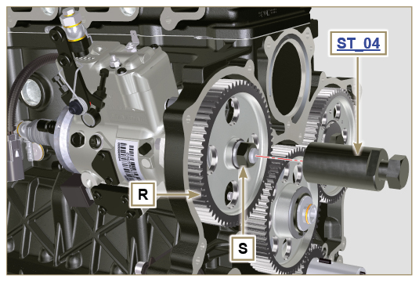  Fig 7.22
- Undo the screws T .  - Tighten the screw U of the unit in order to separate the injector pump S from the high pressure pump control gear R . | 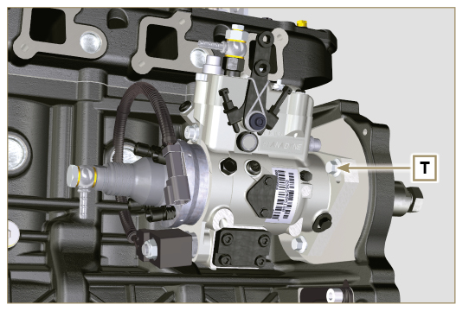  Fig 7.23  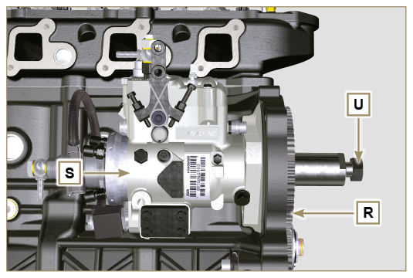  Fig 7.24
NOTE: Click by side to play the procedure. | https://www.youtube.com/embed/tQ9VHKF4u_0?rel=0
7.8.6 Fuel filter ( )  NOTE: to disassemble the fuel cartridge, refer to operations 3 and 4 of Par. 6.7.1 .  - Undo the screws V and remove the filter support W . | 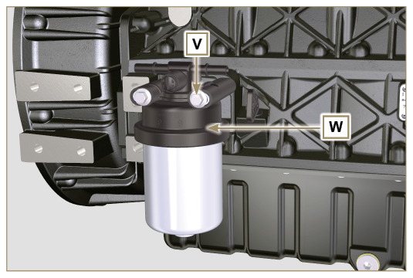  Fig 7.25

Timing system gear disassembly
- Unscrew screws C and remove camshaft gear D .  - Remove lock ring A and the shoulder ring B .  - Remove the intermediate gear L . | 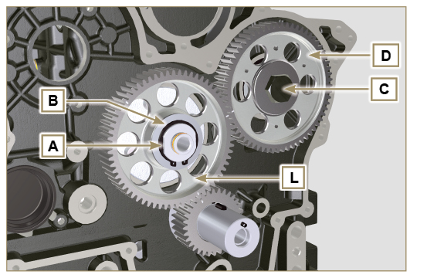  Fig 7.26
- Undo the screws F and remove the intermediate gear support G. | 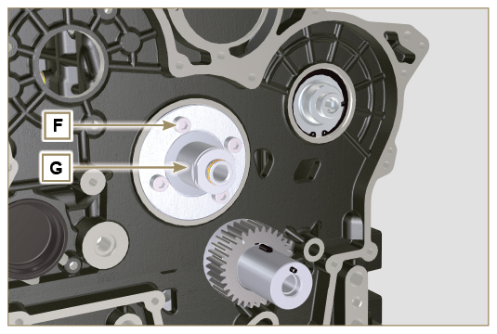  Fig 7.27

Flange unit disassembly
7.10.1 Flywheel  Important  - Leave the special tool ST_34 for blocking the flywheel.  - Only undo the screw C located upwards.  - Insert the tool ST_09 in the seat of the screw C tightening it all the way.  - Undo the remaining screws D .  Danger  - The flywheel E is very heavy, pay utmost attention while removing it in order to prevent it from falling, with serious consequences for the operator.  - Remove the flywheel E.  - Remove the tool ST_09 .  - Remove the tool ST_34 shown in Fig. 7.1 . | 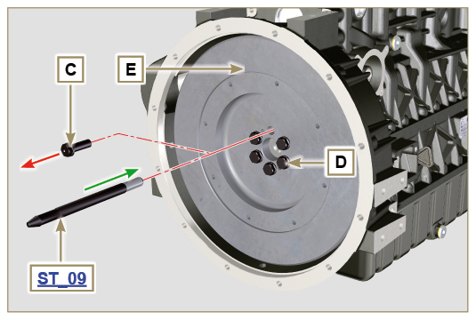  Fig 7.28
7.10.2 Flange housing  - Undo the screws F and remove the engine housing G .  Danger  - The housing G is very heavy, pay utmost attention while removing in order to prevent it from falling, with serious consequences for the operator. | 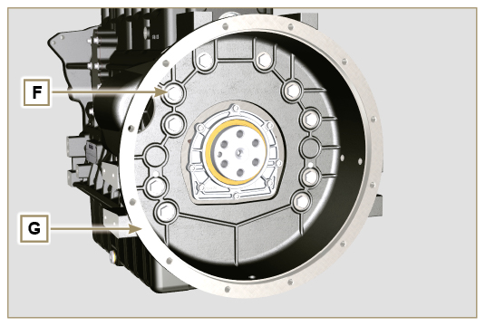  Fig 7.29

Cylinder head unit disassembly
7.11.1 Rocker arm pin  - Undo the screws A .  - Remove the rocker arm pin unit B . | 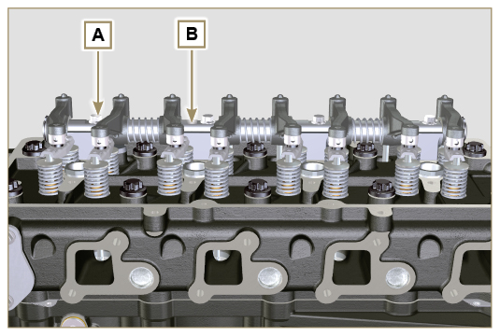  Fig 7.30
7.11.1.1 Rocker arm ( )  - Remove the retainer snap ring C .  - Remove the shoulder rings D .  - Remove the rocker arms E and springs. | 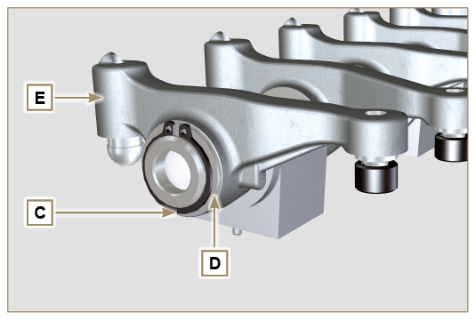  Fig 7.31
7.11.2 Rods and u-bolts  - Remove the valve control U-bolts H .  - Remove the rocker arm control rods L . | 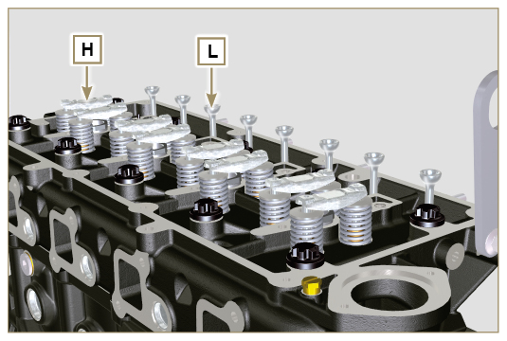  Fig 7.33
7.11.3 Cylinder head  Important  - Wait for the engine to reach ambient temperature before to remove the head in order to prevent deforming.  - The cylinder head fastening bolts M must be replaced every time they are disassembled.  - Undo the bolts M .  - Remove the cylinder head N .  Important  • Only use the eyebolts AE installed by KOHLER to move the cylinder head Q.  3. Remove the head gasket P . | 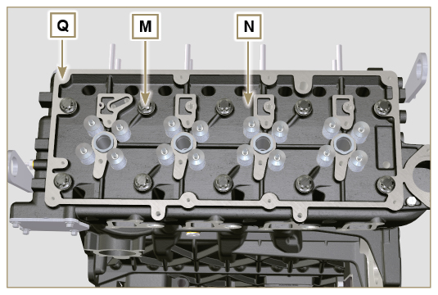  Fig 7.34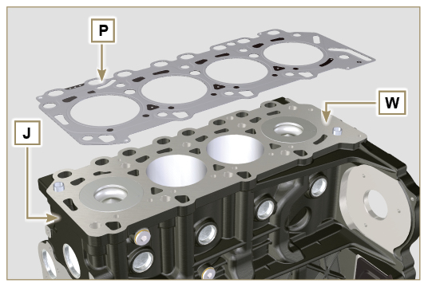  Fig 7.35
7.11.3.1 Valves ( )  - Mount the tool ST_07 on the head Q fixing it on one of the holes for fixing the rocker arm cover.  NOTE: change the fixing hole according to the position of the valves to be removed.  - Position the tool striker ST_07 on the valve concerned as shown in the figure. | 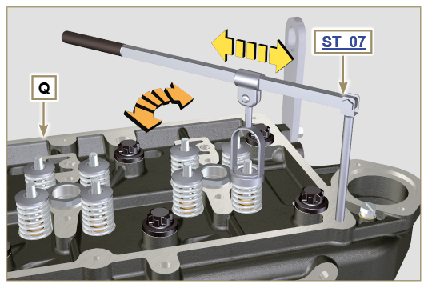  Fig 7.36
- Push the lever of the tool ST_07 downwards, in order to lower the valve plates S in the direction of the arrow T , using a magnet, remove the cotters U .  NOTE : repeat all the operations for all the valves concerned. | 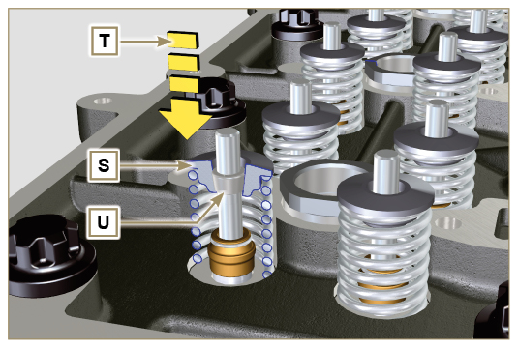  Fig 7.37
Important  - Before removing the valves, make some marks in their original position, in order to prevent confusing them when they are re-assembled, if they are not replaced.  - Remove the valves V . | 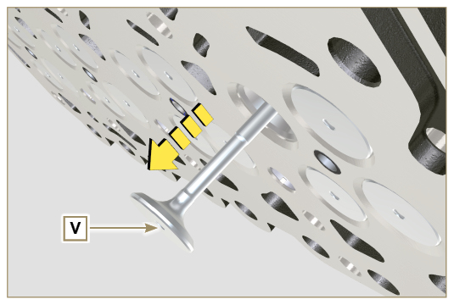  Fig 7.38
7.11.3.2 Injector sleeve ( )  - Unscrew and remove the sleeves Z from the head Q .  - Remove the gaskets AA and AB . | 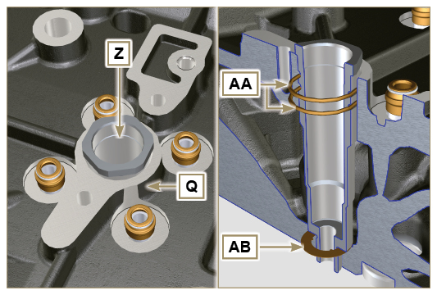  Fig 7.39
7.11.3.3 Valve steam gasket ( )  - Remove the oil seals AC . | 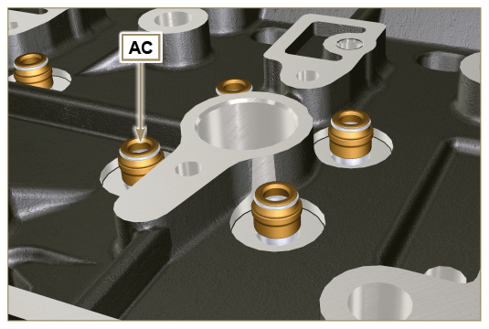  Fig 7.40
7.11.3.4 Lifting eyebolts ( )  - Undo the screws AD and remove the eyebolts AE .  - Make the thorough washing the cylinder head Q . | 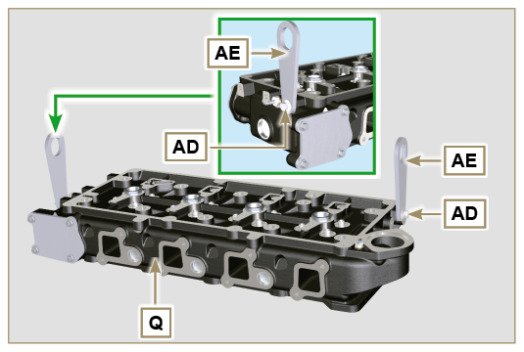  Fig 7.41

Oil sump unit disassembly
7.12.1 Oil sump  - Undo the screws A .  - Remove the oil sump B by inserting a plate in the areas indicated by the arrow AA. | 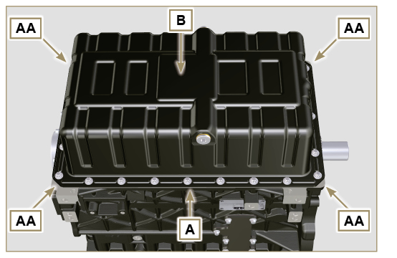  Fig 7.42
7.12.2 Oil intake pipe  - Undo the screws C and remove the oil pipe D . | 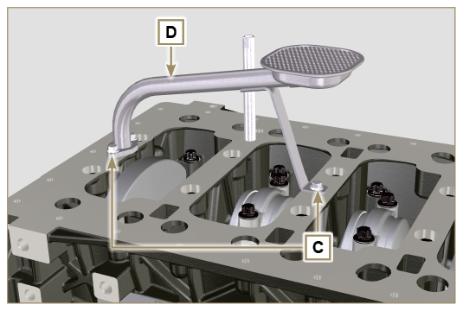  Fig 7.43
7.12.3 Oil vapour pipes ( )  - Unscrew and removethe pipes E . | 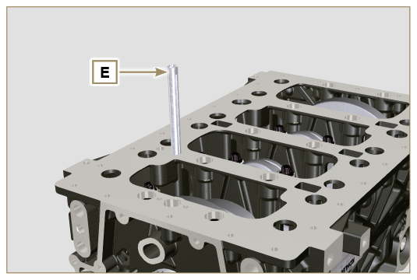  Fig 7.44

Engine block disassembly
7.13.1 Crankshaft gasket flange  - Undo the screws A .  - Remove the flange B and the gasket C . | 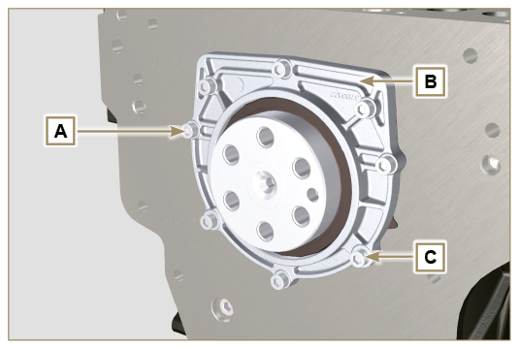  Fig 7.45
7.13.2 Piston unit/connecting rod  Important  - Mark some numerical references (cylinder n°) on the connecting rods, connecting rod caps F1 , pistons and gudgeon pins to prevent unintentionally confusing the components not replaced during assembly. Failure to do this may result in engine malfunctions.  - References on connecting rod M and cap F1 must only be carried out on a side in correspondence with K1 and K2 , as illustrated in Fig. 7.46a .  - Screw the bolt AM temporarily.  - Unsrew bolts E1 and remove the connecting rod caps F1 . | 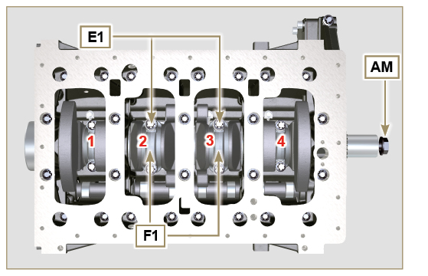  Fig 7.46
NOTE : coupling cap F1 on the connecting rod can be carried out with centring taper pins (Fig. 7.46b) or broken ( Fig. 7.46c - without centring taper pins).  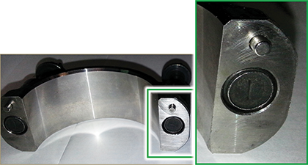  Fig. 7.46b  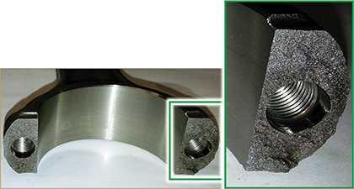  Fig. 7.46c | 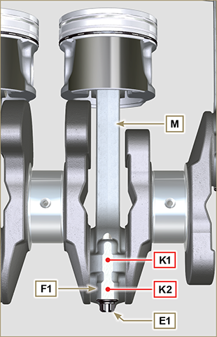  Fig 7.46a
- Pull out the connecting rod - piston assembly from position 2 and 3 by manually applying pressure on the connecting rod big end L in the direction of arrow AK .  - Couple the connecting rod big end caps L with the relevant piston and connecting rod unit M .  - Turn capscrew AM and rotate the crankshaft by 180°.  - Repeat points 2 to 5 to disassemble the connecting rod-piston assembly to position 1 and 4 . | 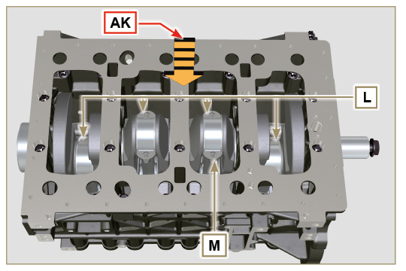  Fig 7.47
Warning  - The connecting rod half-bearings Z are made of special material. Therefore, they must be replaced every time they are removed to prevent seizures. | 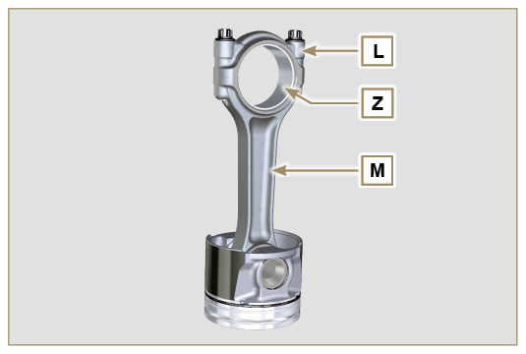  Fig 7.48
7.13.3 Lower semi-crankcase  3 CYLINDERS  - Undo capscrews E and F by following the order indicated in the figure.  - Remove the lower semi-crankcase D and store it in a suitable container for washing. | 3 Cylinders  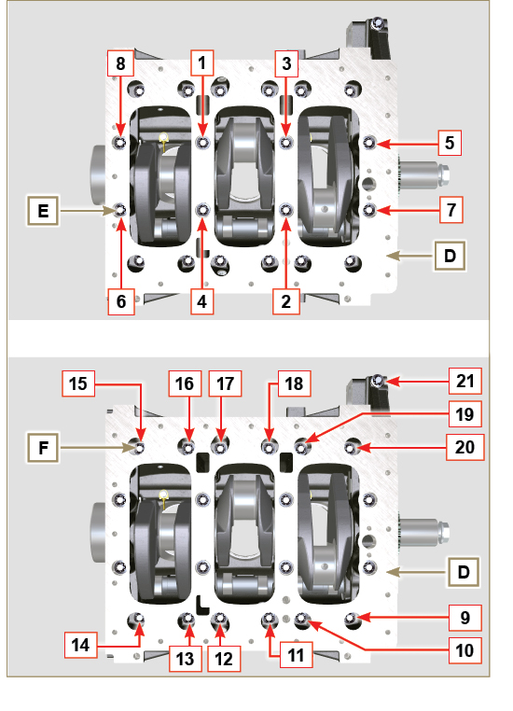  Fig 7.49
4 CYLINDERS  - Undo capscrews E and F by following the order indicated in the figure.  - Remove the lower semi-crankcase D and store it in a suitable container for washing. | 4 Cylinders  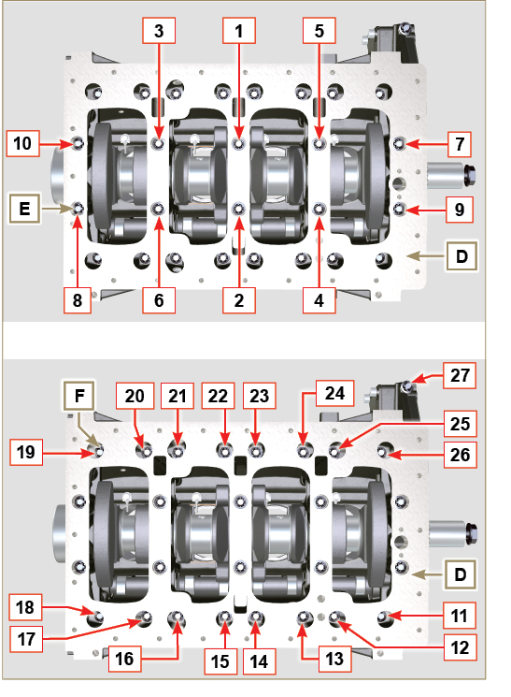  Fig 7.50
7.13.4 Crankshaft  Remove:  - Crankshaft G .  - The four shoulder semi-rings H . | 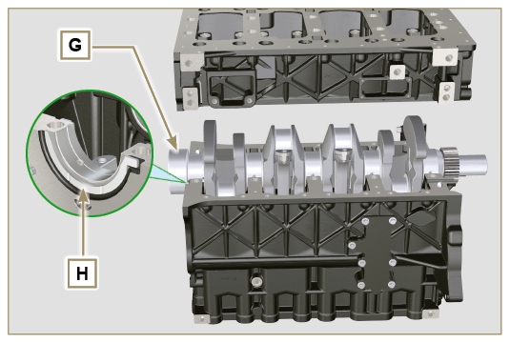  Fig 7.51
7.13.5 Piston ( )  - Remove the retainer ring N .  - Remove the pin P to separate the piston Q from the connecting rod R .  Important  - If they are not replaced, keep the components together (connecting rod - piston - gudgeon pin) by using references in order to prevent them from getting mixed up during assembly. | 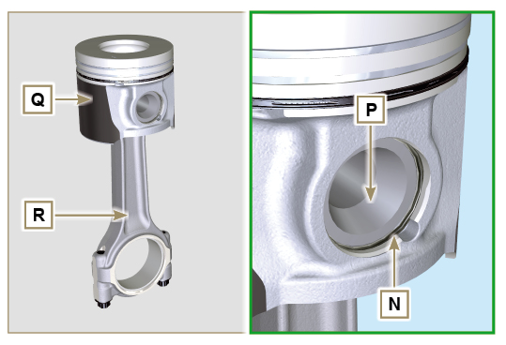  Fig 7.52
7.13.5.1 Rings ( )  - Remove the seal rings S . | 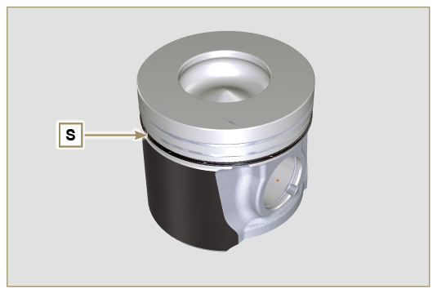  Fig 7.53
7.13.6 Breather room closing cover ( )  - Undo the screws AE and remove the cover AF . | 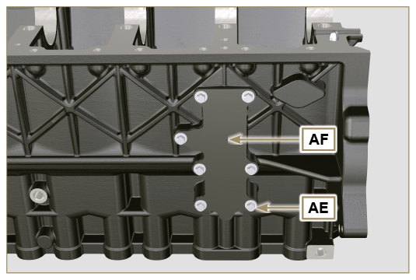  Fig 7.54
7.13.7 Camshaft  - Remove the retainer ring V .  - Extract the camshaft W from the upper crankcase AB . | 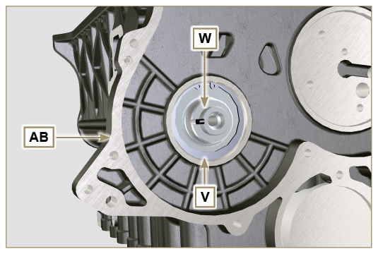  Fig 7.55
7.13.8 Camshaft tappets  - With a magnet, remove the tappets AA from the upper semi-crankcase AB . | 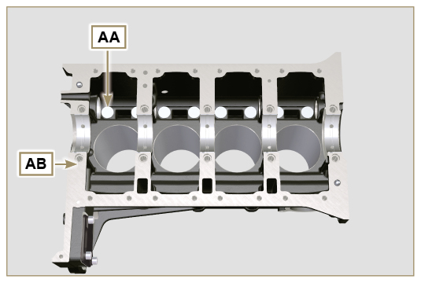  Fig 7.56
7.13.9 Crankshaft bushings  - Remove the crankshaft bushings AC from the upper semi-crankcase AB .  Important  - The crankshaft half-bearings AC are made of special material. Therefore, they must be replaced every time they are removed to prevent seizures. | 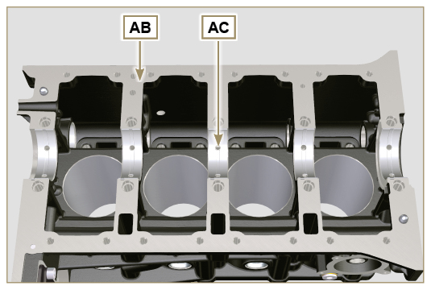  Fig 7.57
- Remove the crankshaft bushings AF from the lower crankcase D . | 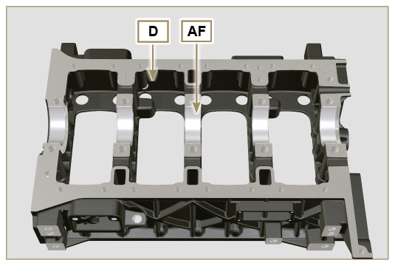  Fig 7.58
7.13.10 Cover 3 ^{at} PTO ( )  - Undo the screws AG .  - Remove the cover AH and the gasket AL . | 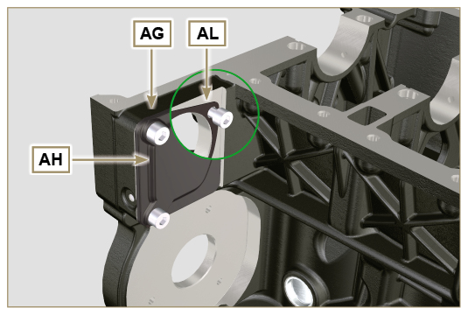  Fig 7.59

