Technical information
KDI 3404 TCR-SCR Owner Manual (REV. 03.5)

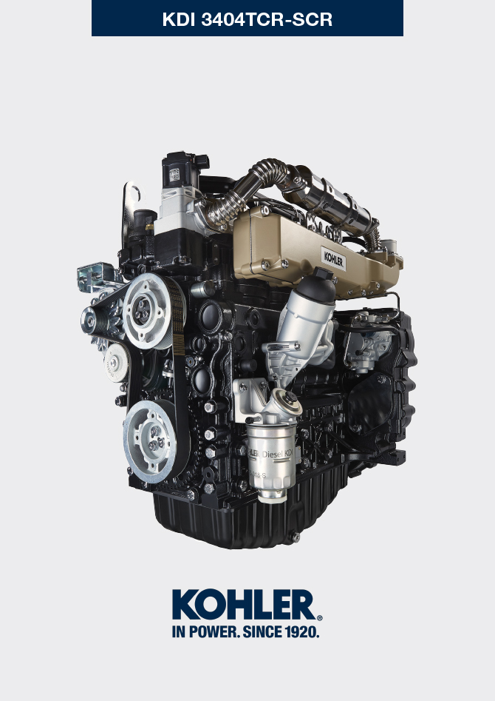
Sommario
1. TITOLO 1 2
1.1. Asdfsdfsdf 2
1.2. Asdfsdfsdfggg 2

Technical information

General description of the engine
- 4-stroke, in-line cylinders Diesel engine; - Liquid-cooling system;

- 4 valves per cylinder with hydraulic tappets;

- Turbocharger with Waste-gate valve;

- Common rail - Direct injection.

Engine specifications
2.1
TECHNICAL DATA |  | UNIT OF MEASURE
Engine type |  |  | KDI 3404 TCR SCR
Cylinders |  | n. | 4
Bore |  | mm | 96
Stroke |  | mm | 116
Displacement |  | cm ³ | 3359
MAX INCLINATION DURING OPERATION (even in combined) |  | α | 40° max 30 min.
 |  | α | 45° max 1 min.
OIL CAPACITY (MAX level.) including oil filter | standard version | lt. | 15.6
DRY WEIGHT |  |  | 394

Engine dimensions (mm)
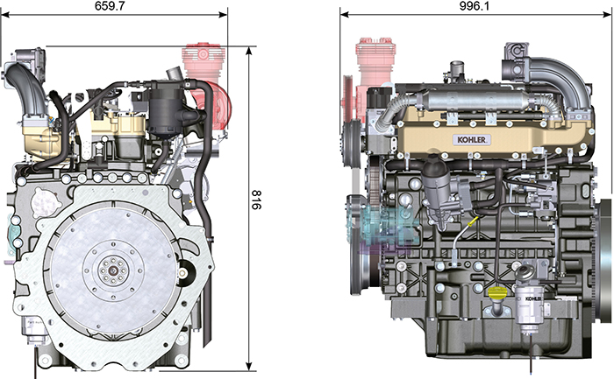

Oil

Important

- The engine may be damaged if operated with improper oil level.
- Do not exceed the MAX level because a sudden increase in engine rpm could be caused by its combustion.
- Use only the recommended oil to ensure adequate protection, efficiency and service life of the engine.
- The use of lubricants other than recommended may shorten the engine life.
- Viscosity must be appropriate to the ambient temperature to which the engine is to be exposed.

Danger

- Prolonged skin contact with the exhausted engine oil can cause cancer of the skin.
- If contact with oil cannot be avoided, thoroughly wash your hands with soap and water as soon as possible.
- For the exhausted oil disposal, refer to the Par. DISPOSAL and SCRAPPING .
2.4.1 SAE oil classification
- In the SAE classification, oils are identified according to viscosity without considering any other qualitative characteristic.
- The code is composed of two numbers, which indicate, and must correspond to, the ambient temperature in which the engine operates, the first number refers to the viscosity when cold, for use during winter (" W "), while the second number is for viscosity at high temperatures.

2.2
RECCOMENDED OIL
 |  | TCR STAGE-V (*1) (*2) | TCR TIER IV FINAL (*1) | TCR/D TIER III o NON CERTIFICATO (*3)
WITH SPECIFICATIONS | API | CJ-4 Low S.A.P.S  CK-4 Low S.A.P.S | CJ-4 Low S.A.P.S  CK-4 Low S.A.P.S | CI-4 Plus  CI-4  CH-4
 | ACEA | E6 Low S.A.P.S. | E6 Low S.A.P.S. | E7  E4
VISCOSITY | SAE | 0w-40 (-40°C ÷ +50°C)  5w-40 (-30°C ÷ +50°C)  10w-40 (-25°C ÷ +50°C) | 0w-40 (-40°C ÷ +50°C)  5w-40 (-30°C ÷ +50°C)  10w-40 (-25°C ÷ +50°C) | 0w-40 (-40°C ÷ +50°C)  5w-40 (-30°C ÷ +50°C)  10w-40 (-25°C ÷ +50°C)
- Low S.A.P.S. technology (oil with low Sulfated Ash, Phosphorus, Sulfur content) keeps catalyst in good working conditions. The presence of sulfated ash, phosphorus and sulfur causes with time the catalyst clogging and its consequent inefficiency.
- For Mid S.A.P.S oil sequence the sulfated ash level is the same as API CJ-4 ≤ 1.0% but as per ACEA standardization those oils are referenced as mid SAPS.
- Filtration of oils is critical to proper operation and lubrication; always change filters regularly as specified in this manual.

(*1) NOTA : Do NOT use fuel with sulphur content above 15ppm.

(*2) - On all engines compliant with Stage-V emission regulation (engines with DPF device), the oil to use must comply with the specification API CJ-4 Low S.A.P.S or ACEA E6 Low S.A.P.S.

(*3) - NOTE : Do NOT use fuel with sulphur content above 500ppm.

(*3) - NOTE : Low S.A.P.S. oils, sulfate ashes <1% may not be used with fuels with a sulfur content >50ppm.

Fuel
Important  - Use of other types of fuel could damage the engine. Do not use dirty diesel fuel or mixtures of diesel fuel and water since this will cause serious engine faults.  - Any failures resulting from the use of fuels other than recommended will not be warranted. | Warning  - Clean fuel prevents the fuel injectors from clogging. Immediately clean up any spillage during refuelling.  - Never store diesel fuel in galvanized containers (i.e. coated with zinc). Diesel fuel and the galvanized coating react chemically to each other, producing flaking that quickly clogs filters or causes fuel pump and/or injector failure.
2.3
FUEL COMPATIBILITY
EN 590 (biodiesel content max. 7% (V/V))
ASTM D 975 Grade 1-D S15
ASTM D 975 Grade 2-D S15
NATO F-54, equivalent to diesel fuel in accordance with EN 590
EN 590 or ASTM D 975 Grade 1, 2 -D S15 Arctic Diesel
JIS K 2204 N. 1, N. 2

NOTE: In a warranty case the customer must prove by a certificate from the fuel supplier that an allowed fuel was used.

KDI Electronic Injection Tier 4 final – Stage IIIB – Stage IV- Stage V certified Engine
Those engines are designed for fuels in accordance with EN 590 and ASTM D975 for a cetane number of at least 45. Since those engines are equipped with exhaust gas after-treatment such as Diesel Oxidation Catalyst (DOC), Diesel Particulate Filter (DPF), Selective Catalytic Reduction (SCR), they may only be operated with sulfur-free diesel fuels (EN 590, DIN 5168, ASTM D975 Grade 2-D S15, ASTM D975 Grade 1-D S15). Otherwise, compliance with the emission requirements and durability are not guaranteed.

Insufficient lubricating capacity can lead to serious wear problems above all in common rail injection systems. Too low a lubricating capacity is particularly a problem in fuels with a low sulfur content (and in this respect sulfur contents ‹500 mg/kg can already be considered low). An adequate lubricating capacity is guaranteed by the appropriate additives in low-sulfur (‹50 mg/kg) or sulfur-free (‹10 mg/kg or ‹15 mg/kg) diesel fuels according to EN 590 and ASTM D 975. In low-sulpur and sulfur-free diesel fuels which do not comply with this standard, the lubricating capacity may have to be guaranteed by additives. The parameter for sufficient lubricating capacity is a maximum wear spot of 460 micrometers in the HFRR test (EN ISO 12156-1).
2.5.1 Fuel for low temperatures
- When operating the engine in ambient temperatures lower than 0 degrees C, use suitable low temperature fuel normally available from fuel distributors and corresponding to the specifications of Tab. 2.3.
- These fuels reduce the formation of paraffin in diesel at low temperatures.
- When paraffin forms in the diesel, the fuel filter becomes blocked interrupting the flow of fuel.

2.5.2 Biodiesel fuel
- Fuels containing 10% methyl ester or B10, are suitable for use in this engine provided that they meet the specifications listed in the Tab. 2.3.
- DO NOT USE vegetable oil as a biofuel for this engine.
2.4
BIODIESEL COMPATIBILITY
Biodiesel according to EN 14214 (only permissible for mixture with diesel fuel at max. 10% (V/V))
US biodiesel according to ASTM D6751 – 09a (B100) (only permissible for mixtures with diesel fuel at 10% (V/V))

2.5.3 Synthetic fuels: GTL, CTL, BTL, HV
It is a well-known fact that engines which are operated for longer periods with conventional diesel fuel and then converted to synthetic fuels suffer shrinkage of polymer seals in the injection system and thus fuel leaks. The reason for this behavior is that the aromatic-free synthetic fuels can lead to a change in the sealing behavior of polymer seals.
Therefore, conversion from diesel fuel to synthetic fuel may only be done after changing the critical seals. The problem of shrinkage does not occur when an engine was operated with synthetic fuel from the start.
2.5.4 Emission-Related Installation Instructions
Failing to follow the instructions in the applications guidebook when installing a certified engine in a piece of nonroad equipment violates federal law (40 CFR 1068.105(b)), subject to fines or other penalties as described in the Clean Air Act.
OEM must apply a separate label with the following statement: “ULTRA LOW SULFUR FUEL ONLY” near the fuel inlet.
Ensure you are installing an engine appropriately certified for your application. Constant speed engines may only be installed on constant speed equipment for constant speed operation.
If you install the engine in a way that makes the engine's emission control information label hard to read during normal engine maintenance, you must place a duplicate label on the equipment, as described in 40 CFR 1068.105.5.

DEF
- Also known as "AUS 32" in Europe, "DEF" or "Urea Solution" in the USA, it is registered with the “AdBlue ® ” brand at the Verband der Automobilindustrie (VDA), and must comply with the following ISO standards:
- ISO 22241-1 Quality requirements
- ISO 22241-2 Test Methods
- ISO 22241-3 Handling, transportation and Storing
- ISO 22241-4 Refilling Interface
- The DEF tank must be filled by means of the specific automatic filling nozzle at the authorised distributors, refer to the car manual for refilling operations.
- Upon refilling, comply with the MAX level indicated on the tank.
- During the refilling operations prevent any impurity from entering the tank.
- At tank inlet there is a filter that must be periodically cleaned or replaced (see maintenance and replacement table - for tank supplied by Kohler only).
- DEF quality must comply with the specifications described in Table 2.5.
Warning
- Do not mix DEF with fuel or other liquids (including water) and do not fill the fuel tank with DEF.
- The presence of DEF inside the specific tank is required to start the engine.
- Purchase in containers: the container, even if opened, can be stocked with the same conditions of a sealed container.
- Do not stock the container with a temperature higher than 35°C as this could alter the DEF.
- In case of DEF freezing inside the container (< -11,5 °C | 11,3 °F), DEF can be used when it returns to its liquid state.
- Do not expose DEF to direct sunlight.
- In case of opening and closing of the original purchase container, DEF must be checked through a spectrometer to check its quality before use.
- Do not insert altered DEF in the tank as the engine could not respect the emission parameters, generate DCU errors and as a consequence turn off or fail to start the engine.
2.5
PARAMETERS | UNIT OF MEASUREMENT | VALUE
Title | Weight % | 31,8 ÷ 33,2
Density at 20°C | kg/m3 | 1.087 ÷ 1.093
Refraction index at 20°C | °C | 1,3814 ÷ 1,3843
Alkalinity like NH3 | Weight % | < 0,2
Biuret | Weight % | < 0,3
Aldehyde | mg/kg | < 5
Insoluble | mg/kg | < 20
Phosphates like PO4 | mg/kg | < 0,5
Calcium | mg/kg | < 0,5
Iron | mg/kg | < 0,5
Copper | mg/kg | < 0,2
Zinc | mg/kg | < 0,2
Chrome | mg/kg | < 0,2
Nickel | mg/kg | < 0,2
Aluminium | mg/kg | < 0,5
Magnesium | mg/kg | < 0,5
Sodium | mg/kg | < 0,5
Potassium | mg/kg | < 0,5
Freezing point | °C | 11

Coolant recommendation
A mixture of 50% demineralized water and 50% low silicate ethylene glycol based coolant liquid must be used. Use a Long Life or Extended Life Heavy Duty OAT coolant free of: silicates, phosphates, borates, nitrites and amines.

The following ethylene-glycol based engine coolant for all models within KDI engine family may be used:

- OAT (Organic Acid Technology) Low Silicate: ASTM D-3306 D-6210
- HOAT (Hybrid Organic Acid Technology) Low Silicate: ASTM D-3306 D-6210

The above coolants in concentrated formulation must be mixed with distilled, deionized, or demineralized water. A pre-mixed formulation (40-60% or 50-50%) can be used directly when available.

Important
- Do not mix ethylene glycol and propylene glycol based coolants. Do not mix OAT and HOAT based coolant. OAT performance life can be drastically reduced if contaminated with nitrite-containing coolants.
- Never use automotive-type coolants. These coolants do not contain the correct additives to protect heavy – duty diesel engines.

OAT coolants are maintenance free up to 6 years or 6000hrs of operation , provided that the cooling system is topped up using the same type of coolant. Do not mix different coolant types. Test the coolant condition annually with coolant test strips.
HOAT are not all maintenance free and it is recommended to have SCA (Supplemental Coolant Additives) added at the first maintenance interval.

Battery recommendation
Battery not supplied by Kohler

2.6
RECOMMENDED BATTERIES
AMBIENT TEMPERATURE | STARTER MOTOR | OIL | BATTERY TYPE | MACHINE CONDITION
≥ - 25°C | 3.2kW + HEATER | 10W-40  5W-40 | 880CCA SAE (=1000 A (EN)) | light hydraulic parasitic loads or mechanical clutch and gearbox
≥ - 25°C | 4.2kW + HEATER |  | 1000CCA SAE =(1250 A (EN)) | heavy hydraulic parasitic loads

Inducement strategy of ATS system
The inducement is the operation aimed at reducing the engine performance due to a malfunction or tampering with the ATS system detected by the DCU.
The inducement degree is decided by the ECU according to the error detected by the DCU.
The information on the car panel or the activation of the inducement can occur for the following reasons:

- Low DEF level
- Poor DEF quality
- Interruption of DEF supply
- EGR valve malfunctioning
- Tampering with the monitoring systems of the ATS system.
The inducement strategy is applied according to:

- detected problem
- hours passed.
NOTE: Hours are reset after 40h if the DCU does not detect any fault, otherwise the hours are added to those already counted. For low DEF level, activation depends on the percentage of liquid inside the DEF tank, and the fault hours are not counted.
The strategy for the different faults is listed below (Stage V - EU):

The inducement can have the following 2 levels:
- Level 1: 25% reduction of the MAX available torque.
- Level 2: 50% reduction of the MAX available torque and 40% reduction of MAX rpm available.

Before activating the inducement (level 1 or level 2) the ECU activates a warning or a warning light on the car panel (refer to the car documentation for the warning type).
Low DEF level
- information activation on car panel: <10% of MAX level
- Level 1 inducement: <2.5% of MAX level
- Level 2 inducement: 0% of MAX level
Poor DEF quality
- information activation on car panel: upon fault detection
- Level 1 inducement: after 10h from fault detection
- Level 2 inducement: after 20h from fault detection
Interruption of DEF supply
- information activation on car panel: upon fault detection
- Level 1 inducement: after 10h from fault detection
- Level 2 inducement: after 20h from fault detection
EGR valve malfunctioning
- information activation on car panel: upon fault detection
- Level 1 inducement: after 36h from fault detection
- Level 2 inducement: after 100h from fault detection
Tampering with the monitoring systems of the ATS system
- information activation on car panel: upon fault detection
- Level 1 inducement: after 36h from fault detection
- Level 2 inducement: after 100h from fault detection
The strategy for the different faults is listed below (Tier 4 Final - USA):

The inducement can have the following 3 levels:
- Level 1: 25% reduction of the MAX available torque.
- Level 2: 50% reduction of the MAX available torque and 40% reduction of MAX rpm available.
- Level 3: the engine operates at minimum rpm and MAX torque available

Before activating the inducement (level 1, level 2 or level 3) the ECU activates a warning or a warning light on the car panel (refer to the car documentation for the warning type).
Low DEF level
- information activation on car panel: <10% of MAX level
- Level 1 inducement: <5% of MAX level
- Level 2 inducement: <2.5% of MAX level
- Level 3 inducement: <0.5% of MAX level
Poor DEF quality
- information activation on car panel: upon fault detection
- Level 1 inducement: after 1h from fault detection
- Level 2 inducement: after 2h from fault detection
- Level 3 inducement: after 3h from fault detection
Interruption of DEF supply
- information activation on car panel: upon fault detection
- Level 1 inducement: after 1h from fault detection
- Level 2 inducement: after 2h from fault detection
- Level 3 inducement: after 3h from fault detection
EGR valve malfunctioning
- information activation on car panel: upon fault detection
- Level 1 inducement: after 1h from fault detection
- Level 2 inducement: after 2h from fault detection
- Level 3 inducement: after 3h from fault detection
Tampering with the monitoring systems of the ATS system
- information activation on car panel: upon fault detection
- Level 1 inducement: after 1h from fault detection
- Level 2 inducement: after 2h from fault detection
- Level 3 inducement: after 3h from fault detection

