Information about optional components
KDI 2504 TM Workshop manual (Rev. 07.6)

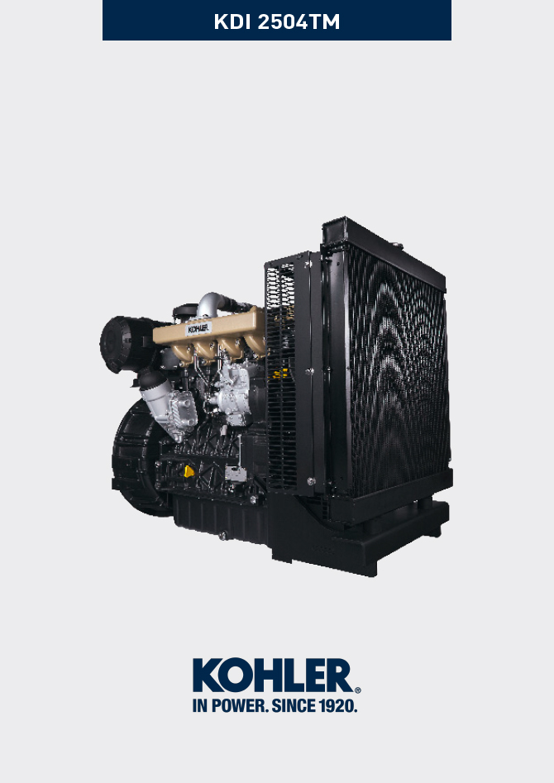
Sommario
1. TITOLO 1 2
1.1. Asdfsdfsdf 2
1.2. Asdfsdfsdfggg 2

Information about optional components

Oil dipstick in cylinder head
Important

- Before proceeding with operation, read Par. 3.3.2 .
11.1.1 Check  - Pull out the dipstick B in the direction of the arrow A .  - Check that the mark left by the oil on the dipstick is between the MIN . and MAX . notches. | 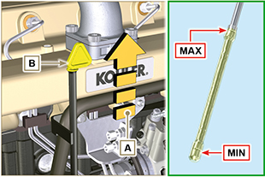  Fig 11.1
11.1.2 Replacement  11.1.2.1 Disassembly  - Undo the screw D .  - Pull out the oil dipstick hose E in the direction of the arrow F . | 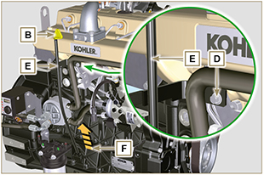  Fig 11.2
11.1.2.2 Assembly  Important  - Always replace the gasket G every time it is disassembled.  - Insert the gasket G in the seat K of the hose E .  - Insert the hose E in the crankcase H . | 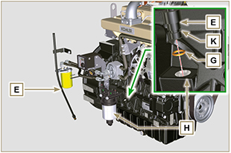  Fig 11.3
- Tighten the oil dipstick hose E using the screw D on the manifold L (Tightening torque of 10 Nm ). | 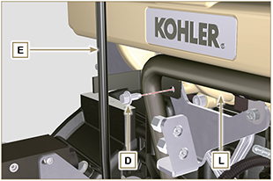  Fig 11.4
NOTE: Check the integrity of the gaskets J.  - Insert the dipstick B inside the hose E . | 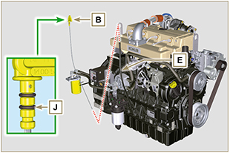  Fig 11.5

Heater (replacement)
Important

- Before proceeding with operation, read Par. 3.3.2 .
11.2.1 Disassembly  - Undo the screws A and the relevant washers and remove the earth cable B .  - Remove the flange C and the manifold D .  - Remove the heater E and the relevant gaskets F . | 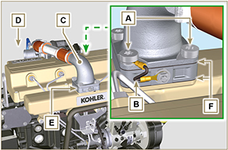  Fig 11.6
11.2.2 Assembly  Important  - Always replace gaskets F , with each assembly.  - In sequence, fit the manifold G with the gasket F , the new heater E , the second gasket F , the flange C, the washers H , the screws A and the cable B .  - Secure the flange H with the screws A (tightening torque at 22 Nm ).  - Secure the earth cable B with the nut J and the relevant washer on the heater E . | 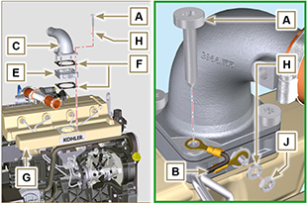  Fig 11.7

Idler gear (for 3rd / 4th PTO)
Important

- Before proceeding with operation, read Par. 3.3.2 .
11.3.1 Disassembly  - Undo the screw A and remove the gear unit B . | 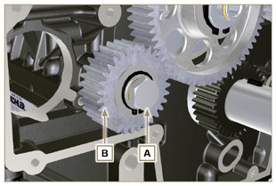  Fig 11.8
2. Remove the retainer ring C from the seat of the pin D .  3. Remove the shoulder washer E , the gear B , the shoulder ring F and the bushing G from the pin D . | 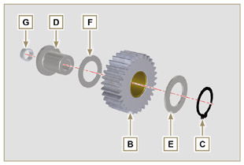  Fig 11.9
11.3.2 Assembly  - Fit into the pin D :  - The shoulder ring F (of least thickness)  - The gear B  - The shoulder ring E  - The retainer ring C .  - Insert the bushing G on the crankcase L . | 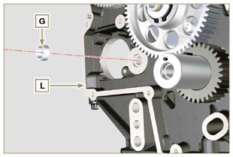  Fig 11.10
Important  - Always replace the washer H every time it is disassembled.  Modified component, see service letter 700019 - 700021 .  - Check that the perforated screw A is free from impurities inside it.  - Position the gear unit B on the hole J using the bushing G to centre.  - Secure the gear B using the screw A inserting the washer H (tightening torque at see service letter 700019 - 700021 ). | 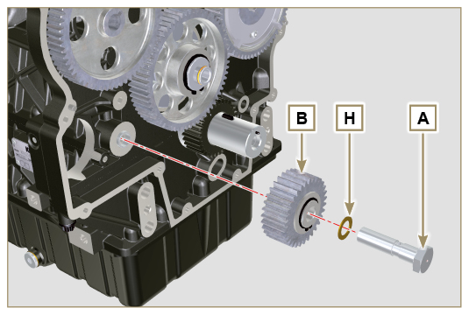  Fig 11.11

3rd PTO (replacement)
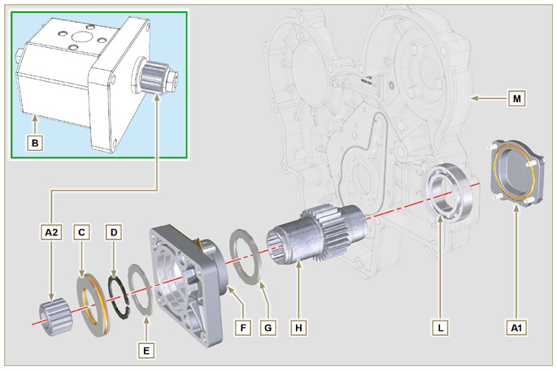
Fig 11.12
Important

- Before proceeding with operation, read Par. 3.3.2 .
11.4.1 Disassembly  - Undo the screws A and remove the pump B . | 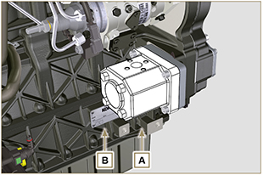  Fig 11.13
- Remove the centring ring C and the relative gaskets  - Undo the screws N . | 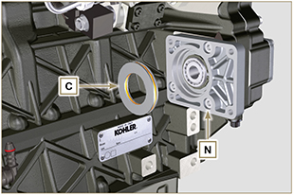  Fig 11.14
- Remove the flange F with the components D, E , G and H in the direction of the arrow P .  - Remove the gasket J . | 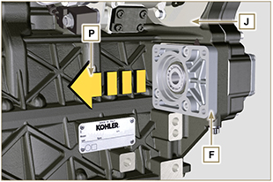  Fig 11.15
- Remove the retainer ring D and the shoulder washer E .  - Remove the gear H and the shoulder ring G from the flange F in the direction of the arrow Q . | 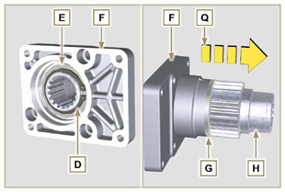  Fig 11.16
11.4.2 Assembly  Important  - Always replace the gasket J after each assembly.  - Lubricate the gear H with oil.  - It is mandatory to replace the screws N or apply a few beads of Loctite 2701 .  - Insert the gear H in the flange F in the direction of the arrow R inserting the shoulder ring G .  - Insert the shoulder ring E on the flange F and clamp the gear H using the retainer ring D .  - Position the flange F on the crankcase K inserting the gasket J , and inserting the gear H up to the stop on the bearing L ( Fig. 11.31 ). | 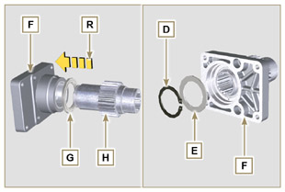  Fig 11.17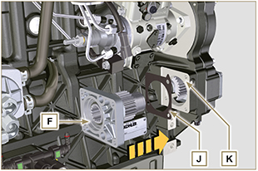  Fig 11.18
- Secure the flange F using the screws N (tightening torque at 25 Nm ).  Important  - Always replace the gaskets P and Q at each assembly.  - Insert the centring ring C in the flange F up to the stop. | 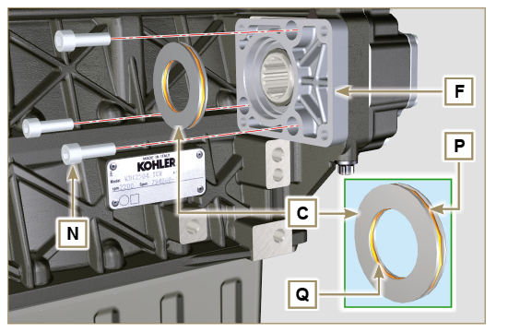  Fig 11.19
- Insert the pump B on the flange F engaging the gear H .  - Secure the pump B using the screws A on the flange F (tightening torque at 25 Nm ). | 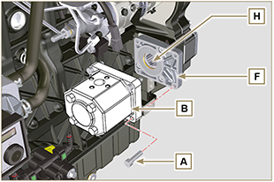  Fig 11.20

4th PTO (replacement)
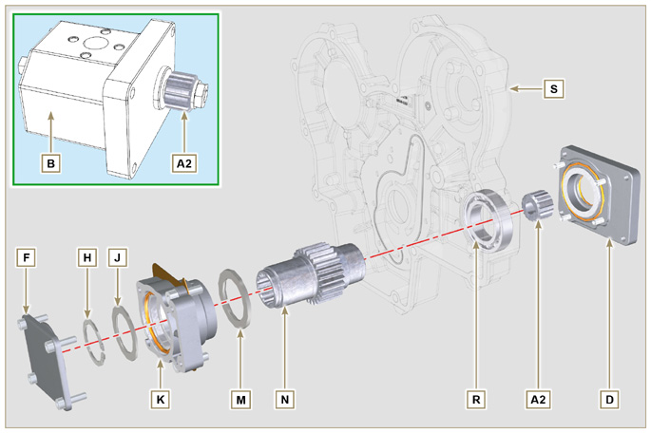
Fig 11.21
Important

- Before proceeding with operation, read Par. 3.3.2 .
11.5.1 Disassembly  - Undo the screws A and remove the pump B . | 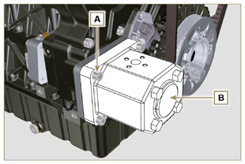  Fig 11.22
- Undo the screws C and remove the flange D . | 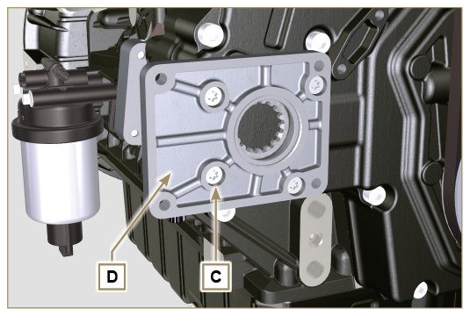  Fig 11.23
- Undo the screws E and remove the cover F . | 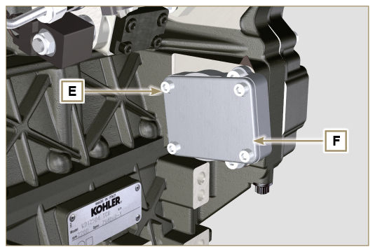  Fig 11.24
- Undo the screws G and remove the flange K with the components H , J , M and N . | 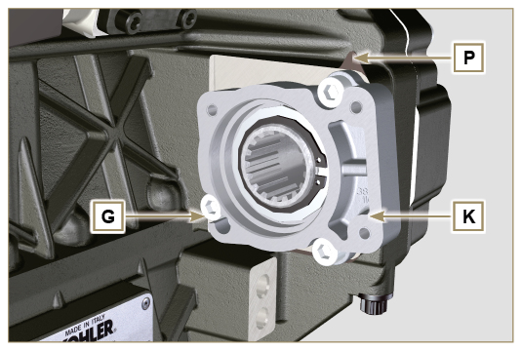  Fig 11.25
- Remove the retainer ring H and the shoulder ring J from the flange K .  - Remove the gear N and the shoulder ring M from the flange K . | 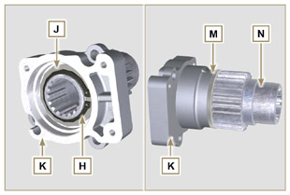  Fig 11.26
11.5.2 Assembly  Important  - Always replace the shoulder ring J after each assembly.  - Lubricate the gear N with oil.  - It is mandatory to replace the screws G or apply a few beads of Loctite 2701 .  - Insert the gear N in the flange K in the direction of the arrow W inserting the shoulder ring M .  - Insert the shoulder ring J on the flange K and clamp the gear N using the retainer ring H . | 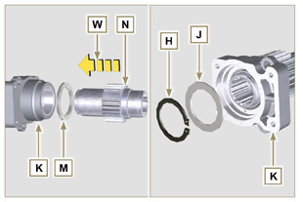  Fig 11.27
- Position the flange K on the crankcase Q inserting the gasket P , and insert gear N in crankcase Q .  - Secure the flange K using the screws N (tightening torque at 25 Nm ). | 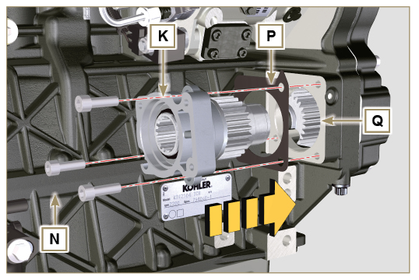  Fig 11.28
Important  - Always replace the gasket V after each assembly.  - Insert the gasket V on the cover F , insert and position the cover F on the flange K .  - Secure the cover F using the screws E on the flange K (tightening torque at 25 Nm ) | 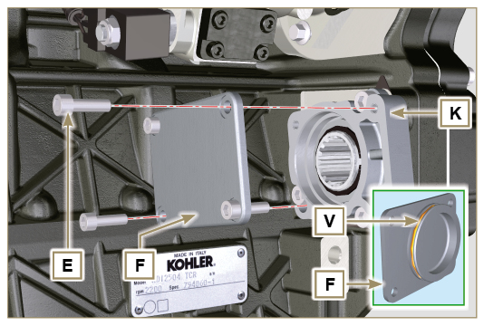  Fig 11.29
Important  - Always replace the gasket T after each assembly.  - Position and secure the flange D using the screws C on the crankcase S (tightening torque at 10 Nm ). | 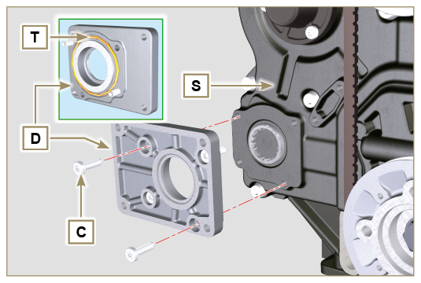  Fig 11.30
Important  - Always replace the gasket U after each assembly.  - Position the gasket U on the flange D .  - Secure the pump B using the screws A on the flange D (tightening torque at 25 Nm ). | 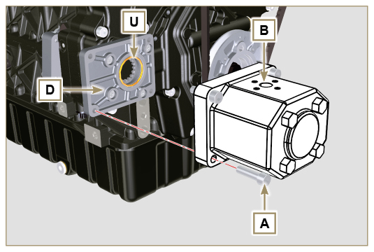  Fig 11.31

3rd + 4th PTO (configurations)
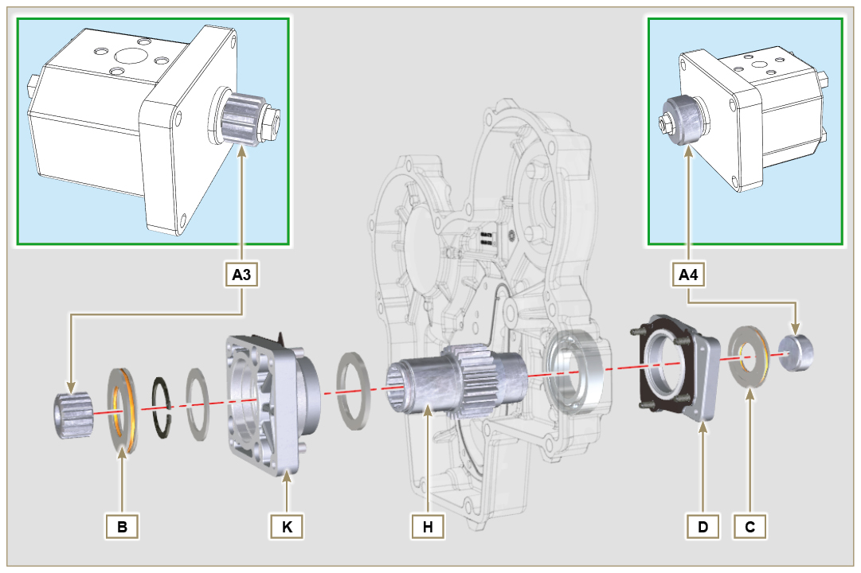
Fig. 11.32

11.6.1 Information  Hydraulic pumps on the 3rd and 4th PTO can be installed at the same time.  In some configurations, there is also the centering ring C on the 4th PTO.  Important  - For disassembly or installation, refer to Par. 11.4 , Par. 11.5 e Par. 11.6 .  - Always replace the gasket of the rings B and C and flanges D and K at each assembly.  - Lubricate the gear H with oil. | 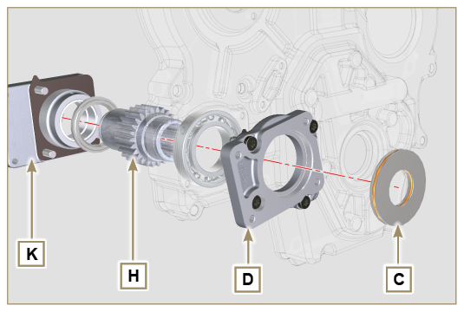  Fig. 11.33

Air filter (cartridge replacement)
Important

- Before proceeding with operation, read Par. 3.3.2 .
- Release the two hooks A and remove the cover B from the body C .  - Remove the cartridges D . | 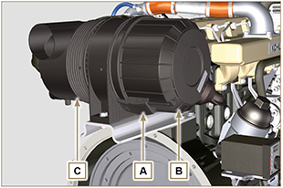  Fig 11.34
- Insert the new cartridge D and both of them inside the filter body C .  - Secure the cover B via the hooks A . | 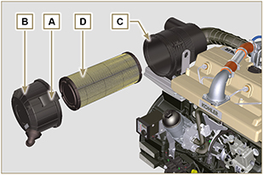  Fig. 11.35

Remote oil filter (disassembly and assembly)
Important  - Modified component, see service letter 700018 .  11.9.1 Disassembly  - Perform the operations described in Par. 5.2 .  Important  - Before proceeding with operation, read Par. 3.3.2 .  - For the replace the cartridge, please refer to operation number 6 (Par. 11.9.1) and 2 (Par. 11.9.2) .  - For the disassembly of the pipes B and C, lock with a tool the fittings K, H (Fig. 11.37) and L (Fig. 11.38) in order to prevent their lose together with the nuts A , with the consequent of oil leakage.  - Undo the nuts A and remove the hoses B and C . | 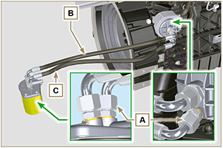  Fig 11.36
- Release the clamps D and remove the hoses E and F from Oil Cooler G .  - Unscrew and remove the fitting H with its copper gasket from the oil filter head J .  - Unscrew and remove:  - the fitting K with the copper gasket;  - Oil Cooler G and the relative gaskets;  - the oil filter head J . | 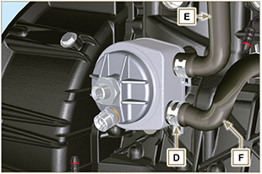  Fig 11.37
- Unscrew the fittings L and remove the copper gaskets from the support M .  - Unscrew the cartridge N with gasket from the support M . | 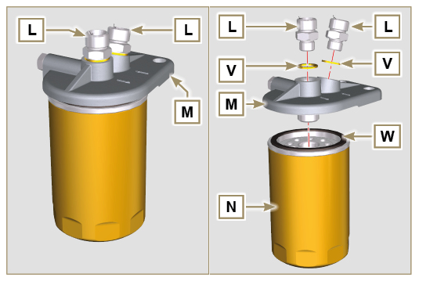  Fig 11.38
11.9.2 Assembly  Important  - Always replace the gaskets V after each assembly.  - Always replace the gaskets P, Q, and U at each assembly.  - Lubricate the gaskets P, Q with oil before assembling them.  - Clamp unions L on support M inserting gasket V (tightening torque at 40 Nm ).  - Lubricate gasket W and clamp cartridge N on support M (tightening torque at 20 Nm ).  - Insert the gasket P on the seat of the fitting K .  - Insert flange head J on the union K and the gasket Q in the seat of head J .  - Insert the Oil Cooler G on the union K and the gasket R in the seat of Oil Cooler G .  - Onto crankcase S apply Oil Cooler G and flange J by means of union K (tightening torque at 25 Nm + Loctite 2701 on thread) as positioned in Fig. 11.39 .  - Clamp union H on flange J inserting gasket U (tightening torque at 40 Nm ). | 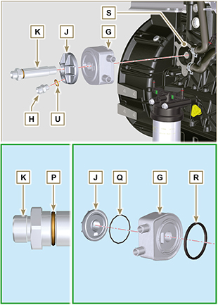  Fig 11.39
- Connect the hose B to the central fitting of support M and of flange J .  - Connect the hose C to the side fitting of the support M and of head J .  - Clamp the nuts A on the head J (tightening torque at 30 Nm ).  - Clamp the nuts A on the support M (tightening torque at 35 Nm ).  Important  - Check the tightening of the fittings K, H (Fig. 11.37) and L (Fig. 11.38) (tightening torque at 40 Nm ). | 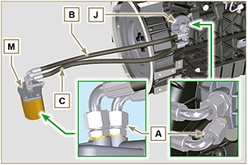  Fig 11.40

Poly-V alternator belt (replacement and adjustment)
Important

- Before proceeding with operation, read Par. 3.3.2 .
- Loosen the nut B and manually tighten the screw C until it just touches the pulley pin D . | 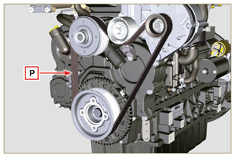  Fig 11.41
- Untighten the screw E by around 32mm (A) .  - Untighten the screw C .  NOTE: The belt tensioner pulley F should move towards the arrow G . If it does not, please move it manually. | 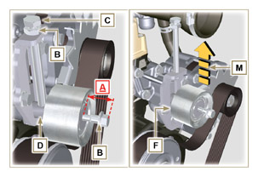  Fig 11.42
- Remove the V-Belt H and install the new one.  NOTE: Ensure that the internal profile of belt H is properly inserted into the grooves of the pulley A (as illustrated in D1 e D2 ). | 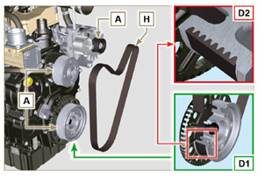  Fig 11.43
- Tighten capscrew C , to shift gudgeon D fully to the bottom of the grooved guide.  - Tighten capscrew E (tightening torque at 45Nm ).  - Hold the screw C still with a key, and tighten the screw B on the plate L to secure the screw C (tightening torque at 45Nm ).  - Check, in point P (Fig. 11.8) ,the tension of the belt. Check by the appropriate tool that at point p the tension value is between 149 and 196 Hz .  NOTE: After the engine has been in operation for around 15 minutes, repeat point 8 . | 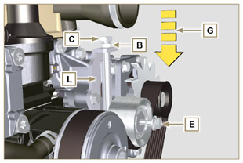  Fig 11.44

Tightening pulley and alternator for Poly-V belt
Important

- Before proceeding with operation, read Par. 3.3.2 .
11.4.1 Disassembly  - Perform the operations from point 1 to 3 of Par. 11.9.  - Remove the belt H ( Fig. 11.43 ) .  - Undo and remove the screw A .  - Fully undo the screw B and remove the tightening pulley C . | 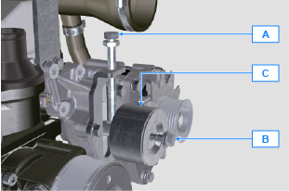  Fig 11.45
- Undo the screws D and remove the plate E and the pin F . | 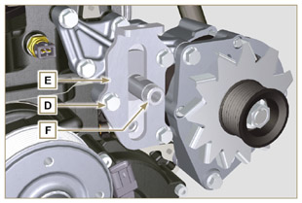  Fig 11.46
- Undo the screws G and H remove the alternator L . | 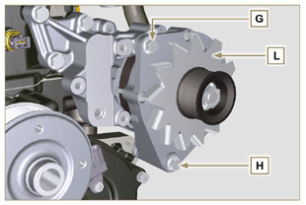  Fig 11.47
- Undo the screws M and remove the bracket N . | 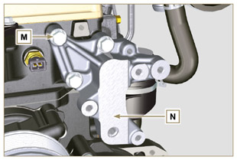  Fig 11.48
11.4.2 Assembly  - Secure the bracket N using the screws M on the cylinder head P (tightening torque at 25 Nm ). | 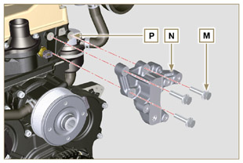  Fig 11.49
- Insert the screw H into the fixing hole on the alternator L .  - Insert the spacer R on the screw H (between the alternator and crankcase).  - Tighten the screw manually H onto the crankcase Q .  - Orientate the second fixing hole of the alternator L with the hole of the bracket N , secure the alternator L using the screw G (tightening torque at 25 Nm ) onto the bracket N and then the screw H (tightening torque at 25 Nm ). | 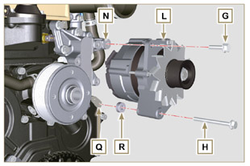  Fig 11.50
- Insert the pin F in the plate slot E .  - Orientate the pin F with the surface S (support for screw A ) upwards.  - Secure the plate E using the screws D on the bracket N (tightening torque at 25 Nm ). | 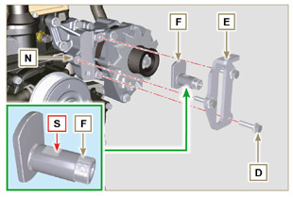  Fig 11.51
- Insert the screw B in the plate C1 and pulley C .  - Manually tighten the screw B onto the pin F up to the stop; Undo the screw B again by one turn.  NOTE: The screw B must protrude by about 32 mm (A) from the surface of the tightening pulley C (see detail X ).  - Install the new belt H ( Fig. 11.43 ) .  - Tighten the screw A onto the plate E up to the stop on the pin F .  - Perform the operations point 6 to 8 of Par. 11.9 . | 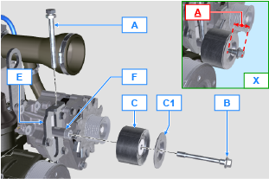  Fig 11.52

Oil sump with supporting structure
11.11.1 Flywheel (J) disassembly  - Execute the operations described in Par. 7.11.1 .  11.11.2 Plate/flange housing (L) disassembly  - Loosen supplementary capscrews A and B .  - Execute the operations described in Par. 7.11.2 .  - Remove housing or plate L . | 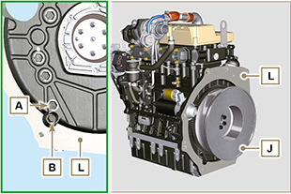  Fig. 11.53

11.11.3 Oil sump disassembly  - Execute the operations described in Par. 5.2 .  - Loosen capscrews C and remove bypass tube D .  - Loosen capscrews E and remove oil sump F . | 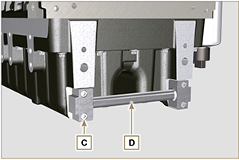  Fig. 11.54

11.11.4 Oil sump assembly  - Make sure contact surfaces G of oil sump F and crankcase H have no impurities.  - Apply a sealing bead of approximately 2.5 mm ( Loctite 5660 ) onto surface G of crankcase H .  - Place oil sump F onto crankcase H in correspondence with the fastening holes (use tool ST_18 ). | 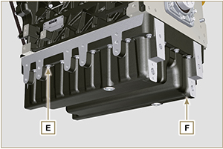  Fig. 11.55

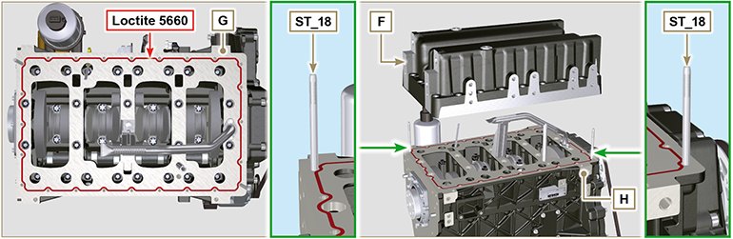
Fig. 11.56

- Apply capscrews E into the fastening holes and use torque at 10 Nm .  - Loosen capscrews E , leaving approximately 1 mm leeway ( position A ) between the neck surface of capscrews E and oil sump F .  - Place flange housing or plate L onto crankcase H , complying with centring tap pins M .  - Using 2 capscrews A , fasten housing or plate L onto crankcase H (tightening torque at 20 Nm ).  - Using 2 capscrews A , fasten housing or plate L onto oil sump F (tightening torque at 20 Nm ). | 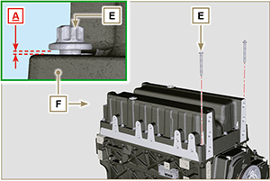  Fig. 11.57

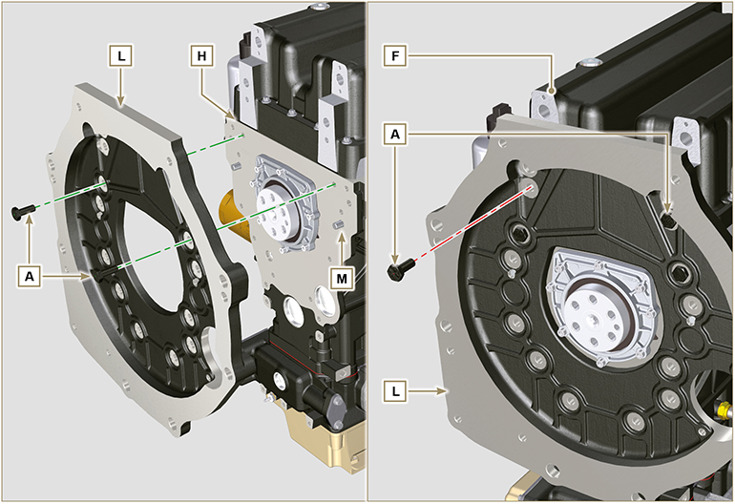
Fig. 11.58

- Fasten oil sump F by tightening capscrews E and strictly following the order shown in Fig. 11.59 (tightening torque at 20 Nm ).  - Loosen capscrews A and remove housing or plate L ( Fig. 11.58 ).  - Fasten oil sump F by tightening capscrews E and strictly following the order shown in Fig. 11.59 (tightening torque at 47 Nm ).  Loosen the screw 1 again and tighten it to 47 Nm . | 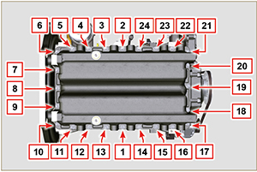  Fig. 11.59

- Insert gaskets N into seats P of bypass tube D .  - Fasten bypass tube D onto oil sump F using capscrews C (tightening torque at 10 Nm ). | 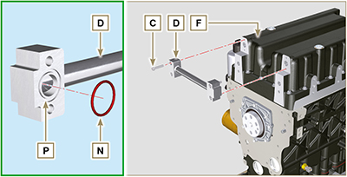  Fig. 11.60

11.11.5 Flange plate / housing assembly  - Execute the operations described in point 6 of Par. 11.11.4 .  - Fasten housing or plate L by using capscrews A and strictly following the order shown in Fig. 11.61 (tightening torque at 85 Nm ).  - Fasten housing or plate L by using capscrews B (tightening torque at 270 Nm ).  11.11.6 Flywheel assembly  - Execute the operations described in Par. 9.5.2 . | 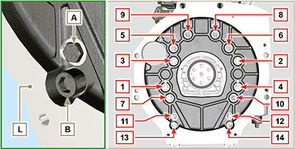  Fig. 11.61

