Information for replacing the functional units
KDI 2504 TM Workshop manual (Rev. 07.6)

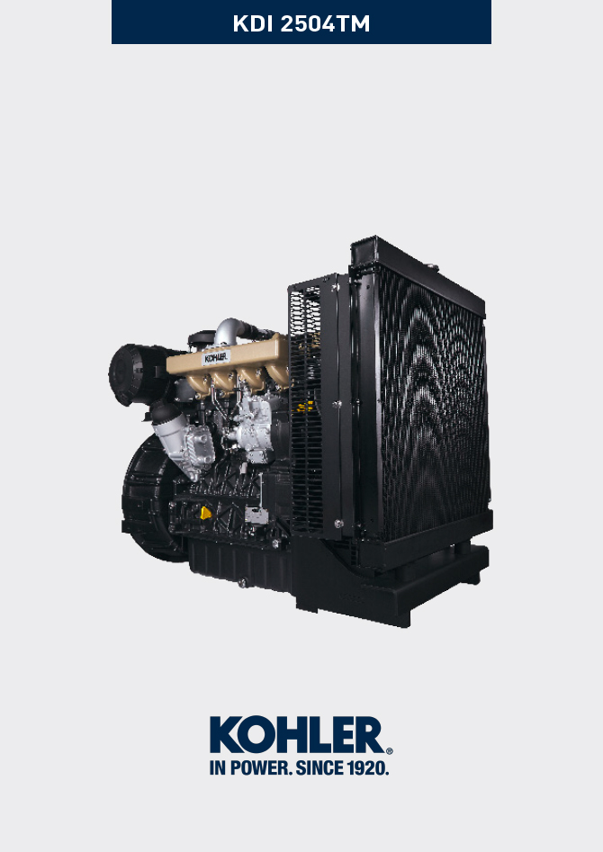
Sommario
1. TITOLO 1 2
1.1. Asdfsdfsdf 2
1.2. Asdfsdfsdfggg 2

Information for replacing the functional units

Injectors and injection pump replacement
Important  - Before proceeding with operation, read Par. 3.3.2 .  - Replace the high pressure pipes after two disassemblies.  - Always replace the gaskets after each disassembly.  - Handle the components as described in Par. 2.17 .  - Please referring to Par. 2.9.7 in order to see the operating references during disassemble and assemble procedures.  - When repaired, RSN-A injectors must be certified by a Stanadyne centre to check their correct operation - check the type of engine mounted injectors on the spare parts list ( RSN-A is specified in the description). | 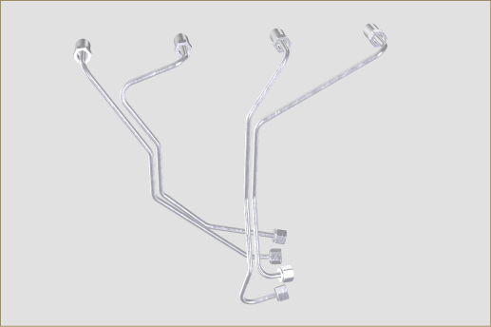  Fig 6.1
6.1.1 Injection fuel pump disassembly (injection pump/injectors)  - Undo the screws A and remove plate B .  - Remove the retainers C for the hoses D . | 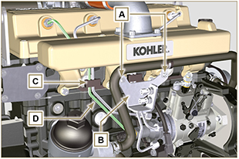  Fig 6.2
- Undo the nuts F .  - Undo the nuts E.  - Remove the tube D . | 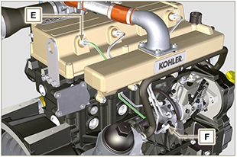  Fig 6.3
6.1.2 Rocker arms cover disassembly  - Undo the screws AR .  - Loosen clamp G and disconnect hose H  - Undo the screws L and remove the rocker arm cap C . | 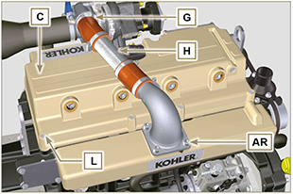  Fig 6.4
6.1.3 Fuel return pipes disassembly  - Undo the screws M and remove hose N . | 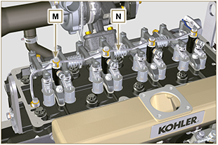  Fig 6.5
6.1.4 Injectors disassembly  - Undo the screw P and remove washer Q and bracket R .  - Remove the injector Z .  NOTE : Should you be unable to remove the injector (acting only on point BC ), use an open-ended spanner (11 mm), by applying small rotations to unblock the component.  - Seal all injection component unions as illustrated in Par. 2.9.7 .  - Ensure that gasket S has remained in the correct position ( Fig. 6.7 ). Otherwise, recover the gasket from inside the electronic injector V manifold.  NOTE : If the washer S is not found on the injector Z , recover it from inside the sleeve V . | 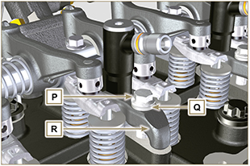  Fig 6.6  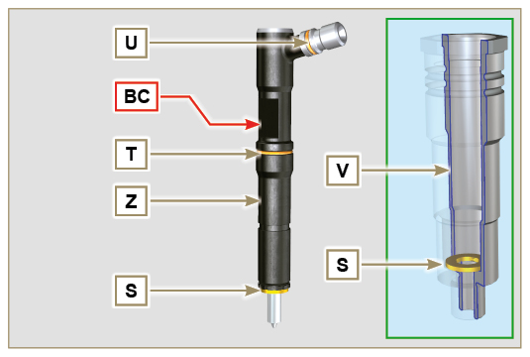  Fig 6.7
6.1.5 Injection pump disassembly  Important  - Before proceeding with the disassembly, identify the pump code from its identifying name plate (Pos. 12 - Tab. 2.12 ).  - Alternatively, you can identify the pump from the online spare parts catalogue ( https://partners.lombardini.it/App/SparepartCatalogue/Default/Catalogue.aspx ).  - Insert the tool ST_30 into the injector N°1 and fix it with the fixing brace R of the injector, capscrew P and washer Q .  NOTE : Do not tighten the capscrew P.  - Disassemble the starter motor.  - Mount the tool ST_34 in the seat of the starter motor Y and fit it with the two starter motor fixing screws.  - Rotate the crankshaft clockwise ST_34 tool bringing reference X upwards.  NOTE: During the positioning phase of reference X , check that cylinder N° 1 is in compression phase (intake and exhaust valves of cylinder N° 1 must be in closing position).  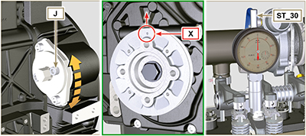  Fig 6.10  Tab. 6.1  PUMPCODE PISTON LOWERING (mm) ADVANCE α  ED0065900040-S 1,695 13°  ED0065905050-S 1,695 13°  ED0065905110-S 1,963 14°  ED0065905350-S 1,963 14°  ED0065905470-S 1,695 13°  ED0065905480-S 1,963 14°  ED0065905490-S 0,363 6°  ED0065905540-S 1,006 10°  ED0065905550-S 1,695 13°  ED0065905950-S 0,815 9° | 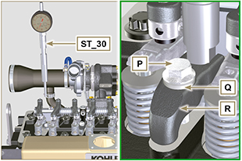  Fig 6.8  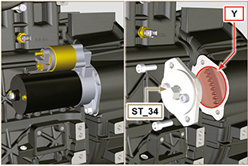  Fig 6.9
5. With reference X pointed upwards, find the TDC through tool ST_30 , then bring the dial gauge indicator to 0 .  6. Having identified the value to lower the piston, rotate the crankshaft anti-clockwise by going beyond the value described in Tab. 6.1 , once again, rotate the crankshaft clockwise, stopping at the correct advance value by using tool ST_30  7. Lock the ST_34 tool through J screws and ensure that the crankshaft does not rotate, which would alter the correct advance value. If this happens, repeat the instructions described in points 4, 5, 6, 7 and 8.  NOTE: The value indicated in Tab. 6.1 must be reached by rotating the shaft with the piston in compression phase. Use the ST_34 tool to totate the crankshaft. | 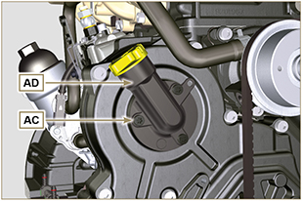  Fig 6.11  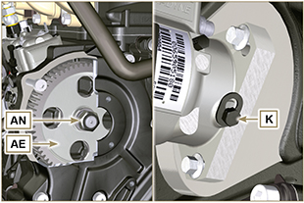  Fig 6.12
8. Lock the ST_34 tool through J screws and ensure that the crankshaft does not rotate, which would alter the correct advance value. If this happens, repeat the instructions described in points 4, 5, 6, 7 and 8 .  9. Undo the screws AC and remove the oil filling flange AD .  10. Undo and remove the nut AN fixing the injection pump control gear AE .  11. Undo the capscrew K and shift the slotted plate AB in the direction of arrow AA .  12. Tighten screw K to block the pump (tightening torque to 12 Nm ).  Important  - After removing the nut AN , ensure that the correct advance value has remained unchanged on ST_30 .  - Be careful that the nut AN does not fall into the timing cover.  13. Screw the tool ST_04 on the gear AE .  14. Loosen the screws AF . | 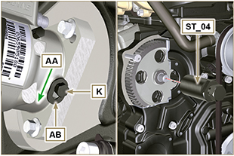  Fig 6.13  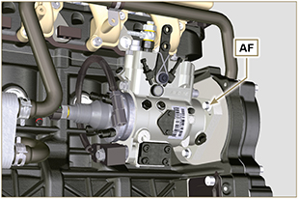  Fig 6.14
15. Tighten the screw of tool ST_04 to disconnect the injection pump AG from the high pressure pump control gear AE .  16. Undo the screws AF and extract the injection pump AG .  17. Undo and remove the tool ST_04 . | 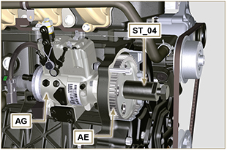  Fig 6.15
NOTE : Click on the right to play the procedure. | https://www.youtube.com/embed/NaOHNXyU03c?rel=0
6.1.6 Injection pump assembly  Warning  - Before assembling the new pump AG , make sure that plate AB can move freely and that fastening capscrews K are not loose (the pump sold as a spare part is supplied with the cylinder injection timing blocked N° 1 ).  - Ensure that the coupling surfaces on shaft AP and gear AE are free from impurities and lubrication residues.  - Remove the guard cap only when the pipes are reconnected.  - Do not remove the tool ST_30 .  1. Mount the injection pump AG , inserting the shaft AP in the gear AE .  Important  - Always change screws AF with new ones or apply Loctite 270 to the threads.  2. Clamp the screws AF on the crankcase AH (tightening torque at 25 Nm ).  3. Ensure that the correct advance value has remained unchanged, tighten nut AN on shaft AP (as shown in Fig. 6.17, is allowed the aid of a screwdriver to guide the nut AN on the shaft AP in order to avoid the fall of it into the timing cover AQ - tightening torque at 70 Nm ). | 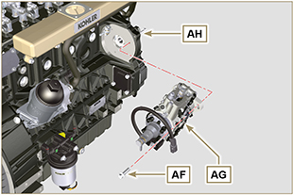  Fig 6.16  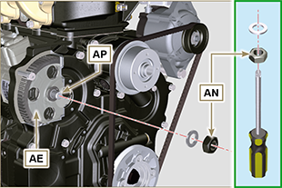  Fig. 6.17
4. Undo the capscrew K and shift the slotted plate AB in the direction of arrow AA .  5. Tighten screw K (tightening torque to 5.5 Nm ). The injection pump is unlocked.  6. Remove the tool ST_30 and ST_34 . | 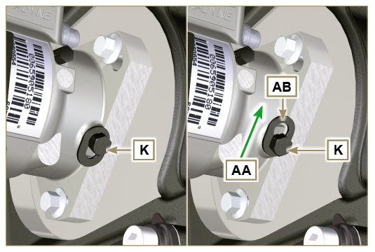  Fig 6.18
NOTE : Always replace the gasket AJ after each assembly.  7. Position the gasket AJ in the set on the flange AD .  8. Fix the flange AD on the crankcase AQ with the screws AC (tightening torque at 10 Nm ). | 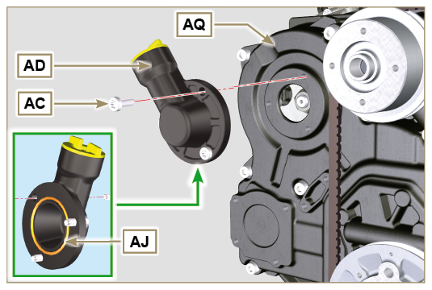  Fig 6.19
NOTE : Click on the right to play the procedure. | https://www.youtube.com/embed/XsOMihldXno?rel=0
6.1.7 Injector assembly  Important  - To prevent damaging the injection system, the protection caps ( Par. 2.9.7 ) must be removed during assembly.  - Lubricate the gaskets U, T, S and fit them on the injector Z. | 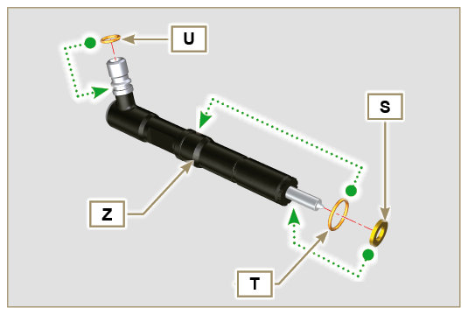  Fig 6.20
2. Fit the injector Z in the sleeve V . | 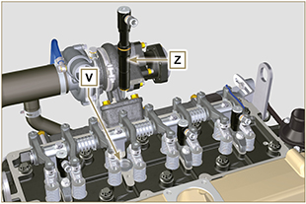  Fig 6.21
3. Assemble the parts P, Q, R and fit the parts so assembled on the injector Z . | 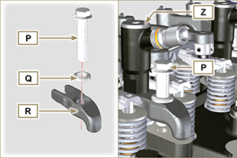  Fig 6.22
4. Insert tool ST_51 on the injectors junctions Z (detail X1 ).  5. Tighten the screw P (tightening torque to 20 Nm ) | 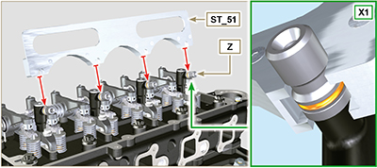  Fig 6.23
6.1.8 Assembly of the injector return pipes  - Position the tube N on the injectors Z , and tighten screws M (tightening torque to 14 Nm ). | 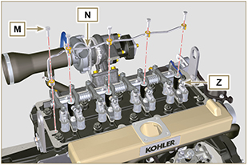  Fig 6.24
6.1.9 Assembly Rocker arm cover  Important  - The gasket AM between the rocker arm cover and the cylinder head must always be replaced every time it is disassembled.  - Position the two guide pins ST_17 before mounting the rocker arm cover.  - Position the gasket AM on the head AL respecting the fastening screw holes L .  - Attach the rocker arm cover C on the head AL with the screw L adhering to the tightening sequence shown in Fig. 6.26.  - Connect pipe H and tighten the clamp G .  - Connect tube H to turbine AS and tighten clamp G .  - Fasten flange AT by means of capscrews AR to manifold AU , inserting gasket AV .  Important  - Always replace the gaskets AK ( ST_36 ) - AV after each disassembly . | 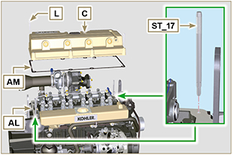  Fig 6.25  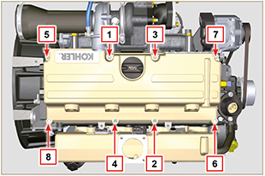  Fig 6.26  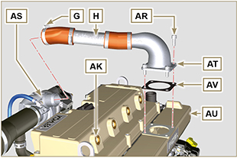  Fig 6.28
6.1.10 Installation of the fuel injector pipes (pump injector/injectors)  - Position pipes D on the injectors and on the injector pump.  Important  - Tighten the nuts E and F manually, without clamping them.  2. Tighten the nuts E ed F (tightening torque at 25 Nm ).  3. Reinstall the retainers C of the hoses D .  4. Fix the plate B by using screws A (tightening torque to 10 Nm ). | 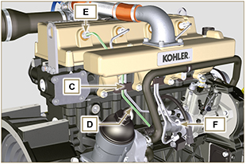  Fig 6.29  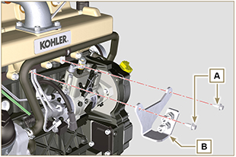  Fig 6.30

Coolant pump replacement
6.2.1 Disassembly  - Perform the operations described in Par. 5.1 .  Important  - Before proceeding with operation, read Par. 3.3.2 .  - The pump G isn't repairable.  - If the engine is fitted with the Poly-V belt, perform the operations described in Par. 11.9 .  2. Loosen the screws A and B.  3. Push the alternator C in the direction of the arrow D and remove the belt E .  4. Remove the clamp M and disconnect the pipe N from the pump G .  5. Loosen the screws F and remove the pump G and relative gasket H .  NOTE : If union R , is disassembled, replace it or alternatively apply Loctite 2701 on the thread when assembling on pump G (tightening torque of 20 Nm ). | 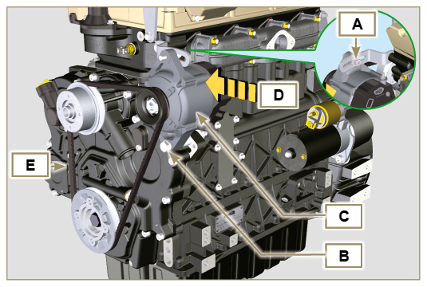  Fig 6.31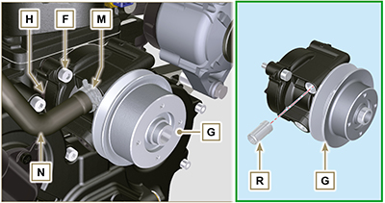  Fig 6.32
6.2.2 Assembly  Important  - Always replace the gaskets H , after each disassembly.  - Always replace the belt E after each assembly.  - Fit the coolant pump G with the screws F interposing the new gasket H (tightening torque at 25 Nm ). | 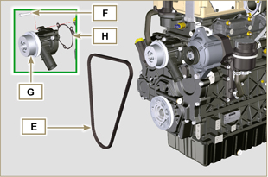  Fig 6.33
- Insert the belt E on the pulleys L .  - Push the alternator C in the direction of the arrow D .  - While tensioning the alternator C , first clamp screw A (tightening torque at 25 Nm ) and then screw B (tightening torque at 69 Nm [thread M10] - 40 Nm [thread M8] ).  - Check the tension of the belt E with the instrument ( DENSO BTG-2 ), positioning it in point p (the tension must be between 200 and 230 N )  - If the tension values do not correspond, tighten screws A and B , then repeat operations 3, 4 and 5 . | 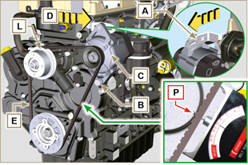  Fig 6.34

Replace the crankshaft pulley
6.3.1 Disassembly  Important  - Before proceeding with operation, read Par. 3.3.2 .  NOTE: Perform the operations described in Par. 6.1.5 steps 2 and 3 .  - Position the crankshaft with the 1st cylinder in TDC, reference A .  - Remove the alternator belt following steps 2 and 3 ( Par. 6.2.1 ) . | 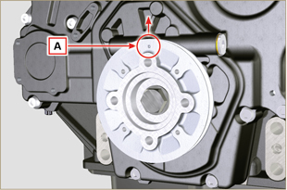  Fig 6.35
- Undo the screw P (clockwise) and remove the pulley Q . | 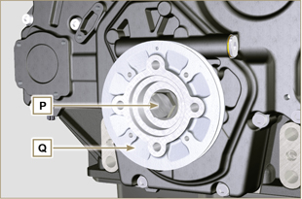  Fig 6.36
6.3.2 Assembly  - Check that the pin U is mounted properly on the camshaft V .  - Insert the pulley Q on camshaft V respecting the reference of the pin U .  - Apply Molyslip grease on the screw thread P .  - Fit the pulley Q with the screw P (tightening torque 360 Nm ) and remove the tool ST_34 . | 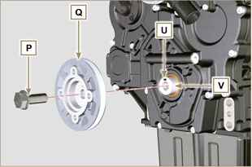  Fig 6.37

Oil pump replacement
Important

- Before proceeding with operations, read Par. 3.3.2 .
- The oil pump is not repairable.
6.4.1 Coolant pump disassembly

- Perform the operations described in Par 6.2.1 .
6.4.2 Engine pulley disassembly

- Perform the operations described in Par 6.3.1 .
6.4.3 Timing system crankcase disassembly  Important  - Perform the operations described in Par. 5.2 .  - Make sure that the reference pin A is facing upwards.  - Undo the screws B and remove the timing system crankcase C . | 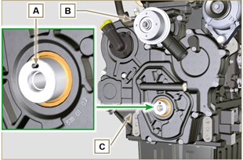  Fig 6.38
6.4.4 Oil pump disassembly  - Undo the screws D and remove the group pump E from the timing system crankcase C .  - Remove the rotors F and G from the oil pump crankcase E . | 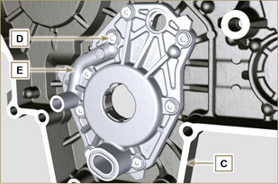  Fig 6.39  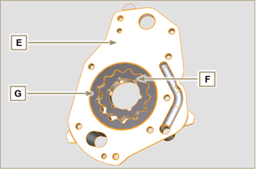  Fig 6.40
6.4.5 Oil pump assembly  Important  - Carry out the checks described in Par. 8.7 prior to assembly.  - Check that all surfaces in contact between F, G, H, E and C are free from impurities - scratches - dents.  - When assembling, do not use any type of gasket between E and C.  - Thoroughly lubricate the seat of the rotors H on the oil pump crankcase E and the two rotors F and G.  - Within housing H insert the 2 rotors (in sequence) G and F , observing the references BP as described in figure (or refer to Par. 2.10.2 ).  - Check that the 2 pins L are inserted properly in the timing system crankcase C .  - Position the oil pump carter E using the reference pins L.  - Clamp the oil pump carter E with the screws D (tightening torque 10 Nm - ST_06 ). | 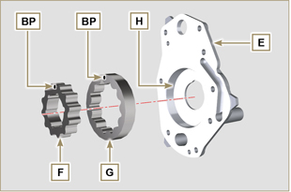  Fig 6.41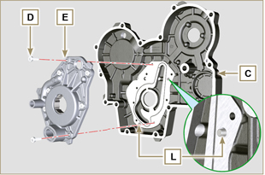  Fig 6.42
6.4.6 Timing system crankcase assembly  Important  - Always replace the oil seal J after each assembly.  - Always replace the gasket P after each assembly.  - Lubricate the lip of the oil seal J .  - Distribute a bead of Loctite 5188 , about 1mm thick, on the  surfaces K of the crankcase C .  - Make sure that the key M (Fig. 6.44) is inserted properly on the crankshaft and that it is facing upwards.  - Check that the 2 pins N are inserted properly in the timing system crankcase C . | 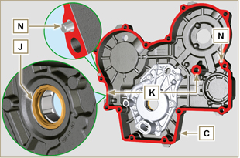  Fig 6.43
- Lubricate and insert the gasket P in the seat of the oil pump Q .  - Tighten the tool ST_10 on the crankshaft.  - Position the crankcase C on the base, using the reference pins M , inserting the oil pump Q on the crankshaft. | 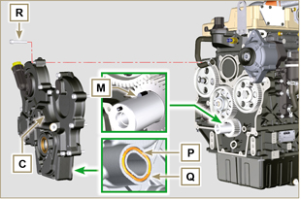  Fig 6.44
- Fit the timing system crankcase C with the screws R observing the indicated clamping sequence (tightening torque at 25 Nm ). | 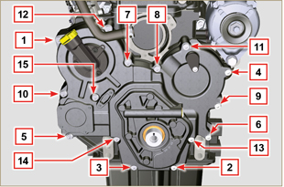  Fig 6.45
6.4.7 Crankshaft pulley assembly
- Perform the operations described in Par 6.3.2 .
6.4.8 Coolant pump assembly

- Perform the operations described in Par 6.2.2 .

Oil pressure valve replacement
6.5.1 Disassembly  Important  - Before proceeding with operation, read Par. 3.3.2 .  - Undo the cap A .  - From the crankcase D , remove the spring B.  - Remove the valve piston C using a magnet. | 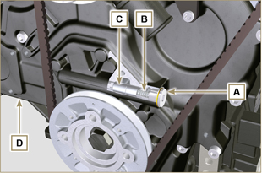  Fig 6.46
6.5.2 Assembly  Important  - Carry out the checks described in Par. 8.7.3 prior to assembly.  - Always replace the gasket F after each assembly.  - Lubricate the piston C and fully insert it in the seat E .  - Insert the spring B in the piston.  - Mount the gasket F on cap A.  - Clamp the cap A on the crankcase D (tightening torque at 50 Nm ). | 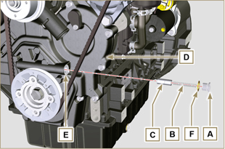  Fig 6.47

Oil cooler unit and oil filter replacement
6.6.1 Oil Cooler unit disassembly  Important  - Before proceeding with operation, read Par. 3.3.2 .  - Perform the operations described in Par 5.1 and Par 5.2 .  - Oil Cooler unit E is not repairable.  - Release the clamps A .  - Remove the pipes B out of the Oil Cooler unit E . | 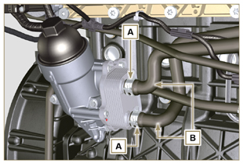  Fig 6.67
Warning  - Electric/pneumatic screwdrivers are forbidden.  - Use a suitable container to recover any residue oil.  - Unscrew cartridge holder cover H by performing three complete turns and wait 1 minute.  NOTE : this operation allows to oil contained in the support E to flow into the oil sump in the correct way.  - Unscrew cartridge holder cover H and check that the oil in the lub. oil filter support E has flowed towards the oil sump.  - Undo the screws C and D and remove the Oil Cooler unit E . | 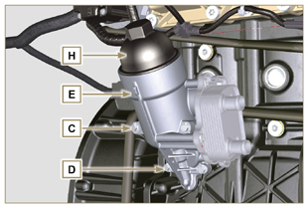  Fig 6.68
- Remove the gaskets F and G from the Oil Cooler unit E . | 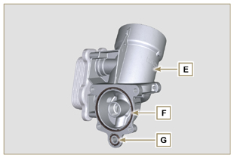  Fig 6.69
6.6.2 Oil filter cartridge replacement  - Remove gaskets L, M and N from element holder cover H .  - Remove cartridge P from element holder cover H . | 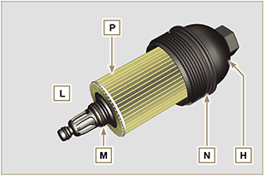  Fig 6.70
- Lubricate and insert gaskets L, M and N in the L1, M1 and N1 seats of element holder cover H .  - Insert element P into element holder cover H . | 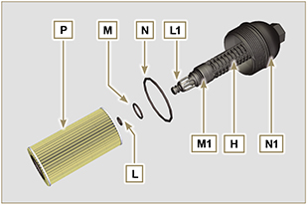  Fig 6.71
6.6.3 Oil Cooler unit assembly  Important  - In the event of assembly of union U on crankcase S , manual tightening torque with Loctite 2701 on the thread).  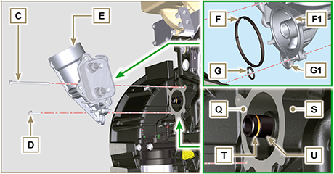  Fig 6.72  - Check that the surface Q on the support E and on the crankcase S are free from impurities.  - Lubricate and insert the gasket T on the fitting U .  - Lubricate and insert the gaskets on the support E :  F in seat F1 ;  G in seat G1 .  - Fit the support R with the screws C and D (tightening torque at 10 Nm ).  - Insert and tighten the cartridge support H on the filter support E (tightening torque at 25 Nm ).  - Fit the pipes B on the support E and secure the pipes B with the clamps A . | 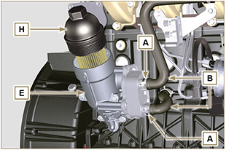  Fig 6.73

Fuel filter replacement
Important  - Before proceeding with operation, read Par. 3.3.2.  Warning  - In case of low use replace il 12 months.  - Procure a suitable container to collect the fuel.  - Rotate the filter A to take it to the unlocked position and remove it.  - Lubricate the gasket C .  Assemble the filter A on the support B and rotate it until reaches the lock position.  Important  - Do not fill the new cartridge A with fuel.  - Turn the key on the control panel to the ON position.  The electric pump D sends fuel to the filter and then the injection pump E .  - Loosen the air bleeding screw F on fuel filter bracket B .  The air inside the circuit and the filter will begin to escape from the screw G .  - Tighten the bleeding screw F (tightening torque of 1.5 Nm ) when the fuel begins to flow. | 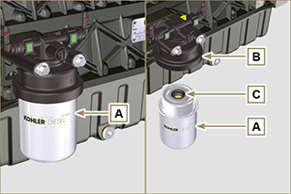  Fig 6.74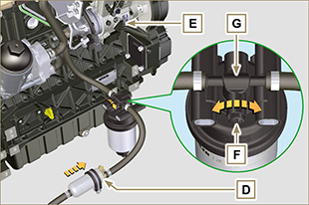  Fig 6.75
Warning  - Check that the fuel supply pump filter is present, and replace if necessary.  - Release the clamp D .  - Demount the hose E .  - Unscrew the filter G from the pump Q . | 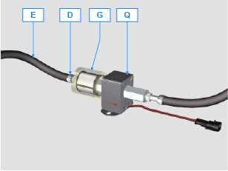
- Screw the new filter G onto the pump Q (tightening torque 20 Nm ).  - Connect the hose E to the filter G and fasten with the clamp D . | 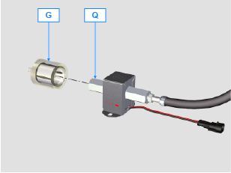

Oil vapour separator replacement
6.8.1 Disassembly  Important  - Before proceeding with operation, read Par. 3.3.2 .  - Release the clamp AA and remove the pipe D .  - Release the clamps F .  - Remove the clamp P cutting it in the point indicated and remove the separator body C removing it from the hose AG and G . | 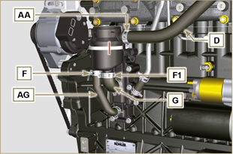  Fig 6.63
- Release the clamp F .  - Remove the pipes G and AG .  - Undo the screws B .  - Release the clamp S from the sleeve K .  - Pull the flange H out of the manifold K and remove the relevant gasket, being careful not to bend the pipe E . | 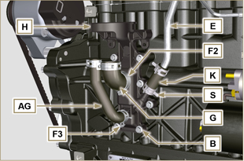  Fig 6.64
6.8.2 Assembly  Warning  - Always carefully inspect the condition of the tubes, and replace them if there is any doubt regarding their integrity.  - Always replace the gasket M after each assembly.  - Check that the contact surface L is free from impurities.  - Position flange H inserting hose K onto the flange union H , being careful not to bend tube E .  - Insert the gasket M between the flange H and the crankcase N .  - Secure the flange H using the screws B on the crankcase N (tightening torque at 10 Nm ).  - Secure the clamp S on the manifold K .  - Fit the pipes G and AG on the flange H .  - Fit breather body C onto tubes G, AG and D and fasten tube G - AG - D with their relative clamps.  - Fit the breather body C on the support flange H with the new clamp P . | 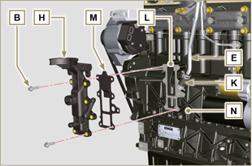  Fig 6.65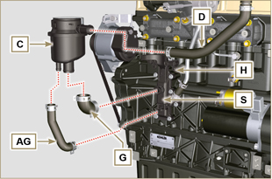  Fig 6.66

