Diagbox Diagnostic Tool
Diagnostic tool manual

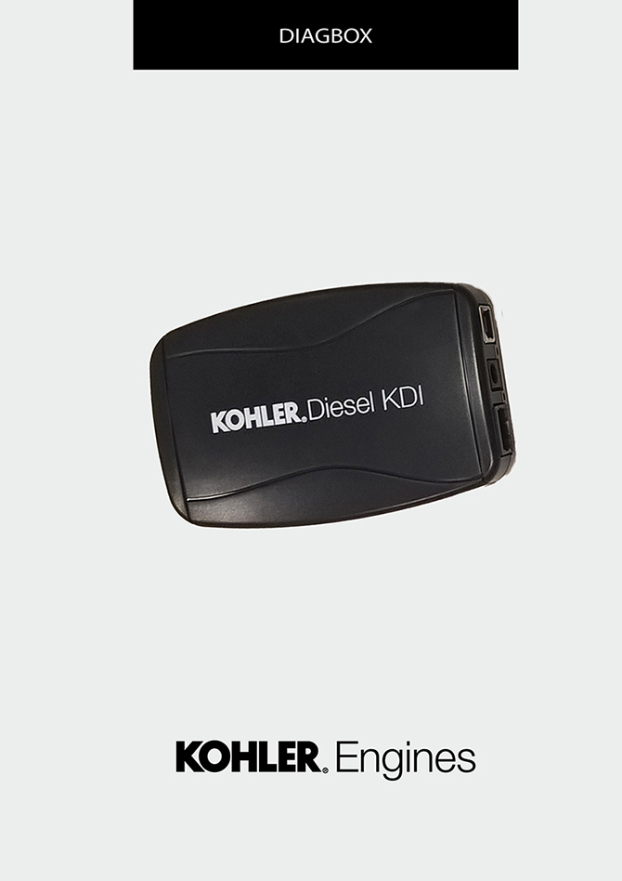
Sommario
1. TITOLO 1 2
1.1. Asdfsdfsdf 2
1.2. Asdfsdfsdfggg 2

DIAGBOX

DIAGBOX Diagnostic tool
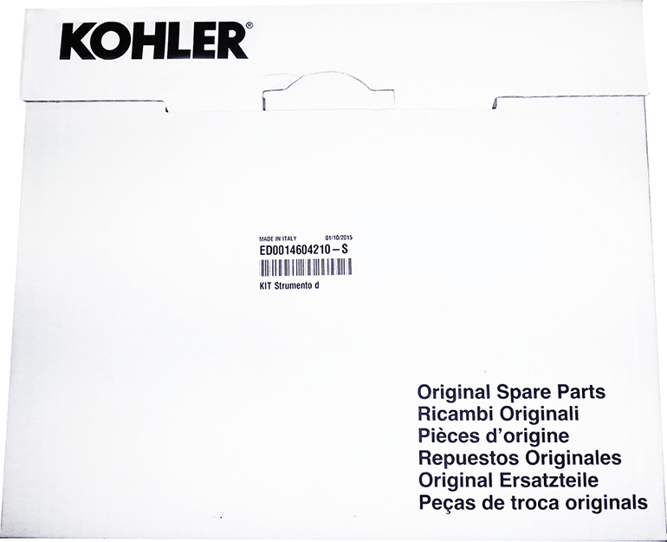

Cod. ED0014604210-S - * Pn to the complete kit tool

Contents of suitcase
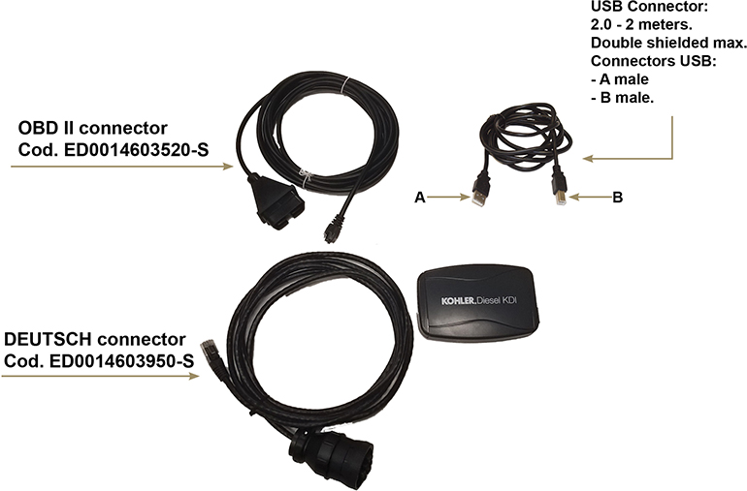

Connections

Connection with OBD II connector
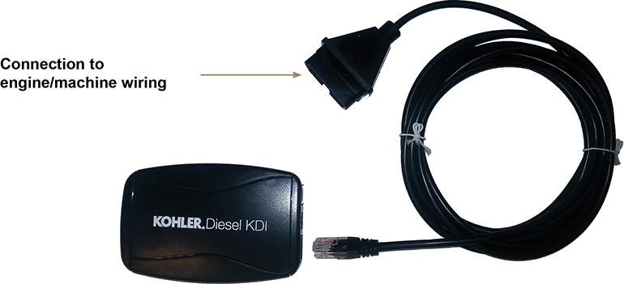

Connection with DEUTSCH connector
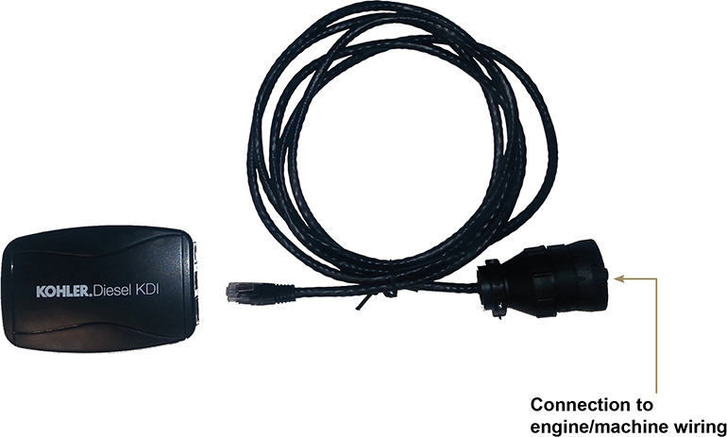

USB connection
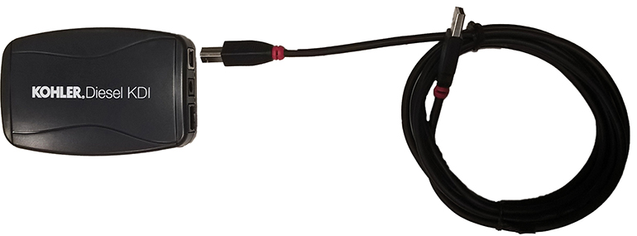

Complete connection with DEUTSCH
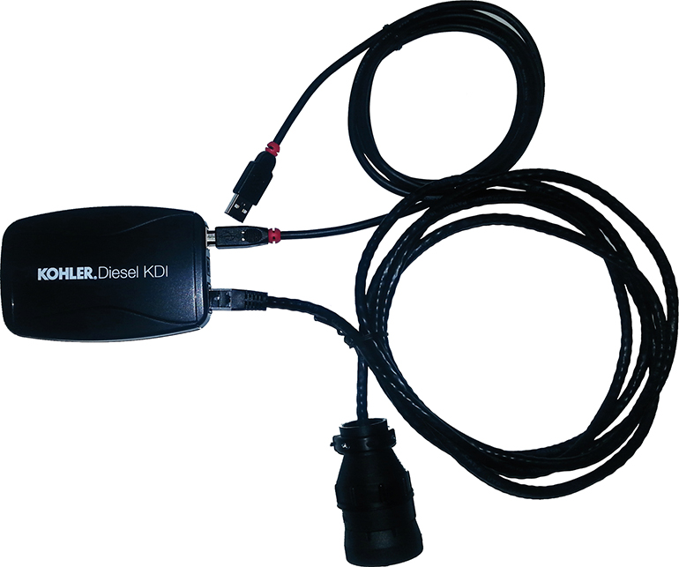

Complete connection with OBD II
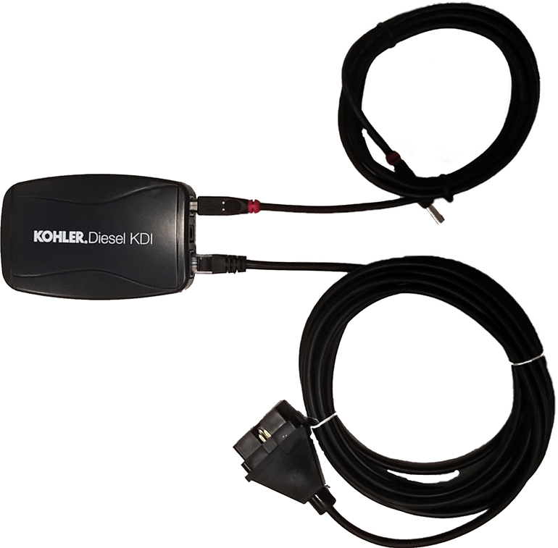

PC Arrangement for Diagbox software

PC Arrangement for Diagbox software
Warning
Start the engine; connect the test equipment ONLY after starting the engine.
NOTE : if the test equipment is connected before starting the engine, hunting may occur.
To cure the issue, disconnect test equipment cable from the engine, allow a few seconds and then reconnect the equipment.
To download the "Setup DiagBox.exe" oftware, perform the following operations:
Go to website "http://iservice.lombardini.it" and click on "KDI KOHLER DIESEL".

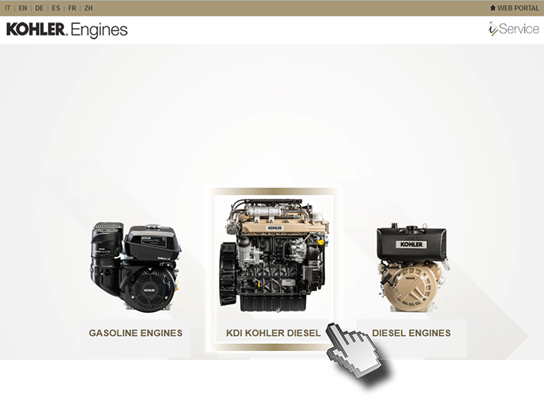

Read carefully "PRIVACY" box and click on "I ACCEPT"

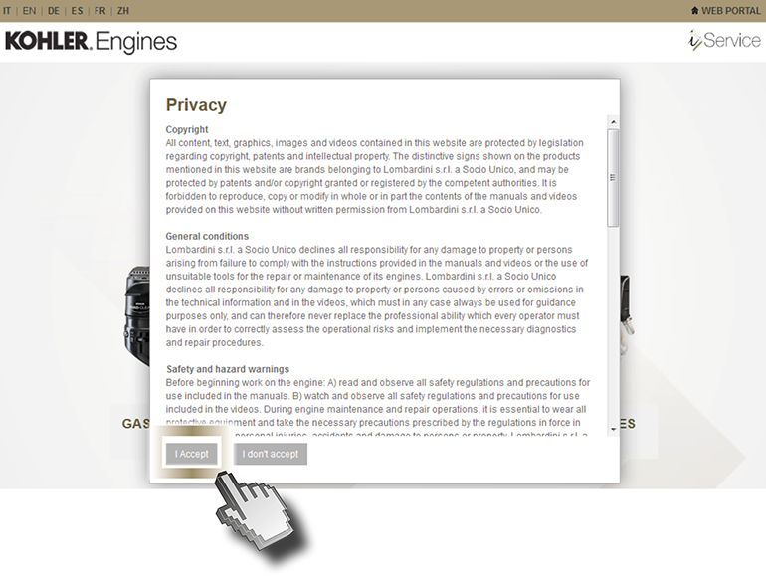
Enter the "Username and Password", flag "I AM NOT A ROBOT" and clicking "Log-in"

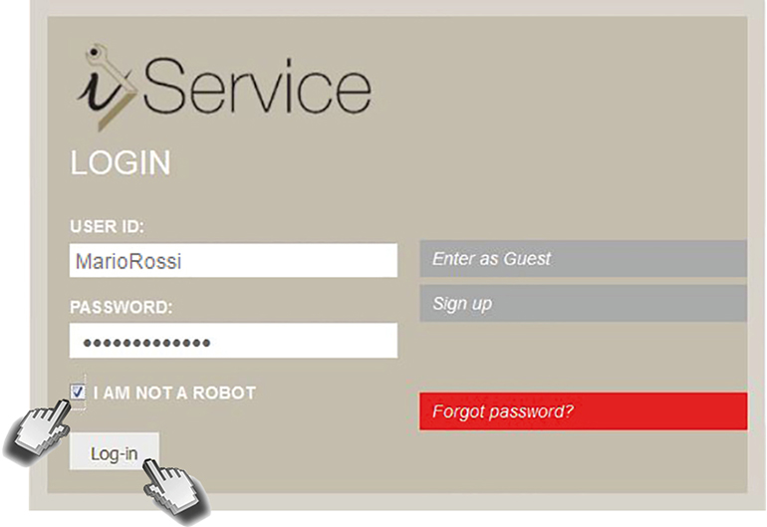

If you have no "USER ID" and "PASSWORD", register by clicking on "SIGN IN".

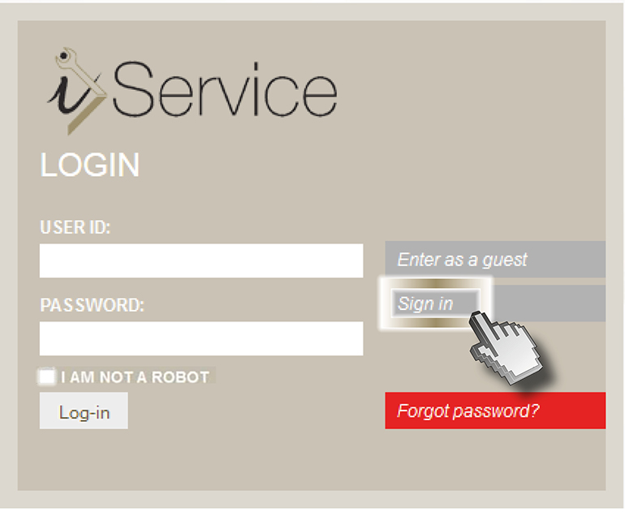
Fill out the required fields and “DIAGNOSTIC TOOL CODE (ONLY IF YOU HAVE THE TOOL)" box. | 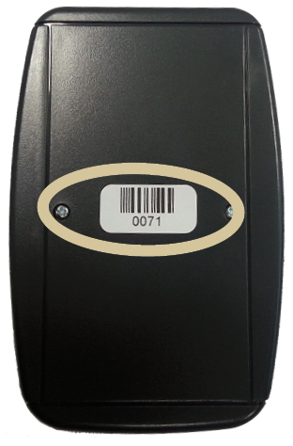
Wait for the email to confirm your registration.
Click on "DIAGNOSIS AND FLASHING"

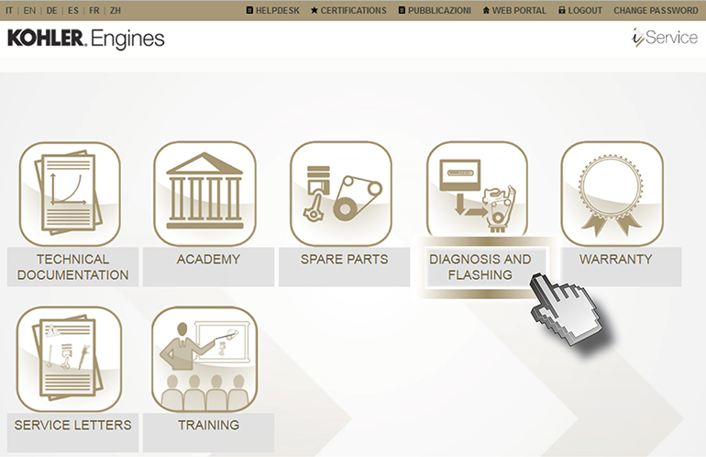

Click on "DIAGNOSTIC TOOL"

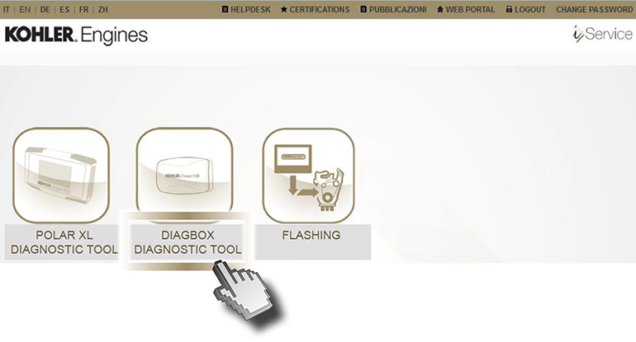

Download from i-Service Setup DiagBox.exe and click on "Salva file".

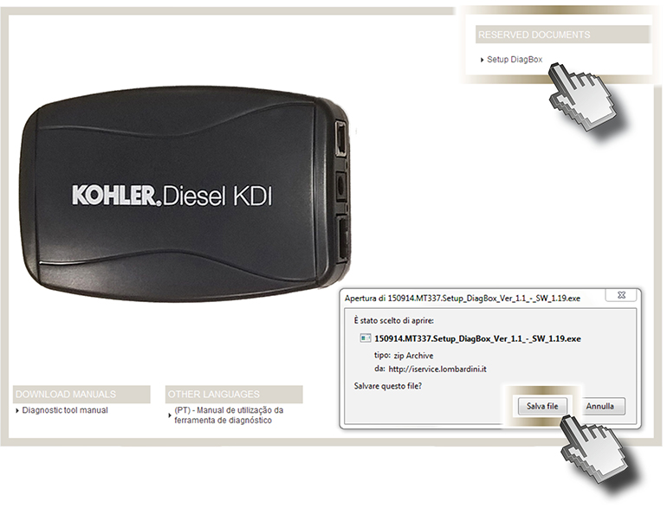
Click on "Esegui".

Warning
If you upgrade your software, you can:
- uninstall the earlier version and install the most recent version using the wizard, or
- launch the new software installation wizard directly (click on "Modify" when prompted)
Warning
In the event that the PC is equipped with anti-virus protection, proceed as follows

Click on "Azioni".

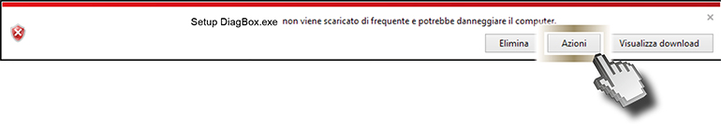

Click on "Run anyway".

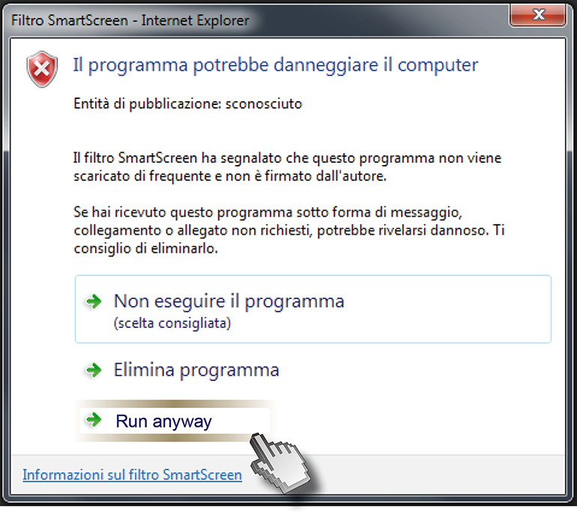

Click on "Allow this file".

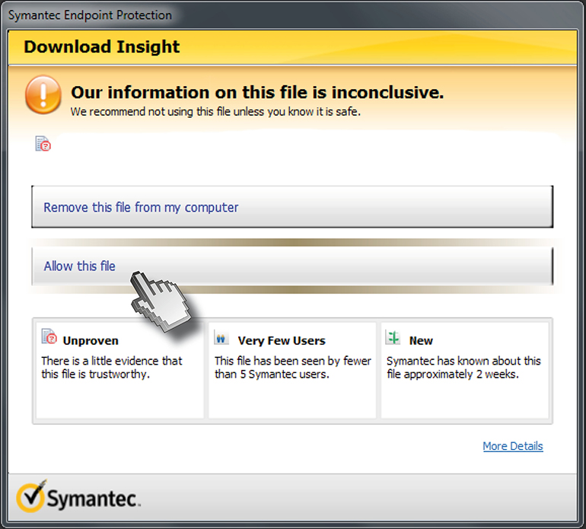

Select the desired language (1) and press "OK" (2).

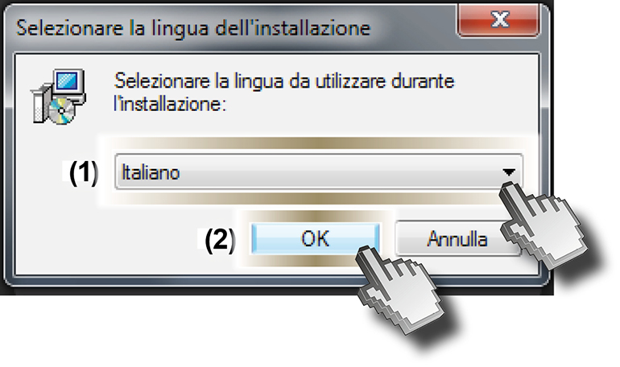
Click on "Next".

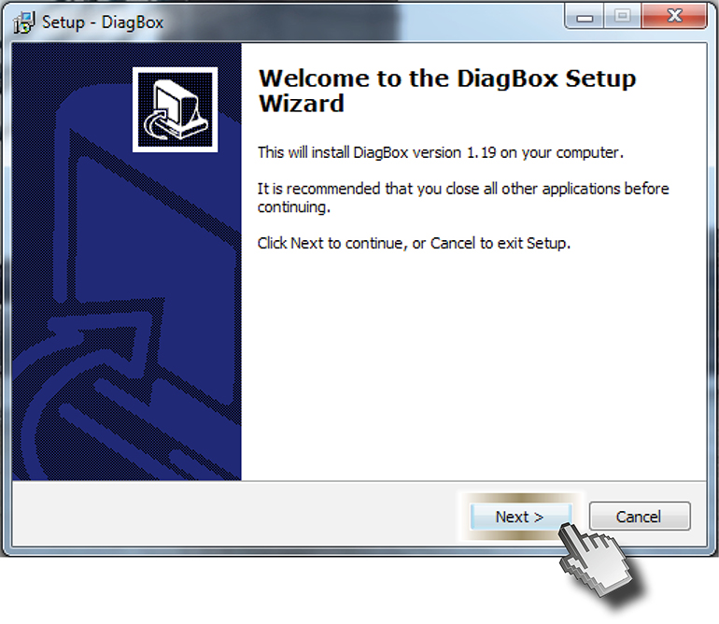
Click on "Next".

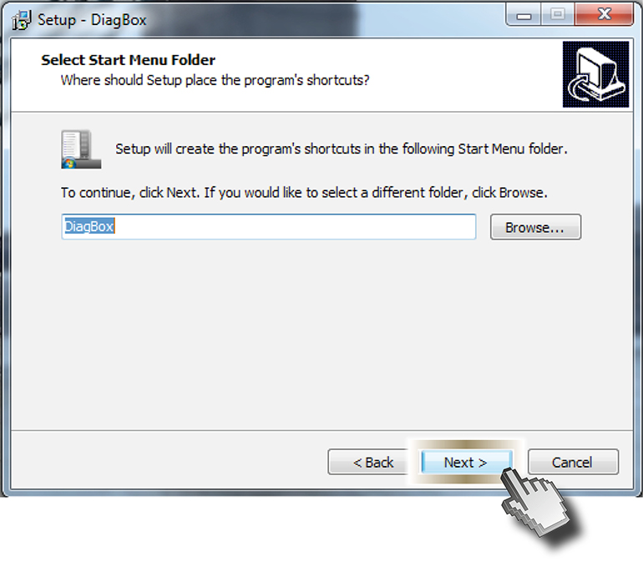
Tick "Create a desktop icon" (1) and then click on "Next" (2).

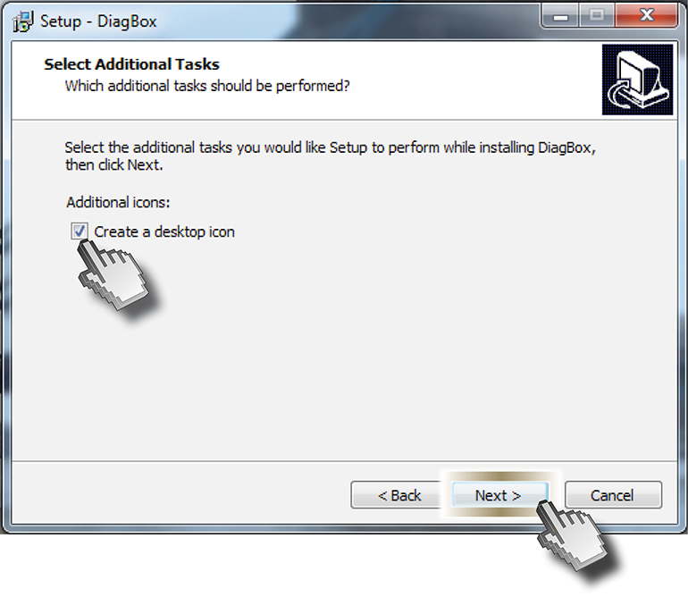
Click on "Install".

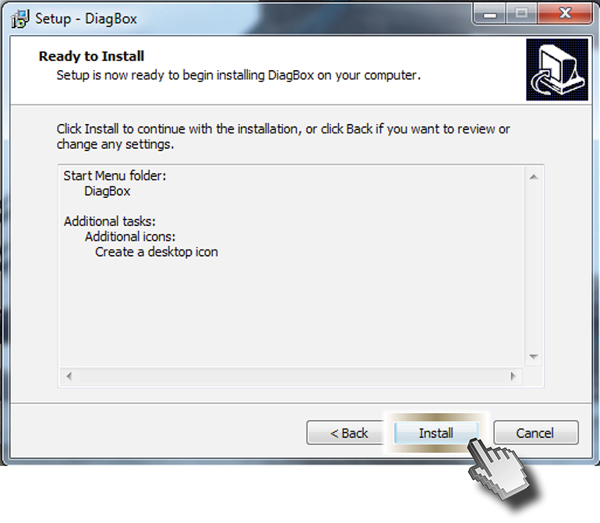
Please wait while setup installs DiagBox on your computer.

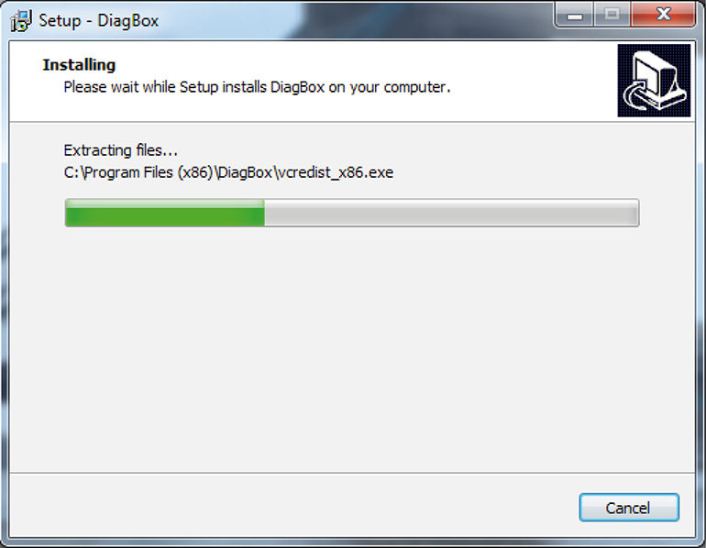

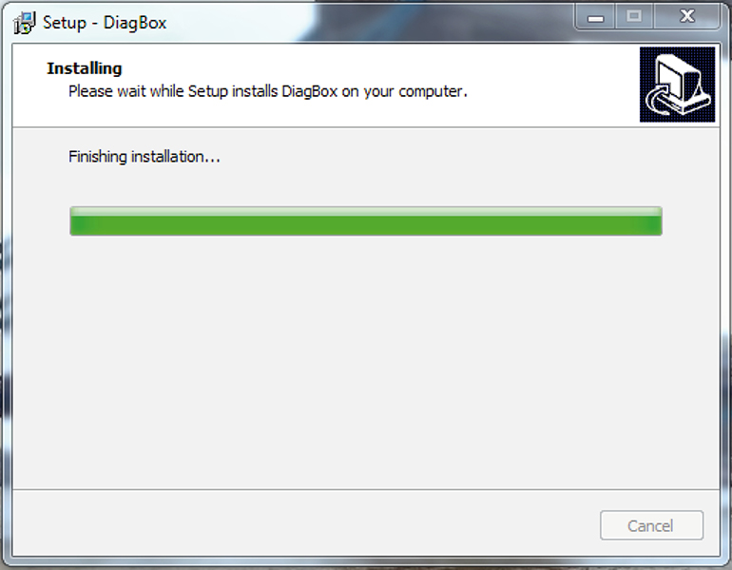

Click on "Next"

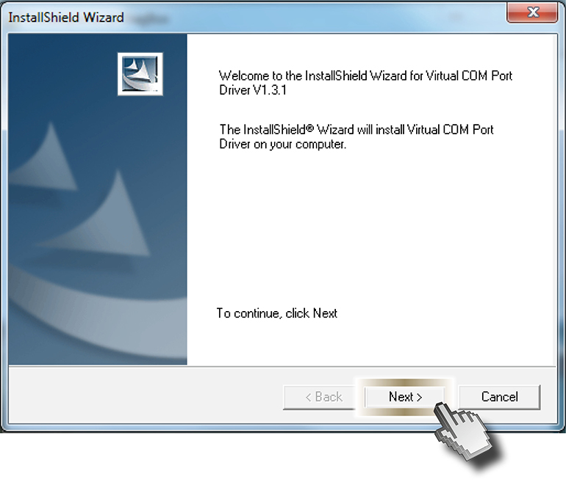
Click on "Next"

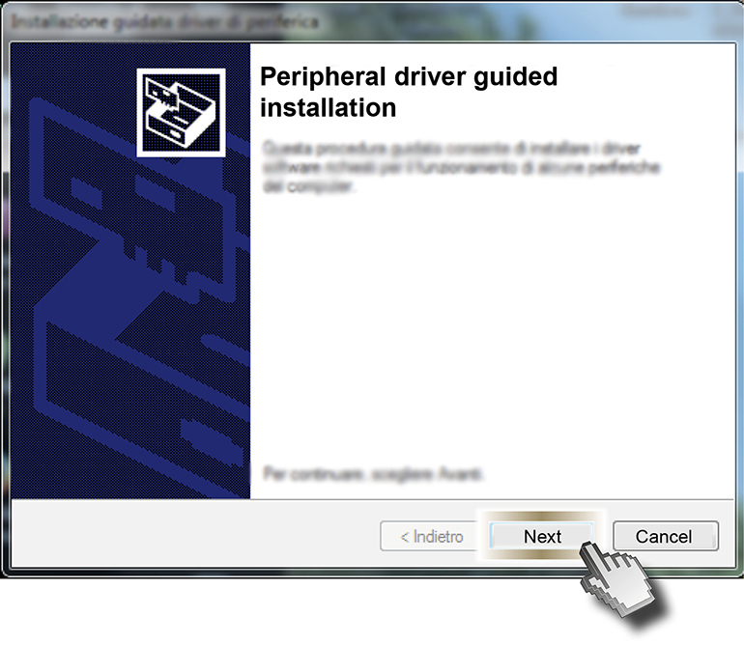
Click on "I have read the licence conditions" and press "Install"

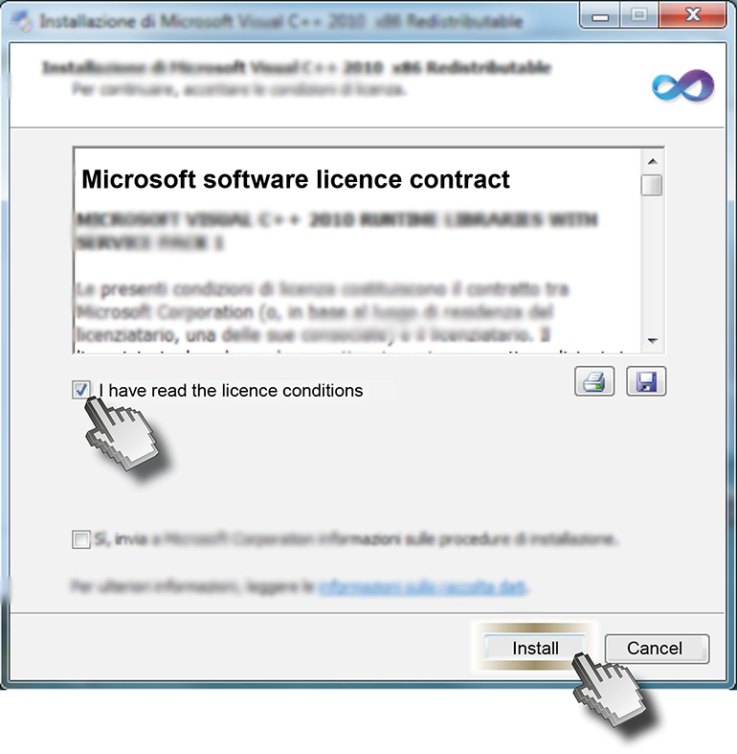
Please wait while setup installs on your computer.

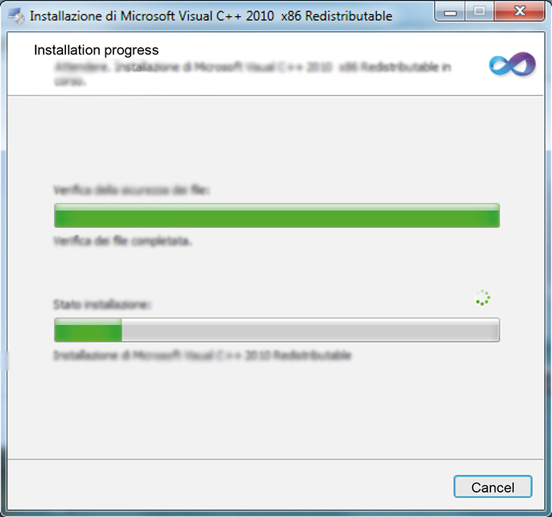

Click on "Finish".

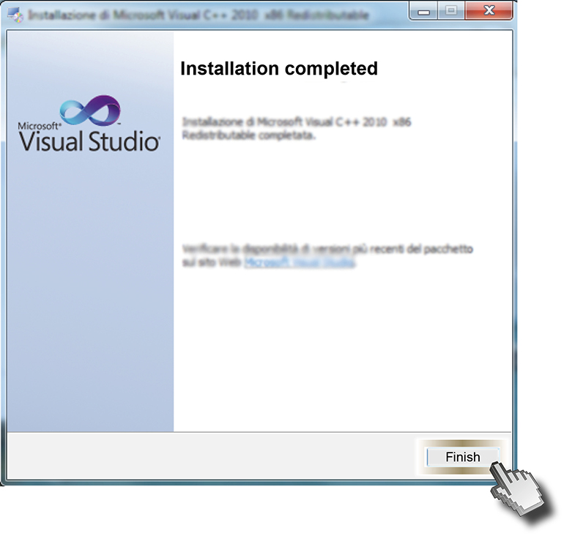
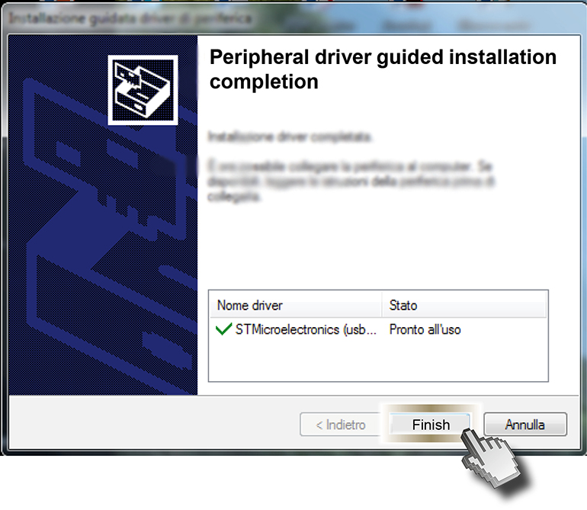
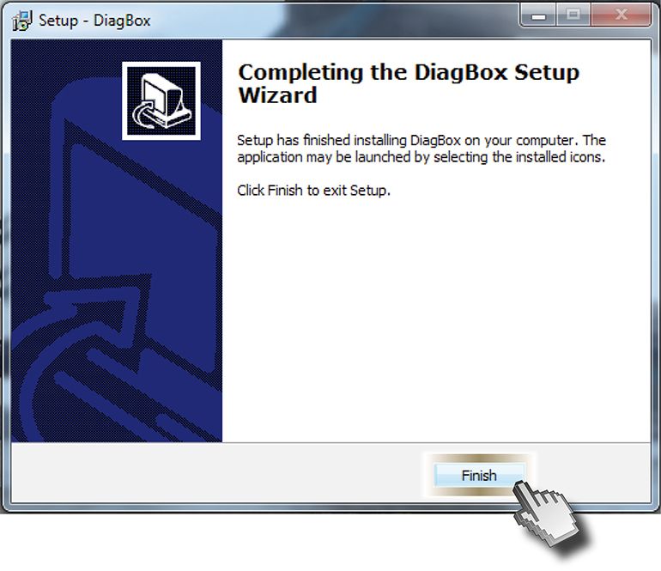

Warning
The USB DRIVER will be installed automatically when Diagbox is connected to the PC for the first time

Information on resources used in graphics software

Home Screen
The purpose of this document is to provide a reference for the images that characterise the graphical user interface of software.

Warning
The screens are for information purposes.

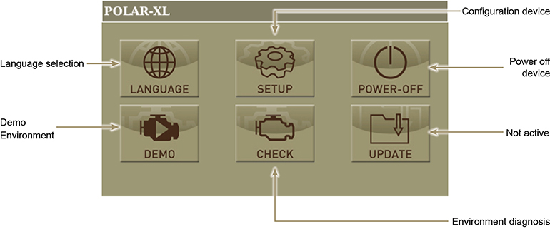

Language selection
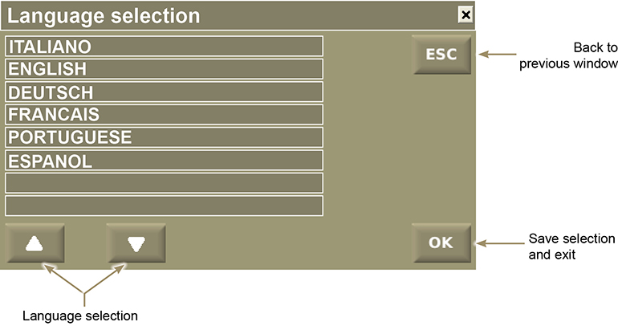

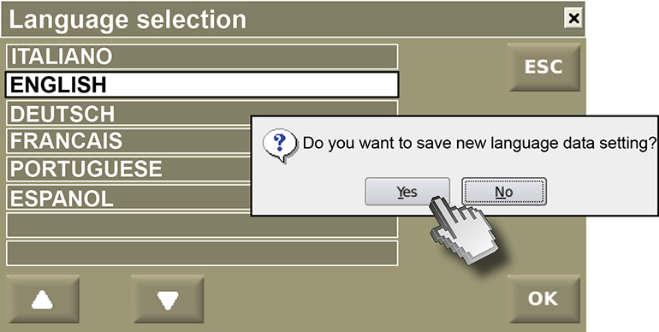

Diagnosis selection
Press the "Check" push button to access the "Diagnosis" display screen.

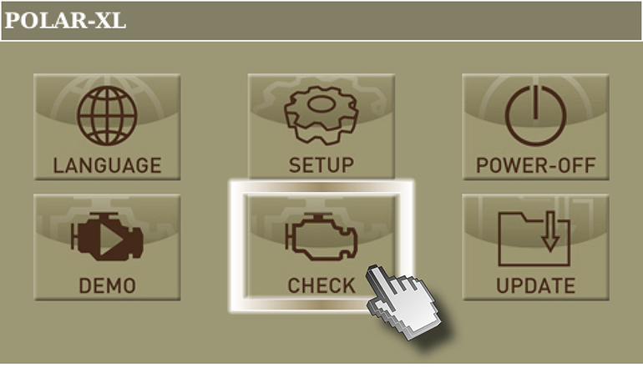

Press on "I agree"

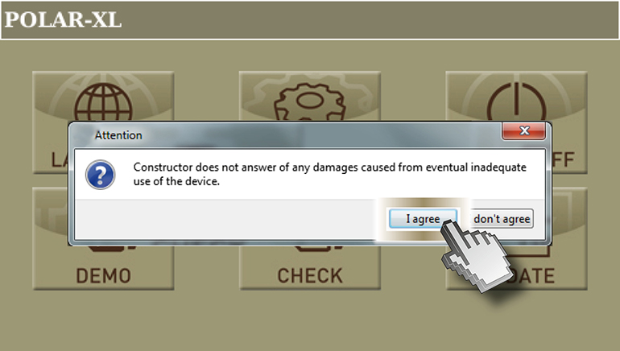

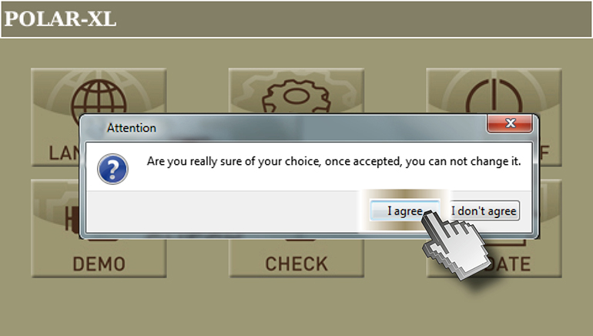

Press the "KDI" push button to access the "KDI engine series diagnosis"

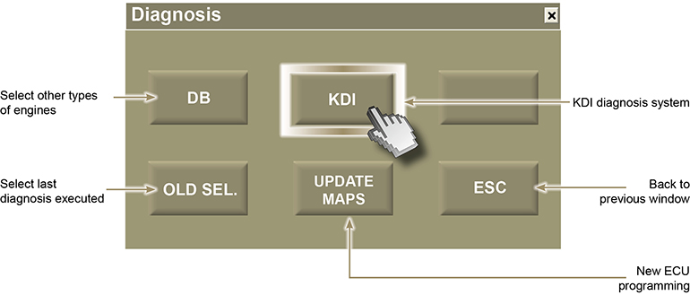

Press "OK" to enter the "Engine parameters" menu.

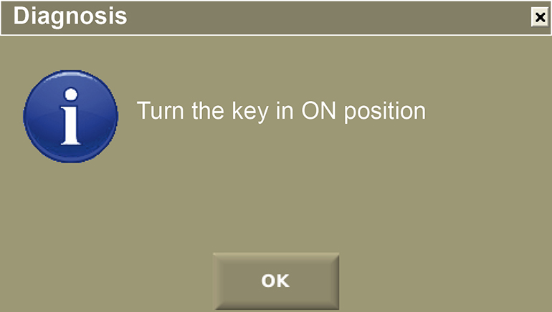

Diagnosis menu
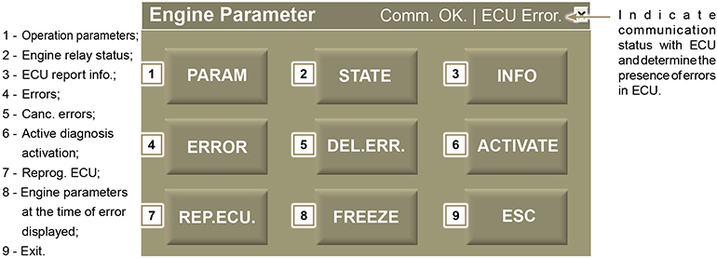

Parameters menu
Press the ''Param.'' push button to access the ''Parameter'' display screen.

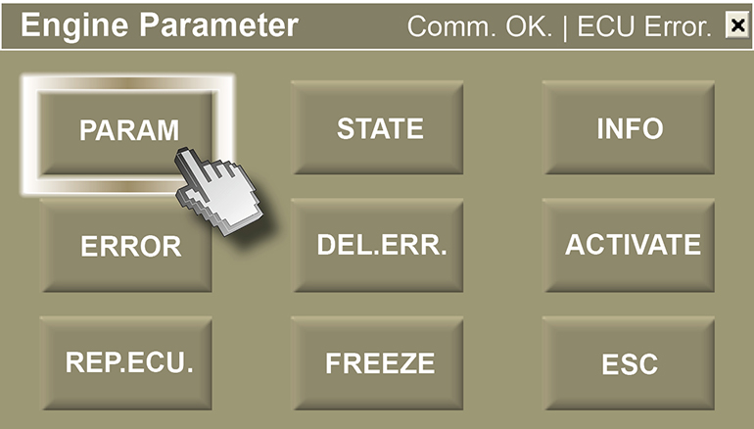

Parameters

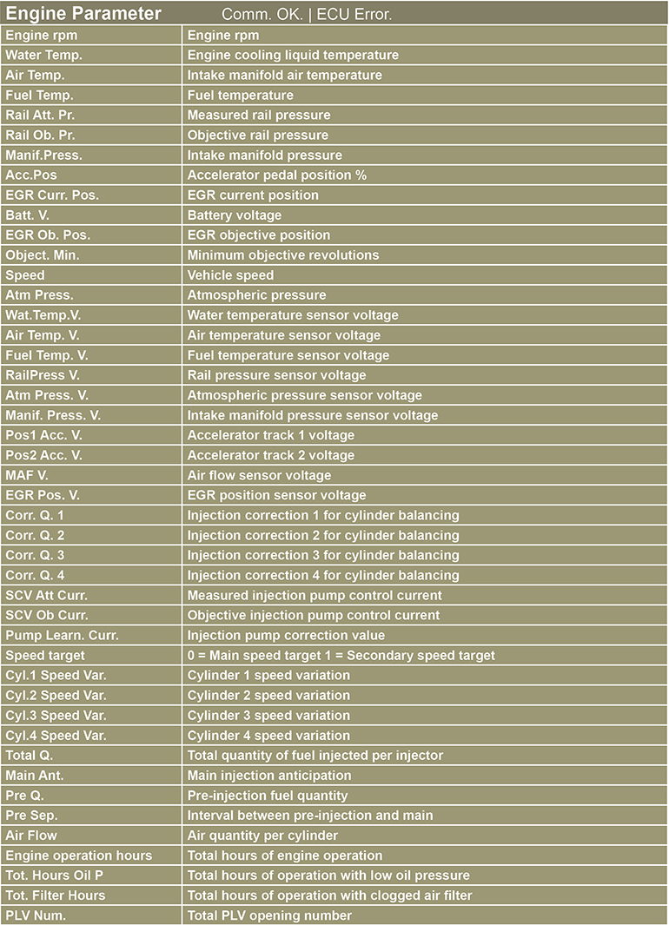

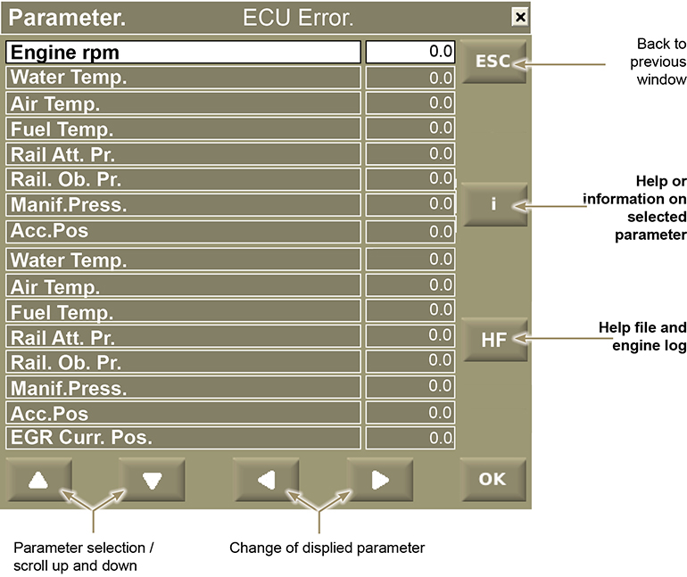

Press the ''i'' push button to access the ''Help'' display screen.

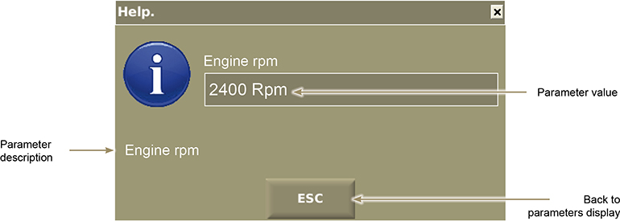

Engine log

Press "HF" to start engine parameters log. "Attention" box is displayed when log starts.
Click “OK” to stop the log..

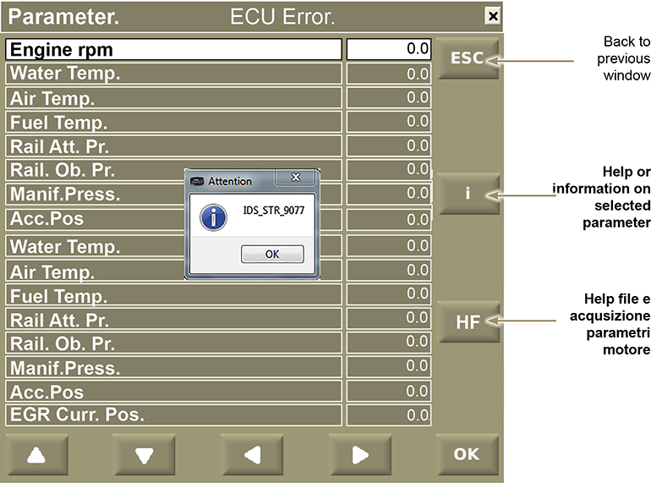

Warning
Log can record a maximum of 40 minutes

Once engine parameters are logged, the relevant file will be saved to "Documents > Lombardini Kohler > Road tests" which was automatically created upon software installation.

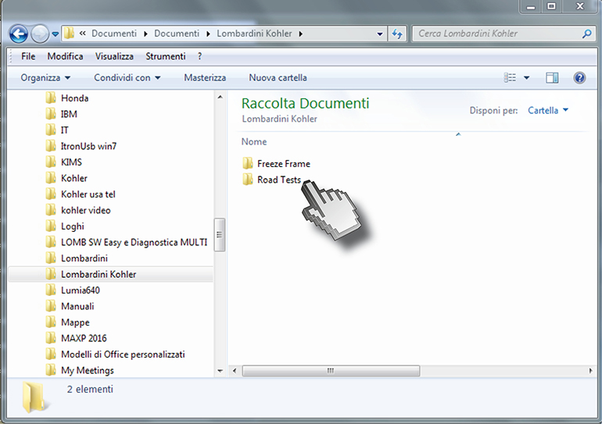

Click "ROAD TESTS" and then .csv excel file to view engine parameters.

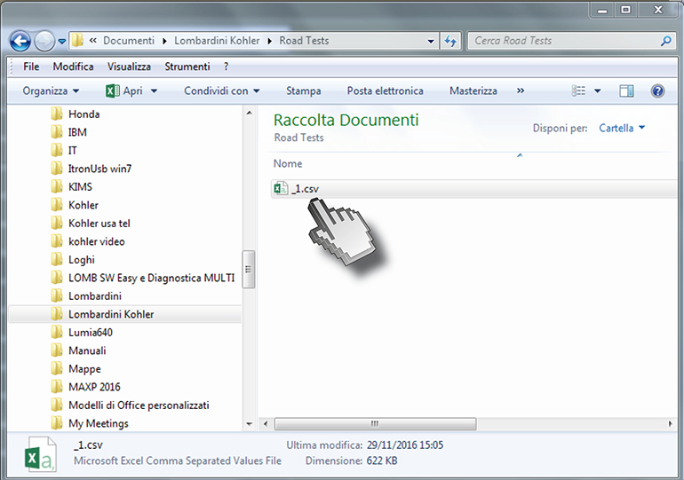

Warning
When several log files are recorded, it is recommended to move any previous log file to another folder and rename it, or it will be overwritten

Relay status menu and ECU sensors
Press the ''Status'' push button to access the ''Status'' display screen.

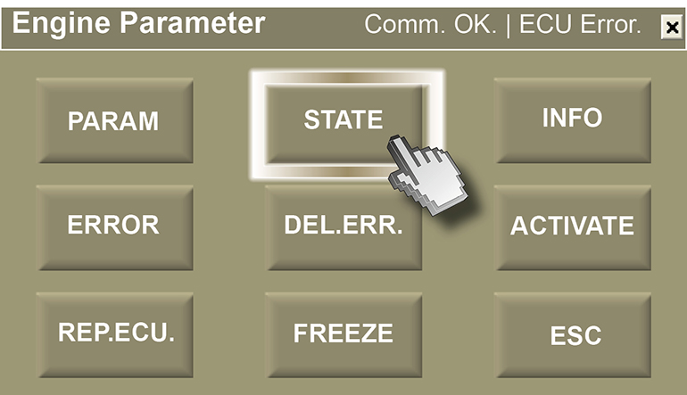

List of existing engine statuses displayed

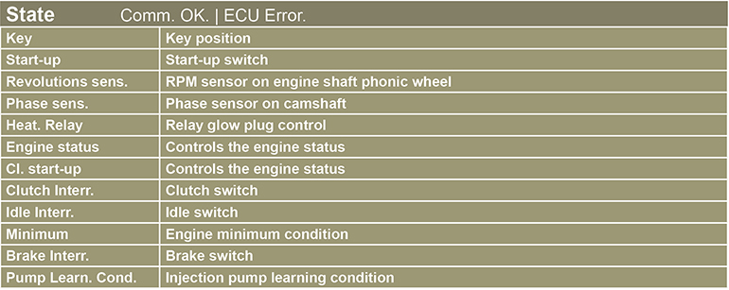

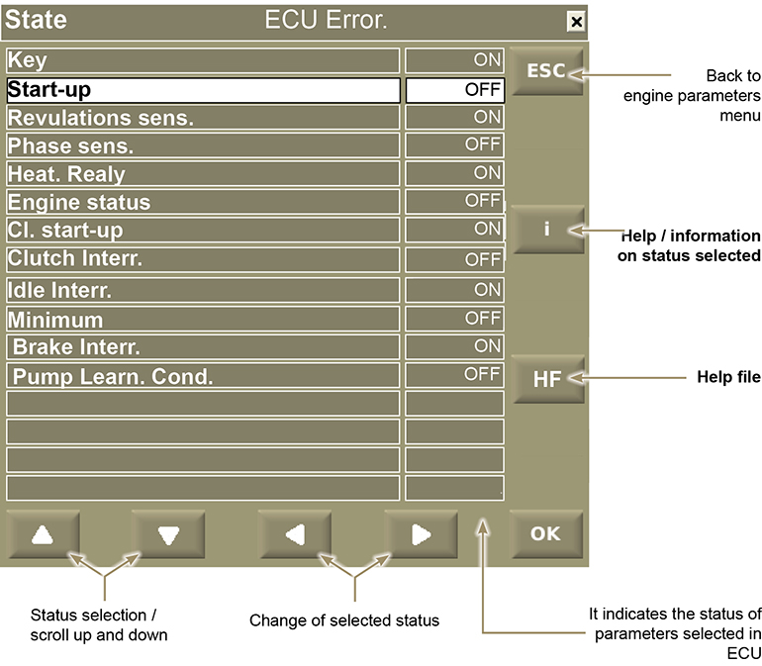

Press the ''i'' push button to access the ''Help'' display screen.

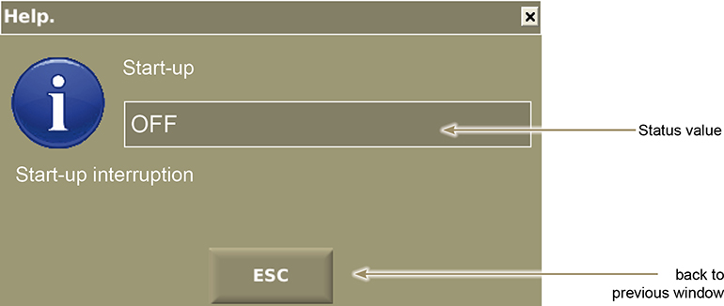

Menu information reported in ECU
Press the ''Info'' push button to access the ''Information'' display screen.

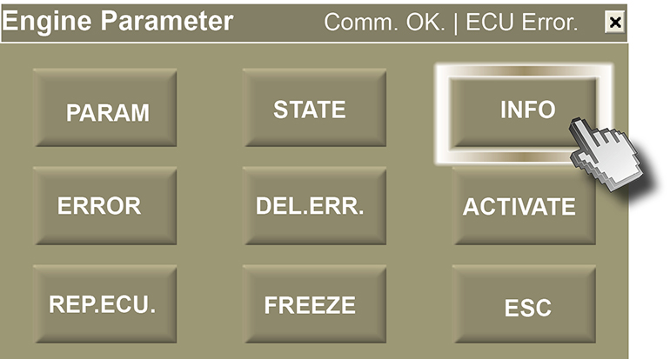

List of information engine statuses displayed

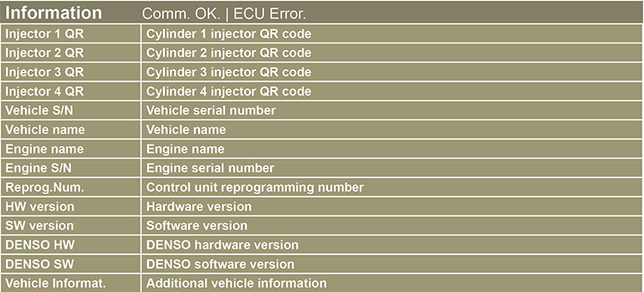

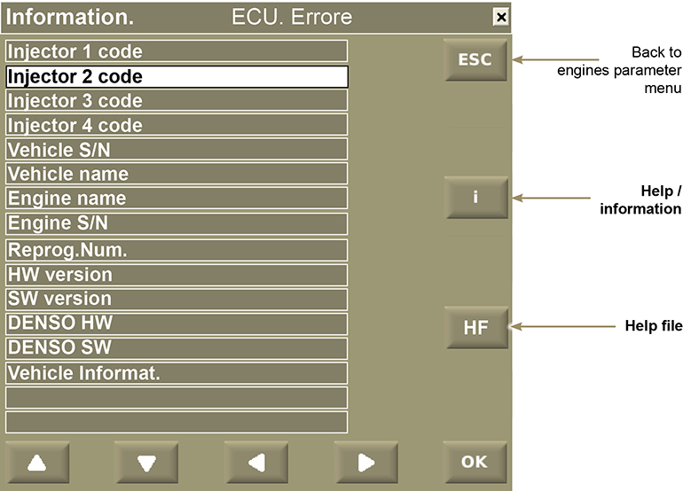

Press the ''i'' push button to access the ''Information'' display screen.

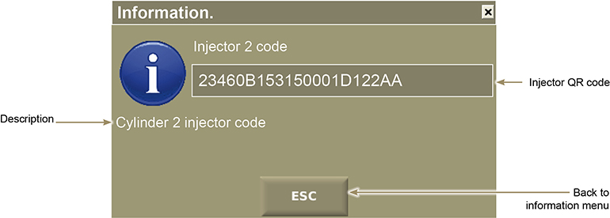

Activation menu for active diagnosis
Press the ''Activate'' push button to access the ''Activation'' display screen.

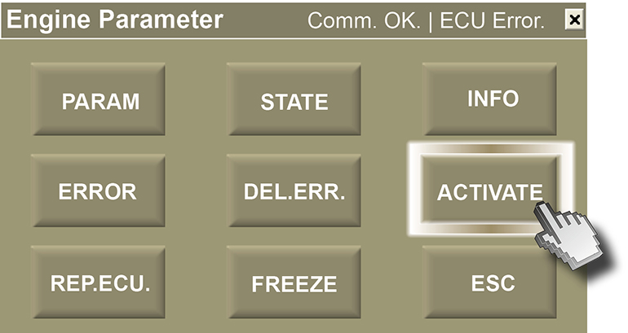

List of activation engine statuses displayed

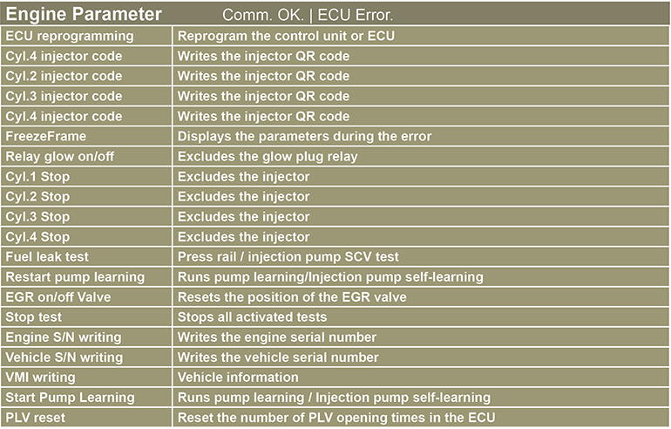

Reset PLV opening times
To open the "Reset no.PLV" menu, use arrow button to select "Select other detail from list" and then "Replace selected activation with activation not displayed".
Once you open the "Reset no.PLV" menu, press "ACT" to reset the number of PLV opening times.

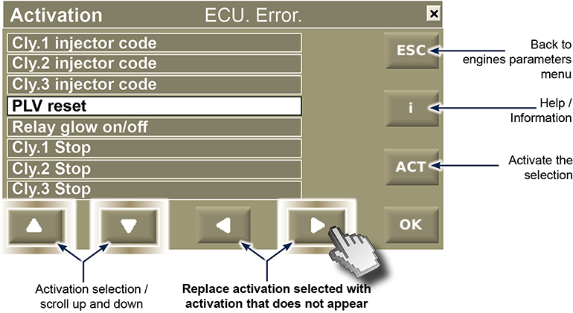

QR injectors entry code

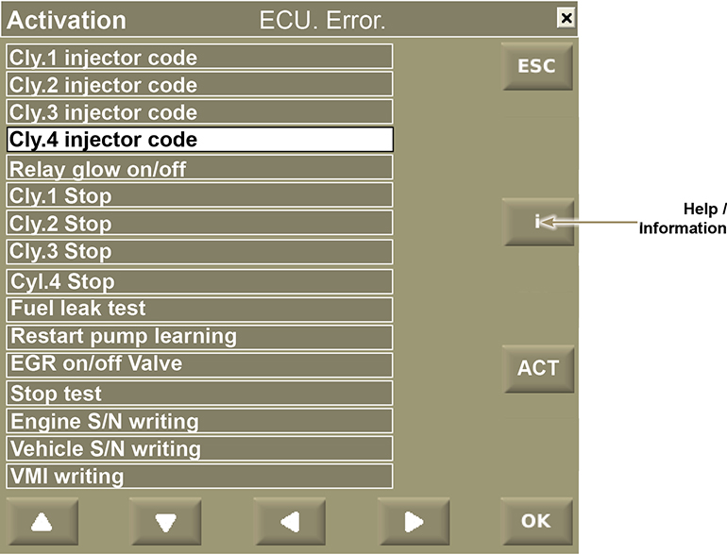

Press the ''i'' push button to access the ''Activation" (information)' display screen.

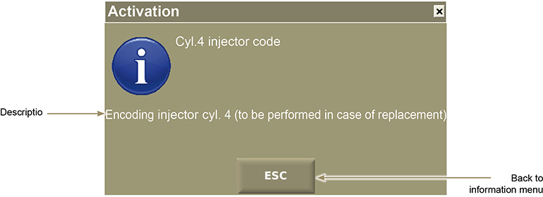

Push the button "ACT" to activate the QR code writing procedure.

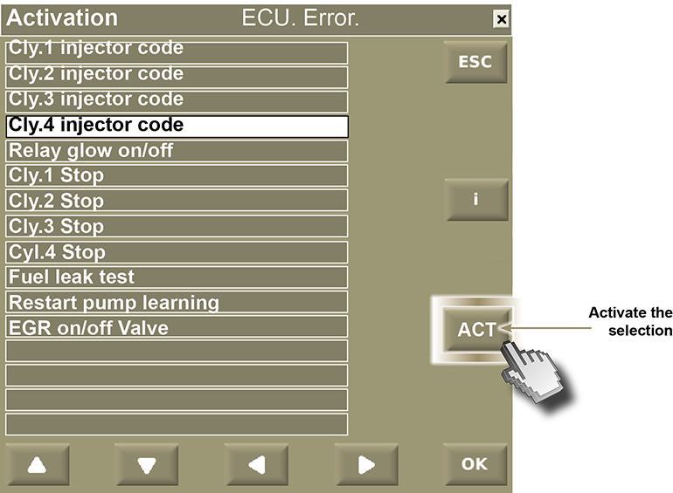

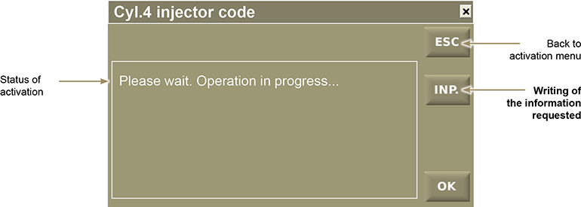

The injector code is composed of 30 characters to insert at two different times.
Insert the first 15 characters of the code and press "OK"

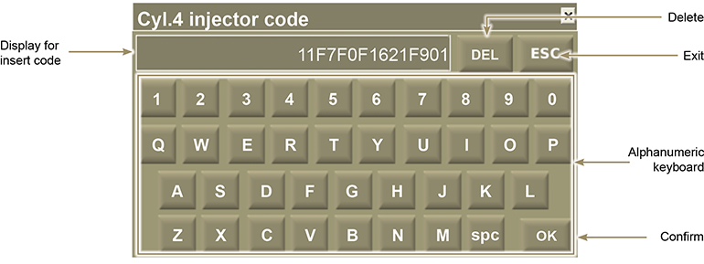

Wait for confirmation to insert the second 15 characters of the injector code

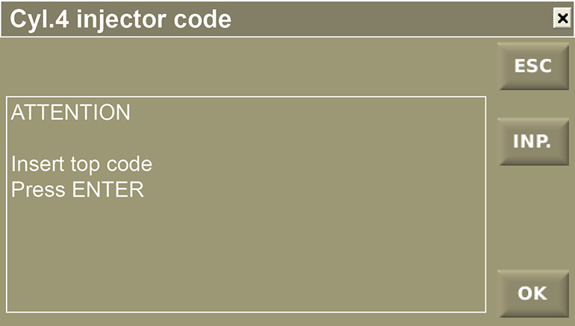

Insert the second 15 characters of the code and press "OK"

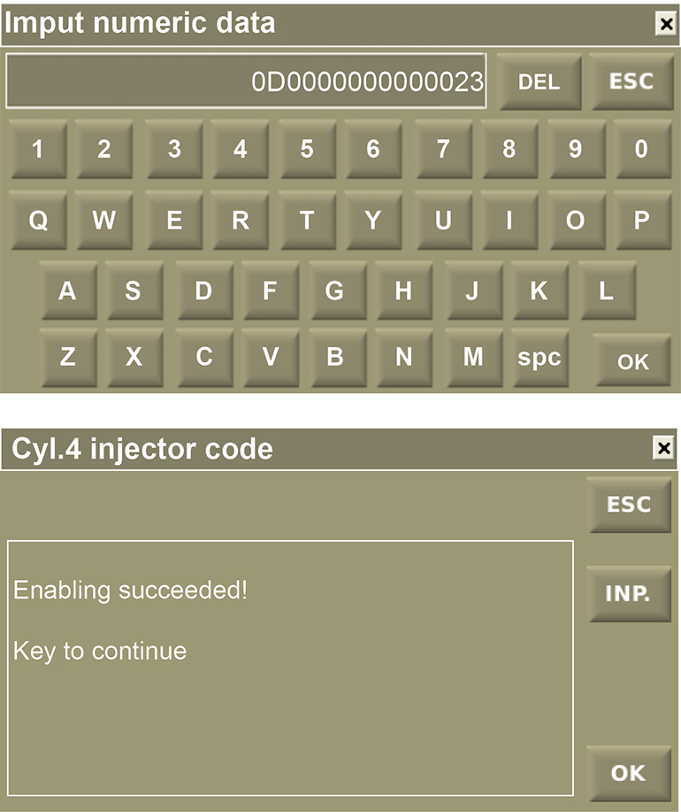

"Activate" diagnosis example .

If you wish to verify the operation of the EGR valve, follow this procedure:

To access the "EGR valve on/off" display screen, press the right push button "Activation selection / scroll up and down".

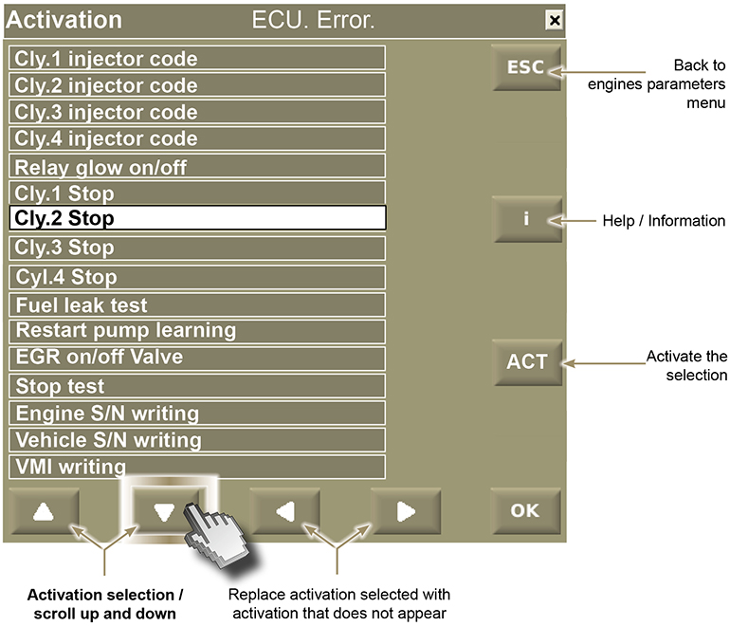

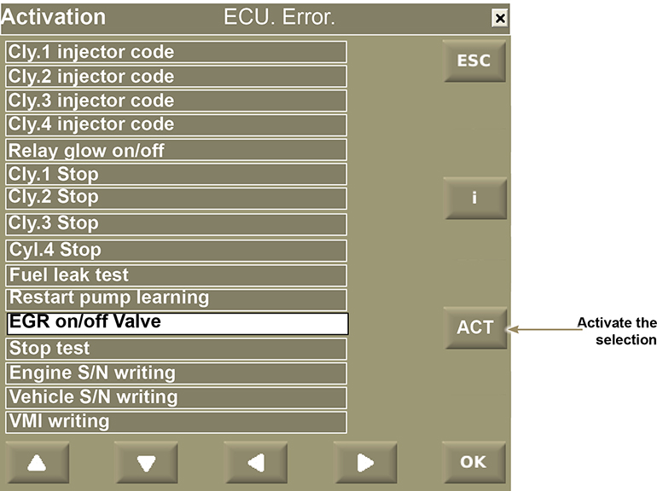

By pressing the "ACT" push button, it activates the "EGR" test.

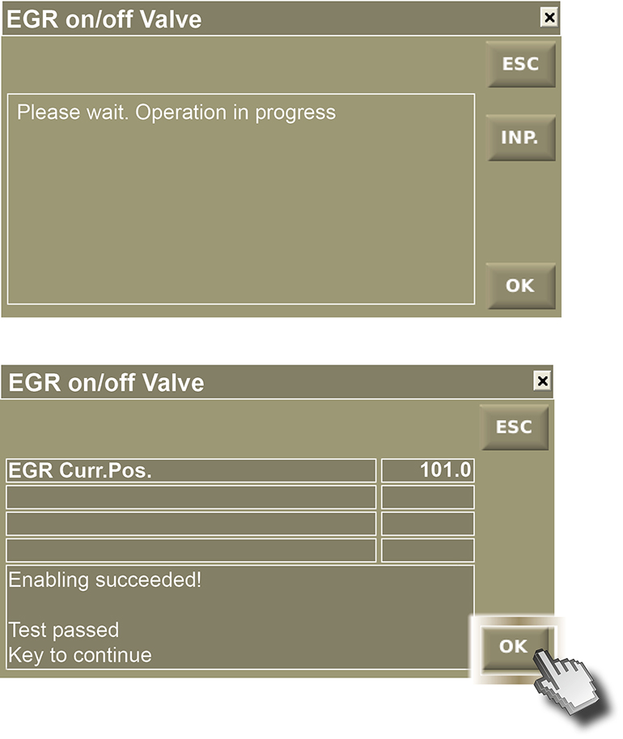

Press "OK"

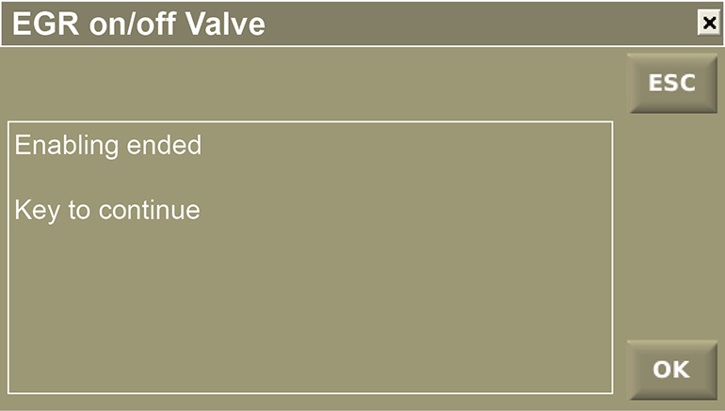

NOTE : For another active diagnosis, select the desired activations by following the previous example

Error menu
Press the ''Error'' push button to access the ''Error'' display screen.

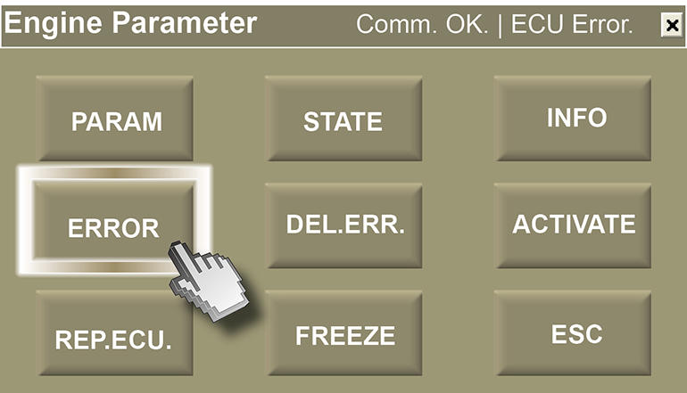

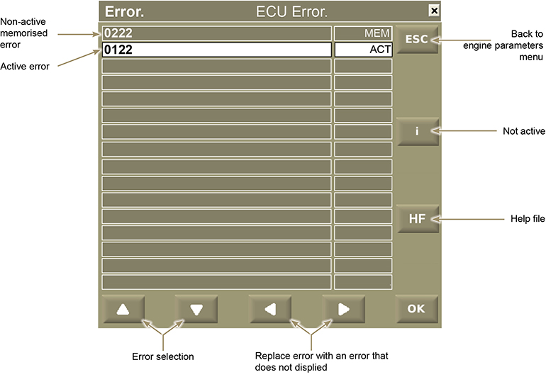

Press the "HF" push button to access the "Active error image information" video display

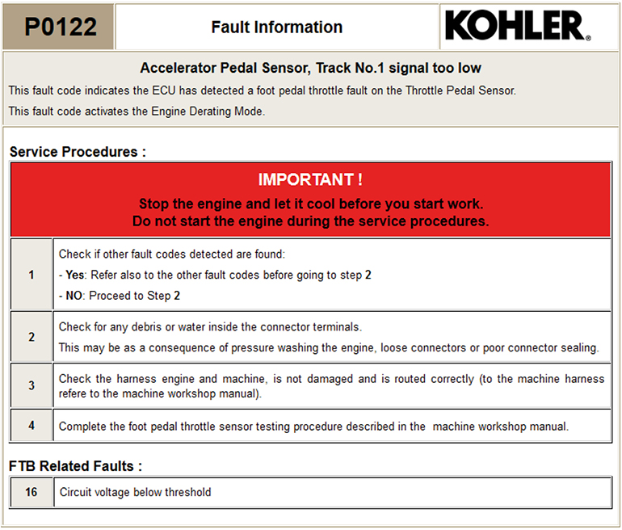

Freeze frame menu
Displays engine parameters that are memorised at the time of the error.

Press the ''Freeze'' push button to access the ''Freeze Frame'' display screen"

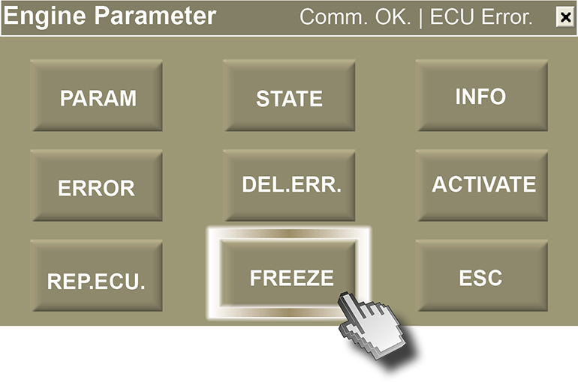
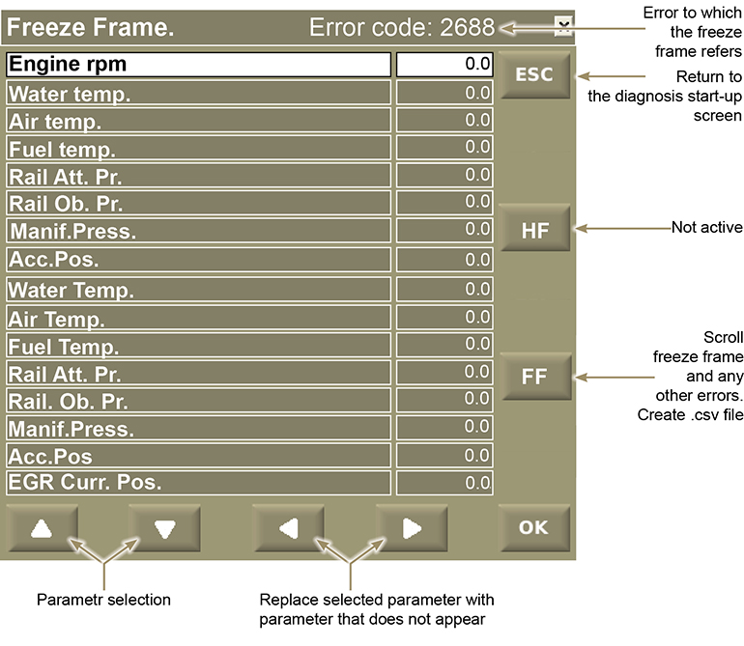

Press "FF" to scroll the "Freeze Frame" referred to any errors.
Every error will create a .csv file and data will be saved to "Documents > Lombardini Kohler > Freeze Frame".
At the end of the list, the following page will be displayed.

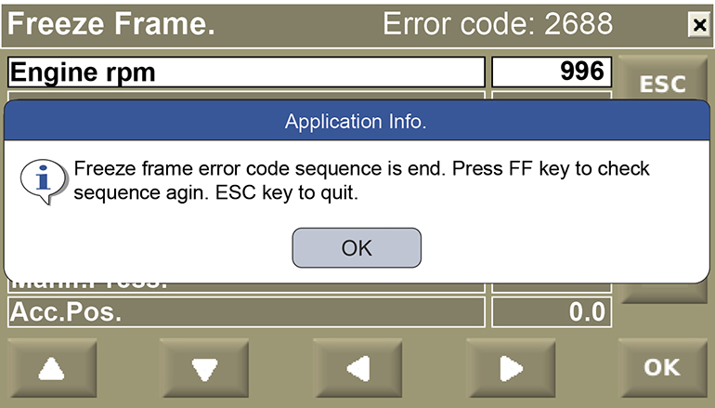

Page "Documents > Lombardini Kohler > Freeze Frame".

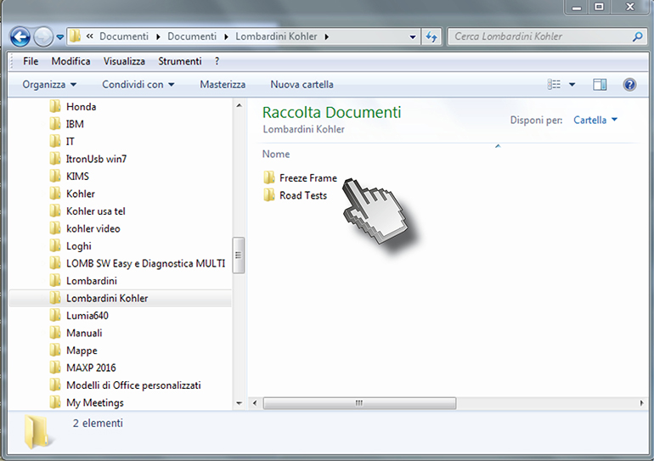

Click "FREEZE FRAME" and then file .csv.

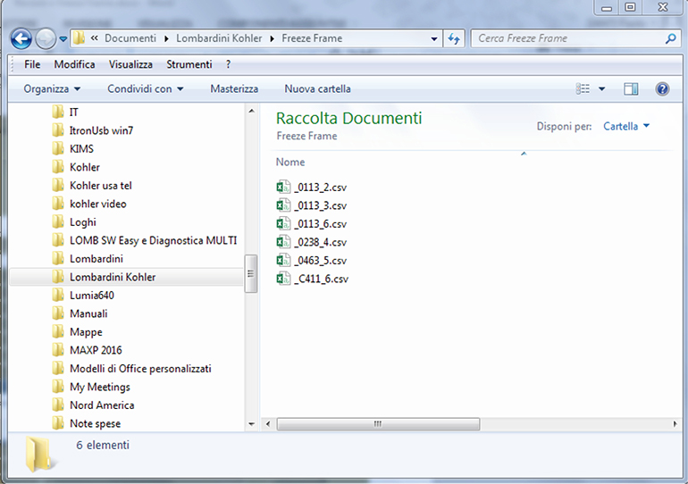

Flashing

Map download from the KOHLER server
Go to websiteo "http://iservice.lombardini.it" and click on "KDI KOHLER DIESEL"
Read carefully "PRIVACY" box and click on "I ACCEPT"

Enter the "Username and Password", flag "I AM NOT A ROBOT" and clicking "Log-in".

Click on "DIAGNOSIS AND FLASHING"

Click on "FLASHING"

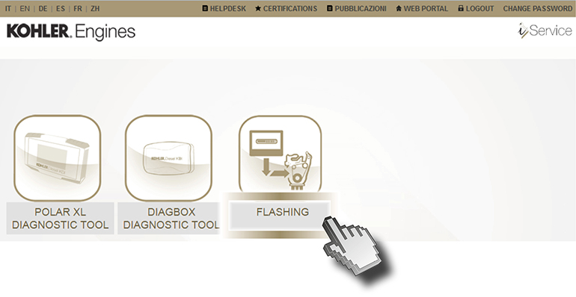
Enter the Username and Password, then click on "Login"

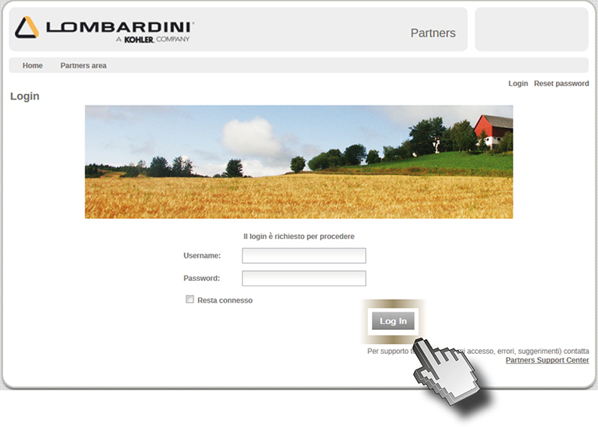

Click on "Flashing ROM"

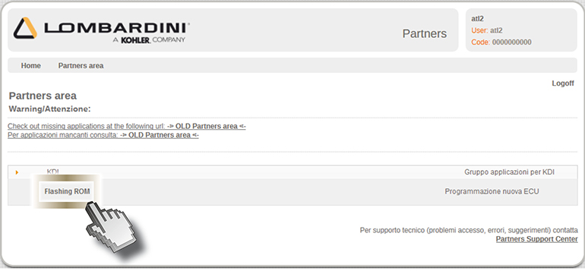

Click on "Obtain MAC address" (1) and then enter the "Serial number" (2). Click on "Search" (3) and then "Download" (4).

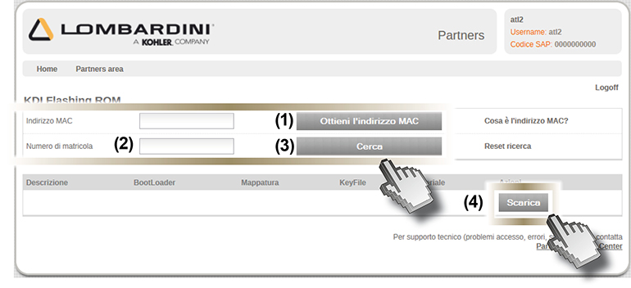

Warning
If the "MAC address" is not detected automatically, perform the following operations:

Click on "START" > "All programs" > Accessories > Command prompt.

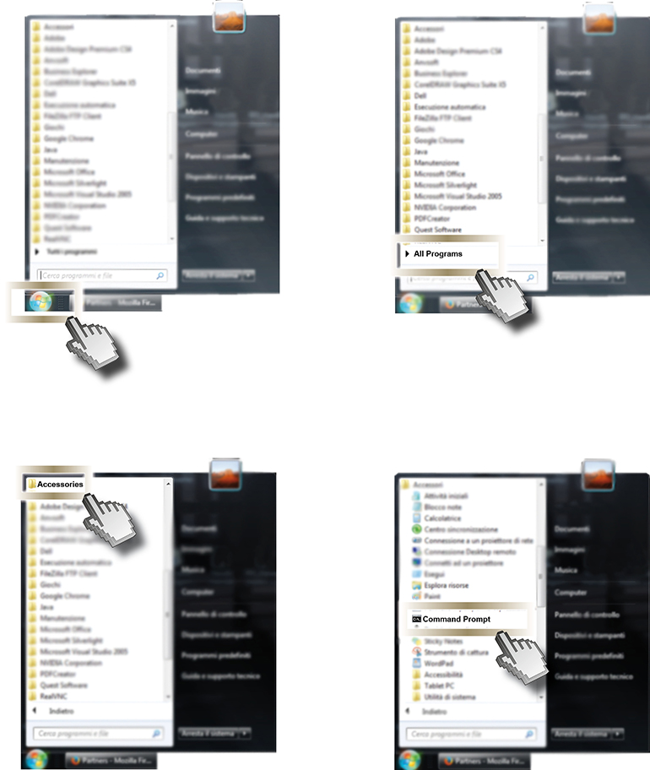

Write: ipconfig/all.

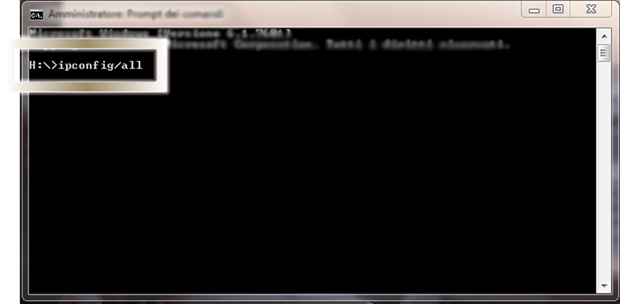

Press enter.

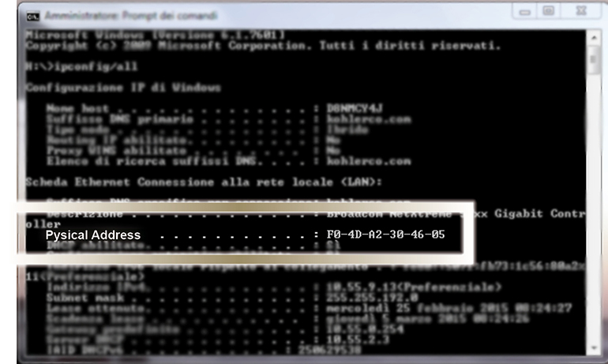

Per i PC portatili, nella scheda "LAN wireless Connessione rete wireless" è indicato il numero dell' "Indirizzo fisico"; per i PC fissi l'indirizzo fisico si trova nella scheda "Ethernet Ethernet".
Each computer has a different number.

Write down the physical address number (1) (separating the numbers with ":" and no longer with "-") in the "MAC address" field of the PC.

Enter the "Serial number" (2) and then click on "Search" (3).

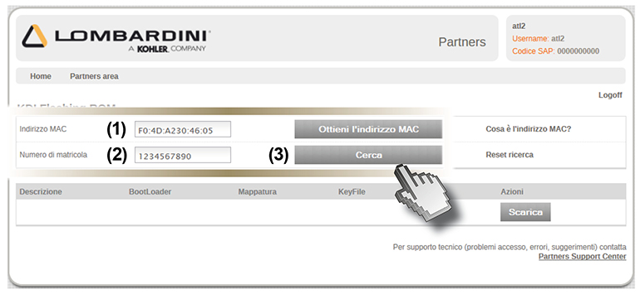

When the search is complete, the name of the file will appear, identified by the engine K of the relevant map.

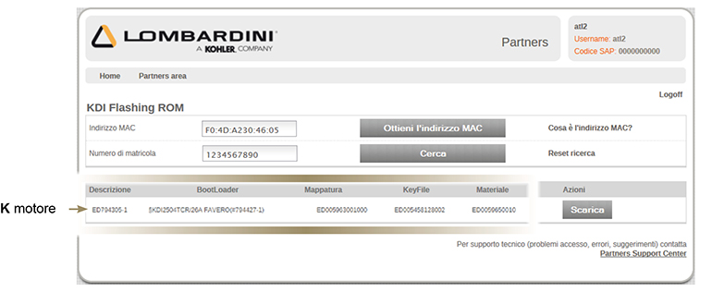

Click on "Download" (4) and click on "Save" (5).

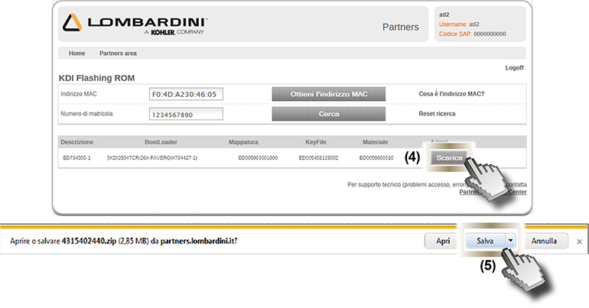

The file will be saved automatically to the "Download" folder of the computer.

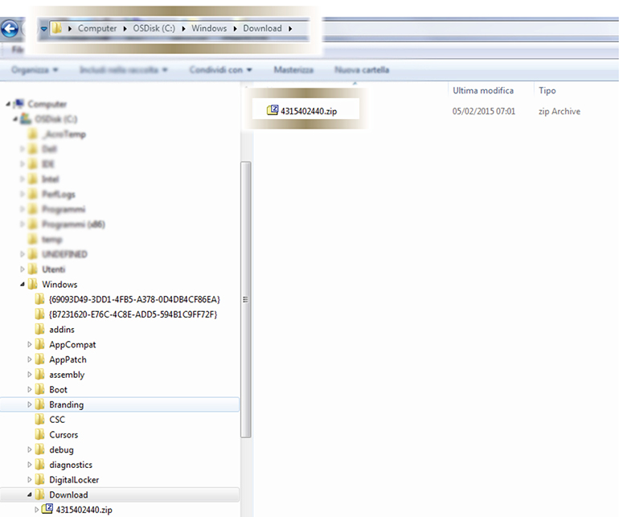

Flashing
Press the "Check" push button to access the "Diagnosis" display screen.

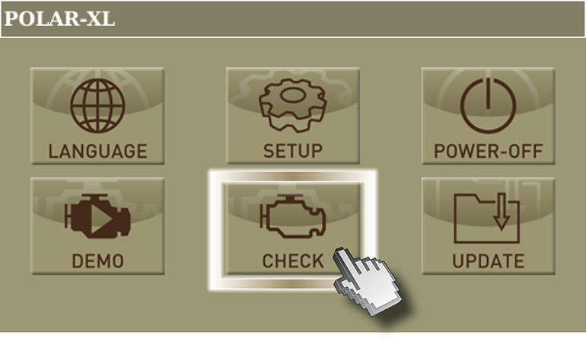

Click on "UPDATE MAPS" and wait some seconds.

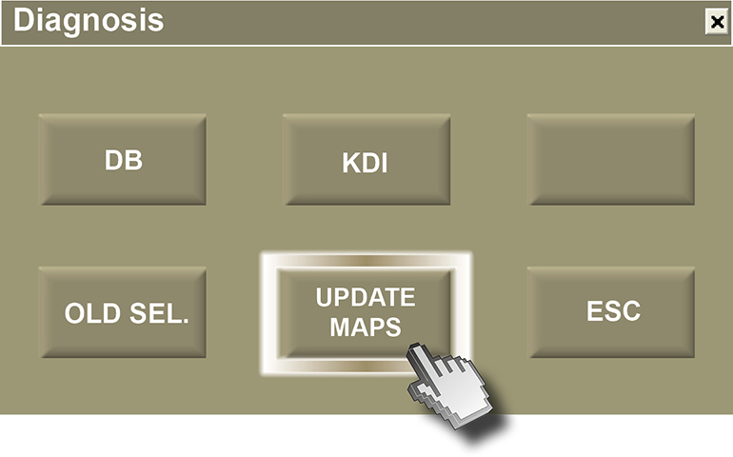
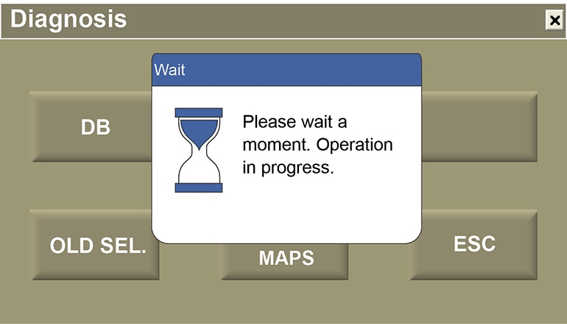

Turn on the panel and press "OK"

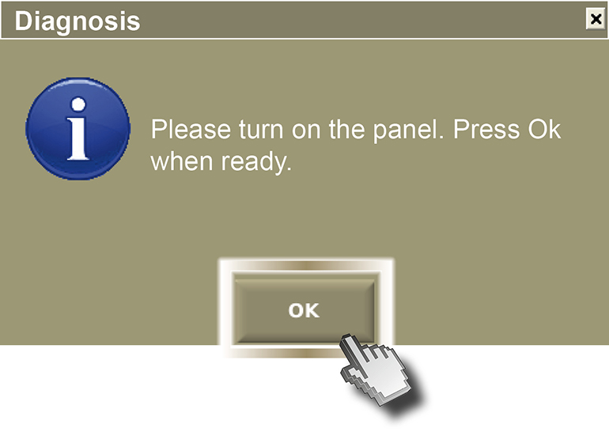
Click on "REP.ECU." (ECU reprogramming).

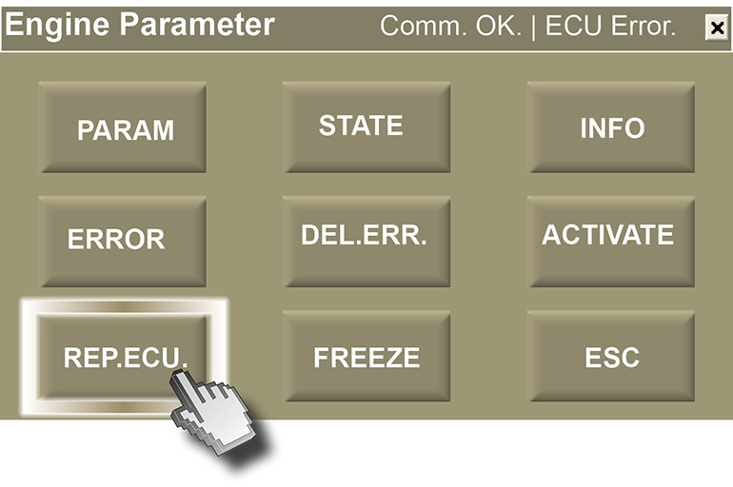

Click on "YES".

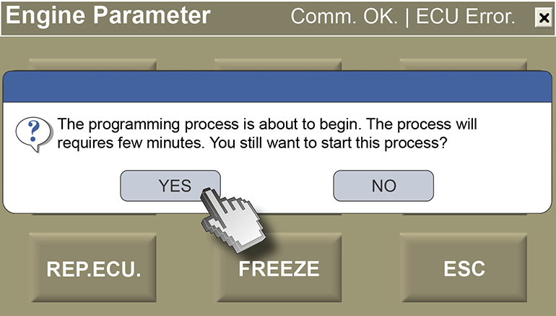

Wait some minutes.

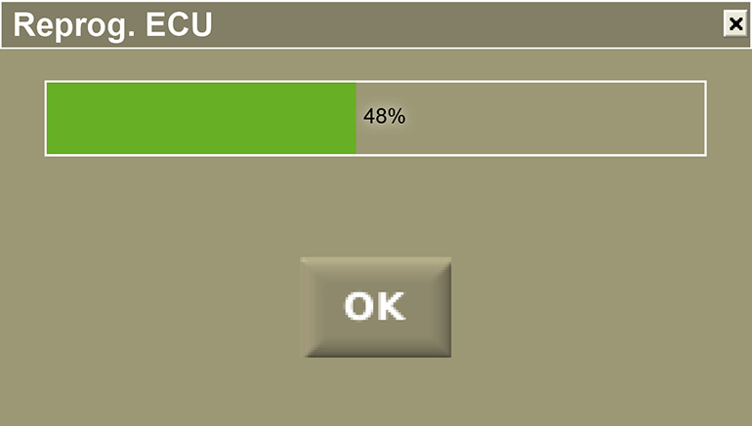

Click on "OK".

