Information for disassembly
KDI 3404 TCR-SCR Workshop Manual (Rev. 10.4)

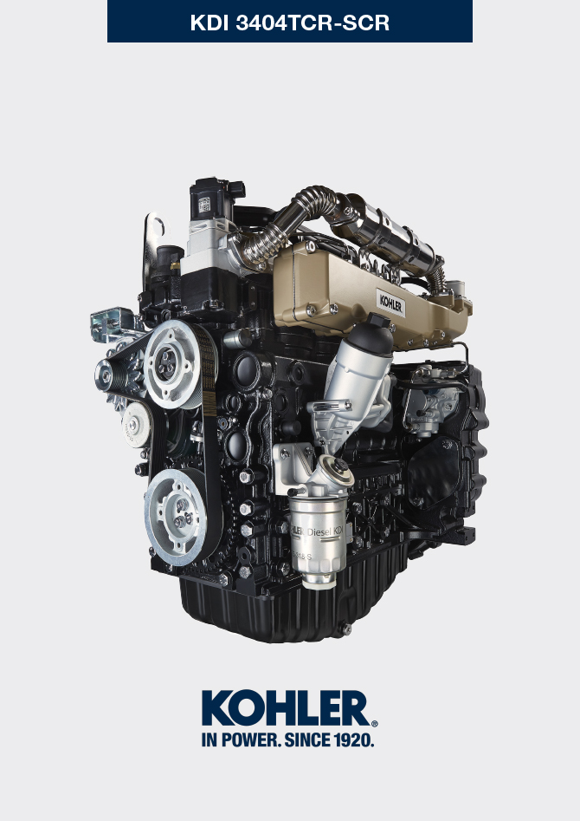
Sommario
1. TITOLO 1 2
1.1. Asdfsdfsdf 2
1.2. Asdfsdfsdfggg 2

Information for disassembly

Recommendations for disassembly

Important

- The mark ( ) after the title of a paragraph, indicates that the procedure is not required in order to disassemble the engine, however the procedures are featured in order to illustrate the disassembly of components.
- The operator should prepare all equipment and tools in order to enable him to carry out the operations correctly and safely.
- Before disassembly, perform the operation described in Chap. 5 .
- Before proceeding with operation, carefully read Chap. 3 .
- In order to operate safely and easily, we recommend positioning the engine on a rotating stand for engine overhauling.
- Seal all injection component unions as illustrated in P ar. 2.9.8 during assembly.
- Protect all disassembled components and coupling surfaces subject to oxidation with lubricant.
- Where necessary, reference to special tools to use during disassembly operations is indicated (es. ST_05 ), identified in Tab. 13.1 - 13.2 - 13.3 .

EGR circuit disassembly
7.2.1 EGR cooler unit  - Undo the screws A ( ST_05 ) and B and remove the pipe C with the relative gaskets. | 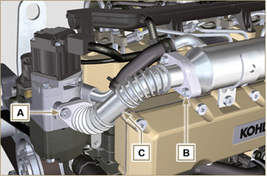 Fig 7.1
- Undo the screws D, E ( ST_05 ) and remove pipe F and the relevant gaskets. | 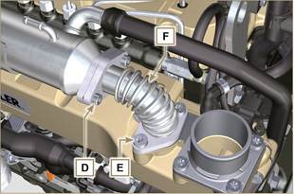  Fig 7.2
- Release the clamp M and remove hose N1 .  - Release the clamp L , and remove hose N2 .  - Undo capscrews G ( ST_05 ) and remove EGR Cooler H. | 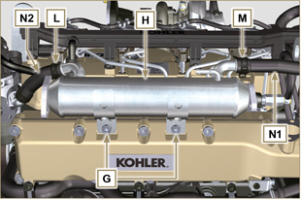  Fig 7.3

Coolant recirculation components disassembly
7.3.1 Oil Cooler manifold  - Release the clamps A .  - Undo the screw B and remove hoses C ( ST_05 ) . | 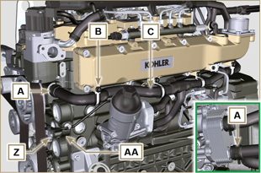  Fig 7.4
- Release the clamp D and remove hoses E . | 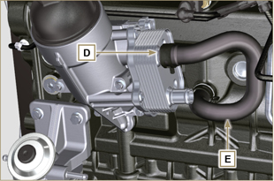  Fig 7.5
7.3.2 Coolant pump  Important  - The pump B is not repairable.  - Perform the operations described in Par. 6.5.1 .  - Undo capscrews F and remove flange G with the relative gasket. | 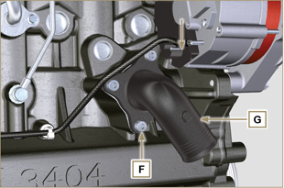  Fig 7.6
7.3.3 Thermostatic valve  - Undo the screws A and remove the thermostatic valve cover B .  - Remove the thermostatic valve C and its gasket.  Important  - Always replace the gasket D every time it is disassembled.  - Check that the air bleeding hole is not clogged or blocked ( Par. 2.11.4 ). | 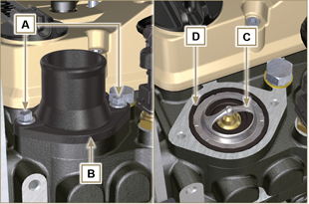  Fig 7.7

Electric components disassembly
7.4.1 Electric wiring  Important  - Refer to Par. 2.13 prior to proceeding with disassembly.  - Disconnect the connector A .  - Undo the screw B .  - Release the clamp C . | 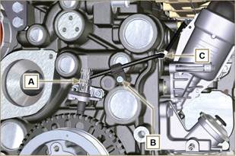  Fig 7.8
- Disconnect the connector D . | 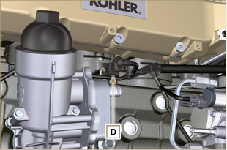  Fig 7.9
- Disconnect the connectors E and F . | 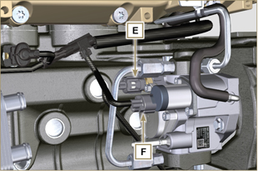  Fig 7.10
- Disconnect the connector G . | 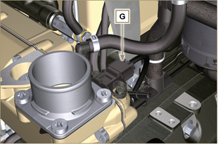  Fig 7.11
- Remove nuts H and disconnect cables L and M .  - Release the clamp P .  - Undo the screw Q . | 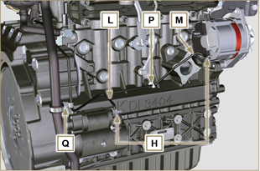  Fig 7.12
- Disconnect the connectors R , S , T , U .  - Undo the screws V ( ST_06 ) and remove the wiring support Z . | 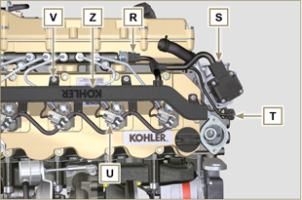  Fig 7.13
7.4.2 Starter motor  Important  - The motor is not repairable.  - Perform the operations from point 2 to 3 of Par. 6.6.1 .  7.4.3 Alternator  - Undo the screws A1 and B1 and remove the alternator C1 . | 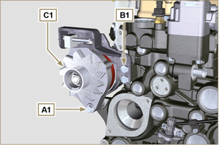  Fig 7.14
7.4.4 EGR Valve  - Perform the operations of Par. 6.4.1 .  - Undo capscrews D1 and remove flange E1 with the relative gasket.  NOTE: The EGR valve is not a serviceable item, and if damaged/worn, it should be replaced with a new one. | 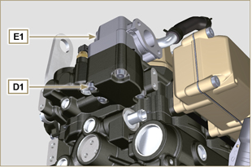  Fig 7.15
7.4.5 Sensors and switches  Important  - After disassembly, protect the sensors suitably against knocks, dampness and any high temperature sources.  - The sensors and switches cannot be repaired, therefore they must be replaced in the event of anomalies.  7.4.5.1 Oil pressure switch ( )  - Unscrew and remove the oil pressure switch AD . | 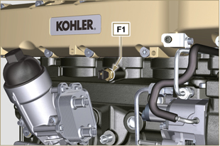  Fig 7.16
7.4.5.2 Coolant temperature sensor ( )  - Unscrew and remove the coolant temperature sensor AE . | 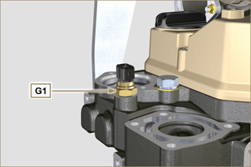  Fig 7.17
7.4.5.3 Speed sensor ( )  - Undo the screw H1 and remove the sensor L1 with the relative spacer ( ST_06 ) .  - Undo the screws M1 and remove the sensor N1 . | 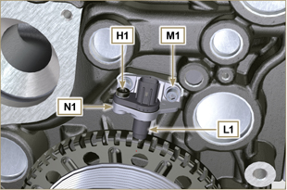  Fig 7.18
7.4.5.4 Camshaft phase sensor  - Undo the screw P1 and remove the sensor Q1 with the relative spacer. | 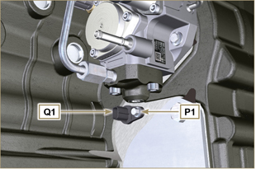  Fig 7.19
7.4.5.5 T-MAP Sensor ( )  - Undo the screw R1 and remove the sensor S1 ( ST_06 ). | 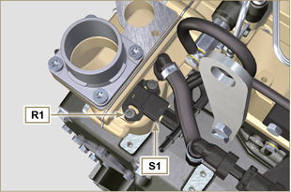  Fig 7.20
7.4.5.6 Fuel filter water detection sensor ( )  Warning  - The fuel filter is not always mounted on the engine.  - When disassembling the sensor U1 , use a suitable container to recover the fuel contained in the cartridge T1 .  - Unscrew the sensor U1 from the cartridge T1 . | 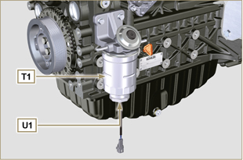  Fig 7.21

Turbocharger disassembly
- Unscrew the fittings A and remove the pipe B with the relative gaskets C . | 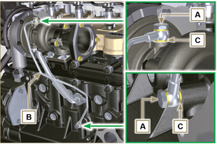  Fig 7.22
- Undo the screws D and remove pipe E and the relevant gaskets. | 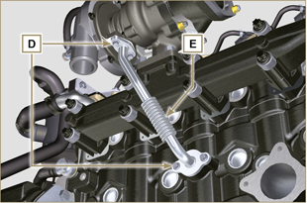  Fig 7.23
- Undo the nuts F and remove the turbocharger G . | 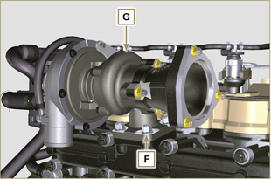  Fig 7.24

Exhaust manifold disassembly
- Remove nuts A , capscrews B and spacers C , manifold D and gaskets E .  - Close the openings and manifolds to prevent foreign bodies from entering. | 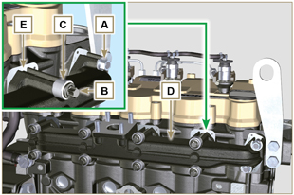  Fig 7.25

Crankshaft and target wheel pulley disassembly
- Perform the operations from point 4 to 5 of Par. 6.6.1 .

Flange unit disassembly
7.8.1 Flywheel  - Perform the operations of point 2 Par. 6.2.2 .  - Loosen, but not remove, nut A .  Important  - Leave the special tool ST_34 for blocking the flywheel ( Par. 7.7 ).  Danger  - The flywheel E is very heavy. Pay the utmost attention while removing it in order to prevent it dropping or falling, as this may have serious consequences for the operative.  - Undo the screws B and remove the flywheel C by means of tool ST_43 . | 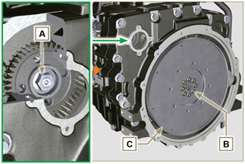  Fig 7.26
7.8.2 Flange housing  Danger  - The flange housing F is very heavy. Pay the utmost attention while removing it in order to prevent it dropping or falling, as this may have serious consequences for the operative  - Secure tool ST_41 onto gear D by means of capscrews B .  - Undo capscrews E by following the order indicated in the figure.  - Remove the engine housing F by means of tool ST_44 . | 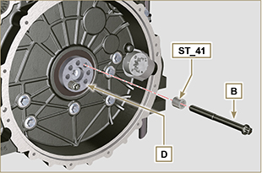  Fig 7.27  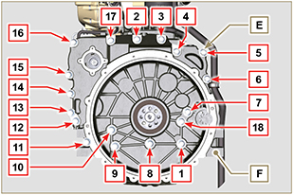  Fig 7.28

Lubrication circuit disassembly
7.9.1 Oil pump  Important  - The oil pump is not repairable.  - Undo the screws A and remove the pump unit B . | 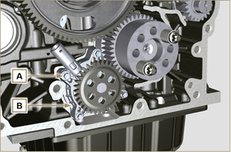  Fig 7.29
7.9.2 Oil pressure valve ( )  - Remove cotter pin C .  - Remove disk D , spring E , piston valve F using a magnet. | 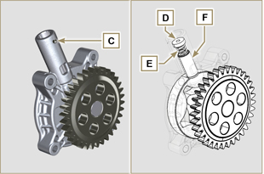  Fig 7.30
7.9.3 Oil Cooler unit and oil filter
- Perform the operations of Par. 6.8.1 .

NOTE : To replace the oil cartridge, refer to operations of Par. 6.8.2 .

7.9.4 Oil vapour separator unit  - Perform the operations of Par. 6.7.1 .  - Undo the screws G and remove the support H .  - Loosen clamp B and remove hose M .  - Undo the screw N and remove hoses P .  - Remove quick fitting R and remove hose S . | 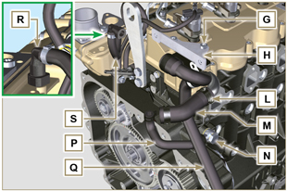  Fig 7.31

Fuel system disassembly
Important  - Seal all injection component unions as illustrated in Par. 2.9.8 .  7.10.1 Fuel return pipes  - Release the clip A .  - Disconnect unions B from electronic injectors C .  Warning  - After removing the union, the clip A must automatically return to its initial position; otherwise it must be replaced.  - Undo the screw D.  - Disconnect the pipe E .  - Undo and remove the screw F with the relative gaskets and put the cap on the Common Rail pressure relief valve G .  - Remove the fuel return pipes. | 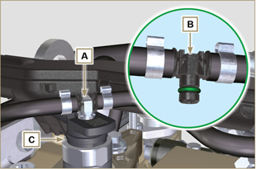  Fig 7.32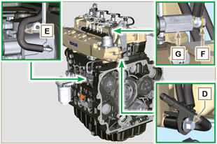  Fig 7.33
7.10.2 Fuel flow pipes  - Remove the pipes H, L. | 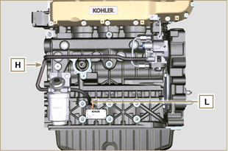  Fig 7.34
7.10.3 High pressure fuel pipes  Danger  - The fuel injection circuit undergoes high pressure, use safety protections as described in Par 3.4.3 .  - Ensure that the Common Rail is not under pressure by slowly and carefully unscrewing one of the nuts N .  - Undo the screw M .  - Loosen the nuts N, P in sequence.  - Fully undo the nuts N, P in sequence and remove the high pressure pipes Q, R. | 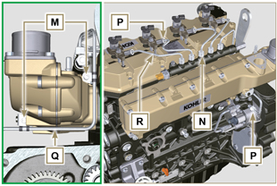  Fig 7.35
7.10.4 Common Rail  - Undo the screws S and remove the Common Rail T .  NOTE: Take care to protect te sensor U from knocks, moisture and any high temperature source. The internal parts of the rail cannot be repaired. | 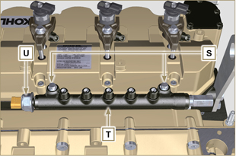  Fig 7.36
7.10.5 Electronic injectors  Important  - In the event that the electronic injectors are disassembled (not necessarily replaced), mark them with the relevant cylinder number from which they originate so as not to confuse them during re-assembly (Fig. 7.38) .  - The electronic injectors cannot be repaired.  - If one or more electronic injectors are to be replaced, the new calibration data must be inserted in the ECU via a specific instrument ( ST_01 ).  - Be careful not to damage the gaskets V .  - Undo capscrews J and remove them together with the relative washers K and then brace W .  - Pull out the electronic injector C .  NOTE: Should you be unable to remove the electronic injector (acting only on point X ), use an open-ended spanner (Ø 34 mm), by applying small rotations to unblock the component.  - Seal all injection component unions as illustrated in Par. 2.9.8 .  - Ensure that gasket Y has remained in the correct position (Fig. 7.38) .  Otherwise, recover the gasket from inside the electronic injector Z . | 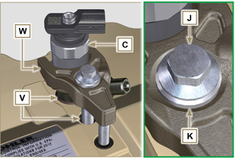  Fig 7.437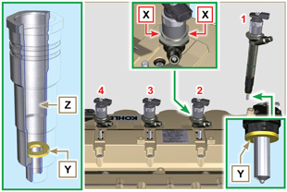  Fig 7.38
7.10.6 Fuel filter ( )  - Undo the fuel cartridge A1 from support B1 .  - Undo the screws C1 and remove the filter support B1 . | 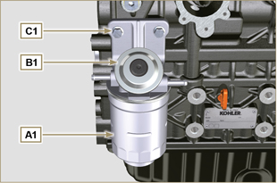  Fig 7.39
7.10.7 High-pressure fuel injection pump  Important  - Before disassembling, carefully read Par. 2.17 .  - The injection pump is not repairable  - Should the fuel feeding pump need to be replaced, after assembly, it is necessary to perform the Pump Learning procedure by means of instrument ST_01 .  - Undo the nut D1 .  - Screw the tool ST_13 on the thread of the gear E1 .  - Redo the capscrew F1 of tool ST_13 to disconnect the pump H1 from gear E1 .  - Undo the screws G1 , remove pump H1 and the relative gasket L1 .  - Seal all injection component unions as illustrated in Par. 2.9.8 . | 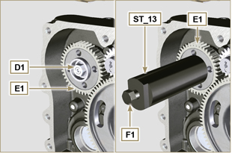  Fig 7.40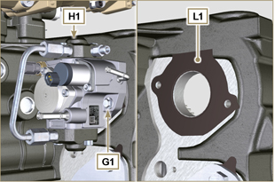  Fig 7.41

Intake manifold disassembly
- Undo the screws A and remove the semi-manifold B ( ST_05 ) .  - Remove the separation plate C and the gaskets D . | 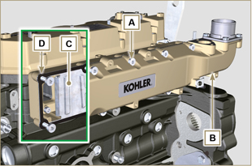  Fig 7.42
- Undo the screws E .  - Remove the semi-manifold F and the gasket G . | 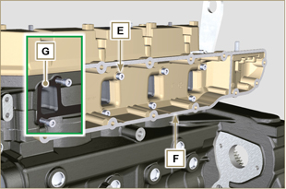  Fig 7.43

Cylinder head unit disassembly
7.12.1 Rocker arms cover  - Undo the screws A .  - Remove the rocker arms cover B .  - Remove the gasket C . | 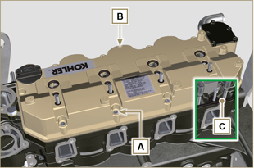  Fig 7.44
7.12.2 Rocker arm pin  - Undo the screws D .  - Remove the rocker arm pin unit E . | 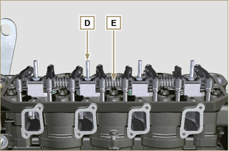  Fig 7.45
7.12.2.1 Rocker arm ( )  - Remove the retainer ring F .  - Remove the shoulder rings G .  - Remove the rocker arms H . | 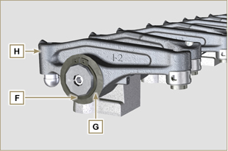  Fig 7.46
7.12.3 Valve rods and bridges  - Remove the valve control U-bolts M .  - Remove the rocker arm control rods N . | 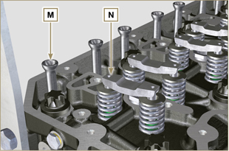  Fig 7.47
7.12.4 Cylinder head  Important  - The capscrews P must be replaced every time they are disassembled.  - Do NOT remove the capscrews completely, first loosen them by turning them a whole cycle following the order shown in the figure.  - Loosen fastening screws P , turning them by one turn following the order shown in the figure.  - Undo capscrews P by following the order indicated in the figure.  Important  - To lift cylinder head Q , only use both eyebolts Y provided by KOHLER (refer to Fig. 7.55 ).  - When removing the cylinder head Q and subsequent disassembly, control, and assembly operations, it is necessary to protect the contact surface W of cylinder head Q and crankcase J against impacts.  - Remove the cylinder head Q .  - Remove the head gasket R . | 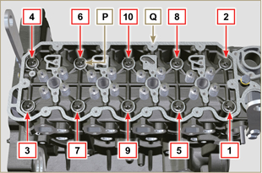  Fig 7.48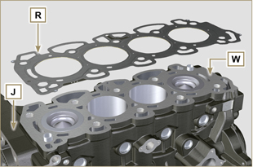  Fig 7.49
7.12.4.1 Valves ( )  - Mount the tool ST_07 on the head Q fixing it on one of the holes for fixing the rocker arm cover.  NOTE: Change the fixing hole according to the position of the valves to be removed.  - Position the tool ST_07 on the valve as shown in the figure. | 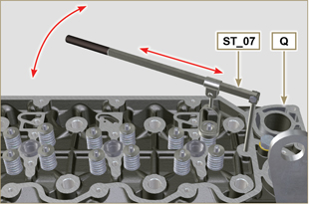  Fig 7.50
- Push the lever of the tool ST_07 downwards, in order to lower the valve plates S in the direction of the arrow T , remove cotters U using a magnet.  NOTE: Repeat all the operations for all the valves concerned. | 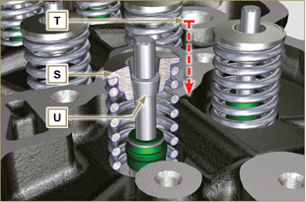  Fig 7.51
Important  - Before removing the valves, make some marks to record their original position, in order to avoid confusing them when reassembling (if they are not replaced).  - Remove the valves V . | 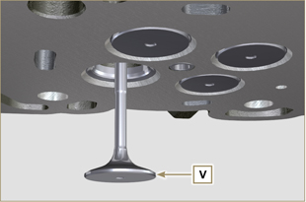  Fig 7.52
7.12.4.2 Electronic injector sleeves ( )  - Unscrew and remove the sleeves Z from the head Q .  - Remove the gaskets J, K . | 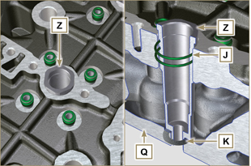  Fig 7.53
7.12.4.3 Valve stem gasket ( )  - Remove the gaskets W . | 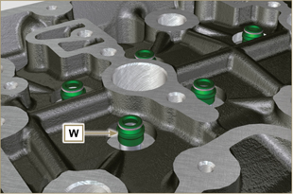  Fig 7.54
7.12.4.4 Lifting eyebolts ( )  - Undo the screws X and remove the eyebolts Y .  - Thoroughly wash the cylinder head Q . | 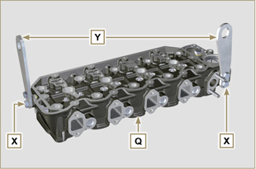  Fig 7.55

Timing system gear disassembly
Important  - For the following operation, turn the engine by bringing the cylinder head surface downwards.  - Remove the gear A .  - Unscrew screw B and remove the gear C .  NOTE: Gear A is assembled on the camshaft by press-fit; remove gear A to also remove the camshaft. | 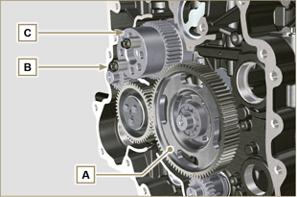  Fig 7.56

Oil sump unit disassembly
7.14.1 Oil sump  - Undo the screws A .  - Remove the oil sump B by inserting a plate between surface C of crankcase D and oil sump B .  - Remove the oil dipstick E . | 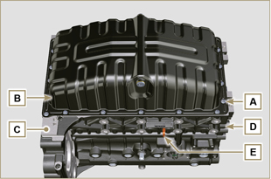  Fig 7.57
7.14.2 Oil suction pipe  - Undo the screws F and remove the oil pipe G . | 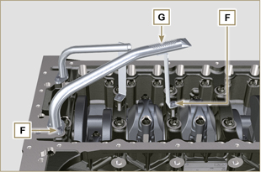  Fig 7.58
7.14.3 Oil drain pipe ( )  - Undo the screws H and remove the pipe L . | 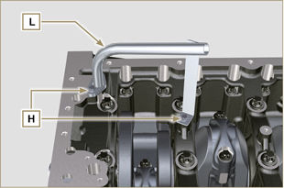  Fig 7.59

Engine block disassembly
7.15.1 Piston unit/connecting rod  Important  - Mark some numerical references (cylinder n°) on the connecting rods, connecting rod caps N , pistons and gudgeon pins to prevent unintentionally confusing the components not replaced during assembly. Failure to do this may result in engine malfunctions.  - References on connecting rod M and cap N must only be carried out on a side in correspondence with K1 and K2 , as illustrated in Fig. 7.61 .  - Screw the bolt M temporarily. | 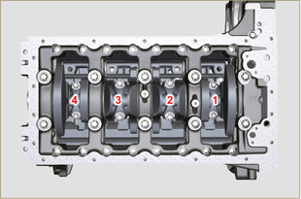  Fig 7.60
NOTE : coupling cap N on the connecting rod can be carried out with centring taper pins (Fig. 7.62) or broken ( Fig. 7.63 - without centring taper pins).  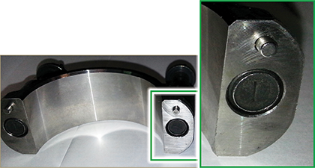  Fig. 7.62  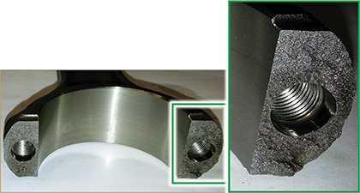  Fig. 7.63 | 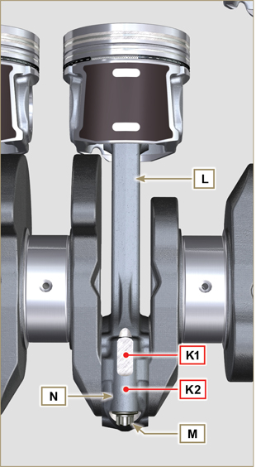  Fig 7.61
- Pull out the connecting rod - piston assembly from position 2 and 3 by manually applying pressure on the connecting rod big end L in the direction of arrow X .  - Couple the connecting rod big end caps N with the relevant piston and connecting rod unit L .  - Rotate the crankshaft by 180°.  - Repeat points 2 to 5 to disassemble the connecting rod-piston assembly to position 1 and 4 . | 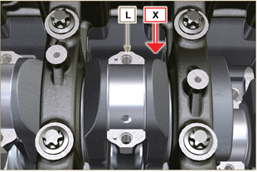  Fig 7.64
Warning  - The connecting rod half-bearings P are made of special material. Therefore, they must be replaced every time they are removed to prevent seizures. | 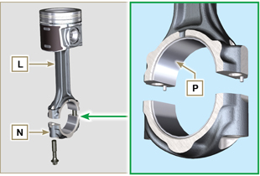  Fig 7.65
7.15.2 Lower semi-crankcase  Important  - The capscrews Q must be replaced every time they are disassembled.  - Do NOT remove the capscrews completely, first loosen them by turning them a whole cycle following the order shown in the figure.  - Loosen fastening screws Q , turning them by one turn following the order shown in the figure.  - Undo capscrews Q by following the order indicated in the figure. | 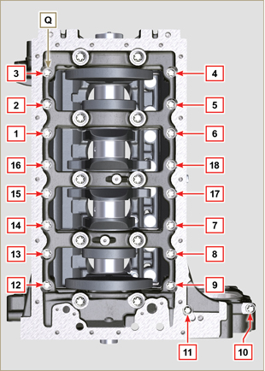  Fig 7.66
Important  - The capscrews R must be replaced every time they are disassembled.  - Do NOT remove the capscrews completely, first loosen them by turning them a whole cycle following the order shown in the figure.  - Loosen fastening screws R , turning them by one turn following the order shown in the figure.  - Undo capscrews R by following the order indicated in the figure.  - Remove the lower semi-crankcase D1 and store it in a suitable container for washing. | 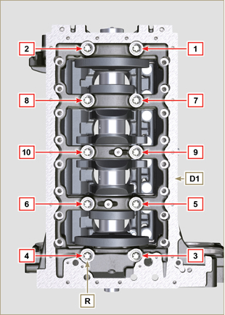  Fig 7.67
7.15.3 Crankshaft  Remove:  - Crankshaft S .  - The shoulder semi-rings T .  - gasket U from crankshaft S . | 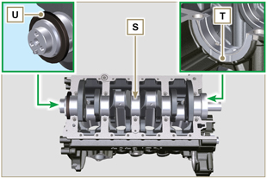  Fig 7.68
7.15.4 Piston ( )  - Remove the retainer ring V .  - Remove the pin Z to separate the piston J from the connecting rod L .  Important  - If they are not replaced, keep the components together (connecting rod - piston - gudgeon pin) by using references in order to prevent them from getting mixed up during assembly. | 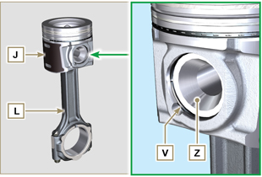  Fig 7.69
7.15.4.1 Rings ( )  - Remove the rings K . | 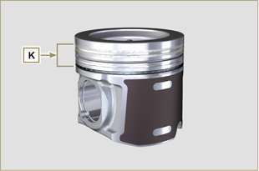  Fig 7.70
7.15.5 Oil spray nozzles ( )  - Undo the screws W and remove the spray nozzles X from the upper semi-crankcase D2 . | 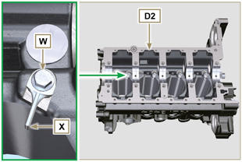  Fig 7.71
7.15.6 Camshaft tappets  - With a magnet, remove the tappets Y from the upper semi-crankcase D2 . | 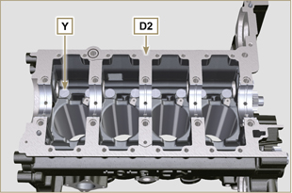  Fig 7.72
7.15.7 Crankshaft bushings  - Remove the crankshaft bushings A1 from the upper crankcase D2 .  Important  - The crankshaft half-bearings A1, B1 are made of special material. Therefore, they must be replaced every time they are removed to prevent seizures. | 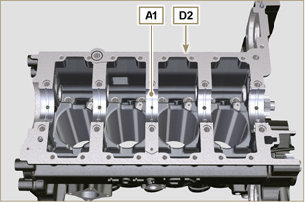  Fig 7.73
- Remove the crankshaft bushings B1 from the lower semicrankcase D2 . | 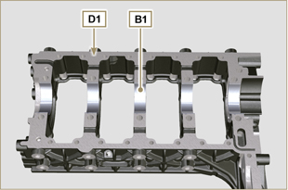  Fig 7.74

