Information regarding discharge of liquids
KDI 2504TCR / KDI 2504TCRE5 Workshop Manual (Rev. 17.8)


Sommario
1. TITOLO 1 2
1.1. Asdfsdfsdf 2
1.2. Asdfsdfsdfggg 2

Information regarding discharge of liquids

Coolant
Important  - Before proceeding with operation, read Par. 3.3.2 .  NOTE: Component not necessarily supplied by KOHLER . The representation of the radiator is purely indicative.  Warning  - Presence of steam pressurized coolant danger of burns.  - Undo the cap A carefully (circuit under pressure). | 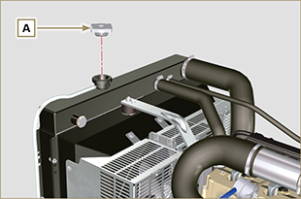  Fig 5.1
- Loosen clamp G and remove cap B from exhaust pipe C , draining the liquid into an appropriate container and refer to ( Par. 3.6 ). | 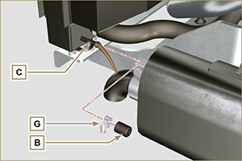  Fig 5.2
- Undo cap F to drain all liquid from the system contained in the engine crankcase ducts into an appropriate container and refer to ( Par. 3.6 ). | 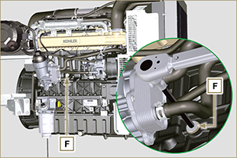  Fig 5.3  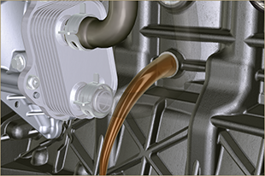 Fig 5.4
NOTE : Click by side to play the procedure. | https://www.youtube.com/embed/_s_qNZuOqQU?rel=0

Engine oil
Important  - Before proceeding with operation, read Par. 3.3.2 .  - This operation should be carried out with vacuum pump. The oil must be drained whilst the engine is hot, which requires particular care to prevent burns. Do not allow oil to come into contact with the skin because of the health hazards involved. It is recommended to use an oil intake pump via the oil dipstick hole B.  - Electric/pneumatic screwdrivers are forbidden.  - Undo the cartridge holder cover C by performing three complete turns and wait 1 minute.  NOTE : this operation will allow to oil contained in the support G to flow into the oil sump in the correct way.  - Unscrew cartridge holder cover C and check that the oil in the lub. oil filter bracket G has flowed towards the oil sump (refer to NOTE in Par. 2.10.3 ).  - Undo the oil filler cap A (Fig. 5.5) .  - Remove the oil dipstick B .  - Remove the oil drain plug D and the gasket E (the oil drain plug is on both sides of the oil sump).  - Drain oil in to an appropriate container.  (For used oil disposal refer to the Par. 3.6 ).  - Replace gasket E .  - Tighten the drain oil plug D (tightening torque at 35 Nm ).  - Perform the operations described in Par. 6.10.2 and the operation 5 Par. 6.10.3. | 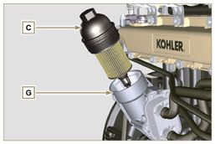  Fig 5.5  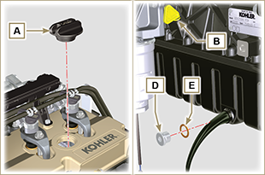  Fig 5.6
NOTE : Click by side to play the procedure. | https://www.youtube.com/embed/7T2NNBQqPpU?rel=0

