Information about optional components
KDI 3404 TCR Workshop Manual (Rev. 10.4)

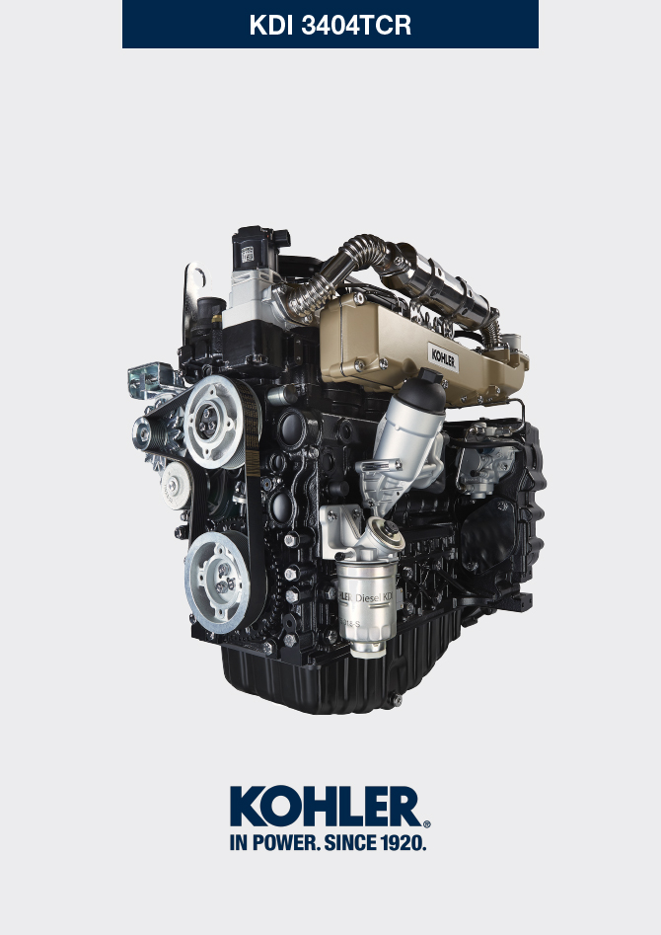
Sommario
1. TITOLO 1 2
1.1. Asdfsdfsdf 2
1.2. Asdfsdfsdfggg 2

Information about optional components

Heater (replacement)
Important

- Before proceeding with operation, read Par. 3.3.2 .
11.1.1 Disassembly  - Undo the screws A .  - Remove the flange C .  - Remove the heater E and the relevant gaskets F . | 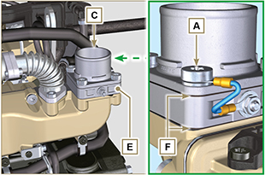  Fig 11.1
11.1.2 Assembly  Important  - Always replace gaskets F , with each assembly.  - In sequence, fit the manifold G with the gasket F , the new heater E , the second gasket F , the flange C , the washers H , the screws A and the cable B .  - Secure the flange C with the screws A (tightening torque at 22 Nm ). | 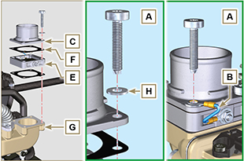  Fig 11.2

Idler gear (for 3rd / 4th PTO)
Important

- Before proceeding with operation, read Par. 3.3.2 .
11.2.1 Disassembly  - Perform the operations of point 7 of Par. 7.4.1 .  - Perform the operations from point 2 to 3 of Par. 6.6.1 .  - Perform the operations of point 3 of Par. 7.8.1 .  - Perform the operations of Par. 7.8.2 .  - Loosen capscrews A and remove plate B1 .  - Extract gear C .  - Remove gudgeon D together with plate B2 . | 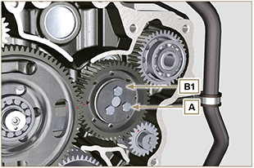  Fig 11.3
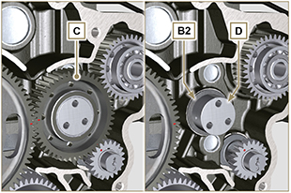
Fig 11.4
11.2.2 Assembly  Important  - Make sure that gudgeon D has no impurities inside.  - On capscrew A , assemble:  - plate B1  - gudgeon D  - gear C  - plate B2 . | Fig 11.5

- Position gear unit C1 onto crankcase E , complying with reference J1 , J2 with gear F .  - Secure unit C1 by means of capscrew A (tightening torque 25 Nm ).  NOTE: the reference J1 can have 2 different configurations for the gear C , Fig. 11.6b shows the correct position of the reference J1 for both configurations. | 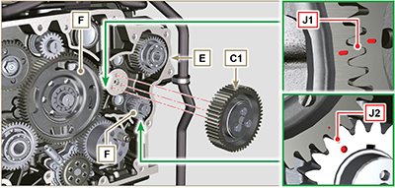  Fig 11.6  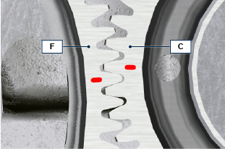  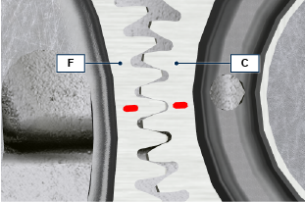  Fig 11.6b

3rd PTO (replacement)
Important

- Before proceeding with operation, read Par. 3.3.2 .
11.3.1 Disassembly  - Perform the operations of point 7 of Par. 7.4.1 .  - Perform the operations from point 2 to 3 of Par. 6.6.1 .  - Perform the operations of point 3 of Par. 7.8.1 .  - Perform the operations of Par. 7.8.2 .  - Extract gear A . | 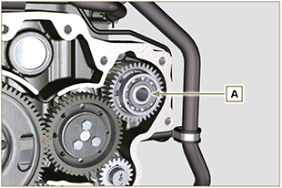  Fig 11.7
11.3.2 Assembly  - Insert gear A into the seat of crankcase B , fitting the shaft of pump C in gear A . | 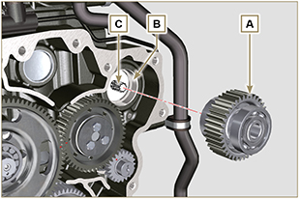  Fig 11.8

4th PTO (replacement)
Important

- Before proceeding with operation, read Par. 3.3.2 .
11.4.1 Disassembly  - Perform the operations of point 7 of Par. 7.4.1 .  - Perform the operations from point 2 to 3 of Par. 6.6.1 .  - Perform the operations of point 3 of Par. 7.8.1 .  - Perform the operations of Par. 7.8.2 .  - Extract gear A . | 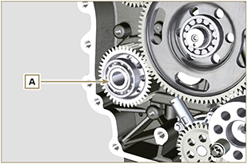  Fig 11.9
11.4.2 Assembly  - Insert gear A into the seat of crankcase B , fitting the shaft of pump C in gear A . | 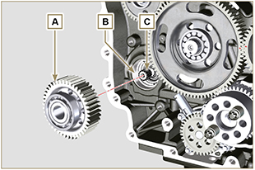  Fig 11.10

Balancer device (replacement)
Importante

- Before proceeding with operation, read Par. 3.3.2 .
11.5.1 Disassembly  - Perform the operations described in Par. 11.2.1 .  - Extract shaft A1 e A2. | 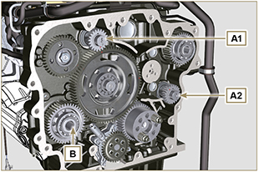  Fig 11.11
11.5.2 Assembly

- Lubricate gudgeon C of shaft A1 and A2 with oil.
- Insert shaft A1 into seat B1 of the crankcase, complying with reference D of gear E .
- Insert shaft A2 into seat B2 of the crankcase.
- Perform the operations described in Par. 11.2.2 .
NOTE: the shafts A1 and A2 are different and it is important not to invert the assembly position, the reference D is specific for the shaft A1 and is timed with the gear E , the reference J2 is specific for the shaft A2 and is timed with the idler gear F (see the Fig. 11.12b ).

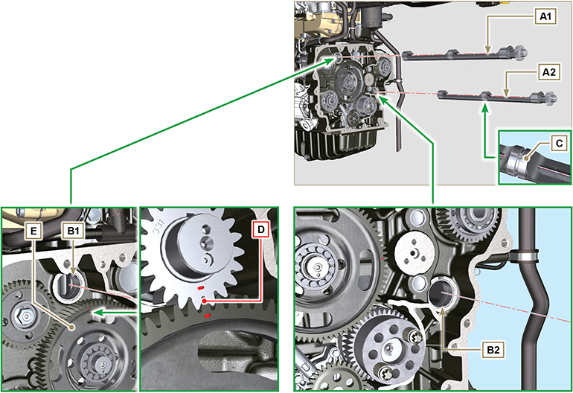
Fig 11.12

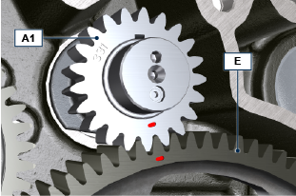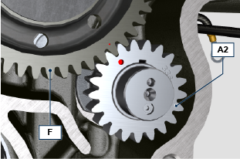
Fig 11.12b

ETB (replacement)
- Unscrew screws A and remove the ETB valve B with its gasket C .  Important  - Always replace the gasket C at each assembly. | 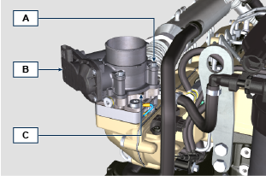  Fig. 11.13
- Fix the ETB valve B and its gasket C by means of screws A (tightening torque 10 Nm ) | 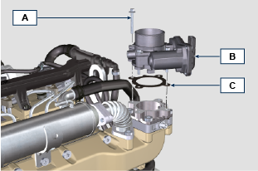  Fig. 11.14

EGR-T (replacement)
- Unscrew sensor A and its gasket B .  Important  - Before assembling the new sensor, see Par. 2.17.5  - Always replace the gasket B at each assembly. | 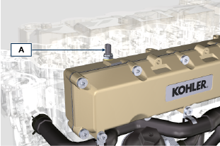  Fig. 11.15
- Fix sensor A and gasket B on their support C (tightening torque 20 Nm ). | 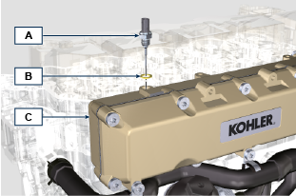  Fig. 11.16

EGTS (Black | Yellow - replacement)
- Unscrew sensors A .  Important  - Before assembling the new sensor, see Par. 2.17.6 | 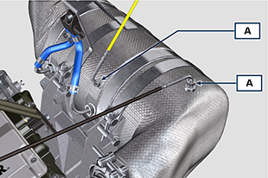  Fig. 11. 17
- Fix sensors A on the ATS B (tightening torque 30 Nm ). | 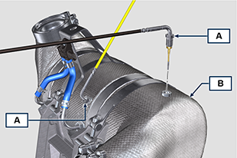  Fig. 11.18

DPF & DOC filter (replacement)
Danger
- Highly carcinogenic material!
- The dust contained inside the DPF is particularly fine and therefore classified as highly dangerous to living beings.
- Before proceeding to any operation, wear:
dust mask
gloves
goggles
- Do not allow any other operator who is not equipped with the above mentioned protective equipment to approach.
- Obtain a new replacement KIT for the DPF filter or a replacement KIT with regenerated DPF filter from your spare parts service.  Important  - Before disassembling/assembling any sensors, see Par. 2.17.5 and 2.17.6  - Always replace the seal P upon every assembly.  - During disassembly, do not expose the DPF to the surrounding environment for a long time and store it in a sealed bag as soon as possible.  - During disassembly operations, avoid using electric screwdrivers as vibrations could release the dust inside the DPF  - Do not try to clean the DPF  - Do not blow with compressed air  - Do not release the DPF or the dust contained in it in the environment  - Dispose of the DPF only in authorised centres  - Perform the operations indicated in point 1 of Par. 11.8 .  - Open the package of the DPF replacement KIT, taking care not to damage it.  - Unscrew screw A and loosen clamps B , then remove the Delta-P sensor D .  - Disconnect pipes C from their unions J and remove the Delta-P sensor D .  - Unscrew and remove unions J . | 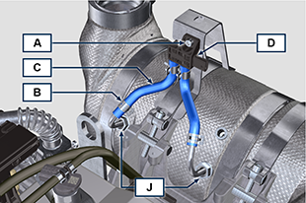  Fig. 11.19
- Loosen clamps E and remove manifold N . | 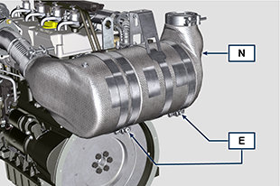  Fig. 11.20
- Loosen clamp G and remove the DPF filter H .  NOTE: do not remove clamp G .  - Inspect the DPF filter to detect any visible signs of oil contamination.  - Put the removed DPF filter in the plastic container supplied with the replacement KIT and send it to your spare parts service using the replacement KIT package.  NOTE : a residual value will be recognised depending on whether the used DPF is intact and recyclable or damaged and requiring a correct disposal. | 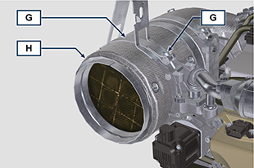  Fig. 11.21
- Loosen the clamps Q and S and remove the manifold with DOC M from the flexible hose R . | 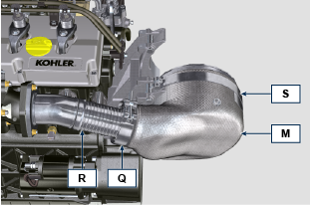  Fig. 11.22
- Fit the new manifold with the DOC filter M on the support T , inserting the flexible hose R inside the inlet of the manifold M . | 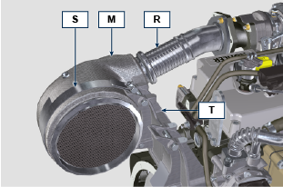  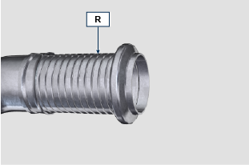  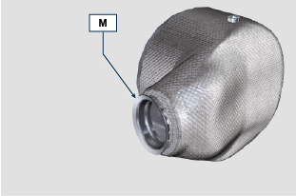  Fig. 11.23
Important  - Do not apply any tension during the assembly of components.  - Before fastening the manifold M , it must be oriented in the same position as the previously installed DOC filter.  - Tighten the clamp Q (tightening torque of 10 Nm ).  - Tighten the clamp S (tightening torque of 12 Nm ). | Fig. 11.24
- Insert the gasket P on the manifold with DOC filter M .  - Insert the new DPF filter H inside clamp G .  - Insert the DPF filter H on manifold M until reaching the gasket P . | 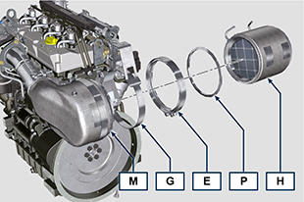  Fig. 11.25
Important  - Before fastening the DPF filter H , it must be oriented in the same position as the previous filter.  - Do not apply any tension during the assembly of components.  - Fasten the DPF filter H with clamp E (tightening torque 12 Nm ). | 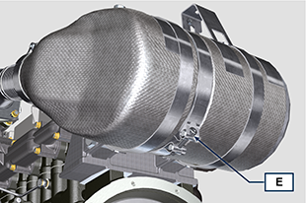  Fig. 11.26
- Insert gasket P on the DPF filter H .  - Insert manifold N on the DPF filter H until reaching the gasket P .  Important  - Before fastening manifold N , it must be oriented in the original position.  - Fasten manifold N with clamp E (tightening torque 12 Nm ). | 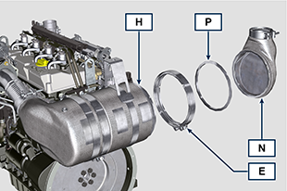  Fig. 11.27
- Position support K in contact with support K1 and fasten clamp G (tightening torque 12 Nm ). | 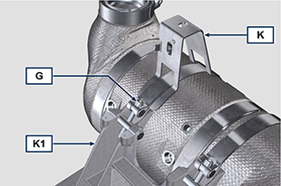  Fig. 11.28
- Screw unions J on the DPF filter H and position them about 20° away from the centre line (as in Fig. 11.30 ). | 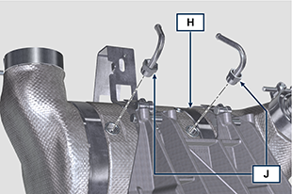  Fig. 11.29
- Fix unions J (tightening torque see service letter 710015 ). | 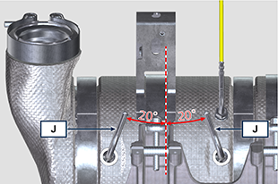  Fig. 11.30
- Fit pipes C on unions J and fasten them with clamps B .  - Fix the Delta-P sensor D on its support K by means of screw A (tightening torque 10 Nm ).  - Provide the machine owner with the warranty certificate of the new DPF filter KIT installed.  - Perform the " DPF replacement " procedure to reset the ASH & SOOT through the relevant KOHLER diagnostic tool interfaced with the ECU. | 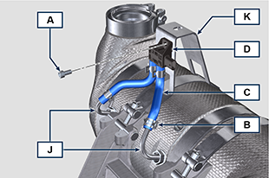  Fig. 11.31

