Technical information
KDI 3404 TM Owner Manual (Rev. 10)

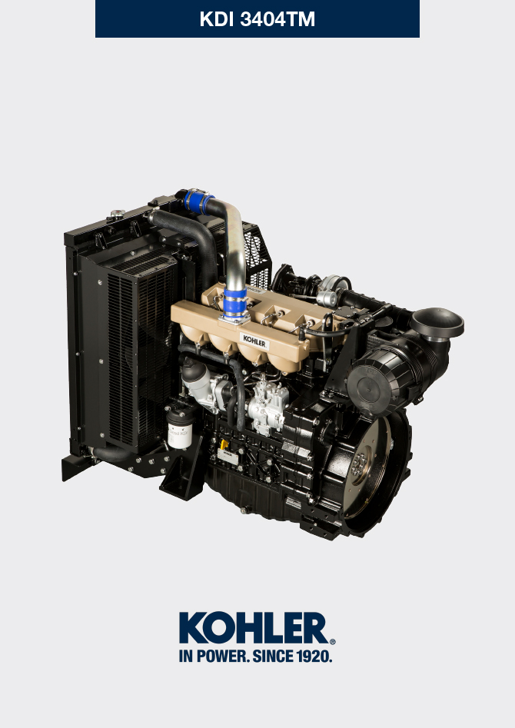
Sommario
1. TITOLO 1 2
1.1. Asdfsdfsdf 2
1.2. Asdfsdfsdfggg 2

Technical information

General description of the engine
- 4-stroke, in-line cylinders Diesel engine; -Liquid-cooling system;

- 4 valves per cylinder with hydraulic tappets;

- Direct Injection.

Engine specifications
Tab. 2.1
TECHNICAL DATA |  | UNIT OF MEASURE | 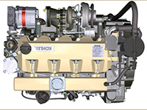
Engine type |  |  | KDI 3404 TM
Cylinders |  | n. | 4
Bore |  | mm | 96
Stroke |  | mm | 116
Displacement |  | cm ³ | 3359
MAX INCLINATION DURING OPERATION (even in combined) |  | α | 40° max 30 min
 |  | α | 45° max 1 min
OIL CAPACITY (MAX level.) including oil filter | standard version | lt. | 15.6
DRY WEIGHT |  |  | 405

Engine dimensions (mm)
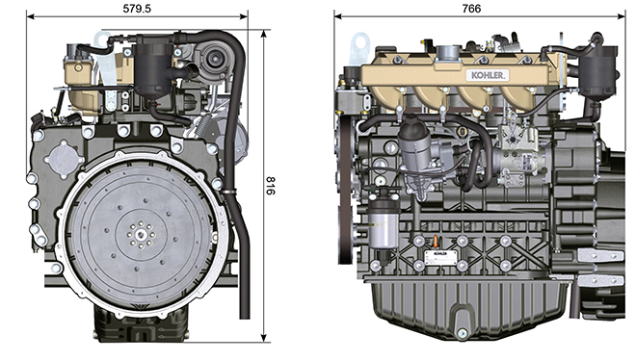

Oil

Important

- The engine may be damaged if operated with improper oil level.
- Do not exceed the MAX level because a sudden increase in engine rpm could be caused by its combustion.
- Use only the recommended oil to ensure adequate protection, efficiency and service life of the engine.
- The use of lubricants other than recommended may shorten the engine life.
- Viscosity must be appropriate to the ambient temperature to which the engine is to be exposed.

Danger

- Prolonged skin contact with the exhausted engine oil can cause cancer of the skin.
- If contact with oil cannot be avoided, thoroughly wash your hands with soap and water as soon as possible.
- For the exhausted oil disposal, refer to the Par. DISPOSAL and SCRAPPING .
2.4.1 SAE oil classification
- In the SAE classification, oils are identified according to viscosity without considering any other qualitative characteristic.
- The code is composed of two numbers, which indicate, and must correspond to, the ambient temperature in which the engine operates, the first number refers to the viscosity when cold, for use during winter (" W "), while the second number is for viscosity at high temperatures.

2.2
RECCOMENDED OIL
VISCOSITY | SAE | 10w-40 (-25°C ÷ +50°C)  5w-40 (-30°C ÷ +50°C)  0w-40 (-40°C ÷ +50°C)
WITH SPECIFICATIONS | API | CI-4 Plus CI-4  CH-4
 | ACEA | E7  E4

- Low S.A.P.S. oils, sulfate ashes <1% may not be used with fuels with a sulfur content >50ppm.
- Filtration of oils is critical to proper operation and lubrication; always change filters regularly as specified in this manual.

Fuel
Important  - Use of other types of fuel could damage the engine. Do not use dirty diesel fuel or mixtures of diesel fuel and water since this will cause serious engine faults. | Warning  - Clean fuel prevents the fuel injectors from clogging. Immediately clean up any spillage during refuelling.  - Never store diesel fuel in galvanized containers (i.e. coated with zinc). Diesel fuel and the galvanized coating react chemically to each other, producing flaking that quickly clogs filters or causes fuel pump and/or injector failure.  - Any failure resulting from the use of fuel other than Tab. 2.3, 2.4 will not be covered by warranty.
Cetane number of 40 minimum. Cetane number greater than 47 is preferred, especially for temperatures below –20 °C (–4 °F) or elevations above 1675 m (5500 ft.).

2.3
Certification --> | Stage 5 | Stage 3A | Tier III | no certification (*1) | Remarks  *1: the regions known as poor lubricity diesel fuel quality or if the engine is operated with Jet fuels, the primary filter must be with lubricity dosing capability. Contact Kohler for information about the approved filter for this purpose .
Fuel Type --> | (EN 590 - DIN 51628) |  |  | (EN 590 - DIN 51628) | Do NOT USE vegetable oils as a biofuel not compliant with EN590 prescription.
 | HVO 100% (EN 15940) |  |  |  | Power and torque might be 1% to 5% lower due to low fuel density compared to standard diesel fuel.
 | Military NATO Fuel F-54 (S = 10 ppm)
 | JIS K 2204 No.1, No.2
 |  |  | Grade 1-D S15 |  | For ambient temperatures below 0°C (32°F) with no arctic fuel available (Grade 1-D S15, Grade 2-D S15, ASTM D 975) use the following additives to prevent possible engine damage with low engine load in cold weather:  - Power Service Diesel Fuel Supplement+Cetane Boost  Different additives are not allowed.  The use of approved additives has no impact on the engine maintenance schedule.  Do NOT USE vegetable oils as a biofuel not compliant with ASTM D975 Grade1 and Grade2 prescription.
 |  |  | Grade 2-D S15
 |  | Sulphur Fuel S < 500 ppm
 |  |  |  | High Sulphur Fuel S < 2000 ppm
 |  |  |  | F-34/F-35 (kerosene, NATO designation) | Operations with Jet Fuels  The jet fuels can be used but only adopting an additional fuel filter with lubricity doser.  Because of lower density and greater leak fuel volume due to lower viscosity, depending on the engine speed and torque, a power loss up to 10% is possible.  There are some problematical fuel proprieties amongst the listed jet fuels (viscosity, lubricating capacities and low boiling point). A slight increase in wear in the injection system is to be expected which can lead to a statistically shorter life of these components. Sulphur content must be below 2000ppm.
 |  |  |  | F-44 (kerosene, NATO designation)
 |  |  |  | F-63 (kerosene, NATO designation, equivalent to F-34/F-35 with additives)
 |  |  |  | JP-8 (kerosene, US military designation)
 |  |  |  | JP-5 (kerosene, US military designation)
 |  |  |  | Jet A (kerosene for civil aviation)
 |  |  |  | Jet A1 (kerosene for civil aviation)

2.4
FUEL ADDITIVES | Remarks
Fuel additives with biocide/algaecide functions only are allowed in case of storage of fuel in the tank for long periods (one year or more). | For suggested brands and types contact Kohler staff
These additives must be diluted in the fuel following the product prescribed percentages when filling the tank.
Additives with functions other than biocide / algaecide are not al-lowed.

Coolant recommendation
A mixture of 50% demineralized water and 50% low silicate ethylene glycol based coolant liquid must be used. Use a Long Life or Extended Life Heavy Duty OAT coolant free of: silicates, phosphates, borates, nitrites and amines.

The following ethylene-glycol based engine coolant for all models within KDI engine family may be used:

- OAT (Organic Acid Technology) Low Silicate: ASTM D-3306 D-6210
- HOAT (Hybrid Organic Acid Technology) Low Silicate: ASTM D-3306 D-6210

The above coolants in concentrated formulation must be mixed with distilled, deionized, or demineralized water. A pre-mixed formulation (40-60% or 50-50%) can be used directly when available.

Important
- Do not mix ethylene glycol and propylene glycol based coolants. Do not mix OAT and HOAT based coolant. OAT performance life can be drastically reduced if contaminated with nitrite-containing coolants.
- Never use automotive-type coolants. These coolants do not contain the correct additives to protect heavy – duty diesel engines.

OAT coolants are maintenance free up to 6 years or 6000hrs of operation , provided that the cooling system is topped up using the same type of coolant. Do not mix different coolant types. Test the coolant condition annually with coolant test strips.
HOAT are not all maintenance free and it is recommended to have SCA (Supplemental Coolant Additives) added at the first maintenance interval.

Battery recommendation
Battery not supplied by Kohler

Tab. 2.7
RECOMMENDED BATTERIES
AMBIENT TEMPERATURE | BATTERY TYPE
≥ - 15°C | 100 Ah - 800 CCA/SAE
< -15°C | 120 Ah - 1000 CCA/SAE

