Information about optional components
KDI 2504TCR / KDI 2504TCRE5 Workshop Manual (Rev. 17.8)


Sommario
1. TITOLO 1 2
1.1. Asdfsdfsdf 2
1.2. Asdfsdfsdfggg 2

Information about optional components

Oil dipstick in cylinder head
Important

- Before proceeding with operation, read Par. 3.3.2 .
11.1.1 Check  - Pull out the dipstick B in the direction of the arrow A .  - Check that the mark left by the oil on the dipstick is between the MIN and MAX notches. | 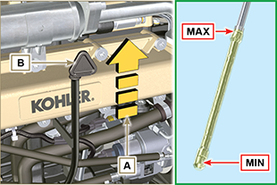  Fig 11.1
11.1.2 Replacement  11.1.2.1 Disassembly  - Undo the screw D .  - Pull out the oil dipstick hose E in the direction of the arrow F | 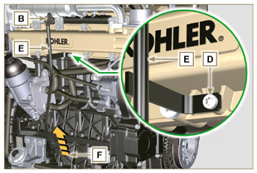  Fig 11.2
11.1.2.2 Assembly  Important  - Always replace the gasket G every time it is disassembled.  - Insert the gasket G in the seat K of the hose E .  - Insert the hose E in the crankcase H . | 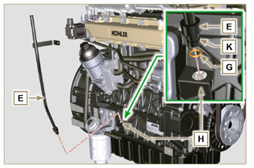  Fig 11.3
- Secure the oil dipstick hose E using the screw D on the manifold L (tightening torque at 10 Nm ). | 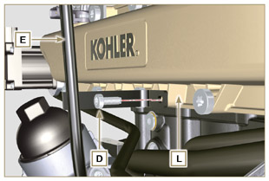  Fig 11.4
NOTE: Check the integrity of the gaskets J .  - Insert the dipstick B inside the hose E . | 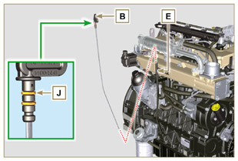  Fig 11.5

Heater (replacement)
Important

- Before proceeding with operation, read Par. 3.3.2 .
11.2.1 Disassembly  - Undo the screws A and the relevant washers and remove the earth cable B .  - Remove the flange C and the manifold D .  - Remove the heater E and the relevant gaskets F . | 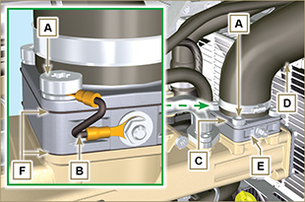  Fig 11.6
11.2.2 Assembly  Important  - Always replace gaskets F , with each assembly.  - In sequence, fit the manifold G with the gasket F , the new heater E , the second gasket F , the flange C , the washers H , the screws A and the cable B .  - Secure the flange H with the screws A (tightening torque at 22 Nm ).  - Secure the earth cable B with the nut J and the relevant washer on the heater E . | 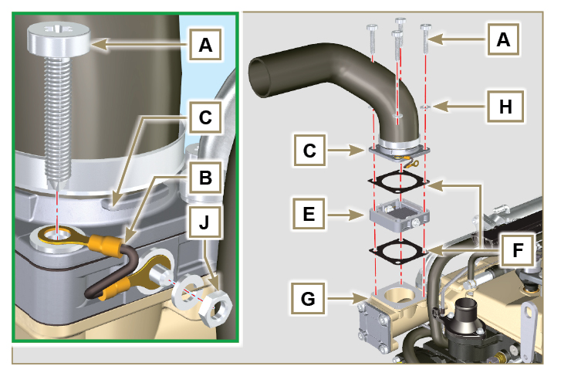  Fig 11.7

Poly-V alternator belt (replacement and adjustment)
Important

- Before proceeding with operation, read Par. 3.3.2 .
- Loosen the nut B and manually tighten the screw C until it just touches the pulley pin D (Fig. 11.9) . | 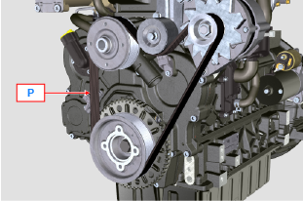  Fig 11.8
- Untighten the screw E by around 32mm (A) .  - Untighten the screw C .  NOTE: The belt tensioner pulley F should move towards the arrow G . If it does not, please move it manually. | 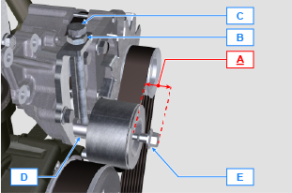  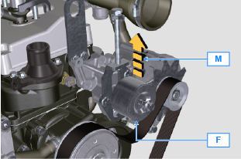  Fig 11.9
- Remove the V-Belt H and install the new one.  NOTE: Ensure that the internal profile of belt H is properly inserted into the grooves of the pulley A (as illustrated in D1 e D2 ). | 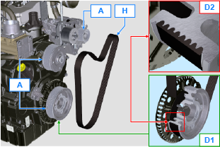  Fig 11.10
- Tighten capscrew C , to shift gudgeon D fully to the bottom of the grooved guide.  - Tighten capscrew E (tightening torque at 45Nm ).  - Hold the screw C still with a key, and tighten the screw B on the plate L to secure the screw C (tightening torque at 45Nm ).  - Check, in point P (Fig. 11.8) ,the tension of the belt. Check by the appropriate tool that at point p the tension value is between 149 and 196 Hz .  NOTE: After the engine has been in operation for around 15 minutes, repeat point 8 . | 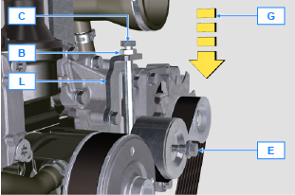  Fig 11.11

Tightening pulley and alternator for Poly-V belt
Important

- Before proceeding with operation, read Par. 3.3.2 .
11.4.1 Disassembly  - Perform the operations from point 1 to 3 of Par. 11.3 .  - Remove the belt H ( Fig. 11.10 ) .  - Undo and remove the screw A .  - Fully undo the screw B and remove the tightening pulley C . | 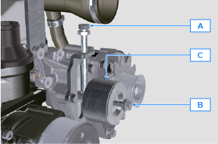  Fig 11.12
- Undo the screws D and remove the plate E and the pin F . | 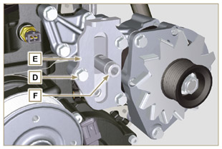  Fig 11.13
- Undo the screws G and H remove the alternator L . | 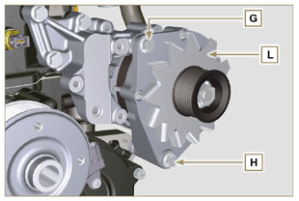  Fig 11.14
- Undo the screws M and remove the bracket N . | 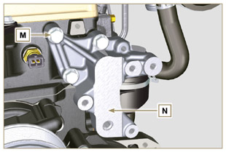  Fig 11.15
11.4.2 Assembly  - Secure the bracket N using the screws M on the cylinder head P (tightening torque at 25 Nm ). | 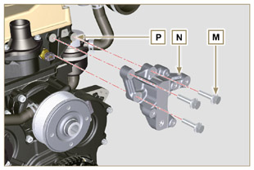  Fig 11.16
- Insert the screw H into the fixing hole on the alternator L .  - Insert the spacer R on the screw H (between the alternator and crankcase).  - Tighten the screw manually H onto the crankcase Q .  - Orientate the second fixing hole of the alternator L with the hole of the bracket N , secure the alternator L using the screw G (tightening torque at 25 Nm ) onto the bracket N and then the screw H (tightening torque at 25 Nm ). | 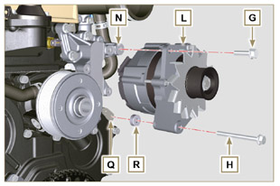  Fig 11.17
- Insert the pin F in the plate slot E .  - Orientate the pin F with the surface S (support for screw A ) upwards.  - Secure the plate E using the screws D on the bracket N (tightening torque at 25 Nm ). | 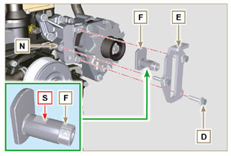  Fig 11.18
- Insert the screw B in the plate C1 and pulley C .  - Manually tighten the screw B onto the pin F up to the stop; Undo the screw B again by one turn.  NOTE: The screw B must protrude by about 32 mm (A) from the surface of the tightening pulley C (see detail X ).  - Install the new belt H (Fig. 11.10) .  - Tighten the screw A onto the plate E up to the stop on the pin F .  - Perform the operations from point 6 to 8 of Par. 11.3 . | 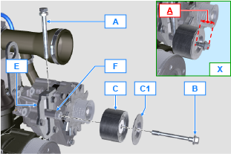  Fig 11.19

Idler gear (for 3rd / 4th PTO)
Important

- Before proceeding with operation, read Par. 3.3.2 .
11.5.1 Disassembly  - Undo the screw A and remove the gear unit B . | 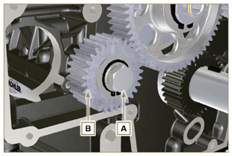  Fig 11.20
- Remove the retainer ring C from the seat of the pin D .  - Remove the shoulder washer E , the gear B , the shoulder ring F and the bushing G from the pin G .  11.5.2 Assembly  - Insert gudgeon D :  - shoulder ring F (minimum shim)  - gear B  - shoulder ring E  - retainer ring C .  - Insert the bushing G on the crankcase L . | 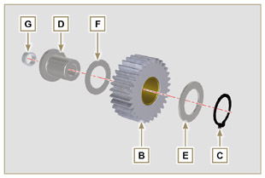  Fig 11.21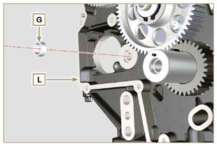  Fig 11.22
Important  - Always replace the washer H every time it is disassembled.  Modified component, see service letter 700019 - 700021 - 700028 .  - Check that the perforated screw A is free from impurities inside it.  - Position the gear unit B on the hole J using the bushing G to centre.  - Secure the gear unit B using the screw A inserting the washer H (tightening torque at see service letter 700019 - 700021 - 700028 ). | 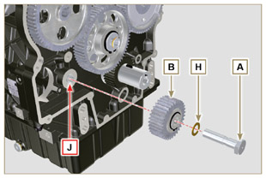  Fig 11.23

3rd PTO (replacement)
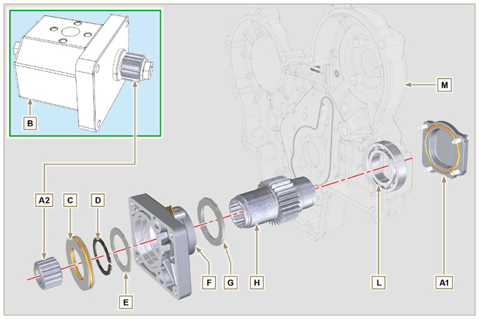
Fig 11.12

Important

- Before proceeding with operation, read Par. 3.3.2 .
11.4.1 Disassembly  - Undo the screws A and remove the pump B . | 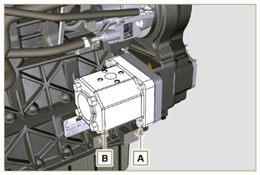  Fig 11.13
- Remove the centring ring C and the relative gaskets.  - Undo the screws N . | 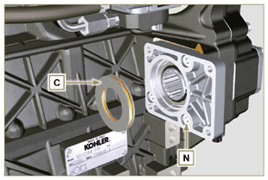  Fig 11.14
- Remove the flange F with the components D, E, G and H in the direction of the arrow P .  - Remove the gasket J . | 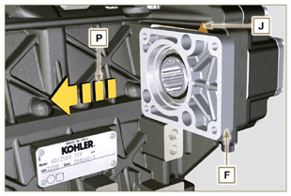  Fig 11.15
- Remove the retainer ring D and the shoulder washer E .  - Remove the gear H and the shoulder ring G from the flange F in the direction of the arrow Q . | 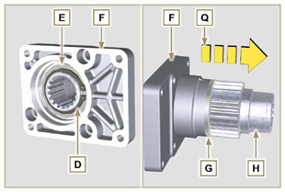  Fig 11.16
11.4.2 Assembly  Important  - Always replace the gasket J after each assembly.  - Lubricate the gear H with oil.  - Insert the gear H in the flange F in the direction of the arrow R inserting the shoulder ring G .  - Insert the shoulder ring E on the flange F and clamp the gear H using the retainer ring D .  - Position flange F on the crankcase K inserting the gasket J , and inser gear H in crankcase K . | 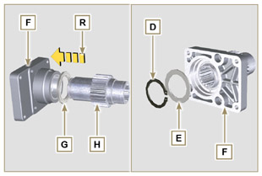  Fig 11.17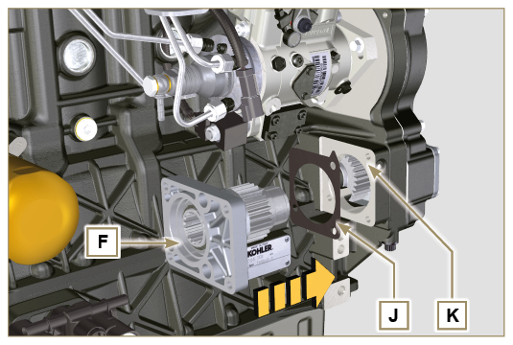  Fig 11.18
- Secure the flange F using the screws N (tightening torque at 25 Nm ). | 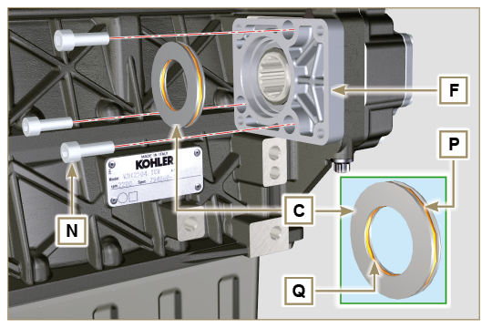  Fig 1
Important  - Always replace rings P and Q after each assembly.  5. Insert the centring ring C in the flange F up to the stop.  6. Position the pump B on the flange F engaging the gear H .  7. Secure the pump B using the screws A on the flange F (tightening torque at 25 Nm ). | 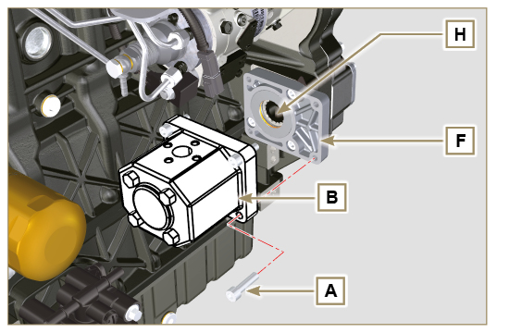  Fig 11.20

4th PTO (replacement)
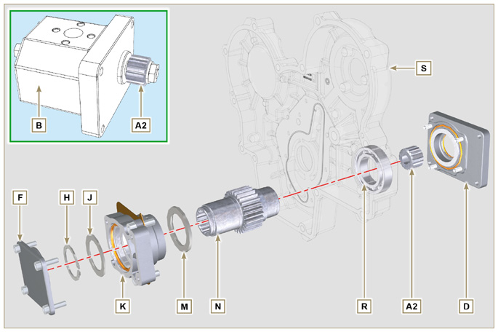
Fig 11.21

Important

- Before proceeding with operation, read Par. 3.3.2 .
11.7.1 Disassembly  - Undo the screws A and remove the pump B . | 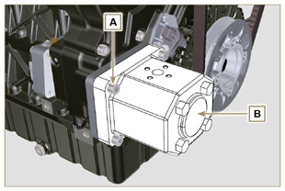  Fig 11.22
- Undo the screws C and remove the flange D . | 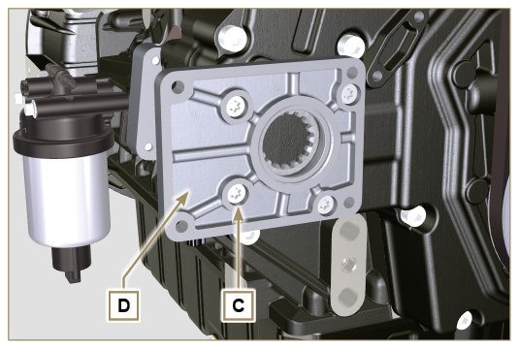  Fig 11.23
- Undo the screws E and remove the cover F . | 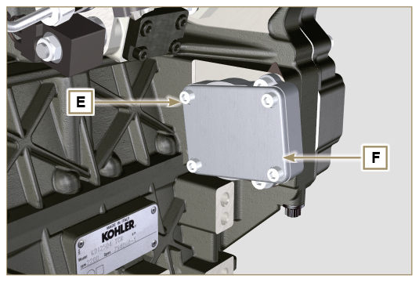  Fig 11.24
- Undo the screws G and remove the flange K with the components H, J, M, N and P . | 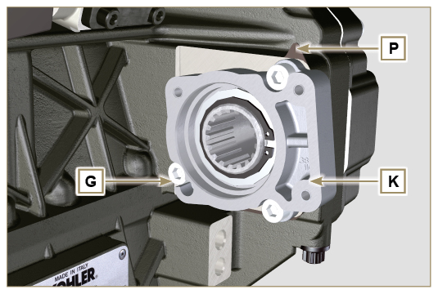  Fig 11.25
- Remove the retainer ring H and the shoulder ring J from the flange K .  - Remove the gear N and the shoulder ring M from the flange K . | 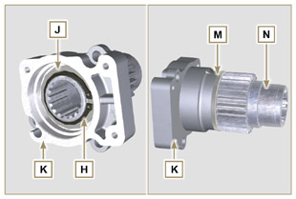  Fig 11.26
11..2 Assembly  Important  - Always replace the gasket J after each assembly.  - Lubricate the gear H with oil.  - Insert the gear N in the flange K in the direction of the arrow W inserting the shoulder ring M .  - Insert the shoulder ring J on the flange K and clamp the gear N using the retainer ring H . | 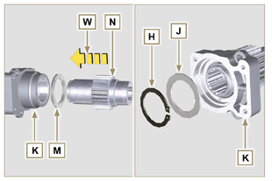  Fig 11.27
- Position flange K onto crankcase Q inserting gasket P and insert gear N in crankcase Q .  Important  - Always change capscrews G with new ones or alternatively apply Loctite 2701 .  - Secure the flange K using the screws G (tightening torque at 25 Nm ). | 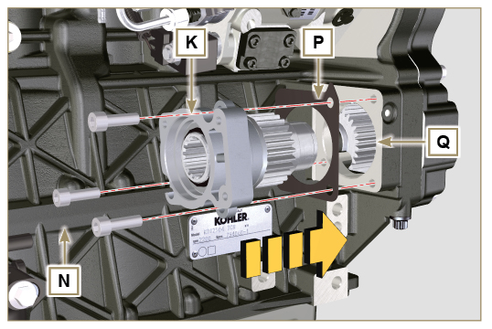  Fig 11.28
Important  - Always replace the gasket V after each assembly.  - Insert gasket V on cover F , insert and position the cover F on flange K .  - Secure the cover F using the screws E (tightening torque at 25 Nm ) on the flange K . | 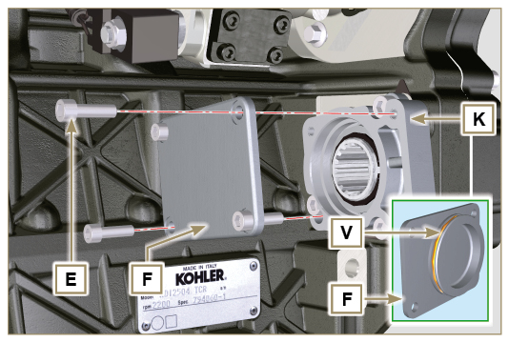  Fig 11.29
Important  - Always replace the gasket T after each assembly.  - Position and tighten flange D by means of capscrews C on carter S (tightening torque 10 Nm - ST_06 ). | 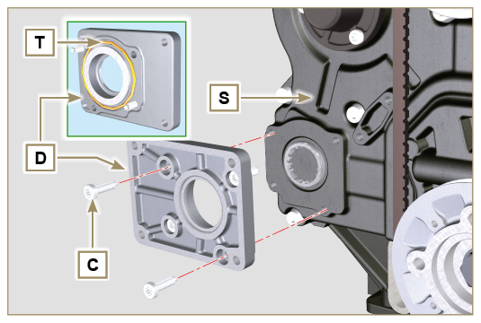  Fig 11.30
Important  - Always replace the gasket U after each assembly.  - Position the gasket U on the flange D .  - Secure the pump B using the screws A (tightening torque at 25 Nm ) on the flange D . | 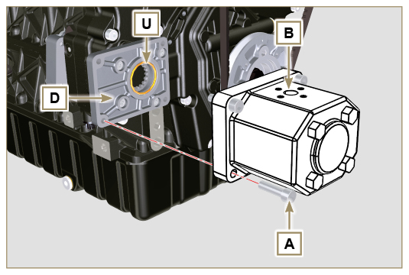  Fig 11.31

3rd + 4th PTO (configurations)
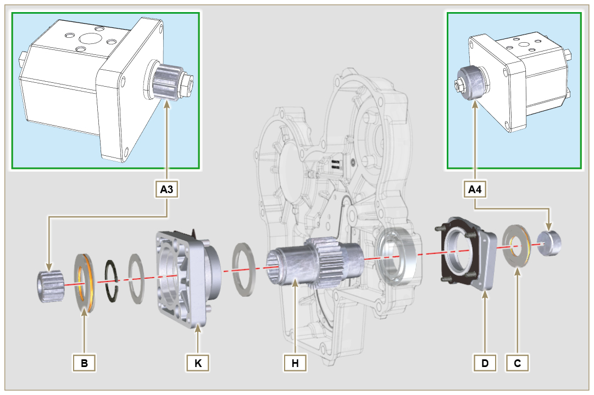
Fig. 11.45

11.8.1 Information  Hydraulic pumps on the 3rd and 4th PTO can be installed at the same time.  In some configurations, there is also the centering ring C on the 4th PTO.  Important  - For disassembly or installation, refer to Par. 11.5 , Par. 11.6 e Par. 11.7 .  - Always replace the gasket of the rings B and C and flanges D and K at each assembly.  - Lubricate the gear H with oil. | 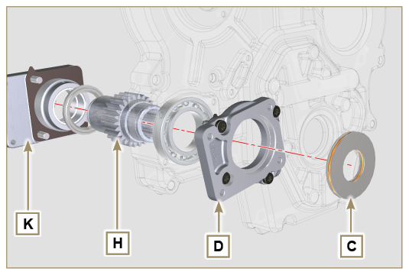  Fig. 11.46

Balancer device (replacement)
Important

- Before proceeding with operation, read Par. 3.3.2 .
11.9.1 Disassembly  - Perform the operations described in Par. 5.2 .  - Undo the screws A and remove the oil sump B . | 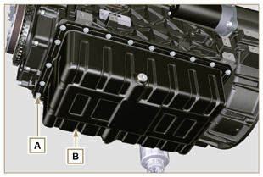  Fig 11.47
- Undo the screws C and remove the hose D . | 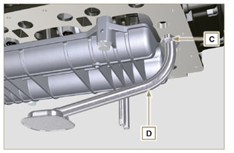  Fig 11.48
- Undo the screws E and remove the shaft support box F . | 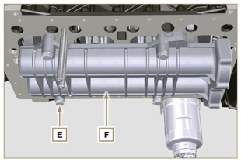  Fig 11.49
- Undo the screws G and remove the plate H . | 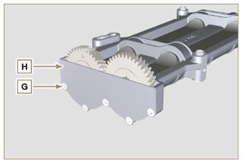  Fig 11.50
- Remove the shafts J and K in the direction of the arrow L from box F . | 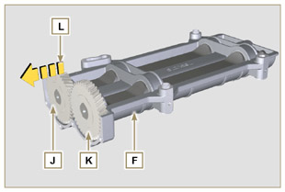  Fig 11.51
11.9.2 Assembly  - Lubricate the bushings V with Molikote grease.  - Insert the shafts J and K inside the box F in the direction of the arrow M . | 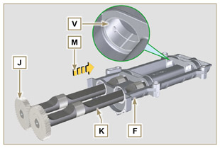  Fig 11.52
- Make sure that the shafts J and K i nside the box F observe the marks N and that the shaft J with the gear indicated by letter " S " stamped on it is on the left with respect to the box F . | 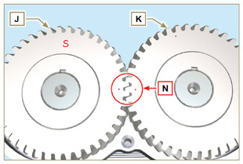  Fig 11.53
- Secure the plate H using the screws G on the box F (tightening torque at 8 Nm ). | 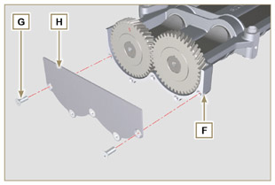  Fig 11.54
- Manually tighten the retainer screw ST_15 on the box F by slightly rotating the shaft K , centring the hole on it using the ST_15 , to lock the device. | 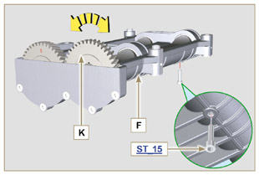  Fig 11.55
- Rotate the crankshaft and clamp it on the TDC (Ref. P upwards) using the tool ST_34 secured in place of the starter motor (detail Q ). | 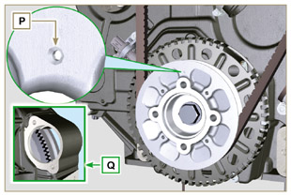  Fig 11.56
- Position the box F on the surface of crankcase R observing the reference bushings.  - Secure housing F using capscrews E and insert washers U (tightening torque at 50 Nm ).  - Remove the retainer screw ST_15 from the box F . | 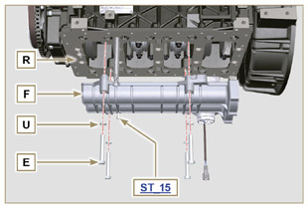  Fig 11.57
Important  - Check that the retainer capscrew ST_15 (Fig. 11.55) is not present in point X on housing F .  - Always replace the gasket W after each assembly.  - Lubricate the gasket W with oil before assembling it.  - Insert the gasket W in the seat on the flange of the oil hose D .  - Secure the oil intake hose D using the screws C .  - Perform the operations described in Par. 9.4.3 to assemble the oil sump. | 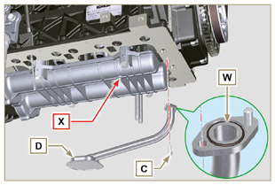  Fig 11.58

Air filter (cartridge replacement)
- Release the two hooks A and remove the cover B from the body C .  - Remove the cartridges D and E .  Important  - Before proceeding with operation, read Par. 3.3.2 .  - The safety cartridge E (if present) must always be replaced if it is dirty or damaged.  - Insert the new cartridge E inside the new cartridge D and both of them inside the filter body C .  - Secure the cover B via the hooks A . | 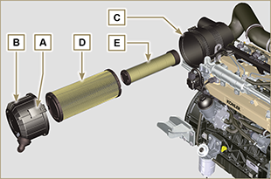  Fig 11.59

Remote oil filter (disassembly and assembly)
11.11.1 Option A  Important  - Modified component, see service letter 700018 .  11.11.1.1 Disassembly  - Perform the operations described in Par. 5.2 .  Important  - Before proceeding with operation, read Par. 3.3.2 .  - For the replace the cartridge, please refer to operation n° 4 (Par. 11.11.1) and operation n° 7 (Par. 11.11.2) .  - For the disassembly of the pipes B and C , lock with a tool the fittings K, H (Fig. 11.61) and L (Fig. 11.62) in order to prevent their lose together with the nuts A , with the consequent of oil leakage.  - The threads of unions L and H have different features - Before removing the unions L and H , apply a distinguishing mark on them in order to reposition them correctly on the support M or on the head J during the assembly phase.  - The threads of nuts A have different features - Before removing the tubes B and C, apply a distinguishing mark on them in order to correctly screw the nuts A to the unions L and H during the assembly phase.  - Undo the nuts A and remove the hoses B and C .  - Unscrew the fittings L and remove the copper gaskets from the support M .  - Unscrew the cartridge N with gasket from the support M . | 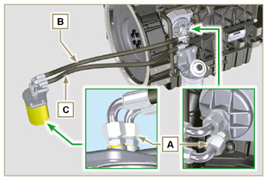  Fig 11.60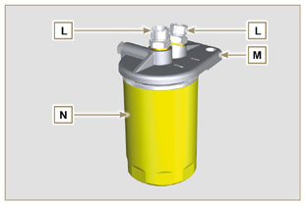  Fig 11.61
- Release the clamps D and remove the hoses E and F from Oil Cooler G .  - Unscrew and remove the fitting H with its copper gasket from the oil filter head J .  - Unscrew and remove:  - the fitting K with the copper gasket;  - Oil Cooler G and the relative gasketsi;  - the oil filter head J . | 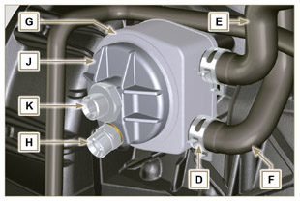  Fig 11.62
11.11.1.2 Assembly  Important  - Always replace the gaskets P, Q, R and W at each assembly.  - Lubricate the gaskets P, Q and R with oil before assembling them.  - Insert the gasket P on the seat of the fitting K .  - Insert flange head J on the fitting K and the gasket Q in the seat of head J .  - Insert the Oil Cooler G on the fitting K and the gasket R in the seat of Oil Cooler G .  - Onto crankcase S apply Oil Cooler G and flange J by means of union K (tightening torque at 25 Nm + Loctite 2701 on thread) as positioned in Fig. 11.64.  - Clamp union H on flange J inserting gasket U (tightening torque at 40 Nm ). | 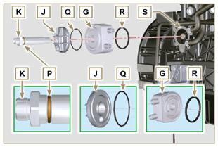  Fig 11.63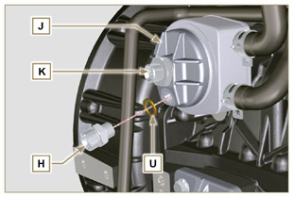  Fig 11.64
Important  - Always replace the gaskets V after each assembly.  - Clamp unions L on support M inserting gasket V (tightening torque at 40 Nm ).  - Lubricate gasket W and clamp cartridge N on support M (tightening torque at 20 Nm ). | 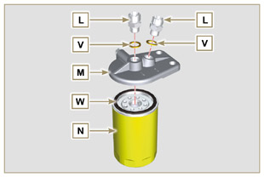  Fig 11.65
8. Connect tube B to the central fitting of support M and of head J .  9. Connect tube C to the side fitting of support M and of head J .  10. Clamp the nuts A on the head J (tightening torque at 30 Nm ).  11. Clamp the nuts A on support M (tightening torque at 35 Nm ).  Important  - Check the tightening of the fittings K, H (Fig. 11.64) and L (Fig. 11.65) (tightening torque at 40 Nm ). | 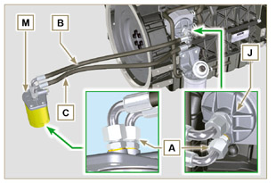  Fig 11.66
11.11.2 Option B  11.11.2.1 Disassembly  - Perform the operations described in Par. 5.2 .  - Perform the operations indicated in point 1 of Par. 7.3.2 .  Important  - Before proceeding with operation, read Par. 3.3.2 .  - The oil filter cartridge may not be supplied by KOHLER (in such cases, refer to the machine’s documentation)  - To replace only the cartridge, refer to operations 5 ( Par. 11.11.1 ) and 7 ( Par. 11.11.2 ).  - to remove the tubes B and C , use a wrench to lock the unions L ( Fig. 11.70 ) and H ( Fig. 11.72 ) in order to prevent them from being loosened and removed together with the nuts A , with subsequent oil leaks.  - The threads of unions L and H have different features - Before removing the unions L and H , apply a distinguishing mark on them in order to reposition them correctly on the support M or on the head J during the assembly phase.  - The threads of nuts A have different features - Before removing the tubes B and C , apply a distinguishing mark on them in order to correctly screw the nuts A to the unions L and H during the assembly phase. | 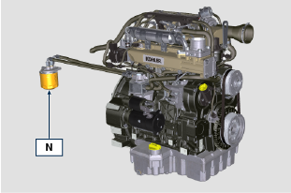  Fig 11.67
- Undo the nuts A and remove the hoses B and C .  - Unscrew the fittings L and remove the copper gaskets from the support M .  - Unscrew the cartridge N with gasket from the support M . | 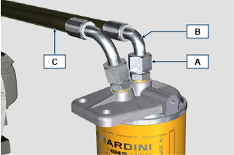  Fig 11.68  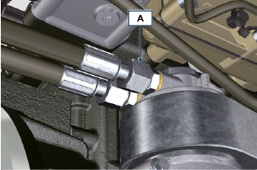  Fig 11.69  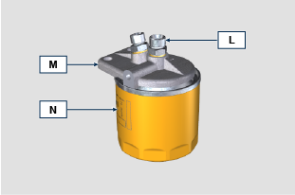  Fig 11.70
- Release the clamps D and remove the hoses E and F from Oil Cooler G .  - Unscrew and remove the unions H together with the relevant copper gasket from the head J .  - Unscrew and remove:  - the union K with its gasket;  - the head J ;  - the Oil Cooler G with relevant gaskets;  - the screws X and Y ;  - the support T ; | 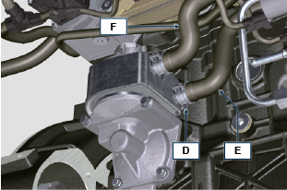  Fig 11.71  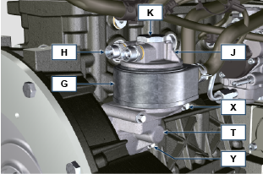  Fig 11.72
11.11.2.2 Assembly  Importante  - Replace the gaskets H1 , J1 , J2 , K1 , L1 , T1 and Z1 at every assembly.  - Lubricate the gaskets J1 , J2 , K1 , T1 and Z1 with oil before performing the assembly.  - Insert the gasket K1 on the seat of the union K .  - Insert the gaskets J1 and J2 on the seats of the union J .  - Assemble on the support T :  Oil Cooler G  head J  - Fix the union K to the support T , aiming the Oil Cooler G and the head J correctly (tightening torque of 25 Nm + Loctite 2701 on the thread). | 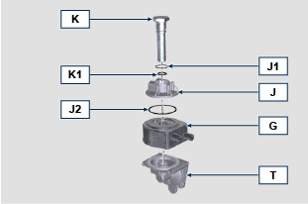  Fig 11.73
- Insert the gasket Z1 on the seat of the union Z .  - Insert the gasket T1 on the seat of the support T .  - Assemble on the support T on the crankcase S and fix it using the screws X and Y (tightening torque of 10 Nm ).  - Fit the tubes E and F on the Oil Cooler G and fix them using the clamps D ( Fig. 11.71 ). | 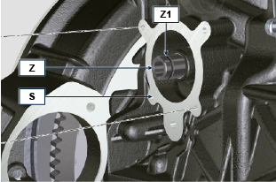  Fig 11.74  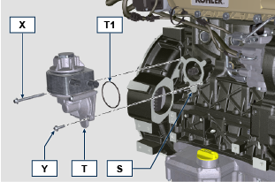  Fig 11.75
- Fix the unions H to the head J placing the gasket H1 in-between (tightening torque of 40 Nm ). | 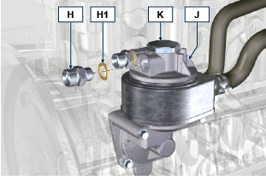  Fig 11.76
- Fix the unions L to the support M placing the gaskets L1 in-between (tightening torque of 40 Nm ).  - Lubricate the gasket N1 and fix the cartridge N to the support M (tightening torque of 20 Nm ). | 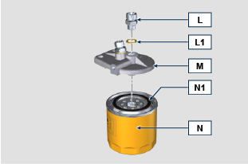  Fig 11.77
- Connect the tubes B and C onto the unions L of the support M and H of the head J .  - hten the nuts A on the head J (tightening torque 30 Nm ).  - Tighten the nuts A on the support M (tightening torque 35 Nm ).  - Perform the operations indicated in point 1 of Par. 9.15.3 .* | Fig 11.78  Fig 11.79

Oil sump with supporting structure
11.12.1 Flywheel (J) disassembly  - Execute the operations described in Par. 7.12.1 .  11.12.2 Plate/flange housing (L) disassembly  - Loosen supplementary capscrews A and B .  - Execute the operations described in Par. 7.12.2 .  - Remove housing or plate L . | 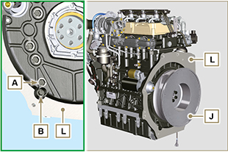  Fig. 11.80

11.12.3 Oil sump disassembly  - Execute the operations described in Par. 5.2 .  - Loosen capscrews C and remove bypass tube D .  - Loosen capscrews E and remove oil sump F . | 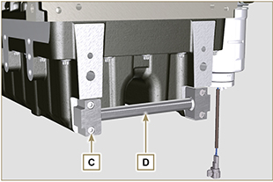  Fig. 11.81

11.12.4 Oil sump assembly  - Make sure contact surfaces G of oil sump F and crankcase H have no impurities.  - Apply a sealing bead of approximately 2.5 mm ( Loctite 5660 ) onto surface G of crankcase H .  - Place oil sump F onto crankcase H in correspondence with the fastening holes (use tool ST_18 ). | 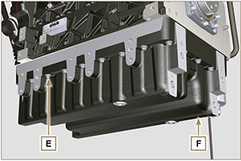  Fig. 11.82

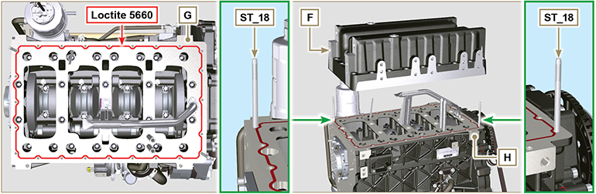
Fig. 11.83

- Apply capscrews E into the fastening holes and use torque at 10 Nm .  - Loosen capscrews E , leaving approximately 1 mm leeway ( position A ) between the neck surface of capscrews E and oil sump F .  - Place flange housing or plate L onto crankcase H , complying with centring tap pins M .  - Using 2 capscrews A , fasten housing or plate L onto crankcase H (tightening torque at 20 Nm ).  - Using 2 capscrews A , fasten housing or plate L onto oil sump F (tightening torque at 20 Nm ). | 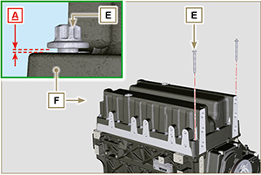  Fig. 11.84

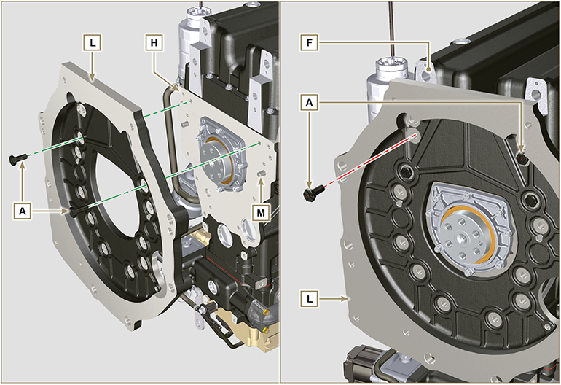
Fig. 11.85

- Fasten oil sump F by tightening capscrews E and strictly following the order shown in Fig. 11.73 (tightening torque at 20 Nm ).  - Loosen capscrews A and remove housing or plate L ( Fig. 11.72 ).  - Fasten oil sump F by tightening capscrews E and strictly following the order shown in Fig. 11.73 (tightening torque at 47 Nm ).  Loosen the screw 1 again and tighten it to 47 Nm . | 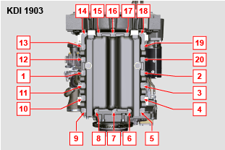  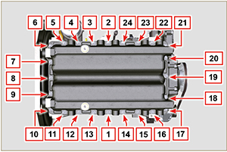  Fig. 11.86

- Insert gaskets N into seats P of bypass tube D .  - Fasten bypass tube D onto oil sump F using capscrews C (tightening torque at 10 Nm ). | 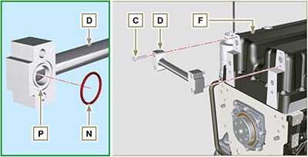  Fig. 11.87

11.12.5 Flange plate / housing assembly  - Execute the operations described in point 6 of Par. 11.12.4 .  - Fasten housing or plate L by using capscrews A and strictly following the order shown in Fig. 11.75 (tightening torque at 85 Nm ).  - Fasten housing or plate L by using capscrews B (tightening torque at 270 Nm ).  11.12.6 Flywheel assembly  - Execute the operations described in Par. 9.5.2 . | 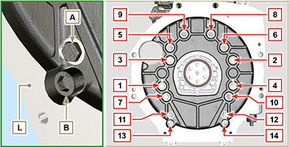  Fig. 11.88

ETB (replacement)
- Unscrew screws A and remove the ETB valve B with its gasket C .  Important  - Always replace the gasket C at each assembly. | 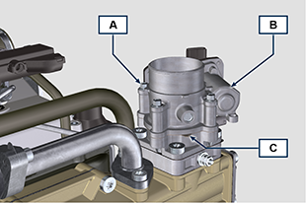  Fig. 11.89
- Fix the ETB valve B and its gasket C by means of screws A (tightening torque 10 Nm ) | 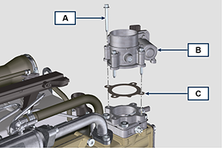  Fig. 11.90

ACACT (replacement)
- Unscrew sensor A and its gasket B .  Important  - Before assembling the new sensor, see Par. 2.17.5  - Always replace the gasket B at each assembly. | 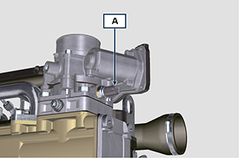  Fig. 11.91
- Fix sensor A and gasket B on their support C (tightening torque 20 Nm ). | 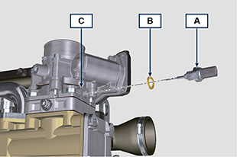  Fig. 11.92

EGTS (Black | Yellow - replacement)
- Unscrew sensors A .  Important  - Before assembling the new sensor, see Par. 2.17.6 | 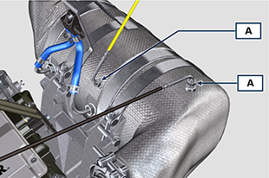  Fig. 11.93
- Fix sensors A on the ATS B (tightening torque 30 Nm ). | 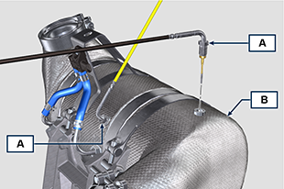  Fig. 11.94

DPF & DOC filter (replacement)
Danger
- Highly carcinogenic material!
- The dust contained inside the DPF is particularly fine and therefore classified as highly dangerous to living beings.
- Before proceeding to any operation, wear:
dust mask
gloves
goggles
- Do not allow any other operator who is not equipped with the above mentioned protective equipment to approach.
- Obtain a new replacement KIT for the DPF filter or a replacement KIT with regenerated DPF filter from your spare parts service.  Important  - Before disassembling/assembling any sensors, see Par. 2.17.5 and 2.17.6  - Always replace the seal P upon every assembly.  - During disassembly, do not expose the DPF to the surrounding environment for a long time and store it in a sealed bag as soon as possible.  - During disassembly operations, avoid using electric screwdrivers as vibrations could release the dust inside the DPF  - Do not try to clean the DPF  - Do not blow with compressed air  - Do not release the DPF or the dust contained in it in the environment  - Dispose of the DPF only in authorised centres  - Perform the operations indicated in point 1 of Par. 11.15 .  - Open the package of the DPF replacement KIT, taking care not to damage it.  - Unscrew screw A and loosen clamps B , then remove the Delta-P sensor D .  - Disconnect pipes C from their unions J and remove the Delta-P sensor D .  - Unscrew and remove unions J . | 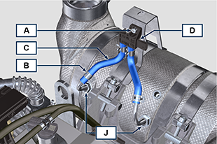  Fig. 11.95
- Loosen clamps E and remove manifold N . | 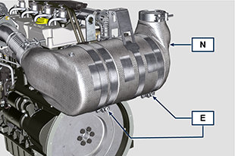  Fig. 11.96
- Loosen clamp G and remove the DPF filter H .  NOTE: do not remove clamp G .  - Inspect the DPF filter to detect any visible signs of oil contamination.  - Put the removed DPF filter in the plastic container supplied with the replacement KIT and send it to your spare parts service using the replacement KIT package.  NOTE : a residual value will be recognised depending on whether the used DPF is intact and recyclable or damaged and requiring a correct disposal. | 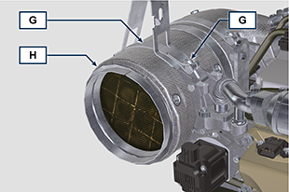  Fig. 11.97
- Loosen the clamps Q and S and remove the manifold with DOC M from the flexible hose R . | 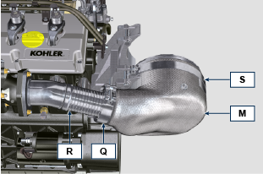  Fig. 11.98
- Fit the new manifold with the DOC filter M on the support T , inserting the flexible hose R inside the inlet of the manifold M . | 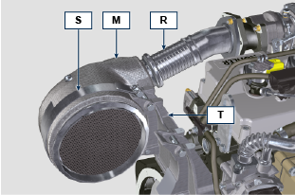  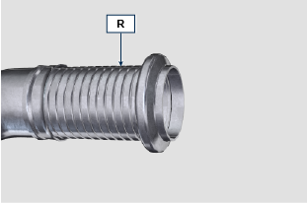  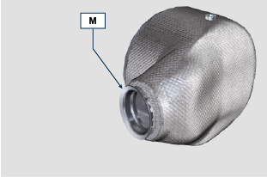  Fig. 11.99
Important  - Do not apply any tension during the assembly of components.  - Before fastening the manifold M , it must be oriented in the same position as the previously installed DOC filter.  - Tighten the clamp Q (tightening torque of 10 Nm ).  - Tighten the clamp S (tightening torque of 12 Nm ). | Fig. 11.100
- Insert the gasket P on the manifold with DOC filter M .  - Insert the new DPF filter H inside clamp G .  - Insert the DPF filter H on manifold M until reaching the gasket P . | 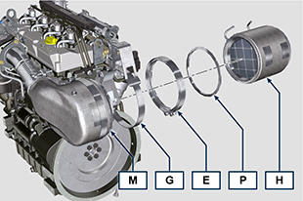  Fig. 11.101
Important  - Before fastening the DPF filter H , it must be oriented in the same position as the previous filter.  - Do not apply any tension during the assembly of components.  - Fasten the DPF filter H with clamp E (tightening torque 12 Nm ). | 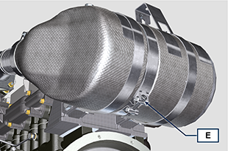  Fig. 11.102
- Insert gasket P on the DPF filter H .  - Insert manifold N on the DPF filter H until reaching the gasket P .  Important  - Before fastening manifold N , it must be oriented in the original position.  - Fasten manifold N with clamp E (tightening torque 12 Nm ). | 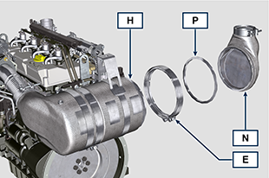  Fig. 11.103
- Position support K in contact with support K1 and fasten clamp G (tightening torque 12 Nm ). | 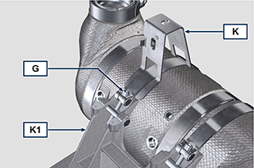  Fig. 11.104
- Screw unions J on the DPF filter H and position them about 20° away from the centre line (as in Fig. 11.90 ). | 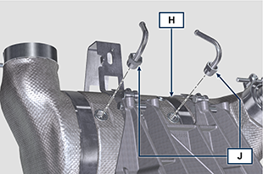  Fig. 11.105
- Fix unions J (tightening torque see service letter 700025 ). | 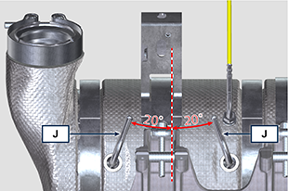  Fig. 11.106
- Fit pipes C on unions J and fasten them with clamps B .  - Fix the Delta-P sensor D on its support K by means of screw A (tightening torque 10 Nm ).  - Provide the machine owner with the warranty certificate of the new DPF filter KIT installed.  - Perform the " DPF replacement " procedure to reset the ASH & SOOT through the relevant KOHLER diagnostic tool interfaced with the ECU. | 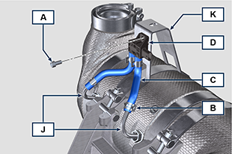  Fig. 11.107

Oil dipstick on timing gears side
Important

- Before proceeding with operation, read Par. 3.3.2 .
11.17.1 Check  - Remove dipstick A .  - Verificare che il segno lasciato dall'olio sull'asta sia tra le tacche MIN e MAX .  NOTE: Check the condition of seal A1 every time dipstick A is inserted into dipstick tube D . | 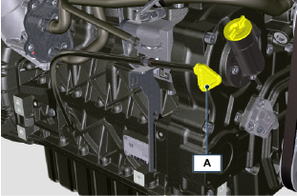  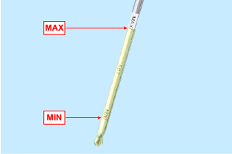  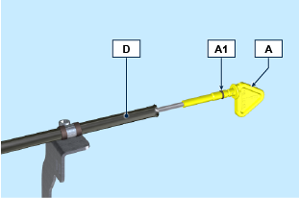  Fig 11.108
11.17.2 Replacement  11.17.2.1 Disassembly  - Unscrew screws B and C .  - Remove the oil dipstick tube D from crankcase H along with support E.  - Unscrew screw F and remove the dipstick tube D from support E along with cable tie G . | 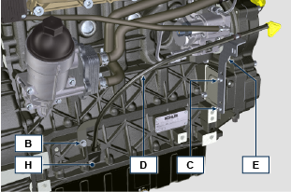  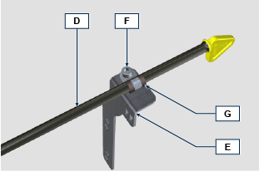  Fig 11.109
11.1.2.2 Assembly  Important  - Always replace O-ring D1 during every assembly.  - Insert cable tie G on dipstick tube D.  - Fit the clamp G onto support E using screw F .  NOTE: Do not tighten screw F.  - Insert the dipstick tube D into position on the crankcase H .  - Position the support E onto cover L , slide clamp G onto the tube D to ensure the correct position.  - Secure the clamp G onto support E (tightening torque 10 Nm ). | 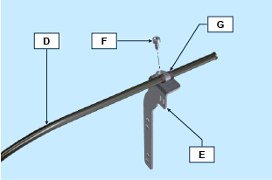  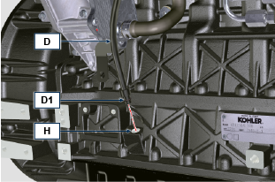  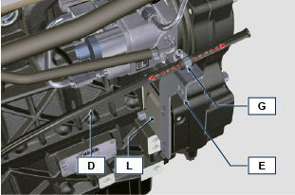  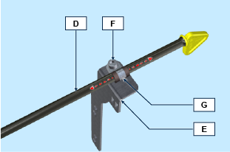  Fig 11.110
- Secure support E using screws C onto crankcase H (tightening torque at 25 Nm ).  - Secure the dipstick tube D to the crankcase H using screw B (tightening torque at 25 Nm ). | 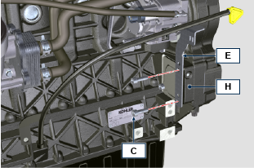  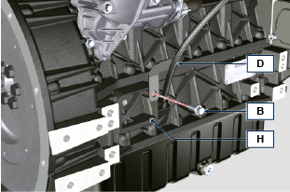  Fig 11.111

Crankshaft pulley (2nd PTO)

Disassembly  - Disassemble the starting motor.  - Mount the tool ST_34 in the seat of the starter motor and fit it with the two starter motor fixing screws. | 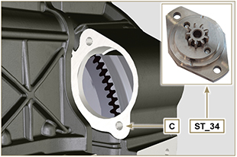
- Position the crankshaft with the 1st cylinder in TDC, reference X1, X2 upwards. | 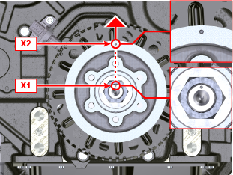
- Undo the nut A (clockwise), remove the washer B and the pulley/targetwheel unit C . | 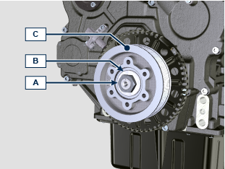
Montaggio  - Position the pulley assembly C on the crankshaft D with the X2 reference upwards and in line with the X1 reference.  - Position the washer B on the crankshaft D .  - Fix the pulley C using the nut A (tightening torque 240 Nm + Loctite 242 on the thread) and remove the tool ST_34 . | 