General Information
KDI 2504 M-MP Owner Manual (Rev.01)

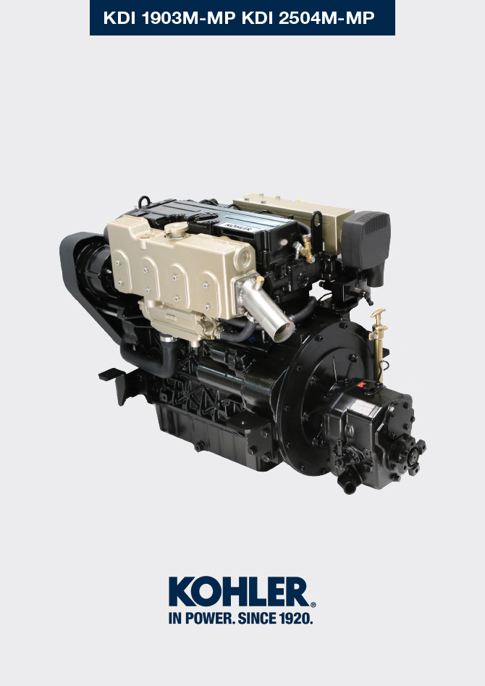
Sommario
1. TITOLO 1 2
1.1. Asdfsdfsdf 2
1.2. Asdfsdfsdfggg 2

General Information

Manual's Purpose
- This manual contains the instructions needed to carry out proper use and maintenance of the engine, therefore it must always be available, for future reference when required.
- This manual is an integral part of the engine, in the event of transfer or sale, it must be attached to it.
- Safety pictograms can be found on the engine and it is the operator's responsibility to keep them in a perfectly visible place and replace them when they are no longer legible.
- Information, description and pictures in this manual reflect the state of the art at the time of the marketing of engine.
- However, development on the engines is continuous. Therefore, the information within this manual is subject to change without notice and without obligation.
- Lombardini Marine reserves the right to make, at any time, changes in the engines for technical or commercial reasons.
- These changes do not require Lombardini Marine to intervene on the marketed production up to that time and not to consider this manual as inappropriate.
- Any additional section that Lombardini Marine will deem necessary to supply some time after the main text shall be kept together with the manual and considered as an integral part of it.
- The information contained within this manual is the sole property of Lombardini Marine . As such, no reproduction or replication in whole or part is allowed without the express written permission of Lombardini Marine .

Glossary and Definitions
The paragraphs, tables and figure are divided into chapter with their progressive numbers.
Ex:
Par. 2.3 - chapter 2 paragraph 3.
Tab. 3.4 - chapter 3 table 4.
Fig. 5.5 - chapter 5 figure 5.

The references of the objects described in the text and in figure and number are indicated by letters, which are always and only related to the paragraph you are reading unless there are specific references to other figures or paragraphs.

NOTE: All data, measurements and relevant symbols are shown in the glossary section.

Emission
Conforme alla normativa 9768 Stage III A per i mercati CE .

Service request
- Authorized service centers can be found on our web site: http://www.lombardinimarine.com .
- If you have any questions regarding your warranty rights and responsibilities or the location of the nearest authorised service location, contact +39 07462251 or go to http://www.lombardinimarine.com .

Engine component identification
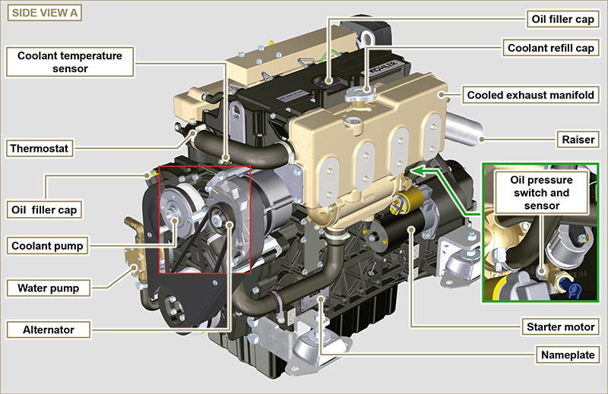

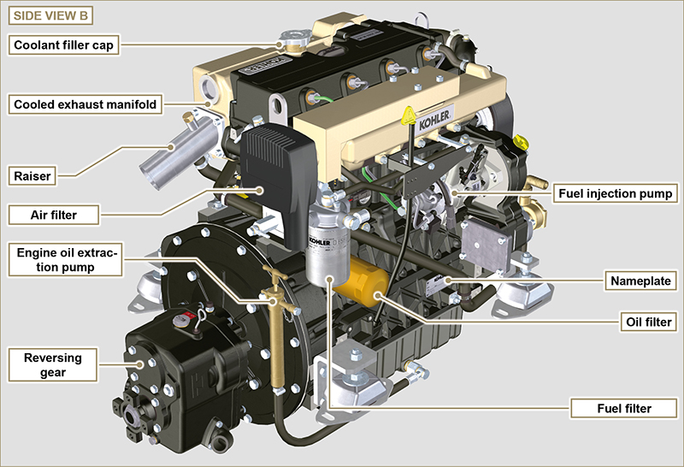

Manufacturer and motor identification data
The engine identification nameplate is located on side A or B as below.

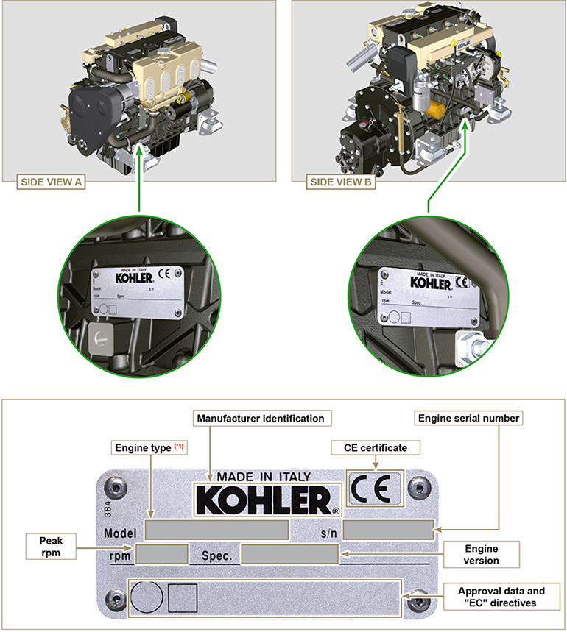
Fig. 1.3

(*1): the engine model reported on the name plate in Fig. 1.3 is generic. For a specific model, refer to the engine model shown on the name place situated on the rocker arm cover, as shown in Fig. 1.4 . | Fig. 1.4

