Information about use
KDI 2504 M-MP Owner Manual (Rev.01)

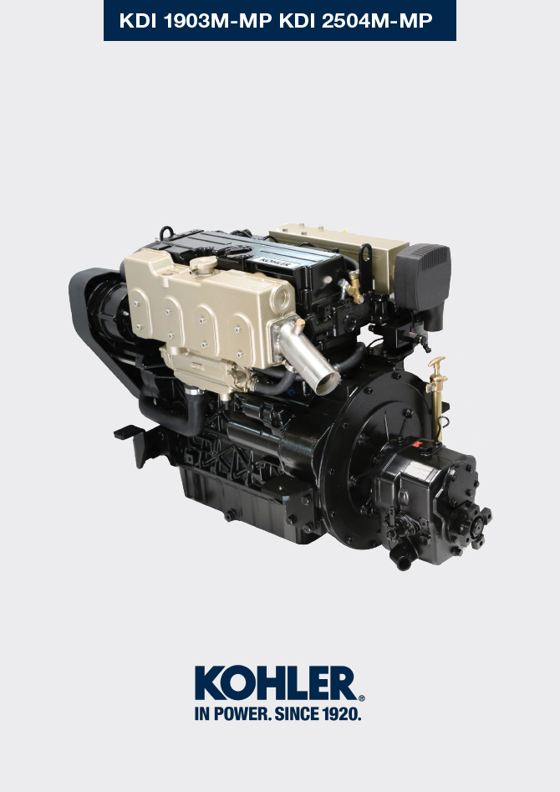
Sommario
1. TITOLO 1 2
1.1. Asdfsdfsdf 2
1.2. Asdfsdfsdfggg 2

Information about use

Pre-start check
- Read carefully the following pages and carry out the operations described below in accordance with the instructions specified.

Important

- Non compliance with the operations described in the following pages involves the risk of damages to the engine and vehicle on which it is installed as well as personal and/or property damage.
- Increase the frequency of maintenance operations in heavy working conditions (engine starts but stops, very dusty and hot environments, etc..).

Break-in running
NOTE: For the first 50 hours of engine operation, it is advisable not to exceed 75% of the maximum power supplied.

Starting and turning off
4.3.1 Starting  - Check the level of the engine oil, fuel and coolant and fill if necessary ( Par. 4.5 e Par. 4.6 ).  - Put the ignition key in the ignition switch.  - Tun the key to 1 position.  - Press the Start push button for it to start automatically.  Important  - RPM reading delay is normal.  - If engine does not start after two attempts see Tab. 7.1 and Tab. 7.2 to found the cause. | 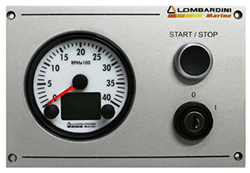  Fig. 4.1
4.3.2 After starting
Warning

- Make sure that all the warning lights on the control panel are off when the engine is running.
- Check for any leakages from the pipes on first start-up

AMBIENT TEMPERATURE | TIME
≤-20°C | 2 minutes
from -20°C a -10°C | 1 minutes
from -10°C a -5°C | 30 seconds
from -5°C a 5°C | 20 seconds
≥ 5°C | 15 seconds

4.3.3 Turning off

- Do not turn off the engine with a full load or when it is running at the maximum rotation speed. Leave it running at idle speed without a load for approximately 1 minute .
- Press the Stop push button (the engine turns off) and turn the key to position 0 .

Refuelling

Important

- Before proceeding with operation, read Par. 3.2.2 .

Danger

- Fill the engine off.
- The only approved fuels are those listed in Tab. 2.3 .
- In those countries where fuel has a high sulphur content, its is advisable to lubricate the engine with a high alkaline oil or alternatively to replace the lubricating oil recommended by Lombardini Marine more frequently.
- To avoid explosions or fire outbreaks, do not smoke or use open flames during the operations.
- Fuel vapours are highly toxic.Only carry out the operations outdoors or in a well ventilated place.
- Keep your face well away from the fuel fill to prevent harmful vapours from being inhaled.
- Dispose of fuel in the correct way and do not litter as it is highly polluting.
- When refuelling, it is advisable to use a funnel to prevent fuel from spilling out.The fuel should also be filtered to prevent dust or dirt from entering the tank.
Do not overfill the fuel tank. Leave room for the fuel to expand.

Oil filling
Important

- For safety precautions see Par. 2.4 .
- Before proceeding with operation, read Par. 3.2.2 .
- Place engine on horizontal surface to ensure accurate measurement of filling.
- Loosen the oil filler cap A or the oil filler cap C if the cap A is not accessible.  - Add the type of oil recommended ( Tab. 2.1 and Tab. 2.2 ). | 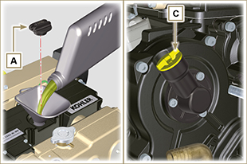  Fig 4.2
- Remove the oil dipstick B and check that the level is up to but does not exceed the MAX .  - If level is not at the MAX . level, add additional oil.  - Re-tighten the cap A or C .  Important  - Do not exceed the MAX level on the dipstick.  - Do not use the engine with the oil level below the MIN . | 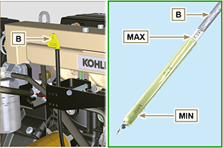  Fig 4.3

Reversing gear oil top-up
Important

- For safety precautions see Par. 2.4 .
- Before proceeding with operation, read Par. 3.2.2 .
- Place engine on horizontal surface to ensure accurate measurement of filling.
- Loosen the oil filler cap A.  - Add the type of oil recommended ( Par. 2.4.2 ). | 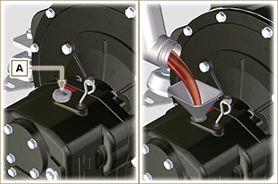  Fig 4.4
- Remove the oil dipstick B and check that the level is up to but does not exceed the MAX .  - If level is not at the MAX level, add additional oil and reinsert the dipstick correctly in the reversing gear seat C .  - Re-tighten the cap A or C .  Important  - Do not exceed the MAX level on the dipstick.  - Do not use the engine with the oil level below the MIN . | 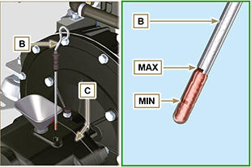  Fig 4.5

Coolant filling
Important

- Before proceeding with operation, read Par. 3.2.2 .
- Place engine on horizontal surface to ensure accurate measurement of filling.

Warning

- An anti-freeze protection liquid (ANTIFREEZE) - mixed with decalcified water - must be used.
- The freezing point of the refrigerant mixture depends on the amount concentration in water.
- As well as lowering the freezing point, the antifreeze also raises the boiling point.
- A 50% mixture is recommended to ensure a general level at protection prevents the formation of rust, galvanic currents and calcium deposits.
NOTE: Before proceeding with any operation on the engine, stop it and allow it to cool.  Warning  - Presence of steam pressurized coolant danger of burns.  - Loosen the cap A and fill the radiator with coolant composed of:  50% ANTIFREEZE and 50% decalcified water.  - Loosen the screw C, release any air and tighten the screw C (Tightening torque of 8 Nm - Fig. 4.7 ).  NOTE : The MAX filling level for exhaust manifold B is in correspondence of capscrew C , complete the coolant refilling procedure as soon as the coolant starts leaking out of capscrew C (Fig. 4.7) .  - Re-tighten the cap A .  - After a few minutes of operator, stop the engine and allow the liquid to cool returns to a ambient temperature and check the coolant level again. | 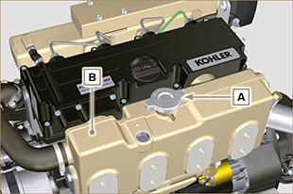  Fig. 4.6  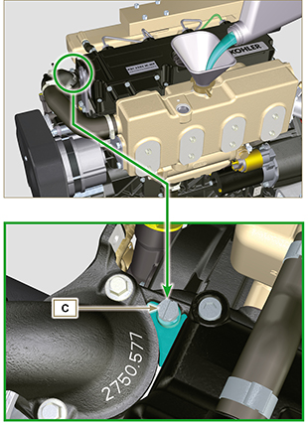  Fig. 4.7

