Information on adjustments
KDI 1903TCR / KDI 1903TCRE5 Workshop manual (Rev. 17.8)


Sommario
1. TITOLO 1 2
1.1. Asdfsdfsdf 2
1.2. Asdfsdfsdfggg 2

Information on adjustments

'Waste Gate' opening valve regulation

Important

- Before proceeding with operation, read Par. 3.3.2 .
- Regulation must not be carried out with the engine running.
- During the procedure in point 5 , pay special attention not to bend rod H .

- Disconnect the hose A from the turbocharger, and connect a pressure gauge B (scale from 0 to 5 bar).
- Connect the gauge B to the network of compressed air, interposing a pressure reducer C .
- Position dial gauge D in such a way that feeler F rests onthe Waste Gate rod control valve extremity H (point E ).
- By using gradually the reduction gear C send the air to the Waste Gate actuator control L in order to move rod H forward by 1 mm (value M to check on dial gauge D). Pressure read on gauge B must be: 1350 mbar for engine model KDI 2504 TCR and 1250 mbar for engine model KDI 1903 TCR.
- If pressure is less or more than the indicated value, proceed as follows: - Undo lock nut G from rod H.

- Remove the retainer cotter pin (point E ) and disconnect rod H from the Waste Gate control lever.
- Tighten (to increase) / or loosen (to decrease) pressure of the ring nut of rod H until reaching the corrected calibration.
- Redo lock nut G .
- Reconnect rod H and assemble the cotter pin point E .

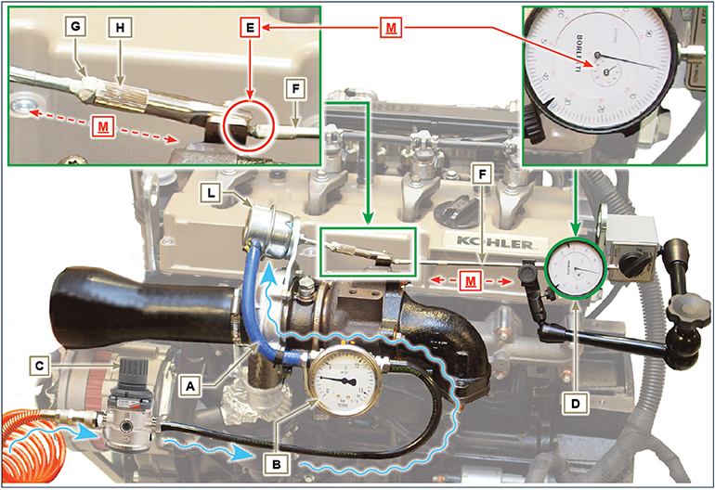
Fig 12.1

Air filter check
Important

- Before proceeding with operation, read Par. 3.3.2 .
- When the cartridge G is dirty, do not clean it but replace cartridges B and G .

- All manifolds connected to the turbo must be fully clean and not damaged.  - Clean the inside components A and D with a damp cloth.  - Do not use compressed air , repeatedly tap the front side E on a flat surface. | 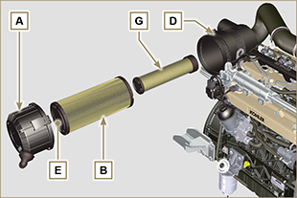  Fig 12.2

Oil steam separator check
Important

- Before proceeding with operation, read Par. 3.3.2 .

- Loosen clamp B and remove hose C from hose D .  - Start the engine at idle speed or without a load; check if air comes out of hose C .  NOTE: If what is described in Point 2 does not occur, proceed with cleaning or replacing oil separator A and accurately clean support flange F , all connecting  hoses, and repeat the operation from P oint 2. | 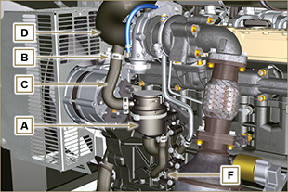  Fig 12.3

Rubber hoses and manifolds check
Important

- Before proceeding with operation, read Par. 3.3.2 .
The check is carried out by applying slight deflection or bending along the tube/hose and next to the hose clamps.  Components must be replaced if they have clear signs of cracks, tears, cuts, leaks, or do not retain a certain degree of elasticity.  - Check the condition of all rubber hoses A .  - Check whether there are any leakages of air, refrigerant, oil or fuel next to their connections. | 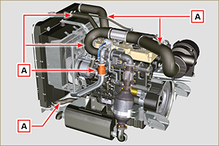  Fig 12.4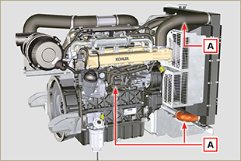  Fig 12.5

Oil leak check
Important

- Before proceeding with operation, read Par. 3.3.2 .

Check that there are no leakages next to area A .  - Start the engine at idle speed or without a load and check whether there are any leakages next to area A.  - It is anyhow necessary to also check the seals of all main components and their surface contact, such as:  - crankcase and gasket (side 1 ª PTO) - oil sump and exhaust caps  - cylinder head and its assembled components  - rocker arm cover  - Timing system carter and gasket (side 2 ª PTO) - oil dipstick housing or rod support tube.  NOTE: Perform the checks described in Points 1 and 2 periodically and during maintenance procedures.  It is also necessary to check for leakages on the components that are not listed.  If necessary, disassemble the components that have a leakage and investigate the possible cause.  The components must be replaced otherwise they do notguarantee their sealing. | 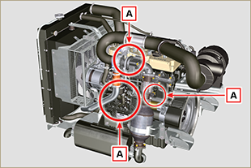  Fig 12.6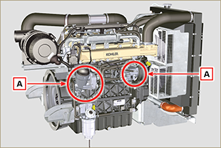  Fig 12.7

Oil pressure check
Important

- Before proceeding with operation, read Par. 3.3.2 .
- Insert a thermocouple instead of the oil dipstick A .  - Unscrew and remove the oil pressure switch and screw on a 10 bar pressure gauge in its seat (Fig. 12.10) .  - Start the engine at idle speed and without a load, check the oil pressure value according to the oil temperature (Fig. 12.9 ).  NOTE : The graph in Fig. 12.9 illustrates the pressure line with speed of 1000 Rpm.  - If the pressure values are below the values indicated in Fig. 12.9 , check to identify the cause of the problem.  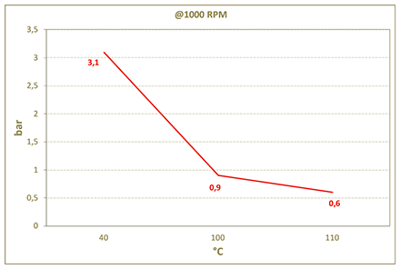  Fig. 12.9 | 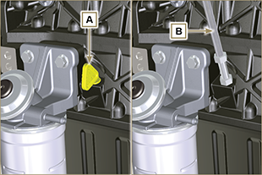  Fig. 12.8  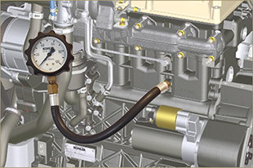  Fig. 12.10

