Information about replacements
KDI 3404 TCR-SCR Owner Manual (REV. 03.7)

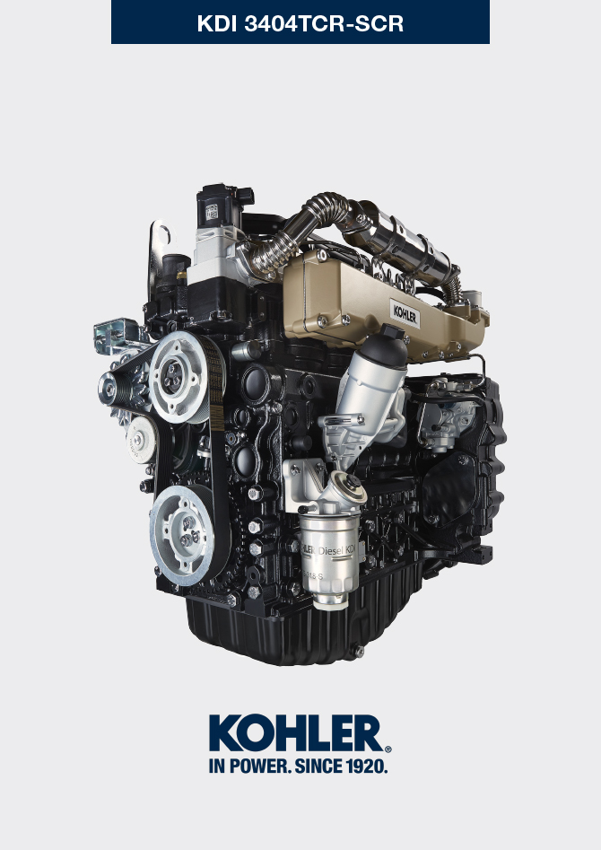

Registration of modifications to the document
Any modifications to this document must be registered by the drafting body, by completing the following table.

Released by | Code | Revision | Release Date | Revision date | Edited by | Endorsed
 | 3404tcr

Translated from the original manual in Italian language
Data reported in this issue can be modified at any time by KOHLER.

Sommario
1. TITOLO 1 2
1.1. Asdfsdfsdf 2
1.2. Asdfsdfsdfggg 2

Information about replacements

Engine oil replacement
Danger:
- Disconnect the negative wire (-) from the battery to avoid accidental engine starting.

Important:
- Before proceeding with operation, read Cap. 3 .

Important :  - Place engine on level surface to ensure accurate measurement of oil level.  Before proceeding, perform the operation described in Par. 6.2 - Point 1.  NOTE: Perform this operation with warm engine, to get a better fluidity of the oil and get a full discharge of oil and impurities contained in it. | 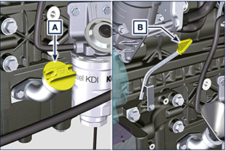  6.1
- Loosen the oil filler cap A (Fig. 6.1).  - Remove the oil dipstick B.  - Remove the oil drain plug D and the gasket E (the oil drain plug is on both sides of the oil sump).  - Drain oil in an appropriate container (For the exhausted oil disposal, refer to ( Par. 6.6 DISPOSAL and SCRAPPING ).  - Replace gasket E.  - Tighten the drain oil plug D (tightening torque at 50 Nm).  - Perform the operation described in Par. 6.2 - point 2 to 5. | 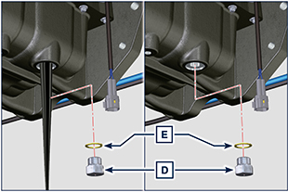  6.2
- Add the type oil recommended ( Tab. 2.1 and Tab. 2.2 ).  Important :  - Do not exceed the MAX level on the dipstick.  - Do not use the engine with the oil level below the MIN.  - Fit and remove the oil dipstick B to check the level. Pour in fluid until reaching the MAX level mark.  - Upon completion, reinstall the oil dipstick B completely.  - Tighten the cap A. | 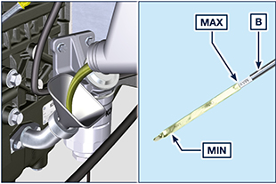  6.3
NOTE: Click on the icon to play the procedure. | https://www.youtube.com/embed/T7XFP3Vn_q0?rel=0

Oil filter cartridge replacement
Important

- Before proceeding with operation, read Par. 3.2.2

Warning:
- Oil filter cartridge replacement (Par. 6.2) and fuel filter replacement ( Par. 6.3 ).
- In case of low use replace it 12 months.
- For disposal of oil filter cartridge and fuel filter refer to Par. 6.6 DISPOSAL and SCRAPPING .
Important:  - Electric/pneumatic screwdrivers are forbidden  - Unscrew cartridge holder cover A by performing three complete turns and wait 1 minute.  NOTE: This operation allows to oil contained in the support F to flow into the oil sump in the correct way.  - Unscrew cartridge holder cover A and check that the oil in the lub. oil filter support F has flowed towards the oil sump.  - Remove the cap A as well as the oil cartridge B from the oil filter support.  - Remove and replace the oil cartridge B with a new one. Remove and replace the gaskets C, D and E with new ones. | 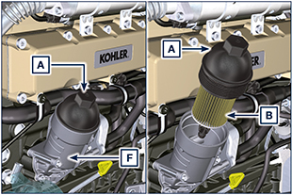  6.4  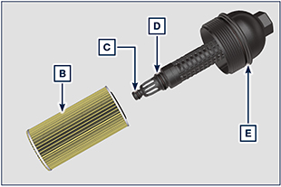  6.5
- Fit and tighten the cover A on the oil filter support F, tightening it with a torque wrench G (tightening torque of 25 Nm). | 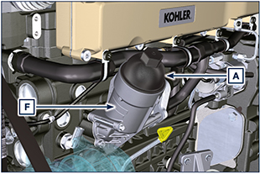  6.6
NOTE: Click on the icon to play the procedure. | https://www.youtube.com/embed/eTL3NSUrZHQ?rel=0?rel=0

Filter cartridge and fuel pre-filter replacement
NOTE: The fuel filter is situated on the crankcase of the engine or it may be assembled on the frame of the vehicle.  Important  - Before proceeding with operation, read Par. 3.2.2  Warning  - In case of low use replace il 12 months.  - For disposal of oil filter cartridge and fuel filter refer to Par. 6.5 DISPOSAL and SCRAPPING  - Disconnect the cable A of the water presence sensor C.  - Remove the water presence sensor C from its cartridge B.  - Loosen the cartridge B using the appropriate wrench (Fig. 6.8).  - Lubricate the gasket D of the new cartridge B.  Important:  - Do not fill the new cartridge B with fuel.  - Tighten the new empty cartridge B (Fig. 6.8) on the diesel fuel filter support E using the special wrench (tightening torque of 17 Nm).  - Tighten the water presence sensor C on the new cartridge B (tightening torque of 5 Nm).  - Reconnect the cable A of the water presence sensor C.  NOTE: Bleeding.  - Push repeatedly the button G in order to fill the circuit. | 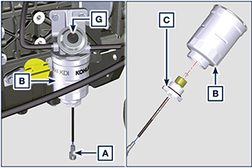  6.7  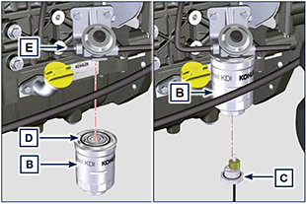  6.8
NOTE: Click on the icon to play the procedure. | https://www.youtube.com/embed/eHPkX9yprM4?rel=0?rel=0

Air filter cartridge replacement
Important
- Before proceeding with operation, read Par. 3.2.2

NOTE: Component not necessarily supplied by KOHLER.
- Pull insert F to unlock cover A.  - Rotate counter clockwise and remove cover A. | 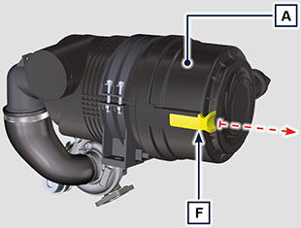  6.9
- Remove the cartridges B and G.  - Fit cartridges G and B.  - Fit cover A by performing the operations indicated in points 2 and 1 in the reverse order. | 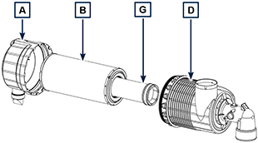  6.10

Replacement of AdBlue®/DEF filter
Warning
- Before proceeding with operation, read Par. 3.2.2
- Do not lubricate gaskets A with oil or fuel.
- Filter D includes gaskets A in the package.
- Avoid any type of contamination during replacement.
- Before starting any operations, make sure the key on the machine’s panel is OFF and the AdBlue®/DEF pump has executed the circuit emptying operation.
- Loosen cap B. | 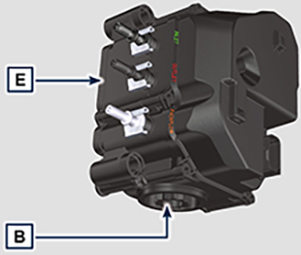  6.11
- Remove cap B and extract filter bracket C.  - Extract filter D.  - Use warm AdBlue®/DEF to clean the seat of filter D on pump E if impurities are detected.  - Lubricate the A gaskets with AdBlue®/DEF or distilled water.  - Place the filter bracket C together with filter D inside pump E.  - Tighten cap B (tightening torque of 20 Nm). | 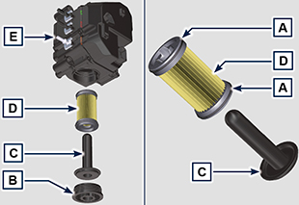  6.12

Disposal and scrapping
- In case of scrapping, the engine shall be disposed of in appropriate locations, in conformity with the law in force.
- Before scrapping, it is necessary to separate the rubber or plastic parts from the rest of the components.
- The parts only composed of plastic material, aluminium and steel can be recycled if collected by the appropriate centers.
- Waste oil must properly be recycled and disposed of in the correct way to safeguard the environment. According to the laws in force, it is classified as hazardous waste, therefore it must be collected by the appropriate centers.

