Information for disassembly
KDI 2504 TM Workshop manual (Rev. 07.6)

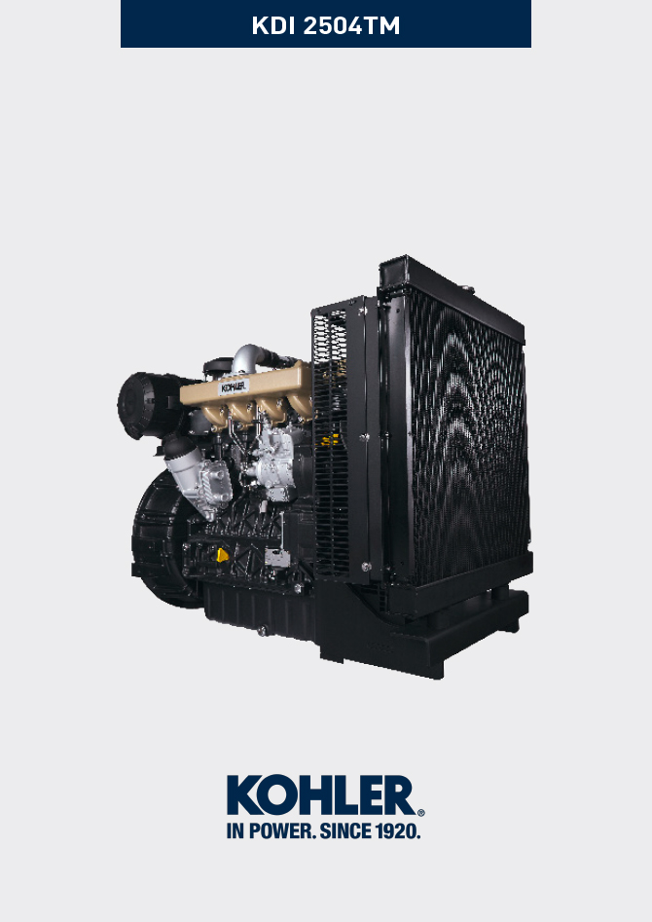

Registration of modifications to the document
Any modifications to this document must be registered by the drafting body, by completing the following table.

Released by | Code | Revision | Release Date | Revision date | Edited by | Endorsed
null | manoff

Translated from the original manual in Italian language
Data reported in this issue can be modified at any time by KOHLER.

Sommario
1. TITOLO 1 2
1.1. Asdfsdfsdf 2
1.2. Asdfsdfsdfggg 2

Information for disassembly

Recommendations for disassembly

Important

- The mark ( ) after the title of a paragraph, indicates that the procedure is not required in order to disassemble the engine, however the procedures are featured in order to illustrate the disassembly of components.
- The operator should prepare all equipment and tools in order to enable him to carry out the operations correctly and safely.
- Before disassembly, perform the operation described in Chap. 5 .
- Before proceeding with operation, carefully read Chap. 3 .
- In order to operate safely and easily, we recommend positioning the engine on a rotating stand for engine overhauling.
- eal all injection component unions as illustrated in Par. 2.9.7 during assembly.
- Protect all disassembled components and coupling surfaces subject to oxidation with lubricant.
- Where necessary, reference to special tools to use during disassembly operations is indicated (es. ST_05 ), identified in Tab. 13.1 - 13.2 - 13.3 .

Electric components disassembly
7.2.1 Electric wiring

- Disconnect and remove the engine wiring.
NOTE : refer to Par. 2.13.1.3 to disconnect all connectors.
7.2.2 Starter motor  Important  - The motor is not repairable.  - Undo the screws A and remove the starter motor B .  - Mount the tool ST_34 in the seat of the starter motor P and fit it with the two starter motor fixing screws to block the flywheel. | 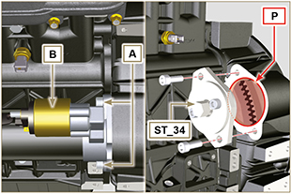  Fig 7.1
7.2.3 Belt and alternator  - Loosen the screws C and D.  - Push the alternator E in the direction of the arrow F .  - Remove the belt G from the pulleys.  Important  - The belt must always be replaced every time it is disassembled, even if it has not reached the scheduled hours for replacement  - Undo the screws C1 and D and remove the alternator E. | 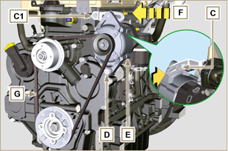  Fig 7.2
7.2.4 Sensors and switches

Important

- After disassembly, protect the sensors suitably against knocks, dampness and any high temperature sources.
- The sensors and switches cannot be repaired, therefore they must be replaced in the event of anomalies.
7.2.4.1 Oil pressure switch disassembly ( )  - Unscrew and remove oil pressure switch H . | 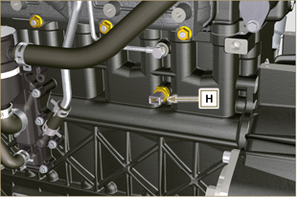  Fig 7.3
7.2.4.2 Coolant temperature sensor ( )  - Unscrew and remove the sensor L . | 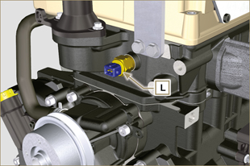  Fig 7.4
7.2.4.3 Fuel filter water detection sensor ( )  Warning  - The fuel filter is not always installed in the engine.  - When disassembling the sensor M, use a suitable container to recover the fuel contained in the cartridge N.  - Unscrew the sensor M from the cartridge N . | 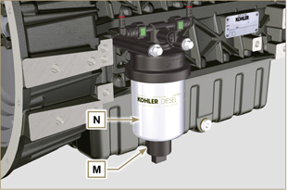  Fig 7.5

Turbocharger disassembly
- Follow operations 1 and 2 of Par. 6.1.2 .  - Release the clamps A and B and remove the manifold C .  - Unscrew the fittings D and remove the pipe E with the relative gaskets G .  - Release clamp M . | 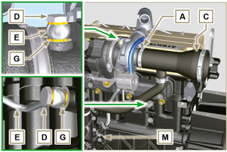  Fig 7.6
- Undo the screws F .  - Undo the nuts H and remove the turbocharger L .  - Remove tube N . | 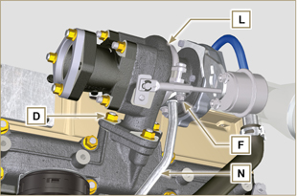  Fig 7.7

Exhaust manifold disassembly
- Undo the nuts A and remove the manifold B and the metallic gaskets C .  - Close the openings and manifolds to prevent foreign bodies from entering. | 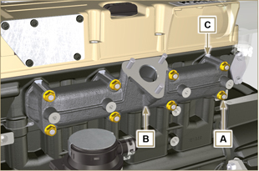  Fig 7.8

Coolant recirculation components disassembly
7.5.1 Oil Cooler manifold  - Release the clamps H .  - Undo the screw J .  - Remove the pipes K out of the Oil Cooler unit. | 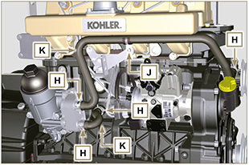  Fig 7.9
7.5.2 Thermostatic valve  - Undo the screws D and remove the thermostatic valve cover E .  - Remove the thermostatic valve F and its gasket.  Important  - Always replace the gasket G every time it is disassembled.  - Check that the air bleeding hole is not clogged or blocked ( Par. 2.11.3 ). | 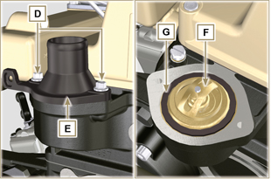  Fig 7.10
7.5.3 Coolant recirculation components disassembly  Important  - The pump B is not reparaible  - Undo the screws A and remove the water pump unit B with its gasket C . | 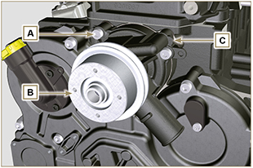  Fig 7.11

Crankshaft pulley disassembly
NOTE: Perform the operations described in Par. 6.1.5 points 2 and 3.  - Undo the screw A (clockwise - as seen from the timing system side - Ref. A Par. 1.3 ) and remove the pulley B . | 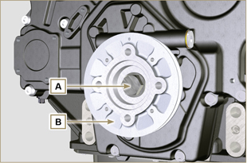  Fig 7.12

Lubrication circuit disassembly
7.7.1 Oil overpressure valve ( )  - Undo the cap A .  - Remove the spring B .  - Remove the valve piston C using a magnet. | 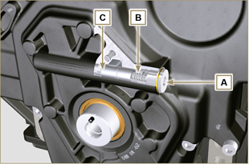  Fig 7.13
7.7.2 Timing system semi-crankcase oil filling flange ( )  - Undo the screws G and remove the oil filling flange E ( ST_06 ) .  - Remove the gasket F . | 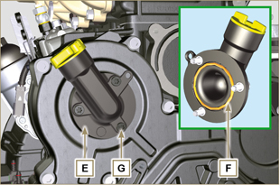  Fig 7.14
7.7.3 Timing system  - Make sure that the crankshaft with the 1st cylinder is at TDC.  - Undo the screws X .  - Remove the timing system crankcase H . | 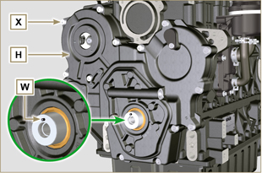  Fig 7.15
7.7.4 Oil pump  Important  - The oil pump is not repairable.  - Undo the screws M and remove the pump crankcase N from the crankcase D ( ST_06 ) . | 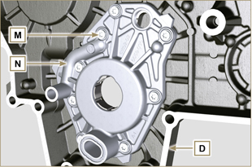  Fig 7.16
- Remove the rotors P and Q. | 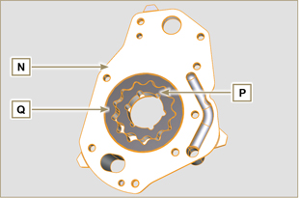  Fig 7.17
7.7.5 Gruppo Oil Cooler e filtro olio
- Follow operations of Par. 6.6.1 .

Warning
- Use a suitable container to recover any residue oil.
7.7.6 Oil vapour separator unit
1 - Follow operations of Par. 6.8.1 .

Warning

- Use a suitable container to recover any residue oil.

Intake manifold disassembly
- Undo the screws C and remove the manifold D together with the washer E . | 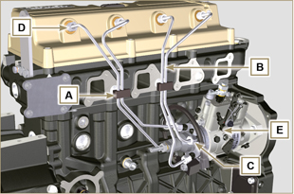  Fig 7.18

Fuel system disassembly
Important
- Seal all injection component unions as illustrated in Par. 2.9.7 .
- The fuel injection circuit undergoes high pressure, use safety protections as described in Par 3.4.3 .
7.9.1 Fuel injection pipes  - Remove loking clips A from pipes B .  - Loose nuts C and D and remove pipes B . | Fig 7.19
7.9.2 Rocker arm cover  - Undo the screws F and remove the rocker arm cap G . | 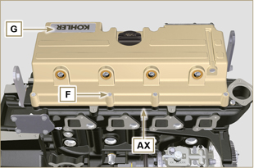  Fig 7.20
7.9.3 Fuel return pipes  - Undo the screws L and remove hose H. | 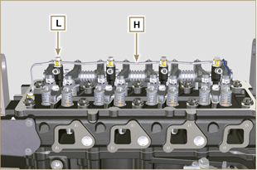  Fig 7.21
7.9.4 Injector  - Undo the screws P and remove the washers Q and the brackets M .  - Pull out the injectors N.  NOTE : Should you be unable to remove the injector (acting only on point BC ), use an open-ended spanner ( ∅ 11 mm ), by applying small rotations to unblock the component. If the washer K is not found on the injector N , recover it from inside the injector sleeve J . | 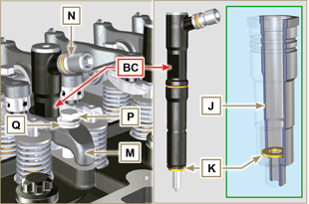  Fig 7.22
7.9.5 Injection pump  Important  - Before disassembling, carefully read Par. 2.17 .  - The injector pump cannot be repaired.  - Carry on operations described in steps 1-13 Par. 6.1.5 .  - Undo the nut S and remove it together with the washer.  - Screw the unit ST_04 on the gear R . | 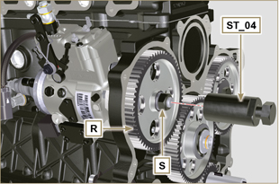  Fig 7.23
- Undo the screws T .  - Tighten the screw U of the unit in order to separate the injector pump S from the high pressure pump control gear R . | 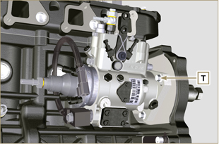  Fig 7.24  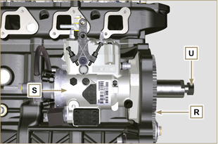  Fig 7.25
NOTE: Click by side to play the procedure. | https://www.youtube.com/embed/NaOHNXyU03c?rel=0
7.9.6 Fuel filter ( )  NOTE: to disassemble the fuel cartridge, refer to operations 1 and 2 of Par. 6.7.1 .  - Undo the screws V and remove the filter support W . | 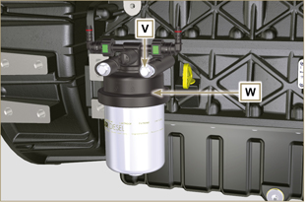  Fig 7.26

Timing system gear disassembly
- Unscrew screws C and remove camshaft gear D .  - Remove lock ring A and the shoulder ring B .  - Remove the intermediate gear L . | 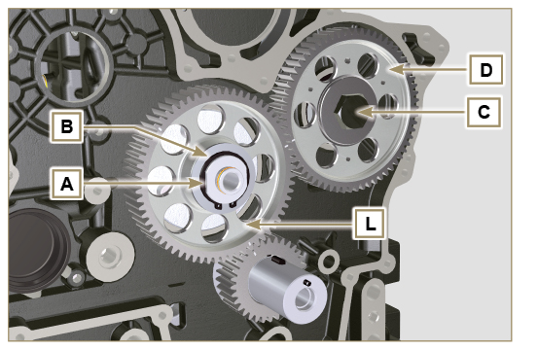  Fig 7.26
- Undo the screws F and remove the intermediate gear support G. | 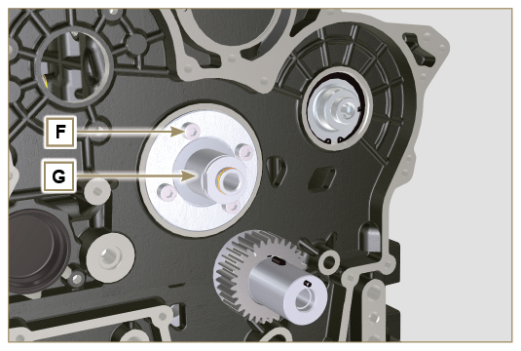  Fig 7.27

Flange unit disassembly
7.11.1 Flywheel  Important  - Leave the special tool ST_34 for blocking the flywheel.  - Only undo the screw C located upwards.  - Insert the tool ST_09 in the seat of the screw C tightening it all the way.  - Undo the remaining screws D .  Danger  - The flywheel E is very heavy, pay utmost attention while removing it in order to prevent it from falling, with serious consequences for the operator.  - Remove the flywheel E.  - Remove the tool ST_09 .  - Remove the tool ST_34 shown in Fig. 7.1 . | 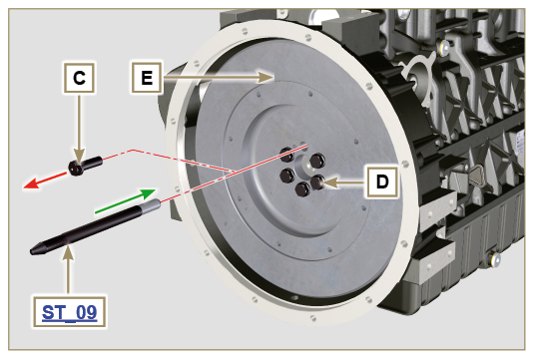  Fig 7.28
7.11.2 Flange housing  - Undo the screws F and remove the engine housing G .  Danger  - The housing G is very heavy, pay utmost attention while removing in order to prevent it from falling, with serious consequences for the operator. | 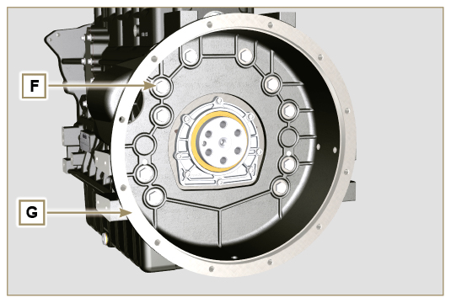  Fig 7.29

Cylinder head unit disassembly
7.12.1 Rocker arm pin  - Undo the screws A .  - Remove the rocker arm pin unit B . | 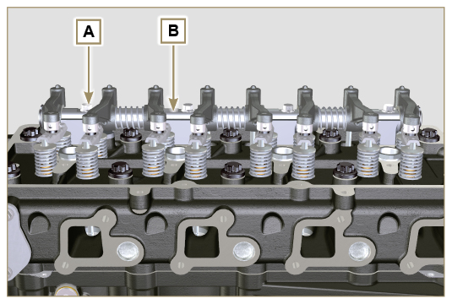  Fig 7.30
7.12.1.1 Rocker arm ( )  - Remove the retainer snap ring C .  - Remove the shoulder rings D .  - Remove the rocker arms E and springs. | 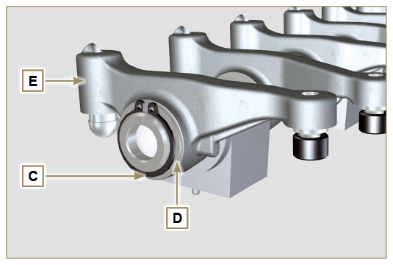  Fig 7.31
7.12.2 Rods and u-bolts  - Remove the valve control U-bolts H .  - Remove the rocker arm control rods L . | 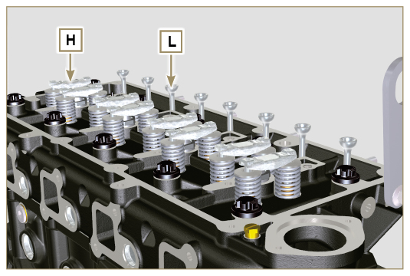  Fig 7.33
7.12.3 Cylinder head  Important  - Wait for the engine to reach ambient temperature before to remove the head in order to prevent deforming.  - The cylinder head fastening bolts M must be replaced every time they are disassembled.  - Undo the bolts M .  - Remove the cylinder head N .  Important  • Only use the eyebolts AE installed by KOHLER to move the cylinder head Q.  3. Remove the head gasket P . | 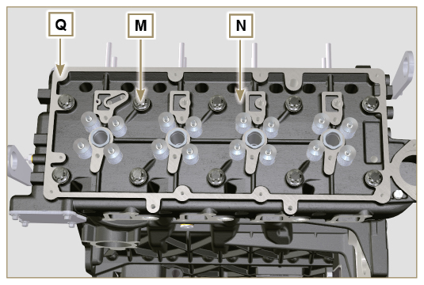  Fig 7.34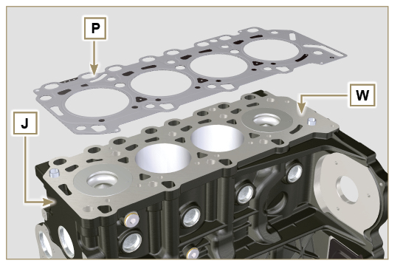  Fig 7.35
7.12.3.1 Valves ( )  - Mount the tool ST_07 on the head Q fixing it on one of the holes for fixing the rocker arm cover.  NOTE: change the fixing hole according to the position of the valves to be removed.  - Position the tool striker ST_07 on the valve concerned as shown in the figure. | 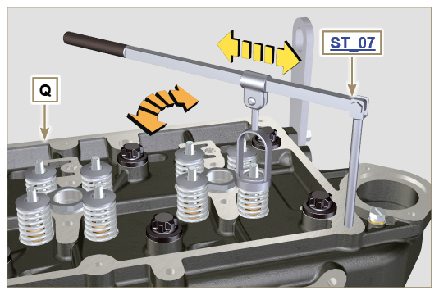  Fig 7.36
- Push the lever of the tool ST_07 downwards, in order to lower the valve plates S in the direction of the arrow T , using a magnet, remove the cotters U .  NOTE : repeat all the operations for all the valves concerned. | 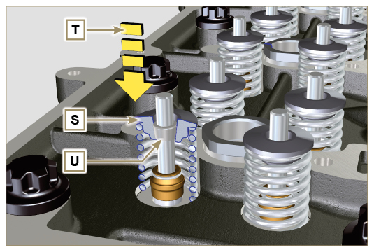  Fig 7.37
Important  - Before removing the valves, make some marks in their original position, in order to prevent confusing them when they are re-assembled, if they are not replaced.  - Remove the valves V . | 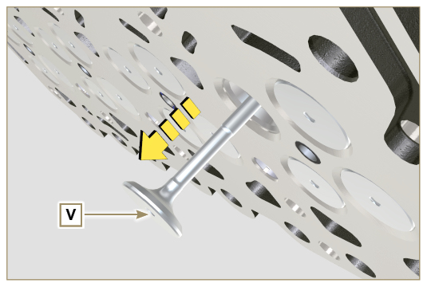  Fig 7.38
7.12.3.2 Injector sleeve ( )  - Unscrew and remove the sleeves Z from the head Q .  - Remove the gaskets AA and AB . | 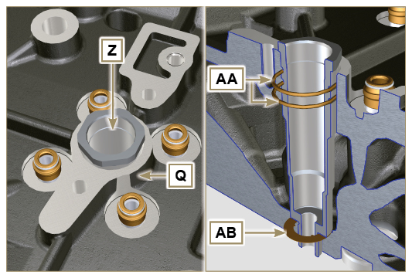  Fig 7.39
7.12.3.3 Valve steam gasket ( )  - Remove the oil seals AC . | 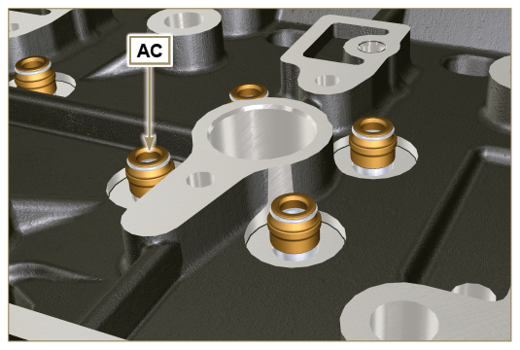  Fig 7.40
7.12.3.4 Lifting eyebolts ( )  - Undo the screws AD and remove the eyebolts AE .  - Make the thorough washing the cylinder head Q . | 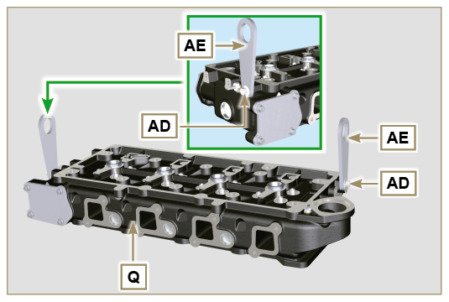  Fig 7.41

Oil sump unit disassembly
7.12.1 Oil sump  - Undo the screws A .  - Remove the oil sump B by inserting a plate in the areas indicated by the arrow AA. | 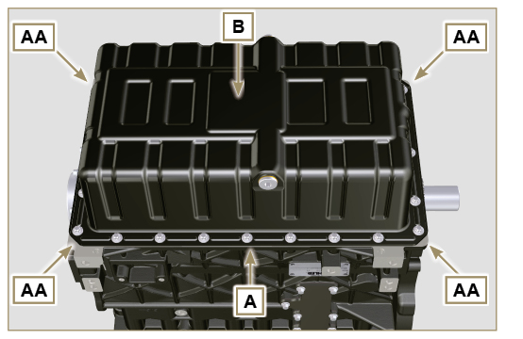  Fig 7.42
7.12.2 Oil intake pipe  - Undo the screws C and remove the oil pipe D . | 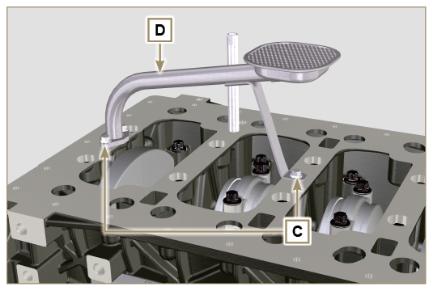  Fig 7.43
7.12.3 Oil vapour pipes ( )  - Unscrew and removethe pipes E . | 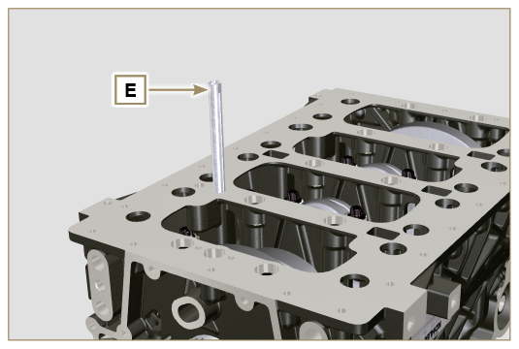  Fig 7.44

Engine block disassembly
7.14 .1 Crankshaft gasket flange  - Undo the screws A .  - Remove the flange B and the gasket C . | 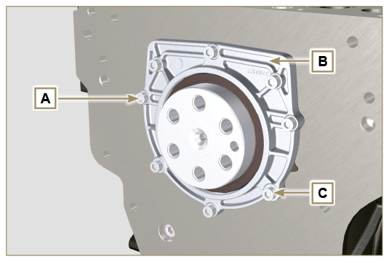  Fig 7.45
7.14.2 Piston unit/connecting rod  Important  - Mark some numerical references (cylinder n°) on the connecting rods, connecting rod caps F1 , pistons and gudgeon pins to prevent unintentionally confusing the components not replaced during assembly. Failure to do this may result in engine malfunctions.  - References on connecting rod M and cap F1 must only be carried out on a side in correspondence with K1 and K2 , as illustrated in Fig. 7.46a .  - Screw the bolt AM temporarily.  - Unsrew bolts E1 and remove the connecting rod caps F1 . | 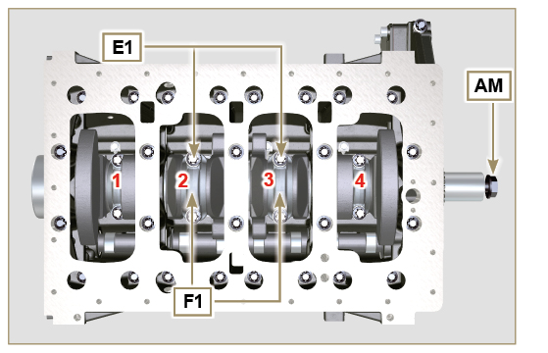  Fig 7.46
NOTE : coupling cap F1 on the connecting rod can be carried out with centring taper pins (Fig. 7.46b) or broken ( Fig. 7.46c - without centring taper pins).  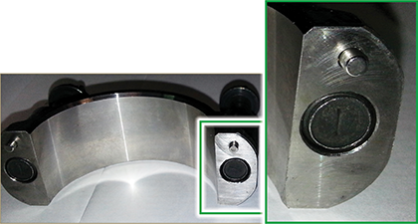  Fig. 7.46b  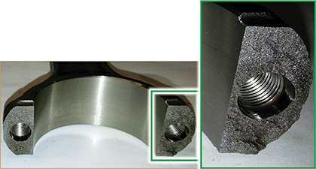  Fig. 7.46c | 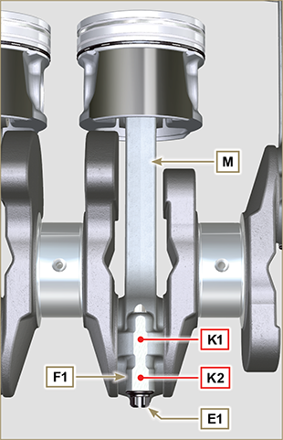  Fig 7.46a
- Pull out the connecting rod - piston assembly from position 2 and 3 by manually applying pressure on the connecting rod big end L in the direction of arrow AK .  - Couple the connecting rod big end caps L with the relevant piston and connecting rod unit M .  - Turn capscrew AM and rotate the crankshaft by 180°.  - Repeat points 2 to 5 to disassemble the connecting rod-piston assembly to position 1 and 4 . | 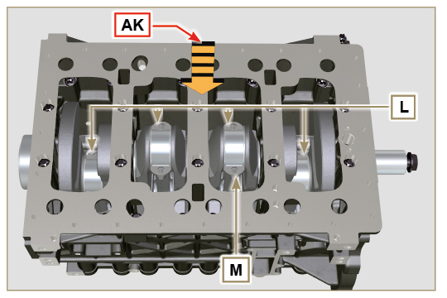  Fig 7.47
Warning  - The connecting rod half-bearings Z are made of special material. Therefore, they must be replaced every time they are removed to prevent seizures. | 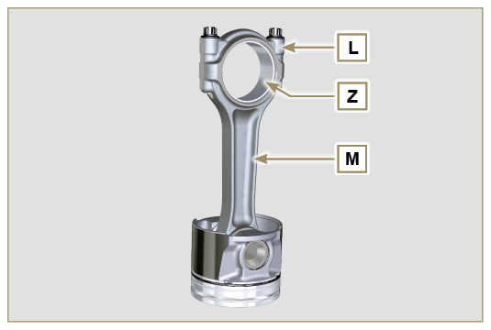  Fig 7.48
7.14.3 Lower semi-crankcase  - Undo capscrews E and F by following the order indicated in the figure.  - Remove the lower semi-crankcase D and store it in a suitable container for washing. | 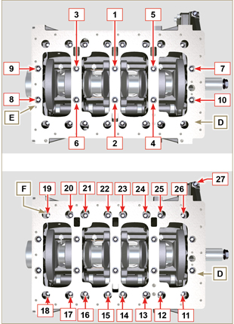  Fig 7.49
7.14.4 Crankshaft  Remove:  - Crankshaft G .  - The four shoulder semi-rings H . | 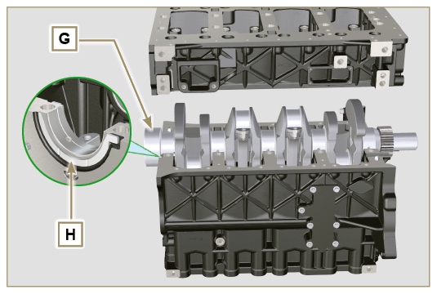  Fig 7.51
7.14.5 Piston ( )  - Remove the retainer ring N .  - Remove the pin P to separate the piston Q from the connecting rod R .  Important  - If they are not replaced, keep the components together (connecting rod - piston - gudgeon pin) by using references in order to prevent them from getting mixed up during assembly. | 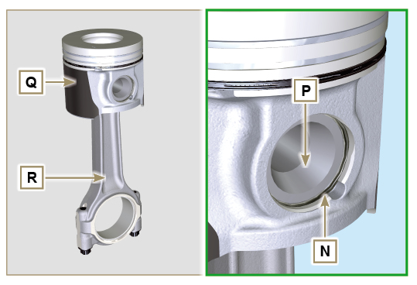  Fig 7.52
7.14.5.1 Rings ( )  - Remove the seal rings S . | 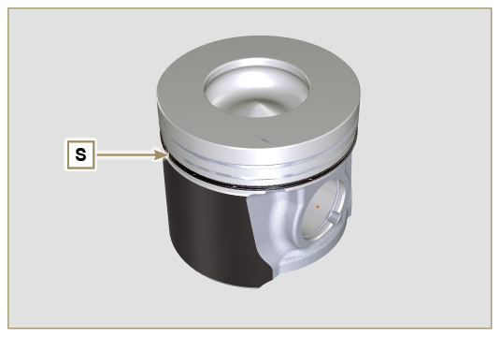  Fig 7.53
7.14.6 Oil spray nozzles ( )  - Undo the screws T and remove the spray nozzles U from the upper semi-crankcase AM . | 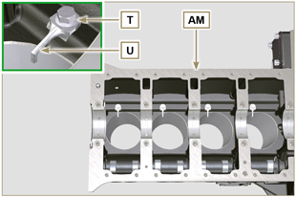  Fig 7.54
7.14.7 Camshaft  - Remove the retainer ring V .  - Extract the camshaft W from the upper crankcase AB . | 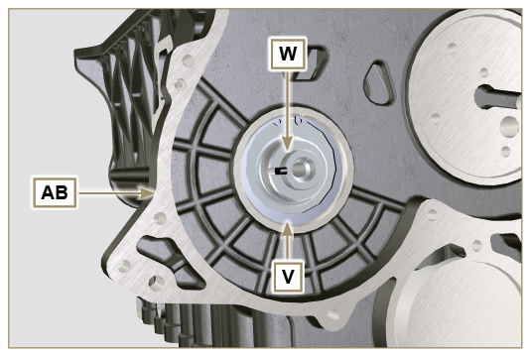  Fig 7.55
7.14.8 Camshaft tappets  - With a magnet, remove the tappets AA from the upper semi-crankcase AB . | 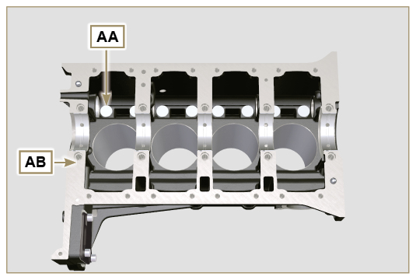  Fig 7.56
7.14.9 Crankshaft bushings  - Remove the crankshaft bushings AC from the upper semi-crankcase AB .  Important  - The crankshaft half-bearings AC are made of special material. Therefore, they must be replaced every time they are removed to prevent seizures. | 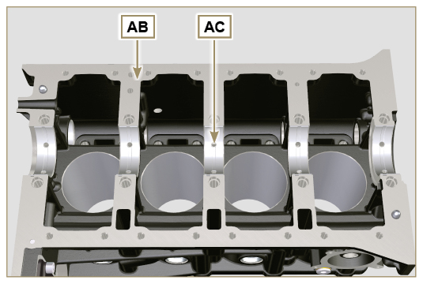  Fig 7.57
- Remove the crankshaft bushings AF from the lower crankcase D . | 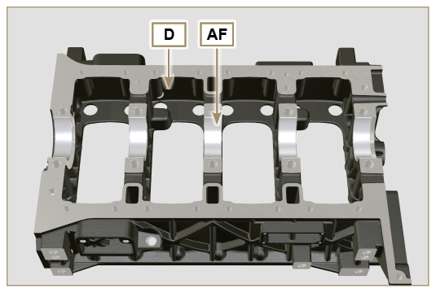  Fig 7.58
7.14.10 Cover 3 ^{at} PTO ( )  - Undo the screws AG .  - Remove the cover AH and the gasket AL . | 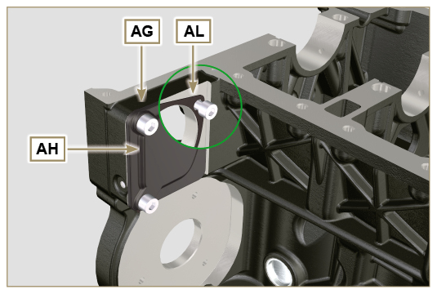  Fig 7.59

