Technical information
KDI 2504 M Workshop manual (Rev_09.6)

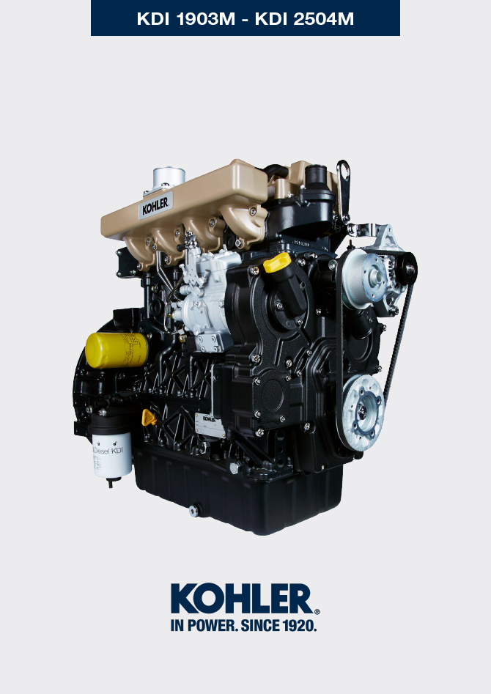

Registration of modifications to the document
Any modifications to this document must be registered by the drafting body, by completing the following table.

Released by | Code | Revision | Release Date | Revision date | Edited by | Endorsed
null | manoff

Translated from the original manual in Italian language
Data reported in this issue can be modified at any time by KOHLER.

Sommario
1. TITOLO 1 2
1.1. Asdfsdfsdf 2
1.2. Asdfsdfsdfggg 2

Technical information

Engine specifications
MANUFACTURER SPECIFICATIONS AND OPERATION
GENERAL INFORMATION | UNIT OF MEASURE | KDI 1903 M | KDI 2504 M
Operating cycle |  | diesel - 4 stroke
Cylinders | N° | 3 | 4
Bore x stroke | mm | 88x102
Displacement | cm ³ | 1861 | 2482
Compression ratio |  | 18.4:1
Intake |  | Atmospheric pressure
Cooling |  | Liquid
Crankshaft rotation (view from flywheel side) |  | Counterclockwise
Combustion sequence |  | 1-3-2 | 1-3-4-2
Timing System
Valves per cylinder | N° | 4
Timing System |  | Rods and rocker arms - Camshaft in the crankcase
Tappets |  | Hydraulic
Injection |  | Direct
Engine dry weight | Kg | 210 | 244
MAX inclination 30' continuous operation | (min./a) | 25°
MAX inclination 1' continuous operation | (min./a) | 35°
Volume of aspirated air (2600 rpm) | Kg/h | 2.2 | 2.9
POWER AND TORQUE
GENERAL INFORMATION | UNIT OF MEASURE | KDI 1903 M | KDI 2504 M
MAX operating speed | Rpm | 2600
MAX operating power (ISO TR 14396 - SAE J1995 - CE 97/68) | kW | 31 | 41
Maximum torque (at 1500 rpm) | Nm | 133 | 170
Admissible axial load on crankshaft | Kg | 300
CONSUMPTIONS
GENERAL INFORMATION | UNIT OF MEASURE | KDI 1903 M | KDI 2504 M
Specific fuel consumption (best point) | g/kWh | 210
Oil consumption | %Fuel | < 0.05
FUEL SUPPLY SYSTEM
GENERAL INFORMATION | UNIT OF MEASURE | KDI 1903 M | KDI 2504 M
Type of fuel |  | Diesel UNI-EN590 - ASTM D975
High-pressure fuel injection pump |  | STANADYNE - DB
Fuel supply |  | Low pressure electric pump
Fuel filter
Filtering surface | cm ² | 2300
Degree of filtration | µm | 5
Maximum pressure at injection pump inlet | bar | < 0.5
LUBRICATION CIRCUIT
GENERAL INFORMATION | UNIT OF MEASURE | KDI 1903 M | KDI 2504 M
Fuel

Lubrication |  | See Par. 2.4
Circuit forced |  | Lobe pump
Oil sump capacity ( MAX ) | Lt. | 8.9 | 11,5
Oil pressure switch
Intervention pressure ( MIN ) | bar | 0.8±0.1
Oil filter

Maximum operating pressure | bar | 7.0
Degree of filtration | µm | 17±2
Filtering surface | cm ² | 1744
COOLING CIRCUIT
GENERAL INFORMATION | UNIT OF MEASURE | KDI 1903 M | KDI 2504 M
Coolant | % | See Par. 2.6
Water pump | Lt./min | 75
Thermostatic valve
Opening temperature | °C | +79
Stroke at 91°C | mm | 7.50
Liquid recirculation | Lt./h | 9
ELECTRICAL SYSTEM - ELECTRIC FAN
GENERAL INFORMATION | UNIT OF MEASURE | KDI 1903 M | KDI 2504 M
Circuit rated voltage | V | 12
External alternator (rated current) | A | 80
Starter motor power | kW | 2
System electrical consumption, excluding:  heater, electric pump, electric fan, starter motor | W | 24
Coolant temperature indicator light
Indicator light operating temperature | °C | +100/+110

Engine dimensions (mm)
NOTE : Dimensions vary according to engine configuration.

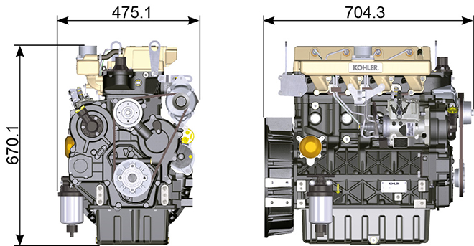
Fig 2.1

Performance
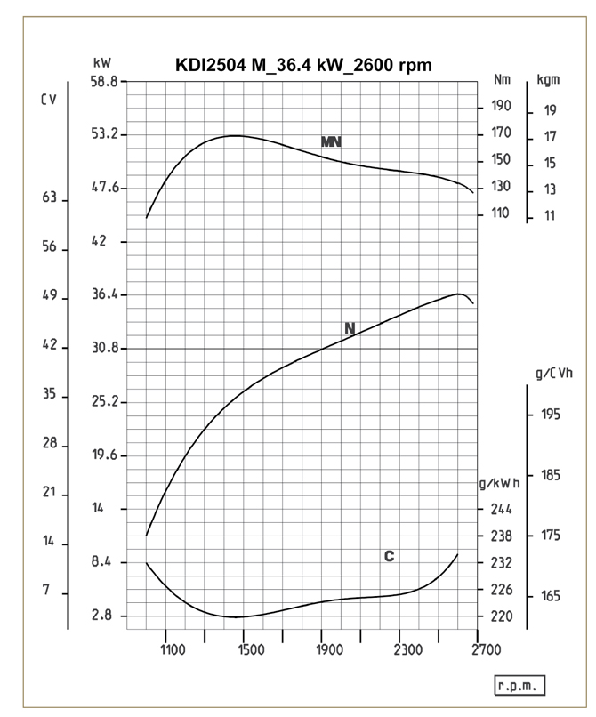

Fig. 2.2
N = Automotive rating curve
MN = Torque curve
C = Specific fuel consumption curve

NOTE: Refer to KOHLER for power curves, torque curves and specific consumptions at speeds other than those given above.

Key

- N (ISO TR 14396 - SAE J1995 - CE 97/68) AUTOMOTIVE RATING CURVE : Intermittent duty at variable speed and load. Engine capacity at intermittent conditions with variable speed and load.

- MN: = TORQUE RATING CURVE : Also called twisting moment, it is the push generated by the engine through transmission. The highest engine performance is obtained at the maximum torque.

- C = SPECIFIC CONSUMPTION CURVE : Engine fuel consumption in a given time at a certain revolution value. Expressed in g/kW (grams/kilowatt), it expresses fuel yield.

* The above curves express indicative values, in that the overall performance depends on the type of application and the ECU control uni.

- The ratings reported in the diagram regard the run-in engine, fitted with air and exhaust filters, at the atmospheric pressure of 1 Bar and at a room temperature of +20°C
- Maximum rating is guaranteed with a 5% tolerance.

Warning

- Non approval by KOHLER for any modification releases the company from liability for damage incurred on the engine.

Oil

Important

- The engine may be damaged if operated with improper oil level.
- Do not exceed the MAX level because a sudden increase in engine rpm could be caused by its combustion.
- Use only the recommended oil to ensure adequate protection, efficiency and service life of the engine.
- The use of lubricants other than recommended may shorten the engine life.
- Viscosity must be appropriate to the ambient temperature to which the engine is to be exposed.

Danger

- Prolonged skin contact with the exhausted engine oil can cause cancer of the skin.
- If contact with oil cannot be avoided, thoroughly wash your hands with soap and water as soon as possible.
- For the exhausted oil disposal, refer to the Par. DISPOSAL and SCRAPPING .
2.4.1 SAE oil classification
- In the SAE classification, oils are identified according to viscosity without considering any other qualitative characteristic.
- The code is composed of two numbers, which indicate, and must correspond to, the ambient temperature in which the engine operates, the first number refers to the viscosity when cold, for use during winter (" W "), while the second number is for viscosity at high temperatures.

2.2
RECCOMENDED OIL
VISCOSITY | SAE | 10w-30 (-25°C ÷ +40°C) 10w-40 (-25°C ÷ +50°C)  5w-30 (-30°C ÷ +40°C)  0w-40 (-40°C ÷ +50°C)
WITH SPECIFICATIONS | API | CI-4 Plus CI-4  CH-4
 | ACEA | E7  E5

- Low S.A.P.S. oils, sulfate ashes <1% may not be used with fuels with a sulfur content >50ppm.
- Filtration of oils is critical to proper operation and lubrication; always change filters regularly as specified in this manual.

Fuel

Important

- Use of other types of fuel could damage the engine. Do not use dirty diesel fuel or mixtures of diesel fuel and water since this will cause serious engine faults.
- Any failures resulting from the use of fuels other than recommended will not be warranted.

Warning

- Clean fuel prevents the fuel injectors from clogging. Immediately clean up any spillage during refuelling.
- Never store diesel fuel in galvanized containers (i.e. coated with zinc). Diesel fuel and the galvanized coating react chemically to each other, producing flaking that quickly clogs filters or causes fuel pump and/or injector failure.
2.3
FUEL COMPATIBILITY
EN 590 (biodiesel content max. 7% (V/V))
ASTM D 975 Grade 1-D S15
ASTM D 975 Grade 2-D S15
NATO F-54, equivalent to diesel fuel in accordance with EN 590
EN 590 or ASTM D 975 Grade 1, 2 -D S15 Arctic Diesel
JIS K 2204 No. 1, No. 2
NOTE : In a warranty case the customer must prove by a certificate from the fuel supplier that an allowed fuel was used.
KDI Mechanical Injection Tier 3 , Tier 4 Final – Stage IIIA, Stage IIIB, Stage V certified Engines (w and w/o EGR)
- Those engines are designed for fuels in accordance with EN 590 and ASTM D975 for a cetane number of at least 45. Since those engines are not equipped with exhaust gas after-treatment, they can be operated with diesel fuels with sulfur content up to 500 mg/kg (ppm). Compliance with the emission requirements is guaranteed only with sulfur content up to 15 mg/kg (ppm).
Engines operated with fuels as per EN 590 and ASTM D975 with sulfur content < 15mg/kg have an oil changing interval of 500hrs. Fuels with a sulfur content > 500 mg/kg demand a shorter lubricating oil change interval. This is set at 250hrs. However, the engine oil must be changed when the Total Base Number TBN is reduced to 6.0 mgKOH/g test method ASTM D4739. With high fuel sulfur content fuel this may happen at 125hrs. Do not use low SAPS oils.

KDI Mechanical Injection Uncertified Engines (no EGR Engines)
- Those engines are designed for fuels in accordance with EN 590 and ASTM D975 for a cetane number of at least 45. Since those engines are not equipped with exhaust gas after-treatment, they can be operated with diesel fuels with sulfur content up to 2000 mg/kg (ppm).Engines operated with fuels as per EN 590 and ASTM D975 with sulfur content < 15mg/kg have an oil changing interval of 500hrs. Fuels with a sulfur content > 500 mg/kg demand a shorter lubricating oil change interval. This is set at 250hrs. However, the engine oil must be changed when the Total Base Number TBN is reduced to 6.0 mgKOH/g test method ASTM D4739
2.5.1 Fuel for low temperatures
- When operating the engine in ambient temperatures lower than 0 degrees C, use suitable low temperature fuel normally available from fuel distributors and corresponding to the specifications of Tab. 2.3 .
- These fuels reduce the formation of paraffin in diesel at low temperatures.
- When paraffin forms in the diesel, the fuel filter becomes blocked interrupting the flow of fuel.
2.5.2 Biodiesel fuel
- Fuels containing 10% methyl ester or B10, are suitable for use in this engine provided that they meet the specifications listed in the Tab. 2.3.
- DO NOT USE vegetable oil as a biofuel for this engine.
2.4
BIODIESEL COMPATIBILITY
Biodiesel according to EN 14214 (only permissible for mixture with diesel fuel at max. 10% (V/V))
US biodiesel according to ASTM D6751 – 09a (B100) (only permissible for mixtures with diesel fuel at 10% (V/V))

2.5.3 Synthetic fuels: GTL, CTL, BTL, HV
It is a well-known fact that engines which are operated for longer periods with conventional diesel fuel and then converted to synthetic fuels suffer shrinkage of polymer seals in the injection system and thus fuel leaks. The reason for this behavior is that the aromatic-free synthetic fuels can lead to a change in the sealing behavior of polymer seals.
Therefore, conversion from diesel fuel to synthetic fuel may only be done after changing the critical seals. The problem of shrinkage does not occur when an engine was operated with synthetic fuel from the start.

2.5.4 Non-Road Fuels
Other non-road fuels may be used if they comply with all the limit values of EN 590 except for the fuel density, the cetane number and the sulfur content.
The following limits apply for these parameters:
2.5
FUEL PARAMETER | UNIT | LIMIT VALUE
Cetane number |  | Min. 49
Fuel density at 15°C | Kg/m ³ | 820 - 860
Sulfur content | mg/kg or ppm | max. 500

2.5.5 Jet Fuels
Only for KDI Mechanical Injection Uncertified Engines (no EGR Engines).
The following jet fuels can be used but only adopting an additional fuel filter with lubricity doser:
2.6
FUEL
F-34/F-35 (kerosene, NATO designation) | JP-8 (kerosene, US military designation)
F-44 (kerosene, NATO designation | JP-5 (kerosene, US military designation)
F-63 (kerosene, NATO designation, equivalent to F-34/F-35 with additives) | Jet A (kerosene for civil aviation)
F-65 (kerosene, NATO designation, 1:1 mixture of F-54 and F-34/F-35) | Jet A1 (kerosene for civil aviation)

2.5.6 Emission-Related Installation Instructions Failing to follow the instructions in the applications guidebook when installing a certified engine in a piece of nonroad equipment violates federal law (40 CFR 1068.105(b)), subject to fines or other penalties as described in the Clean Air Act.

OEM must apply a separate label with the following statement: “ULTRA LOW SULFUR FUEL ONLY” near the fuel inlet.

Ensure you are installing an engine appropriately certified for your application. Constant speed engines may only be installed on constant speed equipment for constant speed operation.

If you install the engine in a way that makes the engine's emission control information label hard to read during normal engine maintenance, you must place a duplicate label on the equipment, as described in 40 CFR 1068.105.

Coolant recommendation
A mixture of 50% demineralized water and 50% low silicate ethylene glycol based coolant liquid must be used. Use a Long Life or Extended Life Heavy Duty OAT coolant free of: silicates, phosphates, borates, nitrites and amines.

The following ethylene-glycol based engine coolant for all models within KDI engine family may be used:

- OAT (Organic Acid Technology) Low Silicate: ASTM D-3306 D-6210
- HOAT (Hybrid Organic Acid Technology) Low Silicate: ASTM D-3306 D-6210

The above coolants in concentrated formulation must be mixed with distilled, deionized, or demineralized water. A pre-mixed formulation (40-60% or 50-50%) can be used directly when available.

Important
- Do not mix ethylene glycol and propylene glycol based coolants. Do not mix OAT and HOAT based coolant. OAT performance life can be drastically reduced if contaminated with nitrite-containing coolants.
- Never use automotive-type coolants. These coolants do not contain the correct additives to protect heavy – duty diesel engines.

OAT coolants are maintenance free up to 6 years or 6000hrs of operation , provided that the cooling system is topped up using the same type of coolant. Do not mix different coolant types. Test the coolant condition annually with coolant test strips.
HOAT are not all maintenance free and it is recommended to have SCA (Supplemental Coolant Additives) added at the first maintenance interval.

Battery recommendations
Battery not supplied by Kohler

Tab. 2.7
RECOMMENDED BATTERIES
AMBIENT TEMPERATURE | BATTERY TYPE
> - 15°C | 12V 100 Ah - 800 CCA/SAE
-15°C ÷ -25°C | 12V 110 Ah - 950 CCA/SAE
< - 25°C | 12V 120 Ah - 1000 CCA/SAE

Periodic maintenance
The intervals of preventive maintenance in Tab. 2.8, Tab. 2.9, Tab. 2.10 and Tab. 2.11 refer to the engine operating under normal operating conditions with fuel and oil meeting the recommended specifications.
2.8
CLEANING AND CHECKING
OPERATION DESCRIPTION | PERIOD (HOURS)
 | 100 | 250 | 500 | 5000
Engine oil level ⁽⁸⁾
Coolant level ⁽⁸⁾ ⁽⁹⁾
Water presence in fuel filter
Cartridge dry-type air filter ⁽²⁾
Radiator heat-exchange surface ⁽²⁾ ⁽⁸⁾
Alternator belt ⁽⁸⁾
Rubber hose (intake air / coolant)
Fuel hose
Starter Motor

Alternator
2.9
REPLACEMENT
OPERATION DESCRIPTION |  | PERIOD (HOURS)
 |  | 500 | 5000
Alternator belt ⁽³⁾
Cartridge dry-type air filter ⁽²⁾
Intake manifold hose (air filter - intake manifold) ⁽⁷⁾
Coolant hoses ⁽⁷⁾
Fuel line hose ⁽⁷⁾
Coolant | OAT
 | HOAT ⁽¹⁰⁾

2.10
ENGINE OIL AND OIL FILTER CARTRIDGE REPLACEMENT
ENGINE VERSION | PERIOD (HOURS)
 | 250 | 500
KDI Mechanical Injection Stage V ⁽¹⁾
KDI Mechanical Injection Tier 4 Final – Stage IIIB ⁽¹⁾
KDI Mechanical Injection Tier 3 – Stage IIIA ⁽¹⁾
KDI Mechanical Injection Uncertified Engines ⁽¹⁾ ⁽¹¹⁾

2.11
FUEL FILTER AND PREFILTER CARTRIDGE REPLACEMENT
ENGINE VERSION | PERIOD (HOURS)
 | 250 | 500
KDI Mechanical Injection Stage V ⁽¹⁾
KDI Mechanical Injection Tier 4 Final – Stage IIIB ⁽¹⁾
KDI Mechanical Injection Tier 3 – Stage IIIA ⁽¹⁾
KDI Mechanical Injection Uncertified Engines ⁽¹⁾
(1) - In case of low use: 12 months.

(2) - The period of time that must elapse before checking the filter element depends on the environment in which the engine operates. The air filter must be cleaned and replaced more frequently under very dusty conditions.

(3) - In case of low use: 36 months.
(7) - The replacement interval is only an indication, it strongly depends from environmental condition and hose status detected during regular visual inspection.
(8) - The first check must be done after 10 hours.
(9) - Test the coolant condition annually with coolant test strips.
(10) - It is recommended to have SCA (Supplemental Coolant Additives) added at the first maintenance interval.
(11) - Read Cap. 2.5, "KDI Mechanical Injection Uncertified Engines (no EGR Engines)"

Fuel system
2.9.1 Supply system

Important

- The high pressure supply injection system is highly susceptible to damage if the fuel is contaminated.
- It is crucial that all components of the injection circuit are thoroughly cleaned before the components are removed.
- Thoroughly wash and clean the engine before maintenance.
- Contamination in the fuel supply injection system may cause a reduction in effectiveness / operation of engine fault indication.
- If the engine is cleaned with high pressure washer, then the nozzle must be kept at a minimum distance of 200mm from the surface, and not directed at electrical components and connectors.

The fuel supply system is under low pressure from the tank 1 to the high-pressure fuel injection pump 5 .  NOTE : The representation of fuel tank is purely indicative. Component not necessarily supplied by KOHLER .  Tab 2.12  POS. DESCRIPTION  1 Fuel tank  2 Fuel supply hose from the tank to the injection pump  3 Fuel filter  4 Electrical fuel feed pump  5 Injection pump  6 Injector high-pressure hose from the injection pump to the injectors  7 Injectors | 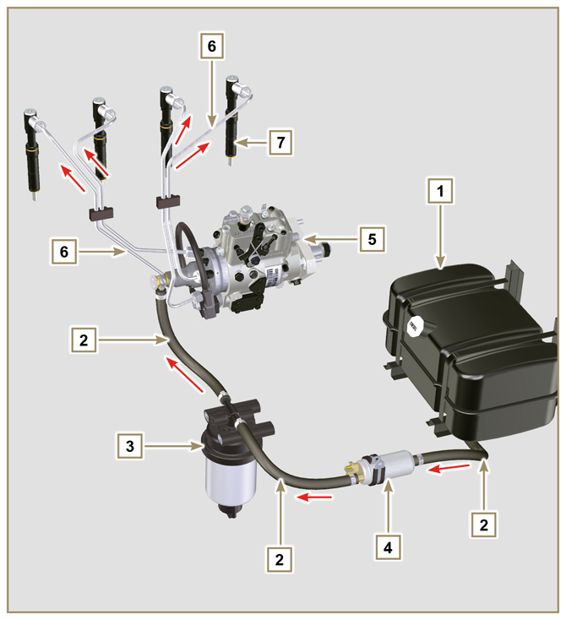  Fig 2.4
2.9.2 Fuel return circuit  The fuel return circuit is under low pressure.  NOTE : The representation of fuel tank is purely indicative. Component not necessarily supplied by KOHLER .  Tab 2.13  POS. DESCRIPTION  1 Injectors  2 Injectors fuel return pipe  3 Injection pump  4 Fuel tank  5 Fuel return pipe to the tank | 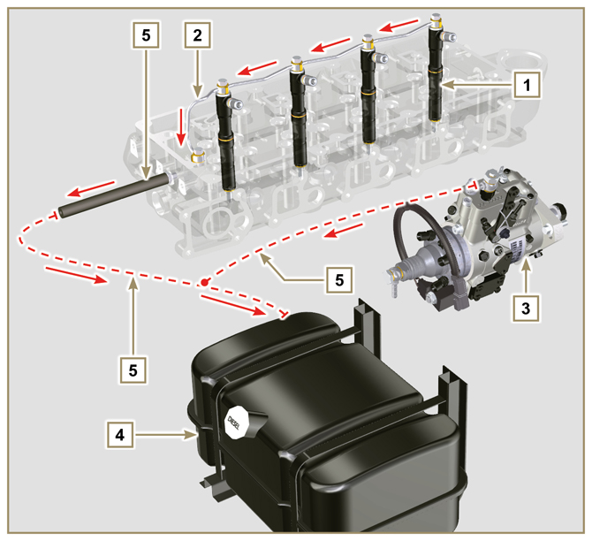  Fig 2.5

2.9.3 Injection pump  Pressure into the injection pump must be positive in all operating conditions.  The injection pump is operated by means of the pump control gear and sends high-pressure fuel to the injectors.  NOTE: In the event of leakage from the high pressure circuit do not intervene with the engine running, but turn it off and wait 5 - 10 minutes before checking the leak.  Tab 2.14  POS. COMPONENTS DESCRIPTION  1 Accelerator lever  2 Min Adjustment  3 Max Adjustment  4 Torque adjustment  5 High pressure delivery to injectors  6 Return to fuel tank  7 Inlet suction fuel  8 Cold starting device  9 Gasket  10 Shaft  11 Advance settings (locked)  12 Pump identification label  13 Air bleeding screw  14 Pump control shaft blocking device. | 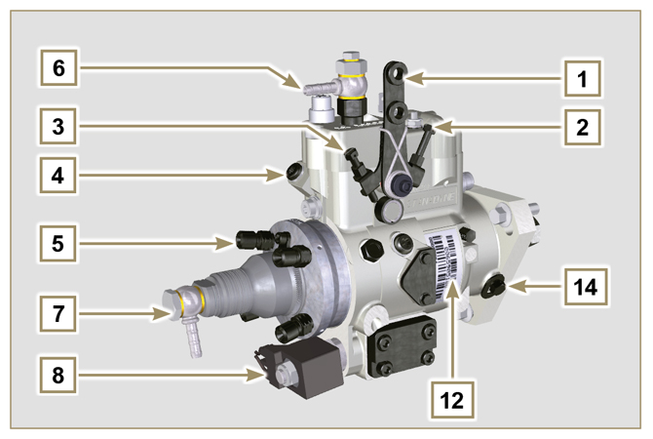  Fig 2.6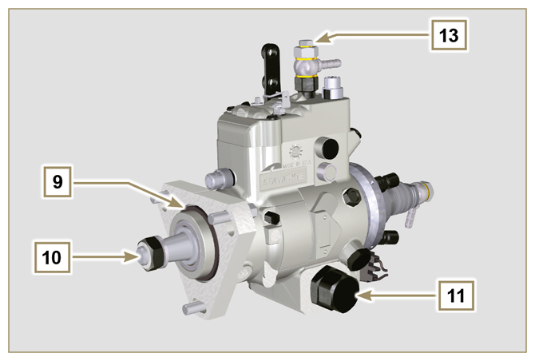  Fig 2.7

2.9.4 Injector  It is a device used to introduce fuel, in the form of one or more jets that are adequately pulverised and suitably oriented directly into the combustion chamber. They consist of a metallic body that internally provides a mobile element that acts on the needle: this, rising against the action of a calibrated spring,  allows the release of fuel under high pressure.  Opening pressure: 260-268 bar (3770-3886 PSI)  Important  - The injectors are calibrated individually.  - Fuel contamination causes serious damage to the injection system.  Tab 2.15  POS. COMPONENTS DESCRIPTION  1 Inlet fuel  2 Gasket  3 Gasket  4 Nozzle  5 Hole for fuel return to fuel tank | 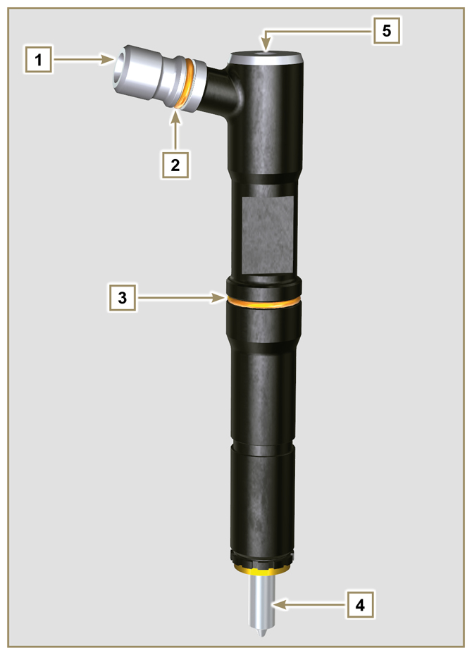  Fig 2.8

2.9.5 Fuel filter  The fuel filter is situated on the crankcase of the engine or it may be assembled on the frame of the vehicle.  Tab 2.16  POS. COMPONENTS DESCRIPTION  1 Fuel filter support cartridge  2 Air bleeding screw  3 Cartridge  4 Water in fuel sensor  5 Hole water drainage  Tab 2.17 Cartridge characteristics  DESCRIPTION VALUE  Filtering surface 2.300 cm ²  Degree of filtration 5 µm  Max operating pressure 2.0 Bar | 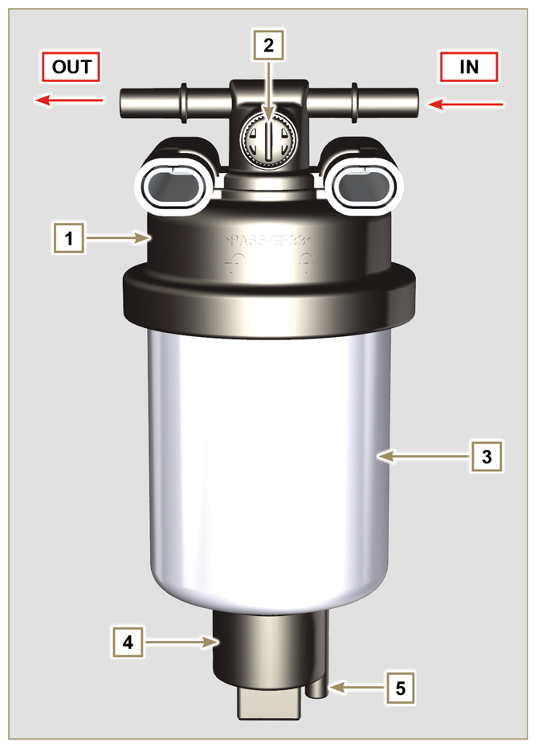  Fig 2.9

2.9.6 Electric fuel pump (optional)  When the electric fuel pump is installed in a diesel engine, one must:  - Remove any filters installed on the inlet of the electric fuel pump;  - Insert a pre-filter between the tank and the electric pump;  - The electric pump must be installed on the application at a height from the minimum tank level such as to generate a MAX . pressure drop equal to a column of 500 mm of fuel;  - Insert a shut-off valve to prevent dry operation due to the emptying of the intake manifold;  - The electric pump must guarantee a supply pressure at the inlet positive in all conditions.  Tab 2.18  POS. DESCRIPTION  1 Fuel tank  2 Arrival pipe from the tank  3 Prefilter  4 Flow pipe from pre-filter to electric pump  5 Electric pump  6 Flow pipe to the fuel filter  7 Fuel filter | 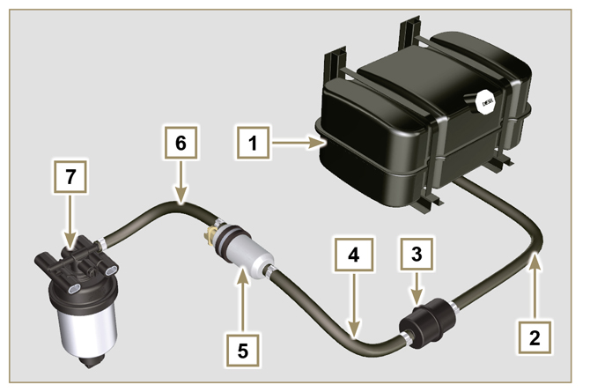  Fig 2.10
2.9.7 Guards for fuel injection circuit components  High-pressure injection circuit components are particularly sensitive to impurities.  To prevent impurities, even microscopic ones, from accessing the fuel input or output unions, you are required to close these accesses by means of specific caps as soon as the various tubes are disassembled and disconnected.  Disassembly of any component of the injection circuit must not occur in dusty environments.  Cap guards must remain closed in their housing (ST_40) until the moment they are to be used.  Pay special attention when using the caps and avoid any contamination of dust or dirt of any kind.  Even after using the caps illustrated in this paragraph, all components of the injection circuit must be placed with care in environments that are free of any type of impurity.  Fig. 2.11 and 2.12 illustrate the caps that must be used on components of the injection circuit.  Cap guards must be accurately washed after use and placed back in their housing (ST_40).  Important  - It is highly recommended to have this page visible during disassembly operations of the components of the fuel injection circuit. | 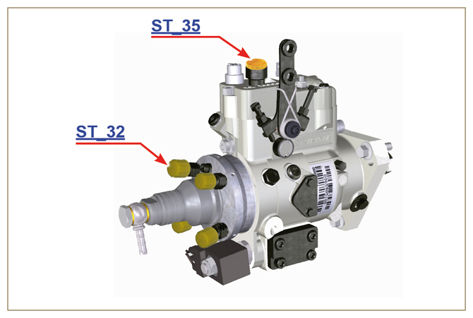  Fig 2.11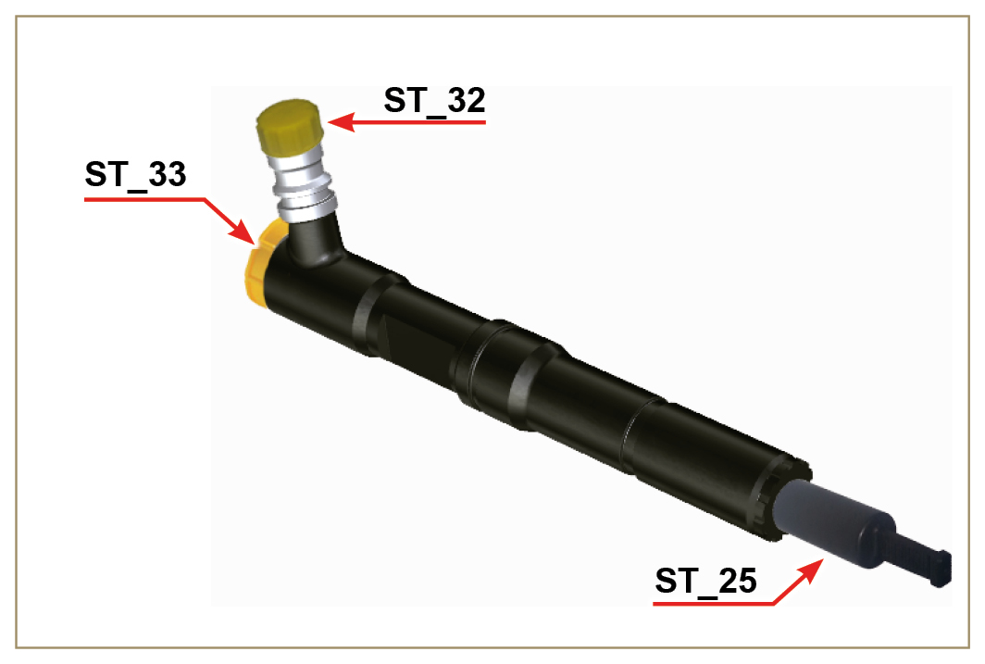  Fig 2.12

Lubrication circuit
2.10.1 Lubrication circuit diagram  The oil pump is driven by the crankshaft on the timing system side.  On the parts of the systems shown in green on In the parts in green, the oil is in intake, in the parts in red, the oil is under pressure and  in those in yellow the oil is returning towards the oil sump 2 (not under pressure).  Tab 2.19  COLOUR DESCRIPTION  Oil in intake  Oil under pressure  Oil returning to the oil sump  Tab 2.20  POS. DESCRIPTION  1 Oil pump rotors  2 Oil sump  3 Crankshaft  4 Camshaft  5 Rocker arm pin  6 Hydraulic tappets  7 Rocker arm cover  8 Cylinder head  9 Upper crankcase  10 Lower crankcase  11 Oil filter  12 PTO 3rd/4th gear housing | 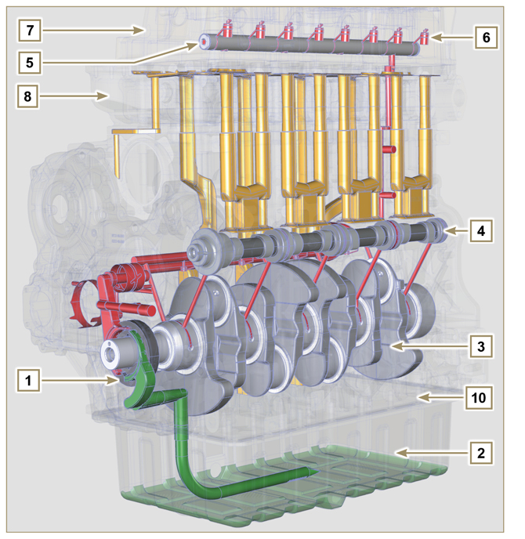  Fig 2.13  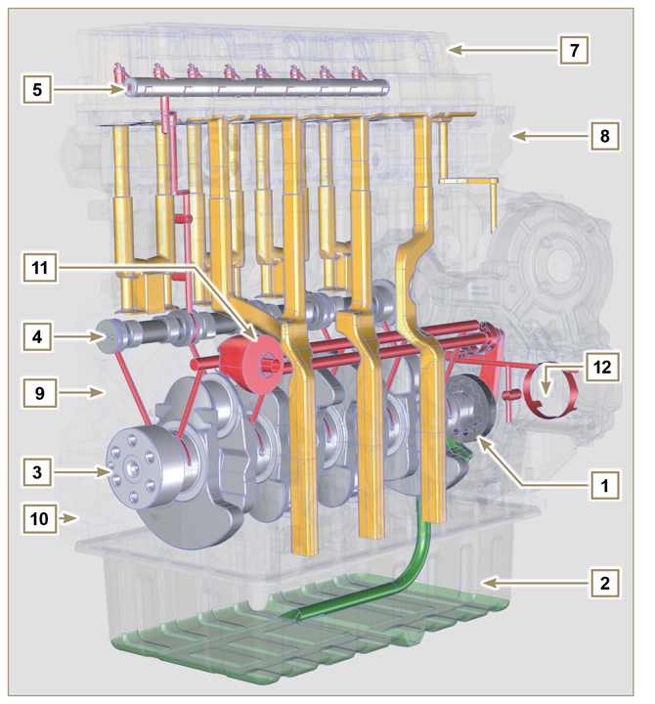  Fig 2.14
NOTE : Click by side to play the procedure. | https://www.youtube.com/embed/5HuLfSgqz6s?rel=0
2.10.2 Oil pump  The oil pump rotors are trochoidal (with lobes) and are activated from the crankshaft by means of the key. The pump body is situated inside the distribution guard.  It is imperative to assemble the rotors with reference A visible by the operator.  Tab 2.21  POS. DESCRIPTION  1 Internal rotor  2 External rotor  3 Oil pump crankcase  4 Pump control key  5 Timing system crankcase  6 Crankshaft | 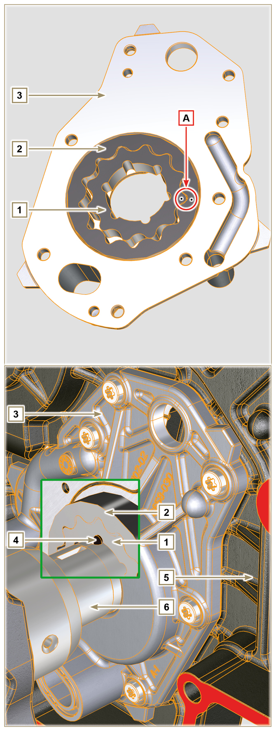  Fig 2.15

2.10.3 Oil filter

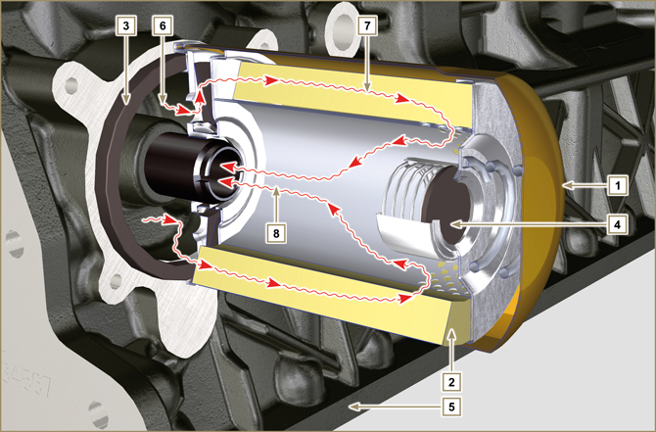
Fig 2.16

Tab 2.22  DESCRIPTION VALUE  Filtering surface 2.000 cm ²  Degree of filtration 15 µm  Max operating pressure 7.0 Bar | Tab 2.23  POS. DESCRIPTION  1 Oil cartridge  2 Filter element  3 Gasket  4 Safety valve  5 Upper cranckcase  6 Inlet oil  7 Oil filtering  8 Output oil (sent to the circuit)

Coolant circuit
2.11.1 Coolant circuit diagram
Tab 2.24  POS. DESCRIPTION  1 Coolant pump  2 Coolant intake  3 Coolant, cylinder  4 Coolant, cylinder head  5 Coolant to radiator  6 Coolant into radiator  7 Vent line from radiator (to 8)  8 Compensation tank  9 Thermostatic valve  10 Return from compensation tank | 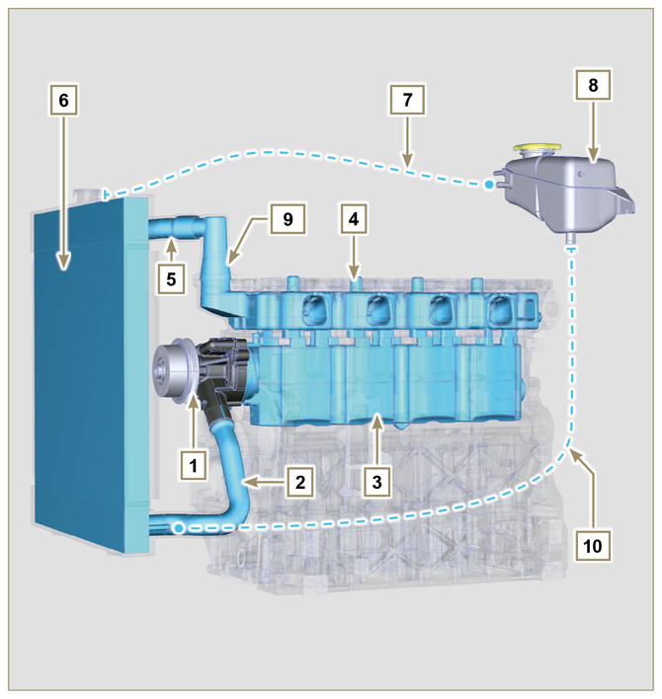  Fig 2.17
2.11.2 Coolant pump  Tab 2.25  POS. DESCRIPTION  1 Coolant pump control pulley  2 Coolant intake fitting | 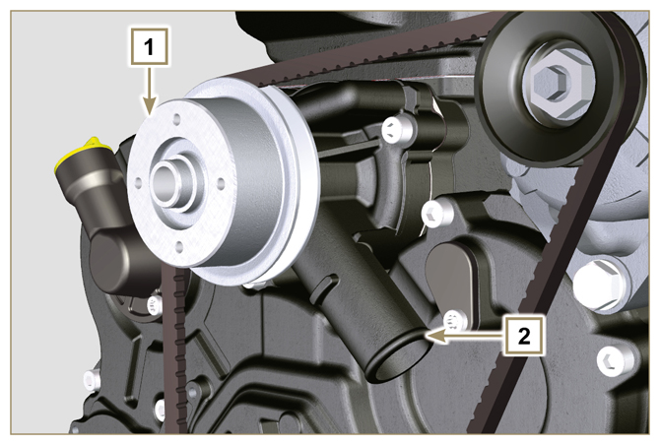  Fig 2.18
2.11.3 Thermostatic valve  Tab 2.26  POS. DESCRIPTION  1 Cylinder head  2 Coolant outlet cover  3 Thermostatic valve  4 Gaskets  5 Air bleeding hole  Opening temperature +79° ± 2°C. | 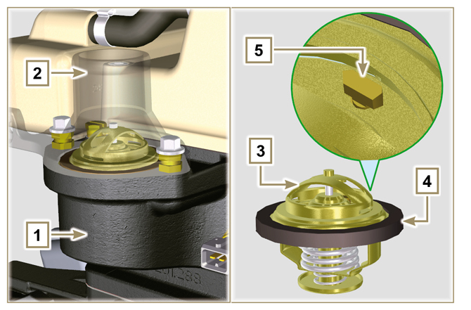  Fig 2.19
2.11.4 Radiator (optional)  NOTE: Component not necessarily supplied by Kohler.  Tab 2.27  POS. DESCRIPTION  1 Radiator group  2 Coolant refill cap  3 Vent tube or excess coolant return  4 Coolant flow manifold  5 Coolant intake manifold  6 Fan  7 Protective grid | 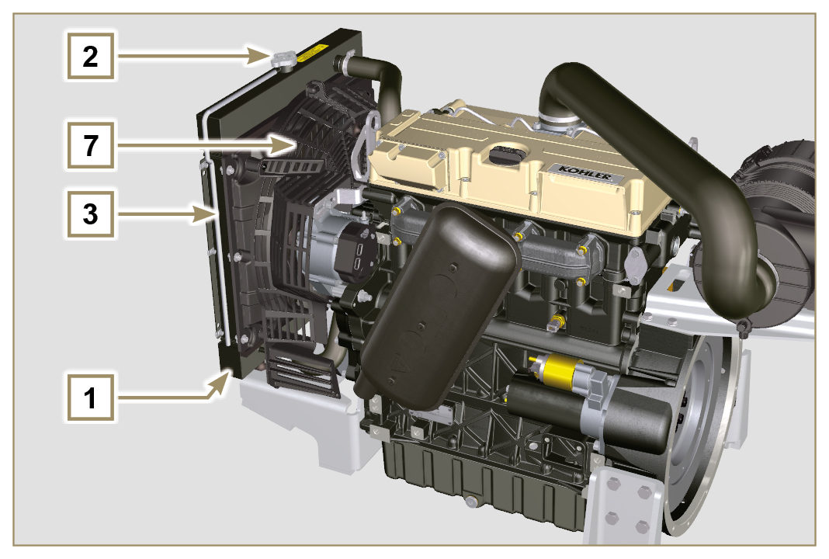  Fig 2.20  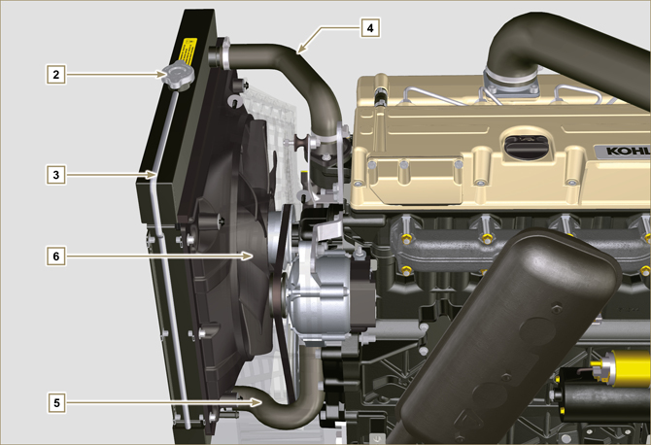  Fig 2.21

Intake and exhaust circuit
 | Air in intake |  | Gas in exhaust

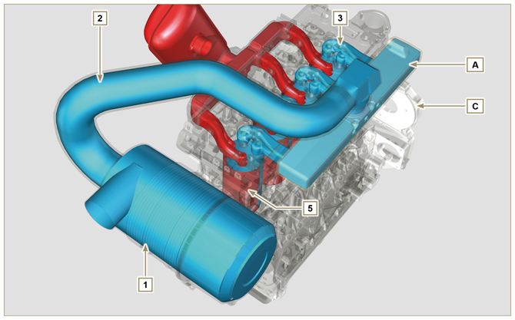
Fig 2.22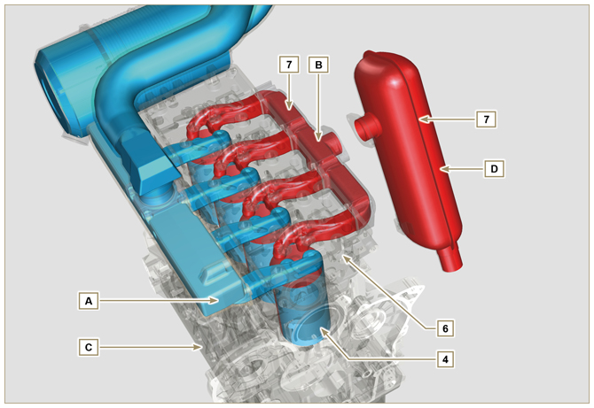
Fig 2.23

Important  - The air temperature inside the intake manifold must never exceed that of the environment by 10°C.  Clean air is sucked by means of an intake manifold and via ducts in the cylinder head, enters the cylinders. Compressed air inside the cylinders and mixed with the fuel transforms into Gas after combustion. Gas is expelled from the cylinders and sent to the exhaust manifold, which expels the gas towards the exhaust muffler. | Tab 2.28  POS. DESCRIPTION  1 Air in air filter  2 Air in intake manifold flow  3 Air in head intake  4 Air in cylinder intake  5 Gas in cylinder outlet  6 Gas in head outlet  7 Outlet gas to muffler  A Inlet manifold  B Exhaust manifold  C Crankcase  D Exhaust muffler (optional)
2.12.1 Air filter (optional)  NOTE: Component not necessarily supplied by KOHLER.  Important  - The air filter is a dry-type one, with a replaceable paper filter cartridge  - The filter intake must be positioned in a cool area.  - The temperature of the aspirated air must never exceed ambient temperature by more than 10°C (if you are using a pipe, its length must not exceed 400 mm and it must be as straight as possible).  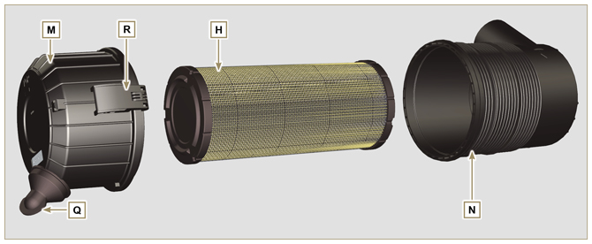  Fig 2.24 | Tab 2.29  POS. DESCRIPTION  H Air filter cartridge  M Filter cover  N Filter support  Q Dust exhaust valve  R Dust exhaust valve

Electric system

2.13.1 Engine electrical wiring (opzional)  NOTE : Component not necessarily supplied by KOHLER .  Electrical wiring is supplied upon request, it interfaces with the panel by means of 19-way Deutsch connectors (female on engine panel - male on accessories panel).  The connectors are described in Tab. 2.30.  Fig 2.25 | Tab 2.30  REF. DESCRIPTION  1 Engine panel connector interface (Fig. 2.26a)  2 Accessories panel connector interface (Fig. 2.26b)  3 Electrical fuel pump connector  4 Cold Start Advance connector (on injection pump - Fig. 2.39 )  5 Fuse connector  6 Electro-Stop connector (on injection pump)  7 "L" alternator connector (Iskra)  8 "W" alternator connectors (Iskra)  9 Alternator connector without "W" (Chengdu)  10 Alternator connector with "W" (Chengdu)  11 Coolant temperature sensor connector  12 Coolant temperature sensor connector  13 Starter motor connector "+ 50"  14 Starter motor connector "+ 30"  15 Air cleaner clogging sensor connector  16 Earth connector

2.13.1.1 Connector panel on the engine/machine  The connector is a female 19-way Deutsch type. There is a list of all PIN connections in Tab. 2.31.  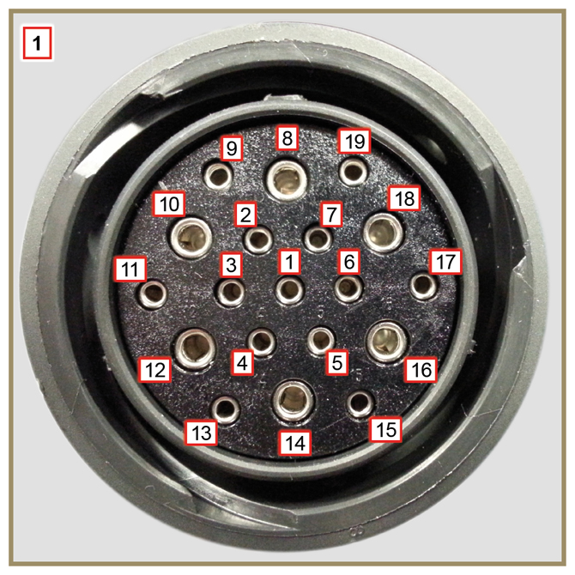  Fig 2.26a | Tab. 2.31  PIN. INLET SIGNALS TO THE PANEL  1 Oil pressure switch  2 Alternator indicator light  3 Coolant temperature warning light  4 Air cleaner clogging warning light  7 Air cleaner clogging warning light  9 Electro-Stop  13 Alternator (W)  14 Starter motor (+ 30)  15 Inlet indicator general alarm  PIN. OUTLET SIGNALS FROM THE PANEL  5 Earth  6 IG excitation alternator (+15 wrench)  8 Starter motor (+ 50)  10 Grid heater (Relay)  11 Electric pump  18 Injection pump (Cold Start Advance - Fig. 2.39 )

2.13.1.2 Accessories panel connector  The connector is a male 19-way Deutsch type. There is a list of all PIN connections in Tab. 2.32.  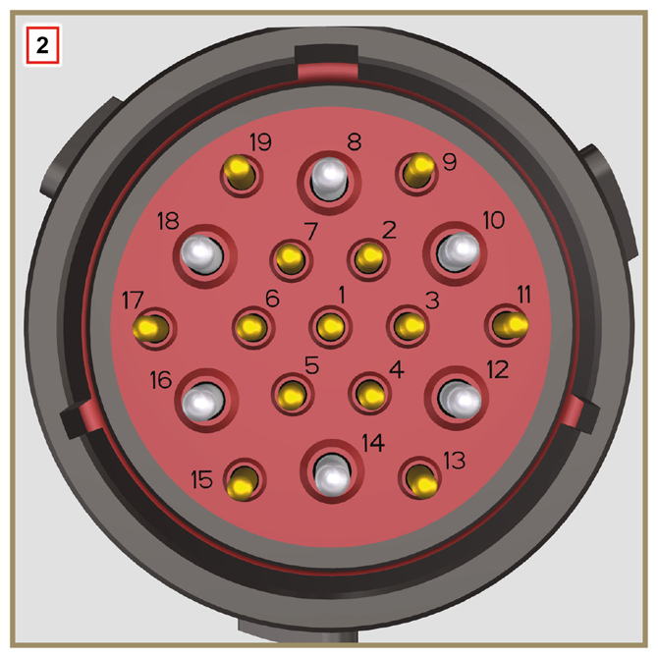  Fig 2.26b | Tab. 2.32  PIN. INLET SIGNALS TO THE PANEL  2 Fuel filter (water detection sensor)  4 Radiator (coolant level sensor)  7 Outlet indicator general alarm  9 External Stop  15 Inlet indicator general alarm  1 Fuel tank (fuel level sensor)  PIN. OUTLET SIGNALS FROM THE PANEL  5 Earth  6 Relay with 5A fuse (+ 15 wrench)  10 Grid heater (Relay)  13 Alternator (W)  17 Coolant temperature warning light

2.13.3.1 Wiring disconnection  Some sensor connectors and electronic control devices are sealed.  This tipe of connectors must be disconnected by means of pressure on tabs A or unblock the retainers B , as illustrated from Fig. 2.26c to Fig. 2.26g. | 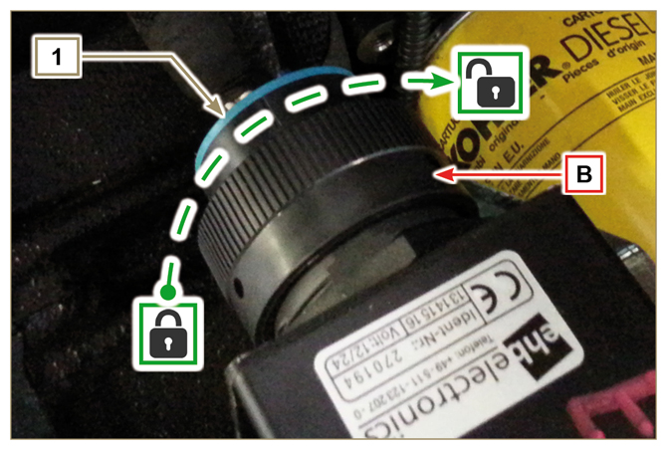  Fig 2.26c
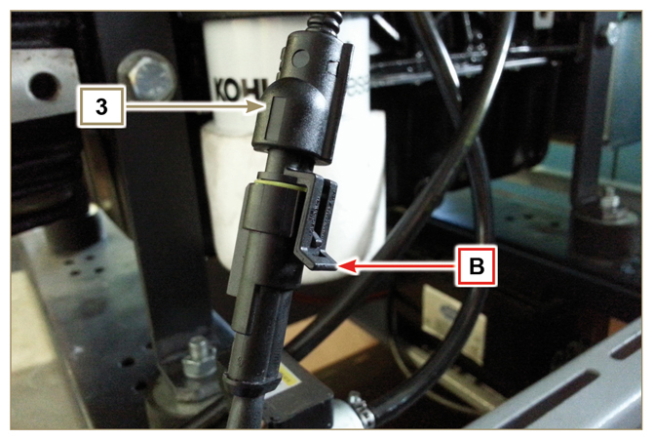  Fig 2.26d | 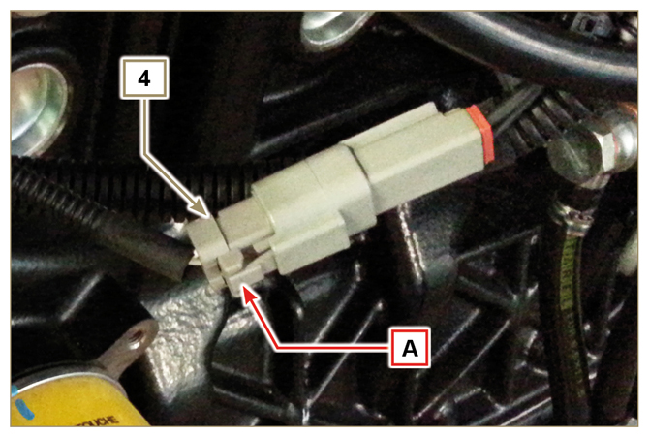  Fig 2.26e
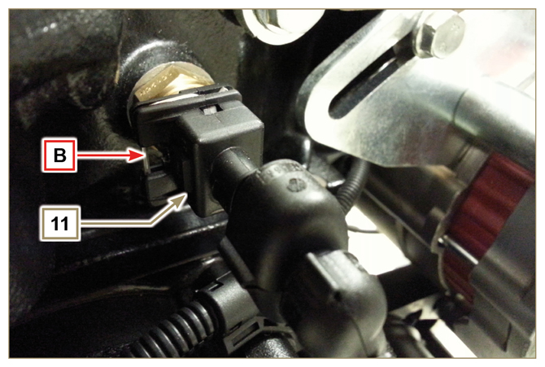  Fig 2.26f | 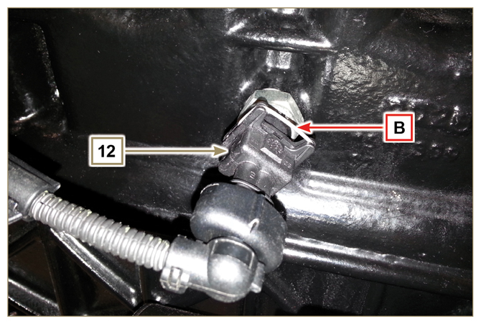  Fig 2.26g

Sensors and switches
2.14.1 Fuel filter water detection sensor (optional)  The water presence sensor in the fuel filter serves to indicate the presence of water in the fuel.  The sensor closes the electrical circuit and the warnin lamp in the panel board switches on the dashboard of the car on which the motor is mounted.  Water, if present in the fuel, because of its greater specific weight separates and settles in the lower part of the filter  where there is a drain plug.  Gently loosen the water drain plug without removing it and spill out the water if present. Re-tighten the water drain plug H as soon as the fuel spills. | 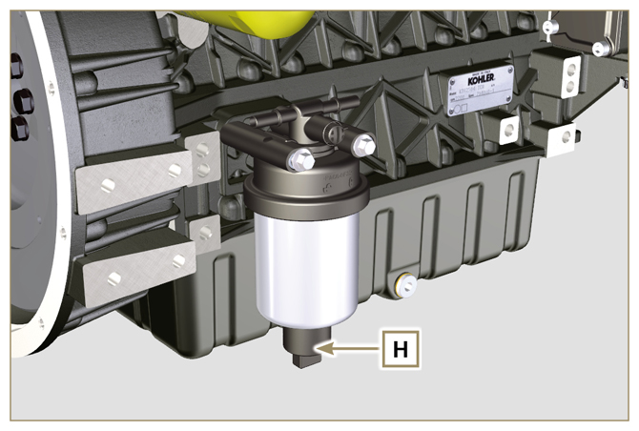  Fig 2.27
2.14.2 Oil pressure switch  Oil pressure switch N is assembled on the crankcase.  It is a N/C sensor, calibrated at 0.6 bar ± 0.1 bar.  With oil low pressure the sensor closes the electrical circuit and the warning lamp in the panel board switches on. | 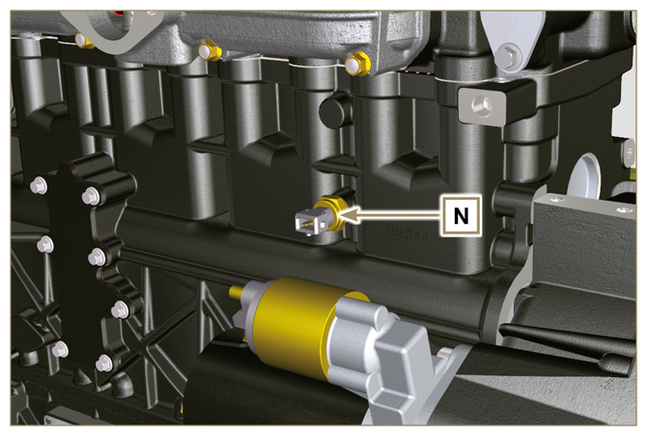  Fig 2.28

2.14.3 Coolant temperature sensor connector  The sensor has the dual function of a thermometer and thermal contact.  The coolant/thermal contact P temperature probe is applied to the cylinder head on the side of the thermostatic valve.  Sensor P1 or P2 (Fig. 2.29) can be assembled on the engine:  P1 Characteristics indicated in Tab. 2.33A (blue connector).  Thermal contact N/O with closing temperature at +110 °C ±3°C, re-opening +88 °C / +100 °C.  P2 Characteristics indicated in Tab. 2.33B (white connector).  Thermal contact N/O with closing temperature at +110 °C ±3°C, re-opening +88 °C / +100 °C.  NOTE : R indicates the pin where it is possible to measure electrical resistance.  Tab 2.33A  SENSOR P1 CHARACTERISTICS  Temperatura °C R min Ω R max Ω  -35 53.983 73.806  -30 39.229 52.941  -15 18.006 20.825  0 7.095 8.929  30 1.717 2.039  60 0.520 0.589  90 0.188 0.204  120 0.076 0.084  Tab 2.33B  SENSOR P2 CHARACTERISTICS  Temperatura °C R min Ω R max Ω  -36 11.835 15.724  -30 8.258 10.834  -16 3.721 4.753  0 1.611 2.003  30 414,1 493  60 132 151,7  90 50,27 56,11  120 21,6 24,29 | 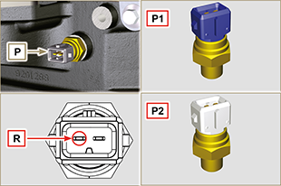  Fig 2.29
2.14.4 Air cleaner clogging switch  NOTE: Component not necessarily supplied by KOHLER .  The switch is assembled on the air cleaner. When the filter is clogged, it sends a signal to the panel.  Features:  - Operating temperature: -30 °C / +100°C  - Contact usually open.  - Contact closed by vacuum: -50 mbar. | 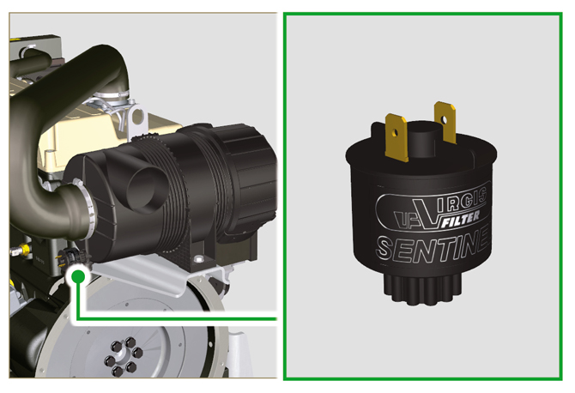  Fig 2.30

Electrical components
2.15.1 Alternator (A)  Externally controlled by the crankshaft by means of a belt.  - Ampere 55 A  - Volt 12V | 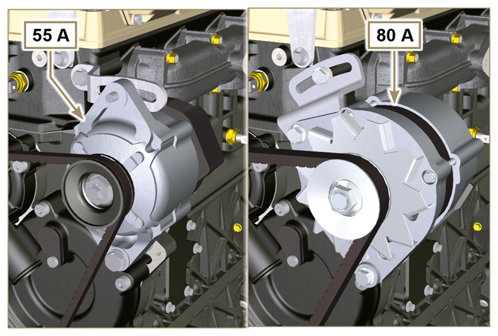  Fig 2.31
2.15.2 Starter Motor (C)  - Type Bosch 12 V  - Potenza 2 kW  - Anticlockwise rotation (seen from timing system side) | 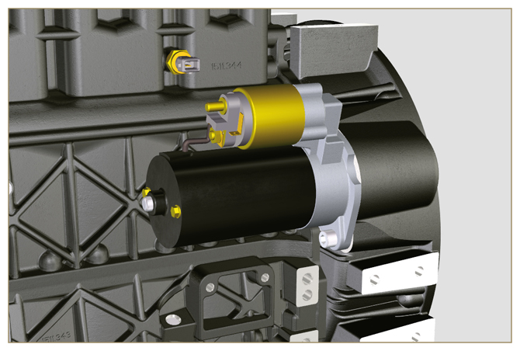  Fig 2.32
2.15.3 Cold starting device (Heater)  The cold starting device consists of a resistance, managed by the ECU, which is activated when the ambient temperature is ≤ -16° C.  The intake air is heated through the resistor and facilitates starting the engine.  Characteristics:  - Type Hidria AET 12 V  - Power 550 W | 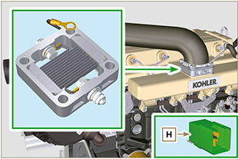  Fig 2.33
2.15.4 Electric pump (optional)  NOTE: Component not necessarily supplied by KOHLER.  The electric pump is located before the fuel filter. One of the following pumps can be assembled A1 - A2 - A3 - A4.  Tab. 2.34 a-b-c-d indicates the pumps' features.  Tab 2.34  POS. DESCRIPTION  1 Electrical connection  2 Prefilter pump  IN Ingoing fitting ( IN ) from tank  OUT Outgoing fitting ( OUT ) to fuel filter  Tab 2.34a  A1 VALUE  Voltage 12 - 24 V  Delivery 100 L/h @ 0.44 - 0.56 bar  Tab 2.34b  A2 VALUE  Voltage 12 V  Delivery 60.56 L/h @ 0.41 bar  Tab 2.34c  A3 VALUE  Voltage 12 V  Delivery 24 L/h @ 0.1 bar  Tab 2.34d  A4 VALUE  Voltage 12 V  Delivery 30 L/h @ 0.4 bar | 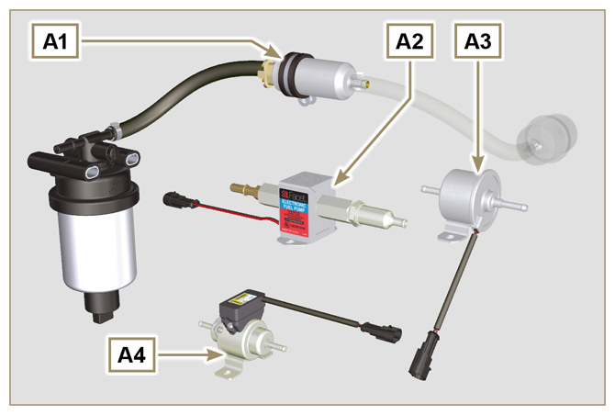  Fig 2.34  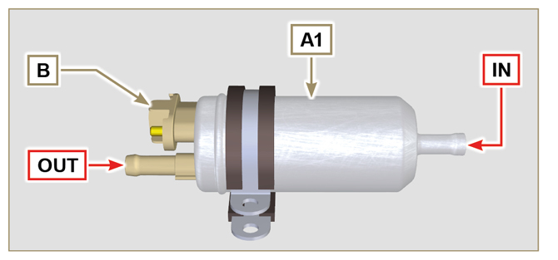  Fig 2.35  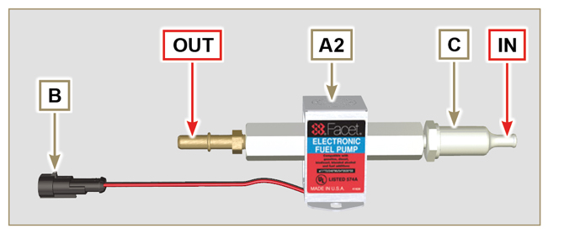  Fig 2.36  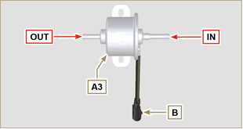  Fig 2.37  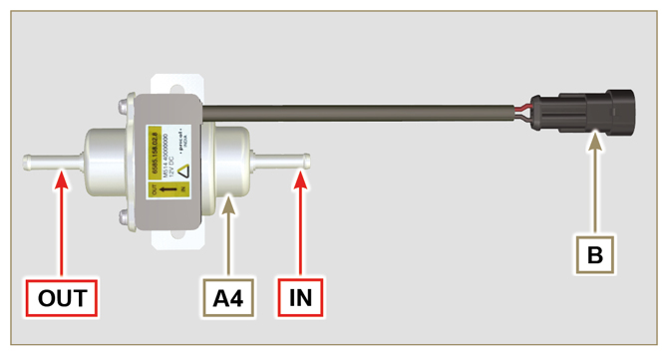  Fig 2.38
2.15.5 Cold start advance  The Cold Start Advance E device is part of injection pump D ; it provides for advance injection modification to enable advance of the engine at low temperatures.  The device is controlled by the ECU H . | 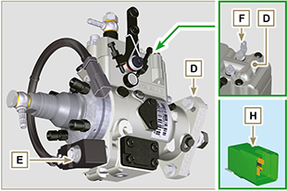  Fig 2.39
2.15.6 Electro-Stop

The electro-stop F device is part of injection pump D ; it turns off the engine by blocking the flow of fuel into pump D .
2.15.7 ECU starting  The H device assists cold engine ignition controlling the "cold starting device" ( Heater ) and the "Cold Start Advance" ( CSA ). Tab. 2.35a indicates the activation times based on the ambient temperatur.  Tab. 2.35a  °C HEATER CSA  ≤ 20 ÷ -15 0'' 120''  - 16 16''  - 21 21''  -26 26''  ≤ -32 32''  Tab. 2.35b  POS. DESCRIPTION  1 Heater  2 50 - ignition  3 15 - ignition  4 CSA  5 30 - battery  6 ...  7 Earth  8 Control panel indicator | 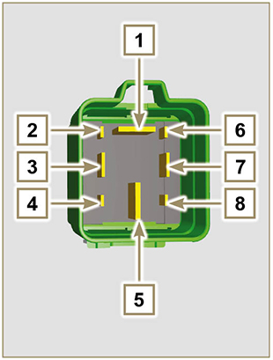  Fig 2.40
2.15.8 Fuse  Device G is assembled on cylinder head P (flywheel side); it protects the electrical circuit in the event of an overload or short circuit.  NOTE: Component not necessarily supplied by KOHLER. | 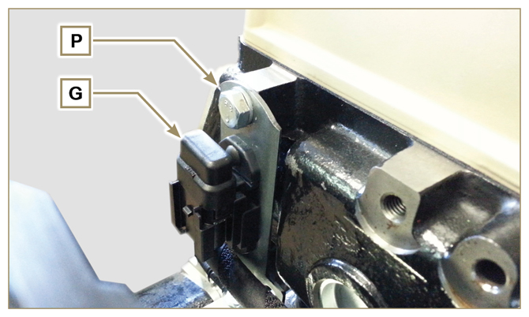  Fig 2.41
2.15.9 Control panel (optional)  Panel L can be assembled on the engine or machine.  The connectors are described in Tab. 2.36 , the main functions are illustrated.  NOTE: Component not necessarily supplied by KOHLER.  Tab 2.36  POS. DESCRIPTION  M Hour-meter indicator  S Control switch to start the engine  W1 Panel ignition indicator  W2 Warning Light - battery not charging  W3 Warning Light - engine oil not pressurised  W4 Warning Light - high coolant temperature  W5 Warning Light - alarm general indicator | 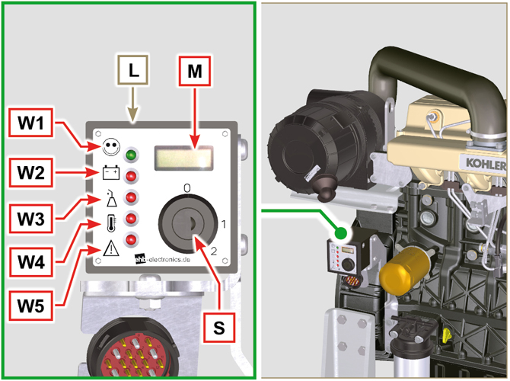  Fig 2.42

Timing system and tappets

The timing system is equipped with hydraulic tappets that automatically recover the operation of the rocker rods assembly.
No registration is therefore required.

2.16.1 Components identification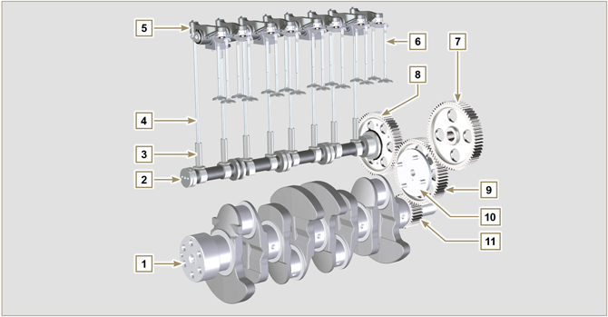
Fig 2.43
Tab 2.37  POS. DESCRIPTION  1 Crankshaft  2 Camshaft  3 Camshaft tappets  4 Rocker arm control rod  5 Rocker arms  6 Valves  7 Injection pump control gear  8 Camshaft control gear  9 Intermediate gear  10 Intermediate gear pin  11 Crankshaft gear  12 Valve control bridge  13 Articulation control valves  14 Hydraulic tappets | 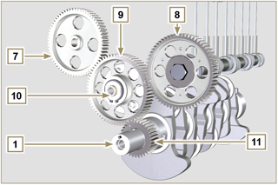  Fig 2.44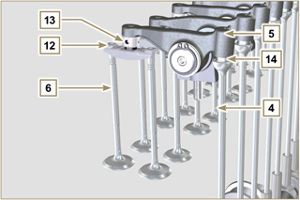  Fig 2.45
2.16.2 Rocker arm pin  Tab 2.39  POS. DESCRIPTION  1 Rocker arm pin  2 Rocker arm distancing spring  3 Rocker arm pin support  4 Exhaust rocker arm  5 Intake rocker arm | 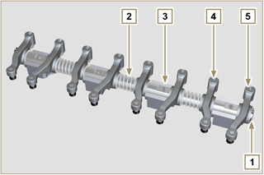  Fig 2.47
2.16.3 Rocker arms  Tab 2.40  POS. DESCRIPTION  1 Rocker arm body  2 Hydraulic tappet oil refill line  3 Valve tappet lubrication line  4 Valve tappet  5 Hydraulic tappet  6 Oil flow line | 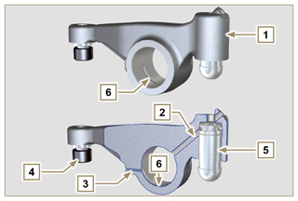  Fig 2.48
2.16.4 Hydraulic tappets  Tab 2.41  POS. DESCRIPTION  A Hydraulic tappets  B Hight pressure chamber  1 Hydraulic tappets oil refill pipe  2 Retaining ring  3 Piston  4 Unidirectional valve  5 Tappet body  2.16.4.1 Hydraulic tappet operation  The operating principle of the hydraulic tappet is based on the incompressibility of the liquids and on controlled leakage.  The oil under pressure enters the tappet chamber A , providing a constant supply of oil in the low-pressure chamber.  Through the non-return valve, 4 the oil can only access the high-pressure chamber B and exit via the clearance between the piston 3 and the tappet body 5 (controlled leakage).  The chamber B is filled when the rocker arm is on the base radius of the cam and the spring 6 keeps the piston 3 against the valve stem, thus eliminating any system play. Thanks to the spring extension, the tappet "extends", creating a small depression in the chamber B , making the non-return  valve 4 open, and allowing the oil in the chamber A to pass to chamber B , restoring the proper amount of oil required to eliminate any play in the valves. | 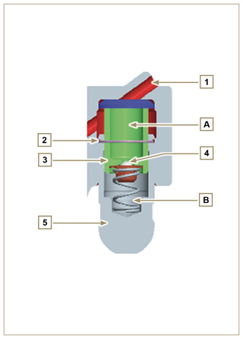  Fig 2.49

2.16.4.2 Difficult operating conditions
For proper operation on the hydraulic tappets it is essentia that the low pressure chamber of the piston 3 is always full of oil.

In some conditions this may not occur (due to the fact that the oil leaks away when the engine is switched off, which can also partially drain the tappets). This situation will be the cause of clearances that will result in a characteristic noise similar toa ticking sound.
- When the engine is cold, the tappet filling time could be very long if the oil used is not suitable for the specific environmental conditions ( Tab. 2.2 )
- If the engine is very hot: at idle speed, oil pressure may be low, and small air bubbles could form in the circuit. Because of this, this compressing the tappet slightly and producing valve play which is responsible for the ticking sound. On account of this, the tappet compresses slightly giving rise to a valve clearance, thus generating a slight ticking sound, which however disappears rapidly ( MAX 10 seconds) once normal operating conditions have been restored.
Anyway the duration of ticking Anyway the duration of ticking sound must be MAX 30 seconds. If not, the problem is surely due to the poor quality of the oil, wear or impurities that, transported by the oil, can infiltrate between the ball valve and its seat inside the piston, compromising the operation of the tappet itself; In these cases, the only solution is to replace the oil or hydraulic tappets.

The prolonged persistence of the ticking sound or abnormal noise must be investigating in order to prevent any malfunctions; if necessary, replace the hydraulic tappets and engine oil.

Components handling
2.17.1 Injection pump  - Only handle by means of the points marked by Y .  - It is forbidden to handle using the points marked by N . | 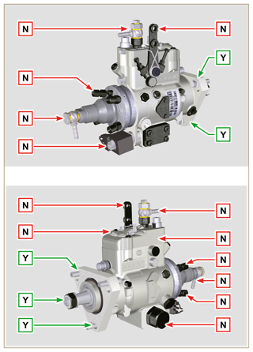  Fig 2.50
2.17.2 Injector  - Only handle by means of the points marked by Y .  - It is forbidden to handle using the points marked by N . | 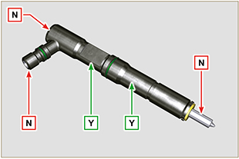  Fig 2.51

Balancer device (optional)
The balancer device is composed of a special crankshaft that activates 2 additional shafts (balancers).  Rotation of the balancers, which have counterweights that oppose the movement of alternating weights (crankshaft - connecting rods - pistons), reduces vibrations caused by them.  The device is developed under the crankshaft, fixed on the crankcase, closed by the oil sump.  Tab 2.43  POS. DESCRIPTION  1 Crankshaft  2 Balancer shaft control gear  3 Balancer shaft support box  4 Conductor balance shaft  5 Conducted balance shaft | 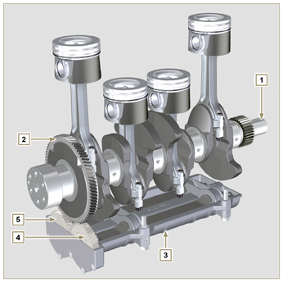  Fig 2.67

