Informa?ii de asamblare
KDI 1903 M Workshop manual (Rev_09.6)

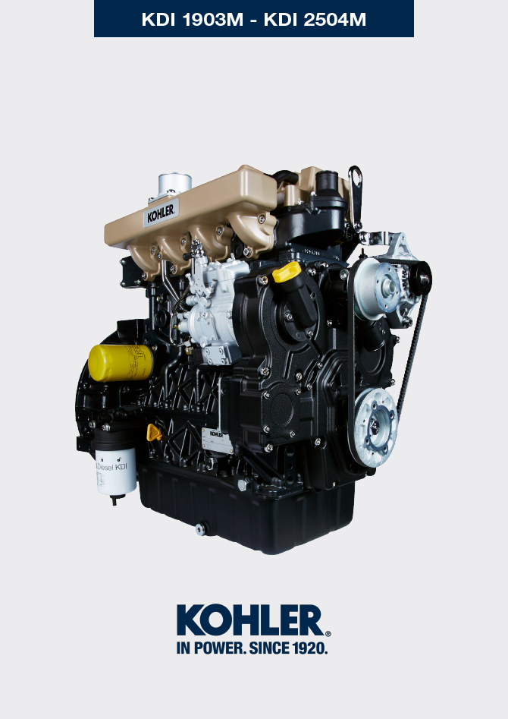

Registration of modifications to the document
Any modifications to this document must be registered by the drafting body, by completing the following table.

Released by | Code | Revision | Release Date | Revision date | Edited by | Endorsed
 | ED005302-960 | 9.6 | 04/2013 | 02/2022 | C. ACCOTI | D. UGHETTI

Translated from the original manual in Italian language
Data reported in this issue can be modified at any time by KOHLER.

Sommario
1. TITOLO 1 2
1.1. Asdfsdfsdf 2
1.2. Asdfsdfsdfggg 2

Assembly information

Information on engine configuration
- In this chapter, the engine is represented as "BASE CONFIGURATION" (refer to Par 1.3 - Par. 1.4 ).
- For the assembly of components not described in this chapter refer to Chap. 11 .
- The following are the components described in Chap. 11 .

11.1 Oil dipstick in cylinder head

11.2 Heater (replacement)

11.3 Idler gear (for 3 ^{rd} / 4 ^{th} PTO)

11.4 3 ^{rd} PTO (replacement)
11.5 4 ^{th} PTO (replacement)
11.6 3 ^{rd} + 4 ^{th} PTO (configurations)
11.7 Balancer shafts (replacement)
11.8 Air filter (cartridge replacement)
11.9 Remote oil filter (disassembly and assembly)

11.10 Intake circuit (replacement)

11.11 Muffler (replacement)

11.12 Cooling circuit (replacement)

11.13 Engine feet (information)

Assembly recommendations
- The information is laid out in sequence, the intervention methods have been selected, tested and approved by the manufacturer's technicians.
- This chapter describes the installation procedures for the assemblies and/ or individual components which have already been checked, overhauled or possibly replaced with original spare parts.
- Where necessary, reference to special tools during assembly operations is indicated and identified in Tab. 13.1 , hereinafter in Tab. 9.1 an example of a special tool ( ST_05 ).

Tab. 9.1
SPECIAL TOOLS
"ST" Code | Picture /draw | DESCRIPTION | PART NUMBER
ST_05 | 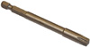 | Six nicks Key SN 8 | ED0014603650-S

Important

- Before proceeding with operations, read Par. 3.3.2 .
- To easily locate specific topics, the reader should refer to the analytical index or chapter index .
- The operator must check that:
  - the components, the assemblies, the coupling surfaces of the parts are washed, clean and thoroughly dried;
  - the coupling surfaces are undamaged;
  - the equipment and tools are ready so that all work can be carried out correctly and safely;
  - ensure that the working environment is safe.
- The operator must:
  - carry out the procedures smoothly and safely. It is thus recommended to install the engine on a special rotating stand used when servicing engines to ensure the safety of the operator and the other individuals involved;
  - tighten the assemblies and / or components in a criss-cross or alternating pattern, initially with a value lower than that preset, and then subsequently, with the tightening torque specified in the procedure;
  - replace all seal gaskets after each assembly for all components on which they are provided.

Engine block assembly
9.3.1 Crankshaft bushings  Important  - Execute the procedure in Par. 8.2.1 and 8.2.2 , before proceeding with assembly..  - The crankshaft half-bearings are made of special material. Therefore, they must be replaced every time they are assembled to prevent seizures.  - Fit the new half-bearings B onto the crankcase upper half E adhering to the reference notches C .  Important  - After the half-bearings are fitted, check that the lubrication holes D correspond with the crankcase grooves E .  - The lower and upper half bearings CANNOT be singularly replaced, and both halves must be replaced together.  - Fit the new half-bearings A onto the lower crankcase F using the reference notches G .  - Lubricate the half-bearings A and B with oil. | 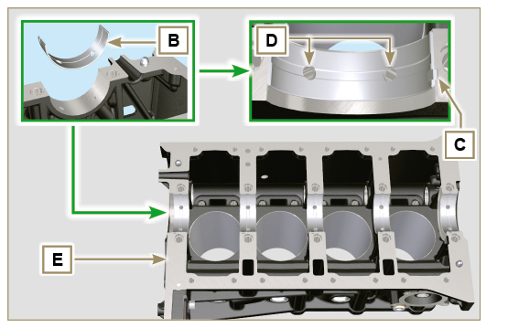  Fig 9.1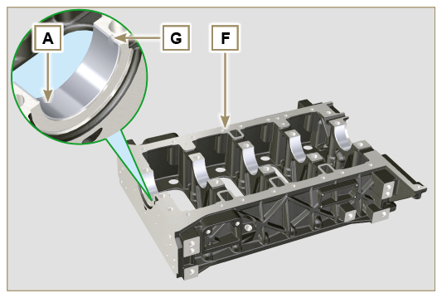  Fig 9.2
9.3.2 Tappets  - Lubricate the tappets G with oil.  - Insert the tappets G into the housings H of the upper crankcase. | 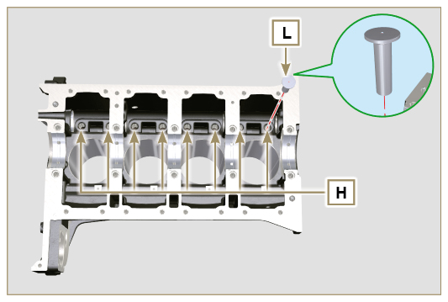  Fig 9.3
9.3.3 Camshaft  - Check that the bushing Q is correctly fitted.  - Lubricate the pins L , the cams M of the camshaft N , all the housing P and the bushing Q with oil.  - Insert the camshaft N all the way into its housing P .  - Fit the lock ring R on to the crankcase E to hold the position of the camshaft N .  - Manually rotate the camshaft N ensuring that it is free. | 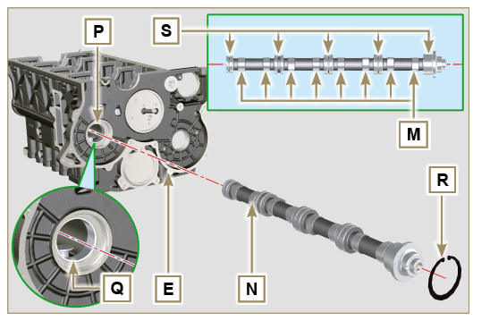  Fig 9.4
9.3.4 Vent compartment closure lid  - With the screws CF tighten the cover CG and the gasket CH (tightening torque to 10 Nm ). | 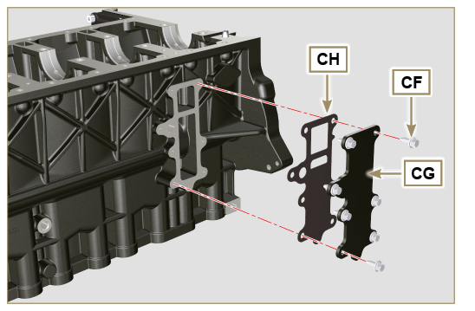  Fig 9.5
9.3.5 Crankshaft  Important  - Carry out the checks described in Par. 8.4.1 and Par. 8.4.2 .  - Check that the crankshaft half-bearings are mounted correctly on the upper crankcase E .  - Lubricate the main journal and crankpin J , with oil.  - Insert the crankshaft W into its seat on the upper crankcase E .  - Insert the 2 shoulder half-rings K , between the crankshaft W and the upper crankcase E ( AB detail). | 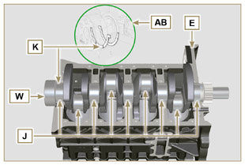  Fig 9.6
9.3.6 Lower crankcase  - Check that the crankshaft half-bearings are mounted correctly on the lower crankcase F ( AC detail).  - Assemble the 2 shoulder half-rings AD onto the lower crankcase F applying two drops of oil to keep them in their seat.  - Check that the coupling surfaces AE are free from dirt and grit. | 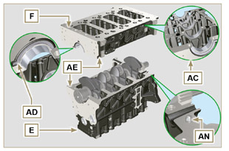  Fig 9.7
- Spread a bead of Loctite 5660 (rif. AL) of approx 1 mm thickness on the surface AM of the upper crankshaft half C being careful not to block the oil feed grooves AG and the return oil sump AH .  - Join the two crankshaft halves E and F observing the guide pins AN . | 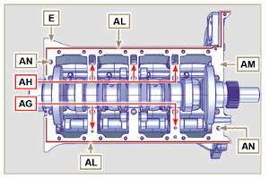  Fig 9.8
Important  - Failure to follow the bolting procedures compromises the functionality of the engine and can cause damage to people and property.  - Tighten the fastening screws strictly following the sequence and the tightening torque indicated.  Tightening sequence for 3 cylinders  Tightening Screws Torx M12x1,25 (from the n° 1 to the n° 8 ):  CYCLE 1 - with a torque of 40 Nm ;  CYCLE 2 - with a torque of 70 Nm ;  CYCLE 3 - with a torque of 120 Nm .  Tightening Screws Torx M8 (from the n° 9 to the n° 21 ):  CYCLE 4 - with a torque of 20Nm ;  CYCLE 5 - with a torque of 35 Nm ;  - Perform the operations described in Par. 8.4.2 .  - Check that crankshaft W rotates smoothly.  NOTE: In the next illustrations of Par. 9.3 the coupled crankcase half will be indicated with the letter E . | 3 Cylinders  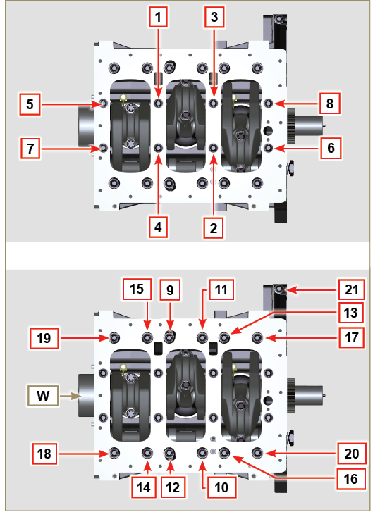  Fig 9.9
- Tightening sequence for 3 cylinders  Tightening Screws Torx M12x1,25 (from the n° 1 to the n° 10 ):  CYCLE 1 - with a torque of 40 Nm ;  CYCLE 2 - with a torque of 70 Nm ;  CYCLE 3 - with a torque of 120 Nm .  Tightening Screws Torx M8 (from the n° 11 to the n° 27 ):  CYCLE 4 - with a torque of 20Nm ;  CYCLE 5 - with a torque of 35 Nm ;  - Perform the operations described in Par. 8.4.2 .  - Check that crankshaft W rotates smoothly. | 4 Cylinders  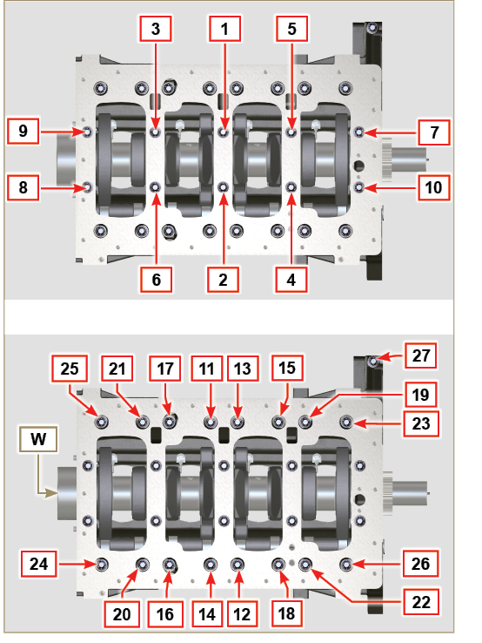  Fig 9.10
9.3.7 Piston rings  - Perform the operations described in Par. 8.5.3 .  - Put the scraper ring AP onto the piston AQ .  - Put the 2° seal ring AR on the piston AQ .  - Put the 1° seal ring AS onto the piston AQ . | 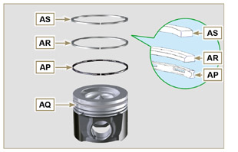  Fig 9.11
- Perform the operations described in Par. 8.5.4 .  - Position the segment openings with a 120° angle between them ( Y ).  NOTE: do not use the segment opening with the pin hole ( N )  - Lubricate the piston skirt and piston rings with oil. | 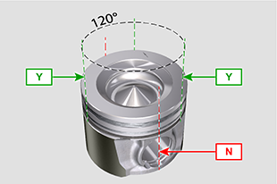  Fig 9.12
9.3.8 Piston and connecting rod  Important  - Before proceeding to the assembly of the piston and connecting rod, carry out the checks described in Par. 8.5.1 .  - Always replace the bearings CE after each assembly.  - Loosen the screws AU and remove the connecting rod cap AV .  - Fit the new bearings CE .  - Insert the connecting rod AZ into the piston AQ and align the seats BA .  - Insert the gudgeon pin BB into the seat BA for the assembly of the connecting rod and piston unit.  - Insert the lock rings BD inside the seat BE of the piston AQ to lock the gudgeon pin BB . | 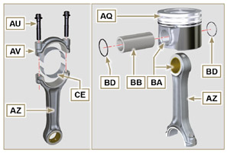  Fig 9.13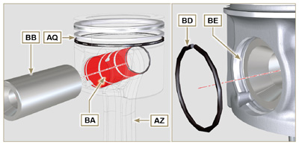  Fig 9.14 - Fig 9.15

9.3.9 Piston and connecting rod assembly  Important  - Before assembling the piston and connecting rod assemblies, execute the controls described in Par. 8.5  - Rotate the crankshaft W by moving the crankpin BG to a TDC position of the affected cylinder.  - Push the piston AQ downwards by centering the crankpin BG with the connecting rod AZ .  - Turn the crankshaft on support to assemble the con rod capp on cylinder 1 and 4. | 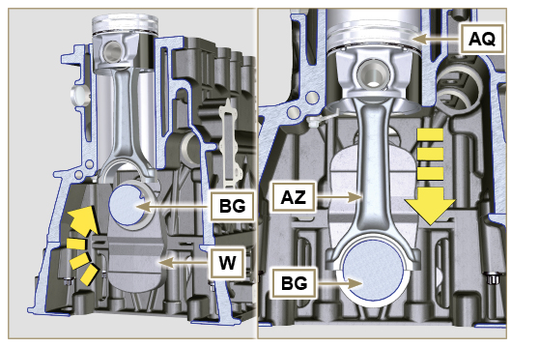  Fig 9.16
- Check that the half-bearing AS is mounted correctly on the connecting rod cap AV .  Important  - As the rods are divided by breaking pay particular attention to the coupling of the cap on the connecting rod.  - Check before you screw and tighten the bolts that the breaking surfaces are perfectly flush.  - Couple the connecting rod cap AV to the connecting rod AZ using the marks made at disassembly ( Par. 7.13.2 )  - Screw in the screws AU .  - Repeat the operations from 1 to 6 for the cylinders 2 and 3. | 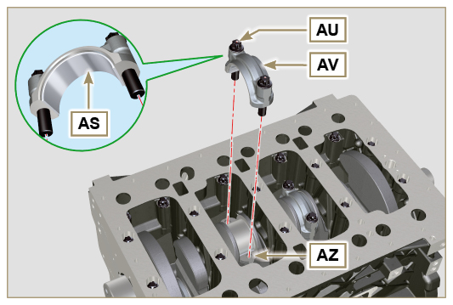  Fig 9.17
Important  - Failure to follow the assembly procedures compromises the functionality of the engine and can cause damage to people and property.  - Tighten the screws AU , alternately, strictly following the tightening torques indicated.  Tightening sequence of screws Torx M10x1:  1° PHASE - with a torque of 40 Nm ;  2° PHASE - with a torque of 85 Nm ;  - Check that the connecting rods have axial play and the crankshaft W rotates smoothly.  NOTE : After the check carried out at point 8, position the shaft W with the first cylinder to TDC. | 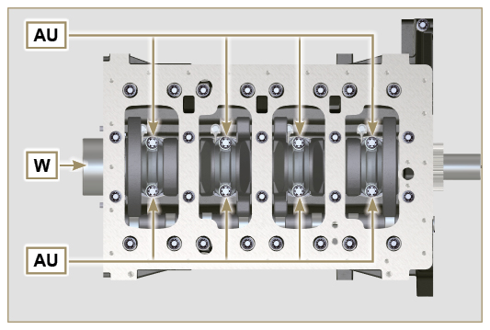  Fig 9.18

9.3.10 Crankshaft gasket flange  Important  - Check that the contact surface between the flange and the crankcase is free of grit and dirt.  - Always replace the gasket BS after each assembly.  - Check that there are bushings BT on the crankcase E .  - Lubricate the oil seal lip BU .  - Position the gasket BS and flange BV on the crankcase E in correspondence with the bushings BT .  - Put Loctite 243 on the 2 screws BW matching the bushings BT .  - Screw the fastening screws all the way in BW without tightening them.  - Tighten all the screws BW strictly following the tightening sequence indicated (tightening torque to 10 Nm ). | 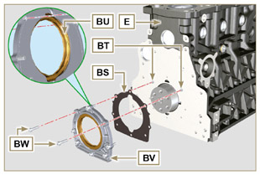  Fig 9.19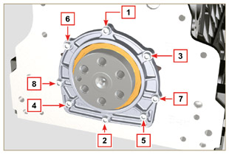  Fig 9.20
9.3.11 Cover 3 ^{rd} PTO  Important  - Replace capscrews CA with each assembly or alternatively apply Loctite 2701 on the thread.  - Secure the cover CB with the screws CA and CC inserting the gasket CD (tightening torque 25 Nm ). | 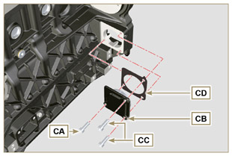  Fig 9.21

Oil sump unit assembly
9.4.1 Oil fume pipes  - Apply Loctite 648 on the pipe threads A .  - Screw and tighten the pipes A (tightening torque of 15 Nm ). | 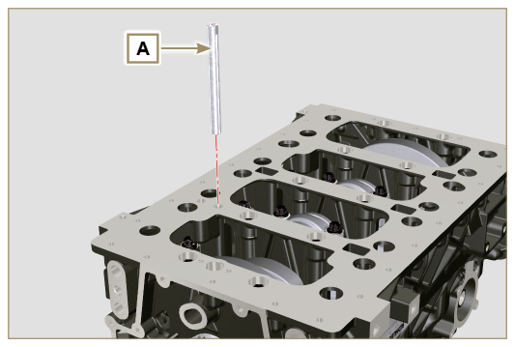  Fig 9.23
9.4.2 Oil suction pipe  Important  - It is mandatory to replace the gasket B after each assembly.  - Always replace capscrews D with new ones or alternatively apply Loctite 2701 .  - Insert the new gasket B in the seat of the oil suction hose flange D .  - Secure the hose C on the crankcase E with the screws D (tightening torque 10 Nm ). | 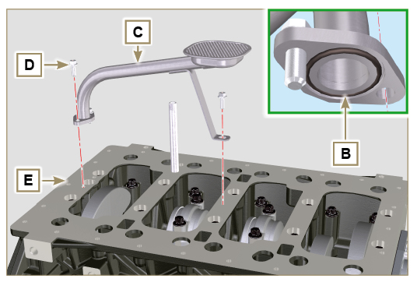  Fig 9.24
9.4.3 Oil Sump  - Ensure that the contact surfaces F of the oil sump G and the crankcase E are completely clean.  - Apply a bead of approx. 2.5 mm of sealant (Loctite 5660) on the surface F of the oil sump G .  - Note : alternatively apply Loctite 5699 . | 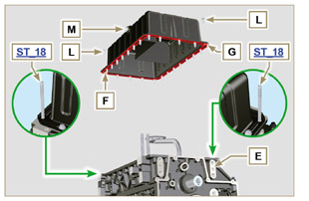  Fig 9.25
Important  - Tighten the screws L , strictly following the sequence and tightening torque indicated.  - Tighten the screws L following the sequence indicated (tightening torque 25 Nm ).  - Remove the two studs ST_18 with the appropriate screws (tightening torque 25 Nm)  - After tightening all of the screws, loosen screw n°1 and retighten it to the torque value specified in step 4 .  - Check that the oil drain plugs M are tight (tightening torque 35 Nm ). | 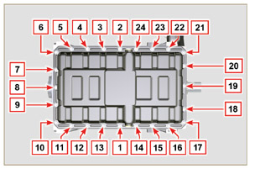  Fig 9.26

Flange unit assembly
9.5.1 Bell housing  Danger  - Bell A is very heavy; pay special attention during assembly operations to avoid dropping and causing serious risks to the operator.  - Install the bell housing A in accordance with the reference pins B on the base C . | 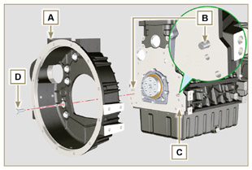  Fig 9.27
Important  - Failure to adhere to the assembly procedures may compromise the functionality of the engine, and also cause damage to persons and property.  - Tighten the fastening screws D strictly following the tightening sequence indicated (tightening torque 50 Nm ). | 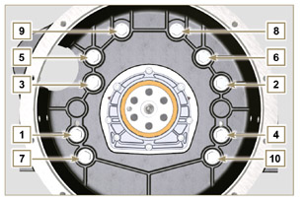  Fig 9.28
9.5.2 Flywheel  Danger  - Flywheel F is very heavy; pay special attention during assembly operations to avoid dropping and causing serious risks to the operator.  - Screw the special tool ST_09 on the crankshaft E instead of the screws G positioned higherup ( Fig. 9.29 ).  - Insert the flywheel F on the crankshaft E using the tool as a guide ST_09 and manually tighten all the screws G (the last screw is fitted in the place of the tool ST_09 ).  - Mount the tool ST_34 in the seat of the starter motor H and fit it with the two starter motor fixing screws.  - Tighten the screws G (tightening torque at 140 Nm ). | 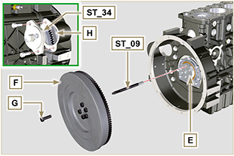  Fig 9.29

Timing system gear assembly and injection pump
9.6.1 Timing system gear assembly  - Check that the key A is correctly fitted on the camshaft B .  - Position the gear C on the camshaft B adhering to the key reference A .  - Screw capscrew D until the end.  - Tighten the middle gear pin H , in the housing J of the crankcase, with the screws K (tightening torque 25 Nm ). | 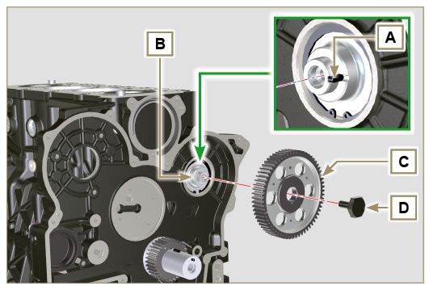  Fig 9.30
Important  - The fitting of the middle gear pin H has only one position, the 4 screw holes K are asymmetric.  - Always replace the gasket L at each assembly.  - Insert the shoulder ring M .  - Check the integrity of the bushing N into the middle gear P , and ensure that it is free from impurities.  - Thoroughly lubricate the pin H and the bushing N .  - Position the gear P on the pin H observing all the marks W of the gears C and S (Fig. 9.33) . | 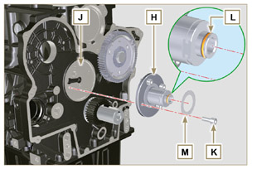  Fig 9.31
Important  - Failure to comply with the marks W on the gears C, P and S , causes engine malfunction and serious damage. | 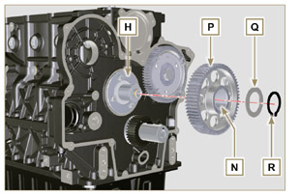  Fig 9.32
- Insert the shoulder ring Q and the lock ring R.  - Tighten the screw D ( Fig. 9.30 - tightening torque at 100 Nm ). | 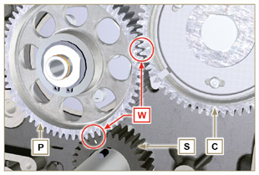  Fig 9.33
9.6.2 Injection pump  Important  - Always change screws T with new ones or alternatively apply Loctite 270 (Fig. 9.34) to the threads.  - Perform the operations described in the warning in Par. 6.1.5 .  - Place a dial gauge to detect the TDC on piston N° 1 , then bring the indicator of the dial gauge to 0 .  NOTE : During the detection phase of the TDC, check that cylinder N° 1 is in compression phase (align the notches W as in Fig. 9.33 ). | 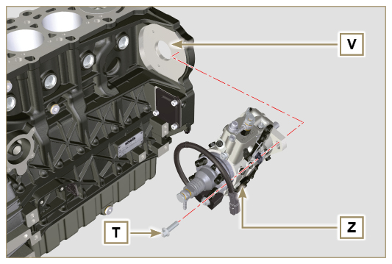  Fig 9.34
- By means of the identified pump code, refer to Tab. 6.1 to know the advance degrees and the corresponding value to lower the piston.  - Mount tool ST_34 in the seat of starter motor H (Fig. 9.29) and fix it with two motor fixing screws.  - Having identified the value to lower the piston, rotate the crankshaft anti-clockwise by going beyond the value described in Tab. 6.1 , once again, rotate the crankshaft clockwise stopping at the correct advance value by using tool ST_03 - ST_34 .  - Lock the ST_34 , ensure that the crankshaft does not rotate, which would alter the correct advance value.  If this happens, repeat the instructions described in points 4, 5 and 6. | 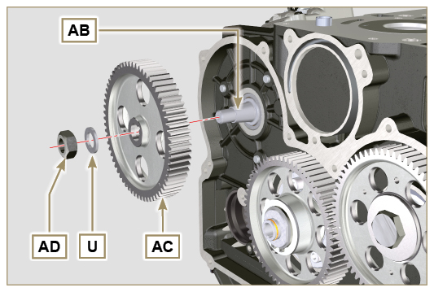  Fig 9.35
- Fix pump Z into housing V by means of screws T ( Fig. 9.34 - tightening torque at 25 Nm ).  - Position the gear AC onto shaft AB of the pump.  NOTE: You are not required to respect the reference Q gear AE ( Fig. 9.36 ).  - Insert washer U and tighten nut AD (tightening torque at 70 Nm ).  Important  - In the event of assembling screw X1 (tightening torque at 10 Nm ).  - In the event of assembling screws X2 and X3 (tightening torque at 2 5 Nm ). | 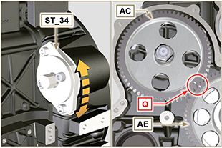  Fig 9.36  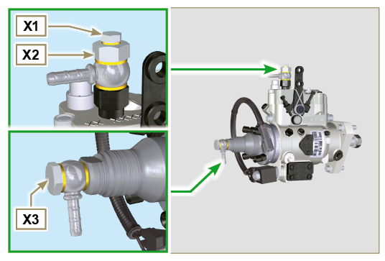  Fig 9.37

Cylinder head unit assembly
9.7.1 Valve stem gasket  Important  - Carry out the checks described in Par. 8.6.4 before proceeding with the following operations.  - Always replace gasket A with every assembly  - Lubricate the gaskets A on the inside.  - Fit the oil seals A on the valve guides B using the tool ST_08 . | 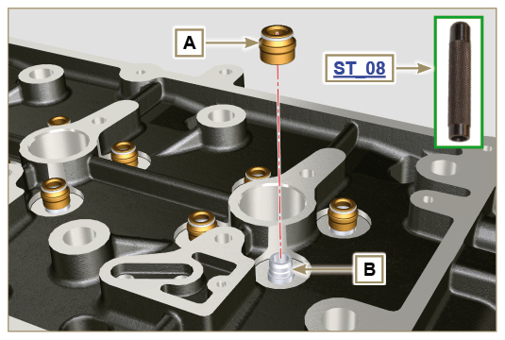  Fig 9.38
9.7.2 Injector sleeves ( )  - Insert the seals C in the seats of the sleeve D .  - Insert the seal E with the convex side facing upward at the base of the sleeve D .  - Lubricate the gaskets C .  - Insert and carefully screw the sleeve D into the seat of the head F .  NOTE: The sleeve D must not protrude above the surface of the head BF .  - Clamp the sleeve D (tightening torque at 30 Nm ). | 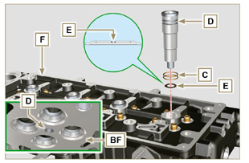  Fig 9.39
9.7.3 Injectors projection  - Insert the injector G inside the sleeve H .  - Mount the injector fixing bracket M and secure it with the screw N , without performing the calibration.  - Check protrusion of injectors by means of the tool ST_03 (Fig. 9.44) , check the projection of the injector, which must range between 1.68 ÷ 2.42 mm.  NOTE : if the value detected does not correspond, replace gasket Q with a different thickness. | 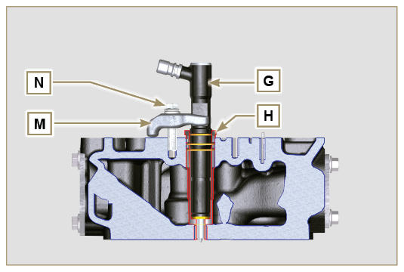  Fig 9.40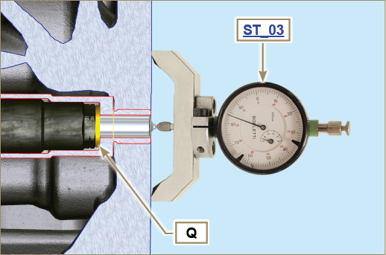  Fig 9.41
9.7.4 Valves  - Pre-lubricate and insert the valves X into the head F taking care to fit them in the original positions as per the reference marks made in Par. 7.13.4.1 .  - Position the spring Y on the seat of the head F .  - Position the disk S on the spring Y centering the valve X .  - Mount the tool ST_07 on the head F fixing it on one of the holes for securing the rocker arm cover.  NOTE: Change the fixing hole according to the position of the valves to be fitted.  - Position the tool ST_07 on the valve as shown in the figure.  - Push the lever of the tool ST_07 downwards, in order to lower the valve disks S in the direction of the arrow AK , and insert the valve cotters AJ inside the disk S .  - Check that the valve cotters AJ are properly mounted on the valve seats X and release the tool ST_07 .  NOTE: repeat all the steps for the relevant valves and remove the tool ST_07 . | 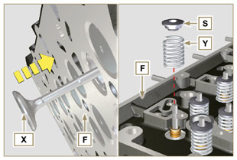  Fig 9.42
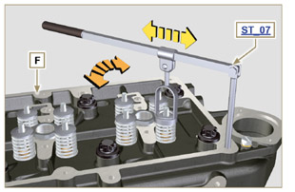
Fig 9.43
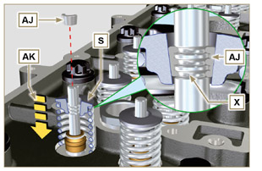
Fig 9.44
9.7.5 Cylinder head  - Fix the eyebolts AW with the screws AX onto the head F (tightening torque of 25 Nm ).  - Position the piston P at the TDC.  - Position the tool ST_03 on the crankcase surface of the head and measure the piston protrusion P from head level K in 4 diametrically opposed points R. Repeat the operation for all pistons P and take note of the highest average value, determining valu e S (Tab. 9.2) .  Tab. 9.2  S (mm) Hole number  0.030 - 0.126 1  0.127 - 0.250 2  0.251 - 0.375 3  - Based on the value detected at point 3 , select the relevant gasket T as shown in the Tab. 9.2 (Fig. 9.47 detail U ).  - Check that the crankcase surface K and the gasket T are completely free of dirt and grit.  Important  - The head gasket must be replaced for each assembly.  - Position the gasket T on the surface K with reference to the centering bushings J . | 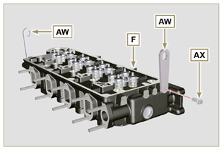  Fig 9.45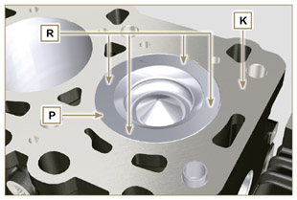  Fig 9.46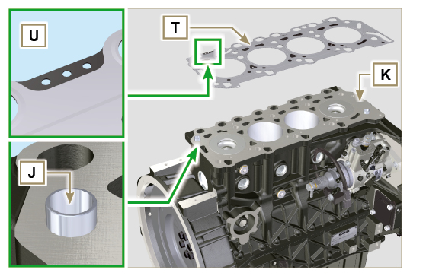  Fig 9.47
- Check that the surface head W is free from impurities.  - Position the head F on the crankcase Z with reference to the centering bushings J .  Important  - The fastening bolts V must be replaced every time they are assembled.  - Secure the head F by tightening the screws V strictly following the sequence indicated in the Fig. 9.52 or Fig. 9.53 and the tightening torque indicated in the Tab. 9.3 . | 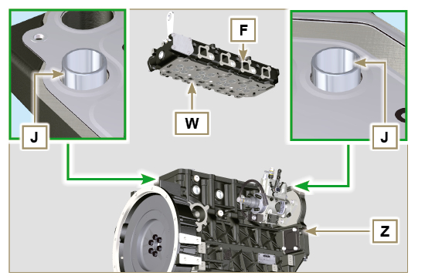  Fig 9.48
Important  - Failure to adhere to the bolt fixing procedures may compromise the functionality of the engine, and also may cause damage to persons and property.  - Tighten capscrews V observing the cycles, tightening, and subsequent rotation as indicated in Tab. 9.3 .  - For engine KDI 1903 M : 8 screws Torx M12x1,25 (Fig. 9.49) .  - For engine KDI 2504 M : 10 screws Torx M12x1,25 (Fig. 9.50) . | 3 CYLINDERS  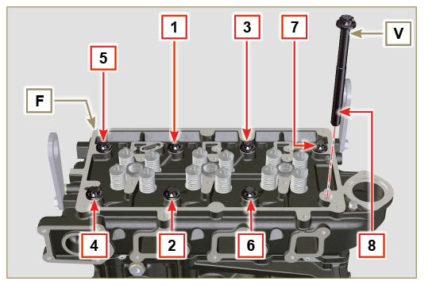  Fig 9.49
Tab. 9.3  CYCLE TORQUE  1 40 Nm  2 70 Nm  3 100 Nm  4 90°  5 90°  6 90° | 4 CYLINDERS  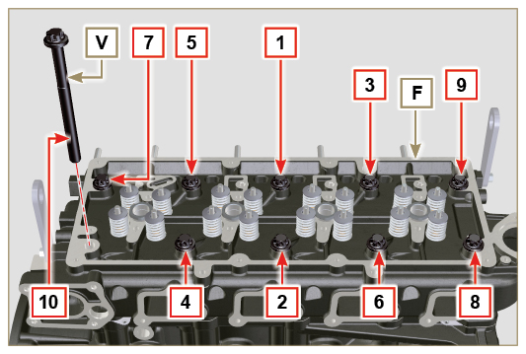  Fig 9.50
9.7.6 Rods and valve bridges  - Insert the rocker control rods AA into the niches of the head F .  Important  - Properly centre the rods AA into the spherical housing of the camshaft tappets AB .  - Mount the valve bridge AC on to the pairs of discharge and suction valves. | 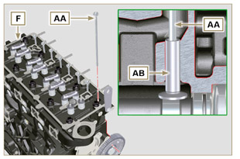  Fig 9.51
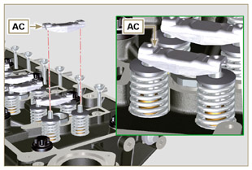
Fig 9.52
9.7.7 Rocker arms  Important  - To correctly position the rocker arms, turn the rocker arm pin AH with the lower height AL towards the timing system side as in Fig.9.54 .  - The discharge rocker arm AT is shorter than the suction arm AR .  - Fit the lock ring AM into the seat AN of the rocker arm pin AH .  - Position the pin AH with the screw support surface AP facing upwards and insert the 2 shoulder rings AQ .  - Insert in sequence the suction rocker arm AR , the holder AS and the discharge rocker arm AT in the pin AH .  - Insert the spring AU in the pin AH .  - Repeat points 3, 4 for all the rocker arms.  NOTE: The holder AV must be fitted with the last pair of rocker arms towards the flywheel.  - Insert 2 shoulder rings AQ and the lock ring AN to lock all the components inserted in the pin AH .  NOTE : The spring AU ensures that the supports AS and AV are kept in place. | 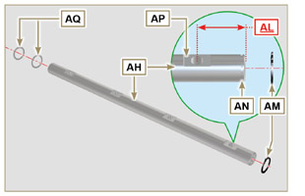  Fig 9.54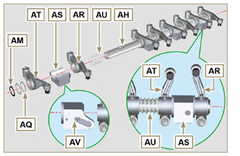  Fig 9.55
9.7.8 Rocker arm pin assembly  Important  - Position the rocker arm pin assembly BB on a level to align all the support surfaces.  - Check that the pistons are positioned half way between the TDC and BDC. Rotate the crankshaft 90° counterclockwise with regard to the 1st cylinder TDC, positioning the crankshaft pin BP as shown in Fig 9.58a . If the crankshaft pulley and the timing gear cover have not been removed, rotate the  crankshaft positioning the reference BQ located on the target wheel in correspondence of the speed sensor, as shown in Fig. 9.58b .  - Position the rocker arm pin assembly BB on the head F , respecting the plug BC on the head using the holder indicated AV .  - Check the correct positioning of all the rocker arms and the u-bolt control valves (detail BD ). House the tappet in the seat of the rocker arms control rod.  - Secure the rocker arm pin BB tightening the screws BE (tightening torque to 25 Nm ). Adhere to the screw tightening sequence BE as shown in Fig. 9.60 . | 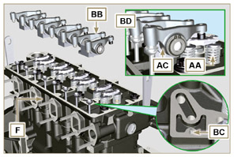  Fig 9.56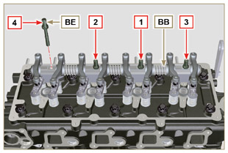  Fig 9.57
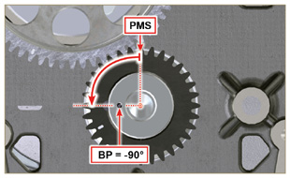  Fig 9.58a | 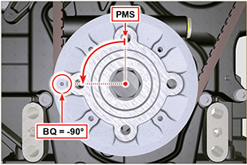  Fig 9.58b

Fuel system assembly
Important  - Replace the high pressure pipes after two disassemblies.  - Remove the protective caps from all the components of the fuel circuit just before assembly (Par. 2.9.7).  - When repaired, RSN-A injectors must be certified by a Stanadyne centre to check their correct operation - check the type of engine mounted injectors on the spare parts list ( RSN-A is specified in the description). | 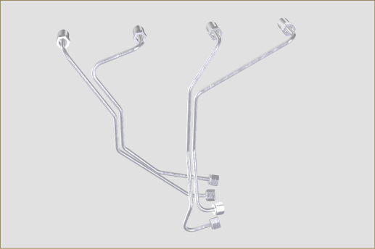  Fig 9.59
9.8.1 Injector  - Lubricate the gaskets U, T, S , and fit them on the injector Z. | 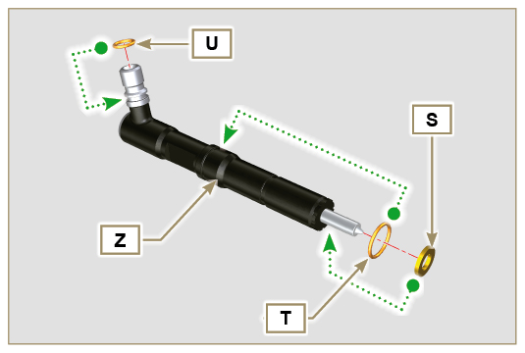  Fig 9.60
2 . Fit the injector Z in the sleeve V . | 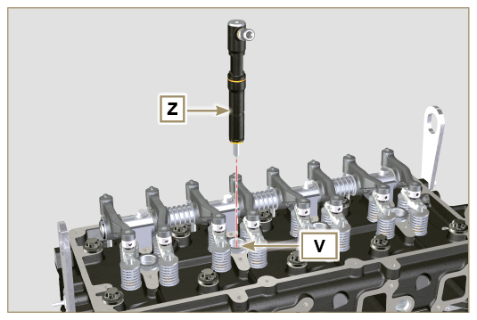  Fig 9.61
- Assemble parts P, Q, R .  - Fit the parts so assembled on the injector Z . | 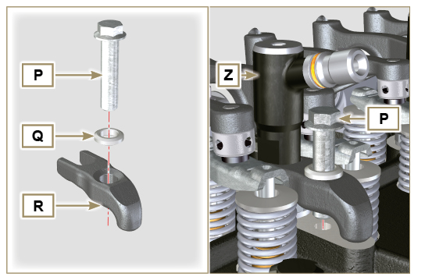  Fig 9.62
- Insert tool ST_51 on the injectors junctions Z (detail X1 ).  - Tighten the screw P (tightening torque to 20 Nm ). | 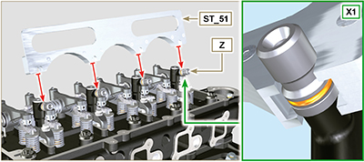  Fig 9.63
9.8.2 Fuel injector ricicle pipe  - Position the tube N on the injectors Z , and tighten screws M (coppia di serraggio a 14 Nm ) and insert the gasket T . | 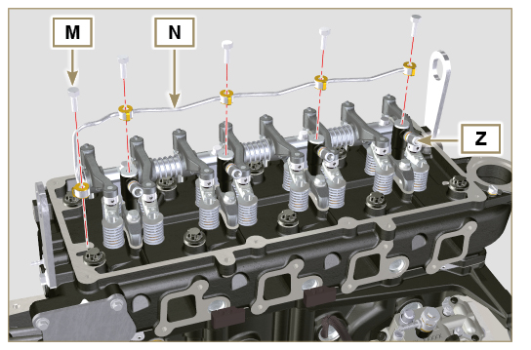  Fig 9.64
9.8.3 Rocker arm cover  Important  - Always replace the gaskets AK after each disassembly ( ST_36 - apply Loctite 480 to the seats of cap C before assembling the gaskets)..  - Position tool ST_17 onto the head in correspondence with the two fastening holes 5 and 6 ( Fig. 9.66 - 9.67 ).  - Position the gasket AM on the head AL using tool ST_17 as a guide.  - Fit the rocker arm cap C on the head AL via the screws L observing the clamping sequence illustrated in Fig. 9.66 ( KDI 1903 M ) or Fig. 9.67 ( KDI 2504 M) (tightening torque at 10 Nm ).  - With vaseline lubricate the gaskets AK .  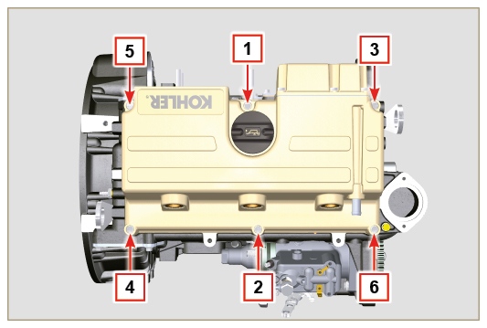  Fig 9.66 | 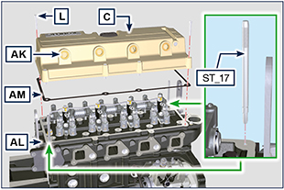  Fig 9.65  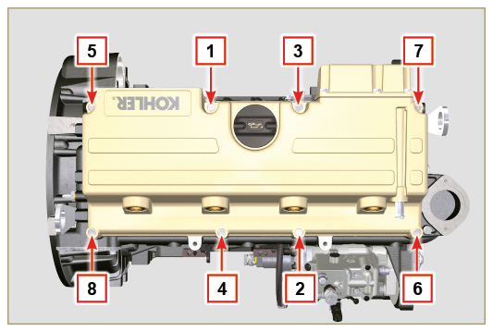  Fig. 9.67
9.8.4 Installation of the fuel injector pipes (injection pump/injectors)  Important  - Replace the high pressure pipes after two disassemblies.  - Position pipes D on the injectors and on the injector pump and tighten the nuts E and F manually, without clamping them.  - Clamp the nuts E and F (tightening torque at 25 Nm ).  - Mount the retainers C of the hoses D. | 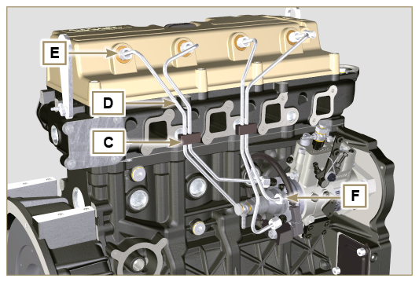  Fig 9.68
9.8.5 Fuel filter  - Secure the fuel filter holder J with the screws K on the crankcase W (tightening torque of 25 Nm ).  NOTE: For the assembly of the fuel cartridge, refer to operation 2 of Par. 6.7.2 . | 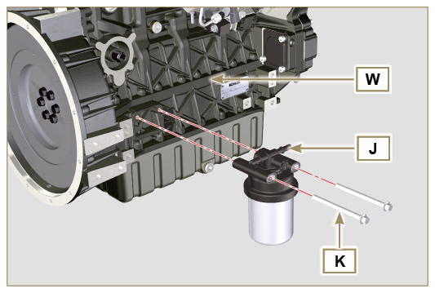  Fig 9.69

Intake manifold assembly
Important  - Check that the contact surfaces between the collector C and the head D are free from impurities.  - Insert ST_18 special tool into market point.  - Mount the gasket A on the head D .  - Mount the manifold C on the head D .  - Fit the manifold C using the screws B (tightening torque of 25 Nm ). | 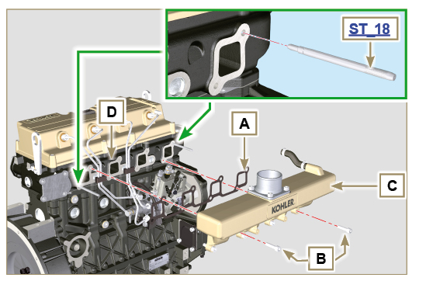  Fig 9.70

Exhaust manifold assembly
Important  - Replace the self-locking nuts B and the metal gaskets D between the manifold and the cylinder head every time they are assembly.  - In the event of mounting the studs C , fix ( 25 Nm tightening torque) with Loctite 2701 on the thread.  - Check that the contact surfaces F are free from impurities.  - Insert the gaskets D and E on the studs C .  - Position the manifold A on the studs C .  - Fix the manifold A on the cylinder head by tightening the self-locking nuts B (tightening torque of 25 Nm ). | 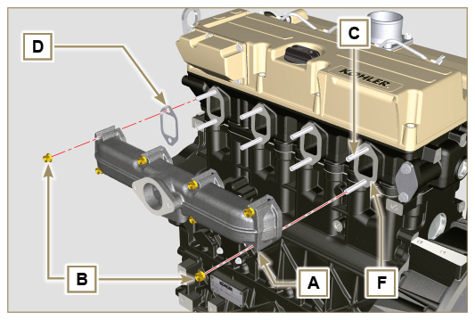  Fig 9.71

Lubrication circuit assembly
9. 11 .1 Oil filter  Important  - In the event of mounting the fitting U on the crankcase S , fix ( 15 Nm tightening torque) with Loctite 2701 on the thread.  - Check that the surface Q on crankcase S are free from impurities.  - Screw the cartridge A on the fitting U (tightening torque at 15 Nm ). | 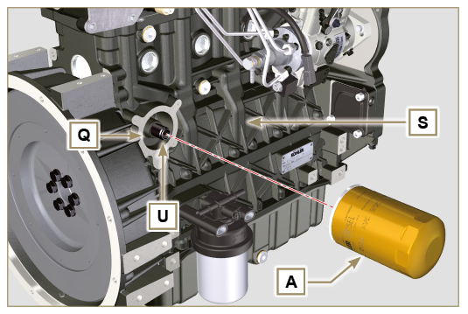  Fig 9.72
9. 11 .2 Oil pump  NOTE: Carry out the checks described in Par. 8.7 before proceeding with the following operations.  - Check that all contact surfaces between AL, AH, AF, AG and AN are free of impurities – scratches - dents.  - When assembling, do not use any type of gasket between AG and AN.  - Thoroughly lubricate the seat of the rotors AF on the oil pump crankcase AG and the two rotors AH and AL .  - Insert, inside the seat AF , the 2 rotors (in sequence) AH and AL , respecting the reference BP as the picture. (or refer to Par. 2.10.2 ) . | 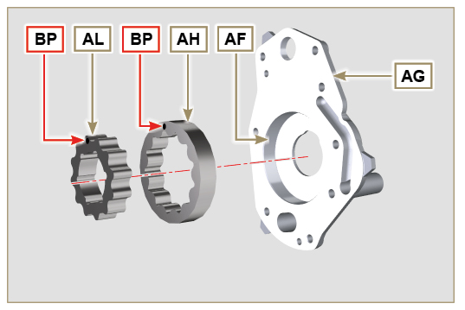  Fig 9.73
- Check that the 2 pins AM are inserted properly in the crankcase timing system AN .  - Position the oil pump assembly AG using the pin marks AM .  - Fasten the oil pump cover AG with the screws AH (tightening torque 10 Nm ). | 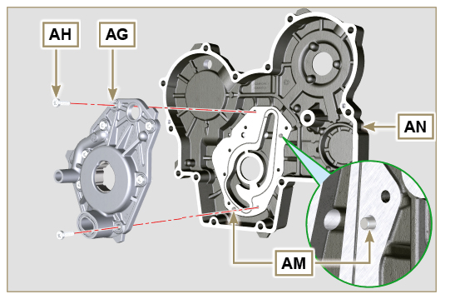  Fig 9.74
9. 11 .3 Timing system crankcase  Important  - Always replace the oil seal J after each assembly ( ST_14 ).  - Always replace the gasket P after each assembly.  - To prepare the surface of the K plane for the new application of the sealant, it must be cleaned through the use of:  - initially Loctite SF 7200  - subsequently Loctite SF 7063  Avoid any contact with the K plane and be careful not to compromise the cleaning performed.  - Distribute a bead of Loctite 5188 , of about 1mm thickness, on the surfaces K of the crankcase C .  - Make sure that the key M ( Fig. 9.76 ) is inserted properly on the crankshaft and that it is facing upwards.  - Lubricate and insert the gasket P in the seat of oil pump Q . | 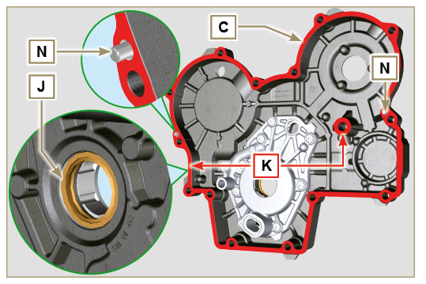  Fig 9.75
- Tighten the tool ST_10 on the crankshaft.  - Check that the 2 pins N are properly inserted in the timing system crankcase C .  - Lubricate the gasket J with oil and position the crankcase C on the crankcase E , using the pins N , inserting the oil pump Q on the crankshaft. | 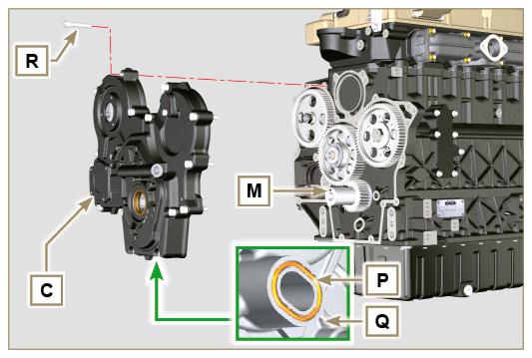  Fig 9.76
- Fasten the screws R (tightening torque of 25 Nm ). | 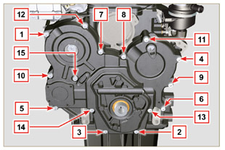  Fig 9.77
9. 11 .4 Crankcase oil filler flange Timing System  Important  - Always replace the gasket BA after each assembly.  - Position the gasket BA in the seat on the flange BB .  - Clamp the flange BB on the crankcase BC with the screws BD (tightening torque of 10 Nm - ST_06 ). | 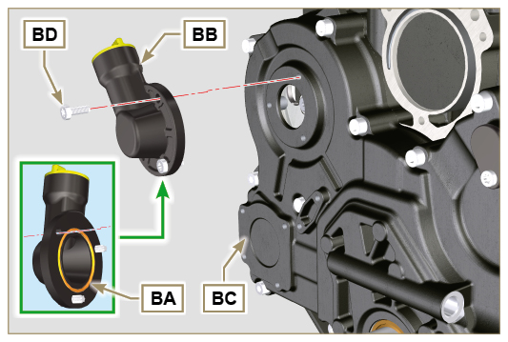  Fig 9.78
9. 11 .5 Oil pressure relief valve  - Lubricate the piston BE and fully insert it in the seat BF .  - Insert the spring BG in the piston.  Important  - Always replace the gasket BH after each assembly.  - Mount the gasket BH on cap BL .  - Tighten the cap BL on the crankcase BC (tightening torque of 50 Nm ). | 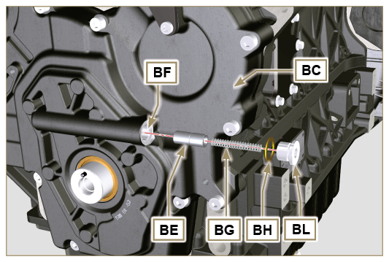  Fig 9.79

Crankshaft pulley assembly
- Check that the pin U is mounted properly on the crankshaft V .  - Position the pulley T on the crankshaft V using the pin mark U .  - Apply Molyslip grease on the screw thread Z .  - Clamp the pulley T with the screw Z (tightening torque of 360 Nm ) and remove special tool ST_34 ( Fig. 9.29) | 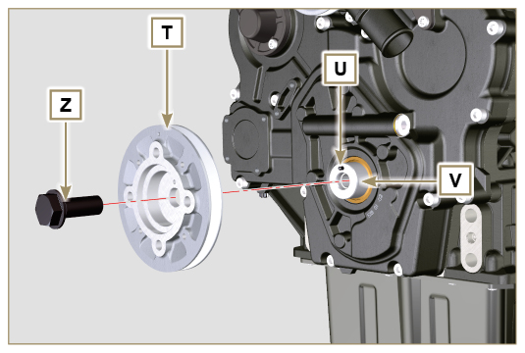  Fig 9.80

Coolant circuit assembly
9.13.1 Thermostatic valve  Important  - Always replace the gasket A after each assembly.  - Check the condition of the seal gasket A and fit it on the thermostatic valve B .  - Position the thermostatic valve B in the seat on the head C (detail D ).  - Secure the cover E with the screws F on the head C (tightening torque of 10 Nm ). | 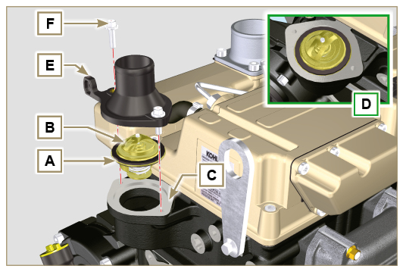  Fig 9.81
9.13.2 Coolant pump  Important  - Always replace the gasket L every time it is assembled.  - Fit the pump G with the screws H interposing the gasket L (tightening torque of 25 Nm ). | 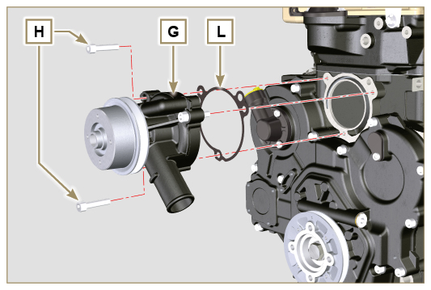  Fig 9.82

Electric component assembly
9.14.1 Sensors and switches
9.14.1.1 Coolant temperature sensor  - Secure the sensor D onto the head E (tightening torque of 20 Nm ). | 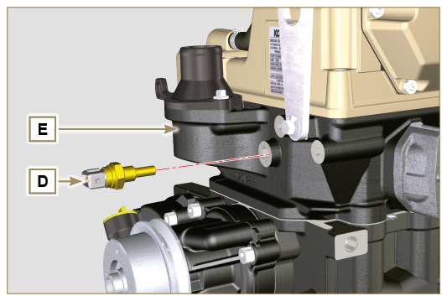  Fig 9.83
9.14.1.2 Oil pressure switch  - Clamp the oil pressure switch F on the crankcase G (tightening torque at 35 Nm ). | 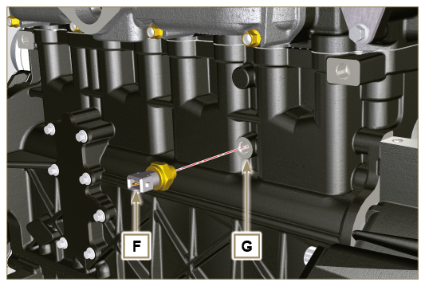  Fig 9.84
9.14.1.3 Fuel filter water detection sensor  - Lubricate and insert the gasket AA on the fitting AB .  - Fix the sensor AB onto the cartridge AC (tightening torque of 5 Nm ). | 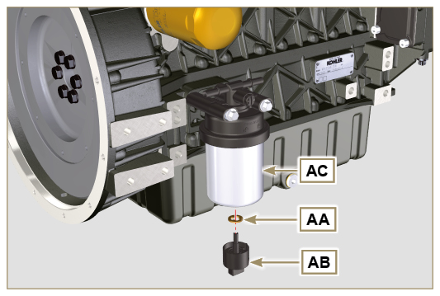  Fig 9.85

9.14.2 Alternator  - Mount the bracket M on the head N using the screw H and relative washer, without clamping it.  - Fit the alternator with the screw A with the relative washer and spacer B .  - Mount the alternator C on the crankcase Q tightening the nut R up to the stop without clamping it.  - Mount the screw L and relative washer on the alternator C , without clamping it.  - Clamp screw H (tightening torque of 25 Nm ). | 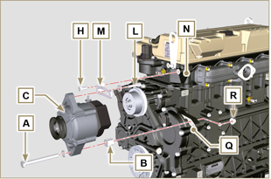  Fig 9.86
Important  - The belt S must always be replaced every time it is assembled, even if it has not reached the scheduled hours for replacement.  - Insert the belt E on the pulleys T .  - Push the alternator C in the direction of the arrow J .  - While tensioning the alternator C , first clamp screw D (tightening torque at 25 Nm ) and then screw A (tightening torque at 69 Nm [thread M10] - 40 Nm [thread M8] ).  - Check the tension of the belt S with the instrument ( DENSO BTG-2 ), positioning it in point P (the tension must be between 200 and 230 N ).  - If the tension values do not correspond, tighten screws A and D, then repeat operations 7 , 8 , 9 and 10 . | 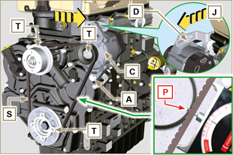  Fig 9.87
9.14.3 Starter Motor  Important  - Remove the tool if still there ST_34 .  - Fit the starter Q with the screws R on to the flange bell S (tightening torque of 45 Nm ). | 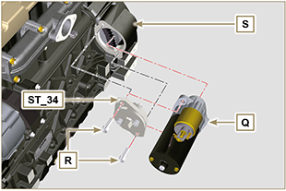  Fig 9.88

Tightening torques and the use of sealants
Tab. 9.4 - * Alternatively to the capscrew replacements, with "Dri-loc"
BASE CONFIGURATION
SHORT BLOCK
Component | Thread (mm) | Torque (Nm) | Sealer
Breather room closing cover fastening capscrew (EXHAUST SIDE) | M6x1 | 10
Lower crankcase fastening capscrew | M12x1.25 | 3 Torque cycles
1st Cycle |  | 40
2nd Cycle |  | 70
3rd Cycle |  | 120
Lower crankcase fastening capscrew | M8x1.25 | 2 Torque cycles
1st Cycle |  | 20
2nd Cycle |  | 35
Connecting rod screw | M8x1 | 2 Torque cycles
1st Cycle |  | 40
2nd Cycle |  | 85
Crankshaft gasket flange fastening capscrew | M6x1 | 10
Closing cover fastening capscrew 3 ^{rd} PTO | M8x1.25 | 25 | Loctite 2701*
Idle gear lubr. hole cap closure | M14x1.5 | 30 | Loctite 2701*
Coolant drain hole closing cap | M16x1.5 | 50
OIL SUMP ASSEMBLY
Component | Thread (mm) | Torque (Nm) | Sealer
Oil fumes tube | M12x1,5 | 15 | Loctite 648
Oil suction hose fastening capscrew | M6x1 | 10 | Loctite 2701*
Oil sump fastening capscrew | M8x1.25 | 25
Oil drain cap | M18x1.5 | 35
FLANGE ASSEMBLY (1st PTO)
Component | Thread (mm) | Torque (Nm) | Sealer
Flange bell fastening capscrew | M10x1,5 | 50
Flywheel fastening capscrew | M12x1,25 | 140
GEAR DISTRIBUTION
Component | Thread (mm) | Torque (Nm) | Sealer
Intermediate gear gudgeon fastening screw | M8x1.25 | 25
Camshaft gear control fastening capscrew | M10x1 | 100
Fastening nut on fuel injection pump gear | M14x1.5 | 65
ENGINE CYLINDER HEAD ASSEMBLY
Component | Thread (mm) | Torque (Nm) | Sealer
Air bleeding cap | M6x1 | 8
Lifting brace fastening capscrew | M8x1.25 | 25
Injector manifold | M12x1 | 30
Cylinder head fastening capscrew | M12x1.25 | 6 Torque cycles
1st Cycle |  | 40
2nd Cycle |  | 70
3rd Cycle |  | 100
4th Cycle |  | 90°
5th Cycle |  | 90°
6th Cycle |  | 90°
Rocker arm gudgeon fastening capscrew | M8x1,25 | 25
Rocker arm cover fastening capscrew | M6x1 | 10
INJECTION SYSTEM
Component | Thread (mm) | Torque (Nm) | Sealer
Injector brace fastening capscrew | M8x1.25 | 20
Waste line fastening drilled capscrew/nipple on Cyl. head | M6x1 | 14
Waste line fastening drilled capscrew on injectors | M10x1 | 15
Injector side injection tube nuts | M12x1.5 | 25
Injection pump side injection tubes nuts | M12x1.5 | 25
Injection pump fastening capscrew | M8x1.25 | 25 | Loctite 2701*
Fuel injection pump locking screw | ...
Fuel delivery fastening drilled capscrew (on injection pump) | M10x1 | 25
Waste line fastening drilled capscrew (on injection pump) | M10x1 | 25
Bleeding screw injection pump (on waste line fastening drilled capscrew) | M6x1 | 22
Fuel filter fastening capscrew | M8x1.25 | 22
INTAKE MANIFOLD
Component | Thread (mm) | Torque (Nm) | Sealer
Fastening screw intake manifold | M8x1.25 | 25
Intake flange fastening capscrew | M8x1.25 | 25
EXHAUST MANIFOLD
Component | Thread (mm) | Torque (Nm) | Sealer
Exhaust manifold fixing stud | M8x1.25 | 25
Exhaust manifold fixing nut | M8x1.25 | 25
Exhaust flange/muffler fixing nut | M8x1.25 | 25
LUBRICATION CIRCUIT
Component | Thread (mm) | Torque (Nm) | Sealer
Oil filter fastening union | M20x1.5 | 15 | Loctite 2701*
Oil filter | M20x1.5 | 15
Oil pump carter fastening capscrew | TG6 | 10
Carter distribution fastening capscrew | M8x1.25 | 25
Fastening capscrew for plug on timing system cover | TG6 | 10
Side oil load flange fastening capscrew (onto carter distribution) | TG6 | 10
Pressure relief valve cap | M16x1.5 | 50
Breather system cover fastening capscrew (on rocker arms cover) | M8x1.25 | 25
CRANKSHAFT PULLEY
Component | Thread (mm) | Torque (Nm) | Sealer
Crankshaft pulley fastening screw | M16x1.5 | 360 | Molyslip
COOLANT CIRCUIT

Component | Thread (mm) | Torque (Nm) | Sealer
Thermostatic valve cover fastening capscrew | M6x1 | 10
Coolant pump fastening capscrew | M8x1.25 | 25
ELECTRICAL COMPONENTS
Component | Thread (mm) | Torque (Nm) | Sealer
Coolant temperature sensor | M12x1.5 | 20 max.
Oil pressure switch | M12x1.5 | 35
Sensor for water presence in fuel |  | 5
Alternator bracket fastening capscrew | M8x1.25 | 25
Alternator fastening capscrew | M8x1.25 | 40
Alternator fastening capscrew | M10x1.5 | 69
Starter motor fastening capscrew | M10x1.5 | 45
Supply cable fastening nut (starter motor) | M8x1.25 | 10
CONTROLS
Component | Thread (mm) | Torque (Nm) | Sealer
Accelerator bracket fastening capscrew | M6x1 | 10
* Alternatively to the capscrew replacements, with "Dri-loc"

OPTIONAL COMPONENTS (CAP. 11)
OIL DIPSTICK ON CYLINDER HEAD
Component | Thread (mm) | Torque (Nm) | Sealer
Oil dipstick tube fastening capscrew | M6x1 | 10
HEATER
Component | Thread (mm) | Torque (Nm) | Sealer
Flange intake with heater fastening capscrew | M8x1.25 | 25
ALTERNATOR WITH POLY-V BELT
Component | Thread (mm) | Torque (Nm) | Sealer
Pulley fastening capscrew | M10x1.5 | 48
Pulley positioning blocking nut capscrew | M10x1.5 | 45
Alternator brace fastening capscrew | M8x1.25 | 25
Alternator fastening capscrew (upper) | M8x1.25 | 25
Alternator fastening capscrew (lower) | M8x1.25 | 40
Pulley sliding plate fastening capscrew | M8x1.25 | 25
IDLE GEAR (FOR 3th /4th PTO)
Component | Thread (mm) | Torque (Nm) | Sealer
Gear drilled fastening capscrew | M14x1.5 |  | Molyslip
3 ª PTO
Component | Thread (mm) | Torque (Nm) | Sealer
Pump support fastening capscrew | M8x1.25 | 25 | Loctite 2701*
Pump fastening capscrew | M8x1.25 | 25
4 ª PTO
Component | Thread (mm) | Torque (Nm) | Sealer
Grooved crankshaft support fastening capscrew | M8x1.25 | 25 | Loctite 2701*
Cover fastening capscrew (3rd PTO side) | M8x1.25 | 25
Sump support fastening capscrew | TG6 | 10
Pump fastening capscrew | M8x1.25 | 25
BALANCE SHAFTS (4 CYLINDERS)
Component | Thread (mm) | Torque (Nm) | Sealer
Housing closing panel fastening capscrew | M6x1 | 8
Shafts support fastening capscrew | M10x1.5 | 50
REMOTE OIL FILTER
Component | Thread (mm) | Torque (Nm) | Sealer
Head fixing joint on crankcase | M20x1.5 | 25 | Loctite 2701
Crankcase head nipple and oil filter support | M14x1.5 | 40
Tube union on crankcase head | G3/8 | 30
Tube union on filter support | G3/8 | 35
Oil filter | M20x1.5 | 20
Filter support head air bleeding cap | M8x1.25 | 25
INTAKE CIRCUIT
Component | Thread (mm) | Torque (Nm) | Sealer
Air filter support plate fastening capscrew (on flange bell) | M8x1.25 | 25
Air filter support fastening capscrew | M8x1.25 | 25
EXHAUST CIRCUIT
Component | Thread (mm) | Torque (Nm) | Sealer
Muffler brace support fastening capscrew | M8x1.25 | 25
Muffler fastening capscrew on muffler | M8x1.25 | 25
Muffler fastening nut | M8x1.25 | 25
COOLING CIRCUIT
Component | Thread (mm) | Torque (Nm) | Sealer
Blower fastening capscrew | M6x1 | 10
Radiator support fastening capscrew | M16x1.5 | 150
Shroud radiator fastening capscrew | M6x1 | 10
Radiator lower brace fastening capscrew | M8x1.25 | 25
Radiator on anti-vibrating | M8x1.25 | 25
Vibration-damping nut fixing (on radiator support) | M8x1.25 | 25
Anti-vibrating and brace fastening capscrew (upper) | M6x1 | 10
Upper brace fastening capscrew (on engine cylinder head) | M8x1.25 | 25
Side bulkheads fastening capscrew | M6x1 | 10
ENGINE SUPPORT
Component | Thread (mm) | Torque (Nm) | Sealer
Side feet fastening capscrew (on flange bell or crankcase) | M12x1.75 | 50
Rear feet fastening capscrew | M16x1.5 | 200

