Information for replacing the functional units
KDI 2504 M Workshop manual (Rev_09.6)

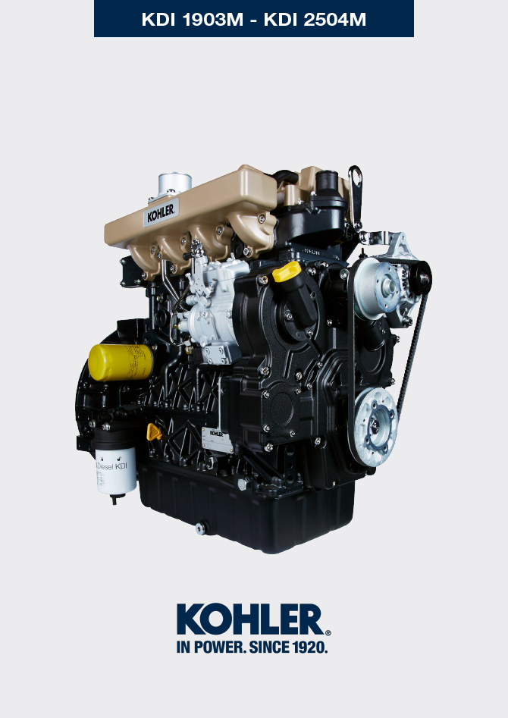

Registration of modifications to the document
Any modifications to this document must be registered by the drafting body, by completing the following table.

Released by | Code | Revision | Release Date | Revision date | Edited by | Endorsed
null | manoff

Translated from the original manual in Italian language
Data reported in this issue can be modified at any time by KOHLER.

Sommario
1. TITOLO 1 2
1.1. Asdfsdfsdf 2
1.2. Asdfsdfsdfggg 2

Information for replacing the functional units

Injectors and injection pump replacement
Important  - Before proceeding with operation, read Par. 3.3.2 .  - Replace the high pressure pipes after two disassemblies.  - Always replace the gaskets after each disassembly.  - Handle the components as described in Par. 2.17 .  - Please referring to Par. 2.9.7 in order to see the operating references during disassemble and assemble procedures.  - When repaired, RSN-A injectors must be certified by a Stanadyne centre to check their correct operation - check the type of engine mounted injectors on the spare parts list ( RSN-A is specified in the description). | 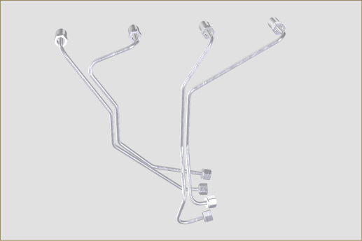  Fig 6.1
6.1.1injection fuel pump disassembly (injection pump/injectors)  - Undo the screws A and remove plate B .  - Remove the retainers C for the hoses D . | 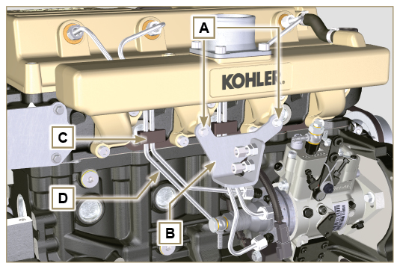  Fig 6.2
- Undo the nuts F .  - Undo the nuts E.  - Remove the tube D . | 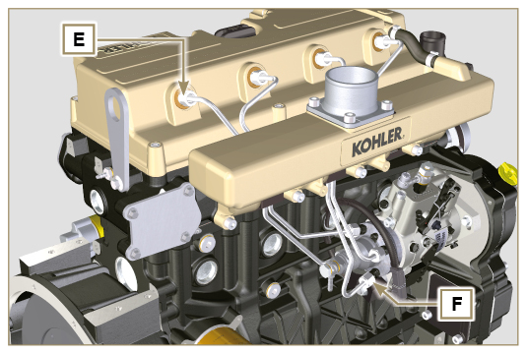  Fig 6.3
6.1.2 Rocker arms cover disassembly  - Loosen clamp G and disconnect hose H  - Undo the screws L and remove the rocker arm cap C . | 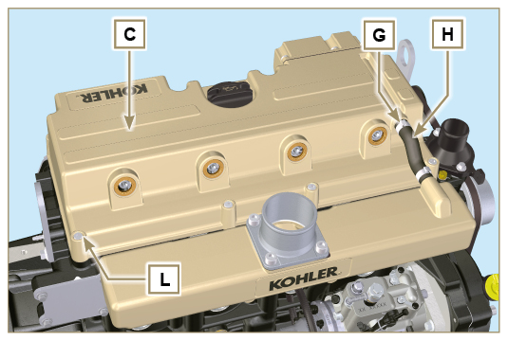  Fig 6.4
6.1.3 Fuel return pipes disassembly  - Undo the screws M and remove hose N . | 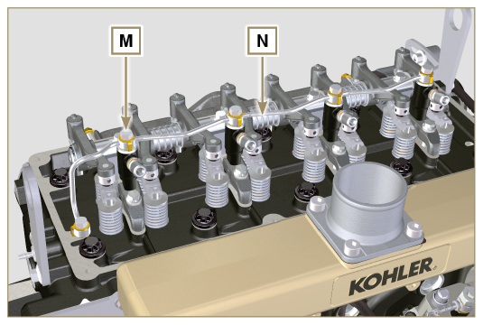  Fig 6.5
6.1.4 Injectors disassembly  - Undo the screw P and remove washer Q and bracket R .  - Remove the injector Z .  NOTE : Should you be unable to remove the injector (acting only on point BC ), use an open-ended spanner (11 mm), by applying small rotations to unblock the component.  - Seal all injection component unions as illustrated in Par. 2.9.7 .  NOTE : If the washer S is not found on the injector Z , recover it from inside the sleeve V . | 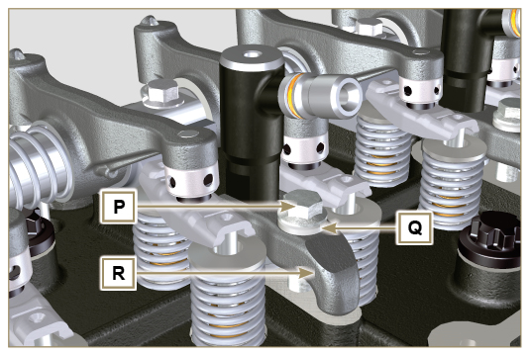  Fig 6.6  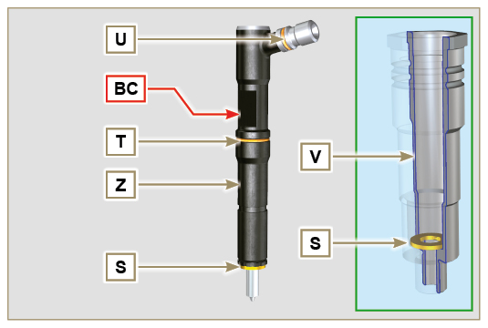  Fig 6.7
6.1.5 Injection pump disassembly  Important  - Before proceeding with the disassembly, identify the pump code from its identifying name plate (Pos. 12 - Tab. 2.12 ).  - Alternatively, you can identify the pump from the online spare parts catalogue ( https://partners.lombardini.it/App/SparepartCatalogue/Default/Catalogue.aspx ).  - Insert the tool ST_30 into the injector N°1 and fix it with the fixing brace R of the injector, capscrew P and washer Q .  NOTE : Do not tighten the capscrew P.  - Disassemble the starter motor.  - Mount the tool ST_34 in the seat of the starter motor Y and fit it with the two starter motor fixing screws.  - Rotate the crankshaft clockwise ST_34 tool bringing reference X upwards.  NOTE: During the positioning phase of reference X , check that cylinder N° 1 is in compression phase (intake and exhaust valves of cylinder N° 1 must be in closing position).  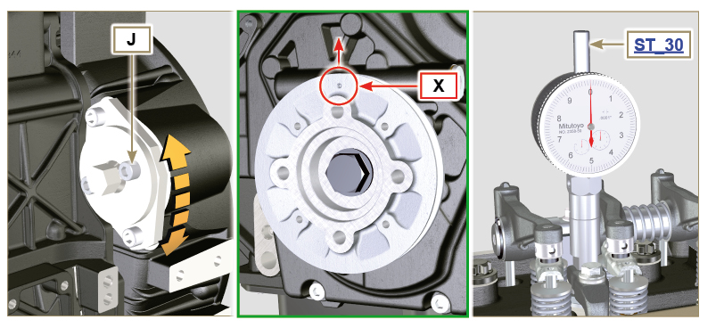  Fig 6.10  Tab. 6.1  PUMP CODE PISTON LOWERING (mm) ADVANCE α  ED0065900040-S 1,695 13°  ED0065900060-S 3,591 19°  ED0065900310-S 0,815 9°  ED0065905050-S 1,695 13°  ED0065905110-S 1,963 14°  ED0065905150-S 1,695 13°  ED0065905160-S 1,695 13°  ED0065905170-S 1,695 13°  ED0065905180-S 1,695 13°  ED0065905350-S 1,963 14°  ED0065905380-S 3,228 18°  ED0065905410-S 2,558 16°  ED0065905470-S 1,695 13°  ED0065905500-S 1,695 13°  ED0065905510-S 1,695 13°  ED0065905540-S 1,006 10°  ED0065905640-S 1,695 13°  ED0065905650-S 1,695 13°  ED0065905660-S 1,695 13°  ED0065905670-S 1,695 13°  ED0065905680-S 1,695 13°  ED0065905760-S 1,695 13°  ED0065905790-S 2,558 16°  ED0065905970-S 0,815 9°  ED0065905980-S 1,216 11° | 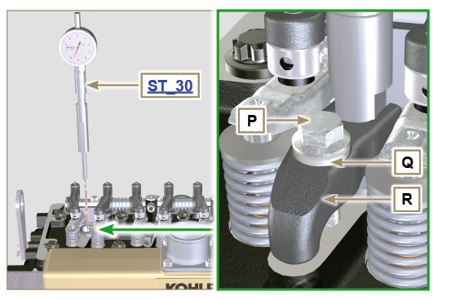  Fig 6.8  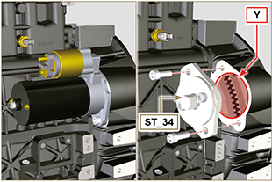  Fig 6.9
5. With reference X pointed upwards, find the TDC through tool ST_30 , then bring the dial gauge indicator to 0 .  6. Having identified the value to lower the piston, rotate the crankshaft anti-clockwise by going beyond the value described in Tab. 6.1 , once again, rotate the crankshaft clockwise, stopping at the correct advance value by using tool ST_30  7. Lock the ST_34 tool through J screws and ensure that the crankshaft does not rotate, which would alter the correct advance value. If this happens, repeat the instructions described in points 4, 5, 6, 7 and 8.  NOTE: The value indicated in Tab. 6.1 must be reached by rotating the shaft with the piston in compression phase. Use the ST_34 tool to totate the crankshaft. | 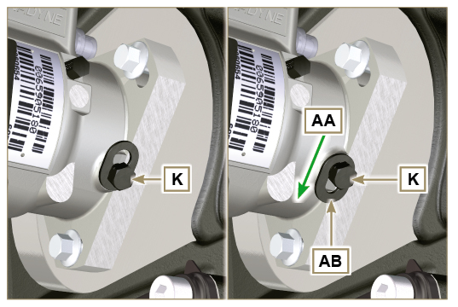  Fig 6.11  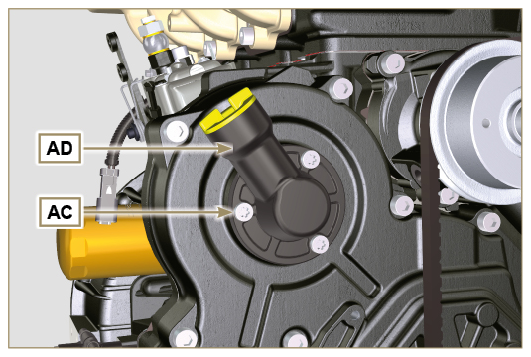  Fig 6.12
8. Lock the ST_34 tool through J screws and ensure that the crankshaft does not rotate, which would alter the correct advance value. If this happens, repeat the instructions described in points 4, 5, 6, 7 and 8 .  9. Undo the screws AC and remove the oil filling flange AD .  10. Undo and remove the nut AN fixing the injection pump control gear AE .  11. Undo the capscrew K and shift the slotted plate AB in the direction of arrow AA .  12. Tighten screw K to block the pump (tightening torque to 12 Nm ).  Important  - After removing the nut AN, ensure that the correct advance value has remained unchanged on ST_30 .  - Be careful that the nut AN does not fall into the timing cover.  13. Screw the tool ST_04 on the gear AE.  14. Loosen the screws AF . | 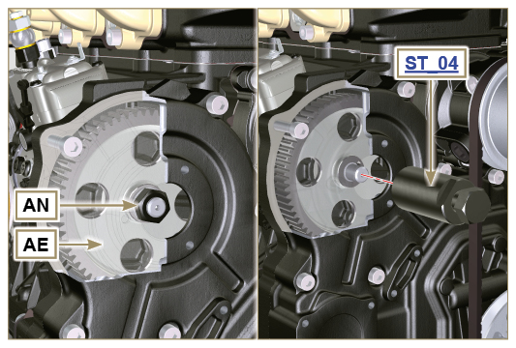  Fig 6.13  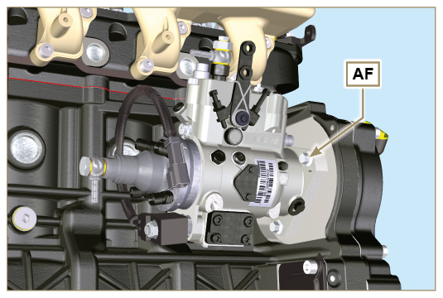  Fig 6.14
15. Tighten the screw of tool ST_04 to disconnect the injection pump AG from the high pressure pump control gear AE .  16. Undo the screws AF and extract the injection pump AG .  17. Undo and remove the tool ST_04 . | 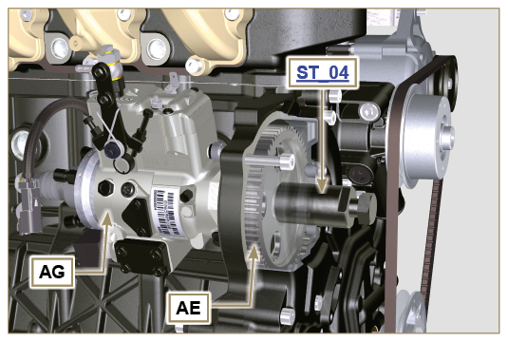  Fig 6.15
NOTE : Click on the right to play the procedure. | https://www.youtube.com/embed/zqY-GFl8lG0?rel=0
6.1.6 Injection pump assembly  Warning  - Before assembling the new pump AG , make sure that plate AB can move freely and that fastening capscrews K are not loose (the pump sold as a spare part is supplied with the cylinder injection timing blocked N° 1 ).  - Ensure that the coupling surfaces on shaft AP and gear AE are free from impurities and lubrication residues.  - Remove the guard cap only when the pipes are reconnected.  - Do not remove the tool ST_30 .  1. Mount the injection pump AG , inserting the shaft AP in the gear AE .  Important  - Always change screws AF with new ones or apply Loctite 270 to the threads.  2. Clamp the screws AF on the crankcase AH (tightening torque at 25 Nm ).  3. Ensure that the correct advance value has remained unchanged, tighten nut AN on shaft AP (as shown in Fig. 6.17, is allowed the aid of a screwdriver to guide the nut AN on the shaft AP in order to avoid the fall of it into the timing cover AQ - tightening torque at 70 Nm ). | 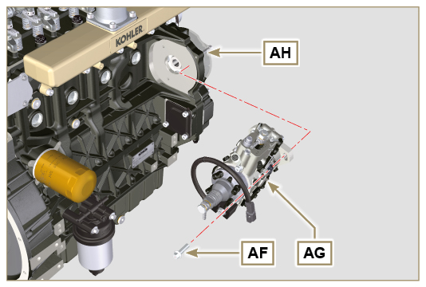  Fig 6.16  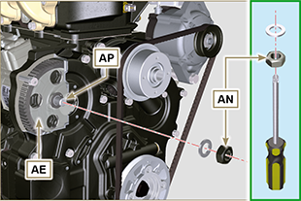  Fig. 6.17
4. Undo the capscrew K and shift the slotted plate AB in the direction of arrow AA .  5. Tighten screw K (tightening torque to 5.5 Nm ). The injection pump is unlocked.  6. Remove the tool ST_30 and ST_34 . | 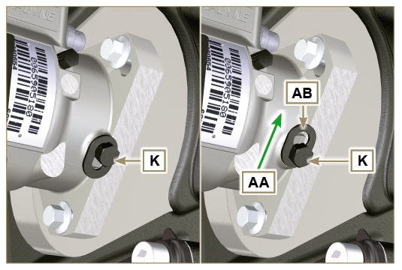  Fig 6.18
NOTE : Always replace the gasket AJ after each assembly.  7. Position the gasket AJ in the set on the flange AD .  8. Fix the flange AD on the crankcase AQ with the screws AC (tightening torque at 10 Nm ). | 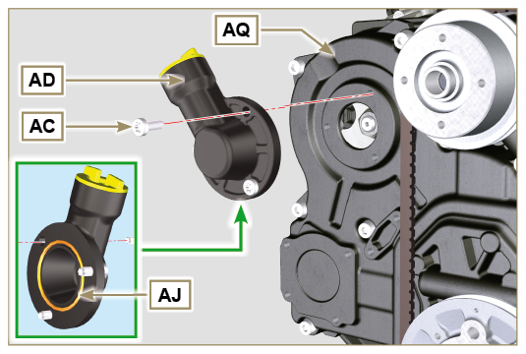  Fig 6.19
NOTE : Click on the right to play the procedure. | https://www.youtube.com/embed/RJLCkTqlczU?rel=0
6.1.7 Injector assembly  Important  - To prevent damaging the injection system, the protection caps ( Par. 2.9.7 ) must be removed during assembly.  - Lubricate the gaskets U, T, S and fit them on the injector Z. | 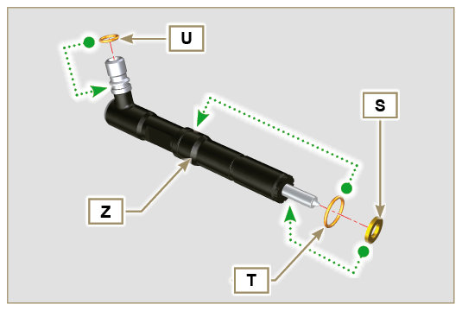  Fig 6.20
2. Fit the injector Z in the sleeve V . | 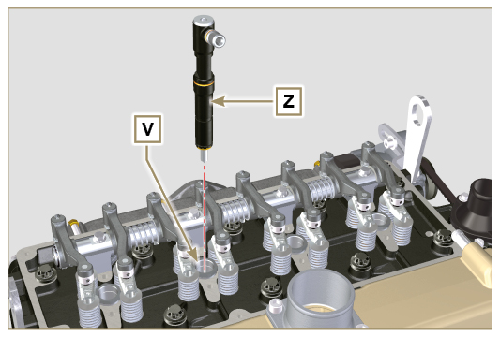  Fig 6.21
3. Assemble the parts P, Q, R and fit the parts so assembled on the injector Z . | 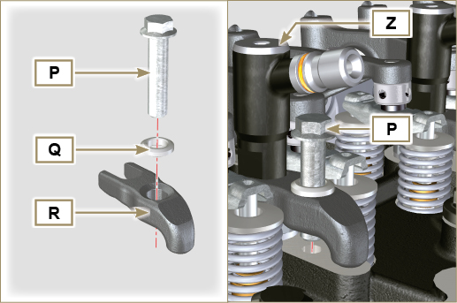  Fig 6.22
4. Insert tool ST_51 on the injectors junctions Z (detail X1 ).  5. Tighten the screw P (tightening torque to 20 Nm ) | 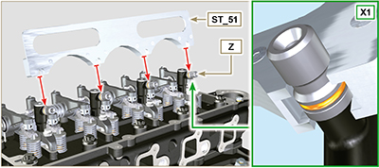  Fig 6.23
NOTE : Click on the right to play the procedure. | https://www.youtube.com/embed/Kcv-_3Edask?rel=0
6.1.8 Assembly of the injector return pipes  - Position the tube N on the injectors Z , and tighten screws M (tightening torque to 14 Nm ). | 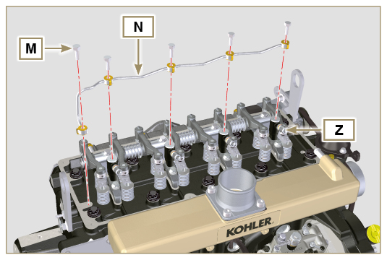  Fig 6.24
6.1.9 Assembly Rocker arm cover  Important  - The gasket AM between the rocker arm cover and the cylinder head must always be replaced every time it is disassembled.  - Position the two guide pins ST_17 before mounting the rocker arm cover.  - Position the gasket AM on the head AL respecting the fastening screw holes L .  - Attach the rocker arm cover C on the head AL with the screw L adhering to the tightening sequence shown in F ig. 6.27 (KDI 1903 M) or Fig. 6.28 (KDI 2504 M) (tightening torque to 10 Nm ).  - Connect pipe H and tighten the clamp G .  Important  - Always replace the gaskets AK after each disassembly ( ST_36 ). | 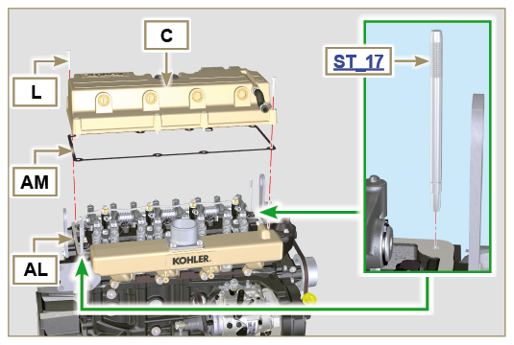  Fig 6.25  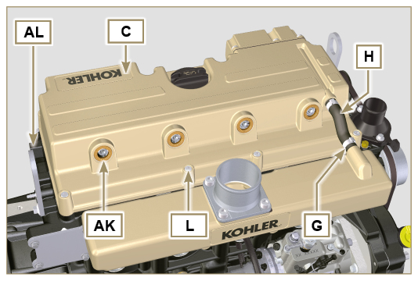  Fig 6.26  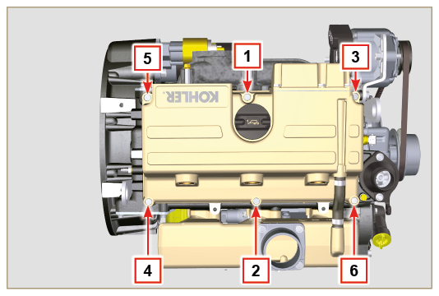  Fig 6.27  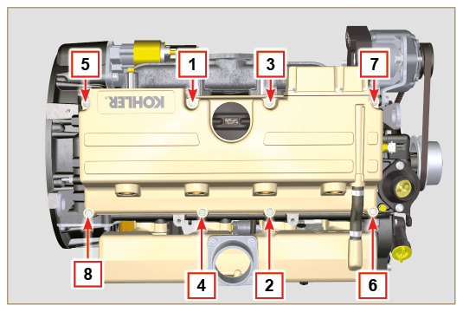  Fig 6.28
6.1.10 Installation of the fuel injector pipes (pump injector/injectors)  - Position pipes D on the injectors and on the injector pump.  Important  - Tighten the nuts E and F manually, without clamping them.  2. Tighten the nuts E ed F (tightening torque at 25 Nm ).  3. Reinstall the retainers C of the hoses D .  4. Fix the plate B by using screws A (tightening torque to 10 Nm ). | 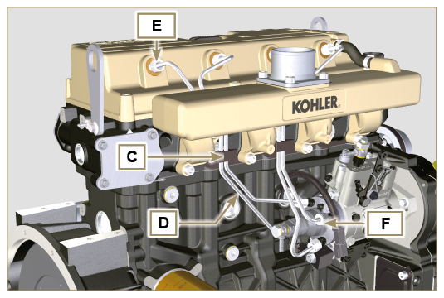  Fig 6.29  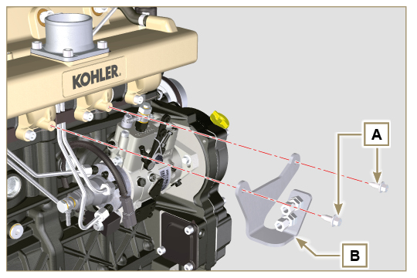  Fig 6.30

Coolant pump replacement
6.2.1 Disassembly  - Perform the operations described in Par. 5.1 .  Important  - Before proceeding with operation, read Par. 3.3.2 .  - The pump G isn't repairable.  2. Loosen the screws A and B.  3. Push the alternator C in the direction of the arrow D and remove the belt E .  4. Loosen the screws F and remove the pump G and relative gasket H . | 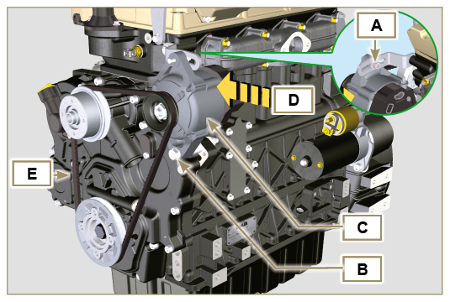  Fig 6.31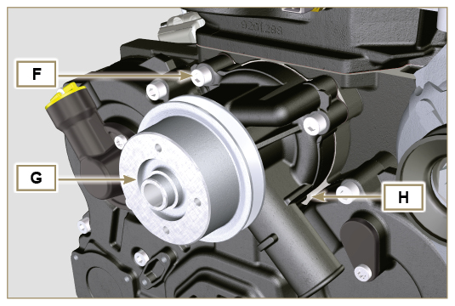  Fig 6.32
6.2.2 Assembly  Important  - Always replace the gaskets H , after each disassembly.  - Always replace the belt E after each assembly.  - Fit the coolant pump G with the screws F interposing the new gasket H (tightening torque at 25 Nm ). | 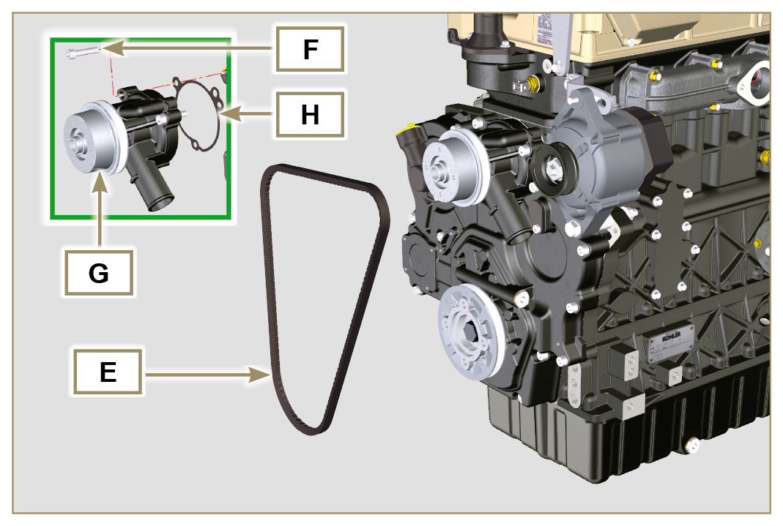  Fig 6.33
- Insert the belt E on the pulleys L .  - Push the alternator C in the direction of the arrow D .  - While tensioning the alternator C , first clamp screw A (tightening torque at 25 Nm ) and then screw B (tightening torque at 69 Nm [thread M10] - 40 Nm [thread M8] ).  - Check the tension of the belt E with the instrument ( DENSO BTG-2 ), positioning it in point p (the tension must be between 200 and 230 N )  - If the tension values do not correspond, tighten screws A and B , then repeat operations 3, 4 and 5 . | 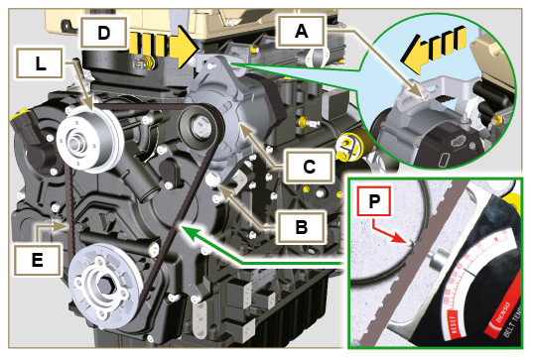  Fig 6.34

Replace the crankshaft pulley
6.3.1 Disassembly  Important  - Before proceeding with operation, read Par. 3.3.2 .  NOTE: Perform the operations described in Par. 6.1.5 steps 2 and 3 .  - Position the crankshaft with the 1st cylinder in TDC, reference A .  - Remove the alternator belt following steps 2 and 3 ( Par. 6.2.1 ) . | 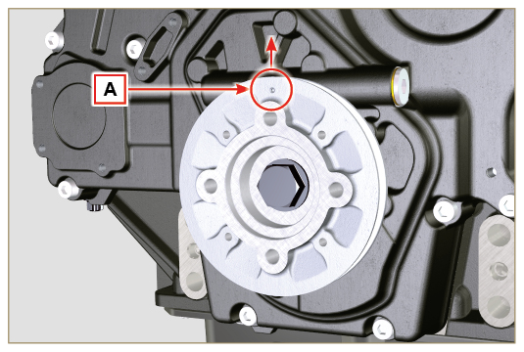  Fig 6.35
- Undo the screw P (clockwise) and remove the pulley Q . | 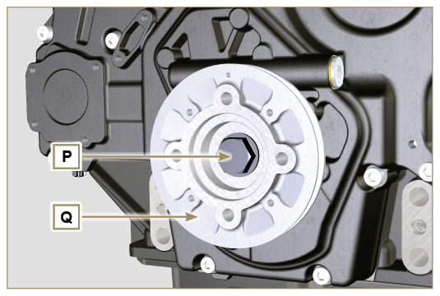  Fig 6.36
6.3.2 Assembly  - Check that the pin U is mounted properly on the crankshaft V .  - Insert the pulley Q on crankshaft V respecting the reference of the pin U .  - Apply Molyslip grease on the screw thread P .  - Fit the pulley Q with the screw P (tightening torque 360 Nm ) and remove the tool ST_34 . | 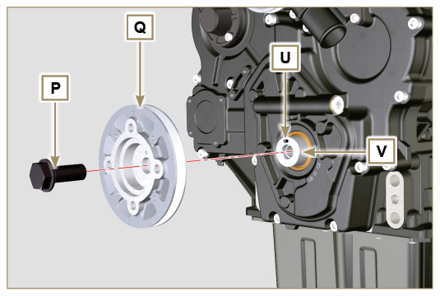  Fig 6.37

Oil pump replacement
Important

- Before proceeding with operations, read Par. 3.3.2 .
- The oil pump is not repairable.
6.4.1 Coolant pump disassembly

- Perform the operations described in Par 6.2.1 .
6.4.2 Engine pulley disassembly

- Perform the operations described in Par 6.3.1 .
6.4.3 Timing system crankcase disassembly  Important  - Perform the operations described in Par. 5.2 .  - Make sure that the reference pin A is facing upwards.  - Undo the screws B and remove the timing system crankcase C . | 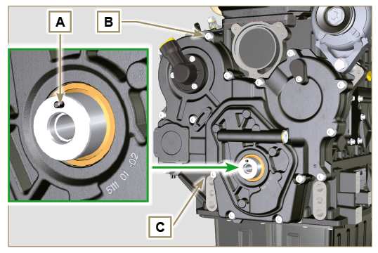  Fig 6.38
6.4.4 Oil pump disassembly  - Undo the screws D and remove the group pump E from the timing system crankcase C .  - Remove the rotors F and G from the oil pump crankcase E . | 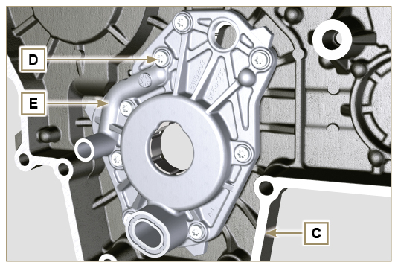  Fig 6.39  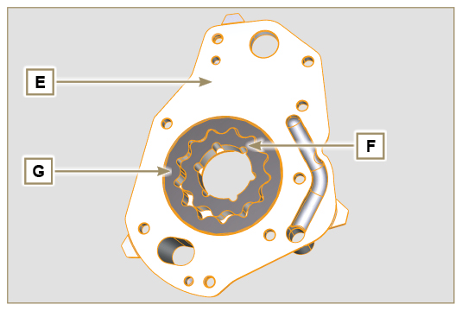  Fig 6.40
6.4.5 Oil pump assembly  Important  - Carry out the checks described in Par. 8.7 prior to assembly.  - Check that all surfaces in contact between F, G, H, E and C are free from impurities - scratches - dents.  - When assembling, do not use any type of gasket between E and C.  - Thoroughly lubricate the seat of the rotors H on the oil pump crankcase E and the two rotors F and G.  - Within housing H insert the 2 rotors (in sequence) G and F , observing the references BP as described in figure (or refer to Par. 2.10.2 ).  - Check that the 2 pins L are inserted properly in the timing system crankcase C .  - Position the oil pump carter E using the reference pins L.  - Clamp the oil pump carter E with the screws D (tightening torque 10 Nm - ST_06 ). | 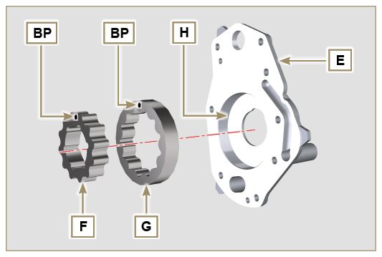  Fig 6.41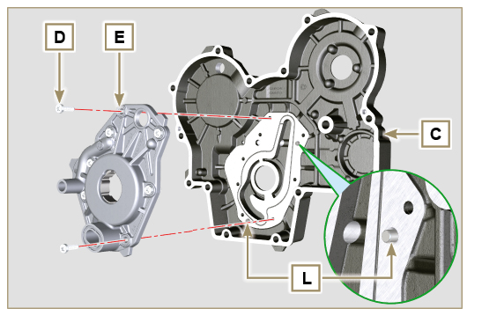  Fig 6.42
6.4.6 Timing system crankcase assembly  Important  - Always replace the oil seal J after each assembly.  - Always replace the gasket P after each assembly.  - To prepare the surface of the K plane for the new application of the sealant, it must be cleaned through the use of:  - initially Loctite SF 7200  - subsequently Loctite SF 7063  Avoid any contact with the K plane and be careful not to compromise the cleaning performed.  - Lubricate the lip of the oil seal J .  - Distribute a bead of Loctite 5188 , about 1mm thick, on the surfaces K of the crankcase C .  - Make sure that the key M (Fig. 6.44) is inserted properly on the crankshaft and that it is facing upwards.  - Check that the 2 pins N are inserted properly in the timing system crankcase C . | 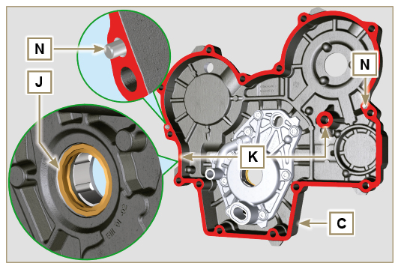  Fig 6.43
- Lubricate and insert the gasket P in the seat of the oil pump Q .  - Tighten the tool ST_10 on the crankshaft.  - Position the crankcase C on the base, using the reference pins M , inserting the oil pump Q on the crankshaft. | 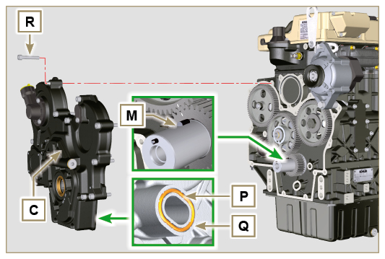  Fig 6.44
- Fit the timing system crankcase C with the screws R observing the indicated clamping sequence (tightening torque at 25 Nm ). | 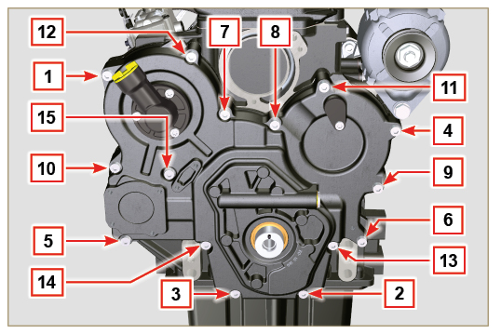  Fig 6.45
6.4.7 Crankshaft pulley assembly
- Perform the operations described in Par 6.3.2 .
6.4.8 Coolant pump assembly

- Perform the operations described in Par 6.2.2 .

Oil pressure valve replacement
6.5.1 Disassembly  Important  - Before proceeding with operation, read Par. 3.3.2 .  - Undo the cap A .  - From the crankcase D , remove the spring B.  - Remove the valve piston C using a magnet. | 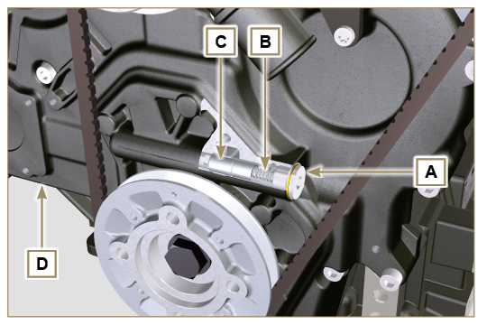  Fig 6.46
6.5.2 Assembly  Important  - Carry out the checks described in Par. 8.7.3 prior to assembly.  - Always replace the gasket F after each assembly.  - Lubricate the piston C and fully insert it in the seat E .  - Insert the spring B in the piston.  - Mount the gasket F on cap A.  - Clamp the cap A on the crankcase D (tightening torque at 50 Nm ). | 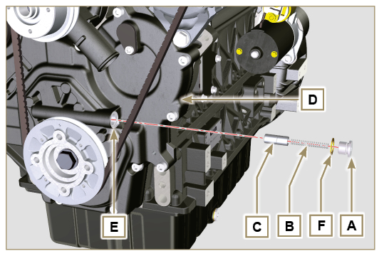  Fig 6.47

Oil filter replacement
6.6.1 Disassembly  Important  - Before proceeding with operation, read Par. 3.3.2 .  - Perform the operations described in Par. 5.2 .  - Unscrew the cartridge A. | 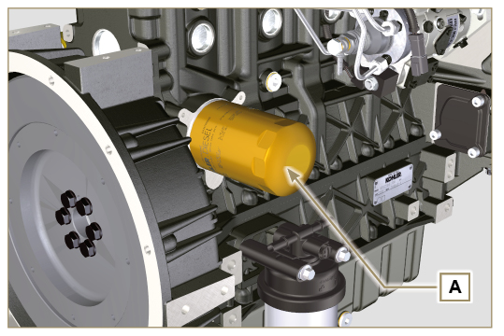  Fig 6.48
6.6.2 Assembly  Important  • In the event of mounting the fitting U on the crankcase S (tightening torque at 1 5 Nm + Loctite 2701 ).  - Check that the surface Q on crankcase S are free from impurities.  - Screw the cartridge A on the fitting U (tightening torque at 15 Nm ). | 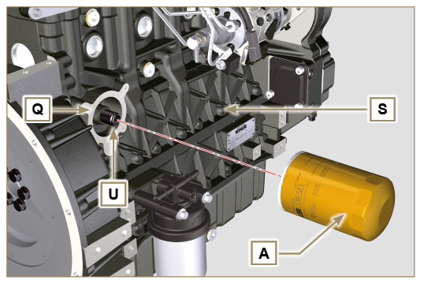  Fig 6.49

Fuel filter replacement
Important  - Before proceeding with operation, read Par. 3.3.2  Warning  - In case of low use replace il 12 months.  - Procure a suitable container to collect the fuel.  - Rotate the filter A to take it to the unlocked position and remove it.  - Lubricate the gasket C .  Assemble the filter A on the support B and rotate it until reaches the lock position.  Important  - Do not fill the new cartridge A with fuel.  - Turn the key on the control panel to the ON position.  The electric pump D sends fuel to the filter and then the injection pump E .  - Loosen the air bleeding screw F on fuel filter bracket B .  The air inside the circuit and the filter will begin to escape from the screw G .  - Tighten the bleeding screw F (tightening torque of 1.5 Nm ) when the fuel begins to flow. | 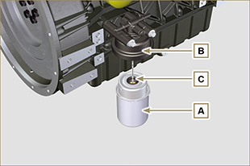  Fig 6.50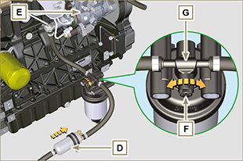  Fig 6.51
Warning  - Check that the fuel supply pump filter is present, and replace if necessary.  - Release the clamp D .  - Demount the hose E .  - Unscrew the filter G from the pump Q . | 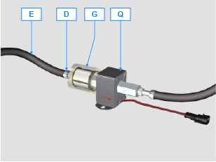
- Screw the new filter G onto the pump Q (tightening torque 20 Nm ).  - Connect the hose E to the filter G and fasten with the clamp D . | 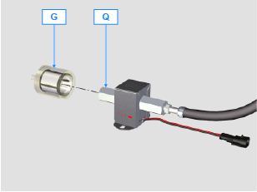
NOTE: Click on the icon to play the procedure. | https://www.youtube.com/embed/meko2s8_-U0?rel=0

