Assembly information
KDI 1903TCR / KDI 1903TCRE5 Workshop manual (Rev. 17.8)



Registration of modifications to the document
Any modifications to this document must be registered by the drafting body, by completing the following table.

Released by | Code | Revision | Release Date | Revision date | Edited by | Endorsed
 | manoff

Translated from the original manual in Italian language
Data reported in this issue can be modified at any time by KOHLER.

Sommario
1. TITOLO 1 2
1.1. Asdfsdfsdf 2
1.2. Asdfsdfsdfggg 2

Assembly information

Information on engine configuration
- In this chapter, the engine is represented as "BASE CONFIGURATION" (refer to Par 1.4 - Par. 1.5 ).
- For the assembly of components not described in this chapter refer to Chap. 11 .
- The following are the components described in Chap. 11 .

11.1 Oil dipstick in cylinder head
11.2 Heater (replacement)
11.3 Poly-V alternator belt (replacement and adjustment)
11.4 Tightening pulley and alternator for Poly-V belt
11.5 Idler gear (for 3 ^{rd} / 4 ^{th} PTO)
11.6 3 ^{rd} PTO (replacement)
11.7 4 ^{th} PTO (replacement)
11.8 3 ^{rd} + 4 ^{th} PTO (configurations)
11.9 Balancer shafts (replacement)
11.10 Air filter (cartridge replacement)
11.11 Remote oil filter (disassembly and assembly)
11.12 Oil sump with supporting structure
11.13 ETB (REPLACEMENT)
11.14 ACACT (REPLACEMENT)
11.15 EGTS (REPLACEMENT)
11.16 DPF & DOC filter (REPLACEMENT)
11.17 Oil dipstick on timing gear side

Assembly recommendations
- The information is laid out in sequence, the intervention methods have been selected, tested and approved by the manufacturer's technicians.
- This chapter describes the installation procedures for the assemblies and/ or individual components which have already been checked, overhauled or possibly replaced with original spare parts.
- Where necessary, reference to special tools during assembly operations is indicated and identified in Tab. 13.1 , Tab. 13.2 and Tab. 13.3 hereinafter in Tab. 9.1 an example of a special tool ( ST_05 ).

Tab. 9.1
SPECIAL TOOLS
"ST" Code | Picture /draw | DESCRIPTION | PART NUMBER
ST_05 | 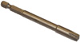 | Six nicks Key SN 8 | ED0014603650-S

Important

- Before proceeding with operations, read Par. 3.3.2 .
- To easily locate specific topics, the reader should refer to the analytical index or chapter index .
- The operator must check that:
  - the components, the assemblies, the coupling surfaces of the parts are washed, clean and thoroughly dried;
  - the coupling surfaces are undamaged;
  - the equipment and tools are ready so that all work can be carried out correctly and safely;
  - ensure that the working environment is safe.
- The operator must:
  - carry out the procedures smoothly and safely. It is thus recommended to install the engine on a special rotating stand used when servicing engines to ensure the safety of the operator and the other individuals involved;
  - tighten the assemblies and / or components in a criss-cross or alternating pattern, initially with a value lower than that preset, and then subsequently, with the tightening torque specified in the procedure;
  - replace all seal gaskets after each assembly for all components on which they are provided.

Engine block assembly
9.3.1 Crankshaft bushings  Important  - Execute the procedure in Par. 8.2.1 and 8.2.2 , before proceeding with assembly..  - The crankshaft half-bearings are made of special material. Therefore, they must be replaced every time they are assembled to prevent seizures.  - Fit the new half-bearings B onto the crankcase upper half E adhering to the reference notches C .  Important  - After the half-bearings are fitted, check that the lubrication holes D correspond with the crankcase grooves E .  - The lower and upper half bearings CANNOT be singularly replaced, and both halves must be replaced together.  - Fit the new half-bearings S onto the lower crankcase F using the reference notches C .  - Lubricate the half-bearings A and B with oil. | 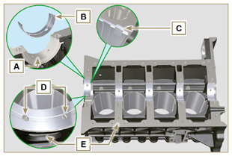  Fig 9.1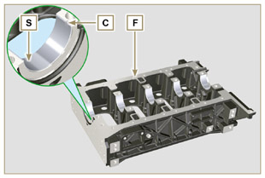  Fig 9.2
9.3.2 Tappets  - Lubricate the tappets G with oil.  - Insert the tappets G into the housings H of the upper crankcase. | 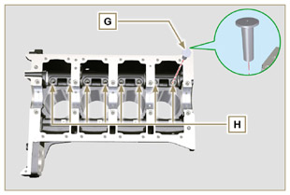  Fig 9.3
9.3.3 Camshaft  - Check that the bushing Q is correctly fitted.  - Lubricate the pins L , the cams M of the camshaft N , all the housing P and the bushing Q with oil.  - Insert the camshaft N all the way into its housing P .  - Fit the lock ring R on to the crankcase E to hold the position of the camshaft N .  - Manually rotate the camshaft N ensuring that it is free. | 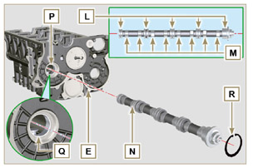  Fig 9.4
9.3.4 Oil spray nozzles  - Insert the sprayers V onto the upper crankcase E manually screwing the screw fittings U .  - Direct the sprayers V as shown Z and tighten the connecting screws U (tightening torque of 10 Nm ). | 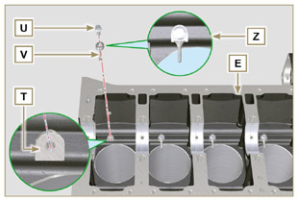  Fig 9.5
9.3.5 Crankshaft  Important  - Carry out the checks described in Par. 8.4.1 and Par. 8.4.2 .  - Check that the crankshaft half-bearings are mounted correctly on the upper crankcase E .  - Lubricate the main journal and crankpin J , with oil.  - Insert the crankshaft W into its seat on the upper crankcase E .  - Insert the 2 shoulder half-rings K , between the crankshaft W and the upper crankcase E ( AB detail). | 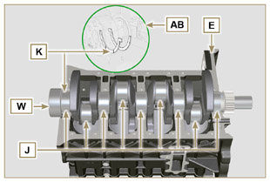  Fig 9.6
9.3.6 Lower crankcase  - Check that the crankshaft half-bearings are mounted correctly on the lower crankcase F ( AC detail).  - Assemble the 2 shoulder half-rings AD onto the lower crankcase F applying two drops of grease to keep them in their seat.  - Check that the coupling surfaces AE are free from dirt and grit. | 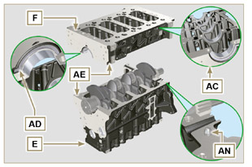  Fig 9.7
- Spread a bead of Loctite 5660 (rif. AL) of approx 1 mm thickness on the surface AM of the upper crankshaft half C being careful not to block the oil feed grooves AG and the return oil sump AH .  - Join the two crankshaft halves E and F observing the guide pins AN . | 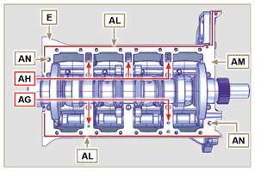  Fig 9.8
Important  - Failure to adhere to the bolt fixing procedures may compromise the functionality of the engine, and may also cause damage to persons and property.  - Tighten the fastening screws strictly following the sequence and the tightening torque indicated.  Tightening sequence for 3 cylinders  Tightening Screws Torx M12x1.25 (from the n° 1 to the n° 8 ):  CYCLE 1 - with a torque of 40 Nm ;  CYCLE 2 - with a torque of 70 Nm ;  CYCLE 3 - with a torque of 120 Nm .  Tightening Screws M8x1.25 (from the n° 9 to the n° 21 ):  CYCLE 4 - with a torque of 20Nm ;  CYCLE 5 - with a torque of 35 Nm ;  - Perform the operations described in Par. 8.4.2 .  - Check that crankshaft W rotates smoothly.  NOTE: In the next illustrations of Par. 9.1 the coupled crankcase half will be indicated with the letter E . | 3 Cylinders  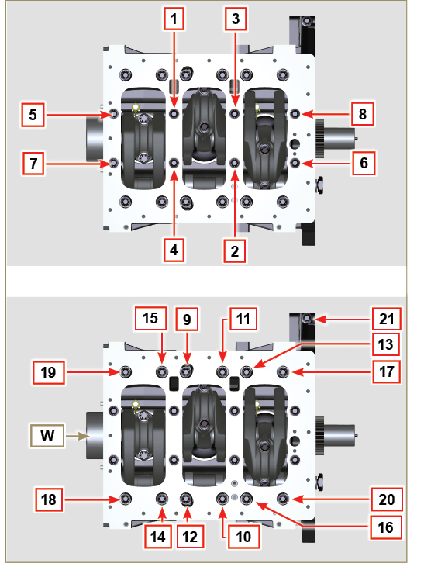  Fig 9.9
- Tightening sequence for 3 cylinders  Tightening Screws Torx M12x1,25 (from the n° 1 to the n° 10 ):  CYCLE 1 - with a torque of 40 Nm ;  CYCLE 2 - with a torque of 70 Nm ;  CYCLE 3 - with a torque of 120 Nm .  Tightening Screws M8x1.25 (from the n° 11 to the n° 27 ):  CYCLE 4 - with a torque of 20Nm ;  CYCLE 5 - with a torque of 35 Nm ;  - Perform the operations described in Par. 8.4.2 .  - Check that crankshaft W rotates smoothly. | 4 Cylinders  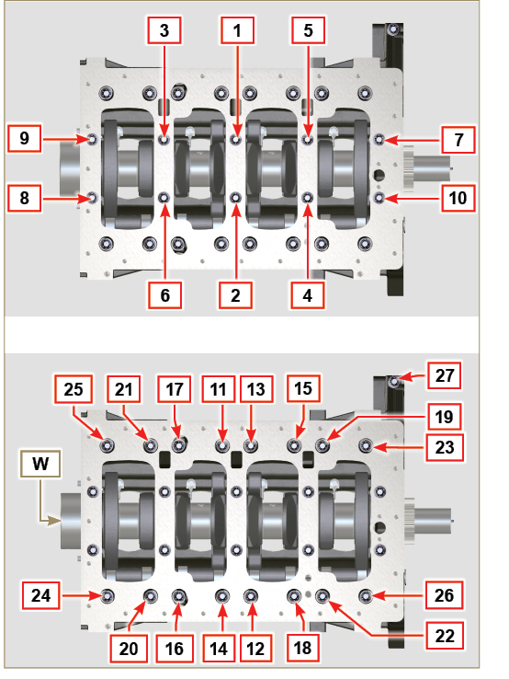  Fig 9.10
9.3.7 Piston rings  - Perform the operations described in Par. 8.5.3 .  - Put the scraper ring AP onto the piston AQ .  - Put the 2° seal ring AR on the piston AQ .  - Put the 1° seal ring AS onto the piston AQ . | 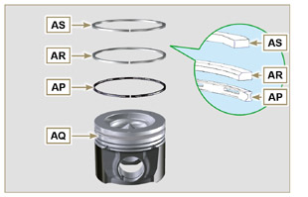  Fig 9.11
- Perform the operations described in Par. 8.5.4 .  - Position the segment openings with a 120° angle between them ( Y ).  NOTE: do not use the segment opening with the pin hole ( N )  - Lubricate the piston skirt and piston rings with oil. | 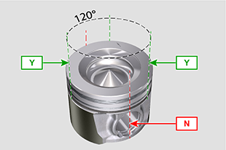  Fig 9.12
9.3.8 Piston  Important  - Before proceeding to the assembly of the piston and connecting rod, carry out the checks described in Par. 8.5.1 .  - Always replace the bearings CE after each assembly.  - Mate components respecting references at Par. 7.15.5 .  - Loosen the screws AU and remove the connecting rod cap AV .  - Fit the new bearings CE .  - Insert the connecting rod AZ into the piston AQ and align the seats BA .  - Insert the gudgeon pin BB into the seat BA for the assembly of the connecting rod and piston unit.  - Insert the lock rings BD inside the seat BE of the piston AQ to lock the gudgeon pin BB . | 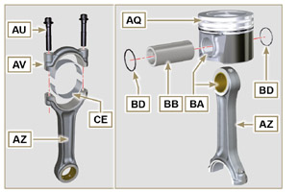  Fig 9.13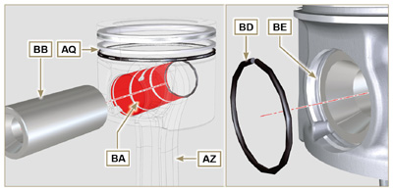  Fig 9.14 - Fig 9.15

9.3.9 Piston and connecting rod assembly  Important  - Before assembling the piston and connecting rod assemblies, execute the controls described in Par. 8.5.5 .  - Rotate the crankshaft W by moving the crankpin BG to a TDC position of the affected cylinder. | 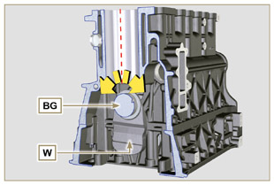  Fig 9.16
- Lubricate the piston skirt and rings AQ .  - Check that the half-bearing AS is mounted correctly and lubricate it thoroughly.  - Using the piston ring compression pliers, insert the piston inside the cylinder BQ by around 10mm (height BM ).  Important  - Make sure you are at the stage described in Point 1 .  - The piston AQ must be mounted with the arrow BN (stamped on the piston crown) facing the timing system side.  - Rotate the piston AQ by 10° counter-clockwise with respect to its correct assembly position ( Fig. 9.18 - height BP ).  NOTE: Doing this prevents the impact between the connecting rod AZ and the sprayer V . | 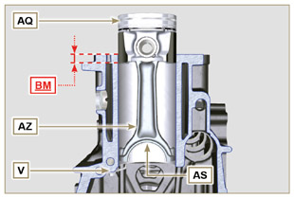  Fig 9.17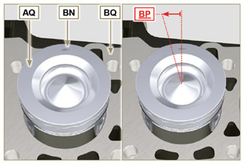  Fig 9.18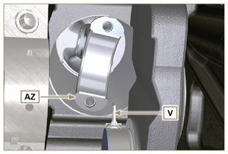  Fig 9.19
Important  - Leave the ring compressor assembled on the piston  - Push piston AQ downwards without introducing the segments in the cylinder, rotate piston AQ by 10° in a clockwise direction (value BR  – correct assembly position). | 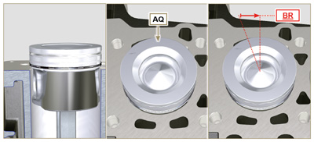  Fig 9.20

- Push the piston AQ downwards by centering the crankpin BG with the connecting rod AZ .  - Turn the crankcase on support to assemble the con rod capp on cylinder 1 and 4.  - Check that the half-bearing AS is mounted correctly on the connecting rod cap AV .  Important  - Check that the break levels of connecting rod cap AV coincide perfectly onto connecting rod AZ before screwing on and tightening capscrews AU.  - Couple the connecting rod cap AV to the connecting rod AZ using the marks made at disassembly ( Par. 7.15.2 and 7.15.5 ).  - Screw in the screws AU .  - Repeat the operations from 1 to 10 for each cylinder.  Important  - Failure to adhere to the assembly procedures may compromise the functionality of the engine, and also cause damage to persons and property.  - Tighten the screws AU , alternately, strictly following the tightening torques indicated.  Tightening sequence of screws Torx M10x1 :  1° CYCLE - with a torque of 40 Nm;  2° CYCLE - with a torque of 85 Nm ;  - Check that the connecting rods have axial play and the crankshaft W rotates smoothly.  NOTE: After the check carried out at point 14 , position the shaft W with the first cylinder to TDC. | 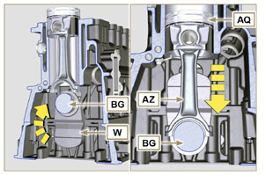  Fig 9.21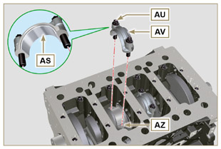  Fig 9.22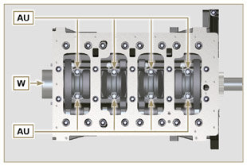  Fig 9.23
NOTE: Click by side to play the procedure. | https://www.youtube.com/embed/Ba8qqxTx6wA?rel=0
9.3.10 Crankshaft gasket flange  Important  - Check that the contact surface between the flange and the crankcase is free of grit and dirt.  - Always replace the gasket BS at each assembly.  - Check that there are bushings BT on the crankcase E .  - Lubricate the oil seal lip BU .  - Position the gasket BS and flange BV on the crankcase E in correspondence with the bushings BT .  - Put Loctite 243 on the 2 screws BW matching the bushings BT .  - Screw the fastening screws all the way in BW without tightening them.  - Tighten all the screws BW strictly following the tightening sequence indicated (tightening torque to 10 Nm ). | 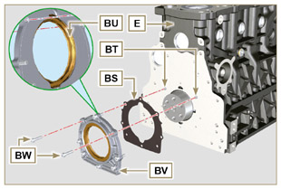  Fig 9.24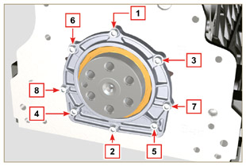  Fig 9.25
9.3.11 Cover 3 ^{rd} PTO  Important  - Replace capscrews CA with each assembly or alternatively apply Loctite 2701 on the thread.  - Secure the cover CB with the screws CA and CC inserting the gasket CD (tightening torque 25 Nm ). | 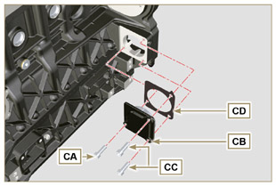  Fig 9.26

Oil sump unit assembly
9.4.1 Oil vapour pipes  - Apply Loctite 648 on the pipe threads A .  - Screw and tighten the pipes A (tightening torque of 15 Nm ). | 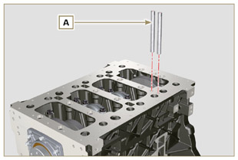  Fig 9.27
9.4.2 Oil suction pipe  Important  - It is mandatory to replace the gasket B after each assembly.  - Always replace capscrews D with new ones or alternatively apply Loctite 2701 .  - Insert the new gasket B in the seat of the oil suction hose flange D .  - Secure the hose C on the crankcase E with the screws D (tightening torque 10 Nm ). | 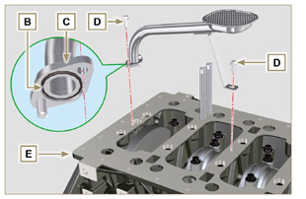  Fig 9.28
9.4.3 Oil Sump  - Ensure that the contact surfaces F of the oil sump G and the crankcase E are completely clean.  - Apply a bead of approx. 2.5 mm of sealant (Loctite 5660) on the surface F of the oil sump G .  - Note : alternatively apply Loctite 5699 . | 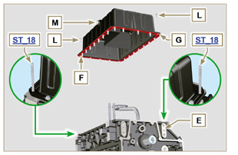  Fig 9.29
Important  - Tighten the screws L , strictly following the sequence and tightening torque indicated.  - Tighten the screws L following the sequence indicated (tightening torque 25 Nm ).  - After tightening all of the screws, loosen screw n°1 and retighten it to the torque value specified in step 4 .  - Check that the oil drain plugs M are tight (tightening torque 35 Nm ). | 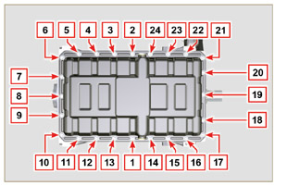  Fig 9.30

Flange unit assembly
9.5.1 Bell housing  Danger  - Bell A is very heavy; pay special attention during assembly operations to avoid dropping and causing serious risks to the operator.  - Install the bell housing A in accordance with the reference pins B on the base C . | 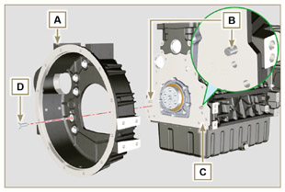  Fig 9.31
Important  - Failure to adhere to the assembly procedures may compromise the functionality of the engine, and also cause damage to persons and property.  - Tighten the fastening screws strictly following the tightening sequence indicated (tightening torque 50 Nm ). | 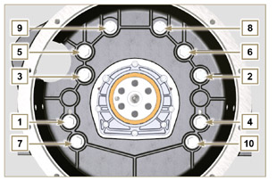  Fig 9.32
9.5.2 Flywheel  Danger  - Flywheel F is very heavy; pay special attention during assembly operations to avoid dropping and causing serious risks to the operator.  - Screw the special tool ST_09 on the crankshaft E instead of the screws G positioned higherup ( Fig. 9.33 ).  - Insert the flywheel F on the crankshaft E using the tool as a guide ST_09 and manually tighten all the screws G , remove the tool ST_09 and install the last screw G.  - Mount the tool ST_34 in the seat of the starter motor H and fit it with the two starter motor fixing screws.  - Tighten the screws G (tightening torque at 140 Nm ). | 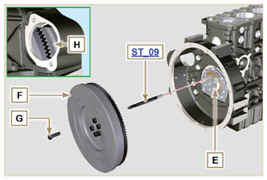  Fig 9.33

Timing system gear assembly and injection pump
9.6.1 Timing system gear assembly  - Check that the key A is correctly fitted on the camshaft B .  - Position the gear C on the camshaft B adhering to the key reference A .  - Screw capscrew D until the end.  - Insert the reference pin E on the gear C .  - Screw the encoder F with the screws G on the gear C observing the plug E .  - Tighten the middle gear pin H , in the housing J of the crankcase, with the screws K (tightening torque 25 Nm ).  Important  - The fitting of the middle gear pin H has only one position, the 4 screw holes K are not equally spaced.  - Always replace the gasket L after each assembly.  - Insert the shoulder ring M .  - Check the integrity of the bushing N on the middle gear P , and ensure that it is free from impurities.  - Thoroughly lubricate the pin H and the bushing N .  - Position the gear P on the pin H observing all the marks W of the gears C and S , (Fig. 9.37).  Important  - Failure to comply with the marks W on the gears C, P and S , causes engine malfunction and serious damage.  - Insert the shoulder ring Q and the lock ring R .  - Tighten the gear C with the screw D ( Fig. 9.34 - tightening torque at 100 Nm ).  - Tighten the screws G on the gear C (tightening torque at 5 Nm ). | 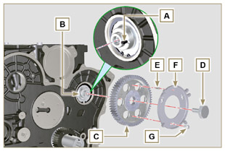  Fig 9.34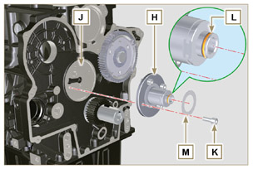  Fig 9.35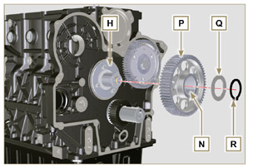  Fig 9.36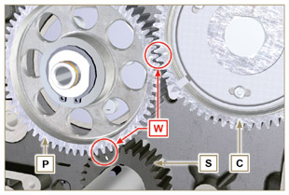  Fig 9.37
9.6.2 High-pressure injection pump  - Check that the surface V is free from impurities ( Fig. 9.38 ).  Important  - Always replace gasket U with every assembly.  - The seal gasket U can only be fitted in one direction( Fig. 9.38 ).  - Always replace capscrews T with new ones or alternatively apply Loctite 2701 (Fig. 9.38) .  - Fit the new gasket U on the injection pump Z (Fig. 9.38) .  - Fix the pump Z into the housing V together with the gasket U by the screws T ( Fig. 9. 38 - tightening torque at 25 Nm ).  - Check the correct fitting of the key AA on the shaft AB of the injection pump ( Fig. 9.39 ).  - Place the gear AC on the shaft AB of the pump respecting the reference to the key AA and the reference Q of the gear A E (Fig. 9.39) .  Serrare il dado AD (coppia di serraggio a 65 Nm ).  - Remove special tool ST_34 ). | 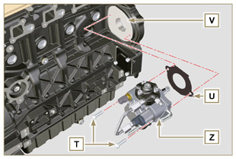  Fig 9.38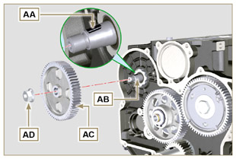  Fig 9.39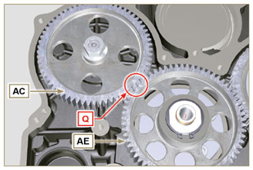  Fig 9.40

Cylinder head unit assembly
9.7.1 Valve stem gasket  Important  - Carry out the checks described in Par. 8.6.4 before proceeding with the following operations.  - Lubricate the oil seals A on the inside.  - Fit the oil seals A on the valve guides B using the tool ST_08 . | 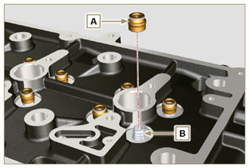  Fig 9.41
9.7.2 Electronic injector sleeves ( )  - Insert the seals C in the seats of the sleeve D .  - Insert the seal E with the convex side facing upward at the base of the sleeve D .  - Lubricate the gaskets C .  - Insert and carefully screw the sleeve D into the seat of the head F .  NOTE: The sleeve D must not protrude above the surface of the head BF .  - Clamp the sleeve D (tightening torque at 30 Nm ). | 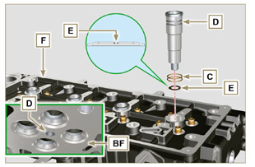  Fig 9.42
9.7.3 Electronic injectors projection  - Insert the electronic injector G inside the sleeve H .  - Mount the rocker arm pin fixing screw L up to the stop.  - Mount the electronic injector fixing bracket M and secure it with the screw N , without performing the calibration.  - Check using ST_03 tool (Fig. 9.44) , the projection of the injector, which must range between 1.68 ÷ 2.42 mm.  NOTE : if the value detected does not correspond, replace gasket Q with a different thickness. | 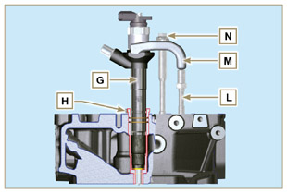  Fig 9.43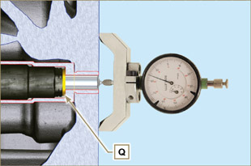  Fig 9.44
9.7.4 Valves  - Pre-lubricate and insert the valves X into the head F taking care to fit them in the original positions as per the reference marks made in Par. 7.13.4.1 .  - Position the spring Y on the seat of the head F .  - Position the disk S on the spring Y centering the valve X .  - Mount the tool ST_07 on the head F fixing it on one of the holes for securing the rocker arm cover.  NOTE: Change the fixing hole according to the position of the valves to be fitted.  - Position the tool ST_07 on the valve as shown in the figure.  - Push the lever of the tool ST_07 downwards, in order to lower the valve disks S in the direction of the arrow AK , and insert the valve cotters AJ inside the disk S .  - Check that the valve cotters AJ are properly mounted on the valve seats X and release the tool ST_07 .  NOTE: repeat all the steps for the relevant valves and remove the tool ST_07 . | 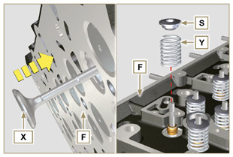  Fig 9.45
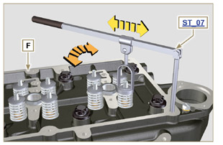
Fig 9.46
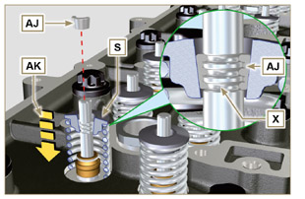
Fig 9.47
9.7.5 Cylinder head  - Fix the eyebolts AW with the screws AX onto the head F (tightening torque of 25 Nm ).  - Position the piston P at the TDC.  - Position the tool ST_03 on the crankcase surface of the head and measure the piston protrusion P from head level K in 4 diametrically opposed points R. Repeat the operation for all pistons P and take note of the highest average value, determining valu e S (Tab. 9.2) .  Tab. 9.2  S (mm) Hole number  0.030 - 0.126 1  0.127 - 0.250 2  0.251 - 0.375 3  - Based on the value detected at point 3 , select the relevant gasket T as shown in the Tab. 9.2 (Fig. 9.50 detail U ).  - Check that the crankcase surface K and the gasket T are completely free of dirt and grit.  Important  - The head gasket must be replaced for each assembly.  - Position the gasket T on the surface K with reference to the centering bushings J . | 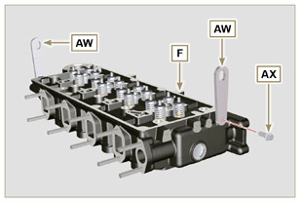  Fig 9.48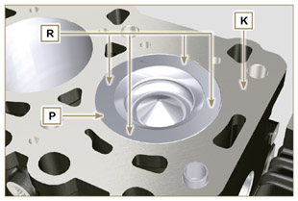  Fig 9.49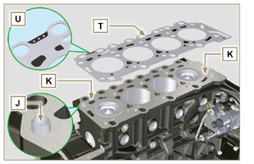  Fig 9.50
- Check that the surface head W is free from impurities.  - Position the head F on the crankcase Z with reference to the centering bushings J .  Important  - The fastening bolts V must be replaced every time they are assembled.  - Secure the head F by tightening the screws V strictly following the sequence indicated in the Fig. 9.52 or Fig. 9.53 and the tightening torque indicated in the Tab. 9.3 . | 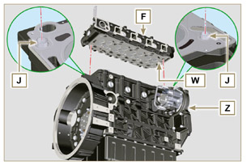  Fig 9.51
Important  - Failure to adhere to the bolt fixing procedures may compromise the functionality of the engine, and also may cause damage to persons and property.  - Tighten capscrews V observing the cycles, tightening, and subsequent rotation as indicated in Tab. 9.3 .  - For engine KDI 1903 TCR : 8 screws Torx M12x1,25 (Fig. 9.52) .  - For engine KDI 2504 TCR : 10 screws Torx M12x1,25 (Fig. 9.53) . | 3 CYLINDERS  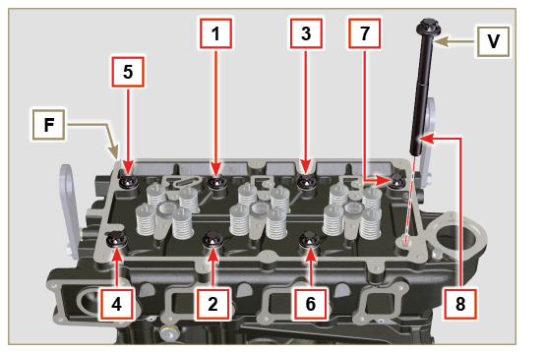  Fig 9.52
Tab. 9.3  CYCLE TORQUE  1 40 Nm  2 70 Nm  3 100 Nm  4 90°  5 90°  6 90° | 4 CYLINDERS  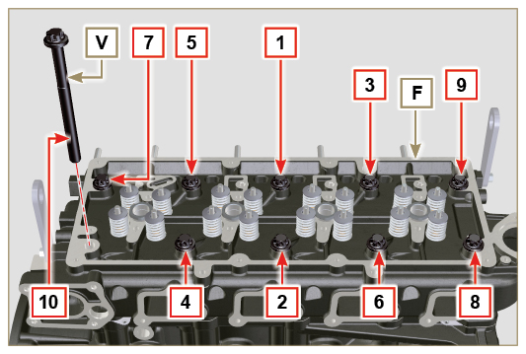  Fig 9.53
9.7.6 Rods and valve bridges  - Insert the rocker control rods AA into the niches of the head F .  Important  - Properly centre the rods AA into the spherical housing of the camshaft tappets AB .  - Mount the valve bridge AC on to the pairs of discharge and suction valves. | 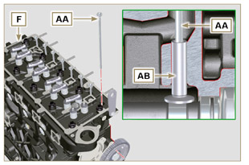  Fig 9.54
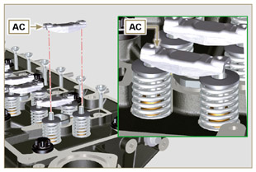
Fig 9.55
9.7.7 Rocker arms  Important  - To correctly position the rocker arms, turn the rocker arm pin AH with the lower height AL towards the timing system side as in Fig.9.57 .  - The discharge rocker arm AT is shorter than the suction arm AR .  - Fit the lock ring AM into the seat AN of the rocker arm pin AH .  - Position the pin AH with the screw support surface AP facing upwards and insert the 2 shoulder rings AQ .  - Insert in sequence the suction rocker arm AR , the holder AS and the discharge rocker arm AT in the pin AH .  - Insert the spring AU in the pin AH .  - Repeat points 3, 4 for all the rocker arms.  NOTE: The holder AV must be fitted with the last pair of rocker arms towards the flywheel.  - Insert 2 shoulder rings AQ and the lock ring AN to lock all the components inserted in the pin AH .  NOTE : The spring AU ensures that the supports AS and AV are kept in place. | 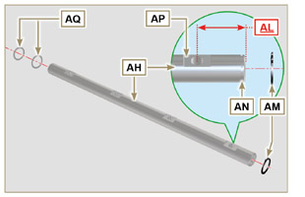  Fig 9.57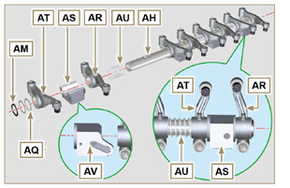  Fig 9.58
9.7.8 Rocker arm pin assembly  Important  - Position the rocker arm pin assembly BB on a level to align all the support surfaces.  - Check that the pistons are positioned half way between the TDC and BDC. Rotate the crankshaft 90° counterclockwise with regard to the 1st cylinder TDC, positioning the crankshaft pin BP as shown in Fig 9.60a . If the crankshaft pulley and the timing gear cover have not been removed, rotate the  crankshaft positioning the reference BQ located on the target wheel in correspondence of the speed sensor, as shown in Fig. 9.60b .  - If the engine is painted or protected with clear paint, replace the fastening screws BE .  - Position the rocker arm pin assembly BB on the head F , respecting the plug BC on the head using the holder indicated AV .  - Check the correct positioning of all the rocker arms and the u-bolt control valves (detail BD ). House the tappet in the seat of the rocker arms control rod.  - Secure the rocker arm pin BB tightening the screws BE (tightening torque to 25 Nm ). Adhere to the screw tightening sequence BE as shown in Fig. 9.60 . | 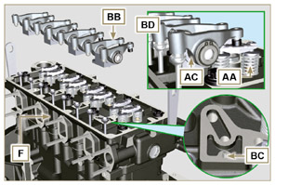  Fig 9.59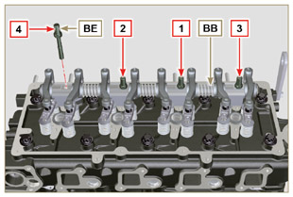  Fig 9.60
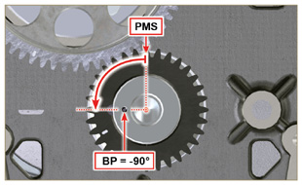  Fig 9.60a | 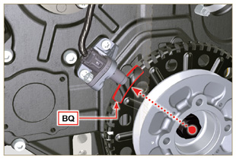  Fig 9.60b
9.7.9 Assembly Rocker arm cover  Important  - Replace gasket BF, BL and BM with each assembly ( ST_11 - ST_12 ) .  Modified component, see service letter 700027.  - Observe the order of tightening illustrated in Fig. 9.62 - 9.63 .  - Position tool ST_17 onto the head in correspondence with the two fastening holes 5 and 6 .  - Position gasket BF on cylinder head F using tool ST_17 as a guide.  - With vaseline lubricate the gaskets BL in the upper part, and the gaskets BM in the lower part.  - Attach the rocker arm cover BN on the head F with the screw BG (tightening torque to 10 Nm ). | 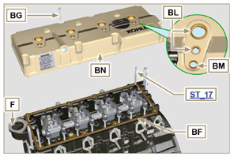  Fig 9.61
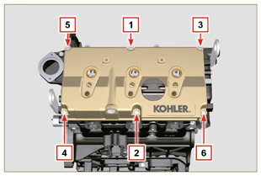  Fig 9.62 | 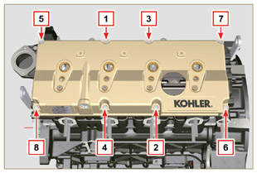  Fig 9.63

Fuel system assembly
Important  - Do NOT mount new or different injectors without the required tool ( Chap. 13 ).  - Remove the protective caps from all the components of the fuel circuit just before assembly just before assembly.  9.8.1 Fuel filter  - Secure the fuel filter holder R with the screws S on the crankcase T (tightening torque of 25 Nm ).  NOTE: For the assembly of the fuel cartridge, refer to operations 4 and 5 of Par. 6.11.2 . | 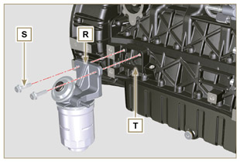  Fig 9.64
- Insert the tube K on the fitting coming out of the filter holder R and on the fuel inlet fitting of the injection pump M and secure it with the clamps N . | 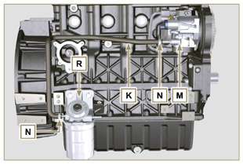  Fig 9.65
9.8.2 Common Rail  - Secure the rail AA on the head AB with the screws AC (tightening torque at 25 Nm ). | 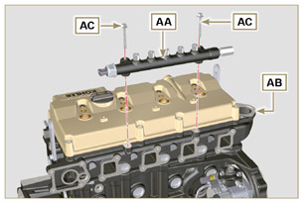  Fig 9.66
- Fit the gaskets AD and the fitting AE on the screw AF .  - Tighten the parts so assembled on the Common Rail AG (tightening torque at 15 Nm ) with the entrance of union AE facing upward. | 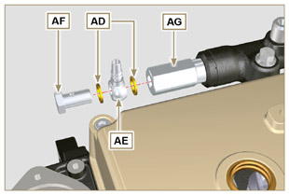  Fig 9.67
9.8.3 Electronic injectors  Important  - Always replace and lubricate the gaskets AH and AL of the electronic injectors AM with fuel, every time they are assembled.  - Pay attention when repositioning the electronic injectors, using the marks as described inl Par. 7.10.5 .  - If a new (or different) electronic injector is fitted on the engine, you are required to prepare tool ST_01 .  - If the engine is painted or protected with clear paint, clean the paint off the diesel injector AM near to the part in contact with the gasket ( BL > Fig. 9.61 ) .  - Insert the gasket AL inside the injector sleeve BQ .  - Insert the electronic injectors AM inside the rocker arm cover AN and orientate them as per Fig. 9.68 . | 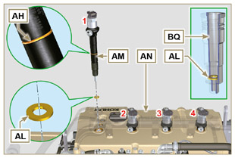  Fig 9.68
9.8.4 High pressure fuel pipes  Important  - Always replace the pipes AQ and tube E after each assembly.  - Position the pipes AQ on the Common Rail AA and on the electronic injectors AM , adjust the position of electronic injectors AM via the fitting inlets with the pipes AQ.  Important  - Tighten the nuts AS and AT manually, without clamping them.  - If the engine is painted or protected with clear paint, replace the fastening screws AU to ensure the gaskets BQ are sealed properly.  - Position the injector fastening brackets AV and the screws AU , inserting the washer AJ .  Important  - Replace the pipes AQ (Fig. 9.69) if the screws AU do not rotate freely.  - Tighten all the nuts AS (tightening torque at 30 Nm ).  - Tighten the nuts AT (tightening torque at 25 Nm ).  - Make sure that the mounting brackets AV are positioned correctly on electroinjectors BR and on fixing screws of the rocker arm assembly AM.  - Tighten the fixing screws of the injector mounting bracket (tightening torque of 20 Nm ).  - Position the pipe E screwing the screws BA and BB .  Important  - Screw the nuts BA and BB manually without tightening them.  - Tighten the nut BA (tightening torque of 30 Nm ).  - Tighten the nut BB (tightening torque of 25 Nm ).  - Tighten the Common Rail fastening screws BC (tightening torque of 25 Nm ). | 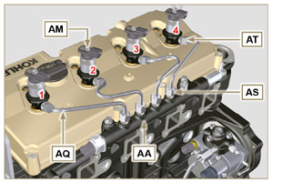  Fig 9.69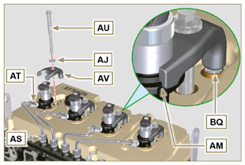  Fig 9.70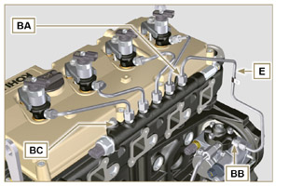  Fig 9.71
9.8.5 Fuel return pipes  - Check the gaskets BD on the fittings BG .  NOTE: Do not disconnect the pipes from the distributor. | 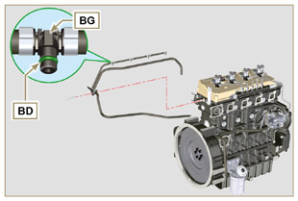  Fig 9.72
- Position the return pipes and fitting the distributor BE with the screw BC on the head BF ( Fig. 9.72 - tightening torque of 10 Nm ).  - Mount the fittings BG ( Fig. 9.74 ) on the injectors AM and lock them with the clips BH .  - Insert the pipe BL on the fitting BN .  - Insert the pipe BM on the fitting BP . | 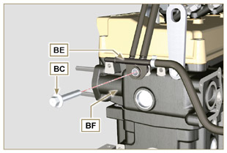  Fig 9.73
Important  - Pipes of a "BASE CONFIGURATION" (refer to Par. 1.5 ) engine are shown. Other return pipes can be missing or different.  - The pipes can vary in quantity, size and dimensions depending on the engine version. | 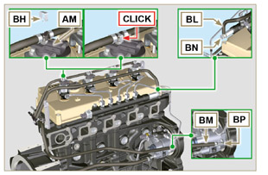  Fig 9.74

Intake manifold assembly
9.9.1 Semi-collettor external  Important  - Check that the contact surfaces between the semi-collector C and the head D are free from impurities.  - Insert the special tool ST_18 into indicated point.  - Insert the screws A and the gasket B on the semi-collector C .  - Secure the semi-collector C with the screws A on the head D (tightening torque of 25 Nm ).  - Tighten the clamp E with the screw F on the semi-collector C (tightening torque of 10 Nm - ST_06 ).  - Tighten the screw G and the holder H on the semi-collector C (tightening torque of 10 Nm - ST_06 ). | 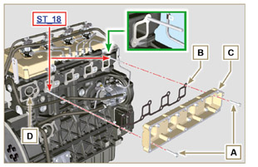  Fig 9.75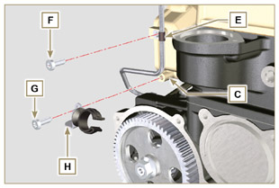  Fig 9.76
9.9.2 External half-manifold  Important  - Check that the contact surfaces between the two semi collectors C and M are free from impurities.  - Fit the screws L on the semi-collector M freeing the holes Q indicated in Fig. 9.78 .  - Mount the gaskets N on the semi-collector by interposing the separation sheet P .  - Fit the semi-collector M on the semi-collector C with the screws L (tightening torque of 22 Nm - ST_05 ). | 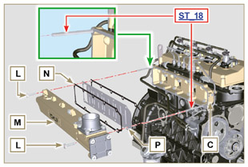  Fig 9.77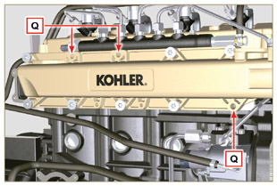  Fig 9.78

Exhaust manifold assembly
Important  - Replace the self-locking nuts B and the metal gaskets D between the manifold and the cylinder head every time they are disassembled.  - In the event of mounting the studs C , fix ( 25 Nm tightening torque) with Loctite 2701 on the thread.  - Check that the contact surfaces F are free from impurities.  - Insert the gaskets D and E on the studs C .  - Position the manifold A on the studs C .  - Fix the manifold A on the cylinder head by tightening the self-locking nuts B (tightening torque of 25 Nm ). | 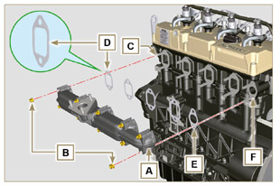  Fig 9.79

Assembly lubrication circuit
9.11.1 Assembly oil mist separator unit  Important  - Always replace the gasket B after each assembly.  - Always carefully inspect the condition of the pipes, and replace them if there is any doubt regarding the integrity of their seal.  - Check that the contact surfaces A are free from impurities.  - Mount the gasket B on the holder C .  - Fix the separator body holder C on the crankcase E with the screws D (tightening torque of 12 Nm ) fitting the gasket B . | 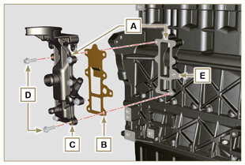  Fig 9.80
- Fit the pipes F and G on the holder C .  - Insert the bleeder H attaching it to the pipes F and G. Secure the pipe F with the clamps J .  - Secure the bleeder H onto the holder C with the clamp K . | 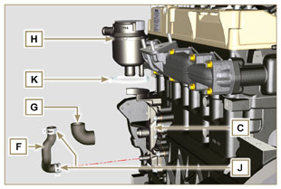  Fig 9.81
9. 11 .2 Oil Cooler and oil filter Unit Assembly  - Check that the surface L on the holder V and on the crankcase E are free from impurities.  - Lubricate and insert the gasket N on the fitting P .  Important  - Always replace the gaskets Q and S every time they are disassembled.  - Lubricate and insert the gaskets Q and S respectively in the seats R and T of the holder V .  - Secure the holder V with the screws AA and AB (tightening torque of 10 Nm ).  Important  - In the event of mounting the fitting P on the crankcase E (tightening torque of 15 Nm with Loctite 2701 on the thread). | 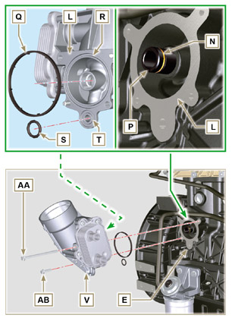  Fig 9.83 e Fig 9.83
NOTE: To assemble the oil cartridge refer to operations 5 and 6 of Par. 6.10.2 .  Important  - Always replace the gaskets BM and BN every time they are assembled.  - Insert and tighten the cartridge-holder cover AC on the filter holder V (tightening torque of 25 Nm ). | 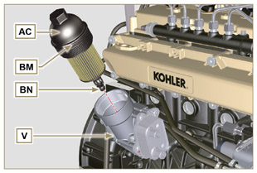  Fig 9.84
9. 11 .3 Oil pump  NOTE: Carry out the checks described in Par. 8.7 before proceeding with the following operations.  - Check that all contact surfaces between AL, AH, AF, AG and AN are free of impurities – scratches - dents.  - When assembling, do not use any type of gasket between AG and AN .  - Thoroughly lubricate the seat of the rotors AF on the oil pump crankcase AG and the two rotors AH and AL .  - Insert, inside the seat AF , the 2 rotors (in sequence) AH and AL , respecting the reference BP as the picture (or refer to Par. 2.10.2 ).  - Check that the 2 pins AM are inserted properly in the crankcase timing system AN .  - Position the oil pump assembly AG using the pin marks AM.  - Fasten the oil pump cover AG with the screws AH (tightening torque 10 Nm ). | 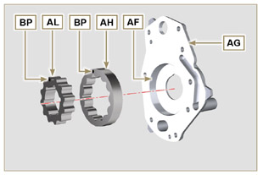  Fig 9.85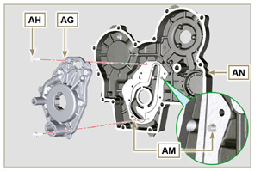  Fig 9.86
9. 11 .4 Timing system carter  Important  - Always replace the the gasket AP after each assembly ( ST_14 ).  - Always replace the gasket AU after each assembly.  - To prepare the surface of the K plane for the new application of the sealant, it must be cleaned through the use of:  - initially Loctite SF 7200  - subsequently Loctite SF 7063  Avoid any contact with the K plane and be careful not to compromise the cleaning performed.  - Distribute a bead of Loctite 5188 , of about 1mm thickness, on the surfaces AQ of the crankcase AN.  - Make sure that the key AS (Fig. 9.88) is inserted properly on the crankshaft and that it is facing upwards.  - Lubricate and insert the gasket AU in the seat of oil pump AV .  - Apply the tool ST_10 onto the crankshaft.  - Check that the 2 pins AT ( Fig. 9.88 ) are properly insertedin the timing system crankcase AN .  - Lubricate oil seal AP with oil and position the carter AN on the crankcase E , using the pins AT , inserting the oil pump AV on the crankshaft.  - Fasten capscrews AW observing the indicated clamping sequence (tightening torque of 25 Nm ). | 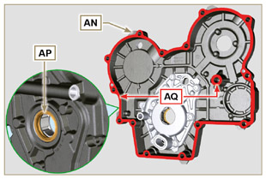  Fig 9.87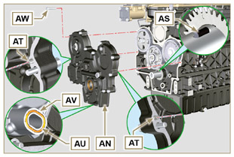  Fig 9.88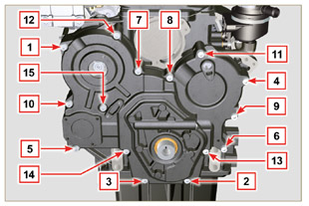  Fig 9.89
9. 11 .5 Crankcase oil filler flange Timing System  Important  - Always replace the gasket BA after each assembly.  - Position the gasket BA in the seat on the flange BB .  - Fasten the flange BB on the crankcase BC with the screws BD (tightening torque of 10 Nm - ST_06 ). | 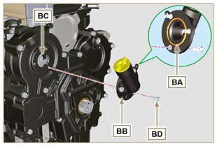  Fig 9.90
9. 11 .6 Oil pressure relief valve  - Lubricate the piston BE and fully insert it in the seat BF .  - Insert the spring BG in the piston.  Important  - Always replace the gasket BH after each assembly.  - Mount the gasket BH on cap BL .  - Tighten the cap BL on the crankcase AN (tightening torque of 50 Nm ). | 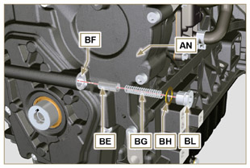  Fig 9.91

Crankshaft and phonic wheel pulley unit assembly
NOTE: To fit the target wheel refer to the operations in Par. 6.6.2 .  - Check that the pin F is mounted properly on the crankshaft G .  - Position the pulley unit H on the crankshaft G using the pin mark F (detail M ).  - Apply Molyslip grease on the screw thread N .  - Fix the pulley T with the screw Z (tightening torque of 360 Nm ) and remove special tool ST_34 ( Fig. 9.33 ). | 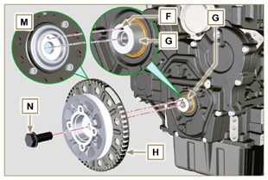  Fig 9.92

Coolant circuit assembly
9.3.1 Thermostatic valve  Important  - Always replace the gasket A after each assembly.  - Check the condition of the seal gasket A and fit it on the thermostatic valve B .  - Position the thermostatic valve B in the seat on the head C (detail D ).  - Secure the cover E with the screws F on the head C (tightening torque of 10 Nm ). | 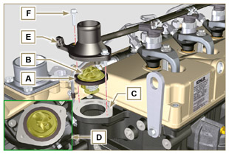  Fig 9.93
9.13.2 Coolant pump assembly  Important  - Always replace the gasket L every time it is assembled.  - Fit the pump G with the screws H interposing the gasket L (tightening torque of 25 Nm ). | 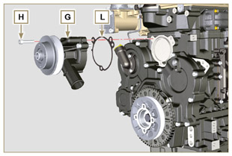  Fig 9.94
9.13.3 Oil Cooler hoses  - Assemble the Oil Cooler hose behind the injection pump and connect to oil heat exchanger.  - Insert hose L into clamp N .  - Fasten hose L by means of clamp P on Oil Cooler M . | 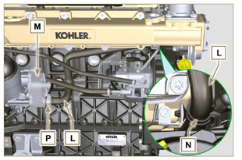  Fig 9.95
4 . Secure the sleeve Q on Oil Cooler M and to the coolant pump T with the clamps K .  5. Fasten the clamp Y with the screw S (tightening torque of 22 Nm - ST_05 ). | 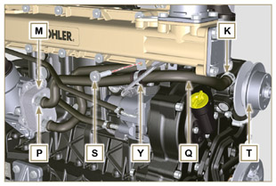  Fig 9.96

Turbocharger Assembly
Important  - Before proceeding, perform the operation described in Par. 2.18 .  - Ensure that tube B is not clogged.  - Fasten the connecting sleeve A to the pipe B with the clamp C onto the flange fitting D .  Important  - Always replace the gasket F after each assembly.  - Lubricate and insert the gasket F into the seat of the pipe G .  Important  - Remove the plastic or foam caps from the turbo compressor before assembling.  - Replace nuts M with each assembly.  - Check that the contact surfaces E are free from impurities deformations or cracks, otherwise replace exhaust manifold L .  - Position the turbo-compressor H on the bolts on the manifold L .  - Fasten the turbo-compressor H with the nuts M (tightening torque of 25 Nm ).  - Fasten the pipe G with the screws N to the turbo-compressor H .  Important  - Always replace the gasket P after each assembly.  - Before assembly of the tube Q , perform the operation described in Par. 2.19.2 - point 2 .  - Ensure that tube Q is not clogged.  - Fasten the fuel outlet pipe Q with the fittings R on the turbocompressor H and on the crankcase S (tightening torque of 15 Nm ).  Insert the gaskets P between:  - Q and R ;  - Q and S ;  - Q and H .  - Insert the sleeve T on the turbo-compressor H and secure it with the clamp U .  - Insert the pipe V onto the sleeve T and onto the relief valve Z . Secure tube V with the clamps W . | 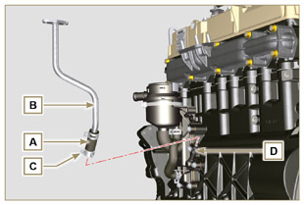  Fig 9.97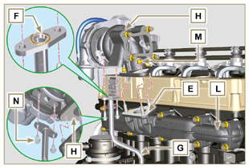  Fig 9.98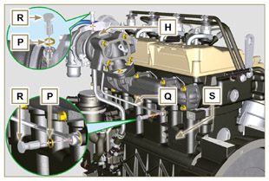  Fig 9.99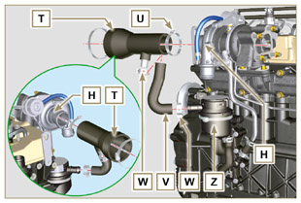  Fig 9.100

Electric component assembly
9.15.1 Sensors and switches
9.15.1.1 T-MAP Sensor  - Fasten the sensor A with the screws B on the manifold C (tightening torque of 10 Nm - ST_06 ). | 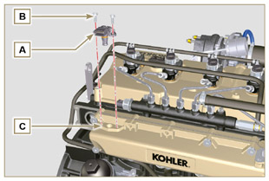  Fig 9.101
9.15.1.2 Coolant temperature sensor  - Secure the sensor D onto the head E (tightening torque of 20 Nm ). | 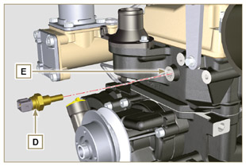  Fig 9.102
9.15.1.3 Oil Pressure Switch  - Clamp the oil pressure switch F on the crankcase G (tightening torque at 35 Nm ). | 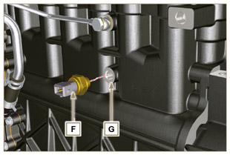  Fig 9.103
9.15.1.4 Camshaft phase sensor disassembly  - Rotate the crankshaft H posizioning a tooth L of the target wheel which is mounted on the camshaft at the center of hole M .  - Carry out the steps described in points 5, 6 and 7 to insert the correct number of spacers N .  - Fit the spacer N on the sensor P .  - Fasten the phase sensor P on distribution guard L with the screw Q (tightening torque of 10 Nm - ST_06 ). | 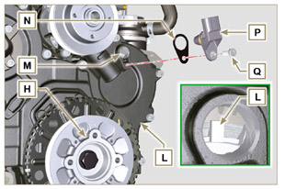  Fig 9.104
- Measure the distance from the coupling surface AD to the tooth surface on the target wheel (X1) .  - Measure the distance between the coupling surface AD and the sensor surface R (Y1) .  - The difference between the 2 measurements determines the air gap value (Z1) .  The value (Z1) permitted must be a minimum of 0.2 mm and a maximum of 1.2 mm .  Insert one or two spacers N (Fig. 9.104) based on the value (Z1) detected.  NOTE: The calibrated spacers N have a thickness of 0.2 mm . | 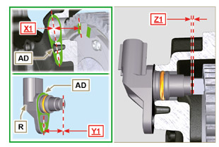  Fig 9.105
9.15.1.5 Speed sensor  - Measure the distance from the coupling surface AE to the external diameter of the target wheel (X2) .  - Measure the distance between the coupling surface AE and the sensor surface V (Y2) .  - The difference between the 2 measurements determines the air gap value (Z2) .  The value (Z2) permitted must be a minimum of 0.2 mm and a maximum of 1.2 mm .  Insert one or two spacers N (Fig. 9.104) based on the value (Z2) detected.  NOTE: The calibrated spacers U have a thickness of 0.2 mm .  Mount the bracket S with the screws T (tightening torque at 10 Nm - ST_06 ).  - Insert the shim U on the sensor V .  Clamp the sensor V on the bracket S with the screw Z (tightening torque at 10 Nm - ST_06 ). | 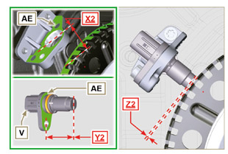  Fig 9.106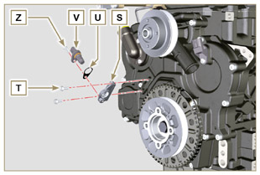  Fig 9.107
9.15.1.6 Fuel filter water detection sensor  - Lubricate and insert the gasket AA on the fitting AB .  - Tighten the sensor AB onto the cartridge AC (tightening torque of 5 Nm ). | 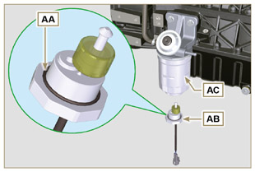  Fig 9.108

9.15.2 Alternator  - Insert the screw BA onto the alternator BB .  - Insert the washer BC onto the screw BA .  - Manually fit the screw BA all of the way onto the crankcase BD without tightening.  - Manually fit the screw BE all of the way onto the head BF without tightening. | 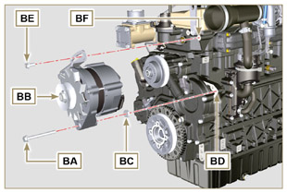  Fig 9.109
- Pull out the dipstick BB in the direction of the arrow BG .  Important  - The belt BH must always be replaced every time it is assembled, even if it has not reached the scheduled hours for replacement.  - Insert the belt BH on the pulleys BJ . | 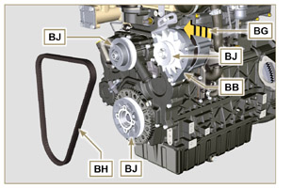  Fig 9.110
- Pull out the dipstick BB in the direction of the arrow BK .  - While tensioning the alternator BB , first clamp screw BE (tightening torque at 25 Nm ) and then screw BA (tightening torque at 69 Nm [thread M10] - 40 Nm [thread M8] ). | 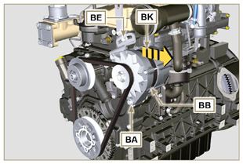  Fig 9.111
- Check the tension of the belt BH with a Clavis type instrument, positioning it in point (the tension must be between 350 and 450 Nm ).  - If the tension values do not correspond, tighten screws BA and BE , then repeat operations 7, 8 and 9 . | 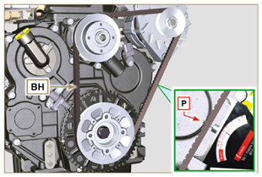  Fig 9.112
9.15.3 Starter Motor  Important  - Remove the ST_34 tool if it remains in position on the engine  - Fit the starter BQ with the screws BR on to the flange bell BS (tightening torque of 45 Nm ). | 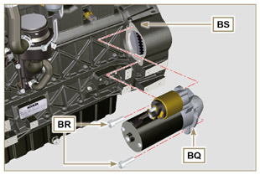  Fig 9.113
9.15.4 Electric cabling  - Position the cable holder BT together with the cabling BU on the rocker cap BV .  - Mount the connectors C1 on the electronic injectors S1 .  - Screw the wiring holder BT on the rocker cap BV with the screws BW (tightening torque of 10 Nm - ST_06 ). | 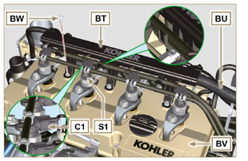  Fig 9.114
- Fit the connector C2 on the sensor S2 .  - Fit the connector C3 on the sensor S3 .  - Insert the clamp H1 on the collector DA . | 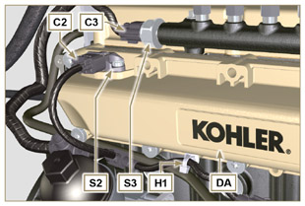  Fig 9.115
- Insert the connector C4 on the fuel intake valve S4 .  - Insert the connector C5 on fuel temperature sensor S5 . | 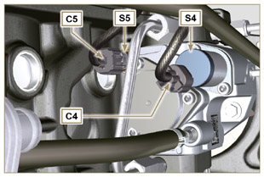  Fig 9.116
- Fit the connector C6 on the sensor S6 .  - Fit the connector C7 on the sensor S7 .  - Insert the clamps H2 on the thermostat cover DB and H3 on the lateral oil intake flange DC .  - Fit the connector C8 on the sensor S8 . | 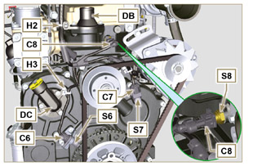  Fig 9.117
- Fit the connector C9 on switch S9 .  - Insert the terminal C10 on the engine S10 .  - Insert the connector C11 on the alternator cable S11 .  - Insert the clamp H4 on the vent holder DD . | 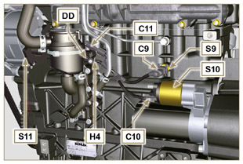  Fig 9.118

EGR Circuit Assembly
9.16.1 EGR valve  Important  - Check that the contact surfaces between flange B and the head D are free from impurities.  - Always replace the gasket A after each assembly.  - Mount the gasket A on the flange B .  - Secure the flange B with the screws C on the head D (tightening torque of 10 Nm ). | 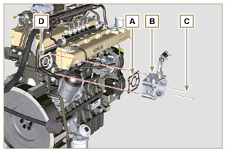  Fig 9.119
- Insert the screws E into the holder F .  - Position the gasket G in correspondence with the screws E on the holder F .  - Secure the EGR valve holder F with the screws E on the flange B (tightening torque of 10 Nm ). | 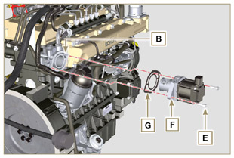  Fig 9.120
- Fit the connector H on the valve L .  - Tighten the clamp J with the screw K on the flange B . | 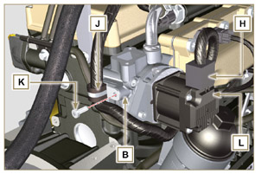  Fig 9.121
9.16.2 EGR Cooler  - Insert the fitting N of EGR Cooler M in the sleeve P of the EGR valve unit.  - Position EGR Cooler M on the intake manifold Q with the screws R ( ST_05 ) .  - Secure the fitting N with the clamp S to the sleeve P . | 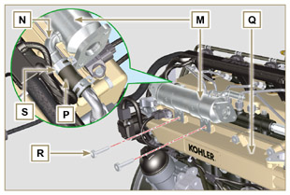  Fig 9.122
- Fasten the pipe T with the screws U on the EGR valve unit V inserting the gasket W (tightening torque of 10 Nm - ST_06 ).  - Fasten the pipe T with the screws AA on EGR Cooler M inserting the gasket AB (tightening torque of 25 Nm ). | 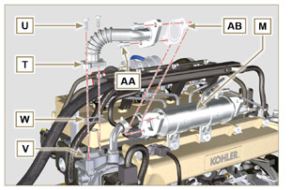  Fig 9.123
- Fasten the pipe AC on the intake manifold AD with the screws AE (tightening torque of 25 Nm - ST_05 ) inserting the gasket AF .  - Fasten the pipe AC on the EGR Cooler M with the screws AG (tightening torque of 25 Nm ) inserting the gasket AH .  - Fit the EGR Cooler M on the intake manifold Q with the screws R (tightening torque of 25 Nm - ST_05 - Fig. 9.122 ).  - Connect hose AL on EGR Cooler M . | 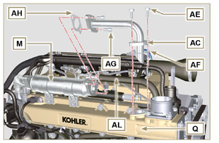  Fig 9.124

Tightening torques and the use of sealants
Tab. 9.4 - *Alternatively to the capscrew replacements, with "Dri-loc"
BASE CONFIGURATION

SHORT BLOCK

Component | Thread (mm) | Torque (Nm) | Sealer
Oil sprays fastening capscrew | M6x1 | 10
Lower crankcase fastening capscrew | M12x1.25 | 3 Torque cycles
1st Cycle |  | 40
2nd Cycle |  | 70
3rd Cycle |  | 120
Lower crankcase fastening capscrew | M8x1.25 | 2 Torque cycles
1st Cycle |  | 20
2nd Cycle |  | 35
Connetting road screw | M8x1 | 2 Torque cycles
1st Cycle |  | 40
2nd Cycle |  | 85
Flange oil seal fastening capscrew | M6x1 | 10
Closing cover fastening capscrew 3rd PTO | M8x1.25 | 25 | Loctite 2701*
Idle gear lubr. hole cap closure | M14x1.5 | 30 | Loctite 2701*
Coolant drain hole closing cap | M16x1.5 | 50
OIL SUMP ASSEMBLY
Component | Thread (mm) | Torque (Nm) | Sealer
Oil fumes tube | M12x1,5 | 15 | Loctite 648
Oil suction hose fastening capscrew | M6x1 | 10 | Loctite 2701*
Oil sump fastening capscrew | M8x1.25 | 25
Oil drain cap | M18x1.5 | 35
FLANGE ASSEMBLY (1ST PTO)
Component | Thread (mm) | Torque (Nm) | Sealer
Flange bell fastening capscrew | M10x1,5 | 50
Flywheel fastening capscrew | M12x1,25 | 140
GEAR DISTRIBUTION
Component | Thread (mm) | Torque (Nm) | Sealer
Intermediate gear gudgeon fastening screw | M8x1.25 | 25
Camshaft gear control fastening capscrew | M10x1 | 100
Gear fastening nut on high-pressure fuel injection pump | M14x1.5 | 65
ENGINE CYLINDER HEAD ASSEMBLY
Component | Thread (mm) | Torque (Nm) | Sealer
Air bleeding cap | M6x1 | 8
Lifting brace fastening capscrew | M8x1.25 | 25
Electronic injector manifold | M12x1 | 30
Cylinder head fastening capscrew | M12x1.25 | 6 Torque cycles
1st Cycle |  | 40
2st Cycle |  | 70
3st Cycle |  | 100
4st Cycle |  | 90°
5st Cycle |  | 90°
6st Cycle |  | 90°
Rocker arm gudgeon fastening capscrew | M8x1,25 | 25
Rocker arm cover fastening capscrew | M6x1 | 10
INJECTION SYSTEM
Component | Thread (mm) | Torque (Nm) | Sealer
Fuel filter fastening capscrew | M8x1.25 | 25
Fuel cartridge fastening | ... | 17
Common rail fastening capscrew | M8x1.25 | 25
Electronic injector brace fastening capscrew | M8x1.25 | 20
Distributor fastening capscrew | M8x1.25 | 10
Waste line fastening drilled capscrew on common rail | M10x1 | 15
Electronic Injector side injection tube nuts | M12x1.5 | 25
Injection pump side injection tubes nuts | M12x1.5 | 25
Common Rail side injection tubes nuts | M14x1.5 | 30
Injection pump fastening capscrew | M8x1.25 | 25 | Loctite 2701*
INTAKE MANIFOLD
Component | Thread (mm) | Torque (Nm) | Sealer
Internal semi-manifold fastening capscrew (on cylinder head) | M8x1.25 | 25
External semi-manifold fastening capscrew | TG8 | 22
Intake flange fastening capscrew | TG8 | 22
EXHAUST MANIFOLD
Component | Thread (mm) | Torque (Nm) | Sealer
Exhaust manifold fastening stud | M8x1.25 | 25
Exhaust manifold fastening nut | M8x1.25 | 25
Exhaust/manifold/muffler flange fastening nut | M8x1.25 | 25
LUBRICATION CIRCUIT
Component | Thread (mm) | Torque (Nm) | Sealer
Oil fumes support fastening capscrew (on crankcase) | M6x1 | 12
Oil filter fastening union | M20x1.5 | 15 | Loctite 2701*
Oil cooler fastening capscrew | M6x1 | 10
Cartridge-holder cover | ... | 25
Oil pump carter fastening capscrew | TG6 | 10
Carter distribution fastening capscrew | M8x1.25 | 25
Side oil load flange fastening capscrew (onto carter distribution) | TG6 | 10
Pressure relief valve cap | M16x1.5 | 50
CRANKSHAFT AND TARGET WHEEL PULLEY ASSEMBLY (2 ^{ND} PTO)
Component | Thread (mm) | Torque (Nm) | Sealer
Phonic wheel fastening capscrew (on crankshaft pulley) | M6x1 | 10
Crankshaft pulley fastening capscrew | M16x1.5 | 360 | Molyslip
COOLANT CIRCUIT
Component | Thread (mm) | Torque (Nm) | Sealer
Coolant tube clamp fastening capscrew (Oil Cooler return) | TG6 | 10
Thermostatic valve cover fastening capscrew | M6x1 | 10
Coolant pump fastening capscrew | M8x1.25 | 25
TURBO COMPRESSOR
Component | Thread (mm) | Torque (Nm) | Sealer
Oil return tube fastening capscrew | M6x1 | 10
Oil supply tube fastening capscrew | M10x1 | 15
Turbine fastening stud (on manifold) | M8x1.25 | 25
Exhaust flange fastening stud (on turbine) | M8x1.25 | 25
Turbine fastening nut | M8x1.25 | 25
Exhaust flange fastening nut (on turbine) | M8x1.25 | 25
ELECTRICAL COMPONENTS
Component | Thread (mm) | Torque (Nm) | Sealer
MAP sensor fastening capscrew | TG6 | 10
Coolant temperature sensor | M12x1.5 | 20 max.
Oil pressure switch | M12x1.5 | 35
Phase sensor fastening capscrew | TG6 | 10
Speed sensor fastening capscrew | TG6 | 10
Sensor for water presence in fuel |  | 5
Alternator bracket fastening capscrew | M8x1.25 | 25
Alternator fastening capscrew | M8x1.25 | 40
Alternator fastening capscrew | M10x1.5 | 69
Starter motor fastening capscrew | M10x1.5 | 45
Supply cable fastening nut (starter motor) | M8x1.25 | 10
Cabling support fastening capscrew | TG6 | 10
EGR CIRCUIT

Component | Thread (mm) | Torque (Nm) | Sealer
Flange EGR valve fastening capscrew | M6x1 | 10
EGR valve fastening capscrew | M6x1 | 10
EGR Cooler tube fastening capscrew (on flange EGR valve) | TG6 | 10
EGR Cooler fastening capscrew | TG8 | 22
Tube fastening capscrew on EGR Cooler | M8x1.25 | 25
Tube fastening capscrew on intake manifold | M8x1.25 | 25
* Alternatively to the capscrew replacements, with "Dri-loc"
OPTIONAL COMPONENTS (CHAP. 11)
OIL DIPSTICK ON CYLINDER HEAD
Component | Thread (mm) | Torque (Nm) | Sealer
Oil dipstick tube fastening capscrew | M6x1 | 10
HEATER

Component | Thread (mm) | Torque (Nm) | Sealer
Flange intake with heater fastening capscrew | M8x1.25 | 22
ALTERNATOR WITH POLY-V BELT
Component | Thread (mm) | Torque (Nm) | Sealer
Pulley fastening capscrew | M10x1.5 | 48
Pulley positioning blocking nut capscrew | M10x1.5 | 45
Alternator brace fastening capscrew | M8x1.25 | 25
Alternator fastening capscrew (upper) | M8x1.25 | 25
Alternator fastening capscrew (lower) | M8x1.25 | 40
Pulley sliding plate fastening capscrew | M8x1.25 | 25
IDLE GEAR (FOR 3TH /4TH PTO)
Component | Thread (mm) | Torque (Nm) | Sealer
Gear drilled fastening capscrew | M14x1.5 | Consultare il Par. >> | Molyslip
3 ^{TH} PTO
Component | Thread (mm) | Torque (Nm) | Sealer
Pump support fastening capscrew | M8x1.25 | 25 | Loctite 2701*
Pump fastening capscrew | M8x1.25 | 25
4 ^{TH} PTO
Component | Thread (mm) | Torque (Nm) | Sealer
Grooved crankshaft support fastening capscrew | M8x1.25 | 25 | Loctite 2701*
Cover fastening capscrew (3 ^{rd} PTO side) | M8x1.25 | 25
Sump support fastening capscrew | TG6 | 10
Pump fastening capscrew | M8x1.25 | 25
BALANCE DEVICE (4 CYLINDERS)
Component | Thread (mm) | Torque (Nm) | Sealer
Housing closing panel fastening capscrew | M6x1 | 8
Shafts support fastening capscrew | M10x1.5 | 50
REMOTE OIL FILTER
Component | Thread (mm) | Torque (Nm) | Sealer
Head fastening and Oil Cooler union on crankcase | M20x1.5 | 25 | Loctite 2701*
Crankcase head nipple and oil filter support | M14x1.5 | 40
Tube union on crankcase head | G3/8 | 30
Tube union on filter support | G3/8 | 35
Oil filter | M20x1.5 | 20
Filter support head air bleeding cap | M8x1.25 | 25
INTAKE CIRCUIT
Component | Thread (mm) | Torque (Nm) | Sealer
Air filter support plate fastening capscrew (on flange bell) | M8x1.25 | 25
Air filter support fastening capscrew | M8x1.25 | 25
EXHAUST CIRCUIT
Component | Thread (mm) | Torque (Nm) | Sealer
Muffler brace support fastening capscrew | M8x1.25 | 25
Muffler fastening capscrew on muffler | M8x1.25 | 25
Muffler fastening nut | M8x1.25 | 25
COOLING CIRCUIT
Component | Thread (mm) | Torque (Nm) | Sealer
Blower fastening capscrew | M6x1 | 10
Radiator support fastening capscrew | M16x1.5 | 150
Shroud radiator fastening capscrew | M6x1 | 10
Radiator lower brace fastening capscrew | M8x1.25 | 25
Radiator on anti-vibrating | M8x1.25 | 25
Anti-vibrating radiator fastening nut (on lower brace) | M8x1.25 | 25
Anti-vibrating and brace fastening capscrew (upper) | M6x1 | 10
Upper brace fastening capscrew (on engine cylinder head) | M8x1.25 | 25
Side bulkheads fastening capscrew | M6x1 | 10
ENGINE SUPPORT
Component | Thread (mm) | Torque (Nm) | Sealer
Side feet fastening capscrew (on flange bell or crankcase) | M12x1.75 | 50
Rear feet fastening capscrew | M16x1.5 | 200

