Information for disassembly
KDI-TCP 3404E5 Workshop Manual (Rev. 01.1)

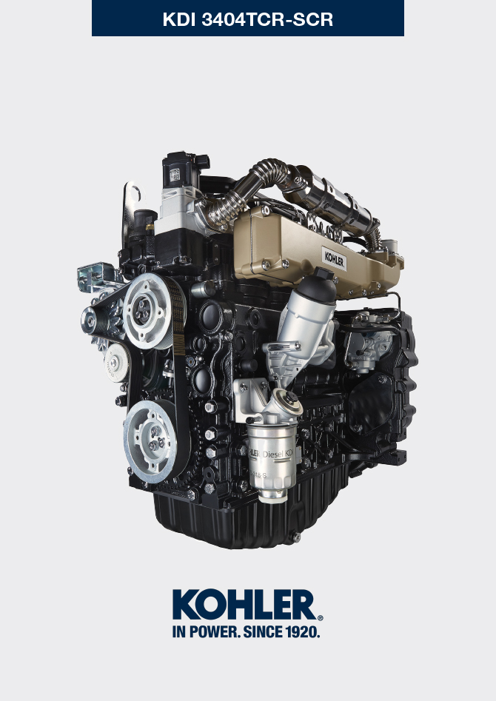

Registration of modifications to the document
Any modifications to this document must be registered by the drafting body, by completing the following table.

Released by | Code | Revision | Release Date | Revision date | Edited by | Endorsed
 | manoff

Translated from the original manual in Italian language
Data reported in this issue can be modified at any time by KOHLER.

Sommario
1. TITOLO 1 2
1.1. Asdfsdfsdf 2
1.2. Asdfsdfsdfggg 2

Information for disassembly

Recommendations for disassembly

Important

- The mark ( ) after the title of a paragraph, indicates that the procedure is not required in order to disassemble the engine, however the procedures are featured in order to illustrate the disassembly of components.
- The operator should prepare all equipment and tools in order to enable him to carry out the operations correctly and safely.
- Before disassembly, perform the operation described in Chap. 5 .
- Before proceeding with operation, carefully read Chap. 3 .
- In order to operate safely and easily, we recommend positioning the engine on a rotating stand for engine overhauling.
- Seal all injection component unions as illustrated in P ar. 2.9.8 during assembly.
- Protect all disassembled components and coupling surfaces subject to oxidation with lubricant.
- Where necessary, reference to special tools to use during disassembly operations is indicated (es. ST_05 ), identified in Tab. 13.1 - 13.2 - 13.3 .

ATS disassembly
1 - Perform the operations described in Par. 6.3.1.1 *  2 - Loosen clamp B through screws A.  3 - Disengage ATS C from exhaust line D. | 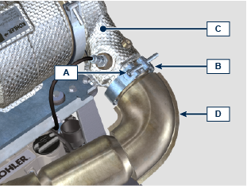
4 - Disengage tubes E .  5 - Loosen screws F and open clamps G .  6 - Remove the ATS C . | 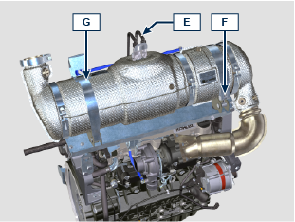  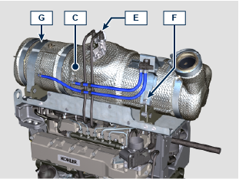
7 - Loosen the screws H1 and remove the support L1 .  8 - Loosen nuts M and remove tube N . | 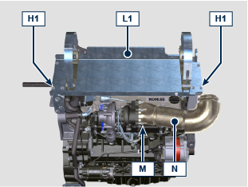
9 - Loosen the screws H2 and H3 and remove the support L2 . | 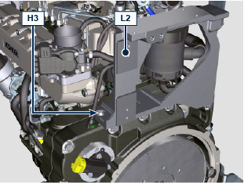  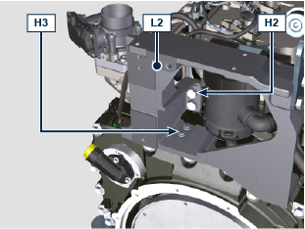 tt  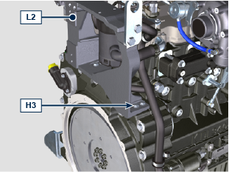
10 - Svitare le viti H2 , H3 rimuovere il supporto L3 . * | 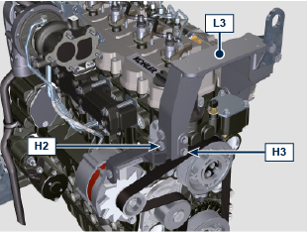  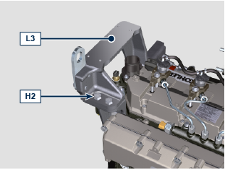

Coolant recirculation components disassembly
7.3.1 Oil Cooler manifold  - Release the clamps A .  - Undo the screw B and remove hoses C ( ST_05 ) . | 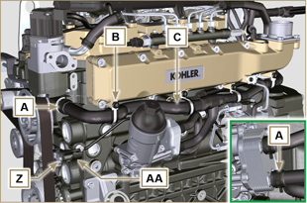  Fig 7.4
- Release the clamp D and remove hoses E . | 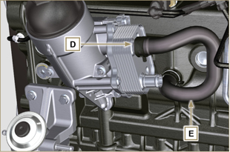  Fig 7.5
7.3.2 Coolant pump  Important  - The pump B is not repairable.  - Perform the operations described in Par. 6.5.1 .  - Undo capscrews F and remove flange G with the relative gasket. | 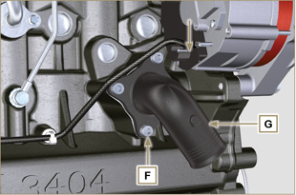  Fig 7.6
7.3.3 Thermostatic valve  - Undo the screws A and remove the thermostatic valve cover B .  - Remove the thermostatic valve C and its gasket.  Important  - Always replace the gasket D every time it is disassembled.  - Check that the air bleeding hole is not clogged or blocked ( Par. 2.11.4 ). | 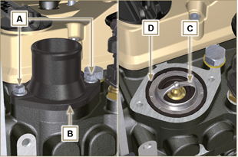  Fig 7.7

Electric components disassembly
7.4.1 Electric wiring  Important  - Refer to Par. 2.13 prior to proceeding with disassembly.  - Disconnect the connector A .  - Undo the screw B .  - Release the clamp C . | 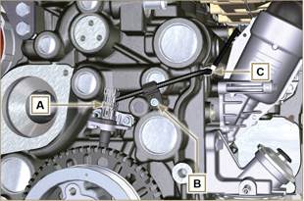  Fig 7.8
- Disconnect the connector D . | 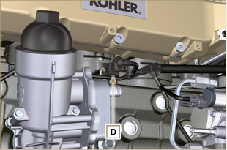  Fig 7.9
- Disconnect the connectors E and F . | 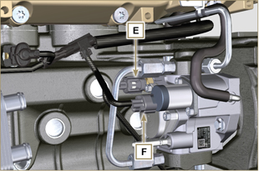  Fig 7.10
- Disconnect the connector G . | 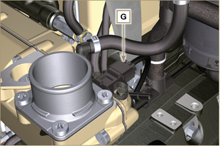  Fig 7.11
- Remove nuts H and disconnect cables L and M .  - Release the clamp P .  - Undo the screw Q . | 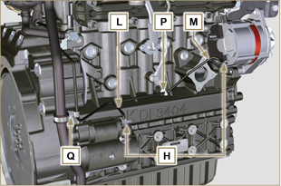  Fig 7.12
- Disconnect the connectors R , S , T , U .  - Undo the screws V ( ST_06 ) and remove the wiring support Z . | 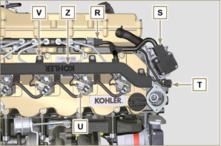  Fig 7.13
7.4.2 Starter motor  Important  - The motor is not repairable.  - Perform the operations from point 2 to 3 of Par. 6.6.1 .  7.4.3 Alternator  - Undo the screws A1 and B1 and remove the alternator C1 . | 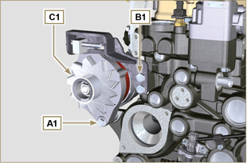  Fig 7.14
7.4.5 Sensors and switches  Important  - After disassembly, protect the sensors suitably against knocks, dampness and any high temperature sources.  - The sensors and switches cannot be repaired, therefore they must be replaced in the event of anomalies.  7.4.5.1 Oil pressure switch ( )  - Unscrew and remove the oil pressure switch AD . | 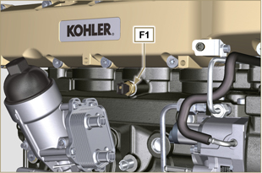  Fig 7.16
7.4.5.2 Coolant temperature sensor ( )  - Unscrew and remove the coolant temperature sensor AE . | 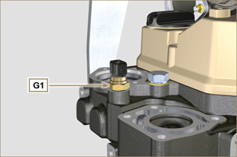  Fig 7.17
7.4.5.3 Speed sensor ( )  - Undo the screw H1 and remove the sensor L1 with the relative spacer ( ST_06 ) .  - Undo the screws M1 and remove the sensor N1 . | 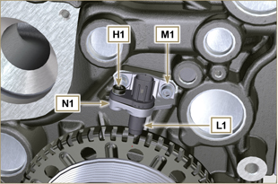  Fig 7.18
7.4.5.4 Camshaft phase sensor  - Undo the screw P1 and remove the sensor Q1 with the relative spacer. | 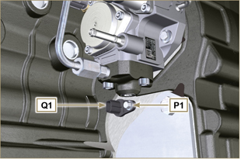  Fig 7.19
7.4.5.5 T-MAP Sensor ( )  - Undo the screw R1 and remove the sensor S1 ( ST_06 ). | 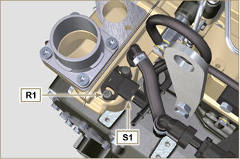  Fig 7.20
7.4.5.6 Fuel filter water detection sensor ( )  Warning  - The fuel filter is not always mounted on the engine.  - When disassembling the sensor U1 , use a suitable container to recover the fuel contained in the cartridge T1 .  - Unscrew the sensor U1 from the cartridge T1 . | 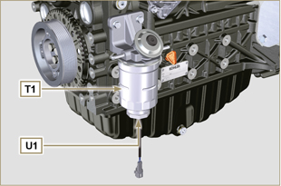  Fig 7.21

Turbocharger disassembly
- Unscrew the fittings A and remove the pipe B with the relative gaskets C . | 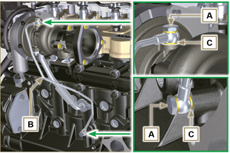  Fig 7.22
- Undo the screws D and remove pipe E and the relevant gaskets. | 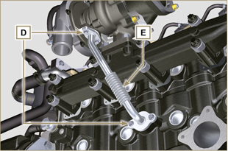  Fig 7.23
- Undo the nuts F and remove the turbocharger G . | 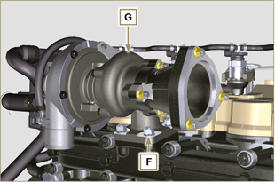  Fig 7.24

Exhaust manifold disassembly
- Remove nuts A , capscrews B and spacers C , manifold D and gaskets E .  - Close the openings and manifolds to prevent foreign bodies from entering. | 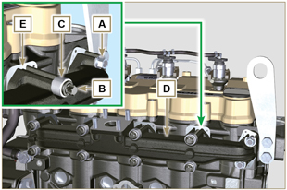  Fig 7.25

Crankshaft and target wheel pulley disassembly
- Perform the operations from point 4 to 5 of Par. 6.6.1 .

Flange unit disassembly
7.8.1 Flywheel  - Perform the operations of point 2 Par. 6.2.2 .  - Loosen, but not remove, nut A .  Important  - Leave the special tool ST_34 for blocking the flywheel ( Par. 7.7 ).  Danger  - The flywheel E is very heavy. Pay the utmost attention while removing it in order to prevent it dropping or falling, as this may have serious consequences for the operative.  - Undo the screws B and remove the flywheel C by means of tool ST_43 . | 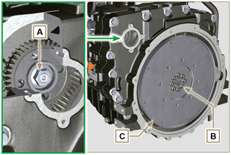  Fig 7.26
7.8.2 Flange housing  Danger  - The flange housing F is very heavy. Pay the utmost attention while removing it in order to prevent it dropping or falling, as this may have serious consequences for the operative  - Secure tool ST_41 onto gear D by means of capscrews B .  - Undo capscrews E by following the order indicated in the figure.  - Remove the engine housing F by means of tool ST_44 . | 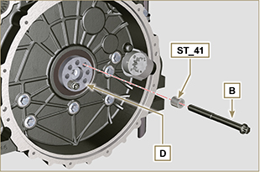  Fig 7.27  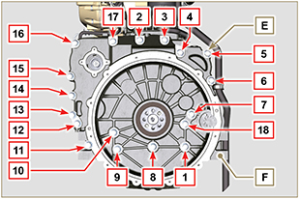  Fig 7.28

Lubrication circuit disassembly
7.9.1 Oil pump  Important  - The oil pump is not repairable.  - Undo the screws A and remove the pump unit B . | 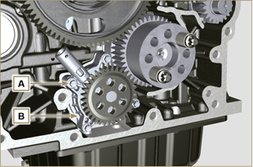  Fig 7.29
7.9.2 Oil pressure valve ( )  - Remove cotter pin C .  - Remove disk D , spring E , piston valve F using a magnet. | 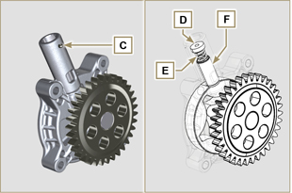  Fig 7.30
7.9.3 Oil Cooler unit and oil filter
- Perform the operations of Par. 6.8.1 .

NOTE : To replace the oil cartridge, refer to operations of Par. 6.8.2 .

7.9.4 Oil vapour separator unit  - Perform the operations of Par. 6.7.1 .  - Undo the screws G and remove the support H .  - Loosen clamp B and remove hose M .  - Undo the screw N and remove hoses P .  - Remove quick fitting R and remove hose S . | 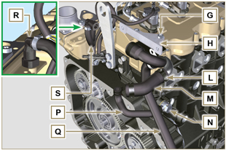  Fig 7.31

Fuel system disassembly
Important  - Seal all injection component unions as illustrated in Par. 2.9.8 .  7.10.1 Fuel return pipes  - Release the clip A .  - Disconnect unions B from electronic injectors C .  Warning  - After removing the union, the clip A must automatically return to its initial position; otherwise it must be replaced.  - Undo the screw D.  - Disconnect the pipe E .  - Undo and remove the screw F with the relative gaskets and put the cap on the Common Rail pressure relief valve G .  - Remove the fuel return pipes. | 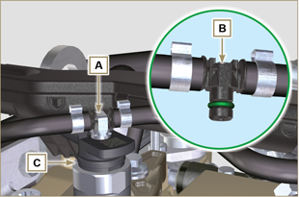  Fig 7.32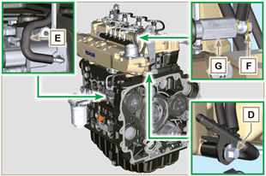  Fig 7.33
7.10.2 Fuel flow pipes  - Remove the pipes H, L. | 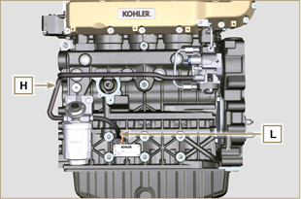  Fig 7.34
7.10.3 High pressure fuel pipes  Danger  - The fuel injection circuit undergoes high pressure, use safety protections as described in Par 3.4.3 .  - Ensure that the Common Rail is not under pressure by slowly and carefully unscrewing one of the nuts N .  - Undo the screw M .  - Loosen the nuts N, P in sequence.  - Fully undo the nuts N, P in sequence and remove the high pressure pipes Q, R. | 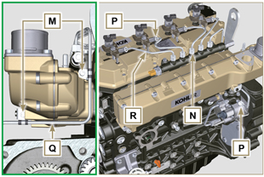  Fig 7.35
7.10.4 Common Rail  - Undo the screws S and remove the Common Rail T .  NOTE: Take care to protect te sensor U from knocks, moisture and any high temperature source. The internal parts of the rail cannot be repaired. | 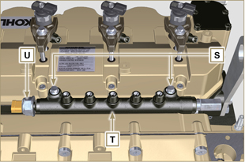  Fig 7.36
7.10.5 Electronic injectors  Important  - In the event that the electronic injectors are disassembled (not necessarily replaced), mark them with the relevant cylinder number from which they originate so as not to confuse them during re-assembly (Fig. 7.38) .  - The electronic injectors cannot be repaired.  - If one or more electronic injectors are to be replaced, the new calibration data must be inserted in the ECU via a specific instrument ( ST_01 ).  - Be careful not to damage the gaskets V .  - Undo capscrews J and remove them together with the relative washers K and then brace W .  - Pull out the electronic injector C .  NOTE: Should you be unable to remove the electronic injector (acting only on point X ), use an open-ended spanner (Ø 34 mm), by applying small rotations to unblock the component.  - Seal all injection component unions as illustrated in Par. 2.9.8 .  - Ensure that gasket Y has remained in the correct position (Fig. 7.38) .  Otherwise, recover the gasket from inside the electronic injector Z . | 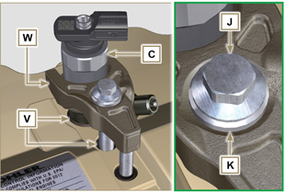  Fig 7.437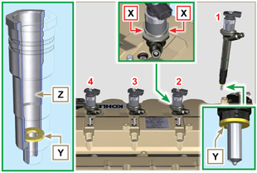  Fig 7.38
7.10.6 Fuel filter ( )  - Undo the fuel cartridge A1 from support B1 .  - Undo the screws C1 and remove the filter support B1 . | 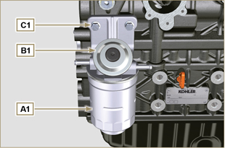  Fig 7.39
7.10.7 High-pressure fuel injection pump  Important  - Before disassembling, carefully read Par. 2.17 .  - The injection pump is not repairable  - Should the fuel feeding pump need to be replaced, after assembly, it is necessary to perform the Pump Learning procedure by means of instrument ST_01 .  - Undo the nut D1 .  - Screw the tool ST_13 on the thread of the gear E1 .  - Redo the capscrew F1 of tool ST_13 to disconnect the pump H1 from gear E1 .  - Undo the screws G1 , remove pump H1 and the relative gasket L1 .  - Seal all injection component unions as illustrated in Par. 2.9.8 . | 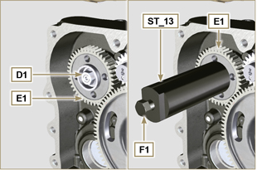  Fig 7.40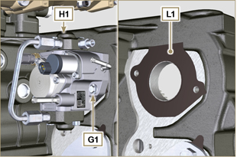  Fig 7.41

Intake manifold disassembly
- Undo the screws A and remove the semi-manifold B ( ST_05 ) .  - Remove the separation plate C and the gaskets D . | 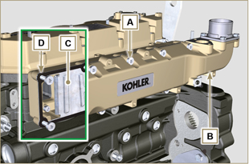  Fig 7.42
- Undo the screws E .  - Remove the semi-manifold F and the gasket G . | 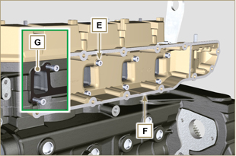  Fig 7.43

Cylinder head unit disassembly
7.12.1 Rocker arms cover  - Undo the screws A .  - Remove the rocker arms cover B .  - Remove the gasket C . | 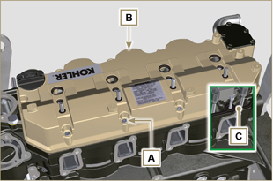  Fig 7.44
7.12.2 Rocker arm pin  - Undo the screws D .  - Remove the rocker arm pin unit E . | 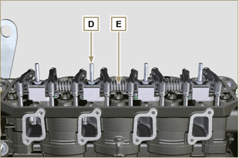  Fig 7.45
7.12.2.1 Rocker arm ( )  - Remove the retainer ring F .  - Remove the shoulder rings G .  - Remove the rocker arms H . | 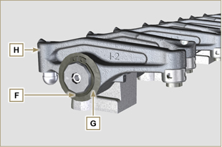  Fig 7.46
7.12.3 Valve rods and bridges  - Remove the valve control U-bolts M .  - Remove the rocker arm control rods N . | 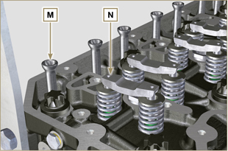  Fig 7.47
7.12.4 Cylinder head

Important

- Fix special tool ST_60 on the cylinder head Q (tightening torque of 20 Nm ).

Important  - The capscrews P must be replaced every time they are disassembled.  - Do NOT remove the capscrews completely, first loosen them by turning them a whole cycle following the order shown in the figure.  - Loosen fastening screws P , turning them by one turn following the order shown in the figure.  - Undo capscrews P by following the order indicated in the figure.  Important  - To lift cylinder head Q , only use both eyebolts Y provided by KOHLER (refer to Fig. 7.55 ).  - When removing the cylinder head Q and subsequent disassembly, control, and assembly operations, it is necessary to protect the contact surface W of cylinder head Q and crankcase J against impacts.  - Remove the cylinder head Q .  - Remove the head gasket R . | 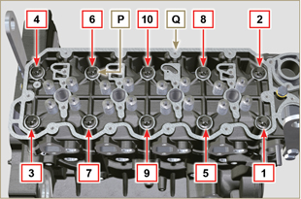  Fig 7.48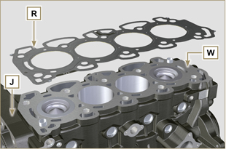  Fig 7.49
7.12.4.1 Valves ( )  - Mount the tool ST_07 on the head Q fixing it on one of the holes for fixing the rocker arm cover.  NOTE: Change the fixing hole according to the position of the valves to be removed.  - Position the tool ST_07 on the valve as shown in the figure. | 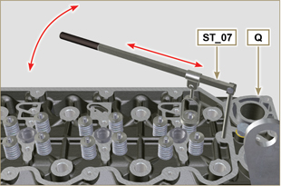  Fig 7.50
- Push the lever of the tool ST_07 downwards, in order to lower the valve plates S in the direction of the arrow T , remove cotters U using a magnet.  NOTE: Repeat all the operations for all the valves concerned. | 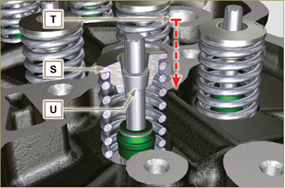  Fig 7.51
Important  - Before removing the valves, make some marks to record their original position, in order to avoid confusing them when reassembling (if they are not replaced).  - Remove the valves V . | 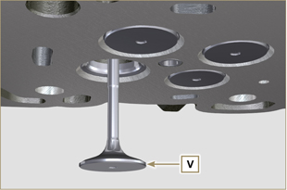  Fig 7.52
7.12.4.2 Electronic injector sleeves ( )  - Unscrew and remove the sleeves Z from the head Q .  - Remove the gaskets J, K . | 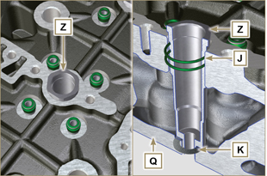  Fig 7.53
7.12.4.3 Valve stem gasket ( )  - Remove the gaskets W . | 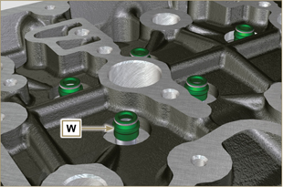  Fig 7.54

Timing system gear disassembly
Important  - For the following operation, turn the engine by bringing the cylinder head surface downwards.  - Remove the gear A .  - Unscrew screw B and remove the gear C .  NOTE: Gear A is assembled on the camshaft by press-fit; remove gear A to also remove the camshaft. | 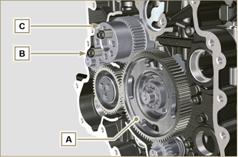  Fig 7.56

Oil sump unit disassembly
7.14.1 Oil sump  - Undo the screws A .  - Remove the oil sump B by inserting a plate between surface C of crankcase D and oil sump B .  - Remove the oil dipstick E . | 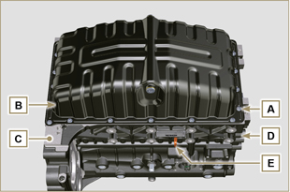  Fig 7.57
7.14.2 Oil suction pipe  - Undo the screws F and remove the oil pipe G . | 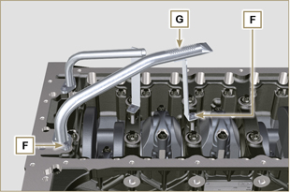  Fig 7.58
7.14.3 Oil drain pipe ( )  - Undo the screws H and remove the pipe L . | 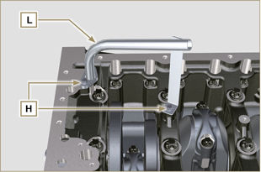  Fig 7.59

Engine block disassembly
7.15.1 Piston unit/connecting rod  Important  - Mark some numerical references (cylinder n°) on the connecting rods, connecting rod caps N , pistons and gudgeon pins to prevent unintentionally confusing the components not replaced during assembly. Failure to do this may result in engine malfunctions.  - References on connecting rod M and cap N must only be carried out on a side in correspondence with K1 and K2 , as illustrated in Fig. 7.61 .  - Screw the bolt M temporarily. | 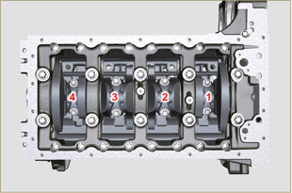  Fig 7.60
NOTE : coupling cap N on the connecting rod can be carried out with centring taper pins (Fig. 7.62) or broken ( Fig. 7.63 - without centring taper pins).  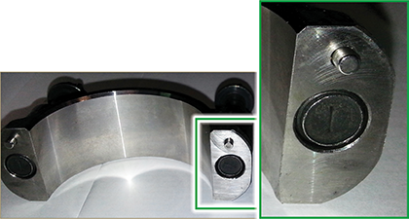  Fig. 7.62  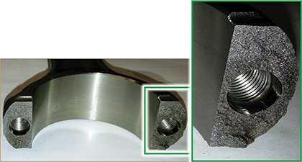  Fig. 7.63 | 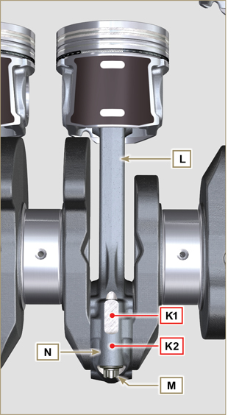  Fig 7.61
- Pull out the connecting rod - piston assembly from position 2 and 3 by manually applying pressure on the connecting rod big end L in the direction of arrow X .  - Couple the connecting rod big end caps N with the relevant piston and connecting rod unit L .  - Rotate the crankshaft by 180°.  - Repeat points 2 to 5 to disassemble the connecting rod-piston assembly to position 1 and 4 . | 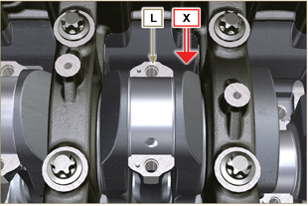  Fig 7.64
Warning  - The connecting rod half-bearings P are made of special material. Therefore, they must be replaced every time they are removed to prevent seizures. | 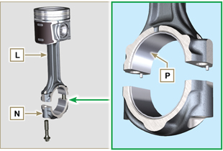  Fig 7.65
7.15.2 Lower semi-crankcase  Important  - The capscrews Q must be replaced every time they are disassembled.  - Do NOT remove the capscrews completely, first loosen them by turning them a whole cycle following the order shown in the figure.  - Loosen fastening screws Q , turning them by one turn following the order shown in the figure.  - Undo capscrews Q by following the order indicated in the figure. | 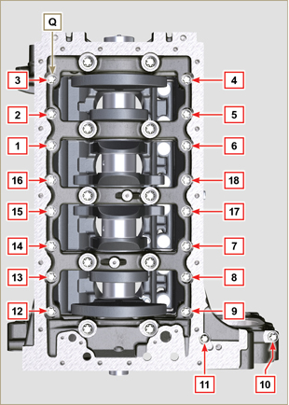  Fig 7.66
Important  - The capscrews R must be replaced every time they are disassembled.  - Do NOT remove the capscrews completely, first loosen them by turning them a whole cycle following the order shown in the figure.  - Loosen fastening screws R , turning them by one turn following the order shown in the figure.  - Undo capscrews R by following the order indicated in the figure.  - Remove the lower semi-crankcase D1 and store it in a suitable container for washing. | 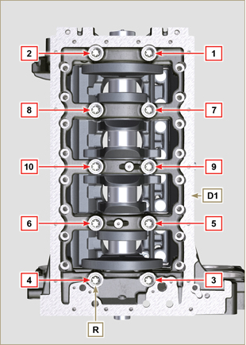  Fig 7.67
7.15.3 Crankshaft  Remove:  - Crankshaft S .  - The shoulder semi-rings T .  - gasket U from crankshaft S . | 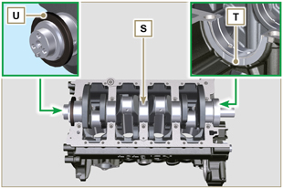  Fig 7.68
7.15.4 Piston ( )  - Remove the retainer ring V .  - Remove the pin Z to separate the piston J from the connecting rod L .  Important  - If they are not replaced, keep the components together (connecting rod - piston - gudgeon pin) by using references in order to prevent them from getting mixed up during assembly. | 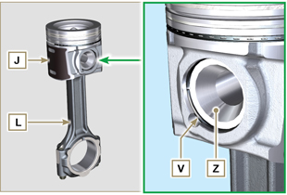  Fig 7.69
7.15.4.1 Rings ( )  - Remove the rings K . | 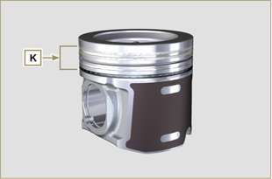  Fig 7.70
7.15.5 Oil spray nozzles ( )  - Undo the screws W and remove the spray nozzles X from the upper semi-crankcase D2 . | 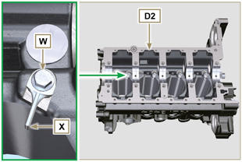  Fig 7.71
7.15.6 Camshaft tappets  - With a magnet, remove the tappets Y from the upper semi-crankcase D2 . | 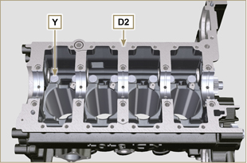  Fig 7.72
7.15.7 Crankshaft bushings  - Remove the crankshaft bushings A1 from the upper crankcase D2 .  Important  - The crankshaft half-bearings A1, B1 are made of special material. Therefore, they must be replaced every time they are removed to prevent seizures. | 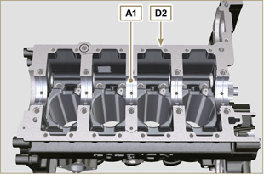  Fig 7.73
- Remove the crankshaft bushings B1 from the lower semicrankcase D2 . | 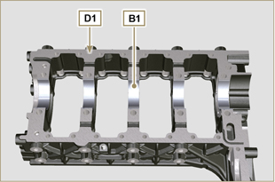  Fig 7.74

