Information about optional components
KDI 1903 M Workshop manual (Rev. 09.6)

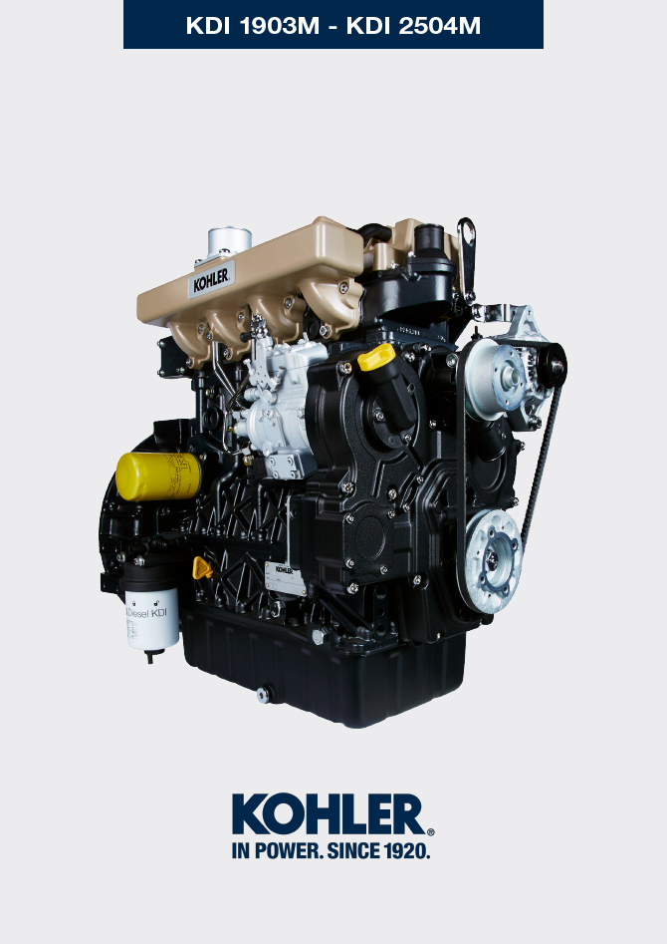

Registration of modifications to the document
Any modifications to this document must be registered by the drafting body, by completing the following table.

Released by | Code | Revision | Release Date | Revision date | Edited by | Endorsed
Technical Documentation | ED005302-960 | 9.6 | 04/2013 | 03/2023 | M. SILVESTRONE | V. MANINI

Translated from the original manual in Italian language
Data reported in this issue can be modified at any time by KOHLER.

Sommario
1. TITOLO 1 2
1.1. Asdfsdfsdf 2
1.2. Asdfsdfsdfggg 2

Information about optional components

Oil dipstick in cylinder head
Important

- Before proceeding with operation, read Par. 3.3.2 .
11.1.1 Check  - Pull out the dipstick B in the direction of the arrow A .  - Check that the mark left by the oil on the dipstick is between the MIN . and MAX . notches. | 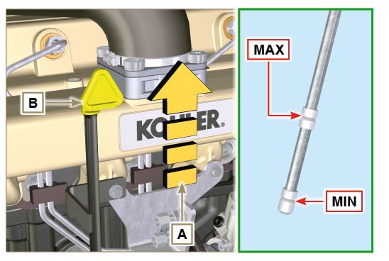  Fig 11.1
11.1.2 Replacement  11.1.2.1 Disassembly  - Undo the screw D .  - Pull out the oil dipstick hose E in the direction of the arrow F . | 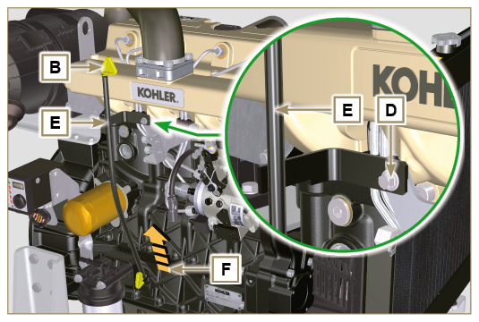  Fig 11.2
11.1.2.2 Assembly  Important  - Always replace the gasket G every time it is disassembled.  - Insert the gasket G in the seat K of the hose E .  - Insert the hose E in the crankcase H . | 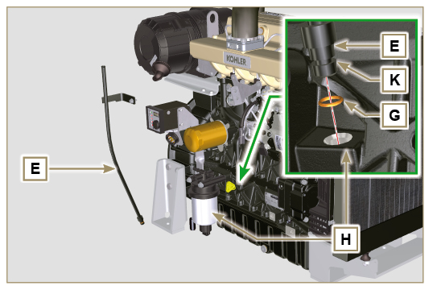  Fig 11.3
- Tighten the oil dipstick hose E using the screw D on the manifold L (Tightening torque of 10 Nm ). | 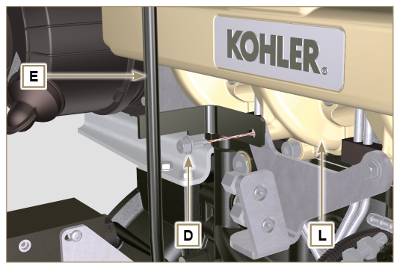  Fig 11.4
NOTE: Check the integrity of the gaskets J.  - Insert the dipstick B inside the hose E . | 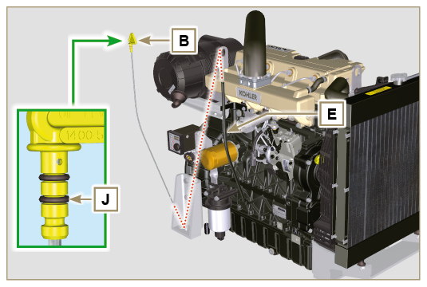  Fig 11.5

Heater (replacement)
Important

- Before proceeding with operation, read Par. 3.3.2 .
11.2.1 Disassembly  - Undo the screws A and the relevant washers and remove the earth cable B .  - Remove the flange C and the manifold D .  - Remove the heater E and the relevant gaskets F . | 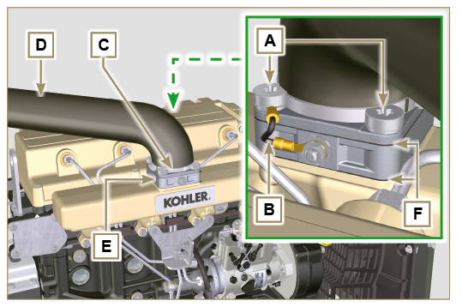  Fig 11.6
11.2.2 Assembly  Important  - Always replace gaskets F , with each assembly.  - In sequence, fit the manifold G with the gasket F , the new heater E , the second gasket F , the flange C, the washers H , the screws A and the cable B .  - Secure the flange H with the screws A (tightening torque at 22 Nm ).  - Secure the earth cable B with the nut J and the relevant washer on the heater E . | 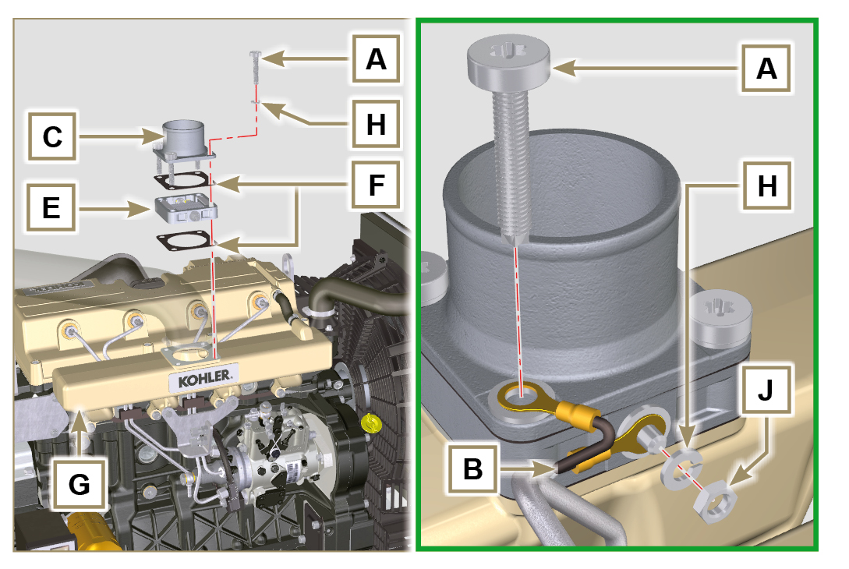  Fig 11.7

Poly-V alternator belt (replacement and adjustment)
Important

- Before proceeding with operation, read Par. 3.3.2 .
- Loosen the nut B and manually tighten the screw C until it just touches the pulley pin D (Fig. 11.9) . | 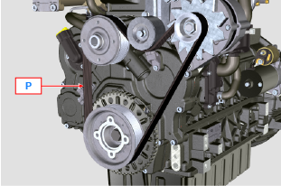  Fig 11.8
- Untighten the screw E by around 32mm (A) .  - Untighten the screw C .  NOTE: The belt tensioner pulley F should move towards the arrow G . If it does not, please move it manually. | 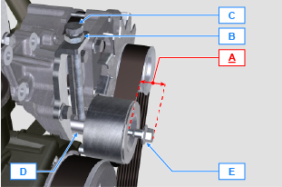  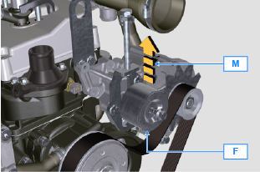  Fig 11.9
- Remove the V-Belt H and install the new one.  NOTE: Ensure that the internal profile of belt H is properly inserted into the grooves of the pulley A (as illustrated in D1 e D2 ). | 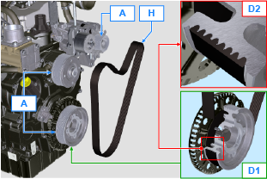  Fig 11.10
- Tighten capscrew C , to shift gudgeon D fully to the bottom of the grooved guide.  - Tighten capscrew E (tightening torque at 45Nm ).  - Hold the screw C still with a key, and tighten the screw B on the plate L to secure the screw C (tightening torque at 45Nm ).  - Check, in point P (Fig. 11.8) ,the tension of the belt. Check by the appropriate tool that at point p the tension value is between 149 and 196 Hz .  NOTE: For belt ED0024404960-S the value is between 155 and 201 Hz .  NOTE: After the engine has been in operation for around 15 minutes, repeat point 8 . | 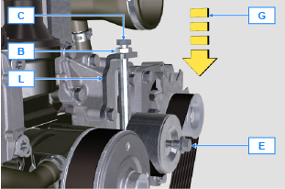  Fig 11.11

Tightening pulley and alternator for Poly-V belt
Important

- Before proceeding with operation, read Par. 3.3.2 .
11.4.1 Disassembly  - Perform the operations from point 1 to 3 of Par. 11.3 .  - Remove the belt H ( Fig. 11.10 ) .  - Undo and remove the screw A .  - Fully undo the screw B and remove the tightening pulley C . | 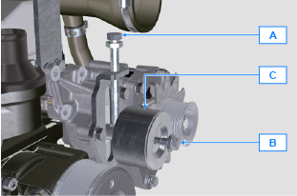  Fig 11.12
- Undo the screws D and remove the plate E and the pin F . | 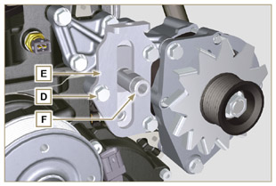  Fig 11.13
- Undo the screws G and H remove the alternator L . | 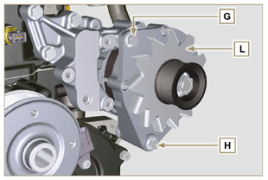  Fig 11.14
- Undo the screws M and remove the bracket N . | 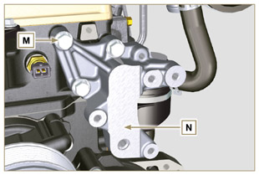  Fig 11.15
11.4.2 Assembly  - Secure the bracket N using the screws M on the cylinder head P (tightening torque at 25 Nm ). | 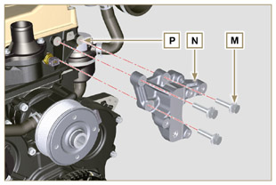  Fig 11.16
- Insert the screw H into the fixing hole on the alternator L .  - Insert the spacer R on the screw H (between the alternator and crankcase).  - Tighten the screw manually H onto the crankcase Q .  - Orientate the second fixing hole of the alternator L with the hole of the bracket N , secure the alternator L using the screw G (tightening torque at 25 Nm ) onto the bracket N and then the screw H (tightening torque at 25 Nm ). | 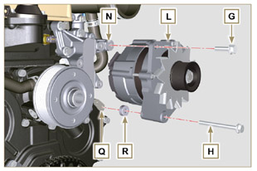  Fig 11.17
- Insert the pin F in the plate slot E .  - Orientate the pin F with the surface S (support for screw A ) upwards.  - Secure the plate E using the screws D on the bracket N (tightening torque at 25 Nm ). | 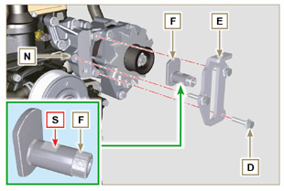  Fig 11.18
- Insert the screw B in the plate C1 and pulley C .  - Manually tighten the screw B onto the pin F up to the stop; Undo the screw B again by one turn.  NOTE: The screw B must protrude by about 32 mm (A) from the surface of the tightening pulley C (see detail X ).  - Install the new belt H (Fig. 11.10) .  - Tighten the screw A onto the plate E up to the stop on the pin F .  - Perform the operations from point 6 to 8 of Par. 11.3 . | 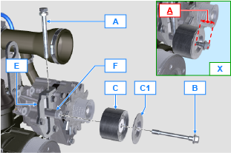  Fig 11.19

Idler gear (for 3rd / 4th PTO)
Important

- Before proceeding with operation, read Par. 3.3.2 .
11.3.1 Disassembly  - Undo the screw A and remove the gear unit B . | 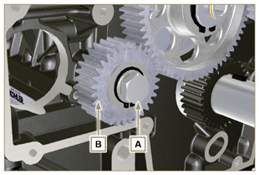  Fig 11.8
2. Remove the retainer ring C from the seat of the pin D .  3. Remove the shoulder washer E , the gear B , the shoulder ring F and the bushing G from the pin D . | 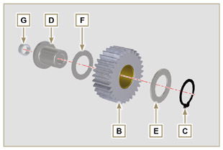  Fig 11.9
11.3.2 Assembly  - Fit into the pin D :  - The shoulder ring F (of least thickness)  - The gear B  - The shoulder ring E  - The retainer ring C .  - Insert the bushing G on the crankcase L . | 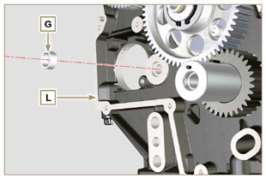  Fig 11.10
Important  - Always replace the washer H every time it is disassembled.  Modified component, see service letter 700019 - 700021 - 700028 .  - Check that the perforated screw A is free from impurities inside it.  - Position the gear unit B on the hole J using the bushing G to centre.  - Secure the gear B using the screw A inserting the washer H (tightening torque at see service letter 700019 - 700021 - 700028 ). | 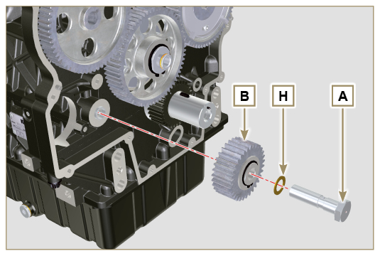  Fig 11.11

3rd PTO (replacement)
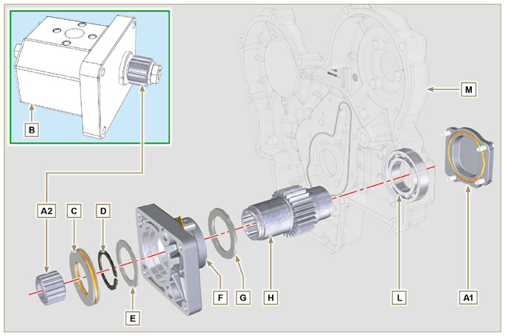
Fig 11.12
Important

- Before proceeding with operation, read Par. 3.3.2 .
11.4.1 Disassembly  - Undo the screws A and remove the pump B . | 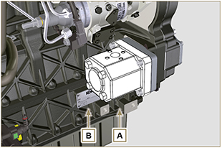  Fig 11.13
- Remove the centring ring C and the relative gaskets  - Undo the screws N . | 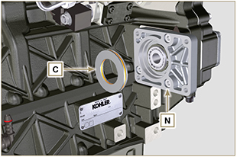  Fig 11.14
- Remove the flange F with the components D, E , G and H in the direction of the arrow P .  - Remove the gasket J . | 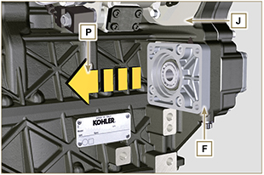  Fig 11.15
- Remove the retainer ring D and the shoulder washer E .  - Remove the gear H and the shoulder ring G from the flange F in the direction of the arrow Q . | 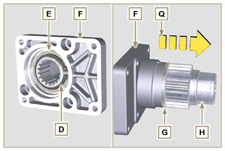  Fig 11.16
11.4.2 Assembly  Important  - Always replace the gasket J after each assembly.  - Lubricate the gear H with oil.  - It is mandatory to replace the screws N or apply a few beads of Loctite 2701 .  - Insert the gear H in the flange F in the direction of the arrow R inserting the shoulder ring G .  - Insert the shoulder ring E on the flange F and clamp the gear H using the retainer ring D .  - Position the flange F on the crankcase K inserting the gasket J , and inserting the gear H up to the stop on the bearing L ( Fig. 11.31 ). | 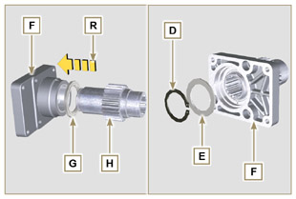  Fig 11.17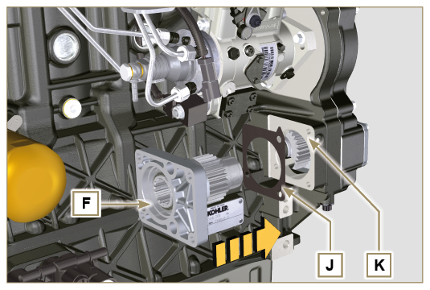  Fig 11.18
- Secure the flange F using the screws N (tightening torque at 25 Nm ).  Important  - Always replace the gaskets P and Q at each assembly.  - Insert the centring ring C in the flange F up to the stop. | 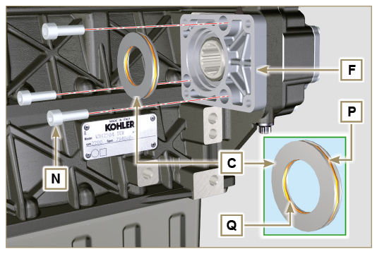  Fig 11.19
- Insert the pump B on the flange F engaging the gear H .  - Secure the pump B using the screws A on the flange F (tightening torque at 25 Nm ). | 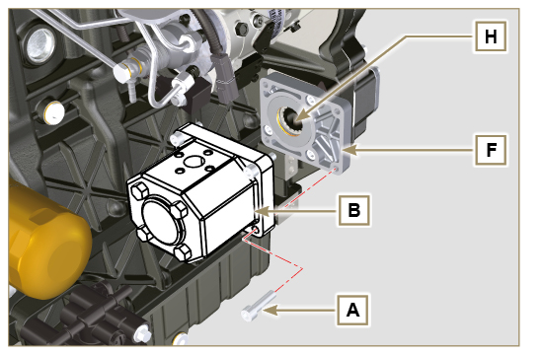  Fig 11.20

4th PTO (replacement)
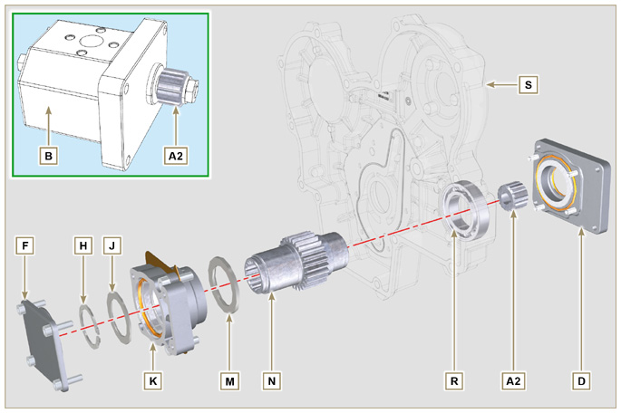
Fig 11.21
Important

- Before proceeding with operation, read Par. 3.3.2 .
11.5.1 Disassembly  - Undo the screws A and remove the pump B . | 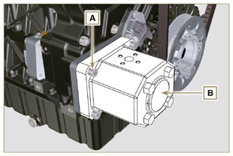  Fig 11.22
- Undo the screws C and remove the flange D . | 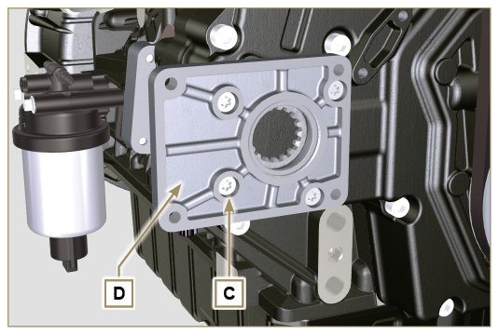  Fig 11.23
- Undo the screws E and remove the cover F . | 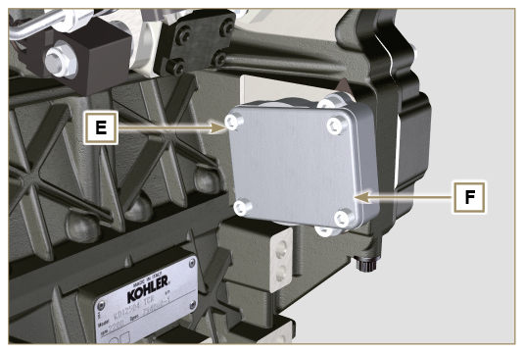  Fig 11.24
- Undo the screws G and remove the flange K with the components H , J , M and N . | 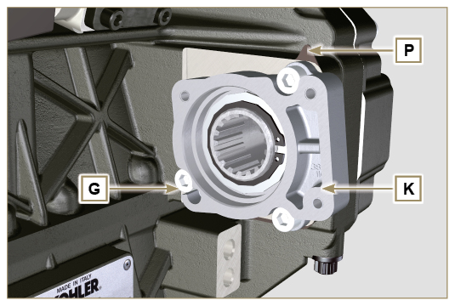  Fig 11.25
- Remove the retainer ring H and the shoulder ring J from the flange K .  - Remove the gear N and the shoulder ring M from the flange K . | 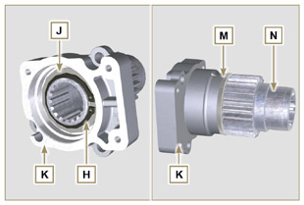  Fig 11.26
11.5.2 Assembly  Important  - Always replace the shoulder ring J after each assembly.  - Lubricate the gear N with oil.  - It is mandatory to replace the screws G or apply a few beads of Loctite 2701 .  - Insert the gear N in the flange K in the direction of the arrow W inserting the shoulder ring M .  - Insert the shoulder ring J on the flange K and clamp the gear N using the retainer ring H . | 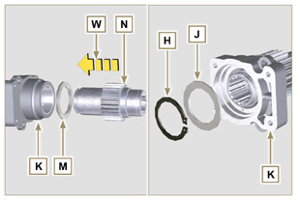  Fig 11.27
- Position the flange K on the crankcase Q inserting the gasket P , and inserting the gear N up to the stop on the bearing R ( Fig. 11.41 ).  - Secure the flange K using the screws N (tightening torque at 25 Nm ). | 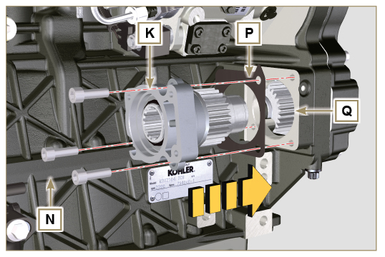  Fig 11.28
Important  - Always replace the gasket V after each assembly.  - Insert the gasket V on the cover F , insert and position the cover F on the flange K .  - Secure the cover F using the screws E on the flange K (tightening torque at 25 Nm ) | 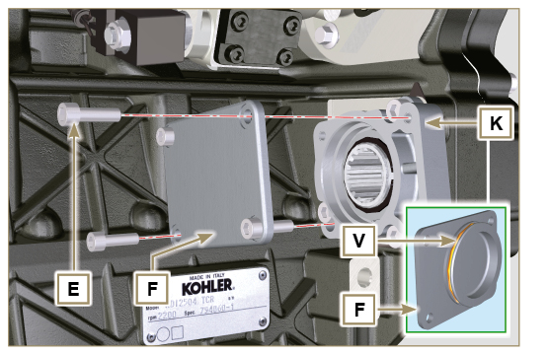  Fig 11.29
Important  - Always replace the gasket T after each assembly.  - Position and secure the flange D using the screws C on the crankcase S (tightening torque at 10 Nm ). | 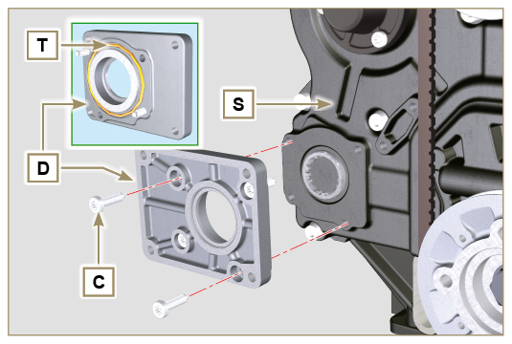  Fig 11.30
Important  - Always replace the gasket U after each assembly.  - Position the gasket U on the flange D .  - Secure the pump B using the screws A on the flange D (tightening torque at 25 Nm ). | 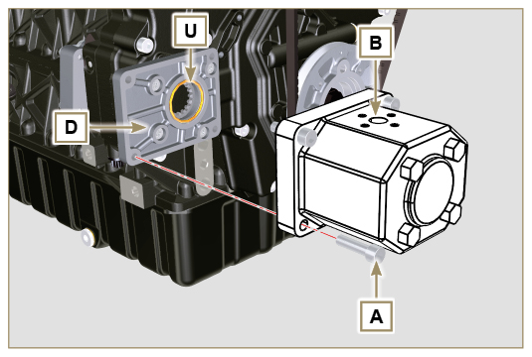  Fig 11.31

3rd + 4th PTO (configurations)
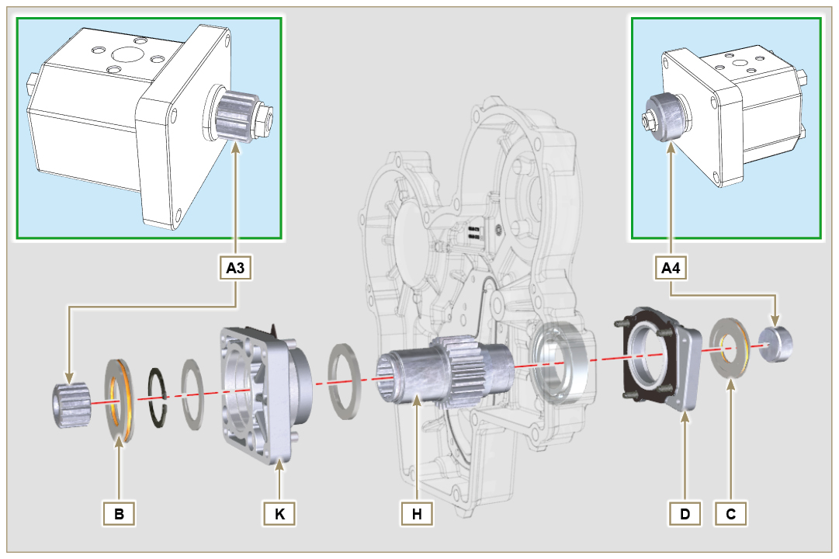
Fig. 11.32

11.6.1 Information  Hydraulic pumps on the 3rd and 4th PTO can be installed at the same time.  In some configurations, there is also the centering ring C on the 4th PTO.  Important  - For disassembly or installation, refer to Par. 11.5 , Par. 11.6 and Par. 11.7 .  - Always replace the gasket of the rings B and C and flanges D and K at each assembly.  - Lubricate the gear H with oil. | 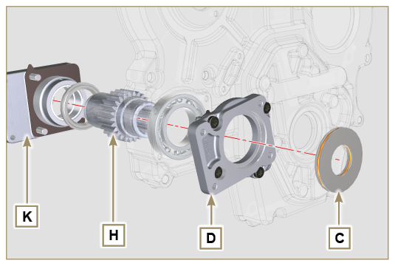  Fig. 11.33

Balancer device (replacement)
Important

- Before proceeding with operation, read Par. 3.3.2 .
11.7.1 Disassembly  - Perform the operations described in Par. 5.2 .  - Undo the screws A and remove the oil sump B . | 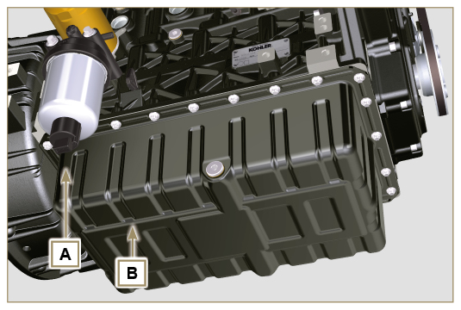  Fig 11.34
- Undo the screws C and remove the hose D . | 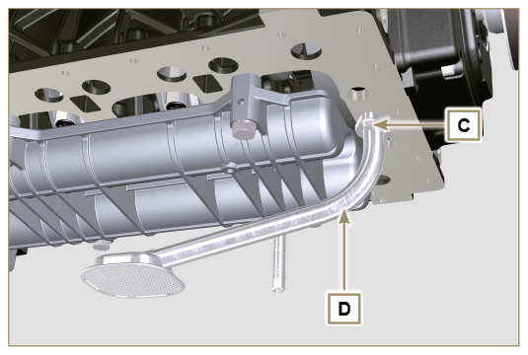  Fig 11.35
- Undo the screws E and remove the shaft support box F . | 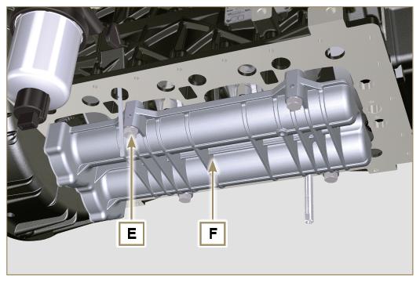  Fig 11.36
- Undo the screws G and remove the plate H . | 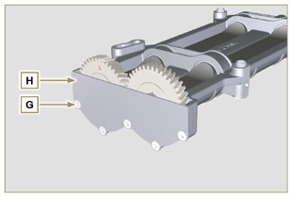  Fig 11.37
- Remove the shafts J and K in the direction of the arrow L from box F . | 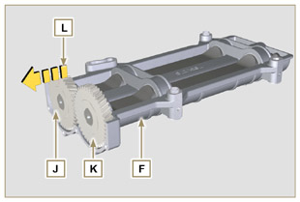  Fig 11.38
11.7.2 Assembly  - Lubricate the bushings V with Molikote grease.  - Insert the shafts J and K inside the box F in the direction of the arrow M . | 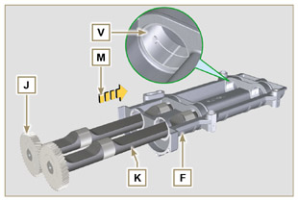  Fig 11.39
- Make sure that the shafts J and K inside the box F observe the marks N and that the shaft J with the gear indicated by letter " S " stamped on it is on the left with respect to the box F . | 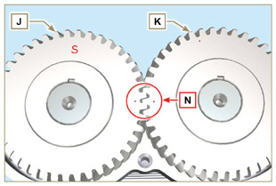  Fig 11.40
- Secure the plate H using the screws G on the box F (tightening torque at 8 Nm ). | 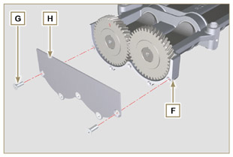  Fig 11.41
- Manually tighten the retainer screw ST_15 on the box F by slightly rotating the shaft K , centring the hole on it using the ST_15 , to lock the device. | 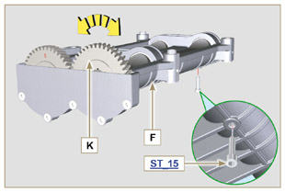  Fig 11.42
- Rotate the crankshaft and clamp it on the TDC ( Ref. P upwards) using the tool ST_34 secured in place of the starter motor (detail Q ). | 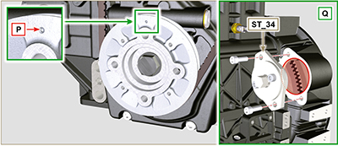  Fig 11.43
- Position the box F on the surface R of the crankcase observing the reference bushings.  - Secure the box F using the screws E and Loctite 242 inserting the washers U (tightening torque at 50 Nm ).  - Remove the retainer screw ST_15 from the box F . | 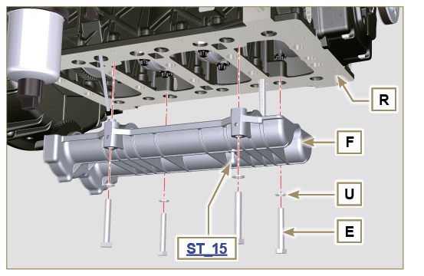  Fig 11.44
Important  - Check that the retainer screw ST_15 is not present on the box F ( Fig. 11.42 ).  - Always replace the gasket W after each assembly.  - Lubricate the gasket W with oil before assembling it.  - Insert the gasket W in the seat on the flange of the oil hose D .  - Secure the oil intake hose D using the screws C .  - Perform all operations described in Par. 9.4.3 to assemble the oil sump. | 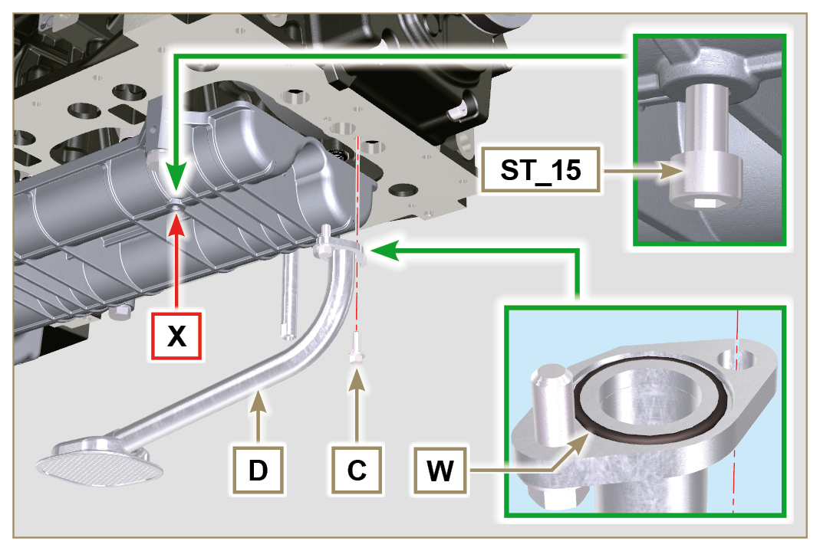  Fig 11.45

Air filter (cartridge replacement)
Important

- Before proceeding with operation, read Par. 3.3.2 .
- Release the two hooks A and remove the cover B from the body C .  - Remove the cartridges D . | 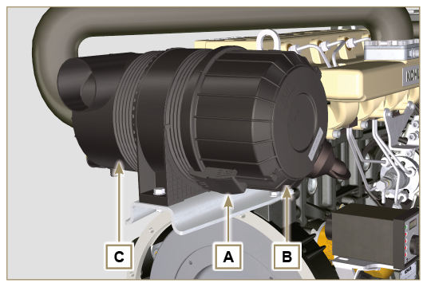  Fig 11.46
- Insert the new cartridge D and both of them inside the filter body C .  - Secure the cover B via the hooks A . | 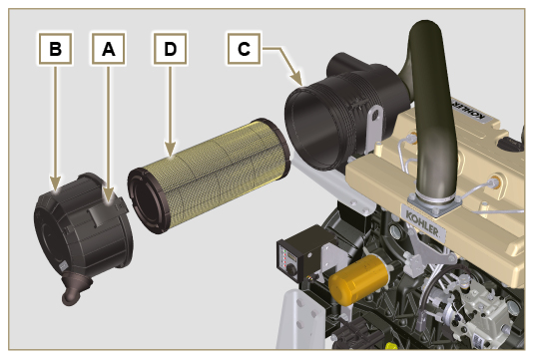  Fig. 11.47

Remote oil filter (disassembly and assembly)
Important  - Modified component, see service letter 700018 .  11.9.1 Disassembly  - Perform the operations described in Par. 5.2 .  Important  - Before proceeding with operation, read Par. 3.3.2 .  - For the replace the cartridge, please refer to operation number 6 (Par. 11.9.1) and 2 (Par. 11.9.2) .  - For the disassembly of the pipes B and C, lock with a tool the fittings K, H (Fig. 11.49) and L (Fig. 11.50) in order to prevent their lose together with the nuts A , with the consequent of oil leakage.  - Undo the nuts A and remove the hoses B and C . | 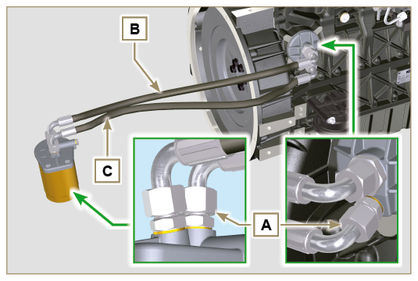  Fig 11.48
- Unscrew and remove the fitting H with its copper gasket from the head J .  - Unscrew the fittings K and remove the copper gaskets from the head J . | 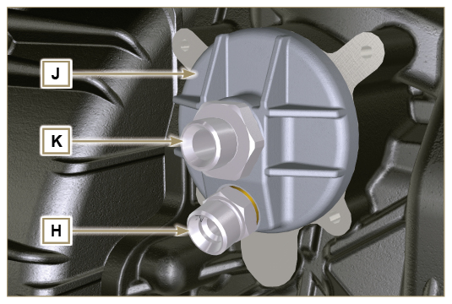  Fig 11.49
- Unscrew the fittings L and remove the copper gaskets from the support M .  - Unscrew the cartridge N with gasket from the support M . | 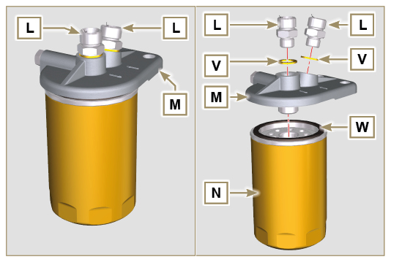  Fig 11.50
11.9.2 Assembly  Important  - Always replace the gaskets V after each assembly.  - Clamp the fittings H on the support M inserting the gasket V (tightening torque at 65 Nm ).  - Lubricate the gasket W and clamp the cartridge N on the support M (tightening torque at 20 Nm ).  Important  - Always replace the gaskets P, Q, and U at each assembly.  - Lubricate the gaskets P, Q with oil before assembling them.  - Insert the gasket P on the seat of the fitting K .  - Insert the head J on the fitting K and the gasket Q in the seat of the head J .  - Clamp the fitting K (tightening torque at 45 Nm + Loctite 2701 ).  - Clamp the fitting H on the flange J inserting the gasket U (tightening torque at 65 Nm ). | 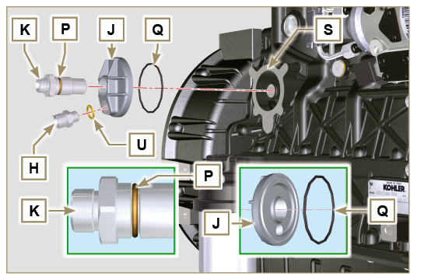  Fig 11.51
- Connect the hose B to the central fitting of support M and of flange J .  - Connect the hose C to the side fitting of the support M and of head J .  - Clamp the nuts A on the head J (tightening torque at 48 Nm ).  - Clamp the nuts A on the support M (tightening torque at 48 Nm ).  Important  - Check the tightening of the fittings H (Fig. 11.51) and L (Fig. 11.52) (tightening torque at 65 Nm ). | 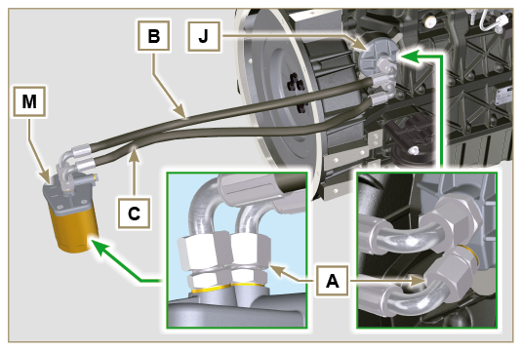  Fig 11.52

Intake circuit (replacement)
Important

- Before proceeding with operation, read Par. 3.3.2 .
11.10.1 Air filter disassembly  - Release the clamp B .  - Untighten the screws A and remove the filter C . | 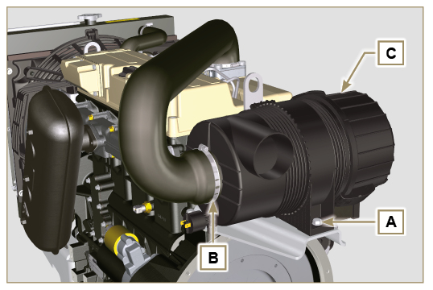  Fig. 11.53
11.10.2 Manifold air filter disassembly  - Release the clamp D .  - Remove the manifold E .  - Loosen capscrews G and remove plate H . | 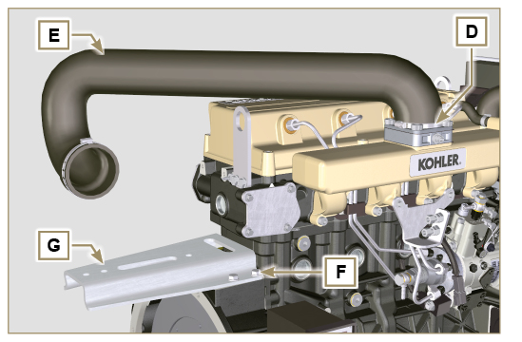  Fig. 11.54
11.10.3 Air filter manifold assembly  - Insert the fitting G on the flange H .  - Tighten the clamps D .  - Fasten plate G by means of capscrews F (tightening torque at 25 Nm ). | 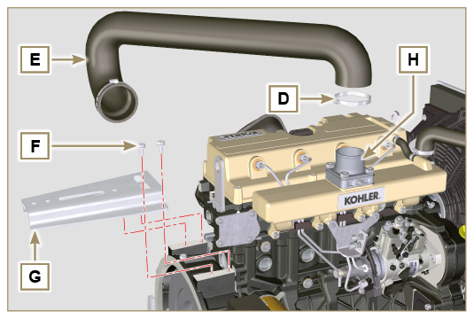  Fig. 11.55
11.10.4 Air filter assembly  - Insert the filter C into the manifold E .  - Tighten the clamps B .  - Tighten the screws A (tightening torque at 25 Nm ) | 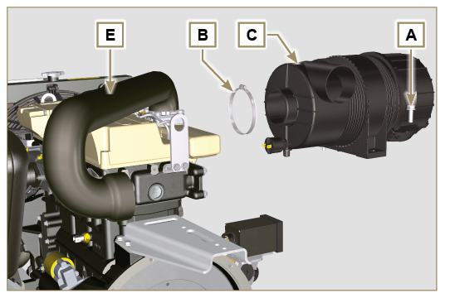  Fig. 11.56

Muffler (replacement)
Important

- Before proceeding with operation, read Par. 3.3.2 .
11.11.1 Disassembly  - Undo the screw A .  - Undo the nuts B .  - Remove the muffler C . | 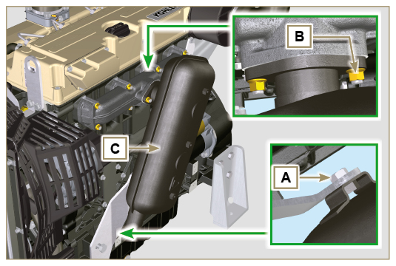  Fig. 11.57
11.11.2 Assembly  - Position the gasket D and the muffler C on the intake manifold E .  - Position the muffler C on the bracket F and tighten the screws A (tightening torque at 25 Nm ).  - Tighten the nuts B (tightening torque at 25 Nm ). | 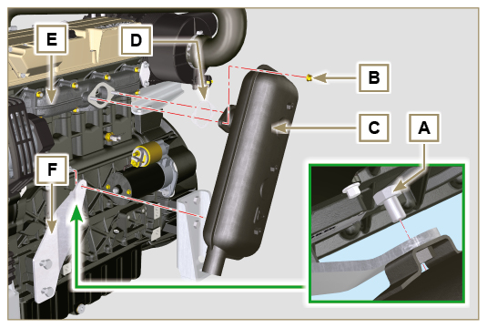  Fig. 11.58

Cooling circuit (replacement)
Important

- Before proceeding with operation, read Par. 3.3.2 .
11.12.1 Radiator disassembly  - Release the clamp A .  - Remove the sleeve B . | 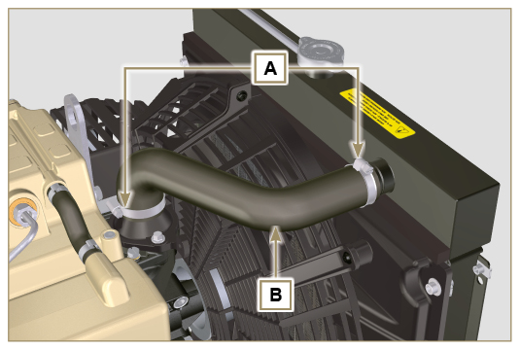  Fig. 11.59
- Loosen the 4 capscrews C and capscrew E . | 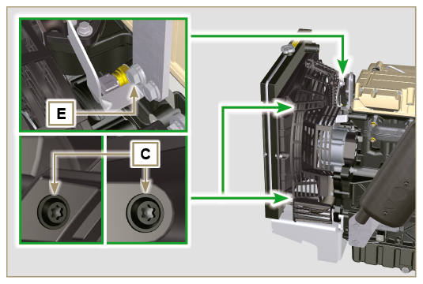  Fig. 11.60
- Remove guard D . | 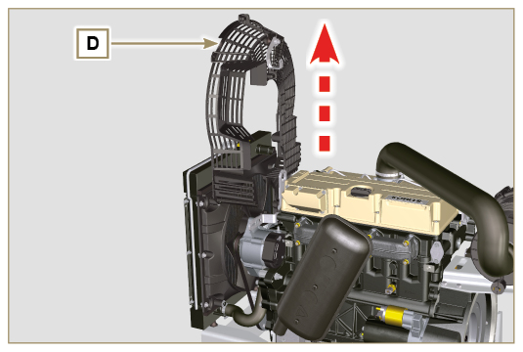  Fig. 11.61
- Release the clamp H .  - Release the pipe L from the radiator M . | 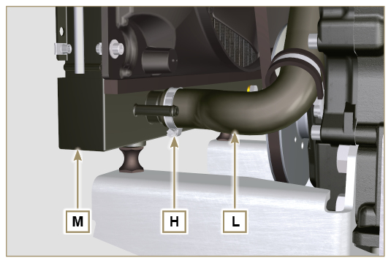  Fig. 11.62
- Undo nuts N and remove the radiator M . | 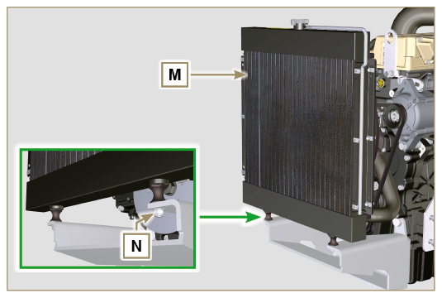  Fig. 11.63
11.12.2 Fan disassembly  - Undo the screws P and remove the plate Q from the fan R . | 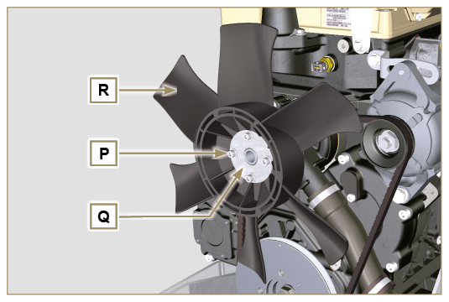  Fig. 11.64
11.12.3 Fan assembly  - Assemble the fan R on the pulley U .  - Position the plate Q on the fan R .  - Fasten the fan R by using the screws P and interposin washers S (tightening torque at 10 Nm ). | 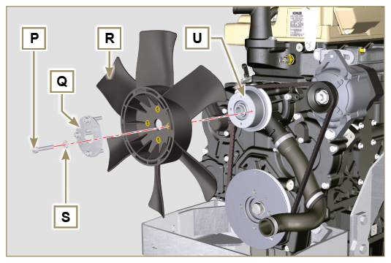  Fig. 11.65
11.12.4 Radiator assembly  - Position the radiator on the support V.  - Fasten radiator M on support V by means of nut N inserting washer W (tightening torque at 20 Nm ). | 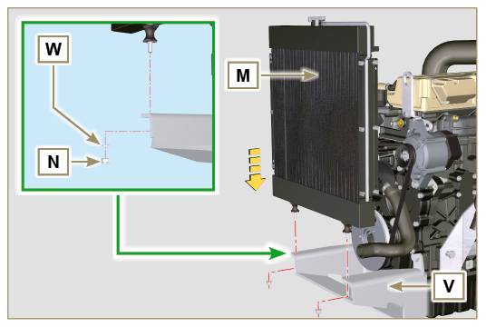  Fig. 11.66
- Fit the sleeve L on the fitting of the radiator M .  - Tighten the clamp H . | 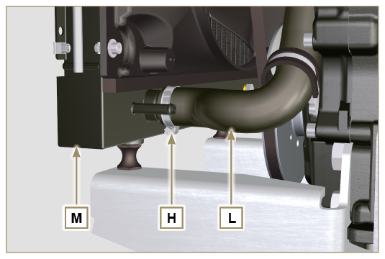  Fig. 11.67
- Position bulkhead D onto shroud F . | 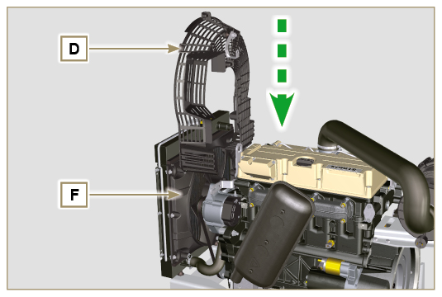  Fig. 11.68
- Fasten brace G by means of capscrews E (tightening torque at 25 Nm ).  - Fasten guard D by means of capscrews C (tightening torque 10 Nm ). | 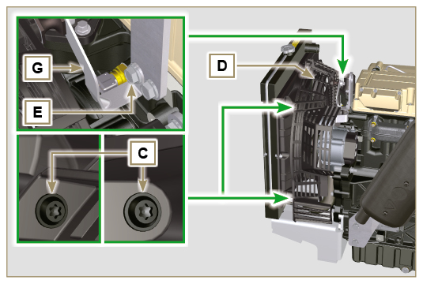  Fig. 11.69
- Fit the sleeve B on the fitting of the radiator M and of the thermostat cover Y .  - Tighten the clamps A . | 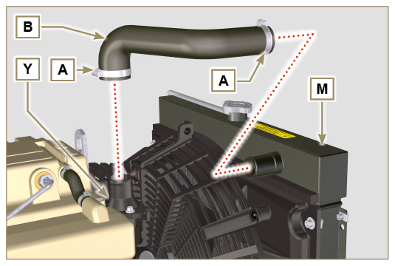  Fig. 11.70

Engine feet (information)
NOTE : Component not necessarily supplied by KOHLER . The representation of the engine is purely indicative.  Important  - The motor supports A can be installed on the bell B or on the crankcase C by using the screws D (tightening torque at 50 Nm ). | 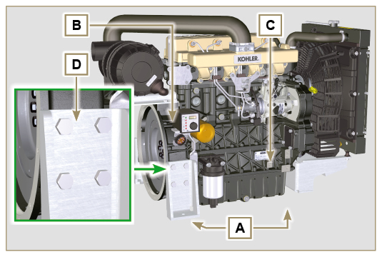  Fig. 11.71

Oil sump with supporting structure
11.14.1 Flywheel (J) disassembly  - Execute the operations described in Par. 7.10.1 .  11.14.2 Plate/flange housing (L) disassembly  - Loosen supplementary capscrews A and B .  - Execute the operations described in Par. 7.10.2 .  - Remove housing or plate L . | 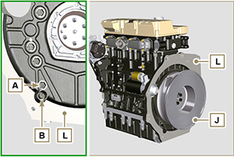  Fig. 11.72

11.14.3 Oil sump disassembly  - Execute the operations described in Par. 5.2 .  - Loosen capscrews C and remove bypass tube D .  - Loosen capscrews E and remove oil sump F . | 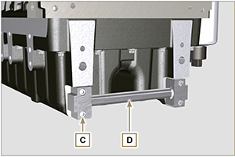  Fig. 11.73

11.14.4 Oil sump assembly  - Make sure contact surfaces G of oil sump F and crankcase H have no impurities.  - Apply a sealing bead of approximately 2.5 mm ( Loctite 5660 ) onto surface G of crankcase H .  - Place oil sump F onto crankcase H in correspondence with the fastening holes (use tool ST_18 ). | 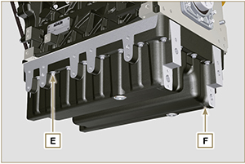  Fig. 11.74

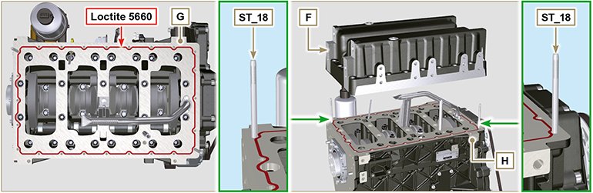
Fig. 11.75

- Apply capscrews E into the fastening holes and use torque at 10 Nm .  - Loosen capscrews E , leaving approximately 1 mm leeway ( position A ) between the neck surface of capscrews E and oil sump F .  - Place flange housing or plate L onto crankcase H , complying with centring tap pins M .  - Using 2 capscrews A , fasten housing or plate L onto crankcase H (tightening torque at 20 Nm ).  - Using 2 capscrews A , fasten housing or plate L onto oil sump F (tightening torque at 20 Nm ). | 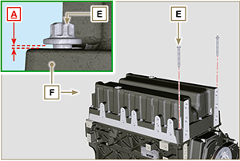  Fig. 11.76

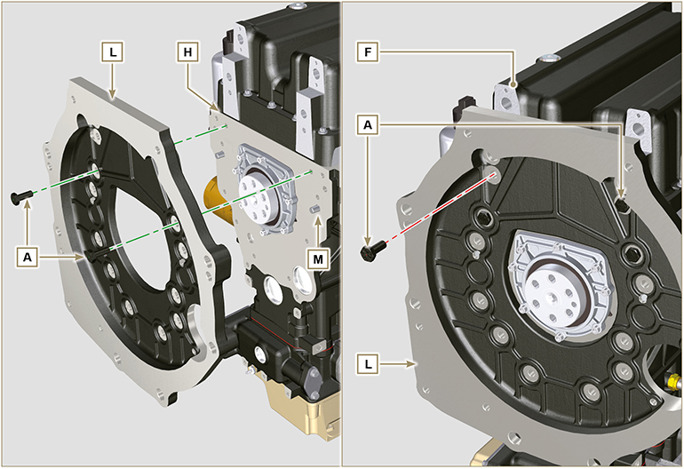
Fig. 11.77

- Fasten oil sump F by tightening capscrews E and strictly following the order shown in Fig. 11.77 (tightening torque at 20 Nm ).  - Loosen capscrews A and remove housing or plate L ( Fig. 11.76 ).  - Fasten oil sump F by tightening capscrews E and strictly following the order shown in Fig. 11.77 (tightening torque at 47 Nm ).  Loosen the screw 1 again and tighten it to 47 Nm . | 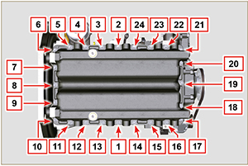  Fig. 11.78

- Insert gaskets N into seats P of bypass tube D .  - Fasten bypass tube D onto oil sump F using capscrews C (tightening torque at 10 Nm ). | 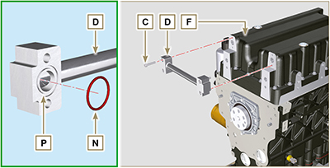  Fig. 11.79

11.14.5 Flange plate / housing assembly  - Execute the operations described in point 6 of Par. 11.14.4 .  - Fasten housing or plate L by using capscrews A and strictly following the order shown in Fig. 11.79 (tightening torque at 85 Nm ).  - Fasten housing or plate L by using capscrews B (tightening torque at 270 Nm ).  11.14.6 Flywheel assembly  - Execute the operations described in Par. 9.5.2 . | 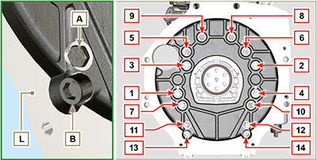  Fig. 11.80

Oil sump 15L
11.15.1 Disassembly  - Perform the operations indicated in Par. 5.2 .  - Loosen the screws A and remove the oil sump B .  - Loosen the screws A1 and remove the oil sump B1 flange. | 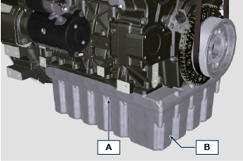  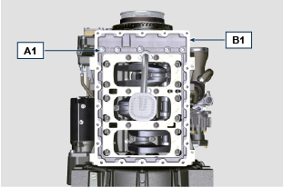  Fig. 11.81
11.15.2 Assembly  - Apply a bead of approx. 2.5 mm of sealant ( Loctite 5660 ) inside the channel B2 of the oil sump B1 flange.  - Position the oil sump B1 on the crankcase H at the fixing holes (use the tool ST_18 ).  - Screw the screws A1 in the fixing holes. | 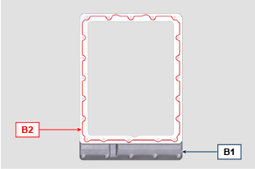  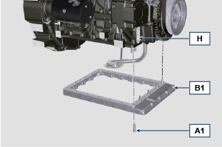  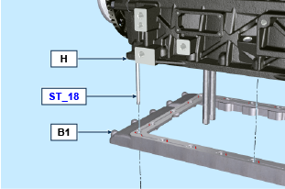  Fig. 11.82
- To fix the sump B1 , tighten the screws A1 by strictly following the order indicated in the Fig. 11.83 (tightening torque of 25 Nm ).  - Loosen the screw 1 again and tighten it to 25 Nm . | 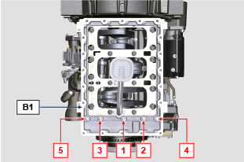  Fig. 11.83
- Apply a bead of approx. 2.5 mm of sealant ( Loctite 5660 ) inside the channel B3 of the oil sump B .  - Position the oil sump B on the oil sump B1 flange at the fixing holes (use the tool ST_18 ).  - Screw the screws A in the fixing holes. | 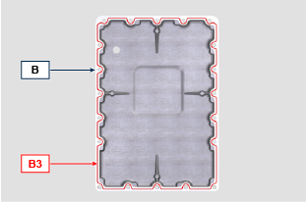  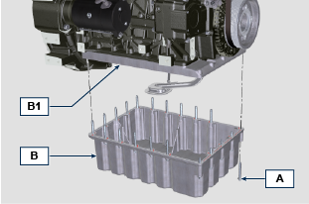  Fig. 11.84
- To fix the sump B , tighten the screws A by strictly following the order indicated in the Fig. 11.85 (tightening torque of 25 Nm ).  - Loosen the screw 1 again and tighten it to 25 Nm . | 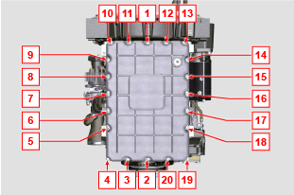  Fig. 11.85

Crankcase oil filter - Lengthwise assembly
11.16.1 Disassembly  - Perform the operations indicated in Par. 5.2.  Important  - Before performing the operation, check Par. 3.3.2 .  - To replace only the cartridge, refer to operations 2 ( Par. 11.16.1 ) and 6 ( Par. 11.16.2 ).  - Unscrew the cartridge A . | 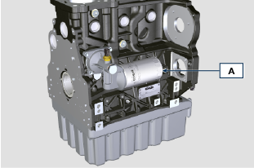  Fig 11.86
- Unscrew and remove the oil pressure switch B together with its copper gasket from the support E .  - Unscrew the union C together with its copper gasket.  - Loosen the screws D and remove the support E . | 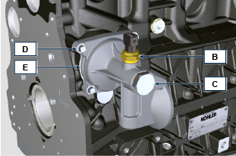  Fig 11.87
11.16.2 Assembly  Important  - Replace the gaskets E1 , C1 , C2 and B1 at every assembly.  - Lubricate the gaskets E1 , C1 with oil before performing the assembly.  - Fit the support E on the crankcase F using the screws D and placing the gasket E1 in-between; do not tighten the screws D .  - Insert the gasket C2 and C1 on the union C .  - Apply Loctite 2701 on the thread of the union C , fix the union C to the crankcase F (tightening torque of 25 Nm ).  - Tighten the screws D (tightening torque of 10 Nm ). | 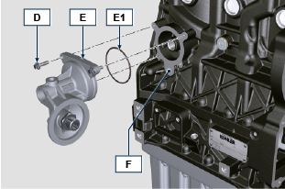  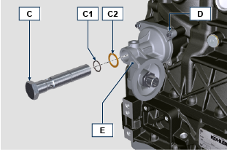  Fig 11.88
- Fix the oil pressure switch B to the support E placing the gasket B1 in-between (tightening torque of 25 Nm ). | 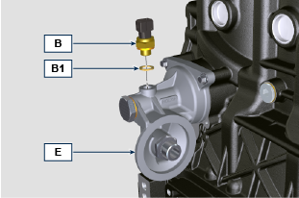  Fig 11.89
- Lubricate the gasket of the cartridge A and secure the cartridge A to the support E (tightening torque of 20 Nm ). | 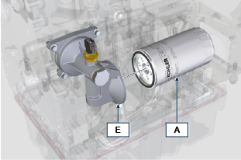  Fig 11.90

