General information
KDI 3404 TCR-SCR Workshop Manual (Rev. 10.4)

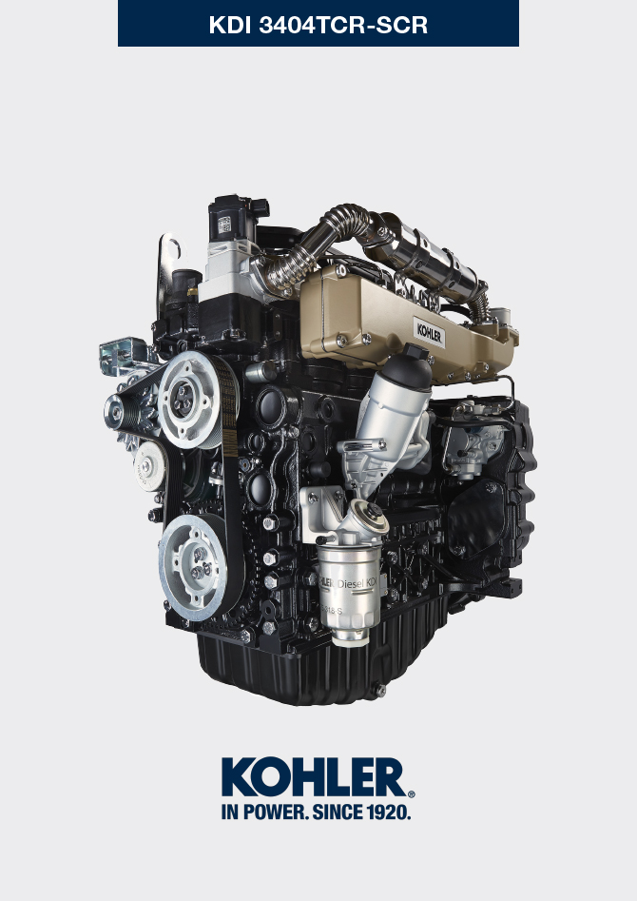

Registration of modifications to the document
Any modifications to this document must be registered by the drafting body, by completing the following table.

Released by | Code | Revision | Release Date | Revision date | Edited by | Endorsed
 | manoff

Translated from the original manual in Italian language
Data reported in this issue can be modified at any time by KOHLER.

Sommario
1. TITOLO 1 2
1.1. Asdfsdfsdf 2
1.2. Asdfsdfsdfggg 2

General information

Useful information
- This manual contains the instructions needed to carry out proper use and maintenance of the engine, therefore it must always be available, for future reference when required.
- Information, descriptions and pictures contained in this manual reflect the basic configuration of the engines ( Par. 1.4 and Par. 1.5 ).
- However, the development of engines is continuous. Therefore, the information in this manual is subject to change without notice.
- KOHLER reserves the right to make, at any time, changes on the engines for technical or commercial reasons.
- These changes do not require KOHLER to intervene on the production marketed up to that time and nor to consider this manual as inappropriate.
- The paragraphs, tables and figures are numbered by chapter and followed by the progressive paragraph, table and/or figure number.
Es: Par. 1.3 - chapter 1 paragraph 3 .
Tab. 2.4 - chapter 2 table 4 .
Fig. 4.5 - chapter 4 figure 5 .
NOTE: The paragraphs may contain sub-paragraphs.

- All technical terms, specific components and symbols ( Tab. 15.1 ) that are in the manual are listed and described inside the glossary, which can be consulted in ( Chap. 15 ).
- The references of the objects described in the text and in the figure are indicated by letters and numbers, which are always and only related to the paragraph you are reading unless there are specific references to other figures or paragraphs.
- Reference to values are indicated by letters or numbers.
- Other important references are highlighted in red.
- The mark ( ) after the title of a paragraph, indicates that the procedure is not required in order to disassemble the engine, however the procedures are featured in order to illustrate the disassembly of components.
- Any additional section that KOHLER will deem necessary to supply at a later stage must be kept with the manual and considered as an integral part of it.
- The information contained in this manual is the sole property of KOHLER , therefore no partial or total reproduction or replication is allowed without the express permission of KOHLER .

1.1.1 Useful Information - accident prevention - environmental impact

- Before proceeding repair - handling the motor , read the entire Chap. 3 , which contains important information about the procedures to be followed for safety and environment .

Manufacturer and engine identification
The engine identification name plate is situated in the lower part of the crankcase; it is visible from the intake or exhaust side.
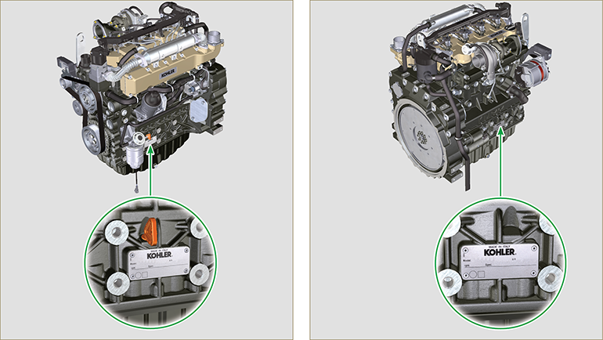
Fig 1.1 - Fig 1.2

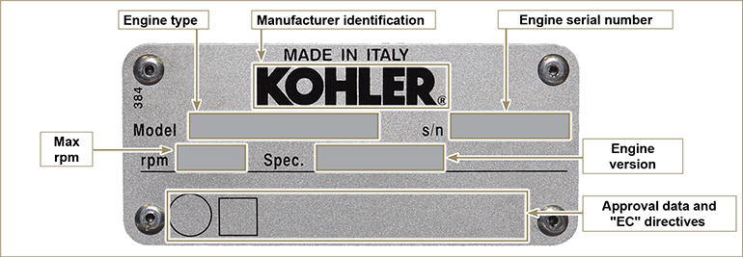
Fig 1.3

Homologation labels
1.3.1 Label for EPA rules (compilation example)

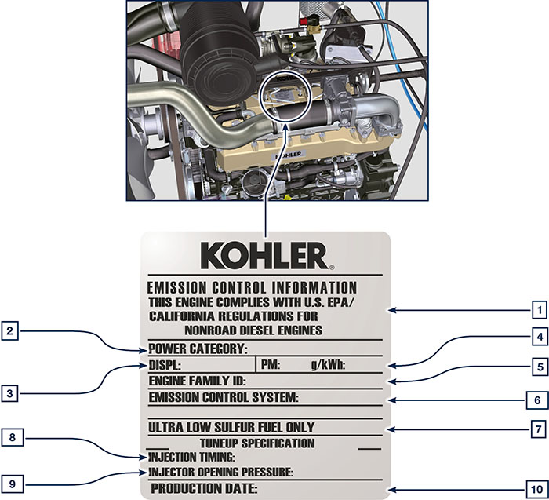

1.1
POS. | DESCRIPTION
1 | Model year in compliance with the rules
2 | Power category (kW)
3 | Engine displacement (L)
4 | Particulate emission limit (g/kWh)
5 | Engine family ID
6 | Emission Control System = ECS
7 | Fuel with low sulphur content
8 | Injection timing
9 | Electronic injector opening pressure (bar)
10 | Production date (example: 2013.JAN)

1.3.2 Label for China Standards (compilation example)

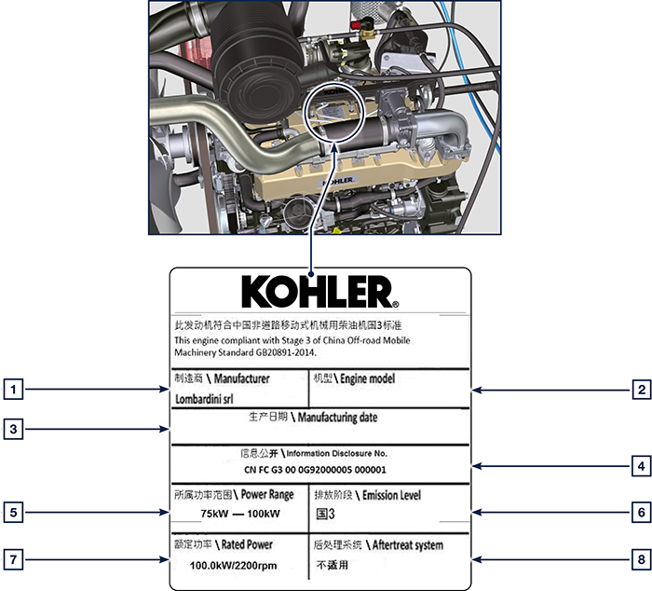

1.2
POS. | DESCRIPTION
1 | Manufacturer
2 | Engine model
3 | Manufactoring date
4 | Certificate N°
5 | Power range (kW)
6 | Emission level
7 | Rated power
8 | Aftertreat system

1.3.3 Label for Korea Standards (compilation example)

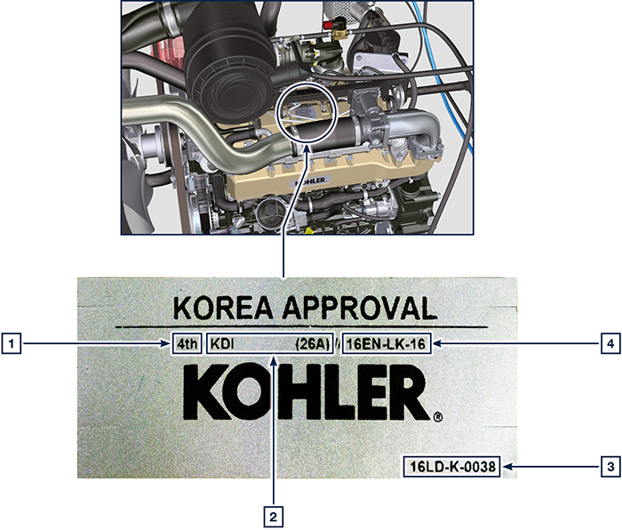

1.3
POS. | DESCRIPTION
1 | Tier 4 Final
2 | Engine model
3 | Manufactoring date and manufacturer code
4 | N° Korea emission certificate

Identification of the main internal components of the engine and operating reference (BASE CONFIGURATION)
WIEW OF EXHAUST SIDE
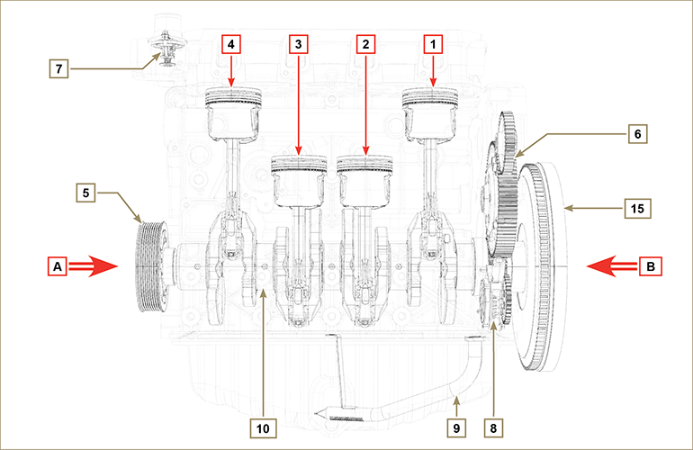
Fig 1.5

The following chapters contain operating references in order to clearly understand the engine. This paragraph illustrates these references that may be recognised by means of some main internal components.  Should you need to execute complex operations, always consult this paragraph.  NOTE: it is advisable to keepthis page visible during disassembly and assembly operations. | Tab 1.2  REF. DESCRIPTION  A View of timing system side (2 ^{nd} PTO)  B View of flywheel side (1 ^{nd} PTO)  C View of exhaust side  D View of intake side  1 Cylinder/Piston N. 1  2 Cylinder/Piston N. 2  3 Cylinder/Piston N. 3  4 Cylinder/Piston N. 4  POS. DESCRIPTION  5 Crankshaft pulley (2 ^{nd} PTO)  6 Gear timing system  7 Thermostatic valve  8 Oil pump  9 Oil suction hose  10 Crankshaft  11 Exhaust manifold  12 Intake manifold  13 Camshaft  14 Gears adaptor for 3 ^{th} /4 ^{th} PTO (optional)  15 Flywheel (1 ^{st} PTO)  16 Gears adaptor for 4th PTO (optional)  17 Balancer shafts
WIEW OF FLYWHEEL SIDE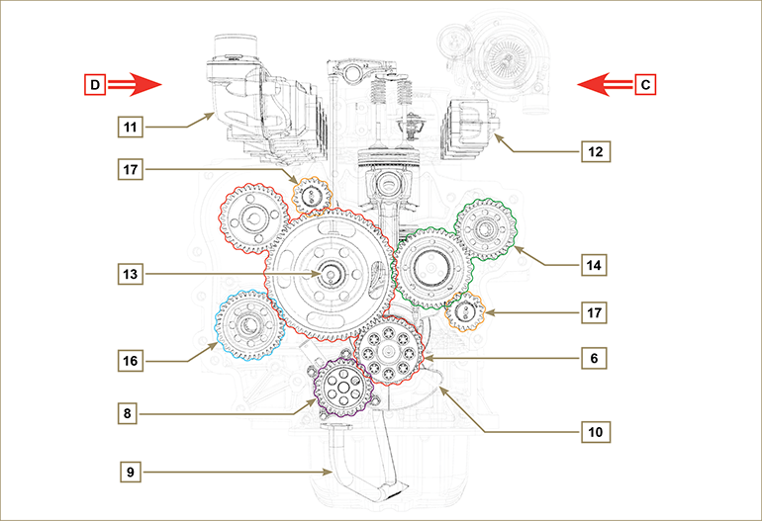
Fig 1.6

Identification of the external components of the engine (BASE CONFIGURATION)
VIEW OF TIMING SYSTEM SIDE - EXHAUST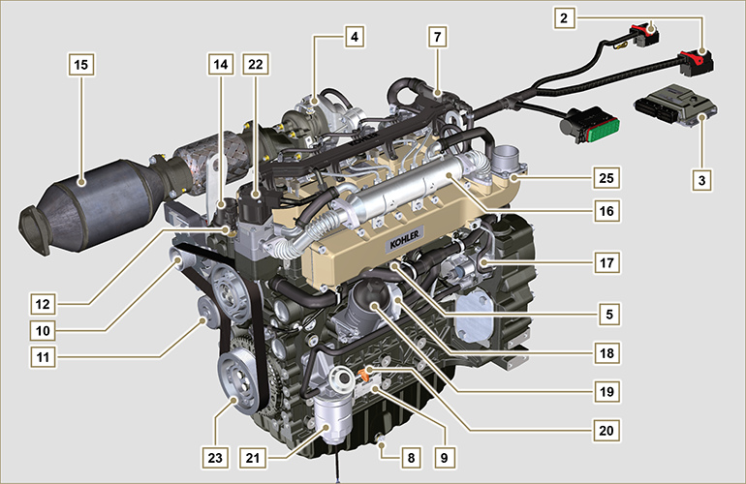
Fig 1.7

VIEW OF FLYWHEEL SIDE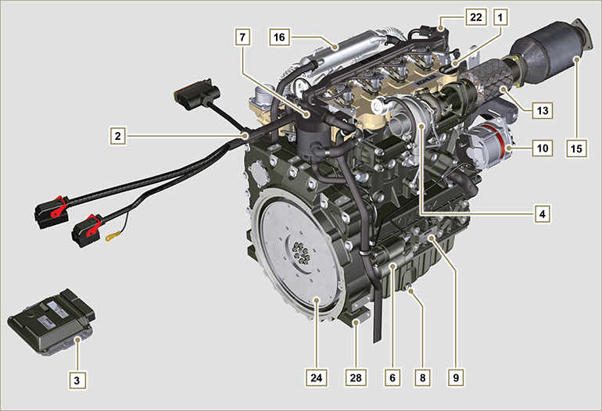
Fig 1.8

This paragraph illustrates all external components that are present in the base configuration of the engine.  For components present on engines that differ from those represented in these illustrations, refer to Chap. 11 . | NOTE: The illustrated components may differ from those illustrated; the illustration is only as an example.
Tab 1.3  POS. DESCRIPTION  1 Oil filler cap  2 Wiring  3 ECU  4 Turbocharger  5 Oil pressure switch  6 Starter motor  7 Oil steam separator  8 Oil drain plug  9 Engine identification name plate  10 Alternator  11 Coolant pump  12 Coolant temperature sensor  13 Oil filler cap side  14 Thermostatic valve  15 DOC  16 EGR Cooler  17 High-pressure fuel injection pump | POS. DESCRIPTION  18 Oil Cooler  19 Lub. oil filter  20 Oil dipstick  21 Fuel filter  22 EGR valve  23 Crankshaft pulley (2 ^{nd} PTO)  24 Flywheel (1 ^{st} PTO)  25 Intake manifold  26 Waste Gate valve control actuator  27 Exhaust manifold  28 Flange bell  29 Electronic injectors  30 Common Rail  31 Air intake hose

UPPER VIEW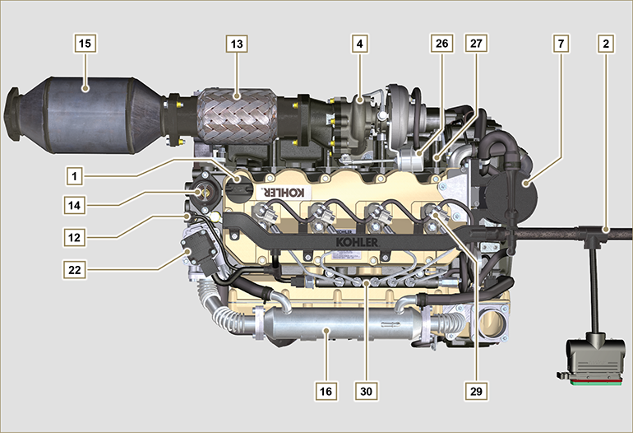
Fig 1.9

SCR Components (Coolant circuit)
VIEW OF SERVICES – INTAKE SIDE  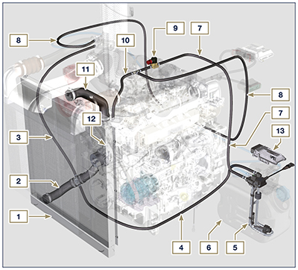  1.10 | POS. DESCRIPTION  1 Radiator  2 Intake sleeve  3 Intake return tube  4 Intake return tube  5 Circuit for DEF heating  6 DEF tank  7 Coolant delivery tube in DEF tank  8 Coolant delivery tube to DEF injector  9 Electronic valve for coolant delivery to DEF tank  10 Coolant delivery tube to SCR system  11 Coolant to radiator return sleeve  12 Coolant pump  13 SCR system control unit  1.6  NOTE: Certain components are for illustrative purposes only, can be subject to change and may not be supplied by KOHLER.
VIEW OF FLYWHEEL – EXHAUST SIDE
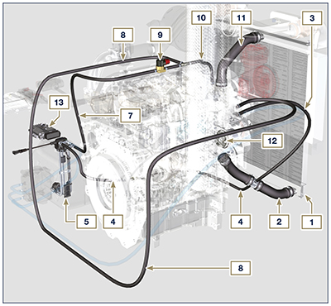
1.11

SCR Components (DEF circuit)
VIEW OF FLYWHEEL – EXHAUST SIDE 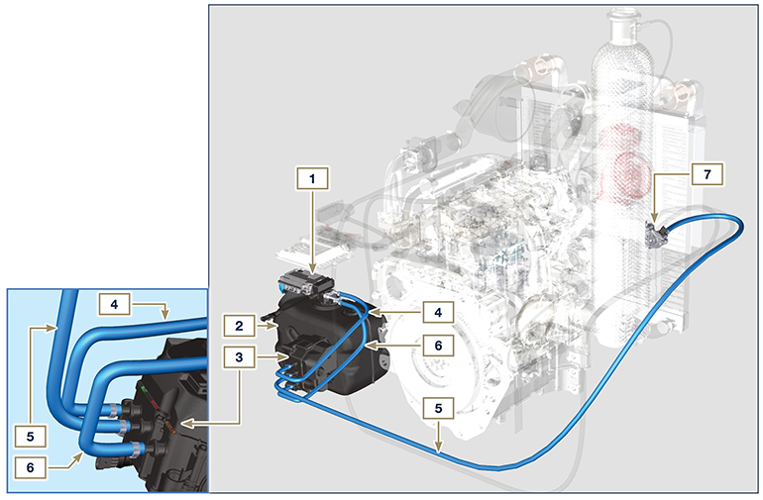
1.12
VIEW OF FLYWHEEL SIDE – INTAKE 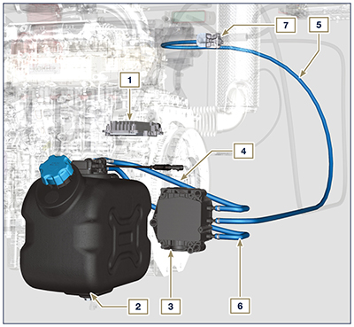  1.13 | Tab. 1.12  POS. DESCRIPTION  1 SCR system control unit  2 DEF tank  3 DEF pump  4 DEF intake tube  5 DEF delivery tube to DEF injector  6 Return tube in DEF tank  7 DEF injector  NOTE: Certain components are for illustrative purposes only, can be subject to change and may not be supplied by KOHLER.

SCR Components (Intake and exhaust circuit)
VIEW OF SERVICES – INTAKE SIDE 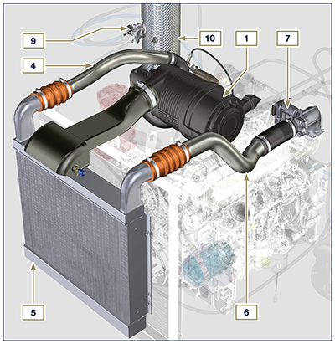  1.14 | POS. DESCRIPTION  1 Air filter  2 Air intake sleeve  3 Turbocharger  4 Air delivery tube to Intercooler  5 Intercooler  6 Air delivery tube to intake manifold  7 Air inlet valve  8 Exhaust gas delivery hose to SCR  9 DEF injector  10 SCR  1.8  NOTE: Certain components are for illustrative purposes only, can be subject to change and may not be supplied by KOHLER.
VIEW OF SERVICES – EXHAUST SIDE 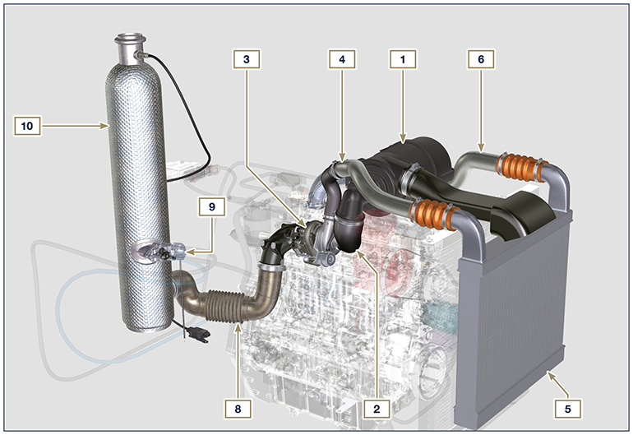
1.15

