Glossar
Werkstatthandbuch KDI 3404 TCR-SCR (Rev. 10.4)

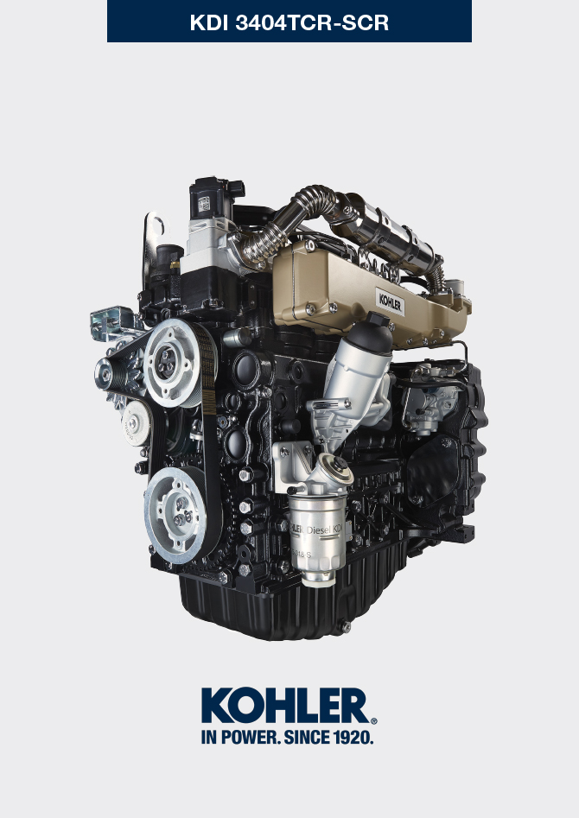

manoff

Sommario
1. TITOLO 1 2
1.1. Asdfsdfsdf 2
1.2. Asdfsdfsdfggg 2

Glossar

Glossar
A

Abb .: | Abbildung.
Abs .: | Absatz.
ACACT: | "After Charge Air Cooler Temperature" - Lufttemperatur nach dem Ladeluftkühler
Altöl : | Öl, dessen Eigenschaften sich durch den Betrieb oder im Laufe der Zeit verändert haben, sodass es nicht mehr für die korrekte Schmierung der Komponenten geeignet ist.
Anziehmoment : | Angabe für das Anziehen von Bauteilen mit Gewinde in der Maßeinheit Nm .
Ausgleichsvorrichtung | Vorrichtung zur Verminderung der Vibrationen, die von der Bewegung der Wechselmassen verursacht werden (Kurbelwelle - Pleuelstangen - Kolben).
Autorisierten Service-Center: | KOHLER Vertragswerkstätten.
ATS: | "After Treatment System" - Nachbehandlungssystem für die vom Motor erzeugten Abgase.

B

Betrieb im Leerlauf: | Betriebsart des Motors bei stillstehendem Fahrzeug oder auf niedrigster Drehzahl.
Bohrung : | Innendurchmesser des Zylinders bei Verbrennungsmotoren.

C

CAN: | Das „Controller Area Network“ - auch CAN-Bus genannt - ist ein Datenkommunikationsstandard für ECUs.
CE : | EG, "Europäische Gemeinschaft"
Common Rail : | gemeinsamer Hochdruckspeicher, der die Einspitzdüsen ständig mit Kraftstoff versorgt.

D

DCU : | Dosing Control Unit - Die Dosierkontrolleinheit ist ein für die Kontrolle der SCR-Anlage ausgelegtes Steuergerät, das in Abhängigkeit von den seitens der verschiedenen Sensoren erfassten Parametern die Zumessung des DEF in den SCR-Katalysator regelt.
DEF: | "Diesel Exaust Fluid"
DOC: | "Diesel Oxidation Catalyst" - Katalysator für Dieselmotoren, verringert die schädlichen Abgase, die vom Motor erzeugt werden
DPF: | "Diesel Particulate Filter" - Dieselpartikelfilter, dieser Filter hält die aus Kohlenstoffverbindungen entstehenden Partikel zurück, die von Dieselmotoren emittiert werden.
Drehmoment: | Kraft, die auf einen Körper einwirkt, der sich um eine Achse
Drehstromgenerator : | Bauteil, das mechanische Energie in Drehstrom umwandelt.

E

ECS : | „Emission Control System“ - Abgasreinigungsanlage.
ECU : | "Electronic Control Unit" - elektronische Steuereinheit, elektrische Vorrichtung zur Überwachung und elektronischen Steuerung anderer elektronisch betätigter Vorrichtungen.
EGR Cooler : | Kühlung der rückgeführten Abgase; System kühlt die vom Auspuff rückgeführten Gase (EGR), so bleibt die Temperatur im Inneren des Ansaugsammelrohrs konstant und die Verbrennung in den Zylindern verbessert sich, wodurch die Schadstoffe weiter reduziert werden.
EGR : | „Exhaust Gas Recirculation“, System bei Motoren mit innerer Verbrennung, das die Rückführung der Verbrennungsabgase ermöglicht, indem diese wieder angesaugt werden. So werden die in den Abgasen enthaltenen Schadstoffe reduziert.
EGR-Ventil: | Elektronisch gesteuerte Vorrichtung, die die Zufuhr von rückgeführten Abgasen in das Ansaugsammelrohr regelt.
EGR-T: | „Exhaust Gas Recirculation Temperature“
EGTS: | "Exhaust Gas Temperature Sensor"
Elektro-Einspritzventil : | Elektronisch betätigtes Bauteil, das Kraftstoffnebel in die Zylinder einspritzt.
EPA : | "Environmental Protection Agency" - Umweltschutzbehörde US-amerikanische Umweltschutzbehörde, die Schadstoffemissionen reguliert und kontrolliert.
Erschwerte Bedingungen : | Extrembedingung in Bezug auf die Arbeitsumgebung, in der der Motor verwendet wird (sehr staubige oder schmutzige Bereiche oder mit verschiedenen Gasen belastete Luft).
ETB: | "Electronic Throttle Body" - Elektronisches Drosselventil, das von der ECU-Motorsteuerung auf Anforderung des Gaspedals gesteuert wird. Die Funktion dieses Ventils ist entscheidend für die einwandfreie Regeneration des ATS Systems

F

Funktionsgruppen: | Komponenten oder Hauptbaugruppen, die eine bestimmte Funktion am Motor ausüben.

G

Galvanisiert : | Material, dessen Oberflächen einer Schutzbehandlung unterzogen wurden.
Grundausstattung: | Motor mit den in Abs. 1.4 - 1.5 angegebenen Komponenten.

H

Heater: | Vorrichtung, das die angesaugte Luft mithilfe eines Heizwiderstands erwärmt.

I

Impulsring: | Ring, der Teil einer Vorrichtung zur Kontrolle einer geradlinigen Bewegung ist; mit den Zacken außen am Ring wird die Geschwindigkeit und Position der Kurbelwelle erfasst und an einen Sensor übermittelt.
Intercooler: | Ladeluftkühler; kühlt die vom Turbolader kommende Druckluft, zwischen der Turbine und dem Ansaugsammelrohr angebracht.

K

Katalysator : | >> siehe " DOC "
KDI : | "Kohler Direct Injection" - Kohler Direkteinspritzung
Kurbelwelle: | Bauteil, mit der eine geradlinie Bewegung in eine Drehbewegung umgewandelt werden kann oder umgekehrt.

L

Lastbetrieb: | Betriebsart des Motors bei hoher Drehzahl.
Luftspalt: | Mindestabstand zwischen einem festen und einem beweglichen Bauteil.

M

Max. : | "Maximal".
Methylester : | Gemisch, das durch eine chemische Reaktion aus Ölen und tierischen und/oder pflanzlichen Fetten entsteht; dient zur Herstellung von Biodiesel.
Min : | "Minuten".
Min. : | "Minimal".
Model : | "Modell", (Kennschild des Motors) gibt das Motormodell an.

N

N/C: | „Normally Closed - normal geschlossen“, Öffnerkontakt, bezogen auf Schalter (Öldruckschalter).

O

Oil Cooler: | Kleiner Kühler, der das Öl kühlt.
OT: | „Oberer Totpunkt“; Moment, in dem sich der Kolben am Ende seines Laufs befindet.

P

Paraffin : | Fett- oder Feststoff, der sich im Diesel bilden kann.
Periodische Wartung : | Instandhaltungsarbeiten, die ausschließlich dazu dienen, Bauteile in festgelegten Zeitabständen zu prüfen oder auszutauschen, ohne dabei die vom System ausgeführten Funktionen zu verändern oder zu verbessern oder dessen Wert zu erhöhen oder die Leistung zu verbessern.
Poly-V : | "Mehrfach-V", Keilrippenriemen zum Antrieb der Nebenaggregate; der Name kommt von den in Längsrichtung verlaufenden Rippen, durch die der Querschnitt wie nebeneinander liegende Vs aussieht.
Pump Learning : | Vorgang, der automatisch von der ECU (mithilfe des Diagnoseinstruments - ST_01) ausgeführt wird, um alle Funktionseigenschaften der Kraftstoffpumpe zu lernen (bei Austausch der Einspritzpumpe oder der ECU).
Punkt : | Bezugspunkt.

Q

QR: | „Quick Response (Code)" - QR-Code, zweidimensionaler Barcode, der aus einer quadratischen Matrix aus schwarzen und weißen Punkten besteht.

R

Rohrbürste: | Hilfsmittel mit rundem Metallkörper und nach außen zeigenden Bürsten. Mit diesen kleinen Bürsten können Bereiche gereinigt werden, die mit der Hand nicht erreicht werden können (z.B. Ölleitungen im Motor).
Rpm: | „Revolutions per minute“ - Umdrehungen pro Minute.

S

s/n : | "Serial number", (Kennschild des Motors) gibt die Seriennummer an, anhand der der Motor identifiziert werden kann.
SCR-T: | "SCR Temperature Sensor"
SCU: | Sensor Control Unit
SCV : | „Suction Control Valve“ - Steuerventil der Ansaugung, befindet sich an der Hochdruck-Einspritzpumpe und wird direkt von der ECU gesteuert, regelt die angesaugte Menge des Kraftstoffs für den Common Rail.
Spec. : | "Specification", (Kennschild des Motors) gibt die Motorversion an.
STD: | (Standard), Grundausstattung eines Bauteils oder einer Baugruppe.
Steuereinheit | >> siehe "ECU".

T

Tab. : | Tabelle.
TCR : | ."Turbo Common Rail".
Thermostatventil: | Ventil, das den Durchfluss von Kühlflüssigkeit regelt; kann durch Temperaturveränderungen gesteuert werden.
T-MAP : | "T-MAP" (Sensor), misst die Temperatur und den Absolutdruck im Ansaugsammelrohr
Turbokompressor : | Vorrichtung, die die angesaugte Luft verdichtet und über eine Turbine zum Ansaugsammelrohr bläst.

V

Verbrennung: | Chemische Reaktion eines Gemischs aus Treibstoff und Sauerstoff (Luft) in einer Brennkammer.
Vertragswerkstatt: | Autorisierte Kundendienstelle von Kohler.

W

Warning Lamp : | (Meist rote) Kontrollleuchte, die eine schwerwiegende Störung beim Betrieb des Motos anzeigt.
Waste-Gate-Ventil: | Direkt oder automatisch betätigte Vorrichtung zur Begrenzung des Luftdrucks im Inneren der Turbine.

Z

Zapfwelle: | Zusätzliche Antriebsquelle an einem Nebenausgang des Getriebes.
Zykloidenverzahnung: | Profil mit abgerundeten Zähnen.

Symbole und Maßeinheiten
Symbol | Maßeinheit | Beschreibung | Beispiel
α | Grad | Übertragungs-/Neigungswinkel | 1°
cm ² | Quadratzentimeter | Fläche | 1 cm ²
Ø | Millimeter | Umfang | Ø 1 mm
Nm | Newtonmeter | Drehmoment | 1 Nm
mm | Millimeter | Länge | 1 mm
µm | 1 Mikrometer (Mikron) |  | 1 µm
h | Stunde | Zeit | 1 h
g/kWh | Gramm pro Kilowattstunde | Spezifischer Verbrauch | 1 g/kWh
kg/h | Kilogramm pro Stunde | Max. Durchflussrate | 1 kg/h
Lt./min. | Liter pro Minute | Durchflussrate | 1 Lt./min.
Lt./h | Liter pro Stunde |  | 1 Lt./h
ppm | Teile pro Million | Parts per million | 1 ppm
N | Newton | Kraft | 1 N
A | Ampere | Stromstärke | 1 A
gr. | Gramm | Gewicht | 1 gr.
kg | Kilogramm |  | 1 kg
W | Watt | Leistung | 1 W.
kW | KiloWatt |  | 1 kW
pa | Pascal | Druck | 1 pa
KPa | Kilopascal |  | 1 KPa
bar | Atmosphärischer Druck |  | 1 bar
mbar (1/1000 bar) | Atmosphärischer Druck |  | 1 mbar
R | Widerstand | Elektrischer Widerstand (bezogen auf ein Bauteil) | 1 Ω
Ω | ohm | Elektrischer Widerstand | 1 Ω
Rpm | Umdrehungen pro Minute | Drehung einer Achse | 1 Rpm
Ra | Durchschnittliche Rauhheit in Mikrometer | Rauheit | 1 Ra
°C | Grad Celsius | Temperatur | 1°C
V | Volt | Elektrische Spannung | 1 V
 | Millimeter | Sechskantschraubenkopf | 1 mm
cm ³ | Kubikzentimeter | Volumen | 1 cm ³
Lt. | Liter |  | 1 Lt.

