Information about optional components
KDI-TCP 3404E5 Workshop Manual (Rev. 01.1)

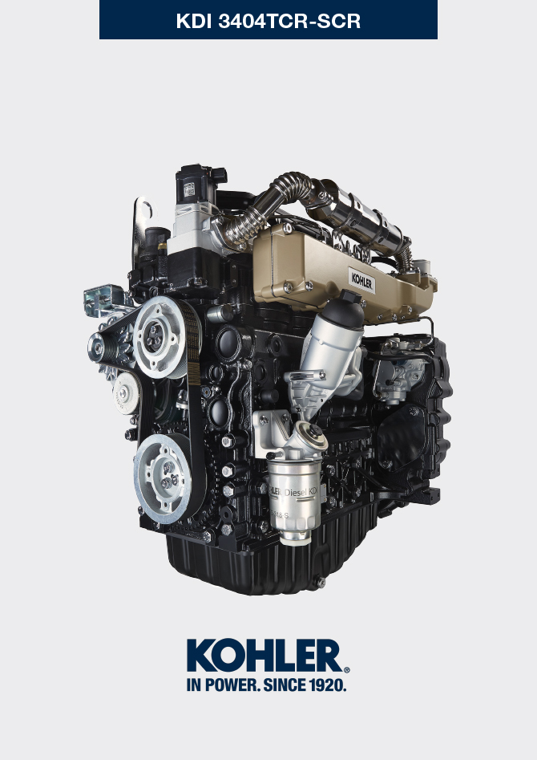

Registration of modifications to the document
Any modifications to this document must be registered by the drafting body, by completing the following table.

Released by | Code | Revision | Release Date | Revision date | Edited by | Endorsed
 | manoff

Translated from the original manual in Italian language
Data reported in this issue can be modified at any time by KOHLER.

Sommario
1. TITOLO 1 2
1.1. Asdfsdfsdf 2
1.2. Asdfsdfsdfggg 2

Information about optional components

Heater (replacement)
Important

- Before proceeding with operation, read Par. 3.3.2 .
11.1.1 Disassembly  - Undo the screws A .  - Remove the flange C .  - Remove the heater E and the relevant gaskets F . | 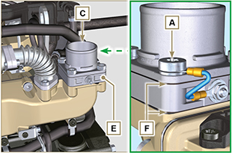  Fig 11.1
11.1.2 Assembly  Important  - Always replace gaskets F , with each assembly.  - In sequence, fit the manifold G with the gasket F , the new heater E , the second gasket F , the flange C , the washers H , the screws A and the cable B .  - Secure the flange C with the screws A (tightening torque at 22 Nm ). | 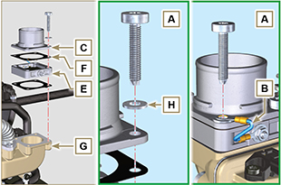  Fig 11.2

Idler gear (for 3rd / 4th PTO)
Important

- Before proceeding with operation, read Par. 3.3.2 .
11.2.1 Disassembly  - Perform the operations of point 7 of Par. 7.4.1 .  - Perform the operations from point 2 to 3 of Par. 6.6.1 .  - Perform the operations of point 3 of Par. 7.8.1 .  - Perform the operations of Par. 7.8.2 .  - Loosen capscrews A and remove plate B1 .  - Extract gear C .  - Remove gudgeon D together with plate B2 . | 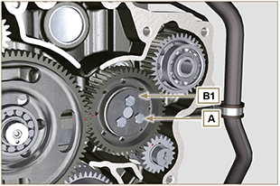  Fig 11.3
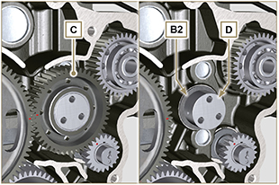
Fig 11.4
11.2.2 Assembly  Important  - Make sure that gudgeon D has no impurities inside.  - On capscrew A , assemble:  - plate B1  - gudgeon D  - gear C  - plate B2 . | Fig 11.5

- Position gear unit C1 onto crankcase E , complying with reference J1 , J2 with gear F .  - Secure unit C1 by means of capscrew A (tightening torque 25 Nm ).  NOTE: the reference J1 can have 2 different configurations for the gear C , Fig. 11.6b shows the correct position of the reference J1 for both configurations. | 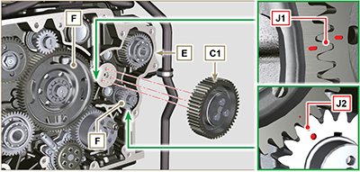  Fig 11.6  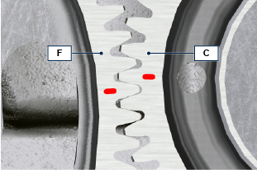  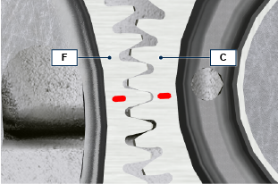  Fig 11.6b

3rd PTO (replacement)
Important

- Before proceeding with operation, read Par. 3.3.2 .
11.3.1 Disassembly  - Perform the operations of point 7 of Par. 7.4.1 .  - Perform the operations from point 2 to 3 of Par. 6.6.1 .  - Perform the operations of point 3 of Par. 7.8.1 .  - Perform the operations of Par. 7.8.2 .  - Extract gear A . | 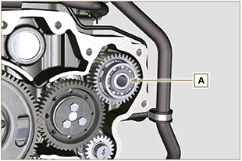  Fig 11.7
11.3.2 Assembly  - Insert gear A into the seat of crankcase B , fitting the shaft of pump C in gear A . | 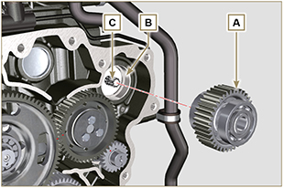  Fig 11.8

4th PTO (replacement)
Important

- Before proceeding with operation, read Par. 3.3.2 .
11.4.1 Disassembly  - Perform the operations of point 7 of Par. 7.4.1 .  - Perform the operations from point 2 to 3 of Par. 6.6.1 .  - Perform the operations of point 3 of Par. 7.8.1 .  - Perform the operations of Par. 7.8.2 .  - Extract gear A . | 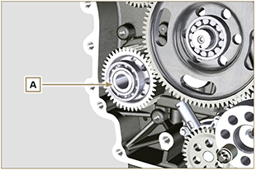  Fig 11.9
11.4.2 Assembly  - Insert gear A into the seat of crankcase B , fitting the shaft of pump C in gear A . | 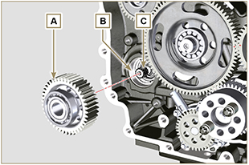  Fig 11.10

Balancer device (replacement)
Importante

- Before proceeding with operation, read Par. 3.3.2 .
11.5.1 Disassembly  - Perform the operations described in Par. 11.2.1 .  - Extract shaft A1 e A2. | 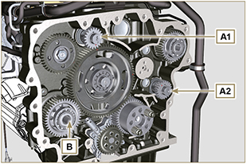  Fig 11.11
11.5.2 Assembly

- Lubricate gudgeon C of shaft A1 and A2 with oil.
- Insert shaft A1 into seat B1 of the crankcase, complying with reference D of gear E .
- Insert shaft A2 into seat B2 of the crankcase.
- Perform the operations described in Par. 11.2.2 .
NOTE: the shafts A1 and A2 are different and it is important not to invert the assembly position, the reference D is specific for the shaft A1 and is timed with the gear E , the reference J2 is specific for the shaft A2 and is timed with the idler gear F (see the Fig. 11.12b ).

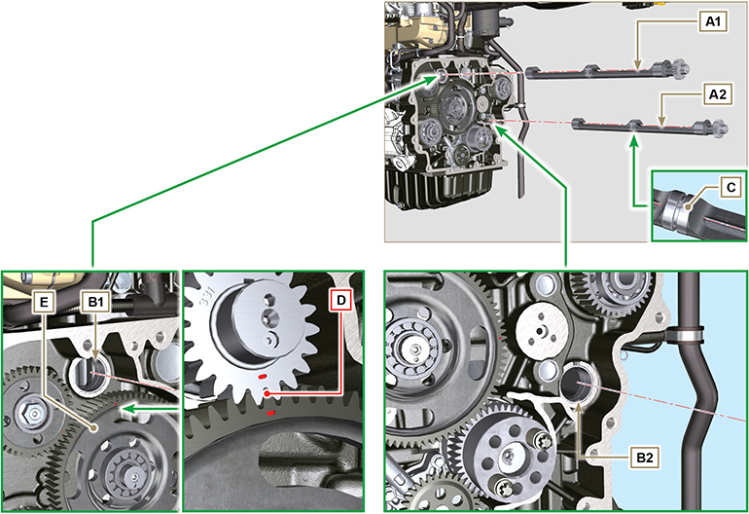
Fig 11.12

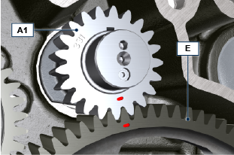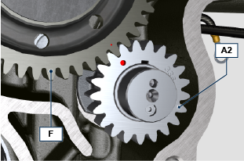
Fig 11.12b

ETB (replacement)
- Unscrew screws A and remove the ETB valve B with its gasket C .  Important  - Always replace the gasket C at each assembly. | 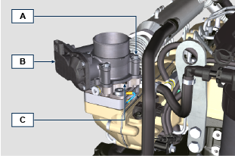  Fig. 11.13
- Fix the ETB valve B and its gasket C by means of screws A (tightening torque 10 Nm ) | 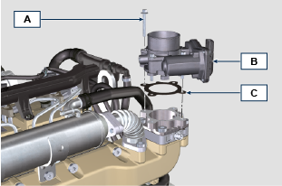  Fig. 11.14

Air filter (cartridge replacement)
- Release the two hooks F and remove the cover A from the body D .  - Remove the cartridges B and G .  Important  - Before proceeding with operation, read Par. 3.3.2 .  - The safety cartridge G (if present) must always be replaced if it is dirty or damaged.  - Insert the new cartridge G inside the new cartridge B and both of them inside the filter body D .  - Secure the cover A via the hooks F . | 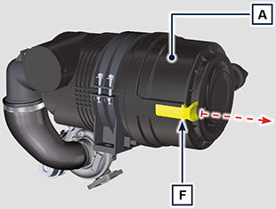  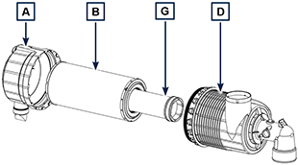  Fig 11.59

Cooling circuit (replacement)
Important  - Before proceeding with operation, read Par. 3.3.2 .  - Before carrying out the operation, refer to the machine manual to disconnect the fuel waste line from the fuel radiator C2 . | 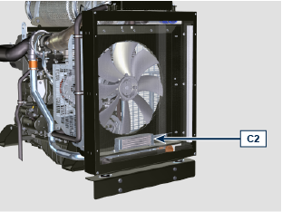
11.8.1 Smontaggio vaschetta di espansione *  1 - Release the clamp A1, A2 .  2 - Disconnect hose B1, B2, B3 .  3 - Loosen capscrews C1 .  4 - Loosen capscrews C3 e rimuovere la vaschetta C4 . * | 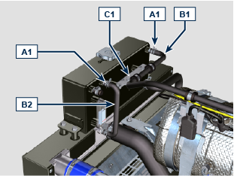  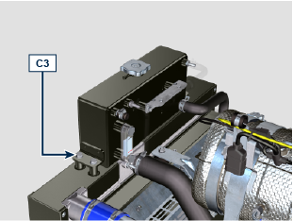  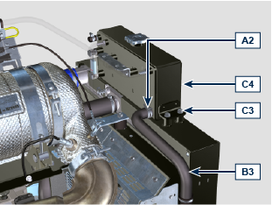
11.8.2 Radiator d isassembly  1 - Release the clamp A3, A5 .  2 - Disconnect hose B4 from radiator C . | 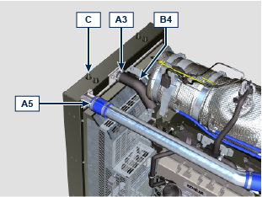
4 - Release the clamp A2, A4, A5 .  5 - Disconnect hose B3, B5 from radiator C . | 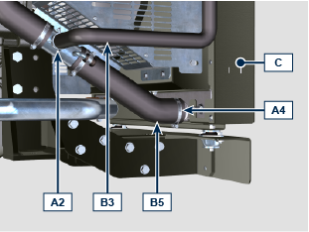  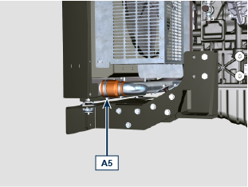
6 - Loosen all capscrews E1, E2, E3.  7 - Release nut F .  8 - Remove floodgates G1 and G2 .  9 - Loosen capscrews K .  10 - Disconnect radiator C from hoses H1 and H2 , being careful not to deform tubes J1 and J2 . | 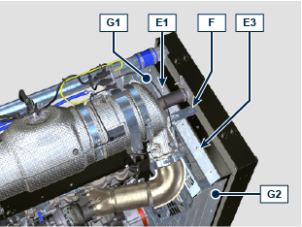  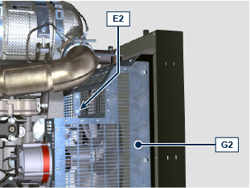  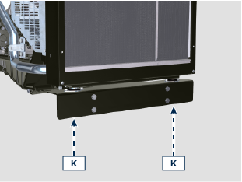  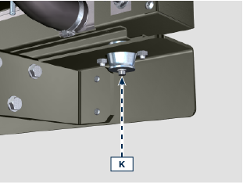  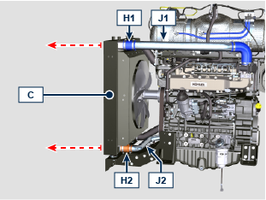
11.8.3 Fuel radiator replacement  1 - Loosen the screws E4 , extract the radiator C2 from the conveyor C1 .  2 - Insert the radiator C2 in the conveyor C1 .  3 - Fasten the radiator C2 with the screws E4 and washers E5 (tightening torque of 10 Nm ). | 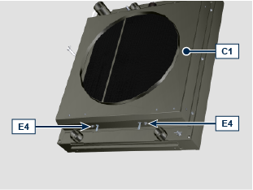  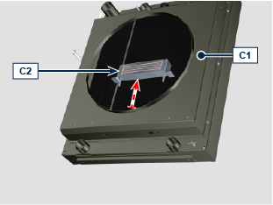  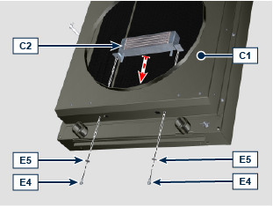
11.8.4 Fan disassembly  1 - Undo the screws P and remove the fan R . | 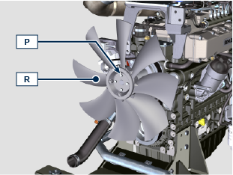
11.8.5 Fan assembly  1 - Assemble the fan R on the pulley U .  2 - Fasten the fan R by using the screws P (tightening torque at 10 Nm ). | 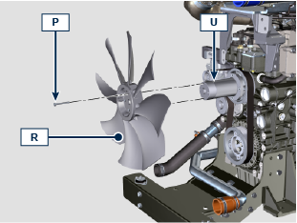

11.8.6 Radiator assembly  1 - Insert the vibration damper V2 correctly on bracket S .  2 - Fit radiator C onto hose H1 , H2 being careful not to deform tube J1 , J2 .  3 - Centre radiator C onto vibration-dampening devices V .  4 - Secure radiator C onto vibration-dampening devices V by means of capscrews K (tightening torque at 25 Nm ).  5 - Fix the vibration damper V2 on the bracket S through the nut F (tightening torque of 25 Nm ).  6 - Secure hose H2 by means of clamp A5 . | 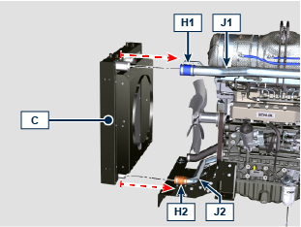  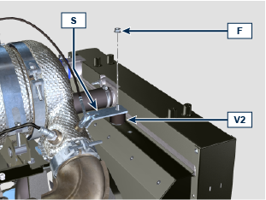  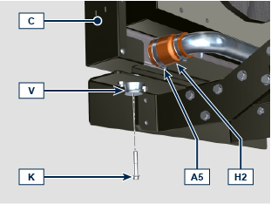
7 - Position floodgate G1 onto radiator C .  8 - Secure all capscrews E1 , E3 , E2 . | 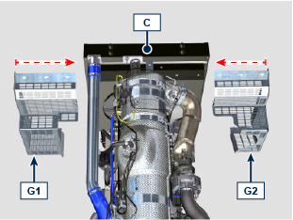  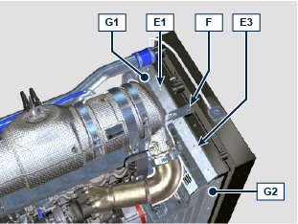

9 - Secure hoses B3, B4, B5 by means of clamps A2 , A3, A4 . | 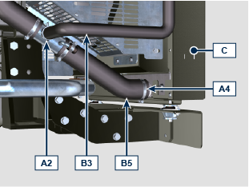
11.8.7 Montaggio vaschetta di espansione *  1 - Fissare la vaschetta C4 sul radiatore C tramite le viti C3 (coppia di serraggio a 25 Nm ). *  2 - Fissare i manicotti B3, B1, B2 tramite le fascette A1 , A2 . * | 