Assembly information
KDI-TCP 3404E5 Workshop Manual (Rev. 01.1)

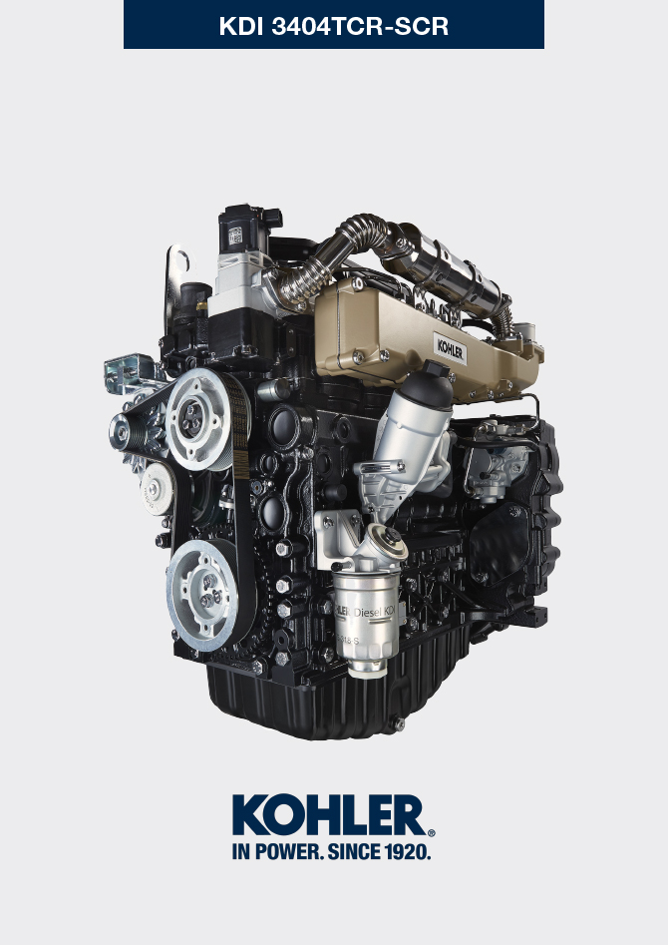

Registration of modifications to the document
Any modifications to this document must be registered by the drafting body, by completing the following table.

Released by | Code | Revision | Release Date | Revision date | Edited by | Endorsed
 | manoff

Translated from the original manual in Italian language
Data reported in this issue can be modified at any time by KOHLER.

Sommario
1. TITOLO 1 2
1.1. Asdfsdfsdf 2
1.2. Asdfsdfsdfggg 2

Assembly information

Information on engine configuration
- In this chapter, the engine is represented as "BASE CONFIGURATION" (refer to Par. 1.4 - 1.5 ).
- For the assembly of components not described in this chapter refer to Chap. 11 .
- The following are the components described in Chap. 11 .

11.1 Heater (reaplacement)
11.2 Idler gear (for III/IV PTO)
11.3 III PTO (replacement)
11.4 IV PTO (replacement)
11.5 Balancer shafts (replacement)
11. 6 ETB (replacement)

Assembly recommendations
- The information is laid out in sequence, the intervention methods have been selected, tested and approved by the manufacturer's technicians.
- This chapter describes the installation procedures for the assemblies and/ or individual components which have already been checked, overhauled or possibly replaced with original spare parts.
- Where necessary, reference to special tools during assembly operations is indicated and identified in Tab 13.1 , hereinafter in Tab. 9.1 an example of a special tool ( ST_05 ).

Tab. 9.1
SPECIAL TOOLS
"ST" Code | Picture /draw | DESCRIPTION | PART NUMBER
ST_05 | 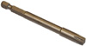 | Six nicks Key SN 8 | ED0014603650-S

Important

- Before proceeding with operations, read Par. 3.3.2 .
- To easily locate specific topics, the reader should refer to the analytical index or chapter index .
- The operator must check that:
  - the components, the assemblies, the coupling surfaces of the parts are washed, clean and thoroughly dried;
  - the coupling surfaces are undamaged;
  - the equipment and tools are ready so that all work can be carried out correctly and safely;
  - ensure that the working environment is safe.
- The operator must:
  - carry out the procedures smoothly and safely. It is thus recommended to install the engine on a special rotating stand used when servicing engines to ensure the safety of the operator and the other individuals involved;
  - tighten the assemblies and / or components in a criss-cross or alternating pattern, initially with a value lower than that preset, and then subsequently, with the tightening torque specified in the procedure;
  - replace all seal gaskets after each assembly for all components on which they are provided.

Engine block assembly
9.3.1 Crankshaft bushings  Important  - Execute the procedure in Par. 8.2.1 and 8.2.2 , before proceeding with assembly.  - The crankshaft half-bearings are made of special material. Therefore, they must be replaced every time they are assembled to prevent seizures.  - Fit the new half-bearings A1 onto the crankcase upper half B1 adhering to the reference notches C .  Importante  - After the half-bearings are fitted, check that the lubrication holes D correspond with the crankcase grooves B1 .  - The lower and upper half bearings CANNOT be singularly replaced, and both halves must be replaced together.  - Fit the new half-bearings A2 onto the lower crankcase B2 using the reference notches C .  - Lubricate the half-bearings A1 and A2 with oil. | 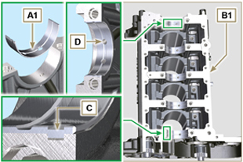  Fig 9.1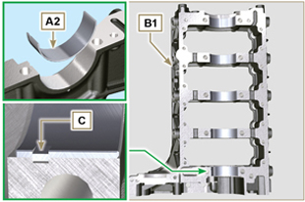  Fig 9.2
9.3.2 Tappets  - Lubricate the tappets E with oil.  - Insert the tappets E into the housings F of the upper crankcase B1 . | 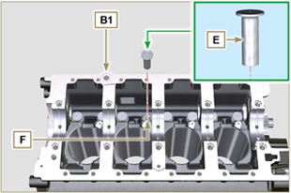  Fig 9.3
9.3.3 Oil spray nozzles  - Insert the sprayers G onto the upper crankcase B1 manually screwing the screw fittings H .  - Ensure that the spray nozzles G are inserted correctly in their seat, as shown in detail L and tighten the capscrews of union H (tightening torque of 10 Nm ). | 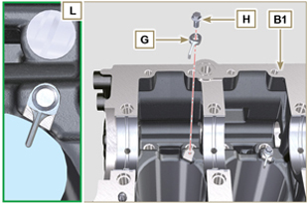  Fig 9.4
9.3.4 Crankshaft  Important  - Carry out the checks described in Par. 8.4.1 and Par. 8.4.2 .  - Check that the crankshaft half-bearings A1 are mounted correctly on the upper crankcase B1 .  - Lubricate the main journal and crankpin J , with oil.  - Insert the crankshaft M into its seat on the upper crankcase B1 .  - Insert the 2 shoulder half-rings N1 , between the crankshaft M and the upper crankcase B1 ( Q detail). | 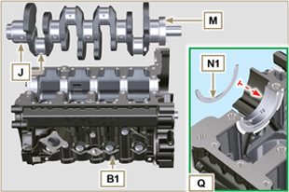  Fig 9.5
9.3.5 Lower semi-crankcase  - Check that the coupling surfaces P are free from dirt and grit.  - Spread a bead of Loctite 5660 of approx 1,5 mm thickness on the surface P of the upper crankshaft half B1 being careful not to block the oil feed grooves X and the return oil sump Y .  - Insert gasket S into the seat of crankcase B1 .  Note :alternatively apply Loctite 5699 . | 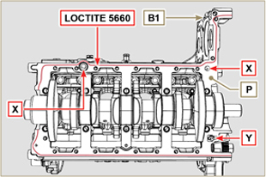  Fig 9.6

- Check that the crankshaft half-bearings A2 are mounted correctly on the lower crankcase B2 .
- Assemble the 2 shoulder half-rings N2 onto the lower crankcase B2 applying two drops of grease to keep them in their seat.
- Join the two crankshaft halves B1 and B2 observing the guide pins T .
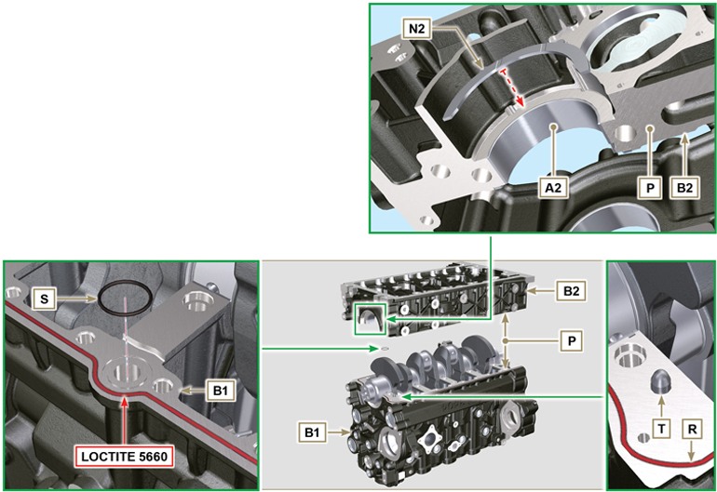
Fig 9.7 - F ig 9.8

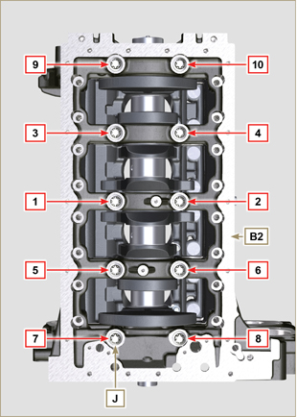  Fig 9.9 | 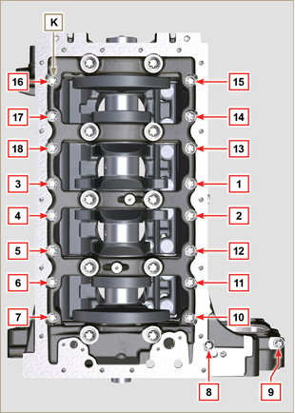  Fig 9.10
Tab 9.2  CYCLE SCREWS TORQUE  1 J - Torx M14x1,5 60 Nm  2 K - Torx M10x1.25 30 Nm  3 J - Torx M14x1,5 45°  4 J - Torx M14x1,5 45°  Important  - The fastening bolts J , K must be replaced every time they are assembled.  - Failure to adhere to the bolt fixing procedures may compromise the functionality of the engine, and also may cause damage to persons and property.  - Tighten capscrews J , K observing the cycles, tightening, and subsequent rotation as indicated in Tab. 9.2 .  - Apply " Molyslip AS COMPOUND 40 " on the threads and under the head of capscrews J and K and manually tighten them until their stop.  - Tightening the screws J , K strictly following the sequence indicated in the Fig. 9.9 or Fig. 9.10 and the tightening torque indicated in the Tab. 9.2 .  - Check that crankshaft M rotates smoothly.  - Insert gasket W into the seat of crankcase B ( ST_47 ) . | 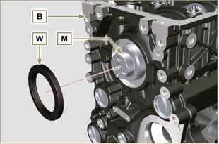  Fig 9.11
9.3.6 Camshaft  - Check that the pin P1 is correctly fitted on the crankshaft M .  - Position the gear M1 on the crankshaft M respecting the reference with pin P1 .  - Fully tighten the screw N1 .  - Lubricate the pins S2 , the cams S3 of the camshaft S1 , all the housing Q1 with oil.  - Insert the camshaft S1 all the way into its housing Q1 .  - Position the gear R1 observing all the marks T1 of the gears M1 .  Important  - Failure to comply with the marks T1 on the gears M1 and R1 causes engine malfunction and serious damage.  7. Check that crankshaft M rotates smoothly. | 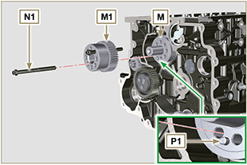  Fig 9.12  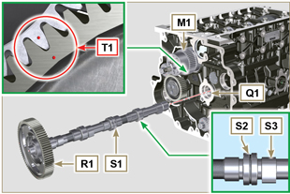  Fig 9.13
9.3.7 Piston rings  - Perform the operations described in Par. 8.5.3 .  - Put the scraper ring Z3 onto the piston Z .  - Put the 2° seal ring Z2 on the piston Z .  - Put the 1° seal ring Z1 onto the piston Z .  - Perform the operations described in Par. 8.5.4 .  - Position the segment openings with a 120° angle between them ( Y ).  NOTE: do not use the segment opening with the pin hole ( N )  - Lubricate the piston skirt and piston rings with oil. | 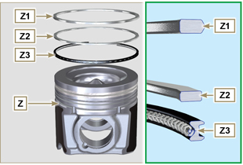  Fig 9.14  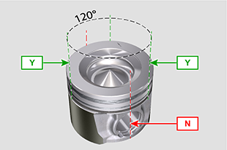  Fig 9.15
9.3.8 Piston  Importante  - The fastening bolts E1 must be replaced every time they are assembled.  - Before proceeding to the assembly of the piston and connecting rod, carry out the checks described in Par. 8.5.1 .  - Always replace the bearings D1 after each assembly.  - Mate components respecting references at Par. 7.15.5 .  - Loosen the screws E1 and remove the connecting rod cap F1 .  - Insert the connecting rod F2 into the piston Z and align the seats G1 .  - Insert the gudgeon pin H1 into the seat G1 for the assembly of the connecting rod and piston unit.  - Insert the lock rings L1 inside the seat G2 of the piston Z to lock the gudgeon pin H1 . | 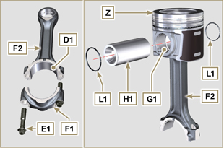  Fig 9.16  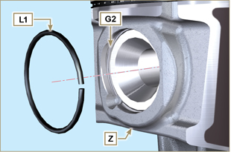  Fig 9.17

9.3.9 Piston and connecting rod assembly  Important  - Before assembling the piston and connecting rod assemblies, execute the controls described in Par. 8.5.5 .  - Rotate the crankshaft M by moving the crankpin J1 to a TDC position of the affected cylinder. | 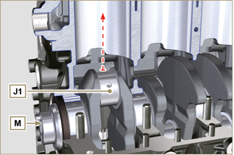  Fig 9.18
- Lubricate the piston skirt and rings Z .  - Check that the half-bearing U1 is mounted correctly and lubricate it thoroughly.  - Using the piston ring compression pliers, insert the piston inside the cylinder W1 by around 10mm (height T2 ).  Important  - Make sure you are at the stage described in Point 1 .  - Piston Z must be assembled with notch K1 on the side of the skirt facing oil spray nozzles G .  - Rotate the piston Z by 10° counter-clockwise with respect to its correct assembly position (Fig. 9.20 - height T3 ).  NOTE: Doing this prevents the impact between the connecting rod F2 and the sprayer G . | 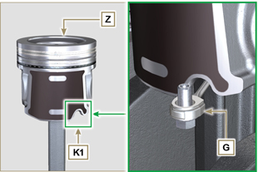  Fig 9.19  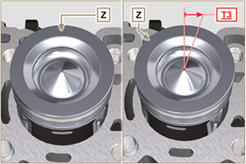  Fig 9.20  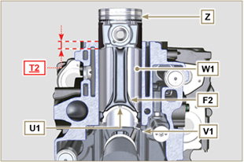  Fig 9.21  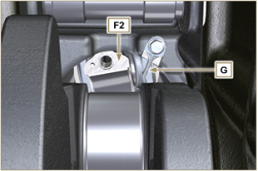  Fig 9.22
Important  - Leave the ring compressor assembled on the piston.  - Push piston Z downwards without introducing the segments in the cylinder, rotate piston Z by 10° in a clockwise direction (value T3 – correct assembly position). | 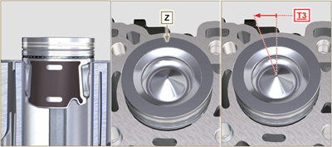  Fig 9.23

- Push the piston Z downwards by centering the crankpin J1 with the connecting rod F2 .  - Rotate the crankshaft M by moving the crankpin J1 to a BDC position of the affected cylinder.  - Push the piston Z downwards by centering the crankpin J1 with the connecting rod F2 .  - Turn the crankcase on support to assemble the con rod capp F1 .  - Check that the half-bearing U1 is mounted correctly on the connecting rod cap F1 .  Important  - Check that the break levels of connecting rod cap F1 coincide perfectly onto connecting rod F2 before screwing on and tightening capscrews E1 .  - Couple the connecting rod cap F1 to the connecting rod F2 using the marks made at disassembly ( Par. 7.15.2 and 7.15.5 ).  - Apply "Molyslip AS COMPOUND 40" on the threads and under the head of capscrew E1 and manually tighten them until their stop.  Important  - Failure to adhere to the assembly procedures may compromise the functionality of the engine, and also cause damage to persons and property.  - Tighten the screws E1 , alternately, strictly following the tightening torques indicated ( Tab. 9.3 ).  - Repeat the operations from 1 to 14 for each cylinder.  - Check that the connecting rods have axial play and the crankshaft M rotates smoothly.  NOTE: After the check carried out at point 16, position the shaft M with the first cylinder to TDC. | 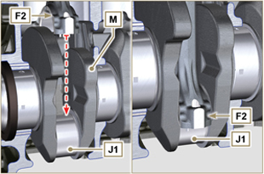  Fig 9.24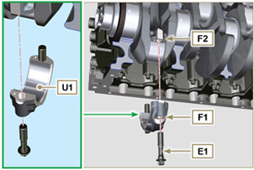  Fig 9.25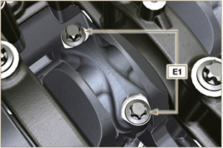  Fig 9.26
Tab 9.3
CYCLE | SCREWS | TORQUE
1 | E1 | 28 Nm
2 | E1 | 30°
3 | E1 | 30°

NOTE : Click by side to play the procedure. | https://www.youtube.com/embed/V4aXYc_0x8U?showinfo=0&rel=0

Oil sump unit assembly
9.4.1 Oil drain pipe  Important  - It is mandatory to replace the gasket D after each assembly.  - Always replace capscrews B with new ones or alternatively apply Loctite 2701 .  - Secure the hose A on the crankcase C with the screws B inserting the gasket D (tightening torque 10 Nm ). | 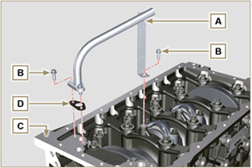  Fig 9.27
9.4.2 Oil suction pipe  Important  - It is mandatory to replace the gasket F after each assembly.  - Always replace capscrews B with new ones or alternatively apply Loctite 2701 .  - Secure the hose E on the crankcase C with the screws B (tightening torque 10 Nm ) fitting the gasket F . | 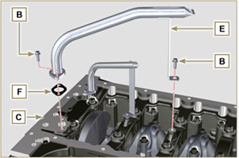  Fig 9.28
9.4.3 Oil Sump  - Ensure that the contact surfaces G of the oil sump H and the crankcase C are completely clean.  - Apply a bead of approx. 2.5 mm of sealant ( Loctite 5660 ) on the surface G of the crankcase C .  Note : alternatively apply Loctite 5699 . | 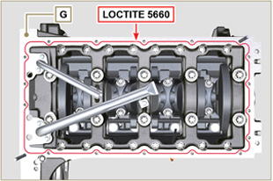  Fig 9.29
- Position the oil sump H on the crankcase C in line with the fastening holes (use the aid of tool ST_18 ). | 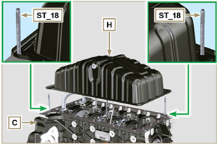  Fig 9.30
Important  - Tighten the screws L , strictly following the sequence and tightening torque indicated.  - Secure oil sump H by means of capscrews L .  - After tightening of the screw n° 10 , loosen screw n°1 and re-tighten it to the torque value specified in step 4 . | 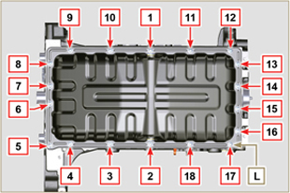  Fig 9.31

Cylinder head unit assembly
9.5.1 Valve stem gasket  Important  - Carry out the checks described in Par. 8.6.4 before proceeding with the following operations.  - Always replace gasket A with every assembly.  - Lubricate the oil seals A on the inside.  - Fit the oil seals A on the valve guides B using the tool ST_08 . | 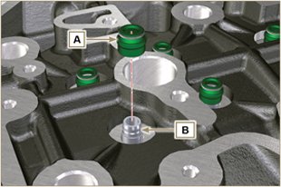  Fig 9.32
9.5.2 Electronic injector sleeves ( )  - Insert the seals C in the seats of the sleeve D .  - Insert the seal E with the convex side facing upward at the base of the sleeve D .  - Lubricate the gaskets C .  - Insert and carefully screw the sleeve D into the seat of the head F .  NOTE: The sleeve D must not protrude above the surface of the head G .  - Clamp the sleeve D (tightening torque at 30 Nm ). | 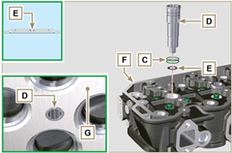  Fig 9.33
9.5.3 Electronic injectors projection  - Perform the operations of point 1 and 2 Par. 6.1.4.  - Perform the operations of point 3 and 4 Par. 6.1.5.  - Check using ST_03 tool (Fig. 9.35) , the projection of the injector, which must range between 1.68 ÷ 2.42 mm.  NOTE : if the value detected does not correspond, replace gasket Q with a different thickness. | 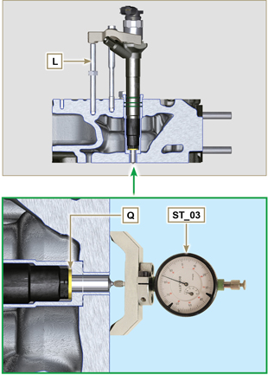  Fig 9.34 - Fig. 9.35
9.5.4 Valves  - Pre-lubricate and insert the valves X into the head F taking care to fit them in the original positions as per the reference marks made in Par. 7.12.4.1 .  - Position the spring Y on the seat of the head F .  - Position the disk S on the spring Y centering the valve X .  - Mount the tool ST_07 on the head F fixing it on one of the holes for securing the rocker arm cover.  NOTE: Change the fixing hole according to the position of the valves to be fitted.  - Position the tool ST_07 on the valve as shown in the Fig. 9.37 .  - Push the lever of the tool ST_07 downwards, in order to lower the valve disks S in the direction of the arrow AK , and insert the valve cotters AJ inside the disk S .  - Check that the valve cotters AJ are properly mounted on the valve seats X and release the tool ST_07 .  NOTE: repeat all the steps for the relevant valves and remove the tool ST_07 . | 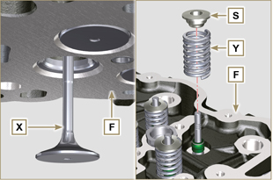  Fig 9.36
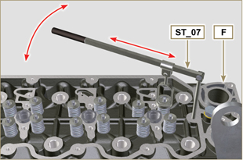
Fig 9.37
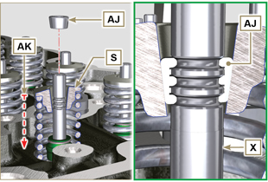
Fig 9.38
9.5.5 Cylinder head  - Fix the eyebolts AW with the screws AX onto the head F (tightening torque of 80 Nm ).  - Position the piston P at the TDC.  - Position the tool ST_03 on the crankcase surface of the head and measure the piston protrusion P from head level K in 4 diametrically opposed points R. Repeat the operation for all pistons P and take note of the highest average value, determining valu e S (Tab. 9.4) .  Tab. 9.42  S (mm) Hole number  0.030 - 0.126 1  0.127 - 0.250 2  0.251 - 0.375 3  - Based on the value detected at point 3 , select the relevant gasket T as shown in the Tab. 9.4 (Fig. 9.41 detail U ).  - Check that the crankcase surface K and the gasket T are completely free of dirt and grit.  Important  - The head gasket must be replaced for each assembly.  - Position the gasket T on the surface K with reference to the centering bushings J . | 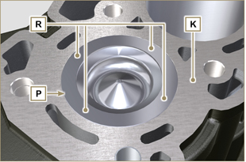  Fig 9.40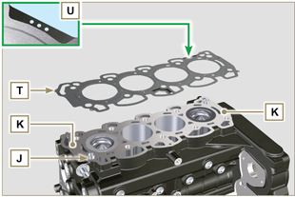  Fig 9.41
- Check that the surface head W is free from impurities.  - Position the head F on the crankcase Z with reference to the centering bushings J .  Important  - The fastening bolts V must be replaced every time they are assembled.  Modified component, see service letter 710009.  - Failure to adhere to the bolt fixing procedures may compromise the functionality of the engine, and also may cause damage to persons and property.  - Tighten capscrews V observing the cycles, tightening, and subsequent rotation as indicated in Tab. 9.5 .  - Secure the head F by tightening the screws V strictly following the sequence indicated in the Fig. 9.43 and the tightening torque and pauses between cycles indicated in the Tab. 9.5 . | 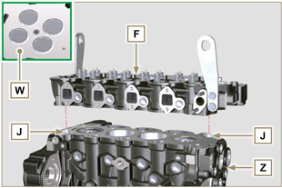  Fig 9.42
Tab. 9.5  CYCLE TORQUE PAUSE  1 75 Nm 3min  2 90° 3min  3 90° 3min  4 90° --- | 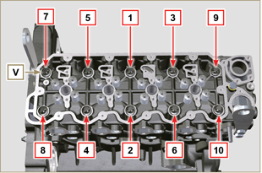  Fig 9.43
- Remove tool ST_60 from cylinder head F . | 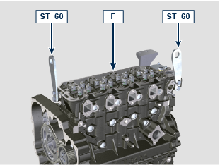
9.5.6 Rods and valve bridges  - Insert the rocker control rods AA into the niches of the head F .  Important  - Properly centre the rods AA into the spherical housing of the camshaft tappets AB .  - Mount the valve bridge AC on to the pairs of discharge and suction valves. | 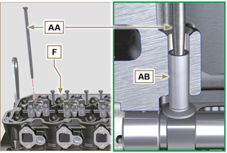  Fig 9.44  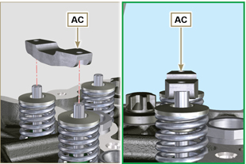  Fig 9.45
9.5.7 Rocker arms  Important  - The discharge rocker arm AT is shorter than the suction arm AR .  - Fit the lock ring AM into the seat AN of the rocker arm pin AH .  - Position the pin AH with the screw support surface AP facing upwards and insert the 2 shoulder rings AQ .  - Insert in sequence the suction rocker arm AR , the holder AS and the discharge rocker arm AT in the pin AH .  - Insert the spring AU in the pin AH .  - Repeat points 3, 4 for all the rocker arms.  NOTE: Support AV , which contains taper pin BV , must be assembled in correspondence with cylinder n° 3 .  - Insert 2 shoulder rings AQ and the lock ring AN to lock all the components inserted in the pin AH .  NOTE : The spring AU ensures that the supports AS and AV are kept in place. | 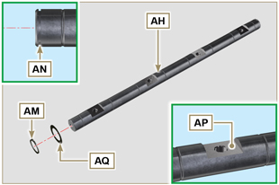  Fig 9.46  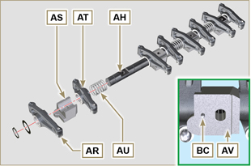  Fig 9.47
9.5.8 Rocker arm pin assembly  Important  - Position the rocker arm pin assembly BB on a level to align all the support surfaces.  - Check that the pistons are positioned half way between the TDC and BDC. As seen from A ⇒ ( Par. 1.4 ) turn the crankshaft anticlockwise by 90°, complying with TDC of the 1st cylinder , positioning taper pin BP of the crankshaft as shown in Fig. 9.48 .  - If the engine is painted or protected with clear paint, replace the fastening screws BE .  - Position rocker arm shaft unit BB on cylinder head F , complying with the taper pin BC reference with hole BF of cylinder head F .  - Check the correct positioning of all the rocker arms and the u-bolt control valves (detail BD ).  House the tappet in the seat of the rocker arms control rod.  - Secure the rocker arm pin BB tightening the screws BE (tightening torque to 40 Nm ). Adhere to the screw tightening sequence BE as shown in Fig. 9.50 . | 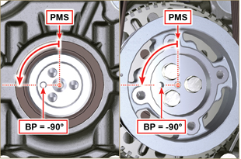  Fig 9.48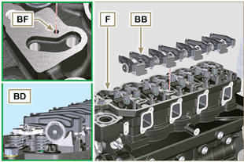  Fig 9.49
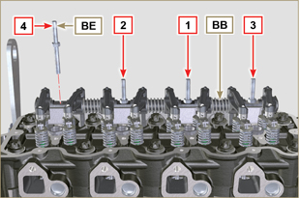
Fig 9.50
9.5.9 Assembly Rocker arm cover  Important  - Replace gasket BF, BL and BM with each assembly ( ST_11 - ST_12 apply Loctite 480 to the seats of cap BN before assembling the gaskets).  Modified component, see service letter 710017.  - Observe the order of tightening illustrated in Fig. 9.52 .  - Position tool ST_17 onto the head in correspondence with the two fastening holes 9 and 10 .  - With vaseline lubricate the gaskets BL in the upper part, and the gaskets BM in the lower part.  - Position gasket BF and the rocker arm cover BN on cylinder head F using tool ST_17 as a guide.  - Attach the rocker arm cover BN on the head F with the screw BG (tightening torque to 10 Nm ). | 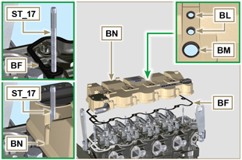  Fig 9.51
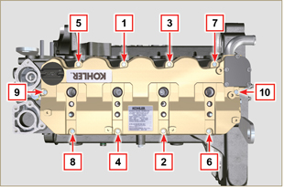
Fig 9.52

Intake manifold assembly
9.6.1 Internal half-manifold  Important  - Check that the contact surfaces between the semi-collector C and the head D are free from impurities.  - Insert the special tool ST_18 into indicated point.  - Position gasket B and manifold C on cylinder head D .  - Secure the semi-collector C with the screws A on the head D (tightening torque of 25 Nm ). | 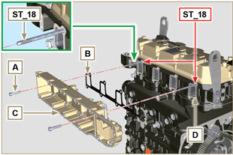  Fig 9.53
9.6.2 External half-manifold  Important  - Check that the contact surfaces between the two semi collectors C and D are free from impurities.  - Insert the special tool ST_18 into indicated point.  - Position gasket N , panel P and semi-manifold M onto semi-manifold C .  - Fit the semi-collector M on the semi-collector C with the screws L (tightening torque of 22 Nm - ST_05 ). | 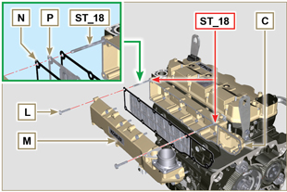  Fig 9.54

Fuel system assembly
Important

- Do NOT mount new or different injectors without the required tool ( Chap. 13 ).
- Remove the protective caps from all the components of the fuel circuit just before assembly just before assembly ( Par. 2.9.8 ).
9.7.1 High-pressure injection pump  - Check that the surface A is free from impurities ( Fig. 9.56 ).  Important  - Always replace gasket B with every assembly.  - The seal gasket B can only be fitted in one direction ( Fig. 9.55 ).  - Always replace capscrews C with new ones or alternatively apply Loctite 2701 ( Fig. 9.55 ).  - Fit the new gasket B on the injection pump D ( Fig. 9.56 ).  - Fix the pump D into the housing A1 together with the gasket B by the screws C ( Fig. 9. 56 - tightening torque at 25 Nm ).  - Check the correct fitting of the key E on the shaft F of the injection pump D ( Fig. 9.57 ).  - Place the gear G on the shaft F of the pump D respecting the reference to the key E and the reference H of the gear L ( Fig. 9.57 ).  - Tighten the nut M (tightening torque at 140 Nm ). | 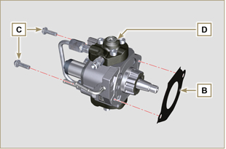  Fig 9.55
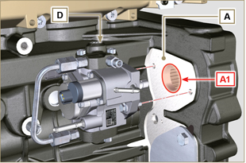
Fig 9.56
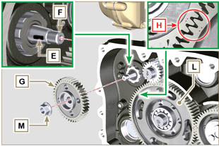
Fig 9.57
9.7.2 Fuel filter  - Secure the fuel filter holder N with the screws P on the crankcase Q (tightening torque of 25 Nm ).  NOTE : For the assembly of the fuel cartridge, refer to operations 4 and 5 of Par. 6.9.2 . | 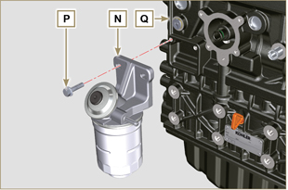  Fig 9.58
9.7.3 Electronic injectors  Importante  - Always replace and lubricate the gaskets R of the electronic injectors S with fuel, every time they are assembled.  - Pay attention when repositioning the electronic injectors, using the marks as described in Par. 7.10.5 .  - If a new (or different) electronic injector is fitted on the engine, you are required to prepare tool ST_01 .  - If the engine is painted or protected with clear paint, clean the paint off the diesel injector S near to the part in contact with the gasket AB .  - Assemble gasket T onto electronic injector S .  - Insert the electronic injectors S inside the rocker arm cover U being extra careful not to damage gasket AB and direct it as indicated in Fig. 9.59. | 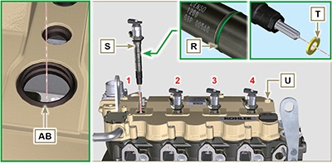  Fig 9.59
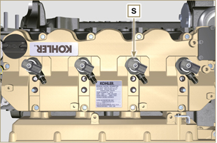
Fig 9.60
9.7.4 Common Rail  - Secure the rail W on the intake manifold X with the screws V (tightening torque at 25 Nm ). | 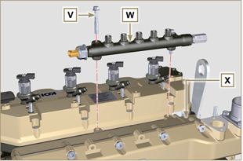  Fig 9.61
9.7.5 High pressure fuel pipes  Important  - Always replace the pipes Y and tube Z after each assembly.  - Position the pipes Y on the Common Rail W and on the electronic injectors S , adjust the position of electronic injectors S via the fitting inlets with the pipes Y .  Important  - Tighten the nuts J and K manually, without clamping them.  - If the engine is painted or protected with clear paint, replace the fastening screws B1 .  - Position the injector fastening brackets A1 and the screws B1 , inserting the washer C1 .  Important  - Replace the pipes Y ( Fig. 9.62 ) if the screws B1 do not rotate freely.  - Tighten all the nuts K (tightening torque at 30 Nm ).  - Tighten the nuts J (tightening torque at 25 Nm ).  - Make sure that the mounting brackets A1 are positioned correctly on electroinjectors S and on fixing screws of the rocker arm assembly D1 .  - Tighten the fixing screws B1 of the injector mounting bracket (tightening torque of 20 Nm ).  - Position the pipe Z screwing the nuts J and K .  Important  - Screw the nuts J and K manually without tightening them.  - Tighten the nut K (tightening torque of 30 Nm ).  - Tighten the nut J (tightening torque of 25 Nm ).  - Fasten the clamp E1 with the screw F1 (tightening torque of 10 Nm ). | 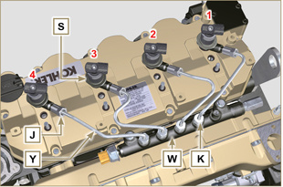  Fig 9.62
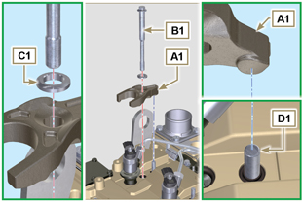
Fig 9.63
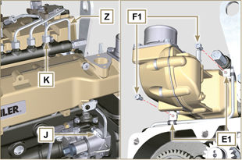
Fig 9.64
9.7.6 Fuel flow pipes  - Insert the pipes G1 on the fitting coming out of the filter holder N and on the fuel inlet fitting of the injection pump D . | 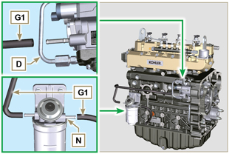  Fig 9.65
9.7.7 Fuel return pipes  - Check the gaskets H1 on the fittings J1 .  NOTE : Do not disconnect the pipes from the distributor K1 .  - Position the return pipes and fitting the distributor K1 with the screw L1 on the intake manifold X ( Fig. 9.67 - tightening torque of 10 Nm ).  - Mount the fittings J1 ( Fig. 9.67 ) on the injectors S and lock them with the clips M1 .  - Insert the pipe N1 on the fitting P1 .  - Fit the gaskets Q1 and the fitting R1 on the screw S1 .  - Tighten capscrews S1 on Common Rail W (tightening torque 15 Nm ) with the opening of union R1 facing upwards. | 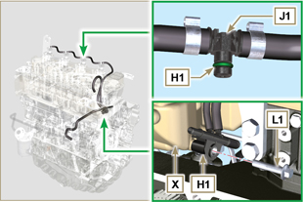  Fig 9.66
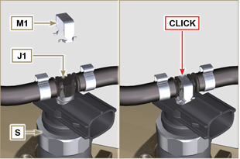
Fig 9.67
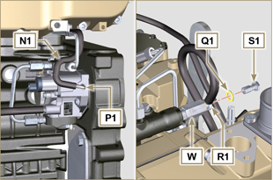
Fig 9.68

Assembly lubrication circuit
9.8.1 Assembly oil mist separator unit  Important  - Always carefully inspect the condition of the pipes, and replace them if there is any doubt regarding the integrity of their seal.  - Secure the plate A using the screws B (tightening torque of 10 Nm - ST_05 ).  - Assemble clamps C onto tube D .  - Secure tube D by means of fastening clamp C with capscrews E , inserting clamp F.  - Fit hose G onto union H .  - Secure tube J by means of capscrew K , inserting gasket L .  - Secure the clamp M .  - Perform the operations of Par. 6.7.2 . | 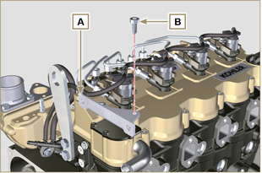  Fig 9.69
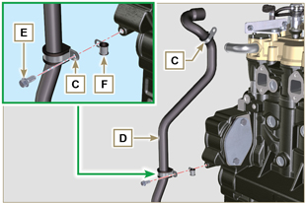
Fig 9.70
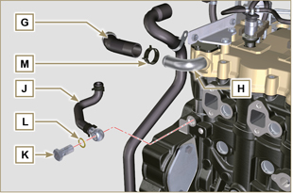
Fig 9.71
9. 8 .2 Oil Cooler and oil filter Unit Assembly

- Perform the operations of Par. 6.8.3 .

NOTE :To replace the oil cartridge, refer to operations of Par. 6.8.2 .

9. 8 .3 Oil pressure relief valve  - Lubricate the piston N and fully insert it in the seat P .  - Insert the spring Q in the piston N .  - Insert disk R onto spring Q .  - Insert cotter pin S in the provided seat of oil pump T to lock components N, Q and R . | 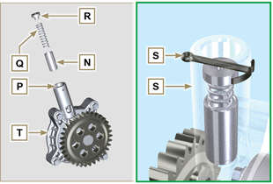  Fig 9.72
9. 8 .4 Oil pump  NOTE: Carry out the checks described in Par. 8.7 before proceeding with the following operations.  - Check that all contact surfaces between T, V are free of impurities – scratches - dents.  - When assembling, do not use any type of gasket between T and V .  - Thoroughly lubricate the seat of the rotors on oil pump T .  - Make sure the external rotor is assembled correctly with Ref. U visible, as shown in the picture (or refer to Par. 2.10.2 ).  - Fasten the oil pump cover T on the crankcase V with the screws X (tightening torque 10 Nm ). | 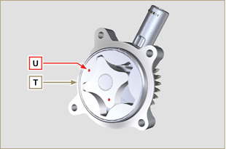  Fig 9.73
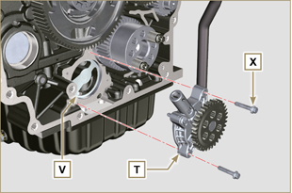
Fig 9.74

Flange unit assembly
9.9.1 Bell housing  Danger  - Bell A is very heavy; pay special attention during assembly operations to avoid dropping and causing serious risks to the operator.  Important  - Failure to adhere to the assembly procedures may compromise the functionality of the engine, and also cause damage to persons and property.  - Always replace and lubricate gasket C with oil with each assembly (gasket C is to be mounted after the operation in point 5 ( ST_47 ) ).  - To assemble components P, Q, R, S , and T , proceed with the operations described in Par. 11.2.2 - 11.3.2 - 11.4.2 - 11.5.2 .  - Apply a bead of approx. 2.5 mm of sealant ( Loctite 5188 ) on the surface B of the bell A .  - Ensure that bearing J is correctly assembled on camshaft K .  - Assemble bell A onto crankcase D , complying with reference taper pins E ( ST_45 ) .  - Apply the screws F by hand without tightening them.  - Tighten the screws F following the tightening sequence indicated (tightening torque 75 Nm ). | 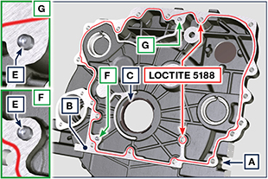  Fig 9.75  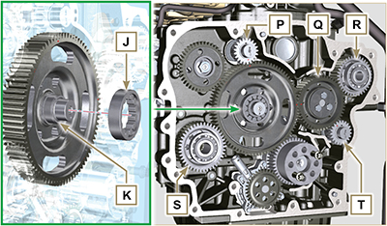  Fig 9.76A  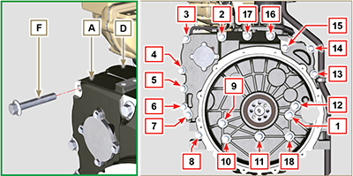  Fig 9.76B

9.9.2 Flywheel  Danger  - Flywheel F is very heavy; pay special attention during assembly operations to avoid dropping and causing serious risks to the operator.  - Loosen capscrews G and remove tool ST_41 .  - Position flywheel H onto crankshaft L by means of tool ST_43 - ST_46 .  - Apply " Molyslip AS COMPOUND 40 " on the threads and under the head of capscrews G and manually tighten them until their stop.  - Secure flywheel H with capscrews G (tightening torque 60 Nm ).  - Once again, tighten capscrews G (2 cycles with tightening torque 130 Nm ). | 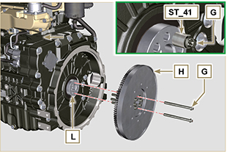  Fig 9.77

Exhaust manifold assembly
Important  - Replace the metal gaskets A, B every time they are assembled.  - In the event of mounting the studs C , fix ( 25 Nm tightening torque) with Loctite 2701 on the thread.  - Gasket B must be assembled with the wording " TOP " visible and facing upwards.  - Check that the contact surfaces D are free from impurities.  - Insert the gasket B on the studs C .  - Position manifold E onto cylinder head G by manually tightening capscrews F , inserting:  - gaskets A between cylinder head G and manifold E ;  - spacers H between capscrews F and manifold E .  - Secure manifold E onto cylinder head G by means of capscrews F (tightening torque 25 Nm ).  - Clamp the nuts L ( 25 Nm tightening torque). | 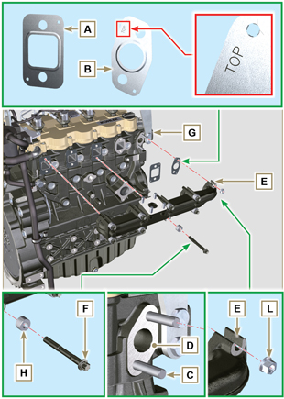  Fig 9.78

Crankshaft pulley assembly
- Perform the operations from point 1 to 7 of Par. 6.6.2 .

Turbocharger Assembly
Importante  - Before proceeding, perform the operation described in Par. 2.18 .  - Ensure that tube C is not clogged.  - Always replace the gaskets A, B, Q at each assembly.  - Remove the plastic or foam caps from the turbo compressor before assembling.  - Check that the contact surfaces D are free from impurities deformations or cracks, otherwise replace the damaged component.  - Position the turbo-compressor E on the bolts F on the manifold G .  - Fasten the turbo-compressor E with the nuts H (tightening torque of 25 Nm ).  - Fasten the pipe L with the screws M to the turbo-compressor E .  - Fasten the pipe G with the screws N on the crankcase P .  Importante  - Always replace the gasket Q after each assembly.  - Before assembly of the tube R , perform the operation described in Par. 2.18.2 - Point 2 .  - Ensure that tube R is not clogged.  - Fasten the pipe R with the fittings S on the turbo-compressor E and on the crankcase P (tightening torque of 15 Nm ).  Insert the gaskets Q between:  - S and R; - E and R;  - P and R. | 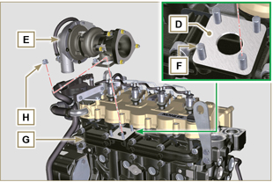  Fig 9.79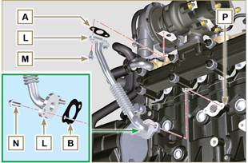  Fig 9.80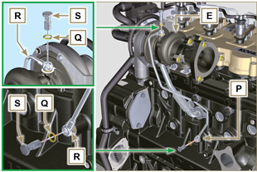  Fig 9.81

Electric component assembly
9.13.1 Sensors and switches

9.13.1.1 T-MAP Sensor  - Fasten the sensor A with the screws B on the manifold C (tightening torque of 10 Nm - ST_06 ). | 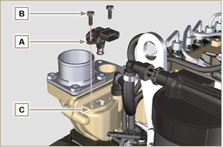  Fig 9.82
9.13.1.2 Coolant temperature sensor  - Secure the sensor D onto the head E (tightening torque of 20 Nm ). | 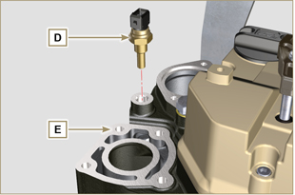  Fig 9.83
9.13.1.3 Oil Pressure Switch  - Clamp the oil pressure switch F on the crankcase G (tightening torque at 35 Nm ). | 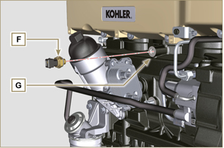  Fig 9.84
9.13.1.4 Camshaft phase sensor disassembly  - Measure the distance between the coupling surface P1 to gear teeth G1 (X1).  - Measure the distance between the coupling surface P1 and the sensor surface S7 (Y1).  - The difference between the 2 measurements determines the air gap value (Z1). The value (Z1) permitted must be a MIN of 0.2 mm and a MAX of 1.2 mm. Insert one spacers K2 based on the value (Z1) detected.  NOTE : The calibrated spacers K1 have a thickness of 0.2mm.  - Insert the shim K1 on the sensor S10.  - Secure phase sensor S10 onto crankcase L using capscrew R2 (tightening torque 10 Nm). | 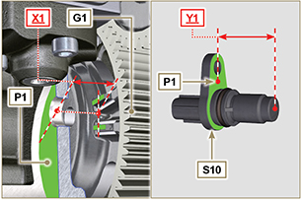  Fig 9.85
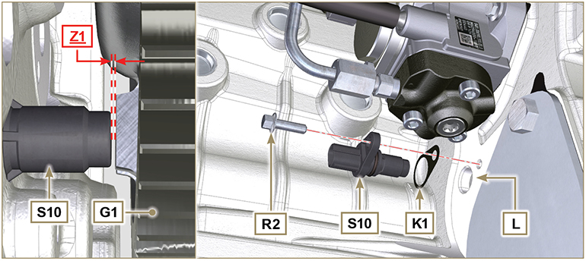
Fig 9.85A
9.13.1.5 Speed sensor  - Measure the distance from the coupling surface J to the external diameter of the phonic wheel ( X2 ).  - Measure the distance between the coupling surface J and the sensor surface H ( Y2 ).  - The difference between the 2 measurements determines the air gap value ( Z2 ).  The value ( Z2 ) permitted must be a MIN of 0.2 mm and a MAX of 1.2 mm .  Insert one or two spacers K based on the value ( Z2 ) detected.  NOTE : The calibrated spacers K have a thickness of 0.2mm.  - Secure the bracket M with the screws N inserting the washer S (tightening torque at 10 Nm ).  - Insert the shim K on the sensor H .  - Clamp the sensor H on the bracket M with the screw R (tightening torque at 10 Nm - ST_06 ). | 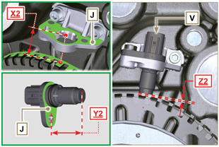  Fig 9.86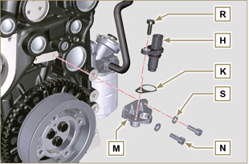  Fig 9.87
9.13.1.6 Fuel filter water detection sensor  - Lubricate and insert the gasket V on the fitting W .  - Tighten the sensor W onto the cartridge Z (tightening torque of 5 Nm ). | 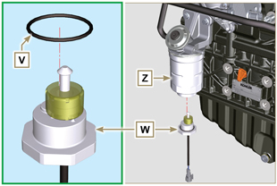  Fig 9.88
9.13.3 Alternator  - Insert the washer E onto the screw F .  - Insert the screw F onto the alternator G .  - Secure the bracket H and the alternator G using the screws L1, F onto the crankcase L .  9.13.4 Starter Motor  - Perform the operations to point 10 of Par. 6.6.2 . | 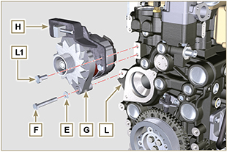  Fig 9.90
9.13.5 Electric cabling  - Position the cable holder N together with the cabling P on the rocker cap Q .  - Screw the wiring holder N on the rocker cap Q with the screws R (tightening torque of 10 Nm - ST_06 ).  - Mount the connectors C1 on the electronic injectors S1 .  Warning  - Slightly move wiring support N to check that there is no voltage in the electrical wire of connector C1 in correspondence with the outlet hole N1 . | 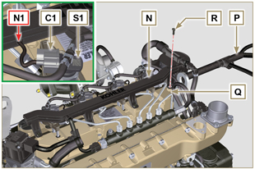  Fig 9.91
- Fit the connector C2 on the sensor S2 . | 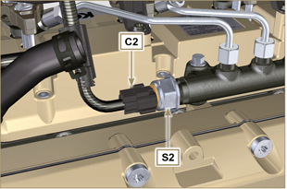  Fig 9.92
- Fit the connector C3 on the sensor S3 . | 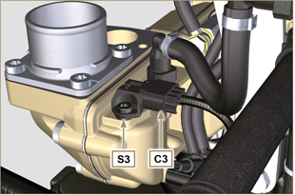  Fig 9.93
- Insert the connector C4 on the fuel intake valve S4 .  - Insert the connector C5 on fuel temperature sensor S5 . | 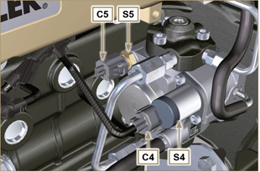  Fig 9.94
- Fit the connector C6 on the sensor S6 . | 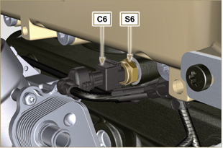  Fig 9.95
- Fit the connector C7 on the sensor S7 .  - Insert the clamp P1 onto the crankcase M .  - Fasten the clamp P2 with the screw T onto the crankcase M (tightening torque of 10 Nm ). | 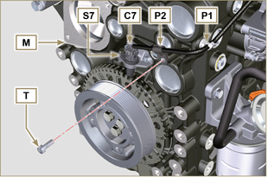  Fig 9.96
- Fit the connector C9 on the sensor S9 . | 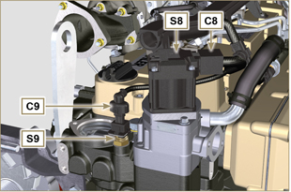  Fig 9.97
- Secure cable X on motor V by means of nut J .  - Secure cable Y on alternator W by means of nut K . | 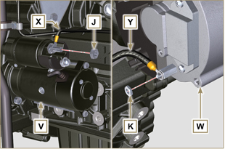  Fig 9.98

Coolant circuit assembly
9.14.1 Thermostatic valve  Important  - Always replace the gasket A after each assembly.  - Check the condition of the seal gasket A and fit it on the thermostatic valve B .  - Position the thermostatic valve B in the seat on the head C (detail D ).  - Secure the cover E with the screws F on the head C (tightening torque of 10 Nm ). | 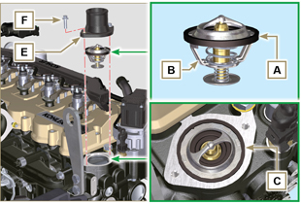  Fig 9.99
9.14.2 Coolant pump  Important  - Always replace the gasket L every time it is assembled.  - Secure the flange G with the screws H interposing the gasket L onto the crankcase M (tightening torque of 25 Nm ).  - Perform the operations of Par. 6.5.2 . | 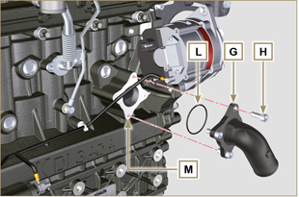  Fig 9.100
9.14.3 Oil Cooler hoses  - Secure hose N on Oil Cooler P and on crankcase M by means of clamps Q .  - Position and secure hose R by means of clamp S on Oil Cooler P and on crankcase M .  - Secure clamps T on manifold U by means of capscrews V in points X (tightening torque 10 Nm - ST_06 ). | 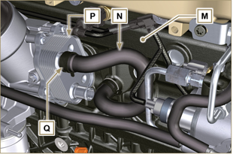  Fig 9.101
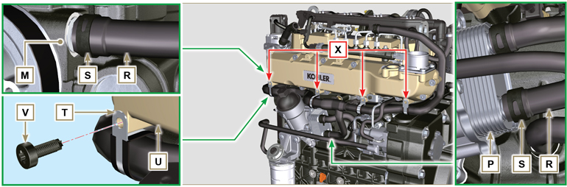
Fig 9.102

ATS ASSEMBLY
1 - Position the support L3 on the cylinder head and tighten the screws H2 and H3 .  2 - Fasten screws H3 (tightening torque of 25 Nm ).  3 - Fasten screws H2 (tightening torque of 85 Nm ). | 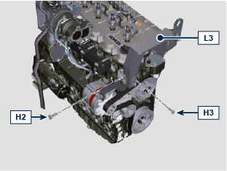  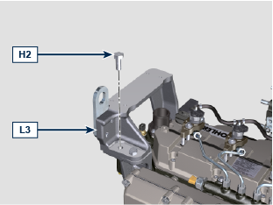
4 - Position the support L2 on the cylinder head and tighten the screws H2 and H3 .  5 - Fasten screws H2 (tightening torque of 85 Nm ).  6 - Fasten screws H3 (tightening torque of 25 Nm ). | 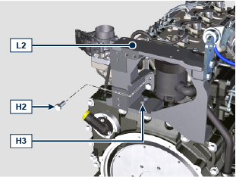  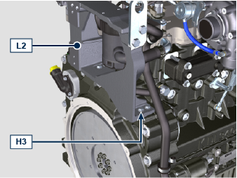  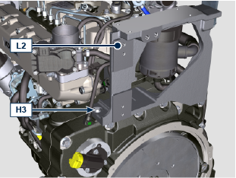
7 - Position the support L1 on supports L2 and L3 and tighten screws H1 .  8 - Fasten screws H1 (tightening torque of 25 Nm ). | 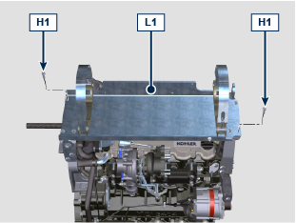
9 - Fasten tube N with nuts M on turbocharger T (tightening torque of 50 Nm ). | 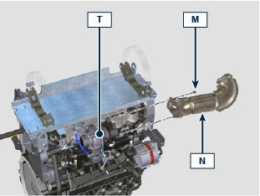
Warning  - Avoid tensioning the assembly of the ATS C on the exhaust line, the MAX misalignment allowed on the junction point is of 1° .  10 - Position the ATS C on clamps G .  11 - Fit ATS C on exhaust line D .  12 - Insert clamp B on the junction and tighten screw A (tightening torque of 12 Nm ). | 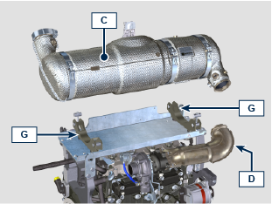  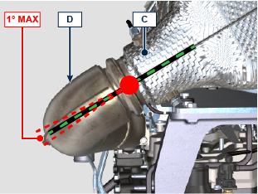  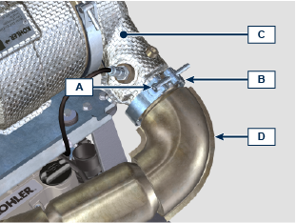
13 - Fasten clamps G with screws F for the fastening of the ATS C (tightening torque of 15 Nm ).  14 - Fit tubes E . | 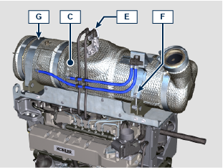  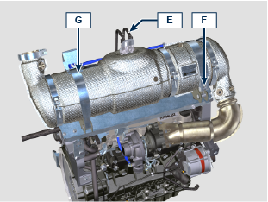

Tightening torques and the use of sealants
Tab. 9.4 - *Alternatively to the capscrew replacements, with "Dri-loc"
BASE CONFIGURATION

SHORT BLOCK
Component | Thread (mm) | Torque (Nm) | Sealer
Oil sprays fastening capscrew | M6x1 | 10
Lower crankcase fastening capscrew | M14x1.25 | 3 Torque cycles
1st Cycle |  | 60
2nd Cycle |  | +45°
3rd Cycle |  | +45°
Lower crankcase fastening capscrew | M10x1.25 | 30
Connecting rod screw | M11x1 | 3 Torque cycles
1st Cycle |  | 28
2nd Cycle |  | +30°
3rd Cycle |  | +30°
Coolant drain hole closing cap | M16x1.5 | 50
Main oil delivery line closing plate | M6x1 | 15
Intermediate idle gear cap fastening screw | M8x1 | 25
OIL SUMP ASSEMBLY
Component | Thread (mm) | Torque (Nm) | Sealer
Oil suction hose fastening capscrew | M6x1 | 10 | Loctite 2701*
Oil return pipe fastening screw | M6x1 | 10 | Loctite 2701*
Oil sump fastening capscrew | M8x1 | 25
Oil drain cap | M18x1.5 | 30
FLANGE ASSEMBLY (1st PTO)
Component | Thread (mm) | Torque (Nm) | Sealer
Flange bell fastening capscrew | M12x1,75 | 75
Flywheel fastening capscrew | M12x1,25 | 3 Torque cycles
1st Cycle |  | 60
2nd Cycle |  | 130
3rd Cycle |  | 130
ENGINE CYLINDER HEAD ASSEMBLY
Component | Thread (mm) | Torque (Nm) | Sealer
Air bleeding cap (Rev. 00) | M6x1 | 6
Air bleeding cap (Rev. 01) | M14x1,5 | 50
Lifting brace fastening capscrew | M8x1.25 | 80
Injector manifold | M12x1 | 30
Cylinder head fastening capscrew | M12x1.25 | 4 Torque cycles
1 ^{st} Cycle |  | 75
2 ^{nd} Cycle |  | +90°
3 ^{rd} Cycle |  | +90°
4 ^{th} Cycle |  | +90°
Rocker arm gudgeon fastening capscrew | M8x1,25 | 40
Rocker arm cover fastening capscrew | M6x1 | 10
INJECTION SYSTEM
Component | Thread (mm) | Torque (Nm) | Sealer
Fuel filter fastening capscrew | M8x1.25 | 25
Fuel cartridge fastening | ... | 17
Common rail fastening capscrew | M8x1.25 | 25
Electronic injector brace fastening capscrew | M8x1.25 | 20
Distributor fastening capscrew | M8x1.25 | 25
Waste line fastening drilled capscrew on common rail | M10x1 | 30
Injector side injection tube nuts | M12x1.5 | 25
Injection pump side injection tubes nuts | M12x1.5 | 25
Common Rail side injection tubes nuts | M14x1.5 | 30
Injection pump fastening capscrew | M8x1.25 | 25 | Loctite 2701*
Gear fastening nut on high-pressure fuel injection pump | M14X1.5 | 140
Screw for cover over injection pump shaft nut (on bell housing) | M6x1 | 10
INTAKE MANIFOLD
Component | Thread (mm) | Torque (Nm) | Sealer
Internal semi-manifold fastening capscrew (on cylinder head) | M8x1.25 | 25
External semi-manifold fastening capscrew | TG8 | 22
Intake flange fastening capscrew | TG8 | 22
EXHAUST MANIFOLD
Component | Thread (mm) | Torque (Nm) | Sealer
Exhaust manifold fastening screw | M10x1.5 | 50
Exhaust manifold fastening nut | M10x1.5 | 50
Exhaust manifold fastening stud | M10x1.5 | 2 Torque Cycles
1 ^{st} Cycle |  | 40
2 ^{nd} Cycle |  | 80
LUBRICATION CIRCUIT
Component | Thread (mm) | Torque (Nm) | Sealer
Oil vapour separator support plate fastening capscrew | TG8 | 22
Oil vapour separator support fastening capscrew (on crankcase) | M6x1 | 12
Oil steam separator return tube drilled fastening screw (on cranckase) | M16x1.5
Oil filter fastening union | M20x1.5 | 15 | Loctite 2701*
Oil cooler fastening capscrew | M6x1 | 10
Cartridge-holder cover | ... | 25
Oil pump fastening screw | M6x1 | 10
CRANKSHAFT AND TARGET WHEEL PULLEY ASSEMBLY (2nd PTO)
Component | Thread (mm) | Torque (Nm) | Sealer
Phonic wheel fastening capscrew (on crankshaft pulley) | M6x1 | 10
Crankshaft pulley fastening capscrew | M12x1.75 | 100 | Molyslip
COOLANT CIRCUIT

Component | Thread (mm) | Torque (Nm) | Sealer
Coolant tube clamp fastening capscrew (Oil Cooler return) | TG8 | 22
Thermostatic valve cover fastening capscrew | M6x1 | 10
Coolant pump fastening capscrew | M8x1.25 | 25
Blower fastening capscrew | M8x1.25 | 25
TURBOCHARGER
Component | Thread (mm) | Torque (Nm) | Sealer
Oil return tube fastening capscrew | M6x1 | 10
Oil supply tube fastening capscrew | M10x1 | 15
Turbine fastening stud (on manifold) | M10x1.5 | 25
Exhaust flange fastening stud (on turbine) | M8x1.25 | 25
Turbine fastening stud | M10x1.5 | 30
Exhaust flange fastening nut (on turbine) | M8x1.25 | 25
ELECTRICAL COMPONENTS
Component | Thread (mm) | Torque (Nm) | Sealer
MAP sensor fastening capscrew | M6x1 | 10
Coolant temperature sensor | M12x1.5 | 20 max.
Oil pressure switch | M12x1.5 | 35
Phase sensor fastening capscrew | M6x1 | 10
Speed sensor fastening capscrew | M6x1 | 10
Sensor for water presence in fuel |  | 5
Alternator fastening capscrew | M10x1.5 | 45
Alternator fastening capscrew | M8x1.25 | 25
Alternator brace fastening capscrew | M12x1.75 | 75
Starter motor fastening capscrew | M10x1.5 | 45
Supply cable fastening nut (starter motor) | M10x1.5 | 15
ETB fastening screw | M6 | 10
ATS COMPONENTS
Component | Thread (mm) | Torque (Nm) | Sealer
DCU fastening screw | M6 | 8
ETB fastening screw | M6 | 10
DEF heating valve fastening screw | M6 | 10
DEF injector fastening screw | M6 | 8
DEF pump fastening screw | M8 | 19
Ambient temperature sensor | M12x1.5 | 20
SCR temperature sensor | M14x1.5 | 45
DEF draining screw (tank supplied by KOHLER) | .... | 20
NOx Sensor | M20x1.5 | 60 | Castrol Optimol Paste MF  o  Bostik Never-Seez Grade
NOx control unit | ... | 3
EGTS (black | yellow) | M12x1.25 | 30 | Castrol Optimol Paste MF  o  Bostik Never-Seez Grade
Union fastening nut for Delta-P tube | M14x1.5 | 55 | Castrol Optimol Paste MF  o  Bostik Never-Seez Grade
Delta-P fastening screw | M6x16 | 10
ATS support fastening screw | M12x30 | 85
 | M8x25 | 25
ATS support plate fastening screw | M8x25 | 25
ATS fastening clamp screw (V clamp) | M8x70 | 15
ATS component fastening clamp screw (V clamp) | M8 | 15
ATS fitting clamp screw (V clamp) on exhaust line | M8 | 12
* Alternatively to the capscrew replacements, with "Dri-loc"

OPTIONAL COMPONENTS (Chap. 11)
HEATER
Component | Thread (mm) | Torque (Nm) | Sealer
Flange intake with heater fastening capscrew | M8x1.25 | 25
IDLE GEAR (FOR 3 ^{rd} )
Component | Thread (mm) | Torque (Nm) | Sealer
Gear fastening capscrew | M8x1 | 25
* Alternatively to the capscrew replacements, with "Dri-loc"

