KDI 3404TCR / KDI 3404 TCR HT
KDI 3404 TCR Workshop Manual (Rev. 10.1)

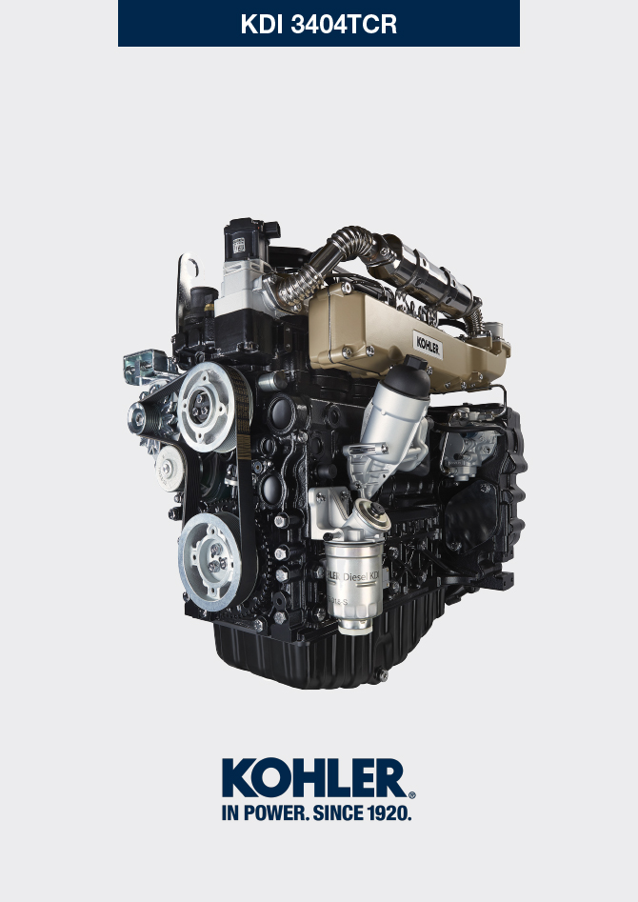
Sommario
1. TITOLO 1 2
1.1. Asdfsdfsdf 2
1.2. Asdfsdfsdfggg 2

General information

Useful information
- This manual contains the instructions needed to carry out proper use and maintenance of the engine, therefore it must always be available, for future reference when required.
- Information, descriptions and pictures contained in this manual reflect the basic configuration of the engines ( Par. 1.4 and Par. 1.5 ).
- However, the development of engines is continuous. Therefore, the information in this manual is subject to change without notice.
- KOHLER reserves the right to make, at any time, changes on the engines for technical or commercial reasons.
- These changes do not require KOHLER to intervene on the production marketed up to that time and nor to consider this manual as inappropriate.
- The paragraphs, tables and figures are numbered by chapter and followed by the progressive paragraph, table and/or figure number.
Es: Par. 1.3 - chapter 1 paragraph 3 .
Tab. 2.4 - chapter 2 table 4 .
Fig. 4.5 - chapter 4 figure 5 .
NOTE: The paragraphs may contain sub-paragraphs.

- All technical terms, specific components and symbols ( Tab. 15.1 ) that are in the manual are listed and described inside the glossary, which can be consulted in ( Chap. 15 ).
- The references of the objects described in the text and in the figure are indicated by letters and numbers, which are always and only related to the paragraph you are reading unless there are specific references to other figures or paragraphs.
- Reference to values are indicated by letters or numbers.
- Other important references are highlighted in red.
- The mark ( ) after the title of a paragraph, indicates that the procedure is not required in order to disassemble the engine, however the procedures are featured in order to illustrate the disassembly of components.
- Any additional section that KOHLER will deem necessary to supply at a later stage must be kept with the manual and considered as an integral part of it.
- The information contained in this manual is the sole property of KOHLER , therefore no partial or total reproduction or replication is allowed without the express permission of KOHLER .

1.1.1 Useful Information - accident prevention - environmental impact

- Before proceeding repair - handling the motor , read the entire Chap. 3 , which contains important information about the procedures to be followed for safety and environment .

Manufacturer and engine identification
The engine identification name plate is situated in the lower part of the crankcase; it is visible from the intake or exhaust side.
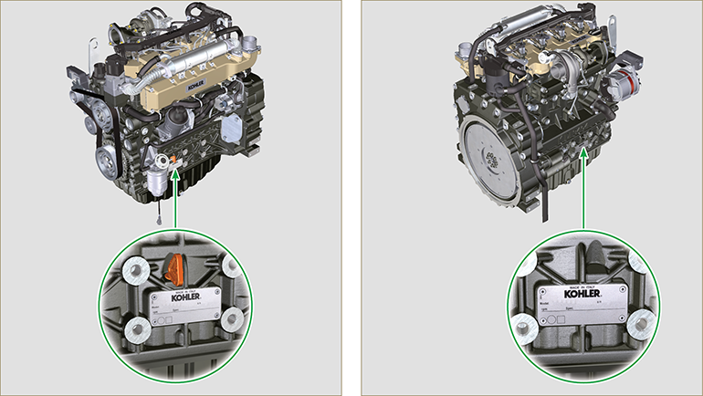
Fig 1.1 - Fig 1.2

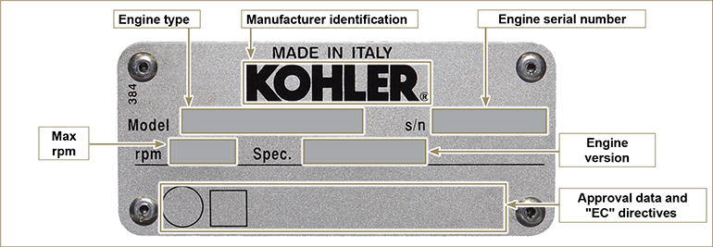
Fig 1.3

Homologation labels
1.3.1 Label for EPA rules (compilation example)

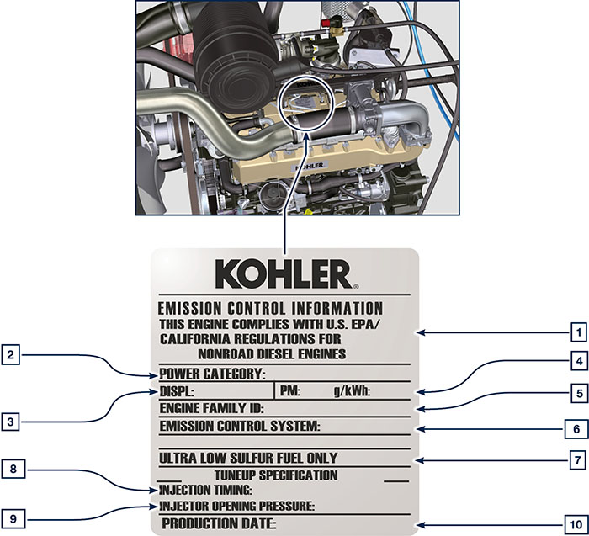

1.1
POS. | DESCRIPTION
1 | Model year in compliance with the rules
2 | Power category (kW)
3 | Engine displacement (L)
4 | Particulate emission limit (g/kWh)
5 | Engine family ID
6 | Emission Control System = ECS
7 | Fuel with low sulphur content
8 | Injection timing
9 | Electronic injector opening pressure (bar)
10 | Production date (example: 2013.JAN)

1.3.2 Label for China Standards (compilation example)

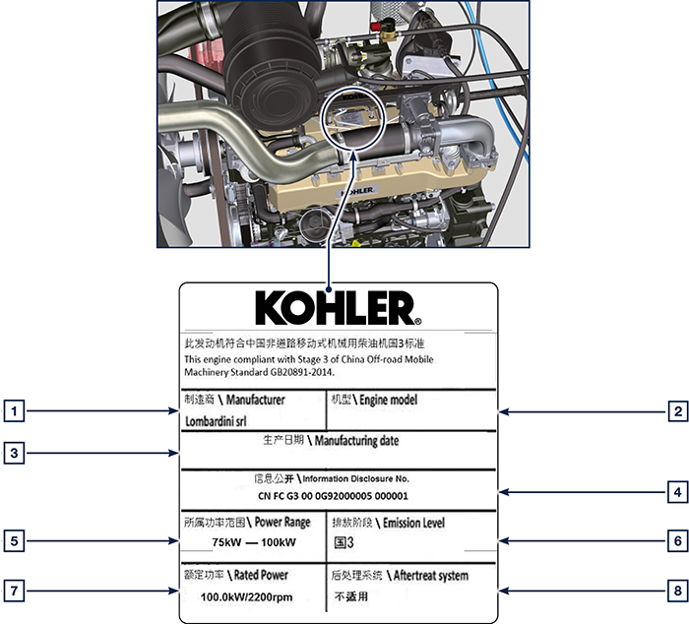

1.2
POS. | DESCRIPTION
1 | Manufacturer
2 | Engine model
3 | Manufactoring date
4 | Certificate N°
5 | Power range (kW)
6 | Emission level
7 | Rated power
8 | Aftertreat system

1.3.3 Label for Korea Standards (compilation example)

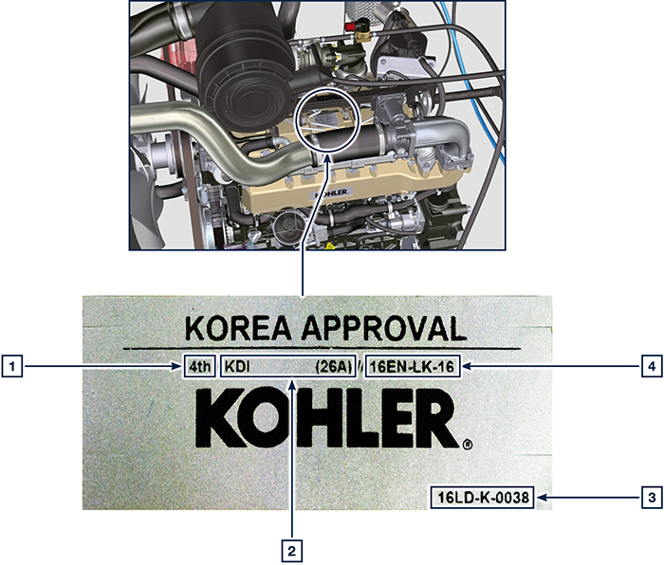

1.3
POS. | DESCRIPTION
1 | Tier 4 Final
2 | Engine model
3 | Manufactoring date and manufacturer code
4 | N° Korea emission certificate

Identification of the main internal components of the engine and operating reference (BASE CONFIGURATION)
WIEW OF EXHAUST SIDE
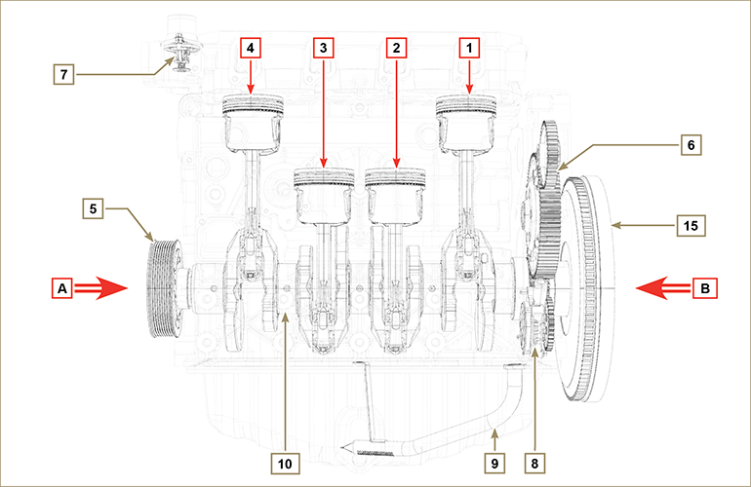
Fig 1.5

The following chapters contain operating references in order to clearly understand the engine. This paragraph illustrates these references that may be recognised by means of some main internal components.  Should you need to execute complex operations, always consult this paragraph.  NOTE: it is advisable to keepthis page visible during disassembly and assembly operations. | Tab 1.2  REF. DESCRIPTION  A View of timing system side (2 ^{nd} PTO)  B View of flywheel side (1 ^{nd} PTO)  C View of exhaust side  D View of intake side  1 Cylinder/Piston N. 1  2 Cylinder/Piston N. 2  3 Cylinder/Piston N. 3  4 Cylinder/Piston N. 4  POS. DESCRIPTION  5 Crankshaft pulley (2 ^{nd} PTO)  6 Gear timing system  7 Thermostatic valve  8 Oil pump  9 Oil suction hose  10 Crankshaft  11 Exhaust manifold  12 Intake manifold  13 Camshaft  14 Gears adaptor for 3 ^{th} /4 ^{th} PTO (optional)  15 Flywheel (1 ^{st} PTO)  16 Gears adaptor for 4th PTO (optional)  17 Balancer shafts
WIEW OF FLYWHEEL SIDE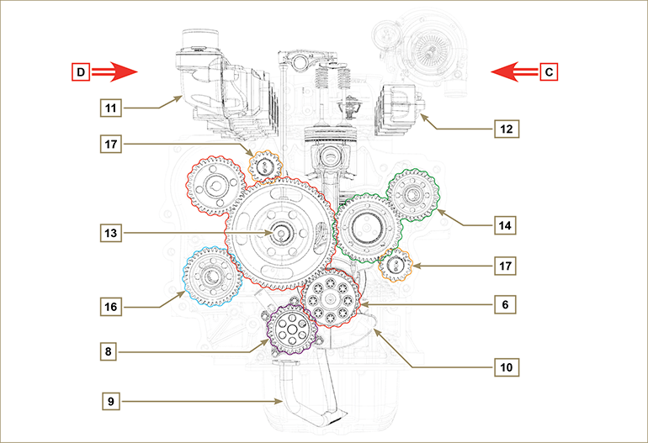
Fig 1.6

Identification of the external components of the engine (BASE CONFIGURATION)
VIEW OF TIMING SYSTEM SIDE - EXHAUST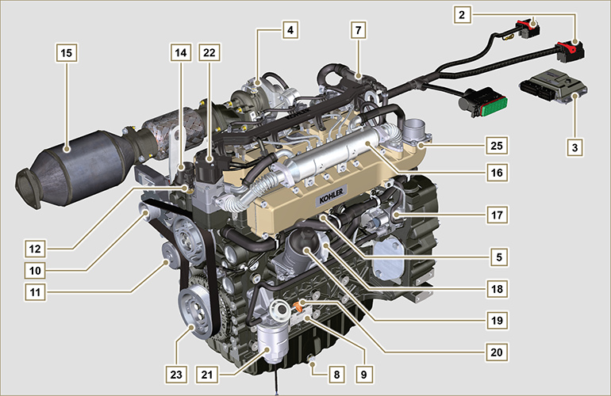
Fig 1.7

VIEW OF FLYWHEEL SIDE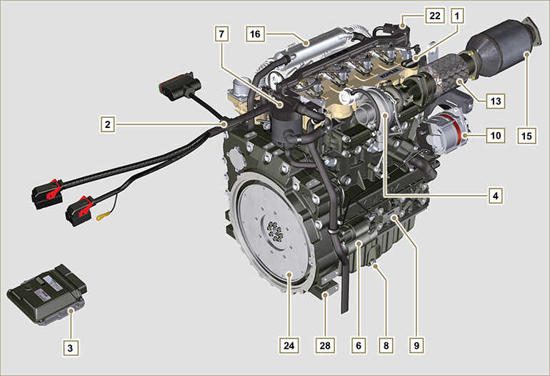
Fig 1.8

This paragraph illustrates all external components that are present in the base configuration of the engine.  For components present on engines that differ from those represented in these illustrations, refer to Chap. 11 . | NOTE: The illustrated components may differ from those illustrated; the illustration is only as an example.
Tab 1.3  POS. DESCRIPTION  1 Oil filler cap  2 Wiring  3 ECU  4 Turbocharger  5 Oil pressure switch  6 Starter motor  7 Oil steam separator  8 Oil drain plug  9 Engine identification name plate  10 Alternator  11 Coolant pump  12 Coolant temperature sensor  13 Oil filler cap side  14 Thermostatic valve  15 DOC  16 EGR Cooler  17 High-pressure fuel injection pump | POS. DESCRIPTION  18 Oil Cooler  19 Lub. oil filter  20 Oil dipstick  21 Fuel filter  22 EGR valve  23 Crankshaft pulley (2 ^{nd} PTO)  24 Flywheel (1 ^{st} PTO)  25 Intake manifold  26 Waste Gate valve control actuator  27 Exhaust manifold  28 Flange bell  29 Electronic injectors  30 Common Rail  31 Air intake hose

UPPER VIEW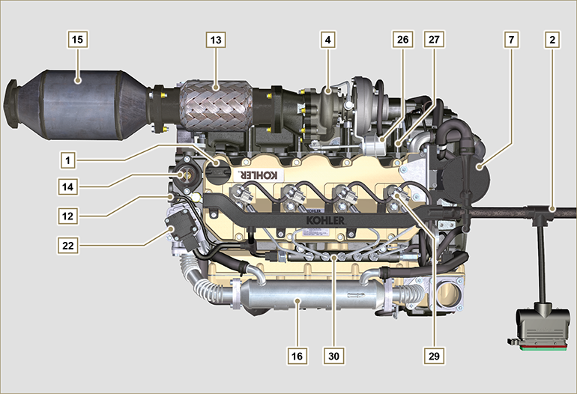
Fig 1.9

ATS (After Treatment System)
1.6.1 ATS with DOC filter  NOTE: The ATS system can be installed in a different way than shown.  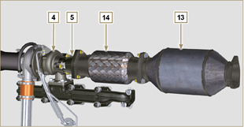  Fig 1.10 | Tab 1.4  POS. DESCRIZIONE  4 Turbocharger  5 Gas exhaust flange  13 DOC  14 Flexible exhaust tube
1.6.2 ATS with DOC+DPF filter  NOTE: the ATS system with DPF filter is only present for versions compliant with "Stage V" emission regulations.  The ATS system can be installed in a different way than shown. | Tab 1.5  POS. DESCRIZIONE  1 Turbocharger  2 Turbine exhaust pipe  3 DOC  4 DPF  5 ETB
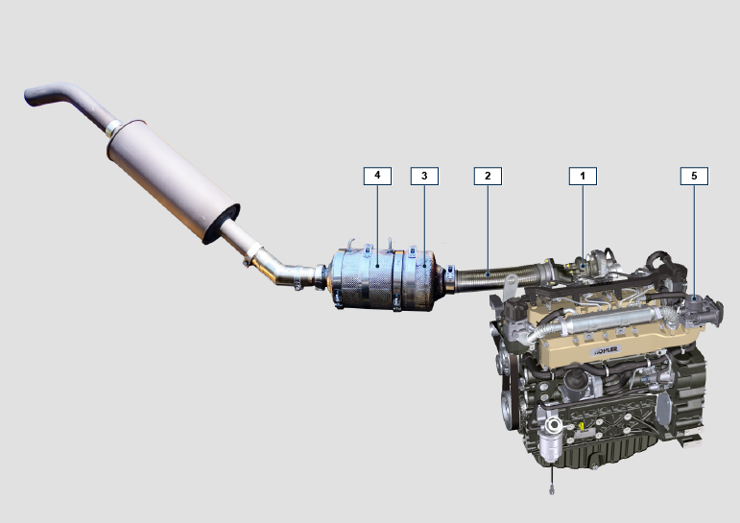
Fig 1.11

Technical information

Engine specifications
Tab. 2.1
MANUFACTURER SPECIFICATIONS AND OPERATION
GENERAL INFORMATION | UNIT OF MEASURE | KDI 3404 TCR / KDI 3404 TCR-SCR
Operating cycle |  | diesel - 4 stroke
Cylinders | N° | 4
Bore x stroke | mm | 88x102
Displacement | cm ³ | 3359
Compression ratio |  | 17:1
Intake |  | Supercharged with Turbocharger
Cooling |  | Liquid
Crankshaft rotation (view from flywheel side) |  | Counterclockwise
Combustion sequence |  | 1-3-4-2
Timing System
Valves per cylinder | N° | 4
Timing System |  | Rods and rocker arms - Camshaft in the crankcase
Tappets |  | Hydraulic
Injection |  | Direct - Common Rail
Engine dry weight | Kg | 394
MAX inclination 30' continuous operation | (min./α) | 40°
MAX inclination 1' continuous operation | (min./α) | 45°
POWER AND TORQUE
GENERAL INFORMATION | UNIT OF MEASURE | KDI 3404 TCR / KDI 3404 TCR-SCR
MAX operating speed | Rpm | 2400
MAX operating power (ISO TR 14396 - SAE J1995 - CE 97/68) | kW | 100
Maximum torque (at 1500 rpm) | Nm | 500
Admissible axial load on crankshaft | Kg
CONSUMPTIONS
GENERAL INFORMATION | UNIT OF MEASURE | KDI 3404 TCR / KDI 3404 TCR-SCR
Specific fuel consumption (best point) | g/kWh | 210
Oil consumption | %Fuel | < 0.1
FUEL SUPPLY SYSTEM
GENERAL INFORMATION | UNIT OF MEASURE | KDI 3404 TCR / KDI 3404 TCR-SCR
Type of fuel |  | Diesel UNI-EN590 - ASTM D975
High-pressure fuel injection pump |  | DENSO HP3
Fuel supply |  | Low pressure electric pump (if necessary)
Fuel filter
Filtering surface | cm ² | 2300
Degree of filtration | µm | 5
Maximum pressure at injection pump inlet | bar | 0,2
LUBRICATION CIRCUIT
GENERAL INFORMATION | UNIT OF MEASURE | KDI 3404 TCR / KDI 3404 TCR-SCR
Lubrication
Recommended oil |  | See Par. 2.4
Circuit forced |  | Lobe pump
Oil sump capacity ( MAX ) | Lt. | 15,6
Oil pressure switch
Intervention pressure ( MIN ) | bar | 0.6±0.1
Oil filter

Maximum operating pressure | bar | 4.0
Degree of filtration | µm | 17±2
Filtering surface | cm ² | 1744
COOLING CIRCUIT
GENERAL INFORMATION | UNIT OF MEASURE | KDI 3404 TCR / KDI 3404 TCR-SCR
Coolant | % | See Par. 2.6
Coolant pump | Lt./min | 155
Thermostatic valve
Opening temperature | °C | +83 (0/-3)
Stroke at 95°C | mm | 7.50
Liquid recirculation | Lt./h
ELECTRICAL SYSTEM - ELECTRIC FAN
GENERAL INFORMATION | UNIT OF MEASURE | KDI 3404 TCR / KDI 3404 TCR-SCR
Circuit rated voltage | V | 12
External alternator (rated current) | A | 90
Starter motor power | kW | 2
System electrical consumption, excluding:  heater, electric pump, electric fan, starter motor | W
Coolant temperature indicator light
Indicator light operating temperature | °C | +100/+110

Engine dimensions (mm)
NOTE : Dimensions vary according to engine configuration.

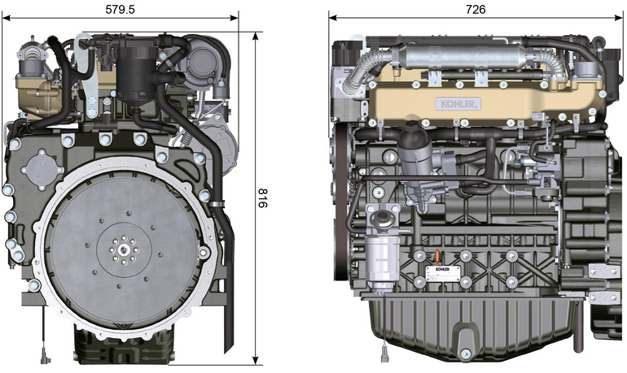
Fig. 2.1 - Fig. 2.2

Performance
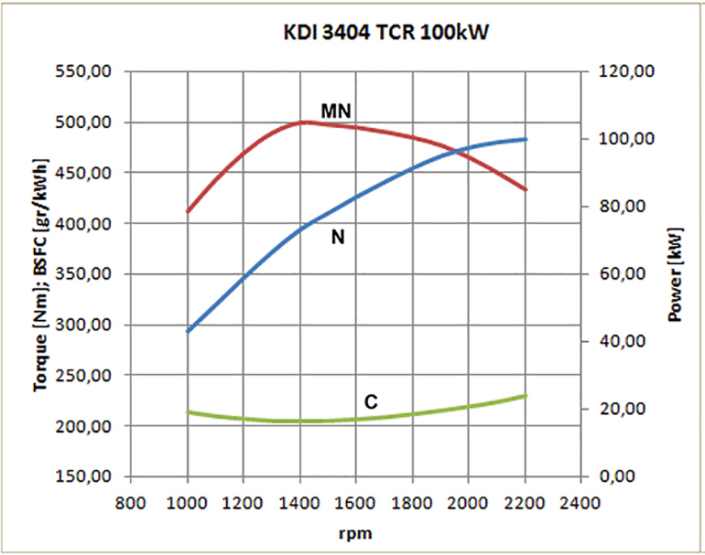

Fig. 2.3
N = Automotive rating curve
MN = Torque curve
C = Specific fuel consumption curve

NOTE: Refer to KOHLER for power curves, torque curves and specific consumptions at speeds other than those given above.

Key

- N ( ISO TR 14396 - SAE J1995 - CE 97/68 ) AUTOMOTIVE RATING CURVE : Intermittent duty at variable speed and load. Engine capacity at intermittent conditions with variable speed and load.

- MN: = TORQUE RATING CURVE : Also called twisting moment, it is the push generated by the engine through transmission. The highest engine performance is obtained at the maximum torque.

- C = SPECIFIC CONSUMPTION CURVE : Engine fuel consumption in a given time at a certain revolution value. Expressed in g/kW (grams/kilowatt), it expresses fuel yield.

* The above curves express indicative values, in that the overall performance depends on the type of application and the ECU control uni.

- The ratings reported in the diagram regard the run-in engine, fitted with air and exhaust filters, at the atmospheric pressure of 1 Bar and at a room temperature of +20°C
- Maximum rating is guaranteed with a 5% tolerance.

Warning

- Non approval by KOHLER for any modification releases the company from liability for damage incurred on the engine.

Oil

Important

- The engine may be damaged if operated with improper oil level.
- Do not exceed the MAX level because a sudden increase in engine rpm could be caused by its combustion.
- Use only the recommended oil to ensure adequate protection, efficiency and service life of the engine.
- The use of lubricants other than recommended may shorten the engine life.
- Viscosity must be appropriate to the ambient temperature to which the engine is to be exposed.

Danger

- Prolonged skin contact with the exhausted engine oil can cause cancer of the skin.
- If contact with oil cannot be avoided, thoroughly wash your hands with soap and water as soon as possible.
- For the exhausted oil disposal, refer to the Par. DISPOSAL and SCRAPPING .
2.4.1 SAE oil classification
- In the SAE classification, oils are identified according to viscosity without considering any other qualitative characteristic.
- The code is composed of two numbers, which indicate, and must correspond to, the ambient temperature in which the engine operates, the first number refers to the viscosity when cold, for use during winter (" W "), while the second number is for viscosity at high temperatures.

2.2
RECCOMENDED OIL
 |  | TCR STAGE-V (*1) (*2) | TCR TIER IV FINAL (*1) | TCR/D TIER III o NON CERTIFICATO (*3)
WITH SPECIFICATIONS | API | CJ-4 Low S.A.P.S | CJ-4 Low S.A.P.S | CI-4 Plus  CI-4  CH-4
 | ACEA | E6 Low S.A.P.S. | E6 Low S.A.P.S. | E7  E5
VISCOSITY | SAE | 0w-40 (-40°C ÷ +50°C)  5w-30 (-30°C ÷ +40°C)  10w-40 (-25°C ÷ +50°C)  10w-30(-25°C ÷ +40°C) | 0w-40 (-40°C ÷ +50°C)  5w-30 (-30°C ÷ +40°C)  10w-40 (-25°C ÷ +50°C)  10w-30(-25°C ÷ +40°C) | 0w-40 (-40°C ÷ +50°C)  5w-30 (-30°C ÷ +40°C)  10w-40 (-25°C ÷ +50°C)  10w-30(-25°C ÷ +40°C)
- Low S.A.P.S. technology (oil with low Sulfated Ash, Phosphorus, Sulfur content) keeps catalyst in good working conditions. The presence of sulfated ash, phosphorus and sulfur causes with time the catalyst clogging and its consequent inefficiency.
- For Mid S.A.P.S oil sequence the sulfated ash level is the same as API CJ-4 ≤ 1.0% but as per ACEA standardization those oils are referenced as mid SAPS.
- Filtration of oils is critical to proper operation and lubrication; always change filters regularly as specified in this manual.

(*1) NOTA : Do NOT use fuel with sulphur content above 15ppm.

(*2) - On all engines compliant with Stage-V emission regulation (engines with DPF device), the oil to use must comply with the specification API CJ-4 Low S.A.P.S or ACEA E6 Low S.A.P.S.

(*3) - NOTE : Do NOT use fuel with sulphur content above 500ppm.

(*3) - NOTE : Low S.A.P.S. oils, sulfate ashes <1% may not be used with fuels with a sulfur content >50ppm.

Fuel

Important

- Use of other types of fuel could damage the engine. Do not use dirty diesel fuel or mixtures of diesel fuel and water since this will cause serious engine faults.
- Any failures resulting from the use of fuels other than recommended will not be warranted.

Warning

- Clean fuel prevents the fuel injectors from clogging. Immediately clean up any spillage during refuelling.
- Never store diesel fuel in galvanized containers (i.e. coated with zinc). Diesel fuel and the galvanized coating react chemically to each other, producing flaking that quickly clogs filters or causes fuel pump and/or injector failure.
2.3
FUEL COMPATIBILITY
EN 590 (biodiesel content max. 7% (V/V))
ASTM D 975 Grade 1-D S15
ASTM D 975 Grade 2-D S15
NATO F-54, equivalent to diesel fuel in accordance with EN 590
EN 590 or ASTM D 975 Grade 1, 2 -D S15 Arctic Diesel
JIS K 2204 No. 1, No. 2
NOTE : In a warranty case the customer must prove by a certificate from the fuel supplier that an allowed fuel was used.
KDI Electronic Injection Tier 4 final – Stage IIIB – Stage IV- Stage V certified Engines
- Those engines are designed for fuels in accordance with EN 590 and ASTM D975 for a cetane number of at least 45. Since those engines are equipped with exhaust gas after-treatment such as Diesel Oxidation Catalyst (DOC), Diesel Particulate Filter (DPF), Selective Catalytic Reduction (SCR), they may only be operated with sulfur-free diesel fuels (EN 590, DIN 5168, ASTM D975 Grade 2-D S15, ASTM D975 Grade 1-D S15). Otherwise, compliance with the emission requirements and durability are not guaranteed.
Insufficient lubricating capacity can lead to serious wear problems above all in common rail injection systems. Too low a lubricating capacity is particularly a problem in fuels with a low sulfur content (and in this respect sulfur contents ‹500 mg/kg can already be considered low). An adequate lubricating capacity is guaranteed by the appropriate additives in low-sulfur (‹50 mg/kg) or sulfur-free (‹10 mg/kg or ‹15 mg/kg) diesel fuels according to EN 590 and ASTM D 975. In low-sulpur and sulfur-free diesel fuels which do not comply with this standard, the lubricating capacity may have to be guaranteed by additives. The parameter for sufficient lubricating capacity is a maximum wear spot of 460 micrometers in the HFRR test (EN ISO 12156-1).

KDI Electronic Injection Tier 3 – Stage IIIA emission equivalent certified Engines (EGR engines)
- Those engines are designed for fuels in accordance with EN 590 and ASTM D975 for a cetane number of at least 45. Since those engines are not equipped with exhaust gas after-treatment, they can be operated with diesel fuels with sulfur content up to 500 mg/kg (ppm). Compliance with the emission requirements is guaranteed only with sulfur content up to 350 mg/kg (ppm).
Fuels with a sulfur content > 50 mg/kg demand a shorter lubricating oil change interval. This is set at 250hrs. However, the engine oil must be changed when the Total Base Number TBN is reduced to 6.0 mgKOH/g test method ASTM D4739. Do not use low SAPS engine oils.

2.5.1 Fuel for low temperatures
- When operating the engine in ambient temperatures lower than 0 degrees C, use suitable low temperature fuel normally available from fuel distributors and corresponding to the specifications of Tab. 2.3 .
- These fuels reduce the formation of paraffin in diesel at low temperatures.
- When paraffin forms in the diesel, the fuel filter becomes blocked interrupting the flow of fuel.

2.5.2 Biodiesel fuel
- Fuels containing 10% methyl ester or B10, are suitable for use in this engine provided that they meet the specifications listed in the Tab. 2.3.
- DO NOT USE vegetable oil as a biofuel for this engine.
2.4
BIODIESEL COMPATIBILITY
Biodiesel according to EN 14214 (only permissible for mixture with diesel fuel at max. 10% (V/V))
US biodiesel according to ASTM D6751 – 09a (B100) (only permissible for mixtures with diesel fuel at 10% (V/V))

2.5.3 Synthetic fuels: GTL, CTL, BTL, HV
It is a well-known fact that engines which are operated for longer periods with conventional diesel fuel and then converted to synthetic fuels suffer shrinkage of polymer seals in the injection system and thus fuel leaks. The reason for this behavior is that the aromatic-free synthetic fuels can lead to a change in the sealing behavior of polymer seals.
Therefore, conversion from diesel fuel to synthetic fuel may only be done after changing the critical seals. The problem of shrinkage does not occur when an engine was operated with synthetic fuel from the start.

2.5.4 Non-Road Fuels
Only for KDI Electronic Injection Tier 3 – Stage IIIA emission equivalent certified Engines (EGR engines).
Other non-road fuels may be used if they comply with all the limit values of EN 590 except for the fuel density, the cetane number and the sulfur content.
The following limits apply for these parameters:
2.5
FUEL PARAMETER | UNIT | LIMIT VALUE
Cetane number |  | Min. 49
Fuel density at 15°C | Kg/m ³ | 820 - 860
Sulfur content | mg/kg or ppm | max. 500

2.5.5 Emission-Related Installation Instructions Failing to follow the instructions in the applications guidebook when installing a certified engine in a piece of nonroad equipment violates federal law (40 CFR 1068.105(b)), subject to fines or other penalties as described in the Clean Air Act.

OEM must apply a separate label with the following statement: “ULTRA LOW SULFUR FUEL ONLY” near the fuel inlet.

Ensure you are installing an engine appropriately certified for your application. Constant speed engines may only be installed on constant speed equipment for constant speed operation.

If you install the engine in a way that makes the engine's emission control information label hard to read during normal engine maintenance, you must place a duplicate label on the equipment, as described in 40 CFR 1068.105.

Coolant recommendation
A mixture of 50% demineralized water and 50% low silicate ethylene glycol based coolant liquid must be used. Use a Long Life or Extended Life Heavy Duty OAT coolant free of: silicates, phosphates, borates, nitrites and amines.

The following ethylene-glycol based engine coolant for all models within KDI engine family may be used:

- OAT (Organic Acid Technology) Low Silicate: ASTM D-3306 D-6210
- HOAT (Hybrid Organic Acid Technology) Low Silicate: ASTM D-3306 D-6210

The above coolants in concentrated formulation must be mixed with distilled, deionized, or demineralized water. A pre-mixed formulation (40-60% or 50-50%) can be used directly when available.

Important
- Do not mix ethylene glycol and propylene glycol based coolants. Do not mix OAT and HOAT based coolant. OAT performance life can be drastically reduced if contaminated with nitrite-containing coolants.
- Never use automotive-type coolants. These coolants do not contain the correct additives to protect heavy – duty diesel engines.

OAT coolants are maintenance free up to 6 years or 6000hrs of operation , provided that the cooling system is topped up using the same type of coolant. Do not mix different coolant types. Test the coolant condition annually with coolant test strips.
HOAT are not all maintenance free and it is recommended to have SCA (Supplemental Coolant Additives) added at the first maintenance interval.

Battery recommendation
Battery not supplied by Kohler

Tab. 2.6
RECOMMENDED BATTERIES
AMBIENT TEMPERATURE | BATTERY TYPE
≥ - 15°C | 120 Ah/20 h - 1000 CCA/SAE
< -15°C | 130 Ah/20 h - 1100 CCA/SAE

Periodic maintenance
The intervals of preventive maintenance in Tab. 2.7, Tab. 2.8, Tab. 2.9 and Tab. 2.10 refer to the engine operating under normal operating conditions with fuel and oil meeting the recommended specifications.

2.7
CLEANING AND CHECKING
OPERATION DESCRIPTION | PERIOD (HOURS)
 | 100 | 250 | 500 | 5000
Engine oil level ⁽⁸⁾
Coolant level ⁽⁸⁾⁽⁹⁾ | Components not supplied by KOHLER .  Refer to the technical documentation of the vehicle
Cartridge dry-type air filter ⁽²⁾
Radiator heat-exchange surface and Intercooler ⁽²⁾
Alternator belt ⁽⁸⁾
Rubber hose (intake air / coolant)
Fuel hose
Starter Motor

Alternator

2.8
REPLACEMENT
OPERATION DESCRIPTION |  | PERIOD (HOURS)
 |  | 1500 | 5000
Intake manifold hose (air filter - intake manifold) ⁽⁷⁾
Coolant hoses ⁽⁷⁾
Fuel line hose ⁽⁷⁾
Alternator belt | Poly-V belt heavy environmental condition
 | Poly-V belt standard condition
Coolant | OAT
 | HOAT ⁽¹⁰⁾
Cartridge dry-type air filter ⁽²⁾ |  | Components not supplied by KOHLER .  Refer to the technical documentation of the vehicle

2.9
ENGINE OIL AND OIL FILTER CARTRIDGE REPLACEMENT
ENGINE VERSION | PERIOD (HOURS)
 | 250 | 500
KDI TCR Tier 4 final – Stage IIIB – Stage IV- Stage V ⁽¹⁾
KDI TCR/D Tier 3 – Stage IIIA ⁽¹⁾

2.10
FUEL FILTER AND PREFILTER CARTRIDGE REPLACEMENT
ENGINE VERSION | PERIOD (HOURS)
 | 250 | 500
KDI TCR Tier 4 final – Stage IIIB – Stage IV- Stage V ⁽¹⁾
KDI TCR/D Tier 3 – Stage IIIA ⁽¹⁾
(1) - In case of low use: 12 months.

(2) - The period of time that must elapse before checking the filter element depends on the environment in which the engine operates. The air filter must be cleaned and replaced more frequently under very dusty conditions.

(3) - In case of low use: 36 months.
(7) - The replacement interval is only an indication, it strongly depends from environmental condition and hose status detected during regular visual inspection.
(8) - The first check must be done after 10 hours.
(9) - Test the coolant condition annually with coolant test strips.
(10) - It is recommended to have SCA (Supplemental Coolant Additives) added at the first maintenance interval.

Fuel system
2.9.1 Injection circuit (pressure 2000 bar) (Fig 2.4)
The materials of the fuel system components (pipes, tank, filters, etc.) and any surface treatments must be free from chemical elements that, transported in the fuel, compromise the operation of the injectors over time (hole clogging).

The most critical chemical element is Zinc (Zn), therefore it is forbidden to use galvanised components.

Other damaging elements are indicated in the table below.
Tab 2.11
POLLUTANTS | LIMIT VALUES OF PRESENCE IN FUEL | LIMIT VALUE
Zn (Zinc) | - Zinc (Zn) is eluted from the rubber (NBR) in the fuel line. Thus, the growing carboxylate (Zn) was adhered on the parts in the injection system for reacting carboxylic acid in the fuel.  - In case that the changed injection quantity, nozzle coking occurs the fuel contents Zn≥1ppm.  - Zinc (Zn) is ≤ 0.3ppm is the limited value to avoid occur coking. | Zn ≤ 0.3ppm
Pb (Lead) | - Lead (Pb)is eluted from Pd coading in the fuel tank. Thus, the growing carboxylate (Pd) was adhered on the injection system for reacting carboxylic acid in the fuel.  - In case that the changed injection quantity and nozzle coking occurs the fuel contents Pd.  - As interim, the identical level is the limited value with Zn. | Pd ≤ 0.3ppm
Na (Sodium) | - The growing carboxylate (Na) was adhered on the parts in the injection system for reacting carboxylic acid in the fuel with fuel contents Na ≥ 0.5ppm. Thus, sliding malfunction was occurred.  - In case that the changed injection quantity and nozzle coking occurs the fuel contents Na.  - Especially concerns of occurring defects, NaOH is residue for using production process of bio fuel.  - ≤ 0.3ppm is the limited value to avoid occur nozzle coking and carboxylate. Combine K with Na equivalent alkali metal that are less than 0.3ppm. | Na + K ≤ 0.3ppm
K (Potassium)
Ca (Calcium) | - In case that carboxylate (Ca) was adhered the injection system inside.  - Under study on the results in the moment.  - Maximum value is 0.3ppm when using fuel that is B100 fuel with regulation EN14214 of contents 7%. | Ca + Mg ≤ 0.3ppm
Mg (Magnesium)
Cu (Copper) | - Copper (Cu) on the fuel that can be acted wear and catalyst for making decline.  - In case that the changed injector quantity and nozzle coking occurs in the fuel contents Cu.  - As interim, the identical level is the limited value with Zn. | Cu ≤ 0.3ppm
Ba (Barium) | - In case that changed injection quantity and nozzle coking occurs in the fuel contents Barium (Ba).  - As interim, the identical level is the limited value with Zn. | Ba ≤ 0.3ppm
P (Phosphorus) | - Phosphorus (P) in the fuel can poison catalyst.  - No failure case is in the injection system in the moment.  - Maximum value is 0.3ppm when using a B100 fuel with regulation EN 14214 of contents 7%. | P ≤ 0.3ppm
Na - K - Ca - Mg - P | These metals are regulated in EN14214

Important

- The high pressure supply injection system is highly susceptible to damage if the fuel is contaminated.
- It is crucial that all components of the injection circuit are thoroughly cleaned before the components are removed.
- Thoroughly wash and clean the engine before maintenance.
- Contamination in the injection system may cause a reduction in in performance or engine faults.
- If the engine is cleaned with high pressure washer, then the nozzle must be kept at a minimum distance of 200mm from the surface, and not directed at electrical components and connectors.

The fuel supply system is under low pressure from fuel tank 1 to the high-pressure fuel injection pump 5 .  NOTE : The representation of fuel tank is purely indicative. Component not necessarily supplied by KOHLER .  Tab 2.12  POS. DESCRIPTION  1 Fuel tank  2 Fuel pipe under low pressure from the tank to the fuel filter  3 Fuel filter  4 Low-pressure fuel tube from the fuel filter to the high-pressure injection pump  5 High-pressure fuel injection pump  6 High-pressure fuel tube from the high-pressure fuel injection pump to the Common Rail  7 Common Rail  8 Fuel pipes under high pressure from the Common Rail to the electronic injectors  9 Electronic injectors | 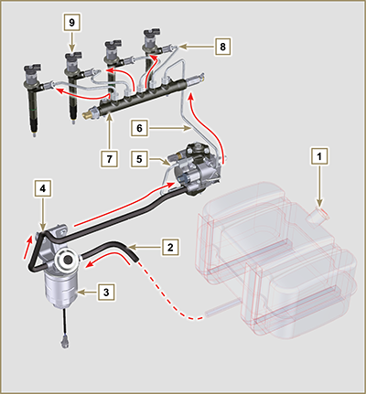  Fig 2.4
2.9.2 Fuel return circuit  The fuel return circuit is under low pressure.  NOTE : The representation of fuel tank is purely indicative. Component not necessarily supplied by KOHLER .  Tab 2.13  POS. DESCRIPTION  1 Electronic injectors  2 Common Rail  3 Low-pressure fuel return tube from the Common Rail to the fuel return distributor  4 Low-pressure fuel return tube from the electronic injectors to the fuel return distributor  5 Low-pressure fuel return distributor  6 Low-pressure fuel return tube from the return distributor to the fuel tank  7 High-pressure fuel injection pump  8 Low-pressure fuel return tube from the injection pump to the fuel return distributor  9 Fuel tank | 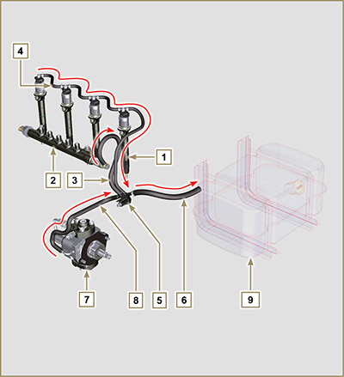  Fig 2.5

2.9.3 High-pressure injection pump (2000 bar)  Important  - DO NOT use the cylinder connecting pipe (item 5) to carry the pump during movement as this may cause damage resulting in fuel leakag; to handle the injection pump, refer Par. 2.17.1.  - The injection pump CANNOT be repaired.  - DO NOT perform any maintenance on temperature sensor 7 as it is integral part of of the injection pump  - DO NOT attempt to remove the temperature sensor 7 from the pump. Should the sensor 7 be defective, replace the injection pump.  - It is possible to replace the fuel intake adjustment valve (SCR) 6.  - DO NOT attempt to remove the fuel intake regulating valve 6 from the injection pump. Should the valve be defective, replace the injection pump.  NOTE: In the event of leakage from the high pressure circuit do not intervene when the engine is running, but turn it off and wait 5 - 10 minutes before checking the leakage.  The inlet pressure to the high pressure pump must be between -250 mbar (suction pump without electric supply) and 200 mbar (with electric pump power) to the high pressure rail.  The high pressure pump is operated via the pump control gear and sends high pressure fuel to the common rail.  NOTE: The supply tube (on union 8) and fuel return (on union 9), have different diameters.  Tab 2.14  POS. COMPONENTS DESCRIPTION  1 High-pressure fuel injection pump  2 Name plate with QR code  3 Fitting for high pressure outlet to Common Rail  4 Plunger housing  5 Connection pipe plunger housing  6 Fuel intake regulating valve  7 Fuel temperature sensor  8 Fuel inlet fitting  9 Fuel return fitting  10 Shaft key positioning on the pump control gear  11 Pump control shaft  12 Gasket | 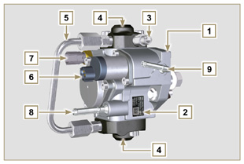  Fig 2.6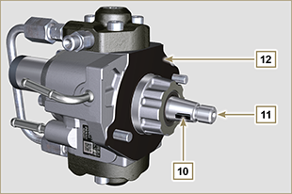  Fig 2.7

2.9.4 Electronic injector  The electronic injector is equipped with an integral solenoid valve which, when excited electronically, manages a valve controlled from  inside the electronic injector to commence fuel injection.  The ECU output signal is digital.  Important  - The electronic injector is NOT repairable.  - The electronic injectors are calibrated individually.  - They are NOT interchangeable with the other cylinders of the same - or other - engines.  - It is assembled on the engine; the new calibration code (QR code) must be inserted in the ECU by means of a diagnostics instrument (ST_01).  - Do NOT fit new or different electronic injectors without the instruments required to enter the injector calibration code.  - Fuel containing impurities causes serious damage to the electronic injectors. | 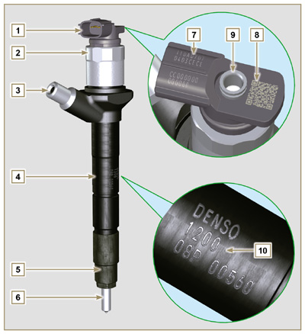  Fig 2.8  Tab 2.15  POS. COMPONENTS DESCRIPTION  1 Connector for solenoid control  2 Solenoid and valve closure ring  3 High pressure pipe inlet fitting  4 Electronic injectors body  5 Nozzle closure ring nut  6 Nozzle  7 QR code (Visual reading)  8 QR code (Electronic reading)  9 Return pipe fitting  10 Electronic injector identification code
2.9.5 Common Rail
Fuel is injected under pressure into the Common Rail ( Pos.3 ), from the high-pressure fuel injection pump.
- The internal volume of the Common Rail is optimised to obtain the best compromise in order to minimise pressure peaks due to the cyclical flow of the injection pump;
- Opening the electronic injectors;
- The high speed response of the system to the requests of the ECU control unit.
The pressure sensor 5 measures the pressure of the fuel in the Common Rail.
Safety valve 2 , only opens if internal pressure of the Common Rail exceeds the maximum value of 2400 bar.
Pressure inside the Common Rail is regulated by the highpressure fuel injection pump by means of the fuel intake regulation valve ( Pos. 6 Fig. 2.6 ).

The fuel ejected from the safety valve is introduced in the circuit of rejection returning to the tank.

Important

- Common Rail is NOT reparaible.
- It is NOT possible to perform any maintenance on the fuel pressure sensor 5 , as it is an integral part of the Common Rail unit.
- Do NOT remove the pressure sensor or the fuel pressure limit valve from the Common Rail.
- If the pressure sensor or the pressure limit valve are not working, replace the entire Common Rail unit.
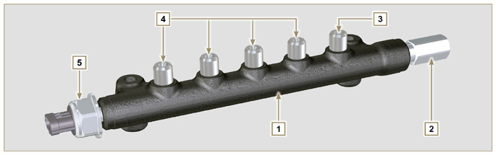
Fig 2.9

Tab 2.16
POS. | DESCRIPTION
1 | Common Rail
2 | Pressure limit valve (return due to overpressure)
3 | Tube inlet union from high-pressure fuel injection pump
4 | Outlet fittings for supply pipes to electronic injectors
5 | Fuel pressure sensor

2.9.6 Fuel filtering
2.9.6.1 Fuel filter  The fuel filter is situated on the crankcase of the engine or it may be assembled on the frame of the vehicle.  Tab 2.17  POS. COMPONENTS DESCRIPTION  1 Fuel filter support  2 Fuel system filling button  3 Cartridge  4 Water in fuel sensor  5 Wing nut, filter drainage  Tab 2.18 Cartridge characteristics  DESCRIPTION VALUE  Filtering surface 2.300 cm ²  Degree of filtration 5 µm  Max operating pressure 2.0 Bar  Max flow rate 190 litres/hour | 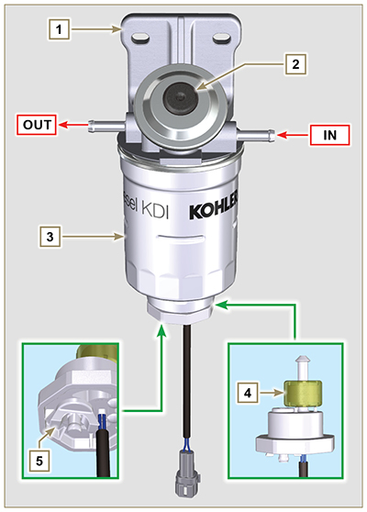  Fig 2.10
2.9.6.2 Fuel pre-filter (optional)  The fuel pre-filter is situated on the engine or may be assembled on the frame of the vehicle, and is always coupled with the electric pump.  2.18b  POS. COMPONENTS DESCRIPTION  1 Fuel filter support  2 Fuel system filling button  3 Cartridge  4 Water in fuel sensor  5 Wing nut, filter drainage  6 Fuel clogging sensor  7 Heater  2.18c Cartridge characteristics  DESCRIPTION VALUE  Filtering surface 1.800 cm ²  Degree of filtration 5 µm  Max operating pressure 2.0 Bar  Max flow rate 126 litres/hour | 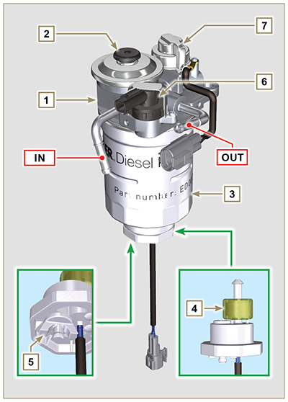  2.10b

2.9.7 Electric fuel pump (optional)  When the electric fuel pump is installed in a diesel engine, one must:  - Install a pre-filter between the tank and electric pump, if one has not already been assembled on the electric pump;  - The electric pump may be assembled on application at a maximum height of 500 mm from the position of the fuel tank.  - Insert a shut-off valve to prevent dry operation due to the emptying of the intake manifold;  - The supply pressure given from the electric pump must not exceed the pressure of 0.2 bar to the input of highpressure injection pump.  Tab 2.19  POS. DESCRIPTION  1 Arrival pipe from the tank  2 Electric pump  3 Flow pipe to the fuel filter  4 Fuel filter  5 Fuel pre-filter | 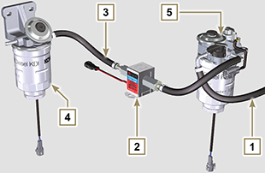  Fig 2.11
2.9.8 Guards for fuel injection circuit components  High-pressure injection circuit components are particularly sensitive to impurities.  To prevent impurities, even microscopic ones, from accessing the fuel input or output unions, you are required to close these accesses by means of specific caps as soon as the various tubes are disassembled and disconnected.  Disassembly of any component of the injection circuit must not occur in dusty environments.  Cap protections must remain closed in their housing (ST_40) until the moment they are to be used.  Pay special attention when using the caps and avoid any contamination of dust or dirt of any kind.  Even after using the caps illustrated in this paragraph, all components of the injection circuit must be placed with care in environments that are free of any type of impurity.  Fig. 2.13, 2.14 and 2.15 illustrate the caps that must be used on components of the injection circuit.  Cap protections must be accurately washed after use and placed back in their housing (ST_40).  Important  - It is highly recommended to have this page visible during disassembly operations of the components of the fuel injection circuit. | 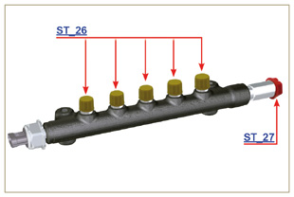  Fig 2.13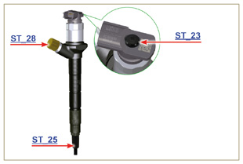  Fig 2.14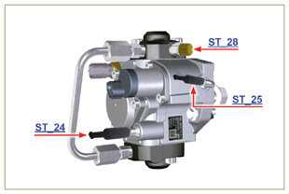  Fig 2.15

Lubrication circuit
2.10.1 Lubrication circuit diagram  The oil pump is driven by the crankshaft on the timing system side.  On the parts of the systems shown in green on In the parts in green, the oil is in intake, in the parts in red, the oil is under pressure and  in those in yellow the oil is returning towards the oil sump 2 (not under pressure).  Tab 2.20  COLOUR DESCRIPTION  Oil in intake  Oil under pressure  Oil returning to the oil sump  Tab 2.21  POS. DESCRIPTION  1 Oil pump rotors  2 Oil sump  3 Crankshaft  4 Camshaft  5 Turbocharger  6 Rocker arm pin  7 Hydraulic tappets  8 Rocker arm cover  9 Cylinder head  10 Upper crankcase  11 Lower crankcase  12 Oil filter  13 Oil Cooler  14 ⁽¹⁾ Idle gear Housing  15 ⁽¹⁾ Left balance shaft  16 ⁽¹⁾ Right balance shaft  ⁽¹⁾ - optional | 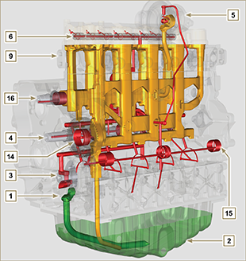  Fig 2.16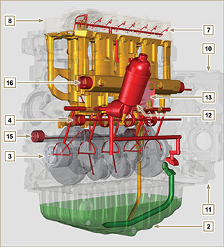  Fig 2.17
NOTE : Click by side to play the procedure. | https://www.youtube.com/embed/rtTjmWlZ1cc?rel=0&showinfo=0
2.10.2 Oil pump The oil pump rotors are trochoidal (with lobes) and are activated from the crankshaft by means of gears.  The pump body is situated on the crankcase.  It is imperative to assemble the rotors with reference A visible by the operator.  Tab 2.22  POS. DESCRIPTION  1 Internal rotor  2 External rotor  3 Oil pump crankcase  4 Oil pump control gear  5 Crankshaft gear | 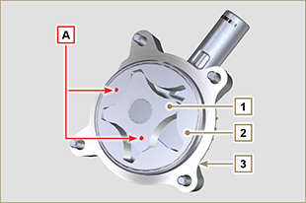  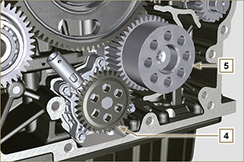  Fig 2.18

2.10.3 Oil filter and Oil Cooler

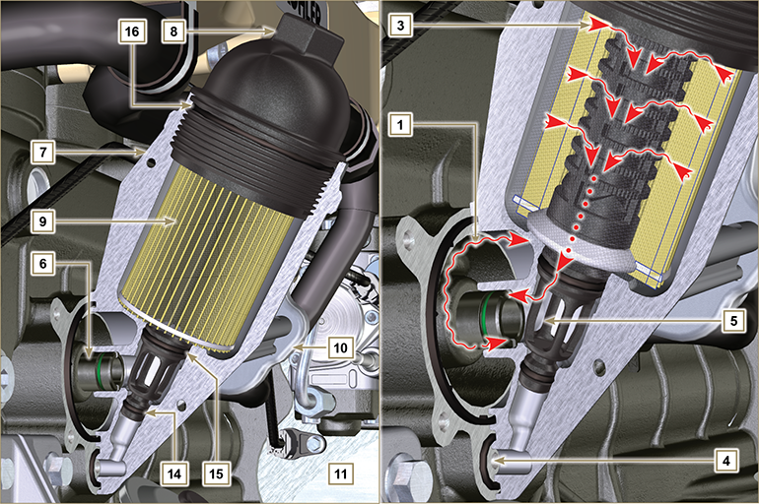
Fig 2.1 9

NOTE : unscrewing the cartridge holder cover makes the oil in support 7 flow towards the oil sump by means of the drain duct 4.
Tab 2.23  POS. DESCRIPTION  1 Oil arriving from the pump  2 Oil cooling  3 Oil filtering  4 Oil drain duct (oil sump return)  5 Oil returning into the circuit  6 Outgoing fitting from filter  7 Oil filter support  8 Cartridge holder cover  9 Oil filter cartridge  10 Oil Cooler  11 Crankcase  12 Oil directly from the cartridge  13 Coolant  14 Oil drain duct closure gasket  15 Oil filtering chamber closure gasket  16 Cartridge holder cover gasket  Tab 2.24 Cartridge characteristics.  DESCRIPTION VALORE  Filtering surface 2.300 cm ²  Degree of filtration 2 µm  Max operating pressure 4.0 Bar  Max flow rate 190 litres/hour | 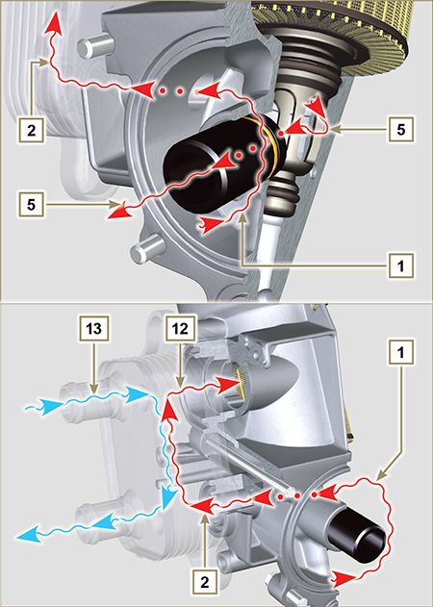  Fig 2.20

Cooling circuit
2.11.1 Cooling circuit diagram  Tab 2.25  POS. DESCRIPTION  1 Coolant pump  2 Coolant intake  3 Coolant, cylinder  4 Coolant, cylinder head  5 EGR gas coolant  6 Coolant to radiator  7 Coolant into radiator  8 EGR valve coolant  9 Coolant in the Oil Cooler  10 Coolant input into the Oil Cooler  11 Coolant output from the Oil Cooler  12 Vent line from radiator (to 15)  13 Vent line to expansion vase (to 15)  14 Return from compensation tank  15 Compensation tank  16 Thermostatic valve  17 Coolant drain cap from crankcase | 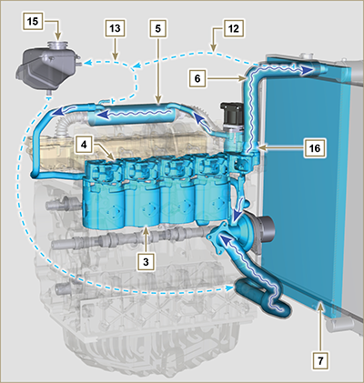  Fig 2.21
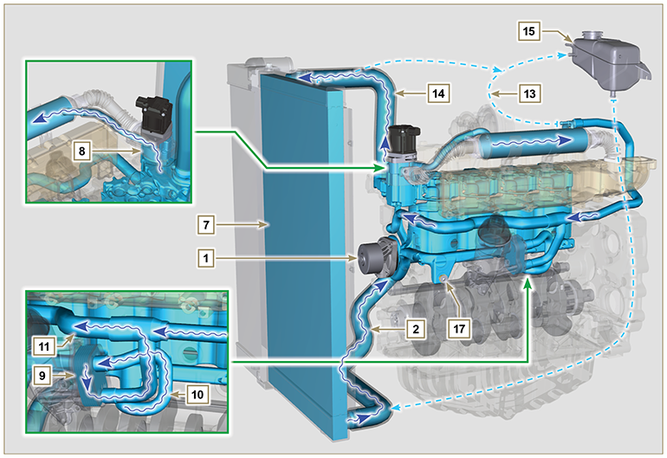
Fig 2.22

2.11.2 Water pump  Tab 2.26  POS. DESCRIPTION  1 Coolant pump control pulley  2 Coolant intake fitting | 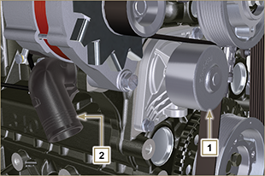  Fig 2.23
2.11.3 Thermostatic valve  Tab 2.27  POS. DESCRIPTION  1 Cylinder head  2 Coolant outlet cover  3 Thermostatic valve  4 Gaskets  5 Air bleeding hole  Starting opening temperature of +83 °C (0/-3 °C). | 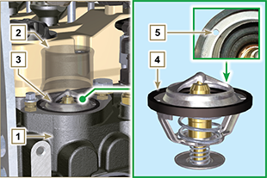  Fig 2.24
2.11.4 EGR gas circuit cooling (EGR Cooler)  Device that cools exhaust gas  Tab 2.28  POS. DESCRIPTION  1 EGR valve  2 EGR gas passage tubes  3 Coolant outlet hose  4 EGR Cooler  5 Coolant draining union  6 Coolant delivery hose  7 Intake manifold  Tab 2.29  COLOR DESCRIPTION  RED Exhaust gas  ORANGE Coolant drain cap from crankcase  BLUE Coolant | 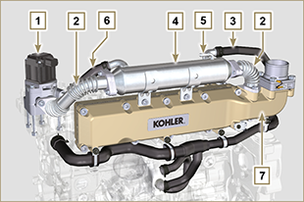  Fig 2.25  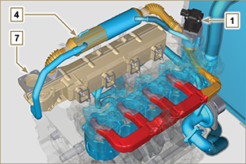  Fig 2.25a

Intake and exhaust circuit
2.12.1 Turbocharger  The turbocharger is controlled by means of exhaust gas that activates the turbine.  Important  - See Par 2.18 .  Tab 2.30  POS. DESCRIPTION  1 Air intake hose  2 Air compression volute  3 Turbo charger central body  4 Turbine housing with Waste Gate valve  5 Gas exhaust flange  6 Waste Gate control valve hose  7 Waste Gate valve control actuator  8 Waste Gate control valve linkage  9 Air compressed flow hose to intercooler  10 Oil drain pipe  11 Turbo charger lubrication pipe | 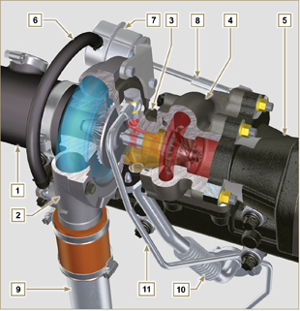  Fig 2.26
2.12.2 Intake and exhaust circuit diagram with EGR

 | Air in intake |  | Gas in recycle |  | Gas in exhaust

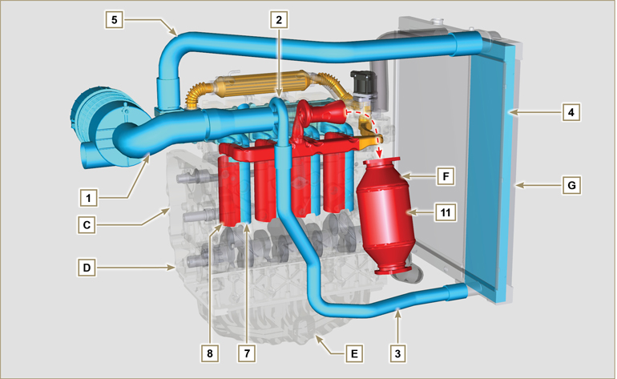
Fig 2.27a

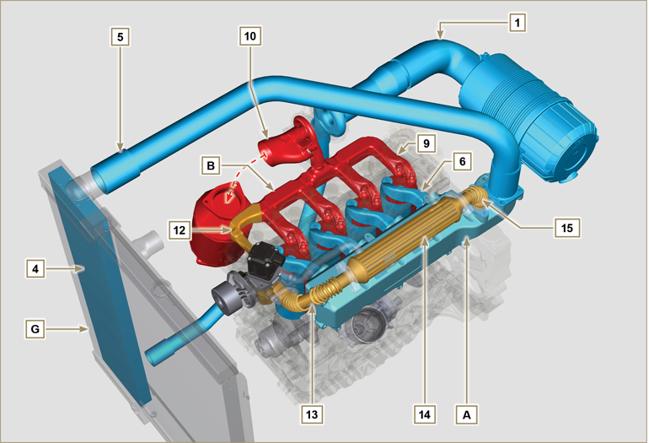
Fig 2.27b

Important

- The air temperature inside the intake manifold must never exceed that of the environment by 10°C.
Filtered air is sucked by the turbocharger, which compresses and sends it to the intercooler (as a consequence of compression, the air increases the temperature - the Intercooler cools it - this process enables better performance during combustion inside the cylinders). From the Intercooler, it is sent to the

intake manifold and, via ducts in the cylinder head, enters the cylinders. Compressed air inside the cylinders and mixed with the fuel transforms into Gas after combustion. The gas is expelled from the cylinders and sent to the exhaust manifold. The exhaust manifold sends the Gases to 2 ducts:

- 1st duct : to the turbocharger body (the expelled Gases activate the turbine), the Gases then proceed towards the catalyst, which break down the pollutants contained in them before being definitely expelled.
- 2nd duct : to the EGR circuit, which takes care of recovering a part of the Gases that return to intake
(this process burns less oxygen when power is not requested, thus breaking down pollutants further).
The EGR circuit is managed by ECU, which controls the EGR valve that provides for the recovery of Gases when the engine does not require power.
The EGR circuit is furnished with a heat exchanger (EGR Cooler), which cools the recovered Gases (this process enables better performance during combustion inside the cylinders).

Tab 2.31a
POS. | DESCRIPTION
1 | Air in intake from air filter
2 | Air in compression
3 | Air in intercooler flow
4 | Air cooling
5 | Air in intake manifold flow
6 | Air in head intake
7 | Air in cylinder intake
8 | Gas in cylinder outlet
9 | Gas in head outlet
10 | Gas in outlet towards catalyst
11 | Gas in oxidation
12 | Gas in recycle towards EGR valve
13 | Gas in EGR valve outlet
14 | Gas cooling (in EGR Cooler)
15 | Exhaust gas recirculation into intake manifold
A | Intake manifold
B | Exhaust manifold
C | Upper crankcase
D | Lower crankcase
E | Oil sump
F | DOC
G | Radiator/intercooler

2.12.3 ATS Device (optional)  2.12.3.1 DOC  The catalyst is a device to filter exhaust gas by means of its oxidation.  Internally, it is composed of hundreds of small ducts that enable the passage of exhaust gas.  It contains precious metals (platinum, palladium, iridium).  NOTE: The image is indicative only. The installation of the DOC must be approved by KOHLER, for each application.  In order to prevent breakage on the connection flange, the catalyst is normally connected via a hose.  Important  - In order to prevent breakage on the connection flange, the DOC must be connected via a flexible exhaust tube ( POS. 14 - Tab. 2.31b ).  Tab 2.31b  POS. DESCRIPTION  4 Turbocharger  5 Gas exhaust flange  13 DOC  14 Flexible exhaust tube | Fig 2.28a
2.12.3.1.1 DOC exhaust gas path and transformation

NOTE: The following data are indicative and may vary based on the engine use conditions.

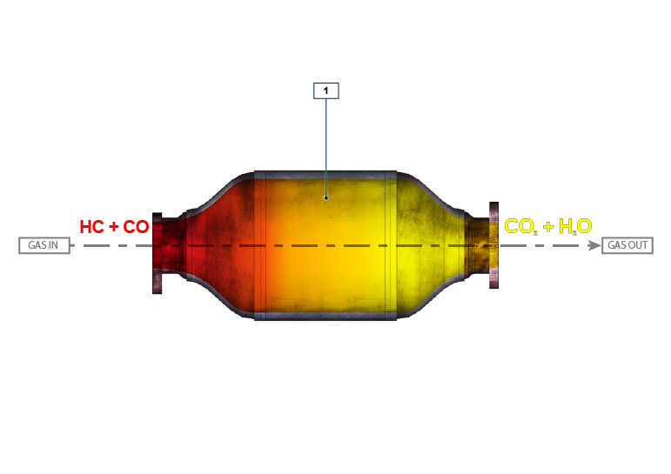
Fig 2.28b

Tab 2. 31c
POS. | DESCRIPTION
1 | DOC Element
HC | Unburnt hydrocarbons
CO | Carbon monoxide
CO ₂ | Carbon dioxide
H ₂ O | Water

2.12.3.2 DOC+DPF

The DOC+DPF system reduces emissions because the DPF eliminates the particulate generated by Diesel fuel combustion. The system triggers automatic DPF regeneration cycles depending on the degree of clogging.
The smell of the gases out of the exhaust line is different than the traditional one of gases from Diesel engines. Moreover, during regeneration stages, the exhaust gases could temporarily be white.

NOTE: During regeneration, engine idling will increase.

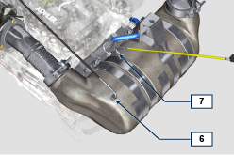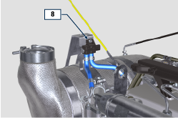
Fig 2.30a

Tab 2. 31f
POS. | DESCRIPTION
1 | turbocharger
2 | exhaust pipe from turbine
3 | DOC
4 | DPF
5 | ETB
6 | EGTS Black
7 | EGTS Yellow
8 | Delta-P (Delta Pressure)

2.12.3.2.1 DPF regeneration strategy

You can intervene on the machine control panel for the DPF regeneration operations "only if requested by means of specific warning lights or messages on the control panel".

Tab. 2.31g describes the level of particulate accumulation, the relationship with the warning lights that will light up on the panel, the performance limitations of the engine and the operator’s options intervention.

Forced regeneration must be executed in accordance with the machine instructions.

Tab 2. 31g
SOOT LEVEL | WARNING LAMPS *1 | ENGINE DE-RATE | OPERATOR POSSIBLE ACTIONS | OPERATING CONDITIONS
Level 0 |  |  |  | - No condition
Level 1
Level 2
Level 3 | Fixed |  | Forced Regeneration is Necessary | - Coolant temperature at 60 °C  - Do not switch the engine off  - Stationary vehicle  - No load applied to the engine *2
Level 4 | Flashing | Engine de-rate | Forced Regeneration is Necessary | - Coolant temperature at 60 °C  - Do not switch the engine off  - Stationary vehicle  - No load applied to the engine *2
Level 5 | Flashing | Strong Engine de-rate | Contact an authorized KOHLER workshop.  Service Regeneration Required | REGENERATION via KOHLER software

*1: The warning lights be different – consult the machine manual.
*2: Unless stated otherwise in the machine manual.

Warning

- Forced regenerations must only be executed if required by the ECU when the "HIGH SOOT" warning light goes on (due to a Level 3 - 5 particulate accumulation).
- Do NOT execute the forced regenerations if not required by the ECU (due to a Level 0 - 2 particulate accumulation).
- The minimum engine speed increases during the forced regeneration phases.
- Repeated forced regenerations cause significant engine oil contamination by the fuel.
- The oil level check must be executed after every forced regeneration.
- If the regeneration inhibition function is misused, the particulate accumulation level will increase within a short time.
- The engine oil filter and oil must be changed after a Service Regeneration is completed via KOHLER software
- (Level 5 Particulate accumulation).
- Fuel contamination allowed in the engine oil is 3% MAX.
- Any engine load must be eliminated during forced regeneration so as to prevent damaging the ATS *2 system.
- Do not switch the engine off during level 3, 4 and 5 regeneration so as to prevent damaging the ATS system.
2.12.3.2.2 DOC+DPF exhaust gas path and transformation

NOTE: The following data are indicative and may vary based on the engine use conditions.

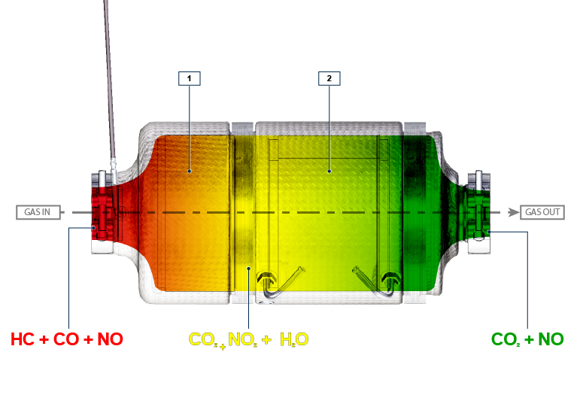
Fig 2.30b

Tab 2. 31h
POS. | DESCRIPTION
1 | DOC Element
2 | DPF filter (particulate accumulation)
HC | Unburnt hydrocarbons
CO | Carbon monoxide
CO ₂ | Carbon dioxide
NO ₂ | Nitrogen dioxide
NO | Nitrogen oxide
H ₂ O | Water

2.12.3.2.3 Intake and exhaust circuit diagram with DOC+DPF

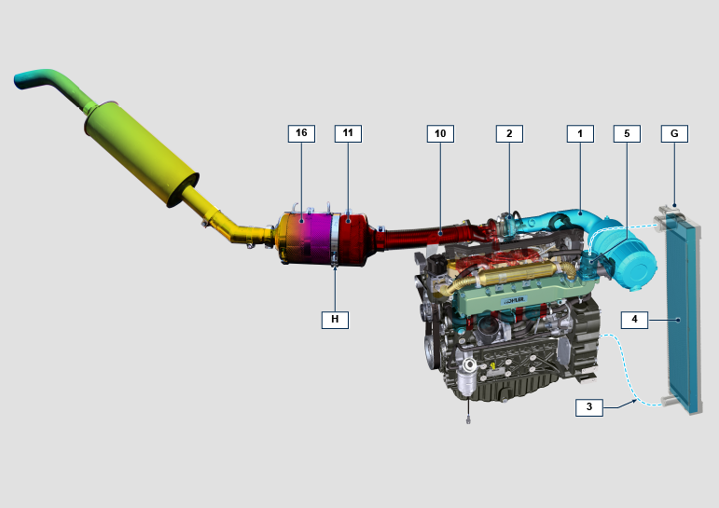
Fig 2.30c

Tab 2. 31i
POS. | DESCRIPTION ( pos. For DPF components only )
1 | Air in intake from air filter
2 | Air in compression
3 | Air in intercooler flow
4 | Air cooling
5 | ETB
10 | Gas in outlet towards DOC
11 | Gas in oxidation (DOC)
16 | Particulate elimination (DPF)
G | Radiator/intercooler
H | ATS

2.12.3 Air filter (optional)  NOTE: Component not necessarily supplied by KOHLER .  Important  - The air filter is a dry type of filter with a paper filtering element; element s H and L are replaceable (refer to Tab. 2.8 and Tab.2.9 for procedure frequency on components).  - Filter suction must be positioned in a cool place.  - Should a hose be used, the length must not exceed 400 mm and is to be as straight as possible.  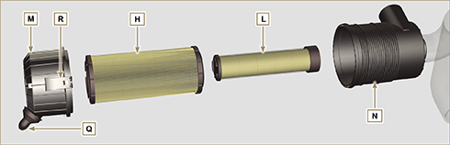  Fig 2.31 | Tab 2.32  POS. DESCRIPTION  H Air filter cartridge  L Air filter safety cartridge  M Filter cover  N Filter support  Q Dust exhaust valve  R Filter cover hook

Electric system
2.13.1ECU (and DCU for SCR versions only) input and output signals diagram

SENSORS/SWITCH (INPUT) |  | DEVICES (OUTPUT)
Power relay | ECU | Electronic injector 1
Engine revolutions sensor |  | Electronic injector 2
Engine phase sensor |  | Electronic injector 3
Coolant temperature sensor |  | Electronic injector 4
Common Rail pressure sensor |  | EGR valve control
Oil pressure switch |  | Fuel intake adjustment valve (SCV)
EGR valve position |  | Revolution indicator
Fuel temperature sensor |  | Heater relay
T-MAP sensor |  | Diagnosis indicator lights
EGR-T sensor |  | ETB control
Main accelerator pedal  (double track) |  | Electric fan control (1-2 speeds or variable speed)
Secondary accelerator pedal (optional) |  | CAN 1 (ISO15765 diagnostics)
Hydraulic oil pressure sensor (optional) |  | CAN 2 (Vehicle SAE J1939)
Fuel level sensor (optional)
Air filter clogging sensor (optional)
Water in fuel sensor
ETB position
EGTS (black) Sensor
EGTS (yellow) Sensor
Delta-P Sensor
MAF Sensor

2.13.2 Control unit (ECU)  The ECU is a central processor, which monitors and controls engine operation.  The electronic control unit is responsible for engine management.  It is fitted on the frame of the vehicle, or in the cab (refer to the technical documentation of the vehicle).  Important  - The ECU must only be used with the configuration defined  by KOHLER , for each individual engine. | 2.13.2.1 Installation rules  - Protection degree: 1P 6K/9K.  - Operating temperature: -40°C - +100°C.  - Storage temperature: -40°C - +100°C.  - Do NOT install the ECU on the engine. It should be mounted on the frame of the vehicle / plant in a position where it will be well cooled, mechanically protected, and free from vibration and ingress of moisture.  - It is crucial that the ECU is earthed. Electrical connection may be as follows: by means of four fixing points D of the ECU to the vehicle brace, thus ensuring good connection (avoid painted or insulated parts).  - Alternatively, connect using a cable (with 4mm ² section and a maximum length of 300 mm) from one of the ECU fixing points D to a plate of mass, taking care to ensure perfect electrical contact.  - The position of the ECU in an application must be done carefully to protect barometric capsule C from liquids (during engine washing or engine/vehicle maintenance).  - The connection area (ECU connectors A-B ) must not be the lowest point of all the wiring to prevent any water infiltrations in the wiring itself.
Fig 2.32 - Fig. 2.33
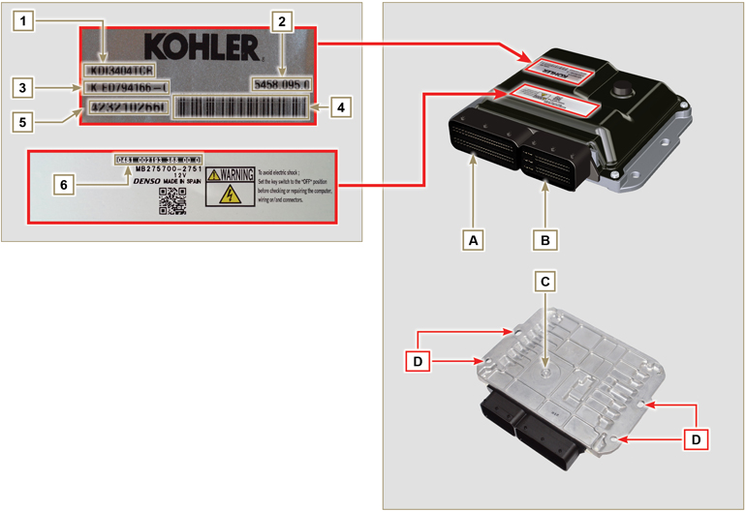

Tab. 2.33
ECU AND ENGINE IDENTIFICATION PLATES
POS. | DESCRIPTION
1 | Engine model
2 | Validation code
3 | Engine specifications
4 | Bar Code of the engine chassis number
5 | Engine chassis number
6 | ECU identification code
A | Connector A (ECU A)
B | Connector B (ECU B)
C | Barometric capsule
D | Fastening points

- Do NOT mount or replace the control unit with that of another engine.
- Although externally each ECU seems to be identical, internally they are specifically configured only for use on the engine that they are supplied with.
- To install a new control unit, is required to recharge on it's the original configuration relating to that specific engine .
- The control units are not interchangeable nor modifiable.
- Each control unit is accompanied by its adhesive identification plate.

2.13.3 Engine electrical wiring

Fig 2.34

Tab. 2.34  RIF. DESCRIPTION  1 Vehicle interface connector (Fig. 2.34a))  2 ECU Connector A (Fig. 2.34b)  3 ECU Connector B (Fig. 2.34b)  4 Fuel pressure regulating valve connector  5 Fuel temperature sensor connector  6 T-MAP sensor connector  7 Common Rail pressure sensor connector  8 Injectors connectors  9 EGR valve connector  10 Engine speed sensor connector  11 Engine phase sensor connector  12 Oil pressure switch connector  13 Coolant temperature sensor connector  14 Throttle Body Connector  15 D+ Connector Alternator  16 Starter motor connector  17 EGR-T (DPF versions only)  18 DPF wiring connector (DPF versions only)  19 Ground  20 Wiring support  21 DPF interface wiring (DPF versions only)  22 Engine wiring connector  23 DPF temperature connector (yellow)  24 DPF temperature connector (black)  25 Delta-P sensor connector | 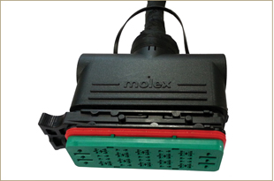  Fig 2.34a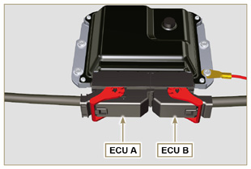  Fig 2.34b
NOTE: Click by side to play the procedure. | https://www.youtube.com/embed/6-0TbYG2EkY?showinfo=0&rel=0
2.13.3.1 Wiring disconnection  All sensor connectors and electronic control devices are sealed.  The connectors must be disconnected by means of pressure on tabs A or unblock the retainers B , as illustrated from Fig. 2.34c to Fig. 2.34q. | 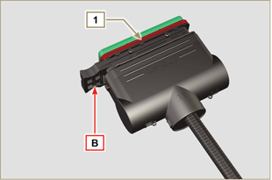  Fig 2.34c
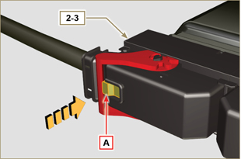  Fig 2.34d | 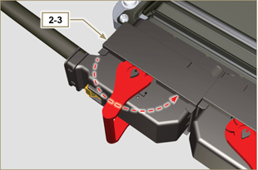  Fig 2.34e
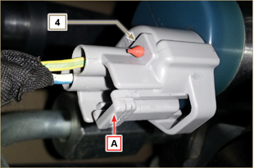  Fig 2.34f | 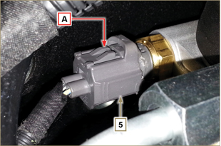  Fig 2.34g
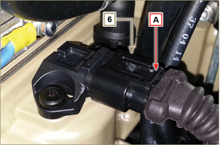  Fig 2.34h | 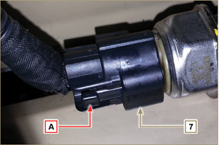  Fig 2.34i
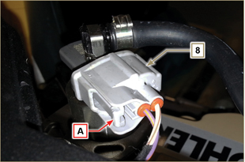  Fig 2.34l | 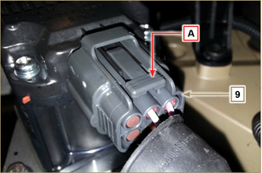  Fig 2.34m
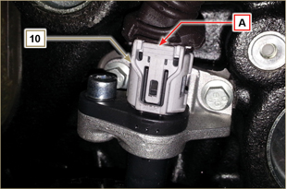  Fig 2.34n | 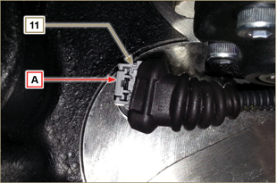  Fig 2.34o
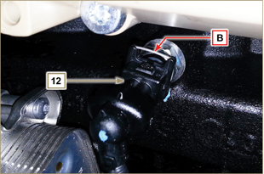  Fig 2.34p | 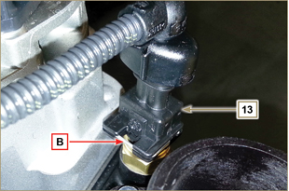  Fig 2.34q
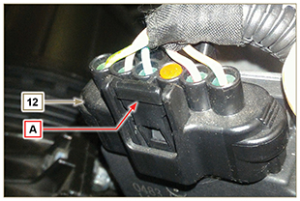
Fig 2.34r

Sensors and switches
2.14.1 Revolution sensor on target wheel  Speed sensor A is situated on the crankcase.  The sensor detects the signal from the target wheel B (60 - 2teeth) situated on the crankshaft pulley. It sends it to the ECU as an analogical signal.  The sensor sends and analogue signal to the ECU.  The sensor produces a 5V square wave signal having a Hall effect while the crankshaft in rotation detects its position and speed.  The data sent by this sensor enables the ECU to pilot fuel anticipation injection for each piston.  For gap adjusting see Par. 9.13.1.5 . | 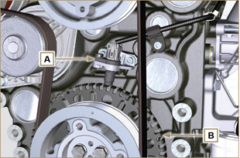  Fig 2.35
2.14.2 Camshaft sensor  Camshaft sensor C is situated on the timing system carter.  The purpose of the camshaft sensor C is to identify the position of the Camshaft control gear D with respect to the engine shaft and consequently the position of the pistons with respect to the T.D.C. The sensor produces a 5V square wave signal having a Hall effect while the camshaft in rotation detects the phases of the 4 strokes of the 1st cylinder. As a consequence, ECU by means of internal calculations, also recognises the phases of the other cylinders.  The data sent by this sensor enables the ECU to pilot fuel anticipation injection for each piston. | 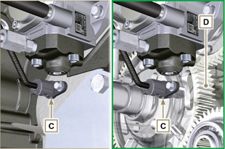  Fig 2.36
2.14.3 T-MAP sensor  The T-MAP F sensor is situated on the intake manifold. It detects the input pressure in the intake manifold by means of electrical voltage variation and the air temperature by means of an electrical resistor.  The sensor sends signals to the ECU, which determines the values and modifies the injection strokes.  Tab. 2.35 reports the electrical resistor values according to the intake air temperature.  NOTE : R indicates the pin where it is possible to measure electrical resistance.  Tab 2.35  °C (°F) R ( Ω )  -30 (-22) 23475 - 25945  0 (32) 5370 - 5935  25 (77) 1900 - 2100  50 (122) 772 - 854  100 (212) 177 - 195  120 (248) 107 - 119 | 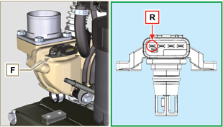  Fig 2.37
2.14.4 Common Rail pressure sensor  Fuel pressure sensor G assembled on the Common Rail, detects the fuel pressure inside it by means of electrical voltage variation.  Depending on the signal sent, ECU manages the fuel intake valve on the injection pump and, if necessary, modifies the injection strokes.  Important  - Refer to Par. 2.9.5 | 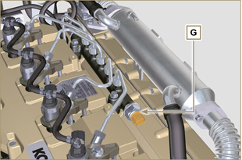  Fig 2.38
2.14.5 Fuel filter water detection sensor  The water presence sensor H is situated in the fuel filter, which is there to indicate the presence of water in the fuel.  Water, if present in the fuel, because of its greater specific weight separates and settles in the lower part of the filter where there is a specific sensor that, by means of the ECU activates an alarm signal on the dashboard.  The butterfly valve nut M situated in the lower part of the body sensor enables the elimination of any water present in the fuel and prevent malfunctions on components of the injection circuit. | 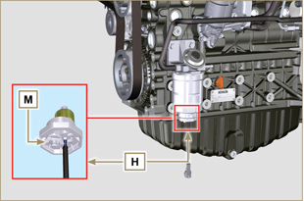  Fig 2.39
2.14.6 Fuel temperature sensor on the fuel injection pump  The fuel temperature sensor L is situated on the high-pressure fuel injection pump.  The fuel temperature sensor L , measures the temperature of the fuel entering the pump at high pressure. The signal sent to the ECU is analogue.  The resistance detected by the ECU is proportional to the fuel temperature.  Important  - Refer to Par. 2.9.3  Tab. 2.36 reports the electrical resistor values according to the fuel’s temperature.  Tab.2.36  ºC (ºF) R (KΩ)  120 (248) 2,811  110 (230) 2,842  100 (212) 2,884  90 (194) 2,940  80 (176) 3,018  70 (158) 3,128  60 (140) 3,284  50 (122) 3,511  40 (104) 3,850  30 (84) 4,360  20 (66) 5,150  10 (50) 6,400  0 (32) 8,440  -10 (14) 11,860  -20 (-4) 17,700  -30 (-22) 28,102 | 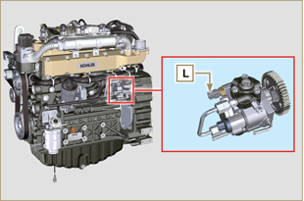  Fig 2.40
2.14.7 Oil pressure switch  Oil pressure switch N is assembled on the crankcase near to the injection pump.  It is a N/C sensor, calibrated at 0.6 bar ± 0.1 bar.  With oil low pressure the sensor closes the electrical circuit and the warning lamp in the panel board switches on. | 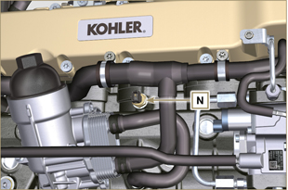 Fig 2.41
2.14.8 Coolant temperature sensor  The P coolant temperature sensor of the coolant circuit is applied to the cylinder head on the side of the thermostatic valve.  It is used by the ECU in order to obtain information regarding the coolant temperature (from PIN R).  NOTE : R refers to the pin where it is possible to measure the electrical resistor.  Tab 2.37  CHARACTERISTICS  Temperature °C R min Ω R max Ω  -35 53983 73806  -30 39229 52941  -15 18006 20825  0 7095 8929  +30 1717 2039  +60 520 589  +90 188 204  +120 76 84 | 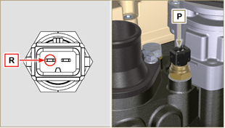 Fig 2.42  NOTE: R indicates the pin where it is possible to measure electrical resistance.
2.14.9 EGR-T sensor (versions with DPF filter only)  The EGR-T J sensor is placed on the air intake manifold after the EGR gas inlet and measures the temperature of the air mixed with EGR gas coming from the turbocharger. Tab. 2.43b shows the electric resistance values based on the intake air temperature.  Tab 2.43b  °C (°F) R (k Ω )  -40 (-40) 130.3  0 (32) 33.87  25 (77) 17.17  50 (122) 9.603  100 (212) 3.739  150 (302) 1.796  200 (392) 1.000 | 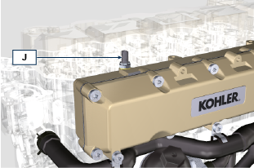  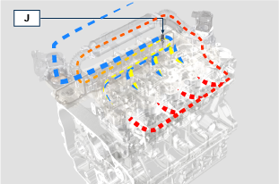  Fig 2.48a
2.14.10 EGTS sensor (yellow - black)  The EGTS sensors K1 and K2 are placed on the ATS system, K1 with black wire before the DOC, K2 with yellow wire after the DOC.  They are both needed for the DPF filter regeneration strategies.  Tab. 2.37b shows the electric resistance values based on the intake air temperature.  Tab 2.43c  °C (°F) R (k Ω )  -40 (-40) 133,8  0 (32) 34,49  50 (122) 9,749  100 (212) 3,771  150 (302) 1,803  200 (392) 1,002  250 (482) 0,6173  300 (572) 0,4127  350 (662) 0,2934  400 (752) 0,2186  450 (842) 0,1690  500 (932) 0,1345  550 (1022) 0,1097  600 (1112) 0,0912  650 (1202) 0,0771  700 (1292) 0,0661  750 (1382) 0,0574  800 (1472) 0,0503  850 (1562) 0,0445 | 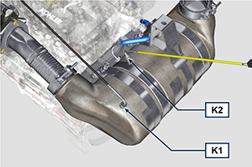  Fig 2.48b
2.14.11 Sensore Delta-P  Delta-P sensor  The Delta-P sensor J detects the clogging level of the DPF filter.  Operating temperature: -30°C - +120°C.  Important  - Connect the J1 and J2 pipes to the Delta-P sensor exclusively as shown in Fig. 2.48c . | 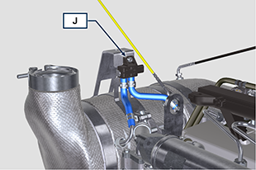  Fig 2.48c  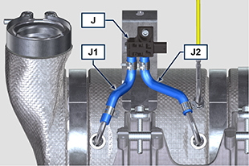  Fig 2.48c
2.14.12 Air cleaner clogging switch  NOTE: Component not necessarily supplied by KOHLER.  The switch is assembled on the air cleaner. When the filter is clogged, it sends a signal to the panel.  Features :  - Operating temperature: - 30 °C / +100°C  - Contact usually open.  - Contact closed by vacuum: -50 mbar. | 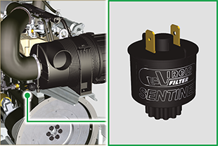  Fig. 2.48d

Electrical components
2.15.1 Alternator (A)  Externally controlled by the crankshaft by means of a belt.  - Ampere 90 A  - Volt 12V | 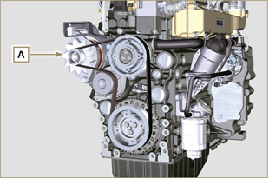  Fig 2.44
2.15.2 Starter Motor (C)  - Type Bosch 12 V  - Potenza 3.2 kW  - Anticlockwise rotation (seen from timing system side) | 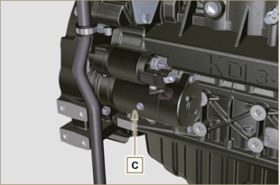 Fig. 2.45
2.15.3 EGR Valve (D)  A device that provides for exhaust gas recovery that is controlled by ECU, which, according to acceleration parameters, RPM and power requested, varies the opening and closing of the valve.  The device has an integrated ECU, which, on each start-up of the control panel, executes an operation self-check.  In the event of a malfunction, it sends a signal to ECU, which, in turn, signals the anomaly on the control panel.  Characteristics:  - Type Dell'Orto EGV A16  - Operating/storage temperature: -30°C / +130°C. | 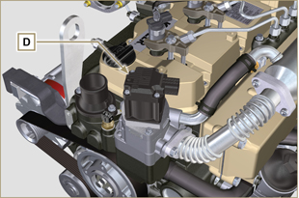 Fig 2.46
2.15.4 Cold starting device (Heater)  The cold starting device consists of a resistance, managed by the ECU, which is activated when the ambient temperature is ≤ -16°C.  The intake air is heated through the resistance and facilitates starting.  Characteristics:  - Type Hidria AET 12 V  - Power 550 W | 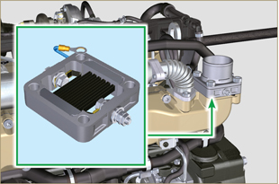 Fig 2.47
2.15.5 Fuel intake regulating valve (SCV)  Valve E is situated on the high-pressure fuel injection pump.  It is managed by ECU, which regulates fuel intake by means of fuel pressure values inside the Common Rail, choking the input entrance of fuel in the injection pump. The digital signal varies the opening of the valve in proportion to the quantity of fuel required for the Common Rail.  Important  - Refer to Par 2.9.3 | 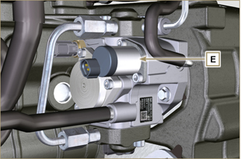 Fig 2.48
2.15.7 Fuel heater  Heater F is situated on the fuel pre-filter. It is activated when required, after checking the fuel, by the clogging sensor G (usually below 10° C).  Note: Both device G and F are connected to the MCU. In the event of faults, refer to the machine’s documentation.  Features:  Volt 12 V  Power140-180 W | 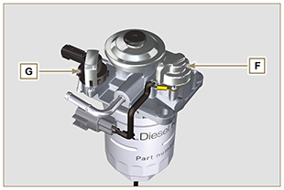  Fig. 2.49
2.15.8 ETB (DPF versions only)  The ETB N is situated on the air intake line, is controlled by the ECU and regulates the amount of intake air and is involved in the DPF system regeneration strategies. | 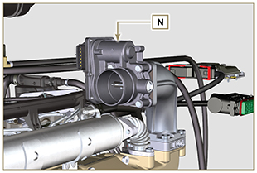  Fig. 2.49e
2.15.9 Electric fuel pump (optional)  NOTE: Component not necessarily supplied by KOHLER.  The electric pump is located before the fuel filter. One of the following pumps can be assembled A1 - A2 - A3 - A4.  Tab. 2.37 (a-d) indicates pump features.  Tab. 2.37  POS. Description  B Electrical connection  C Prefilter pump  IN Ingoing fitting (IN) from tank  OUT Outgoing fitting (out) to fuel filter  Tab. 2.37a  A1 Value  Voltage 12 V - 24 V  Delivery 100 L/h @ 0.44 - 0.56 bar  Tab. 2.37b  A2 Value  Voltage 12 V  Delivery 60.56 L/h @ 0.41 bar  Tab. 2.37c  A3 Value  Voltage 12 V  Delivery 24 L/h @ 0.1 bar  Tab. 2.37d  A4 Value  Voltage 12 V  Delivery 30 L/h @ 0.4 bar | 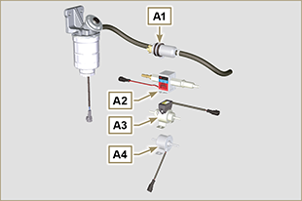  Fig 2.50  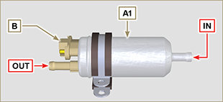  Fig 2.50a  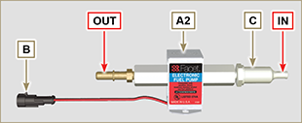  Fig 2.50b  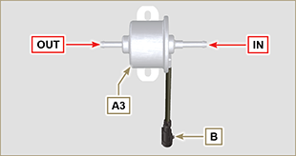  Fig 2.50c  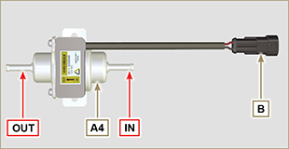  Fig 2.50d

Timing system and tappets
The timing system is equipped with hydraulic tappets that automatically recover the operation of the rocker rods assembly.
No registration is therefore required.

2.16.1 Components identification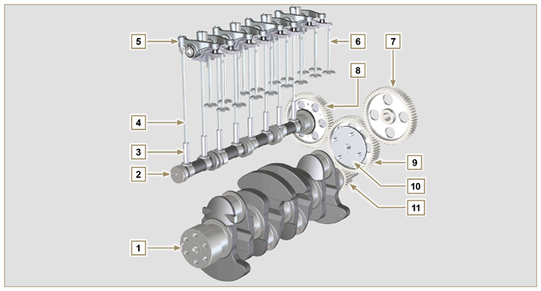
Fig 2.51
Tab 2.38  POS. DESCRIPTION  1 Crankshaft  2 Camshaft  3 Camshaft tappets  4 Rocker arm control rod  5 Rocker arms  6 Valves  7 High-pressure fuel injection gear pump control  8 Camshaft control gear  9 Crankshaft gear  10 Valve control bridge  11 Articulation control valves  12 Hydraulic tappets | 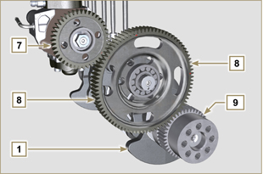 Fig 2.52 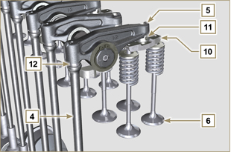  Fig 2.53
2.16.2 Timing system phasing angles  Important  - For information purposes, Tab. 2.39 reports the timing system diagram phasing angle values.  - It should be noted that the said values may be verified by rotating the crankshaft (Pos. 1 of Fig. 2.49) , by means of handling the rocker arm control rod (Pos. 4 of Fig. 2.49) .  NOTE: Detecting the value by means of handling the rocker arm/valves may not be correct due to the hydraulic tappets, which may compress and create clearances that alters the actual value.  Tab 2.39  ENGINE INTAKE EXHAUST  KDI 3404 TCR opens 20° before TDC opens 32° before BDC  closes 32° after BDC closes 16° after TDC | 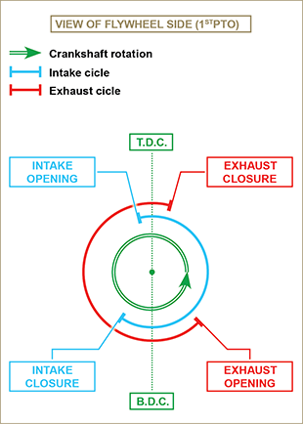  Fig 2.54
2.16.3 Rocker arm pin  Tab 2.40  POS. DESCRIPTION  1 Rocker arm pin  2 Rocker arm distancing spring  3 Rocker arm pin support  4 Exhaust rocker arm  5 Intake rocker arm | 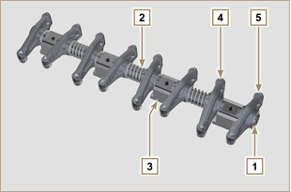 Fig 2.55
2.16.4 Rocker arms  Tab 2.41  POS. DESCRIPTION  1 Rocker arm body  2 Hydraulic tappet oil refill line  3 Valve tappet lubrication line  4 Valve tappet  5 Hydraulic tappet  6 Oil flow line | 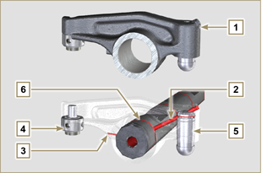 Fig 2.56
2.16.5 Hydraulic tappets  Tab 2.42  POS. DESCRIPTION  A Hydraulic tappets  B Hight pressure chamber  1 Hydraulic tappets oil refill pipe  2 Retaining ring  3 Piston  4 Unidirectional valve  5 Tappet body  6 Spring  2.16.5.1 Hydraulic tappet operation  The operating principle of the hydraulic tappet is based on the incompressibility of the liquids and on controlled leakage.  The oil under pressure enters the tappet chamber A , providing a constant supply of oil in the low-pressure chamber.  Through the non-return valve, 4 the oil can only access the high-pressure chamber B and exit via the clearance between the piston 3 and the tappet body 5 (controlled leakage).  The chamber B is filled when the rocker arm is on the base radius of the cam and the spring 6 keeps the piston 3 against the valve stem, thus eliminating any system play. Thanks to the spring extension, the tappet "extends", creating a small depression in the chamber B , making the non-return  valve 4 open, and allowing the oil in the chamber A to pass to chamber B , restoring the proper amount of oil required to eliminate any play in the valves. | 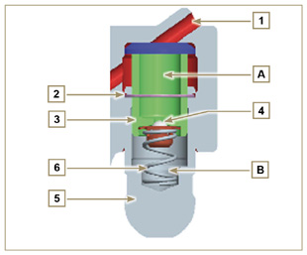  Fig 2.57

2.16.5.2 Difficult operating conditions
For proper operation on the hydraulic tappets it is essential that the low pressure chamber of the piston 3 is always full of oil.

In some conditions this may not occur (due to the fact that the oil leaks away when the engine is switched off, which can also partially drain the tappets). This situation will be the cause of clearances that will result in a characteristic noise similar toa ticking sound.
- When the engine is cold, the tappet filling time could be very long if the oil used is not suitable for the specific environmental conditions ( Tab. 2.2 )
- If the engine is very hot: at idle speed, oil pressure may be low, and small air bubbles could form in the circuit. Because of this, this compressing the tappet slightly and producing valve play which is responsible for the ticking sound. On account of this, the tappet compresses slightly giving rise to a valve clearance, thus generating a slight ticking sound, which however disappears rapidly ( MAX 10 seconds) once normal operating conditions have been restored.

Anyway the duration of ticking Anyway the duration of ticking sound must be MAX 30 seconds. If not, the problem is surely due to the poor quality of the oil, wear or impurities that, transported by the oil, can infiltrate between the ball valve and its seat inside the piston, compromising the operation of the tappet itself; In these cases, the only solution is to replace the oil or hydraulic tappets.

The prolonged persistence of the ticking sound or abnormal noise must be investigating in order to prevent any malfunctions; if necessary, replace the hydraulic tappets and engine oil.

Components handling
2.17.1 High-pressure fuel injection pump  - Only handle by means of the points marked by Y .  - It is forbidden to handle using the points marked by N . | 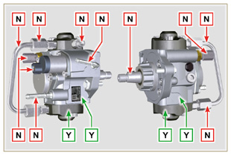  Fig 2.58
2.17.2 Electronic injector  - Only handle by means of the points marked by Y .  -It is forbidden to handle using the points marked by N . | 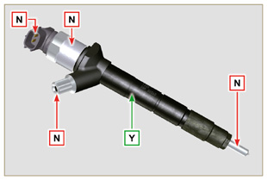  Fig 2.59
2.17.3 Common Rail  - Only handle by means of the points marked by Y .  - It is forbidden to handle using the points marked by N . | 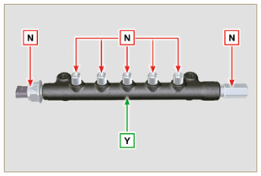  Fig 2.60
2.17.4 Turbocharger  - Only handle by means of the points marked by Y .  - It is forbidden to handle using the points marked by N .  Important  - Refer to Par. 2.18 . | 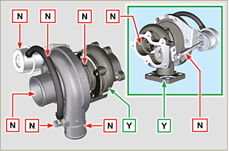  Fig 2.61
2.17.5 EGR-T (versions with DOC+DPF device)  - Only handle by means of the points marked by Y .  - It is forbidden to handle using the points marked by N .  NOTE: The sensor includes ceramic material.  - Do not install sensors which suffered impacts or falls.  - Do not install sensors in case of external contamination  - Do not install visibly damaged sensors  - Use exclusively the socket wrench to install the sensor | 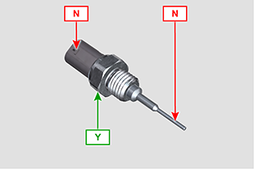  Fig 2.61a
2.17.6 EGTS ( versions with DOC+DPF device )  - Only handle by means of the points marked by Y .  - It is forbidden to handle using the points marked by N .  NOTE: The sensor includes ceramic material.  - Do not install sensors which suffered impacts or falls.  - Do not install visibly damaged sensors  - Do not install sensors in case of external contamination  - Do not apply any force on the cable or the metal elbow | 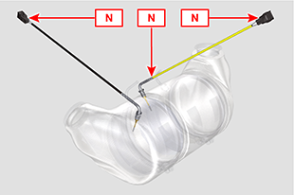  Fig 2.61b  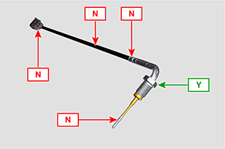  Fig 2.61c

Turbocharger

2.18.1 What to do and what not to do  What to do:  - Before assembling the turbocharger, make sure that the protection caps are fitted on all openings of the turbo.  - Ensure pre-lubrication of the turbocharger.  - Periodically check that the joints are sealed against oil and air.  - Use lubricating oil according to the specifications described in Par. 2.4 .  - Check the engine oil level.  - Before switching it off after it has been used, make the engine run idle, or without a load, for approximately 1 minute.  - Ensure that controls and maintenance intervals of the engine are observed as specified in Tab. 2.8 and 2.9 .  - Make sure that the engine and equipment are used correctly so as not to compromise the life of the turbocharger. | What not to do:  - Do not store turbocharges in damp, wet places if they are not in their original packaging.  - Do not expose the turbocharger to dust and dirt if it is not in its original packaging.  - Do not lift of hold the turbocharger from the actuator rod if it is not in its original packaging.  - Do not apply additives to the lubricating oil and fuel, unless instructed to do so by Kohler.  - Do not increase engine speed, or apply loads, immediately after start-up.  - Do not intervene on the actuator settings A (Fig. 2.61) .  - Do not let the vehicle / engine run at idle speed for more than 20-30 minutes at a time.
2.18.2 Practical operating rules  Users can help to maximise the duration of their turbocharger by following the rules described below.  - Start-up Start the engine at idle speed, or without a load, for approximately one minute. Oil operating pressure is reached within a few seconds and enables the moving parts to warm up and be lubricated.  Immediately increasing the engine speed upon start-up means making the turbocharger run at high speed with suboptimal lubrication, which may compromise the life of the turbocharger.  - After maintenance or a new installation  Proceed with pre-lubrication by filling new oil into the oil supply duct B until filling it completely. Start the engine at idle speed, or without a load, for a few minutes in order to ensure that the oil and bearings system operate satisfactorily.  - Low temperature air or engine inactivity  If the engine has been inactive for some time, or the air temperature is very low, start the engine at idle speed or without a load for a few minutes.  - Engine shutdown  Before switching the engine off after intense activity, one must allow the turbocharger to cool down. One must therefore let the engine run at idle speed or without a load for at least 2 minutes, thus allowing the turbocharger to cool.  - Engine at idle speed  Avoid using the engine at idle speed or without a load for long periods (more than 20-30 minutes). When operating at idle speed or without a load, the turbocharger is at low pressure in the exhaust chamber C and air supply D ; this may cause oil leaks from seals E  to the extremity of the shaft. Even if this does not cause damage, it can cause blue smoke from the exhaust when the engine speed and load are increased. | 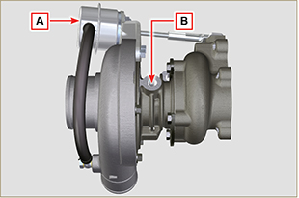  Fig 2.62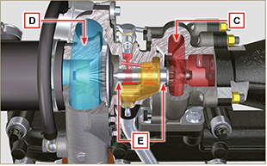  Fig 2.63
2.18.3 Before installing a new turbocharger  Important  - Do not lift the turbocharger with one hand from the box.  - Do not lift turbocharger from Comp hsg side.  - Lift the turbocharger with both hands from box.  - Make sure to use clean gloves.  - Handle the turbocharger as indicated in Par. 2.17.4. | 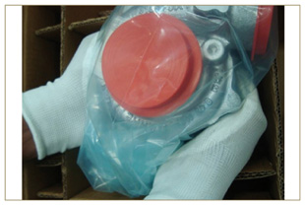  Fig 2.64
- Avoid lifting from the intake side G .  - Remove cap guard F and check that there is no excessive shaft axial and radial clearances. | 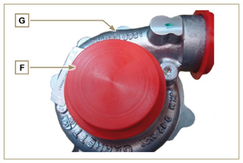  Fig 2.65
- Check for any signs of friction of the turbine on the turbocharger body.  - Check for any traces of oil leaks on the turbocharger body.  - After having check everything, reapply cap F on intake opening H of the turbocharger and do not remove it until assembly has been completed. | 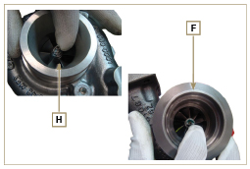  Fig 2.66
- Check the correct assembly of the capscrews and the presence of paint on them. | 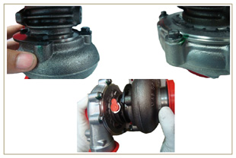  Fig 2.67
2.18.4 Installation instructions  - Remove the cap guards with care only when assembling.  Handle carefully avoiding erratic movements. | 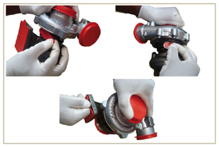  Fig 2.68
2.18.5 Replacement instructions

Always understand the cause of the breakage of the turbocharger before replacing it.

Correct the cause of the breakage before replacing it with a new turbocharger.

If in doubt, contact KOHLER service department.

Important

- Failure to comply with these instructions can cause damage to the turbocharger and void the warranty.
- Modifying the calibration of the turbocharger damages the turbocharger/engine.
- Always use the correct gaskets, and fit carefully to avoid blocking holes when mounting.
- Refer to the manual of the engine / vehicle, for: the correct type and quantity of oil, the correct tightening of components, instructions and installation.
- It is forbidden to use liquid gaskets or sealants, particularly for the oil inlet/outlet.
- Avoid dirt / debris while installing the turbocharger.
- Before mounting the turbocharger, check that the code of the component is correct for the type of engine, as mounting the wrong turbocharger can damage the turbo / engine and void the warranty.

Balancer device (optional)
The balancer device is composed of a special crankshaft that activates 2 additional shafts (balancers).  Rotation of the balancers, which have counterweights that oppose the movement of alternating weights (crankshaft - connecting rods - pistons), reduces vibrations caused by them.  The device is developed under the crankshaft, fixed on the crankcase, closed by the oil sump.  Tab 2.43  POS. DESCRIPTION  1 Crankshaft  2 Balancer shaft control gear  3 Balancer shaft support box  4 Conductor balance shaft  5 Conducted balance shaft | 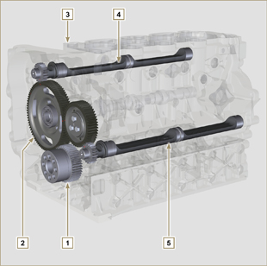  Fig 2.69

Safety information

Before start-up
- Read the manual carefully and carry out the operations described below in compliance with the instructions specified.
- Periodic inspection and maintenance operations must be carried out as indicated in this manual and under the user's responsibility.

Important

- Only use original spare parts and accessories.
- The use of non-original parts, as well as voiding the warranty, affects the life and performance of the engine, and may be dangerous.
- Non compliance with the operations described in the following pages may result damage to the engine and vehicle on which it is installed, as well as to people and/or property.

Safety precautions
- The intended use of the engine is in conformity with the machine on which it is mounted.
- Any use of the machine other than that described cannot be considered as complying with its intended purpose as specified by KOHLER .
- KOHLER declines all responsibility for any change to the engine not described in this manual made by unauthorized KOHLER personnel.
- A proper use of the engine, a strict observance of the rules listed below and the rigorous application of all these precautions will avoid the risk of accidents or injuries.
- Those who carry out the use and maintenance on the engine must wear the safety equipment and the accident-prevention guards (Par 3.4.3) .
- KOHLER declines all direct and indirect liability for failure to comply with the standards of conduct contained in this manual.
- KOHLER cannot consider every reasonably unforeseeable misuse that may cause a potential danger.

General remarks
3.3.1 Note for OEM
- When installing the KDI engines, always bear in mind that any variation to the functional systems may result in serious failures to the engine.
- Any improvement must be verified at KOHLER testing laboratories before application of the engine.
- In case the approval to a modification is not granted, KOHLER shall not be deemed responsible for any consequential failures or damages to the engine.
- Those who carry out the use and maintenance on the engine must wear the safety equipment and the accident-prevention guards.
- KOHLER declines all direct and indirect liability for failure to comply with the standards of conduct contained in this manual.
- KOHLER cannot consider every reasonably unforeseeable misuse that may cause a potential danger.
3.3.2 Note for end user
- The following indications are dedicated to the user of the machine in order to reduce or eliminate risks concerning engine operation and the relative routine maintenance work.
- The user must read these instructions carefully. Failure to do this could lead to serious danger for his personal safety and health and that of any persons who may be in the vicinity of the machine.
- On starting, make sure that the engine is as horizontal as possible, unless the machine specifications differ.
- Make sure that the machine is stable to prevent the risk of overturning.
- The engine must not operate in places containing inflammable materials, in explosive atmospheres, where there is dust that can easily catch fire unless specific, adequate and clearly indicated precautions have been taken and have been certified for the machine.
- To prevent fire hazards, always keep the machine at least one meter from buildings or from other machinery.
- Children and animals must be kept at a due distance from operating machines in order to prevent hazards deriving from their operation.
- Thoroughly wash and clean all the external parts of the engine before performing any operation, in order to avoid the accidental introduction of impurities/foreign bodies. Use only water and/or appropriate products to clean the engine. If cleaning engine with a pressure washer or steam cleaner, it is important to maintain a minimum distance of at least 200mm between the surface to be washed and the nozzle. Avoid directing the nozzle on electrical components, cable connections and sealed rings (oil seals etc). Thoroughly wash and clean the area surrounding the engine following the instructions provided by machine manufacturer.
- Fuel and oil are inflammable. The tank must only be filled when the engine is off. Before starting, dry any spilt fuel.
- Make sure that no soundproofing panels and the ground or floor on which the machine is standing have not soaked up any fuel.
- Fuel vapour is highly toxic. Only refuel outdoors or in a well ventilated place
- Do not smoke or use open flames when refuelling.
- During operation, the surface of the engine can become dangerously hot. Avoid touching the exhaust system in particular.
- Before proceeding with any operation on the engine, stop it and allow it to cool.
- Always open the radiator plug or expansion chamber with the utmost caution, wearing protective garments and goggles.
- The coolant fluid is under pressure. Never carry out any inspections until the engine has cooled.
- If there is an electric fan, do not approach the engine when it is still hot as the fan could also start operating when the engine is at a standstill.
- The oil must be drained whilst the engine is hot. Particular care is required to prevent burns. Do not allow oil to come into contact with the skin because of the health hazards involved. It is recommended to use an oil intake pump.
- During operations that involve access to moving parts of the engine and/or removal of rotating guards, disconnect and insulate the negative wire (-) of the battery to prevent accidental short-circuits and to stop the starter motor from being energized.
- Check belt tension only when the engine is off.
- Fully tighten the tank cap each time after refuelling. Do not fill the tank right to the top but leave an adequate space for the fuel to expand.
- To start the engine follow the specific instructions provided in the engine and/or machine operating manual. Do not use auxiliary starting devices not originally installed on the machine (e.g. Startpilot).
- Before starting, remove any tools that were used to service the engine and/or machine. Make sure that all guards have been refitted.
- Do not mix fuel with elements such as oil or kerosene. Failure to comply with this prohibition will cause the non-operation of the catalyst and non-observance of the emissions declared by KOHLER .
- Pay attention to the temperature of the oil filter when the filter itself is replaced.
- Only check, top up and change the coolant fluid when the engine is off and reached the ambient temperature. Coolant fluid is polluting, it must therefore be disposed of in the correct way.
- Do not use air and water jets at high pressures on cables, connectors and injectors.

Important

- Only use the eyebolts A installed by KOHLER to move the engine (Fig. 3.1) .
- The angle between each lifting chain and the eyebolts shall not exceed 15° inwards.
- The correct tightening of the lifting screws is 80Nm.
- Do not interpose spacers or washers between the eyebolts and engine head.
- Provided that the above requirements are met, if the lifting eyebolts are subject to permanent deformation (inwards), all subsequent lifting operations must be performed in order to prevent them from bending in the opposite direction.
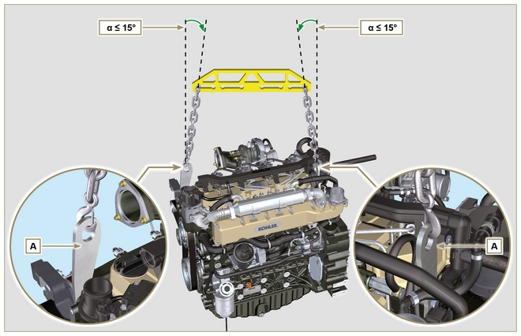
Fig 3.1

Safety signal description
- To ensure safe operation please read the following statements and understand their meaning.
- Also refer to your equipment manufacturer's manual for other important safety information.
- This manual contains safety precautions which are explained below.
- Please read them carefully.

3.4.1 Adhesive safety plates
The following is a list of the adhesive safety plates that may be found on the engine, which indicate potential points of danger to the operator.
Read the Operation and Maintenance handbook before performing any operation on the engine.
Hot Parts.
Danger of burns.
Presence of rotating parts.
Danger of jamming or cutting.
Presence of explosive fuel.
Danger of fire or explosion.
Presence of steam and pressurized coolant.
Danger of burns.
3.4.2 Warnings
Hereunder is a list of safety warnings that may be found in the manual, which advise you to pay attention when carrying out particular procedures that may be potentially dangerous to the operator or things.
Danger
This indicates situations of grave danger which, if ignored, may seriously threaten the health and safety of individuals.
Important
This indicates particularly important technical information that should not be ignored.
Warning
This indicates that failure to comply with it can cause minor damage or injury.
3.4.3 Safety guards Hereunder is a list of safety guards that must be worn prior to carrying out any type of operation and to avoid potential
harm to the operator.
Use suitable protective gloves before carrying out any type of operation.
Use protective goggles before carrying out any type of operation.
Use earmuffs before carrying out any type of operation.

Information and safety signals

ACCIDENTAL START  Accidental Starts can cause severe injury or death.  Before working on the engine or equipment, disconnect the battery negative (-) wire.  HOT PARTS  Hot Parts can cause severe burns.  Engine components can get extremely hot from operation. Do not touch engine while operating or just after stopping.  Never operate the engine with heat shields or guards removed.  ROTATING PARTS  Rotating Parts can cause severe injury.  Stay away while engine is in operation. Keep hands, feet, hair, and clothing away from all moving parts to prevent injury.  Never operate the engine with covers, shrouds, or guards removed.  LETHAL EXHAUST GASES  Carbon Monoxide can cause severe nausea, fainting or death.  Avoid inhaling exhaust fumes and never run the engine in a closed building or confined area.  Carbon monoxide is toxic, odorless, colorless, and can cause death if inhaled.  ELECTRICAL SHOCK  Electrical Shock can cause injury.  Do not touch wires while engine is running. | HIGH PRESSURE FLUID RISK OF PUNCTURE  High Pressure Fluids can puncture skin and cause severe injury or death.  Do not work on fuel system without proper training or safety equipment. Fluid puncture injuries are highly toxic and hazardous.  If an injury occurs, seek immediate medical attention.  EXPLOSIVE FUEL  Explosive fuel can cause fires and severe burns.  Fuel is flammable and its vapours can ignite. Store fuel only in approved containers, in well ventilated, unoccupied buildings. Do not fill the fuel tank while the engine is hot or running, since spilled fuel could ignite if it comes in contact with hot parts or sparks from ignition.  Do not start the engine near spilled fuel.  Never use fuel as a cleaning agent.  EXPLOSIVE GAS  Explosive Gas can cause fires and severe acid burns.  Charge battery only in a well ventilated area. Keep sparks, open flames, and other sources of ignition away from the battery at all times. Batteries produce explosive hydrogen gas while being charged.  Keep batteries out of the reach of children.  Remove all jewelry when servicing batteries. Before disconnecting the negative (-) ground cable, make sure all switches are OFF.  If ON, a spark will occur at the ground cable terminal which could cause an explosion.  CALIFORNIA WARNING - DECLARATION 65  Engine exhaust from this product contains chemicals known to the State of California to cause cancer, birth defects, or other reproductive harm.

Safety and environmental impact
Every organisation has a duty to implement procedures to identify, assess and monitor the influence of its own activities (products, services, etc.) on the environment. Procedures for identifying the extent of the impact on the environment must consider the following factors:

- Liquid waste.

- Waste management.

- Soil contamination.

- Atmospheric emission.

- Use of raw materials and natural resources.

- Regulations and directives regarding environmental impact.

In order to minimise the impact on the environment, KOHLER now provides a number of indications to be followed by all persons handling the engine, for any reason, during its expected lifetime. - All components and fluids must be disposed of in accordance with the laws of the country in which disposal is taking place.

- Keep the fuel and engine control systems and the exhaust pipes in efficient working order to limit environmental and noise pollution.

- When discontinuing use of the engine, select all components according to their chemical characteristics and dispose of them separately.

Location of safety labels on engine
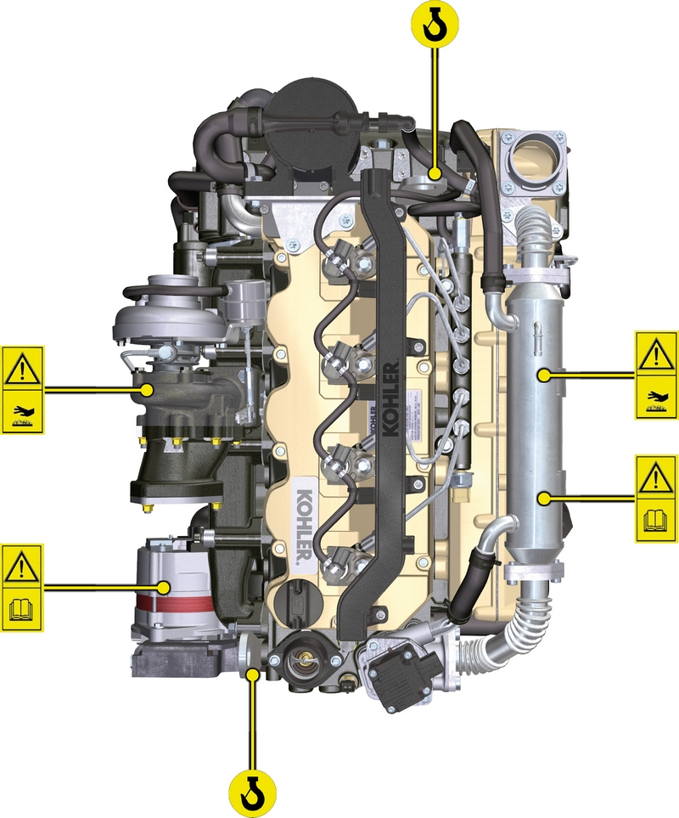

Storage information

Product preservation

Important

- If the engines are not to be used for 6 months, they must be protected by carrying out the operations described in Engine storage (up to 6 months) (Par. 4.2) .
- If the engine is still not in use after the first 6 months, it is necessary to carry out a further procedure to extend the protection period (more than 6 months) (Par. 4.3) .
- If the engine is not to be used for an extended period, the protective treatment procedure must be repeated within 24 months of the previous one.

Engine storage (up to 6 months)
Before storing the engine check that:
- The environments are not humid or exposed to bad weather. Cover the engine with a proper protective sheet against dampness and atmospheric contaminants.
- The place is not near electric panel.
- Avoid storing the engine in direct contact with the ground.

Engine storage (over 6 months)
Follow the steps described in Par. 4.2 .
- Pour protective oil in the carter up to the MAX level.
- Refuel with fuel additives for long storage.The following additives are recommended: DEFA Fluid Plus (Pakelo Lubricants),

Diesel Treatment (Green Star),

Top Diesel (Bardhal),

STP® Diesel Fuel Injector Treatment.
- With expansion tank:
make sure that the coolant is up to the maximum level.
- Without expansion tank: Top liquid up until the pipes inside the radiator are covered by about 5 mm.

Do not overfill the radiator, but leave room for the fuel to expand.
- Start the engine and run it at idle speed for around 2 minutes.
- Bring the engine to 75% of maximum rated speed for 5 to 10 minutes.
- Turn off the engine.
- Empty out completely the fuel tank.
- Spray SAE 10W-40 on the exhaust and intake manifolds.
- Seal the exhaust and intake ducts to prevent foreign bodies from entering.
- When cleaning the engine, if using a pressure washer or steam cleaning device, avoid directing the nozzle on electrical components, cable connections and sealed rings (oil seals etc).
If cleaning engine with a pressure washer or steam cleaner, it is important to maintain a minimum distance of at least 200mm between the surface to be washed and the nozzle - avoiding absolutely electrical components such as alternators, starter motors and engine control units (ECU).
- Treat non-painted parts with protective products.
- Loosen the alternator belt Par. 6.5.1 point 1 and 2 .
If the engine protection is performed according to the suggestions indicated no corrosion damage will be found.

Engine starting after storage
- Remove the protective sheet.
- Use a cloth soaked in degreasing product to remove the protective treatment from the external parts.
- Inject lubricating oil (no more than 2 cm3) into the intake ducts.
- Adjust the alternator belt tension ( Par. 6.5.2 ) or replace if there are signs of deterioration.
- Refill the tank with fresh fuel.

Warning

- Over time, lubricants and filters lose their properties, so itis important to consider whether they need replacing, also based on the criteria described in Tab. 2.9 .

- Make sure that the oil and the coolant are up to the maximum level.
- Start the engine and run it at idle speed for around 2 minutes.
- Bring the engine to 75% of maximum rated speed for 5 to 10 minutes.
- Stop the engine and while the oil still hot, perform the operation in Par. 5.2 .
- Replace the filters (air, oil, fuel) with original spare parts.
- Perform the operations described in Par. 10.1 .
- Perform the operations described in Par. 5.1 and Par. 10.2 .

Unused machine
If the machine is not used for a certain amount of time, follow the operations below:

4.5.1 Operations for TCR versions

Tab 4.1
POINT | PERIOD | OPERATION
1 | up to 2 months | - The place must be dry and fresh throughout the period in which the machine is not used.  - Consult the machine’s manual to disconnect the battery (before disconnecting the battery, wait for minimum 5 mins after turning off the engine).  - Make sure the engine is not exposed to direct sunlight.  - Make sure the engine is not near any heat sources.
1a | Start-up after 2 months | - Before starting the engine, check Para. 2.8 for maintenance operations.  - Consult the machine’s manual to connect the battery and start the engine.
2 | Fino a 9 mesi | - Perform the operations described in point 1.  - Perform the operations described in Para. 12.4 and 12.5.  - Start the engine at least every 4 months as per operations described in point 1a:  - Avoid sudden accelerations for the first few minutes.  - Bring the engine to the working temperature by pressing the accelerator 3/4 from MAX.  - Leave the engine running at minimum speed for a few minutes and turning off the engine.
2a | Start-up after 9 months | - Before starting the engine, check Para. 2.8 for maintenance operations.  - Consult the machine’s manual to connect the battery and start the engine.  - Avoid sudden accelerations for the first few minutes.
3 | over 9 months | - Perform the operations described in point 1 and 2.
3a | Start-up after 9+ months | - Before starting the engine, check Para. 2.8 for maintenance operations.  - Check the quality of coolant from the relative testing strips.  - Consult the machine’s manual to connect the battery and start the engine.  - Avoid sudden accelerations for the first few minutes.

Information regarding discharge of liquids

Coolant
NOTE : Component not supplied by KOHLER .

Refer to the technical documentation of the vehicle.

Engine oil
Important  - Before proceeding with operation, read Par. 3.3.2 .  - This operation should be carried out with vacuum pump. The oil must be drained whilst the engine is hot, which requires particular care to prevent burns. Do not allow oil to come into contact with the skin because of the health hazards involved. It is recommended to use an oil intake pump via the oil dipstick hole B.  - Electric/pneumatic screwdrivers are forbidden.  - Undo the cartridge holder cover C by performing three complete turns and wait 1 minute.  NOTE : this operation will allow to oil contained in the support G to flow into the oil sump in the correct way.  - Unscrew cartridge holder cover C and check that the oil in the lub. oil filter bracket G has flowed towards the oil sump (refer to NOTE in Par. 2.10.3 ).  - Undo the oil filler cap A (Fig. 5.5) .  - Remove the oil dipstick B .  - Remove the oil drain plug D and the gasket E (the oil drain plug is on both sides of the oil sump).  - Drain oil in to an appropriate container.  (For used oil disposal refer to the Par. 3.6 ).  - Replace gasket E .  - Tighten the drain oil plug D (tightening torque at 50 Nm ).  - Perform the operations described in Par. 6.8.2 and the operation 5 Par. 6.8.3 . | 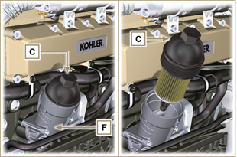  Fig 5.1  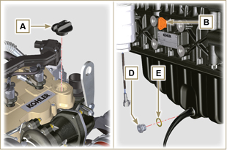  Fig 5.2
NOTE : Click by side to play the procedure. | https://www.youtube.com/embed/3J7y9uoALfI?showinfo=0&rel=0

Information for replacing the functional units

Electronic injector replacement
Important  - Before proceeding with operation, read Par. 3.3.2 .  - In the event of the electronic injectors being disassembled (not necessarily replaced) their position with respect to individual cylinders must not be changed when re-assembled. Refer to the reference between each injector and respective cylinder number.  - Seal all injection component unions as illustrated in Par. 2.9.8 during disassembly.  - Handle the components as described in Par. 2.17 .  - Replace all seal gaskets after each assembly for all components on which they are provided.  - The high pressure pipes must be replaced every time they are disassembled.  - Before disassembling the electronic injectors, make sure the new high pressure pipes are available.  - If a new (or different) electronic injector is fitted on the engine, the new calibration data must be entered in the ECU through a specific instrument ( ST_01 ) .  - Electronic injectors are not repairable.  - This procedure may be performed on one or more electronic injectors.  NOTE: In the event of a leak upon replacement (oil - coolant - fuel - air), do not intervene with the engine running, but stop it and wait for 5/10 minutes before checking and solving the problem. | 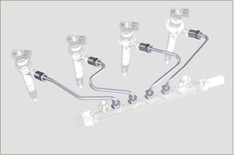  Fig 6.1
6.1.1 Fuel return pipes disassembly (Common Rail/electronic injectors)  - Disconnect the connector C . | 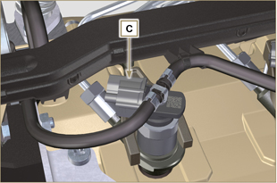  Fig 6.2
- Remove clips E from the electronic injector F .  - Disconnect the junction G from the electronic injector F .  Warning  - After removing the fittings, the clips E must automatically return to their initial position; otherwise they must be replaced.  - Seal all injection component unions as illustrated in Par. 2.9.8 . | 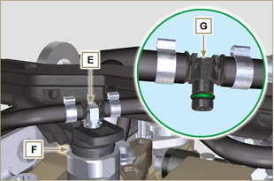  Fig 6.3
6.1.2 High pressure fuel pipes disassembly (Common Rail/electronic injectors)  Danger  - The fuel injection circuit is under high pressure, use safety protections as described in Par 3.4.3 .  - Ensure that the Common Rail is not under pressure by slowly and carefully unscrewing one of the nuts H .  - Undo the nut H on the Common Rail L and then the nut M on the electronic injector F and remove the pipe N .  Important  - In the event that the electronic injectors are disassembled (not necessarily replaced), mark them with the relevant cylinder number from which they originate so as not to confuse them during re-assembly.  - Seal all injection component unions as illustrated in Par. 2.9.8 . | 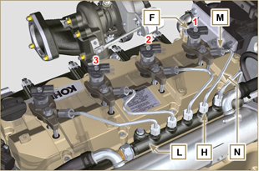  Fig 6.4
6.1.3 Electronic injectors disassembly  - Undo and remove the screw P with the washer R e and then the bracket Q .  Important  - Be careful not to damage the gaskets X .  - Replace rings X , if damaged.  2. Pull out the electronic injector F .  NOTE: Should you be unable to remove the electronic injector (acting only on point BC ), use an open-ended spanner (Ø 34 mm), by applying small rotations to unblock the component.  3. Seal all injection component unions as illustrated in Par. 2.9.8 .  4. Ensure that gasket S has remained in the correct position (Fig. 6.6) . Otherwise, recover the gasket from inside the electronic injector T manifold. | 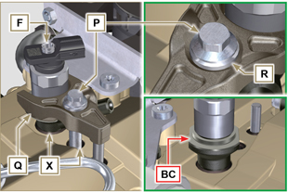  Fig 6.5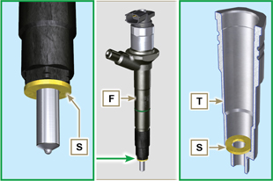  Fig 6.6
NOTE: Click by side to play the procedure. | https://www.youtube.com/embed/slELtJW2bFE?showinfo=0&rel=0
6.1.4 Electronic injector assembly  Important  - Always replace and lubricate the gaskets AA and S of the electronic injectors F with fuel, every time they are replaced.  - Reposition the electronic injectors (not replaced) by following the references made for disassembly, as indicated in Par. 6.1.2.  - If the engine is painted or protected with clear paint, clean the paint off the diesel injector F near to the part in contact with the gasket AB .  - Insert the gasket S on the electronic injectors F (Fig. 6.7) .  - Insert electronic injector F into manifold T , being extra careful not to damage gasket AB and direct it as indicated in Fig. 6.7 .  NOTE : to replace gaskets AB , follow the operations in Para. 7.12.1 and 9.5.9 . | 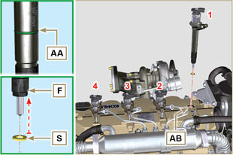  Fig 6.7
6.1.5 High pressure fuel pipes assembly  Important  - Always replace the pipes N after each assembly.  - If the engine is painted or protected with clear paint, replace the fastening screws P to ensure the gaskets are sealed properly.  - Position tube N in the Common Rail seat of the electronic injector; correct the position of the electronic injector by means of the entrance of the electronic injector unions F and Common Rail L .  - Apply the nuts H and M by hand without tightening them.  - Position the fastening brace of electronic injectors Q on capscrew surface AD , insert capscrews P in brace Q inserting washer R . | 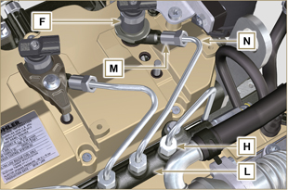  Fig 6.8
Important  - Ensure that brace S is perfectly positioned onto the electronic injector.  4. Tighten the fixing screws P of the electronic injector bracket (tightening torque at 20 Nm ).  5. Tighten the nut M (tightening torque at 25 Nm ).  6. Tighten the nut H (tightening torque at 30 Nm ).  Important  - Replace the pipes N (Fig. 6.8) if the screws P are stiff when tightened. | 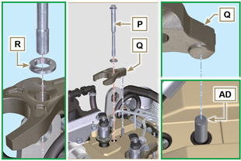  Fig 6.9
6.1.6 Fuel return pipes assembly  - Check the condition of the gaskets AE . | 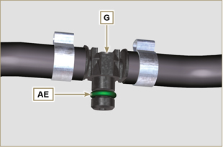  Fig 6.10

- Insert unions G onto electronic injectors F and block them with clips E .  - Mount the connectors C on the electronic injectors F .  Warning  - Slightly move the wiring support to check that there is no voltage in the electrical wire of connector C in correspondence with the outlet hole AF . | 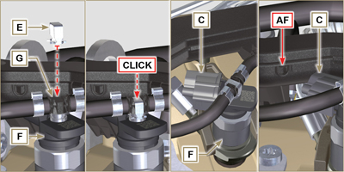  Fig 6.11
NOTE: Click by side to play the procedure. | https://www.youtube.com/embed/IVoumDwS7oY?showinfo=0&rel=0

High-pressure fuel injection pump replacement
Danger  - The fuel injection circuit undergoes high pressure, use safety protections as described in Par 3.4.3 .  - Ensure that the Common Rail is not under pressure by slowly and carefully unscrewing nut A .  Important  - Before proceeding with operation, read Par. 3.3.2 .  - Always replace the high pressure pipes after each disassembly.  - Before disassembling the injection pump, make sure the new high-pressure pipe is available.  - The injection pump is not repairable.  - Should the fuel feeding pump need to be replaced, after assembly, it is necessary to perform the Pump Learning procedure by means of instrument ST_01 . .  - Seal all injection component unions as illustrated in Par. 2.9.8  - To handling components refer to Par. 2.17  - Always replace the gaskets (where are provided) after each disassembly. | 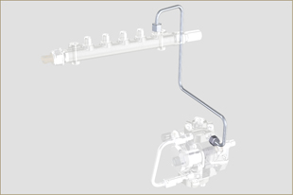  Fig 6.12
6.2.1 High-pressure fuel line disassembly (from the injection pump to the Common Rail).  - Undo the nut A . | 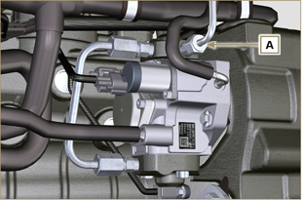  Fig 6.13
- Undo nut D from Common Rail E . | 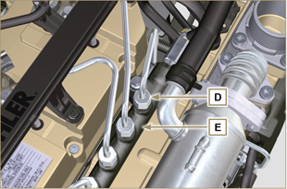  Fig 6.14
- Undo the nut B1 on the intake manifold C.  - Undo the nut B2 on the intake manifold C and remove the pipe F (Fig. 6.16) . | 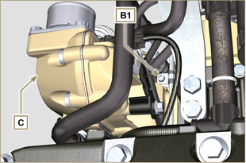  Fig 6.15
6.2.2 Timing system carter oil filling flange disassembly  - Remove starter motor ( Par. 6.6.1 point 2 ) and assemble special tool ST_34 ( Par. 6.6.1 point 3 ) .  - Undo the screws G ,remove the plate H . | 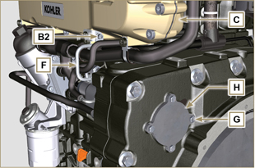  Fig 6.16
- Undo and remove nut L fixing the fuel feeding pump control gear M .  Important  - Be careful that the nut L does not fall into the timing cover.  - Tighten tool ST_13 on the gear M . | 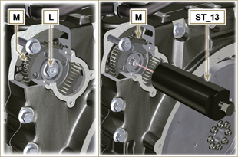  Fig 6.17
Important  - Do NOT use the cylinder connection pipe W as a handle, to prevent damage or fuel leaks.  - Before disassembling, care read Par. 2.17 .  - Seal all injection component unions as illustrated in Par. 2.9.8  - Disconnect tubes P and Q from fuel feeding pump R .  - Disconnect connectors S and T .  - Loosen and distance capscrews U .  - Redo the capscrew of tool ST_13 to disconnect injection  pump R from gear M .  - Undo capscrews U and extract injection pump R with the relevant gasket V .  Important  - Do NOT remove tool ST_13 in order to prevent gear M inside the distribution carter from falling. | 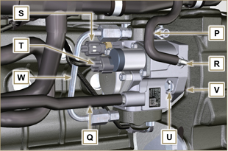  Fig 6.18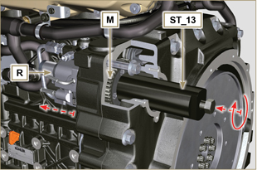  Fig 6.19
NOTE: Click by side to play the procedure. | https://www.youtube.com/embed/jPnRSYu0sKM?showinfo=0&rel=0
6.2.3 High-pressure fuel injection pump assembly  Important  - Before assembling, carefully read Par. 2.17  - Always replace the gasket V after each assembly. The gasket V can only be fitted in one direction.  - Do NOT use the cylinder connection pipe W as a handle, to prevent damage or fuel leaks.  - Remove the protection caps only when reconnecting the hoses. | 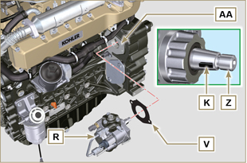  Fig 6.20
- Check that the contact surfaces AA are free from impurities.  - Make sure reference key K is properly inserted into the Z shaft seat.  - Assemble the new gasket V on injection pump R . Insert injection pump R in its housing on crankcase AA making key K coincide with key seat AH of gear M . | 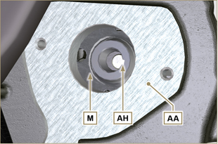  Fig 6.21
- Remove the tool ST_13 from the pump control gear ( Ref. M of Par. 6.2.3 ) if applicable.  Important  - Pay the utmost attention when executing the operation in point 5 so as to prevent nut L from falling inside the distribution carter.  - Fully tighten the nut L on the shaft Z of the injection pump.  Important  - Apply nut L by hand, but do not tighten.  - It is mandatory to replace the screws U or apply a few drops of Loctite 2701 . | 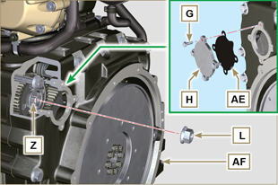  Fig 6.22
- Clamp the screws U on the crankcase AB (tightening torque at 25 Nm ).  - Clamp the nut L (Fig. 6.22) (tightening torque at 70 Nm ).  - Disassemble the special tool ST_34 and assemble the starter motor (tightening torque 45 Nm ).  NOTE: Always replace the gasket AE after each assembly.  - Position the gasket AE in the set on the plate H .  - Fix the plate H on the crankcase AF with the screws G (tightening torque at 10 Nm ). | 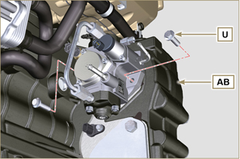  Fig 6.23
- Fit the connector T on the sensor J .  - Fit the connector S on the sensor Y .  - Remove the protection caps.  - Fit the pipe Q on the fitting AA .  - Fit the pipe P on the fitting AB . | 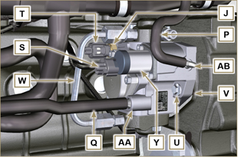  Fig 6.24
6.2.4 High-pressure line assembly (injection pump / Common Rail)  - Remove the protection cap.  - Position the pipe F .  - Manually tighten the nut A . | 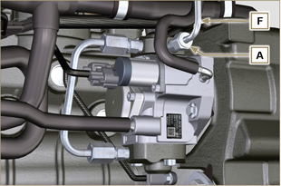  Fig 6.25
- Manually tighten the nut D . | 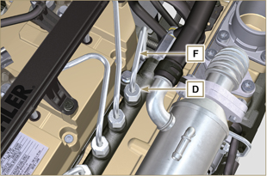  Fig 6.26
- Secure clamps F1 and F2 by means of capscrews B1 and B2 onto intake manifold C (tightening torque 10 Nm ).  - In order, tighten nut D (tightening torque 30 Nm ) and A (tightening torque 25 Nm ). | 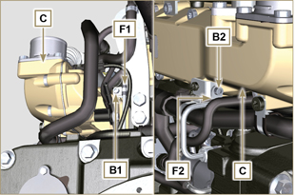  Fig 6.27
NOTE: Click by side to play the procedure. | https://www.youtube.com/embed/3ULD_PiHEaw?showinfo=0&rel=0

Unit EGR Cooler replacement
6.3.1 Disassembly  Important  - Before proceeding with operation, read Par. 3.3.2 .  - To handling components refer to Par. 2.17  - Always replace the gaskets (where are provided) after each disassembly.  NOTE: Perform the operations described in Par. 5.1 .  - Undo the screws B of pipe C .  - Release the clamps F and remove the hose M . | 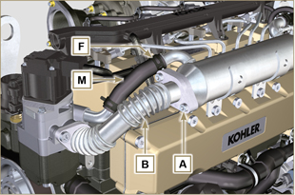  Fig 6.28
- Undo the screws C of pipe E .  - Release the clamp F and remove the hose G. | 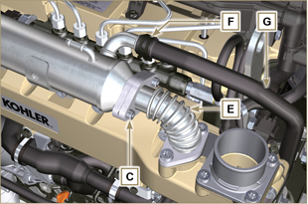  Fig 6.29
- Undo the screws H and remove the EGR Cooler L and the relevant metal gaskets ( ST_05 ).  - Should the passage ducts of the gas exhaust be clogged by soot or carbon, replace EGR Cooler L . | 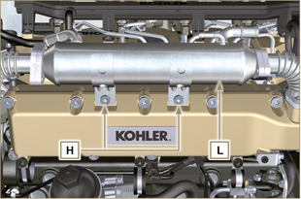  Fig 6.30
NOTE: Click by side to play the procedure. | https://www.youtube.com/embed/A8fU76g4nUQ?showinfo=0&rel=0
6.3.2 Assembly  - Fit the EGR Cooler L with the screws H on the intake manifold S (tightening torque at 22 Nm - ST_05 ). | 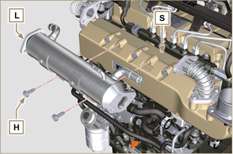  Fig 6.31
- Insert the gasket N between the hoses B-E and the EGR Cooler L . | 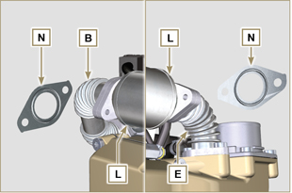  Fig 6.32
- Fit the screws A and C (tightening torque at 25 Nm ).  - Insert the hose M on the fitting V1 and G on V2 .  - Secure the clamps F .  NOTE: Perform the operations described in Par. 10.2 . | 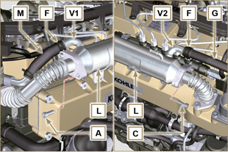  Fig 6.33
NOTE: Click by side to play the procedure. | https://www.youtube.com/embed/vTWVObqWIGE?showinfo=0&rel=0

EGR valve replacement
6.4.1 Disassembly  Important  - Before proceeding with operation, read Par. 3.3.2 .  NOTE: Perform the operations described in Par. 5.1 .  - Disconnect the connector A from the valve C .  - Undo the screws B and remove the EGR valve C with the relevant gasket. | 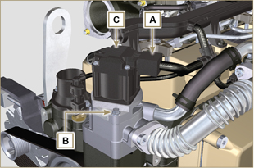  Fig 6.34
NOTE: Click by side to play the procedure. | https://www.youtube.com/embed/JZWXxa3UssY?showinfo=0&rel=0
6.4.2 Assembly  Important  - Always replace gasket D after each assembly.  - The EGR valve is not a serviceable item, and if faulty / worn out, should be replaced with a new one.  - Handle the components as described in Par. 2.17 .  - Mount the new gasket D on the valve C .  - Fit the valve C on the flange E with screws B (tightening torque at 10 Nm ). | 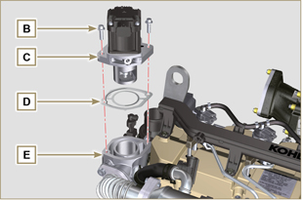  Fig 6.35
- Fit the connector A on the valve C .  NOTE: Perform the operations described in Par. 10.2 . | 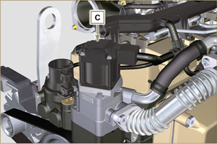  Fig 6.36
NOTE: Click by side to play the procedure. | https://www.youtube.com/embed/JZWXxa3UssY?showinfo=0&rel=0

Coolant pump replacement
6.5.1 Disassembly  NOTE: Perform the operations described in Par. 5.1 .  Important  - Before proceeding with operation, read Par. 3.3.2 .  - Loosen the screws A and B .  - Loosen capscrew C and disconnect voltage from belt D and remove belt D .  - Undo the screws E and remove the pulley F . | 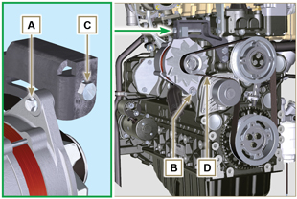  Fig 6.37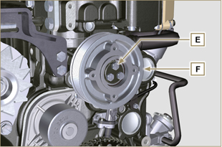  Fig 6.38
- Undo the screws G and remove the pump H with the relevant gasket. | 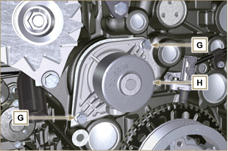  Fig 6.39
NOTE: Click by side to play the procedure. | https://www.youtube.com/embed/tgDL1w2AUd0?showinfo=0&rel=0
6.5.2 Assembly  Important  - Always replace the gaskets J , after each disassembly.  - Always replace the belt D after each assembly.  - To handling components refer to Par. 2.17  - Always replace the gaskets (where are provided) after each disassembly  - Fit the coolant pump G with the screws H interposing the new gasket J (tightening torque at 25 Nm ). | 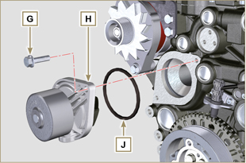  Fig 6.40
- By means of capscrews E , secure pulley F to crankcase K . | 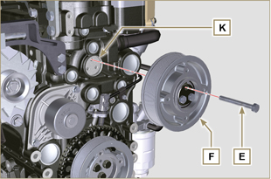  Fig 6.41
- Insert the belt D on the pulleys M .  - Tighten screw C and bring block L at 10 mm from bracket N (value C1 ).  - Fit the screw A (tightening torque at 25 Nm ).  - Fit the screw B (Fig. 6.37 - tightening torque at see service letter 710007 ).  - Start the engine and run it for some minutes, then turn off it, and let it cool down at ambient temperature. Check by the appropriate tool that at point p the tension value is between 135 and 178 Hz.  NOTE: If the poly-v belt tension results out of the above mentioned values, proceed with the replacement. | 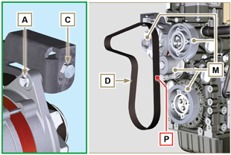  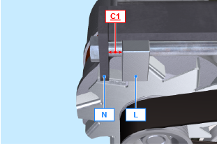  Fig 6.42
NOTE: Click by side to play the procedure. | https://www.youtube.com/embed/Zrhc5qTwPRM?showinfo=0&rel=0

Target wheel replacement
6.6.1 Disassembly  Important  - Before proceeding with operation, read Par. 3.3.2 .  - Remove the alternator belt following steps 1 and 2 ( Par. 6.5.1 ) .  - Undo the screws N and Remove starter motor A .  - Mount the tool ST_34 in the seat of the starter motor B and fit it with the two starter motor fixing screws. | 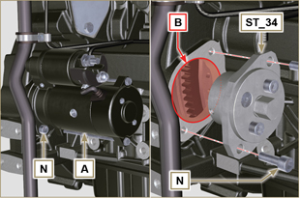  Fig 6.43
Important  - Pay the utmost attention when executing the operation in point 4 so as to prevent knocking speed sensor E .  - Undo the screws C and remove the pulley D . | 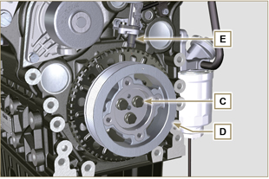  Fig 6.44
- Undo the screws F and remove the target wheel G . | 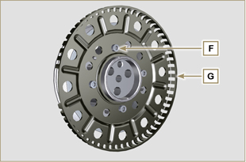  Fig 6.45
6.6.2 Assembly  - Check that the pin H is mounted properly on the pulley D .  - Position the phonic wheel G on the pulley D respecting the reference of the pin H .  - Fit the phonic wheel G with the screws F (tightening torque 10 Nm ). | 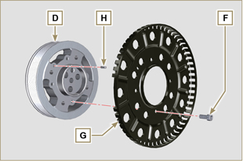  Fig 6.46
- Check that the pin L is mounted properly on the crankshaft M .  Important  - Pay the utmost attention when executing the operation in point 4 so as to prevent knocking speed sensor E .  - Position the pulley unit D on the crankshaft M respecting the reference with the pin L .  - Apply Molyslip grease onto the thread and under the head of capscrew C .  - Clamp the pulley unit D with the screw C (tightening torque at 100 Nm ).  - Perform the operations from point 3 to 7 of Par. 6.5.2. | 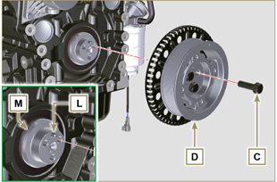  Fig 6.47
- Undo the screws N and remove special tool ST_34 .  - Secure motor A by means of capscrews N (tightening torque at 45 Nm ). | 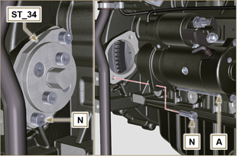  Fig 6.48

Oil vapour separator replacement
6.7.1 Disassembly  Important  - Before proceeding with operation, read Par. 3.3.2 .  - Remove quick fitting A .  - Release the clamps B and C .  - Remove hose D from breather body E . | 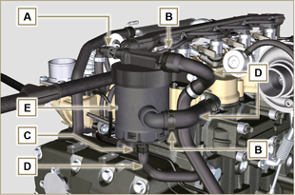  Fig 6.49
- Remove capscrews F and remove breather body E . | 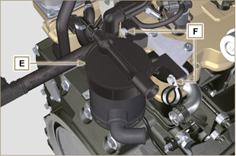  Fig 6.50
6.7.2 Assembly  Warning  - Always carefully inspect the condition of the tubes, and replace them if there is any doubt regarding their integrity.  - Always replace the gasket M after each assembly.  - Secure breather body E by means of capscrews F .  NOTE : Insert clamp G between capscrew F and breather body E .  - Fit hose D onto breather body E (Fig. 6.49) .  - Secure the clamps B and C (Fig. 6.49). | 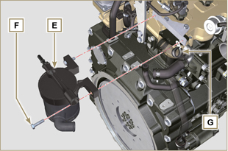  Fig 6.51

Oil cooler unit and oil filter replacement
6.8.1 Oil Cooler unit disassembly  Important  - Before proceeding with operation, read Par. 3.3.2 .  - Perform the operations described in Par 5.1 and Par 5.2 .  - Oil Cooler unit E is not repairable.  - Release the clamps A .  - Remove the manifolds B out of the Oil Cooler unit E . | 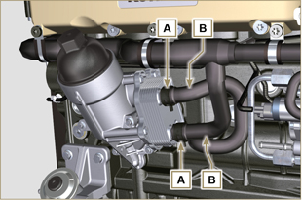  Fig 6.52
Warning  - Electric/pneumatic screwdrivers are forbidden.  - Use a suitable container to recover any residue oil.  - Unscrew cartridge holder cover H by performing three complete turns and wait 1 minute.  NOTE : this operation allows to oil contained in the support E to flow into the oil sump in the correct way.  - Unscrew cartridge holder cover H and check that the oil in the lub. oil filter support E has flowed towards the oil sump.  - Undo the screws C and D and remove the Oil Cooler unit E . | 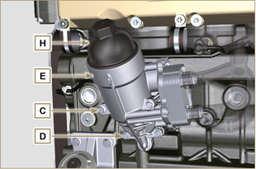  Fig 6.53
- Remove the gaskets F and G from the Oil Cooler unit E . | 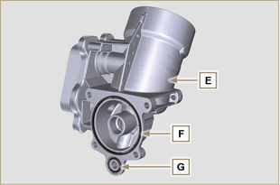  Fig 6.54
6.8.2 Oil filter cartridge replacement  - Remove gaskets L, M and N from element holder cover H .  - Remove cartridge P from element holder cover H . | 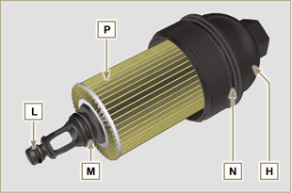  Fig 6.55
- Lubricate and insert gaskets L, M and N in the L1, M1 and N1 seats of element holder cover H .  - Insert element P into element holder cover H . | 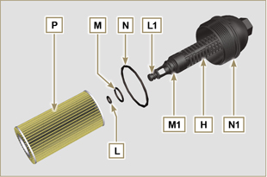  Fig 6.56
6.8.3 Oil Cooler unit assembly  Important  - In the event of assembly of union U on crankcase S , manual tightening torque with Loctite 2701 on the thread).  - Check that the surface Q on the support E and on the crankcase S are free from impurities.  - Lubricate and insert the gasket T on the fitting U .  - Lubricate and insert the gaskets on the support E :  F in seat F1 ;  G in seat G1 .  - Fit the support R with the screws C and D (tightening torque at 10 Nm ).  - Insert and tighten the cartridge support H on the filter support E (tightening torque at 25 Nm ).  - Fit the hoses B on the support E and secure the hoses B with the clamps A . | 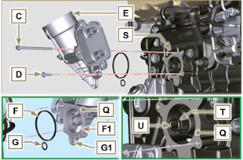  Fig 6.57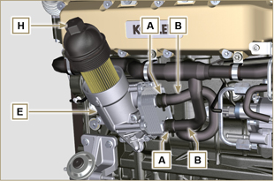  Fig 6.58

Fuel filter replacement
6.9.1 Disassembly  Important  - Before proceeding with operation, read Par. 3.3.2 .  Warning  - The fuel filter is not always mounted in the engine.  - When disassembling the sensor E , use a suitable container to recover the fuel contained in the cartridge F .  - Release the clamps A and pull the pipes B out of the support H .  - Unscrew the sensor E from the cartridge F .  - Unscrew the cartridge F from the support H .  - Undo the screws C and remove the support H . | 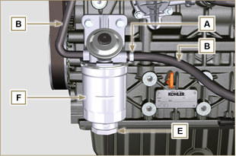  Fig 6.59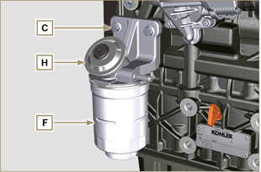  Fig 6.60
Warning  - Check that the fuel supply pump filter is present, and replace if necessary.  - Release the clamp D .  - Demount the hose E .  - Unscrew the filter G from the pump Q . | 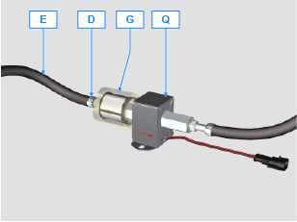
- Screw the new filter G onto the pump Q (tightening torque 20 Nm ).  - Connect the hose E to the filter G and fasten with the clamp D . | 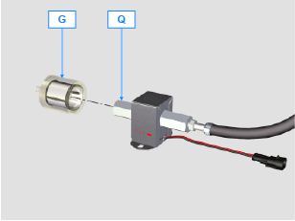
6.9.2 Assembly  - Secure the fuel filter support H with the screws C on the crankcase M (tightening torque at 25 Nm ).  - Fit the pipes B on the support H .  - Secure the pipes B with the clamps A . | 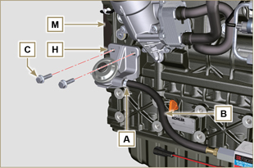  Fig 6.61
- Lubricate the gasket N with fuel.  - Tighten the cartridge F on the support H (tightening torque at 17 Nm ).  - Assemble gasket J onto sensor E and lubricate with fuel.  - Tighten the sensor E on the cartridge F (tightening torque at 5 Nm ). | 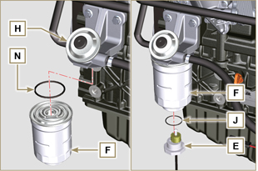  Fig 6.62

Replacement of SCV valve
Warning  - Before starting any replacement operations, make sure the work area is free from dust (part X of valve B is extremely sensitive to micro-dust).  - Pay the utmost attention to cleaning in order to prevent any type of contamination during replacement operations  - - Before proceeding with the replacement, clean the outer part of pump A thoroughly - Avoid any type of contact with part X of the valve during replacement.  - Lubricate part X of valve B with oil spray.  - Before starting any replacement operations, make sure that the key on the vehicle’s panel is OFF .  - Assemble the new valve in the same position as the previous one. | 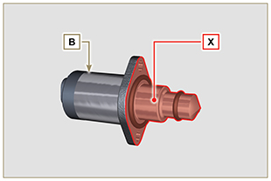  Fig. 6.60
6.13.1 Disassembly  1 - Disconnect connector C from valve B .  2 - Loosen screws D .  3 - Remove valve B from pump A . | 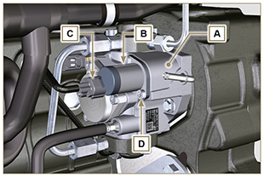  Fig. 6.61
6.13.2 Assembly  1 - Insert studs E supplied with valve B in the fastening holes of pump A and insert gasket F in the seat of pump A .  2 - Assemble valve B on pump A using studs E as positioning guides.  3 - Remove studs E and secure valve B with screws D (tightening torque of 6 Nm).  4 - Fasten valve B by means of screws D (tightening torque of 10 Nm). | 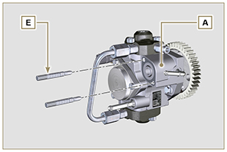  Fig. 6.62
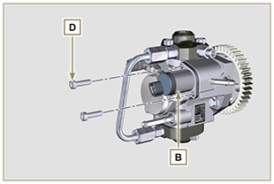  Fig. 6.63 | 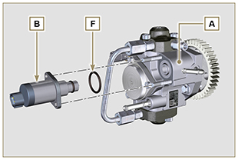  Fig. 6.64

Information for disassembly

Recommendations for disassembly

Important

- The mark ( ) after the title of a paragraph, indicates that the procedure is not required in order to disassemble the engine, however the procedures are featured in order to illustrate the disassembly of components.
- The operator should prepare all equipment and tools in order to enable him to carry out the operations correctly and safely.
- Before disassembly, perform the operation described in Chap. 5 .
- Before proceeding with operation, carefully read Chap. 3 .
- In order to operate safely and easily, we recommend positioning the engine on a rotating stand for engine overhauling.
- Seal all injection component unions as illustrated in P ar. 2.9.8 during assembly.
- Protect all disassembled components and coupling surfaces subject to oxidation with lubricant.
- Where necessary, reference to special tools to use during disassembly operations is indicated (es. ST_05 ), identified in Tab. 13.1 - 13.2 - 13.3 .

EGR circuit disassembly
7.2.1 EGR cooler unit  - Undo the screws A ( ST_05 ) and B and remove the pipe C with the relative gaskets. | 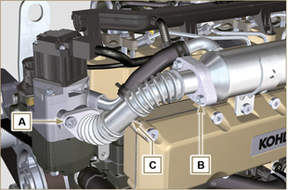 Fig 7.1
- Undo the screws D, E ( ST_05 ) and remove pipe F and the relevant gaskets. | 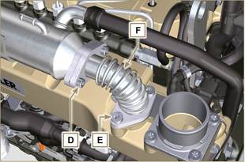  Fig 7.2
- Release the clamp M and remove hose N1 .  - Release the clamp L , and remove hose N2 .  - Undo capscrews G ( ST_05 ) and remove EGR Cooler H. | 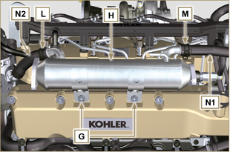  Fig 7.3

Coolant recirculation components disassembly
7.3.1 Oil Cooler manifold  - Release the clamps A .  - Undo the screw B and remove hoses C ( ST_05 ) . | 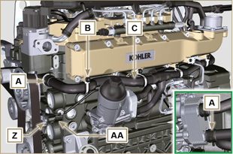  Fig 7.4
- Release the clamp D and remove hoses E . | 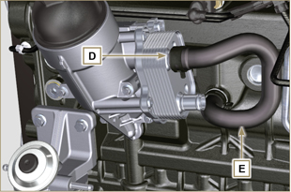  Fig 7.5
7.3.2 Coolant pump  Important  - The pump B is not repairable.  - Perform the operations described in Par. 6.5.1 .  - Undo capscrews F and remove flange G with the relative gasket. | 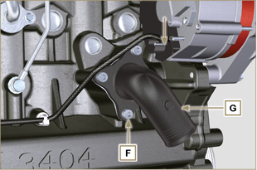  Fig 7.6
7.3.3 Thermostatic valve  - Undo the screws A and remove the thermostatic valve cover B .  - Remove the thermostatic valve C and its gasket.  Important  - Always replace the gasket D every time it is disassembled.  - Check that the air bleeding hole is not clogged or blocked ( Par. 2.11.4 ). | 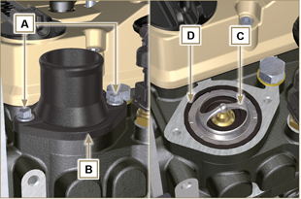  Fig 7.7

Electric components disassembly
7.4.1 Electric wiring  Important  - Refer to Par. 2.13 prior to proceeding with disassembly.  - Disconnect the connector A .  - Undo the screw B .  - Release the clamp C . | 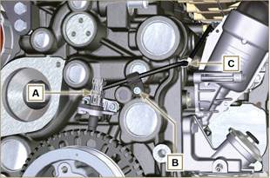  Fig 7.8
- Disconnect the connector D . | 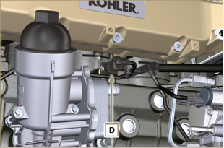  Fig 7.9
- Disconnect the connectors E and F . | 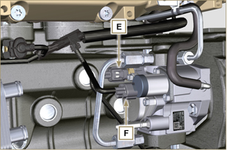  Fig 7.10
- Disconnect the connector G . | 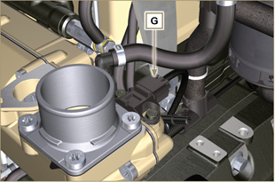  Fig 7.11
- Remove nuts H and disconnect cables L and M .  - Release the clamp P .  - Undo the screw Q . | 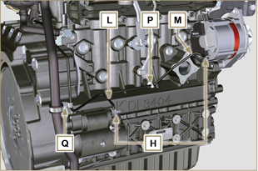  Fig 7.12
- Disconnect the connectors R , S , T , U .  - Undo the screws V ( ST_06 ) and remove the wiring support Z . | 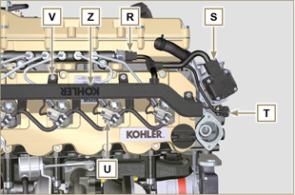  Fig 7.13
7.4.2 Starter motor  Important  - The motor is not repairable.  - Perform the operations from point 2 to 3 of Par. 6.6.1 .  7.4.3 Alternator  - Undo the screws A1 and B1 and remove the alternator C1 . | 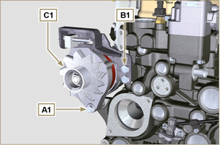  Fig 7.14
7.4.4 EGR Valve  - Perform the operations of Par. 6.4.1 .  - Undo capscrews D1 and remove flange E1 with the relative gasket.  NOTE: The EGR valve is not a serviceable item, and if damaged/worn, it should be replaced with a new one. | 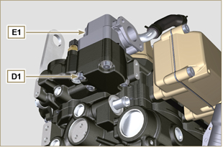  Fig 7.15
7.4.5 Sensors and switches  Important  - After disassembly, protect the sensors suitably against knocks, dampness and any high temperature sources.  - The sensors and switches cannot be repaired, therefore they must be replaced in the event of anomalies.  7.4.5.1 Oil pressure switch ( )  - Unscrew and remove the oil pressure switch AD . | 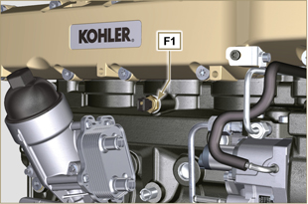  Fig 7.16
7.4.5.2 Coolant temperature sensor ( )  - Unscrew and remove the coolant temperature sensor AE . | 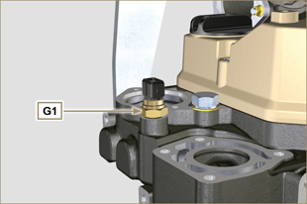  Fig 7.17
7.4.5.3 Speed sensor ( )  - Undo the screw H1 and remove the sensor L1 with the relative spacer ( ST_06 ) .  - Undo the screws M1 and remove the sensor N1 . | 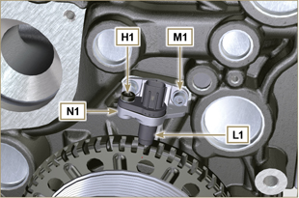  Fig 7.18
7.4.5.4 Camshaft phase sensor  - Undo the screw P1 and remove the sensor Q1 with the relative spacer. | 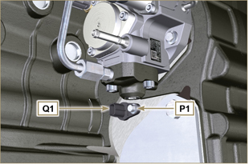  Fig 7.19
7.4.5.5 T-MAP Sensor ( )  - Undo the screw R1 and remove the sensor S1 ( ST_06 ). | 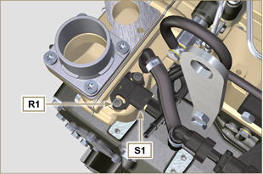  Fig 7.20
7.4.5.6 Fuel filter water detection sensor ( )  Warning  - The fuel filter is not always mounted on the engine.  - When disassembling the sensor U1 , use a suitable container to recover the fuel contained in the cartridge T1 .  - Unscrew the sensor U1 from the cartridge T1 . | 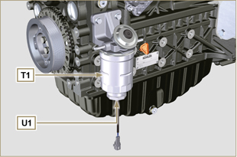  Fig 7.21

Turbocharger disassembly
- Unscrew the fittings A and remove the pipe B with the relative gaskets C . | 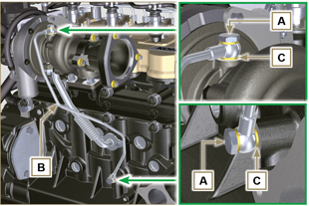  Fig 7.22
- Undo the screws D and remove pipe E and the relevant gaskets. | 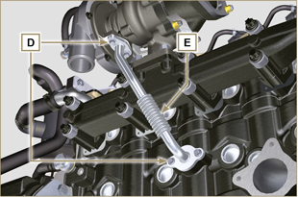  Fig 7.23
- Undo the nuts F and remove the turbocharger G . | 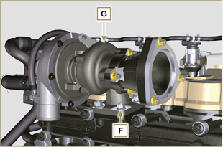  Fig 7.24

Exhaust manifold disassembly
- Remove nuts A , capscrews B and spacers C , manifold D and gaskets E .  - Close the openings and manifolds to prevent foreign bodies from entering. | 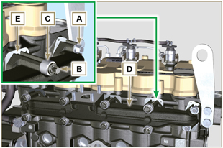  Fig 7.25

Crankshaft and target wheel pulley disassembly
- Perform the operations from point 4 to 5 of Par. 6.6.1 .

Flange unit disassembly
7.8.1 Flywheel  - Perform the operations of point 2 Par. 6.2.2 .  - Loosen, but not remove, nut A .  Important  - Leave the special tool ST_34 for blocking the flywheel ( Par. 7.7 ).  Danger  - The flywheel E is very heavy. Pay the utmost attention while removing it in order to prevent it dropping or falling, as this may have serious consequences for the operative.  - Undo the screws B and remove the flywheel C by means of tool ST_43 . | 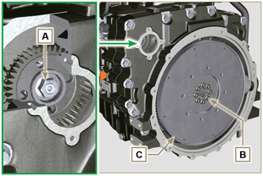  Fig 7.26
7.8.2 Flange housing  Danger  - The flange housing F is very heavy. Pay the utmost attention while removing it in order to prevent it dropping or falling, as this may have serious consequences for the operative  - Secure tool ST_41 onto gear D by means of capscrews B .  - Undo capscrews E by following the order indicated in the figure.  - Remove the engine housing F by means of tool ST_44 . | 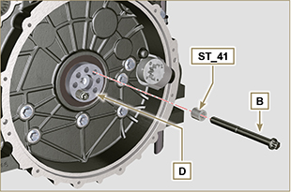  Fig 7.27  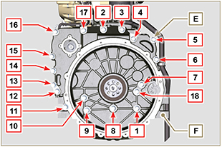  Fig 7.28

Lubrication circuit disassembly
7.9.1 Oil pump  Important  - The oil pump is not repairable.  - Undo the screws A and remove the pump unit B . | 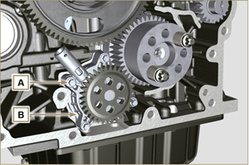  Fig 7.29
7.9.2 Oil pressure valve ( )  - Remove cotter pin C .  - Remove disk D , spring E , piston valve F using a magnet. | 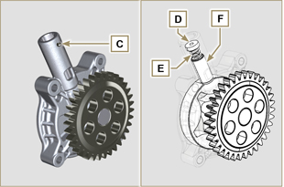  Fig 7.30
7.9.3 Oil Cooler unit and oil filter
- Perform the operations of Par. 6.8.1 .

NOTE : To replace the oil cartridge, refer to operations of Par. 6.8.2 .

7.9.4 Oil vapour separator unit  - Perform the operations of Par. 6.7.1 .  - Undo the screws G and remove the support H .  - Loosen clamp B and remove hose M .  - Undo the screw N and remove hoses P .  - Remove quick fitting R and remove hose S . | 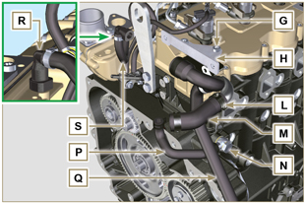  Fig 7.31

Fuel system disassembly
Important  - Seal all injection component unions as illustrated in Par. 2.9.8 .  7.10.1 Fuel return pipes  - Release the clip A .  - Disconnect unions B from electronic injectors C .  Warning  - After removing the union, the clip A must automatically return to its initial position; otherwise it must be replaced.  - Undo the screw D.  - Disconnect the pipe E .  - Undo and remove the screw F with the relative gaskets and put the cap on the Common Rail pressure relief valve G .  - Remove the fuel return pipes. | 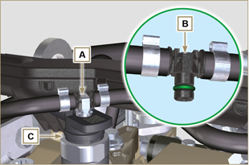  Fig 7.32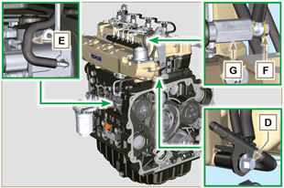  Fig 7.33
7.10.2 Fuel flow pipes  - Remove the pipes H, L. | 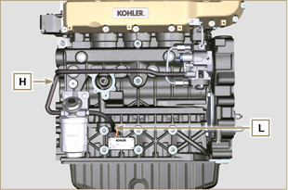  Fig 7.34
7.10.3 High pressure fuel pipes  Danger  - The fuel injection circuit undergoes high pressure, use safety protections as described in Par 3.4.3 .  - Ensure that the Common Rail is not under pressure by slowly and carefully unscrewing one of the nuts N .  - Undo the screw M .  - Loosen the nuts N, P in sequence.  - Fully undo the nuts N, P in sequence and remove the high pressure pipes Q, R. | 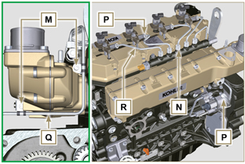  Fig 7.35
7.10.4 Common Rail  - Undo the screws S and remove the Common Rail T .  NOTE: Take care to protect te sensor U from knocks, moisture and any high temperature source. The internal parts of the rail cannot be repaired. | 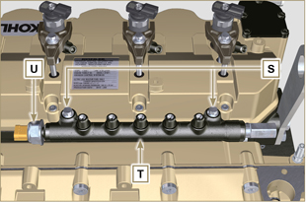  Fig 7.36
7.10.5 Electronic injectors  Important  - In the event that the electronic injectors are disassembled (not necessarily replaced), mark them with the relevant cylinder number from which they originate so as not to confuse them during re-assembly (Fig. 7.38) .  - The electronic injectors cannot be repaired.  - If one or more electronic injectors are to be replaced, the new calibration data must be inserted in the ECU via a specific instrument ( ST_01 ).  - Be careful not to damage the gaskets V .  - Undo capscrews J and remove them together with the relative washers K and then brace W .  - Pull out the electronic injector C .  NOTE: Should you be unable to remove the electronic injector (acting only on point X ), use an open-ended spanner (Ø 34 mm), by applying small rotations to unblock the component.  - Seal all injection component unions as illustrated in Par. 2.9.8 .  - Ensure that gasket Y has remained in the correct position (Fig. 7.38) .  Otherwise, recover the gasket from inside the electronic injector Z . | 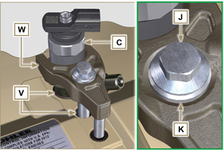  Fig 7.437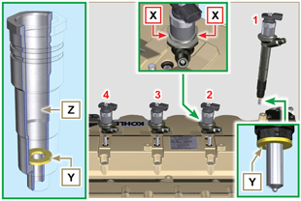  Fig 7.38
7.10.6 Fuel filter ( )  - Undo the fuel cartridge A1 from support B1 .  - Undo the screws C1 and remove the filter support B1 . | 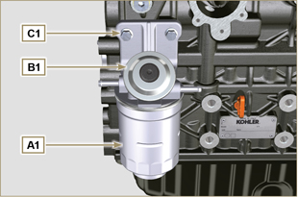  Fig 7.39
7.10.7 High-pressure fuel injection pump  Important  - Before disassembling, carefully read Par. 2.17 .  - The injection pump is not repairable  - Should the fuel feeding pump need to be replaced, after assembly, it is necessary to perform the Pump Learning procedure by means of instrument ST_01 .  - Undo the nut D1 .  - Screw the tool ST_13 on the thread of the gear E1 .  - Redo the capscrew F1 of tool ST_13 to disconnect the pump H1 from gear E1 .  - Undo the screws G1 , remove pump H1 and the relative gasket L1 .  - Seal all injection component unions as illustrated in Par. 2.9.8 . | 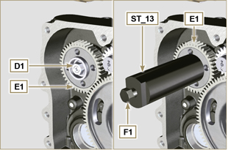  Fig 7.40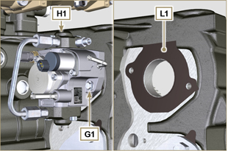  Fig 7.41

Intake manifold disassembly
- Undo the screws A and remove the semi-manifold B ( ST_05 ) .  - Remove the separation plate C and the gaskets D . | 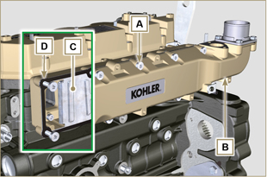  Fig 7.42
- Undo the screws E .  - Remove the semi-manifold F and the gasket G . | 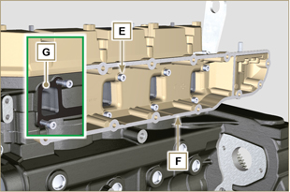  Fig 7.43

Cylinder head unit disassembly
7.12.1 Rocker arms cover  - Undo the screws A .  - Remove the rocker arms cover B .  - Remove the gasket C . | 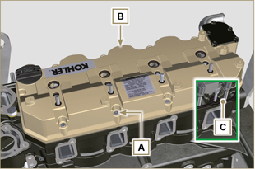  Fig 7.44
7.12.2 Rocker arm pin  - Undo the screws D .  - Remove the rocker arm pin unit E . | 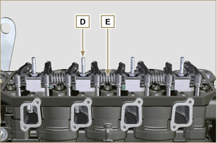  Fig 7.45
7.12.2.1 Rocker arm ( )  - Remove the retainer ring F .  - Remove the shoulder rings G .  - Remove the rocker arms H . | 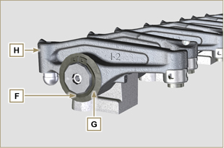  Fig 7.46
7.12.3 Valve rods and bridges  - Remove the valve control U-bolts M .  - Remove the rocker arm control rods N . | 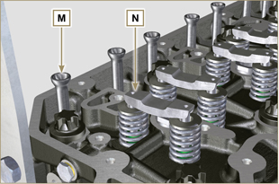  Fig 7.47
7.12.4 Cylinder head  Important  - The capscrews P must be replaced every time they are disassembled.  - Do NOT remove the capscrews completely, first loosen them by turning them a whole cycle following the order shown in the figure.  - Loosen fastening screws P , turning them by one turn following the order shown in the figure.  - Undo capscrews P by following the order indicated in the figure.  Important  - To lift cylinder head Q , only use both eyebolts AE provided by KOHLER (refer to Fig. 7.55 ).  - When removing the cylinder head Q and subsequent disassembly, control, and assembly operations, it is necessary to protect the contact surface W of cylinder head Q and crankcase J against impacts.  - Remove the cylinder head Q .  - Remove the head gasket R . | 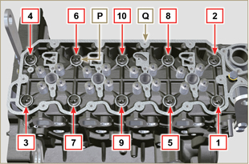  Fig 7.48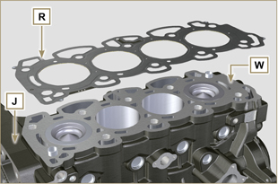  Fig 7.49
7.12.4.1 Valves ( )  - Mount the tool ST_07 on the head Q fixing it on one of the holes for fixing the rocker arm cover.  NOTE: Change the fixing hole according to the position of the valves to be removed.  - Position the tool ST_07 on the valve as shown in the figure. | 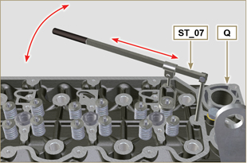  Fig 7.50
- Push the lever of the tool ST_07 downwards, in order to lower the valve plates S in the direction of the arrow T , remove cotters U using a magnet.  NOTE: Repeat all the operations for all the valves concerned. | 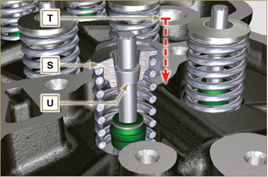  Fig 7.51
Important  - Before removing the valves, make some marks to record their original position, in order to avoid confusing them when reassembling (if they are not replaced).  - Remove the valves V . | 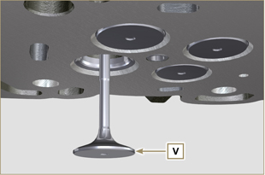  Fig 7.52
7.12.4.2 Electronic injector sleeves ( )  - Unscrew and remove the sleeves Z from the head Q .  - Remove the gaskets J, K . | 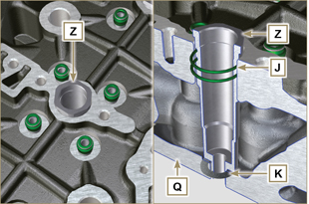  Fig 7.53
7.12.4.3 Valve stem gasket ( )  - Remove the gaskets W . | 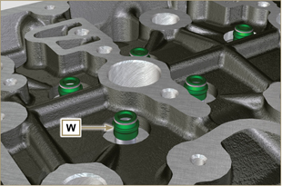  Fig 7.54
7.12.4.4 Lifting eyebolts ( )  - Undo the screws X and remove the eyebolts Y .  - Thoroughly wash the cylinder head Q . | 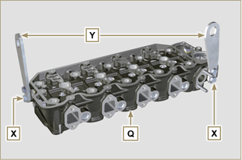  Fig 7.55

Timing system gear disassembly
Important  - For the following operation, turn the engine by bringing the cylinder head surface downwards.  - Remove the gear A .  - Unscrew screw B and remove the gear C .  NOTE: Gear A is assembled on the camshaft by press-fit; remove gear A to also remove the camshaft. | 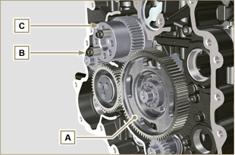  Fig 7.56

Oil sump unit disassembly
7.14.1 Oil sump  - Undo the screws A .  - Remove the oil sump B by inserting a plate between surface C of crankcase D and oil sump B .  - Remove the oil dipstick E . | 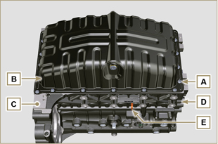  Fig 7.57
7.14.2 Oil suction pipe  - Undo the screws F and remove the oil pipe G . | 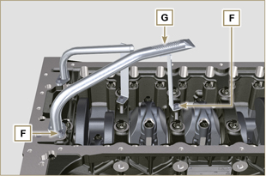  Fig 7.58
7.14.3 Oil drain pipe ( )  - Undo the screws H and remove the pipe L . | 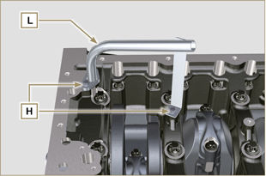  Fig 7.59

Engine block disassembly
7.15.1 Piston unit/connecting rod  Important  - Mark some numerical references (cylinder n°) on the connecting rods, connecting rod caps N , pistons and gudgeon pins to prevent unintentionally confusing the components not replaced during assembly. Failure to do this may result in engine malfunctions.  - References on connecting rod M and cap N must only be carried out on a side in correspondence with K1 and K2 , as illustrated in Fig. 7.61 .  - Screw the bolt M temporarily. | 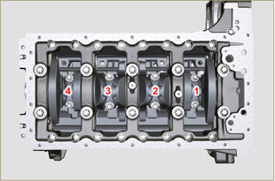  Fig 7.60
NOTE : coupling cap N on the connecting rod can be carried out with centring taper pins (Fig. 7.62) or broken ( Fig. 7.63 - without centring taper pins).  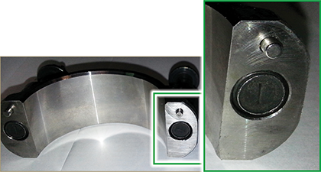  Fig. 7.62  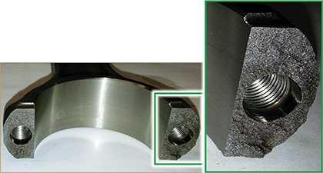  Fig. 7.63 | 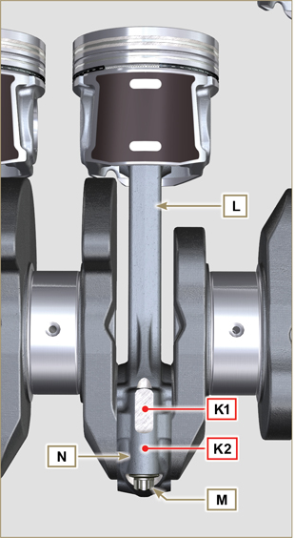  Fig 7.61
- Pull out the connecting rod - piston assembly from position 2 and 3 by manually applying pressure on the connecting rod big end L in the direction of arrow X .  - Couple the connecting rod big end caps N with the relevant piston and connecting rod unit L .  - Rotate the crankshaft by 180°.  - Repeat points 2 to 5 to disassemble the connecting rod-piston assembly to position 1 and 4 . | 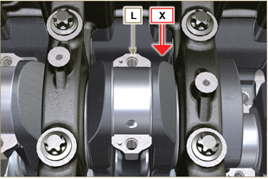  Fig 7.64
Warning  - The connecting rod half-bearings P are made of special material. Therefore, they must be replaced every time they are removed to prevent seizures. | 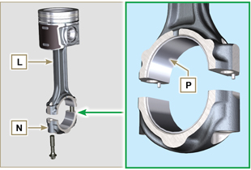  Fig 7.65
7.15.2 Lower semi-crankcase  Important  - The capscrews Q must be replaced every time they are disassembled.  - Do NOT remove the capscrews completely, first loosen them by turning them a whole cycle following the order shown in the figure.  - Loosen fastening screws Q , turning them by one turn following the order shown in the figure.  - Undo capscrews Q by following the order indicated in the figure. | 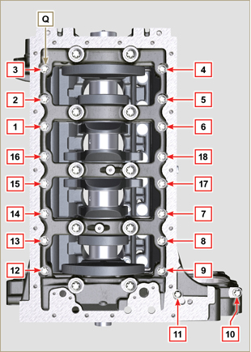  Fig 7.66
Important  - The capscrews R must be replaced every time they are disassembled.  - Do NOT remove the capscrews completely, first loosen them by turning them a whole cycle following the order shown in the figure.  - Loosen fastening screws R , turning them by one turn following the order shown in the figure.  - Undo capscrews R by following the order indicated in the figure.  - Remove the lower semi-crankcase D1 and store it in a suitable container for washing. | 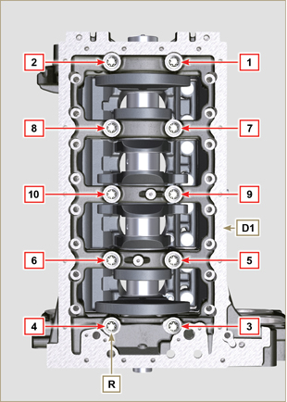  Fig 7.67
7.15.3 Crankshaft  Remove:  - Crankshaft S .  - The shoulder semi-rings T .  - gasket U from crankshaft S . | 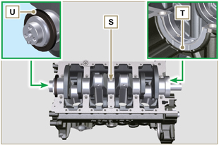  Fig 7.68
7.15.4 Piston ( )  - Remove the retainer ring V .  - Remove the pin Z to separate the piston J from the connecting rod L .  Important  - If they are not replaced, keep the components together (connecting rod - piston - gudgeon pin) by using references in order to prevent them from getting mixed up during assembly. | 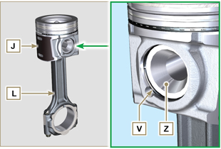  Fig 7.69
7.15.4.1 Rings ( )  - Remove the rings K . | 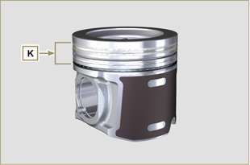  Fig 7.70
7.15.5 Oil spray nozzles ( )  - Undo the screws W and remove the spray nozzles X from the upper semi-crankcase D2 . | 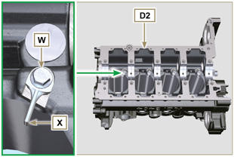  Fig 7.71
7.15.6 Camshaft tappets  - With a magnet, remove the tappets Y from the upper semi-crankcase D2 . | 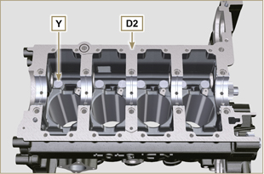  Fig 7.72
7.15.7 Crankshaft bushings  - Remove the crankshaft bushings A1 from the upper crankcase D2 .  Important  - The crankshaft half-bearings A1, B1 are made of special material. Therefore, they must be replaced every time they are removed to prevent seizures. | 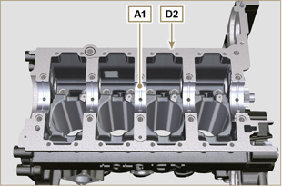  Fig 7.73
- Remove the crankshaft bushings B1 from the lower semicrankcase D2 . | 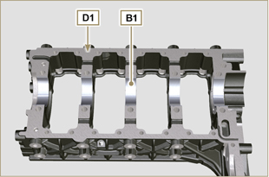  Fig 7.74

Information about overhauling

Recommendations for overhauls and tuning
- The information is laid out in sequence, according to operational requirements, and the intervention methods have been selected, tested and approved by the manufacturer's
technicians.
- This chapter describes procedures for checking, overhauling and tuning units and/or individual components.

NOT E : To easily locate specific topics, the reader should refer to the analytical index or chapter index.

- Before any intervention, the operator should lay out all equipment and tools in such a way as to enable him to carry out operations correctly and safely.
- The operator must comply with the specific measures described in order to avoid errors that might cause damage to the engine.
- Before carrying out any operation, clean the units and/or components thoroughly and eliminate any deposits.
- Do not wash the components with steam or hot water. Use suitable products only.
- Do not use flammable products (petrol, diesel, etc.) to degrease or wash components. Use suitable products only.
- Dry all washed surfaces and components thoroughly with a jet of air or special cloths before reassembling them.
- Apply a layer of lubricant over all surfaces of all disassembled components to protect them against oxidation.
- Check the integrity and state of wear of all disassembled components in order to ensure good working condition of the engine.
- When indicated, some components are to be replaced in pairs or together with other parts (e.g. crankshaft half-bearings/connecting rod, piston complete with rings and gudgeon pin, etc.).
- When indicated, some grinding operations are to be carried out in series (e.g. grinding of cylinders, crankpins, journals, etc.).

Crankcase
8.2.1 Oil line check

Important

- Replace and assemble the conical cap A3 in hole B , B1 (tightening torque at 30 Nm ), after having performed cleaning operations.
- Use a pipe cleaner in access points A , B , B1 , C , D to clean the oil ducts of crankcase G .
- Use compressed air to eliminate any residues.

- Remove capscrews A1 and remove plate A2 with its gasket.

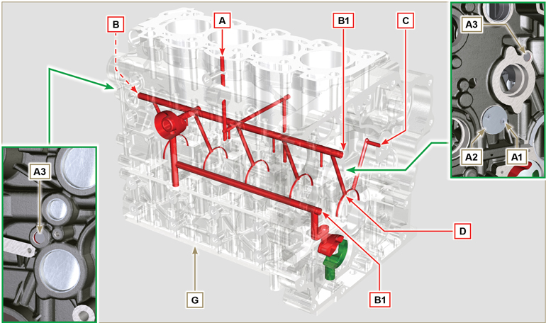
Fig 8.1

8.2.2 Cylinder check
Position crankcase G onto a workbench.
With a dial gauge, measure the diameter in correspondence to points J-M-N (Fig. 8.2) lengthwise and diagonally with regard to axis H of the crankshaft.
If ovalisation or wear detected in a single point in J-M-N is greater than +0.05 mm with regard to the value in Tab. 8.1 , you are required to perform grinding operations on all cylinders F.
Refer to Tab. 8.1a

to establish the clearance value of cylinders subjected to grinding operations.
Important

- Grinding is prohibited before 10000 h of operation on all engines provided with an EPA name plate (refer to Par. 1.3 ).
- The grinding involved is of +0.20, +0.50 e + 1 mm .
- Cylinder grinding operations must observe KOHLER SPECIFICATIONS - cod. ED0035612500.
- Grinding must be strictly performed on all cylinders F .

Tab. 8.1 details the dimensional values of new components only.
- ⁽¹⁾ The increase of +0.20 mm , may already be present on the engine.
Tab 8.1 Grinding values
PISTON | Ø CILINDER (± 0.007 mm) | Ø PISTON (± 0.007 mm) | CLEARANCE VALUE (mm)
STD | 96.010 | 96.950 | 0.046 - 0.074
+0.20 ⁽¹⁾ | 96.210 | 96.150
+0.50 | 96.510 | 96.450
+1.00 | 97.010 | 96.950

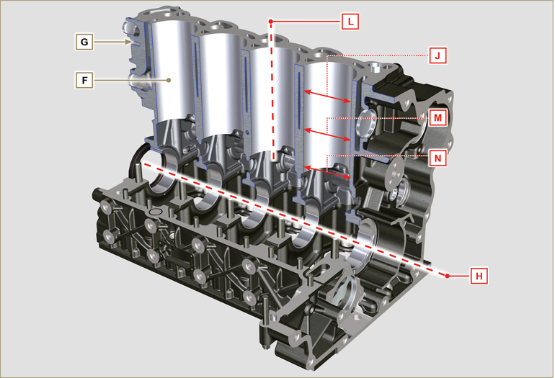
Fig 8.2

8.2.3 Block Surface Flatness  Use a dial gauge to check if the cylinder head surface A1 is level.  The MAX value of allowable irregularity of surface A1 is:  - 0.10 mm on the entire area;  - 0.03 mm on an area of 100x100 mm.  Grinding of surface A1 is not permitted | 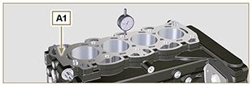  Fig 8.3
8.2.4 Camshaft housing check  Use an internal dial gauge to measure the diameters of housings W - K - Y - Z .  With a micrometer, measure the diameters of gudgeon pins W1 - K1 - Y1 - Z1 (Fig. 8.5) . According to the values measured, calculate the clearance between the housing and gudgeon, which is to observe the  values in Tab. 8.2 .  The MAX value of wear allowed is 0.120 mm  Important  - Tab. 8.2 details the dimensional values of new components only. | Tab 8.2 Housing and camshaft gudgeon dimensions.  REF. DIMENSIONS (mm) CLEARANCE VALUE (mm)  W 47.500 - 47.525 0.060 - 0.105  W1 47.420 - 47.440  K 47.000 - 47.025 0.060 - 0.105  K1 46.920 - 46.940  Y 46.500 - 46.525 0.060 - 0.105  Y1 46.420 - 46.440  Z 35.000 - 36.025 0.060 - 0.105  Z1 34.920 - 35.940
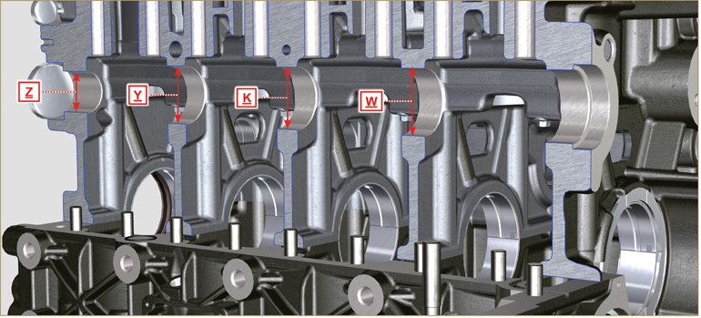
Fig 8.4

8.2.5 Camshaft control  With a micrometer, measure the maximum dimensions of intake camshaft R and exhaust camshaft S (Tab. 8.3) .  The MAX value of wear allowed is 0.1 mm .  Important  - Tab. 8.3 details the dimensional values of new components only. | Tab 8. 3 Camshaft dimensions.  REF. DIMENSIONS (mm)  R 40.495 - 40.433  S 39.175 - 39.113
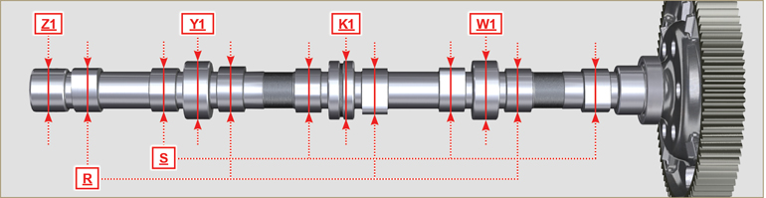
Fig 8.5

Tappets and tappet housings
8.3.1 Tappets check  Use a surface plate and a dial gauge as shown in Fig. 8.5 .  Check the perpendicularity of the plate C , making the tappet D rotate in the direction of the arrow.  The MAX value of wear allowed is 0.02 mm .  With a gauge, check the length of value A and B (Tab. 8.4) . The MAX value of wear allowed is 0.08 mm . | 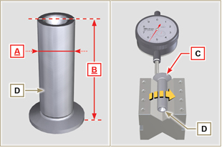  Fig 8.5
8.3.2 Tappet housing check  Use an internal dial gauge to measure the diameter of the tappet housings X .  Use value of A detected (Par. 8.3.1) to calculate the clearance value ( Tab. 8.4 ).  If the clearance values are not observed, replace the worn component.  Important  Tab. 8.4 T appets and t appet housing size.  REF. DIMENSIONS (mm) CLEARANCE VALUE (mm)  A 14.984 - 14.966 0.016 - 0.052  X 15.000 - 15.018  B 47.5 --- | 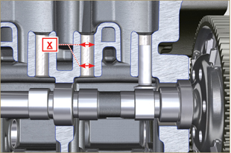  Fig 8.6

Crankshaft
8.4.1 Dimensional check and overhauling

Wash the crankshaft thoroughly using suitable detergent.
Insert the pipe cleaner into all lubrication ducts B and blow compressed air to free them completely from any dirt residues.
Check the state of wear and integrity of journals C and connecting rod D .
Perform the operations described in Par. 9.3.1 and Par. 9.3.5 - except points 2, 3, 5, 9 and 10 .
Tighten capscrews J ( Fig. 9.9 ) and K ( Fig. 9.10 ) observing the cycles, tightening, and subsequent rotation.
Cycle 1 - Screw J - Torx M14x1,5 - Torque 60 Nm. ( Fig. 9.9 );
Cycle 2 - Screw K - Torx M10x1.25 - Torque 30 Nm. ( Fig. 9.10 ).
Measure the crank pins A1 with a micrometer, and using a dial gauge measure the internal diameter of the connecting rod half-bearings A2 .
Measure the main journals B1 , with a micrometer, and using a dial gauge measure the internal diameter of the crankshaft half-bearings B2 .
If the values described in Tab. 8.5 do not correspond, proceed with grinding all gudgeon pins A1 and B1 .

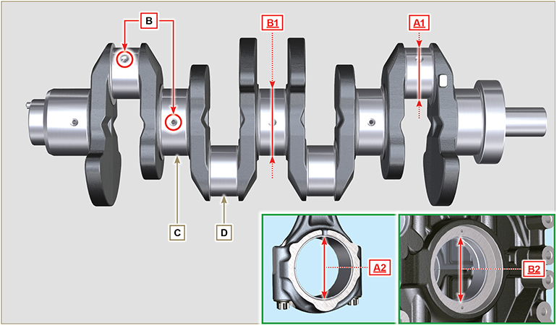
Fig 8.7

Important  - The crankshaft and connecting rod must be replaced every time they are assembled to prevent seizure, as they are made of special lead-free material.  - The MAX allowed value of wear for A1 and A2 is 0.120 mm.  - The MAX allowed value of wear for B1 and B2 is 0.120 mm.  - To grind the crankshaft, a decrease in diameter of the halfbearings and connecting rod is provided for at 0.25 mm and 0.50 mm, to grind gudgeon pins A1 and B1 , measure the values of diameters A2 and B2 by assembling the decreased half-bearings, define the diameter to grind of pins A1 and B1 ,  observing the clearance indicated in Tab. 8.5.  - La Tab. 8.5 riporta i valori dimensionali solo per i componenti nuovi. | Tab 8.5 Connecting rod and journal diameter  REF. DIMENSIONS (mm) CLEARANCE VALUE (mm)  A1 60.980 - 61.000 0.034 - 0.090  A2 61.034 - 61.069  B1 79.978 - 80.000 0.036 - 0.104  B2 80.036 - 80.082
8.4.2 Checking the axial clearance of the crankshaft  Perform the operations described in Par. 9.3.1 , Par. 9.3.4 and. Par. 9.3.6 - except points 2, 3, 5 , and 10 .  Tighten capscrew J ( Fig. 9.9 ) observing the cycles, tightening, and subsequent rotation.  Cycle 3 - Screw J - Torx M14x1,5 - Torque 45°. ( Fig. 9.9 )  Cycle 4 - Screw J - Torx M14x1,5 - Torque 45°. ( Fig. 9.9 ).  Using a dial gauge, measure the axial shift of crankshaft E .  Axial shift must be a MIN of 0.18 mm and MAX 0.38 mm..  If the values measured do not correspond, replace shoulder rings D . | 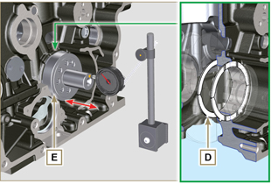  Fig 8.8

Connecting rod - piston assembly
8.5.1 Connecting rod dimensions check  Important  - Before assembling the connecting rod and pistons ( Par. 9.3.7 e 9.3.8 ), check that the difference in weight between the complete connecting rod and piston units do not exceed 15 gr to prevent weight imbalances during rotation of the crankshaft and consequent damage.  - Mark some references on the connecting rods, caps Q , pistons and gudgeon pins to prevent unintentionally confusing the components during assembly. Failure to do this may result in engine malfunctions.  - Connecting rod half-bearings S must be there with each assembly.  Check that the contact surfaces are perfectly clean and intact.  Assemble the connecting rod cap Q to the connecting rod with the half-bearings S and tighten capscrews P (tightening torque at 28 Nm ).  With a dial gauge, measure diameters B and D .  The MAX allowed value of wear for B and D is 0.06 mm.  Tab 8.6  REF. DIMENSIONS (mm) CLEARANCE VALUE (mm)  A 192.980 - 193.020  B 37.025 - 37.015 0.015 - 0.030  C 36.995 - 37.000  D 61.034 - 61.069  E 74.000 - 74.300  F 33.950 - 33.990  Important  - Tab. 8.6 details the dimensional values of new components only.  - Check that the connecting rod and crankshaft half-bearings are coupled properly.  - Refer to the warnings in Par. 8.4.1 for value D decreased.  - If the clearance value between B and C is not observed, you are required to replace bearing R (Fig. 8.10) .  Measure value A, C, D, E and F and confront them with those described in Tab.8.6 .  If the measured values do not follow those described in Tab.8.6 , replace connecting rod T . | 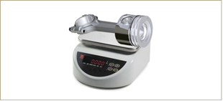  Fig 8.9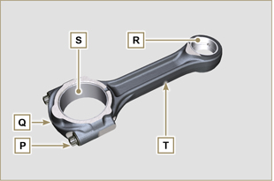  Fig 8.10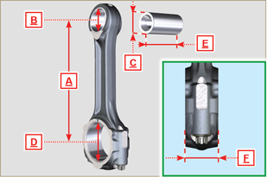  Fig 8.11
8.5.2 Checking the gudgeon pin-pin axes are parallel  Lubricate gudgeon pin A and bearing R (Fig. 8.10) .  Insert the gudgeon pin into bearing R . Use a dial gauge to check the axis parallelism of the connecting rod big end and small end.  Parallel deviation (value V ) measured at the tip of the gudgeonpin, must be a MIN of 0,015 and MAX of 0,030 mm.  If the parallelism values do not comply with the specified ones,replace the connecting rod with a new one.  8.5.3 Piston rings check  Insert ring U into the cylinder, measure value H (distance between the points of ring U ). Repeat for all the seal rings.  If the measured value H does not correspond to the values indicated in the table (Tab. 8.7) , replace the seal rings U .  Important  - Seal rings cannot be replaced separately.  NOTE: refer to Fig. 8.17 to locate the rings.  Tab. 8.7  RINGS H (mm)  U1 0.30 - 0.15  U2 0.50 - 0.70  U3 0.20 - 0.40 | 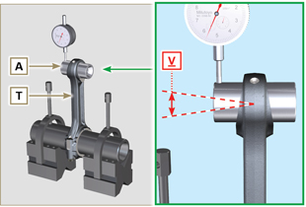  Fig 8.12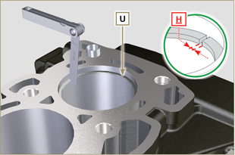  Fig 8.13
8.5.4 Piston dimension check  Clean the piston thoroughly.  Measure the diameter of the piston at 12 mm (quota L ) from the base of the skirt in correspondence with the graphite lubrication windows M .  Refer to Tab. 8.8 to establish the clearance value of the pistons with a decreased diameter.  In correspondence with point W , there are: 3 digits for the STD piston;  3 digits followed by R for a piston with an increased diameter of 0.20 mm; +0.5 for a piston with an increased diameter of 0.50 mm;  +1 for a piston with an increased diameter of 1.00 mm;  If clearance between cylinder and piston is greater than 0,074 mm, the piston and seal rings must be replaced.  Important  - Tab. 8.8 details the dimensional values of new components only.  Tab. 8.8  PISTON Ø CYLINDERS (± 0.007 mm) Ø PISTON (± 0.007 mm) CLEARANCE VALUE (mm)  STD 96.010 95.950 0.046 + 0.074  +0.20 96.210 96.150  +0.50 96.510 96.450  +1.00 97.010 96.950 | 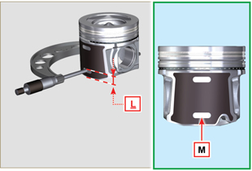  Fig 8.14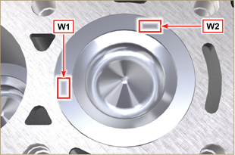  Fig 8.15
Important  - With a feeler gauge, measure the clearance of the seal ring in the respective seat (value L1, L2 e L3 ).  - If the clearance does not comply with the values shown in the Tab. 8.9 , replace the seal rings and the piston.  Tab 8.9  SEAL RINGS CLEARANCE VALUE (mm)  U1 (L1) 0.110 - 0.150  U2 (L2) 0.070 - 0.115  U3 (L3) 0.030 - 0.070 | 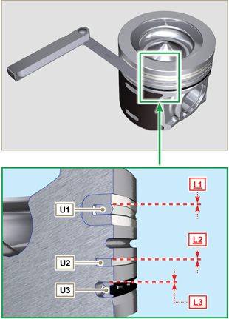  Fig 8.16 / 8.17

Cylinder head
8.6.1 Flatness check  Put the cylinder head on a surface plate and, with a dial gauge, check the flatness of surface C .  The MAX value of allowable irregularity of surface C is 0.10mm.  If the value is not observed, you are required to grind surface C .  The MAX removal allowed is 0.20 mm.  Important  - Grinding is to be performed with sleeves A of the electronic injectors assembled.  - Grinding is prohibited on all engines provided with an EPA name plate (refer to Par. 1.3 ). | 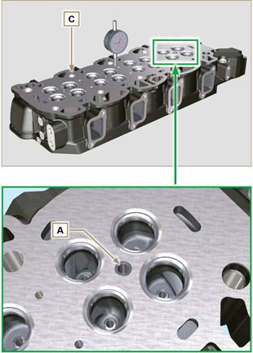  Fig 8.18 - Fig 8.19
8.6.2 Valve seats check  Thoroughly clean the valves and their seats with.  Measure indentation B of each valve with regard to the cylinder head surface C , which is to be a MIN of 0.50 mm and MAX of 0.53 mm.  The B MAX indentation allowed on worn components is 0.90 mm.  If the measured value does not correspond with the values indicated, replace the worn component.  Important  - The seats must be worked after driving to reach value B , go to a rectification workshop for such operations.  8.6.3 Valve springs  Use a gauge to measure the free length Z .  Using a dynamometer, subject the spring to two different forces and check that the length of the spring corresponds to the values indicated in Tab. 8.10 .  Tab 8.10  WEIGHT (kg) LENGHT (mm)  0 Z 42.50  20,4 Z1 33.00  42,8 Z2 23.80 | 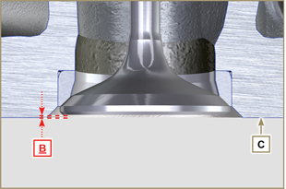  Fig 8.20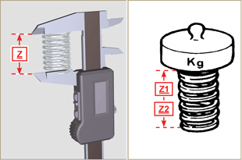  Fig 8.21
8.6.4 Valve guides check  Measure the diameters D and E of the rods and guides valve (Tab. 8.11) .  If the diameters don't correspond to the values indicated, replace the valves or guides.  The MAX allowed value of wear for D and E is 0.10 mm.  Observe values G from surface F when assembling guides H (Tab. 8.11) .  Important  - Carry out the measurements in different points to detect any ovalisation and/or concentrated wear.  - Tab. 8.11 details the dimensional values of new components only.  Tab 8.11 Valve stem - valve guide dimensions  REF. DIMENSIONS (mm) CLEARANCE VALUE (mm)  D 5.978 - 5.990 0.040 - 0.064  E 6.030 - 6.042  G 38.300 - 38.700 | 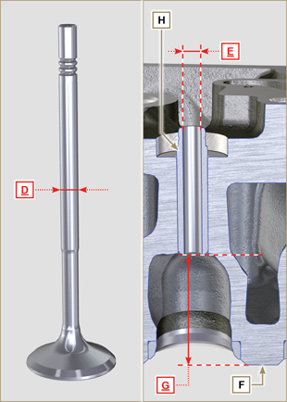  Fig 8.22
8.6.5 Valve guides replacement  The intake and exhaust guides are both made out of grey iron with pearlitic phosphoric matrix and they have the same dimensions.  The guides are press-fit assembled; assembly is possible by cooling the guides with the aid of liquid nitrogen.  Before assembling a new guide, measure value L and M ,calculate the press-fit value, which must observe the values in Tab. 8.12 .  Observe values G from surface F when assembling guides H (Tab. 8.11 - Fig. 8.22) .  Important  - The guides must be worked for value E (Tab. 8.11 - Fig.8.22) after driving. Contact a rectification workshop for such operations.  Tab 8.12 valve guides - housing dimensions  REF. DIMENSIONS (mm) PRESS-FIT VALUE (mm)  L 10.000 - 10.015 0.030 - 0.054  M 10.045 - 10.054 | 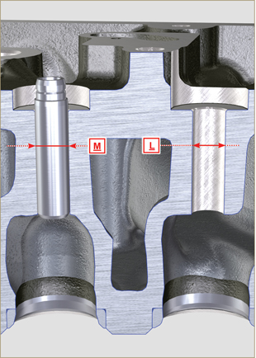  Fig 8.23
8.6.6 Rocker arm check  Measure values W1 in correspondence with holes M located on rocker arm gudgeon L (seen from B in Fig. 8.25 ).  Measure values W2 (Fig. 8.26).  Based on the values measured, calculate the clearance between W1 and W2 , which is to observe the values in Tab. 8.13.  Check that all oil pipes N and M are free from impurities or obstructions.  Tab 8.13  REF. DIMENSIONS (mm) CLEARANCE VALUE (mm)  W1 22.005 - 22.015 0.025 - 0.056  W2 22.040 - 22.061  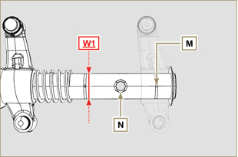  Fig. 8.25 | 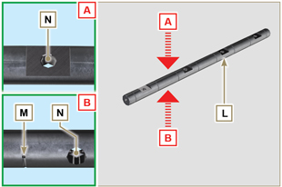  Fig 8.24  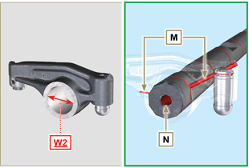  Fig 8.26

Balance device check
8.7.1 Dimensional and visual check  With a micrometre, measure the diameter of the pins A1 - B1 - C1 . Use an internal dial gauge to measure the diameters of housings D1 - E1 - F1 .  According to the values measured, calculate the clearance between the housing and pin, which is to observe the values in Tab. 8.14.  The MAX value of wear allowed is 0.03 mm.  Important  La Tab. 8.14 details the dimensional values of new components only. | 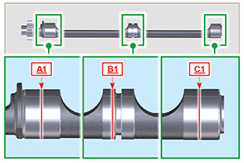  Fig. 8.27
Tab. 8.14  REF . DIMENSIONS (mm) CLEARANCE VALUE (mm)  A1 41.405 - 41.425 0.075 - 0.135  D2 41.500 - 41.540  B1 40.905 - 40.925 0.075 - 0.135  E1 41.000 - 41.040  C1 40.405 - 40.425 0.075 - 0.135  F1 40.500 - 40.540 | 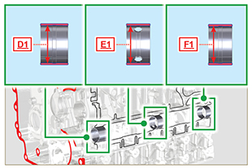  Fig. 8.28
8.7.2 Replacement of bearings  The bearings must be bored after assembly. Refer to the D1, E1, F1 values in Tab. 8.14. Refer to surface P for G1, G2, G3 assembly values in  Important  Bearing G2 must be oriented for engine lubrication circuit oil holes.  Tab. 8.15  REF . DIMENSIONS (mm)  G1 49.5  G2 285  G3 517 | 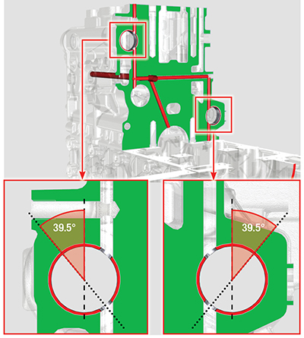  Fig. 8.30
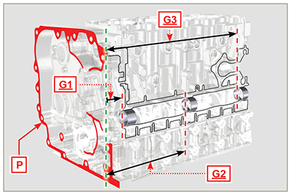
Fig. 8.29

Oil pump check
8.7.1 Dimensional and visual check  Measure clearance value B between the rotor teeth, the value of allowable wear is MAX 0.28 mm.  Important  - Should the results from checks carried out not be in accordance with the conditions described, replace the oil pump A . | 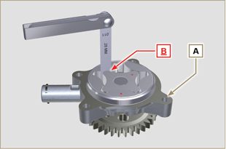  Fig 8.27
8.7.2 Oil pressure valve check  Measure the free length F of spring D , which must be 47.5 mm .  If the measured value does not correspond to the value indicated, replace spring D .  Tab 8.16  POS DESCRIPTION  B Oil stopper  C Gasket  D Spring  E Piston | 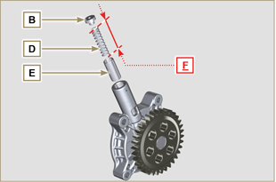  Fig 8.28

Assembly information

Information on engine configuration
- In this chapter, the engine is represented as "BASE CONFIGURATION" (refer to Par. 1.4 - 1.5 ).
- For the assembly of components not described in this chapter refer to Chap. 11 .
- The following are the components described in Chap. 11 .

11.1 Heater (reaplacement)
11.2 Idler gear (for III/IV PTO)
11.3 III PTO (replacement)
11.4 IV PTO (replacement)
11.5 Balancer shafts (replacement)
11. 6 ETB (replacement)
11.7 EGR-T (replacement)
11.8 EGTS (Black | Yellow - replacement)
11.9 DPF & DOC filter (replacement)

Assembly recommendations
- The information is laid out in sequence, the intervention methods have been selected, tested and approved by the manufacturer's technicians.
- This chapter describes the installation procedures for the assemblies and/ or individual components which have already been checked, overhauled or possibly replaced with original spare parts.
- Where necessary, reference to special tools during assembly operations is indicated and identified in Tab 13.1 , hereinafter in Tab. 9.1 an example of a special tool ( ST_05 ).

Tab. 9.1
SPECIAL TOOLS
"ST" Code | Picture /draw | DESCRIPTION | PART NUMBER
ST_05 | 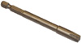 | Six nicks Key SN 8 | ED0014603650-S

Important

- Before proceeding with operations, read Par. 3.3.2 .
- To easily locate specific topics, the reader should refer to the analytical index or chapter index .
- The operator must check that:
  - the components, the assemblies, the coupling surfaces of the parts are washed, clean and thoroughly dried;
  - the coupling surfaces are undamaged;
  - the equipment and tools are ready so that all work can be carried out correctly and safely;
  - ensure that the working environment is safe.
- The operator must:
  - carry out the procedures smoothly and safely. It is thus recommended to install the engine on a special rotating stand used when servicing engines to ensure the safety of the operator and the other individuals involved;
  - tighten the assemblies and / or components in a criss-cross or alternating pattern, initially with a value lower than that preset, and then subsequently, with the tightening torque specified in the procedure;
  - replace all seal gaskets after each assembly for all components on which they are provided.

Engine block assembly
9.3.1 Crankshaft bushings  Important  - Execute the procedure in Par. 8.2.1 and 8.2.2 , before proceeding with assembly.  - The crankshaft half-bearings are made of special material. Therefore, they must be replaced every time they are assembled to prevent seizures.  - Fit the new half-bearings A1 onto the crankcase upper half B1 adhering to the reference notches C .  Importante  - After the half-bearings are fitted, check that the lubrication holes D correspond with the crankcase grooves B1 .  - The lower and upper half bearings CANNOT be singularly replaced, and both halves must be replaced together.  - Fit the new half-bearings A2 onto the lower crankcase B2 using the reference notches C .  - Lubricate the half-bearings A1 and A2 with oil. | 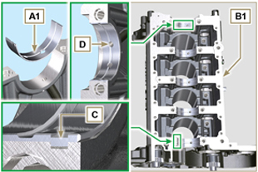  Fig 9.1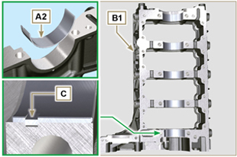  Fig 9.2
9.3.2 Tappets  - Lubricate the tappets E with oil.  - Insert the tappets E into the housings F of the upper crankcase B1 . | 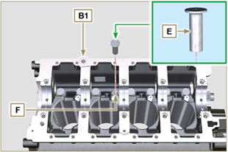  Fig 9.3
9.3.3 Oil spray nozzles  - Insert the sprayers G onto the upper crankcase B1 manually screwing the screw fittings H .  - Ensure that the spray nozzles G are inserted correctly in their seat, as shown in detail L and tighten the capscrews of union H (tightening torque of 10 Nm ). | 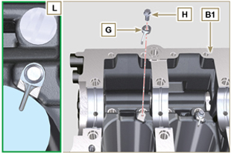  Fig 9.4
9.3.4 Crankshaft  Important  - Carry out the checks described in Par. 8.4.1 and Par. 8.4.2 .  - Check that the crankshaft half-bearings A1 are mounted correctly on the upper crankcase B1 .  - Lubricate the main journal and crankpin J , with oil.  - Insert the crankshaft M into its seat on the upper crankcase B1 .  - Insert the 2 shoulder half-rings N1 , between the crankshaft M and the upper crankcase B1 ( Q detail). | 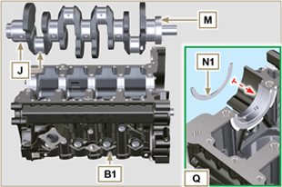  Fig 9.5
9.3.5 Lower semi-crankcase  - Check that the coupling surfaces P are free from dirt and grit.  - Spread a bead of Loctite 5660 of approx 1,5 mm thickness on the surface P of the upper crankshaft half B1 being careful not to block the oil feed grooves X and the return oil sump Y .  - Insert gasket S into the seat of crankcase B1 .  Note :alternatively apply Loctite 5699 . | 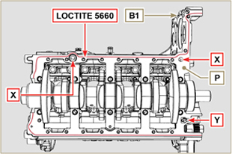  Fig 9.6

- Check that the crankshaft half-bearings A2 are mounted correctly on the lower crankcase B2 .
- Assemble the 2 shoulder half-rings N2 onto the lower crankcase B2 applying two drops of grease to keep them in their seat.
- Join the two crankshaft halves B1 and B2 observing the guide pins T .
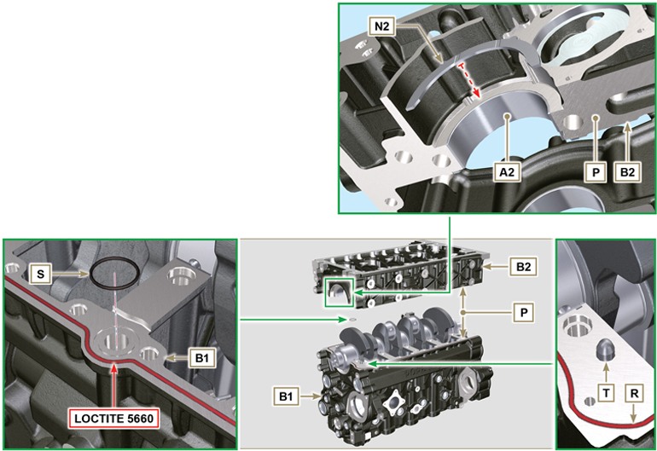
Fig 9.7 - F ig 9.8

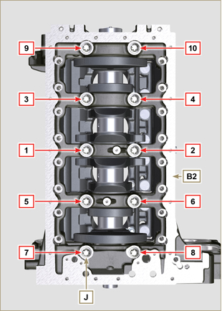  Fig 9.9 | 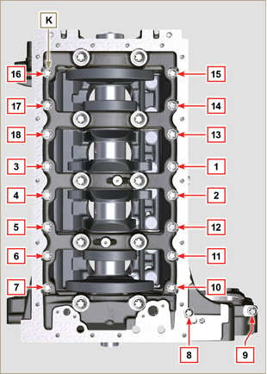  Fig 9.10
Tab 9.2  CYCLE SCREWS TORQUE  1 J - Torx M14x1,5 60 Nm  2 K - Torx M10x1.25 30 Nm  3 J - Torx M14x1,5 45°  4 J - Torx M14x1,5 45°  Important  - The fastening bolts J , K must be replaced every time they are assembled.  - Failure to adhere to the bolt fixing procedures may compromise the functionality of the engine, and also may cause damage to persons and property.  - Tighten capscrews J , K observing the cycles, tightening, and subsequent rotation as indicated in Tab. 9.2 .  - Apply " Molyslip AS COMPOUND 40 " on the threads and under the head of capscrews J and K and manually tighten them until their stop.  - Tightening the screws J , K strictly following the sequence indicated in the Fig. 9.9 or Fig. 9.10 and the tightening torque indicated in the Tab. 9.2 .  - Check that crankshaft M rotates smoothly.  - Insert gasket W into the seat of crankcase B ( ST_47 ) . | 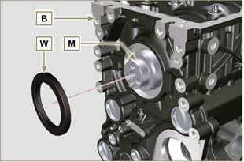  Fig 9.11
9.3.6 Camshaft  - Check that the pin P1 is correctly fitted on the crankshaft M .  - Position the gear M1 on the crankshaft M respecting the reference with pin P1 .  - Fully tighten the screw N1 .  - Lubricate the pins S2 , the cams S3 of the camshaft S1 , all the housing Q1 with oil.  - Insert the camshaft S1 all the way into its housing Q1 .  - Position the gear R1 observing all the marks T1 of the gears M1 .  Important  - Failure to comply with the marks T1 on the gears M1 and R1 causes engine malfunction and serious damage.  7. Check that crankshaft M rotates smoothly. | 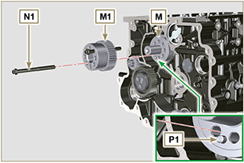  Fig 9.12  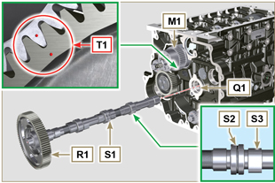  Fig 9.13
9.3.7 Piston rings  - Perform the operations described in Par. 8.5.3 .  - Put the scraper ring Z3 onto the piston Z .  - Put the 2° seal ring Z2 on the piston Z .  - Put the 1° seal ring Z1 onto the piston Z .  - Perform the operations described in Par. 8.5.4 .  - Position the segment openings with a 120° angle between them ( Y ).  NOTE: do not use the segment opening with the pin hole ( N )  - Lubricate the piston skirt and piston rings with oil. | 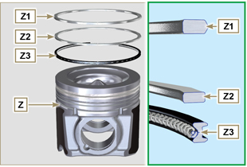  Fig 9.14  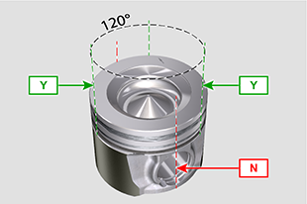  Fig 9.15
9.3.8 Piston  Importante  - The fastening bolts E1 must be replaced every time they are assembled.  - Before proceeding to the assembly of the piston and connecting rod, carry out the checks described in Par. 8.5.1 .  - Always replace the bearings D1 after each assembly.  - Mate components respecting references at Par. 7.15.5 .  - Loosen the screws E1 and remove the connecting rod cap F1 .  - Insert the connecting rod F2 into the piston Z and align the seats G1 .  - Insert the gudgeon pin H1 into the seat G1 for the assembly of the connecting rod and piston unit.  - Insert the lock rings L1 inside the seat G2 of the piston Z to lock the gudgeon pin H1 . | 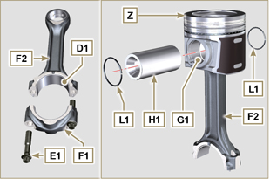  Fig 9.16  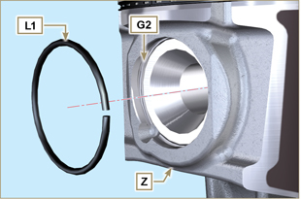  Fig 9.17

9.3.9 Piston and connecting rod assembly  Important  - Before assembling the piston and connecting rod assemblies, execute the controls described in Par. 8.5.5 .  - Rotate the crankshaft M by moving the crankpin J1 to a TDC position of the affected cylinder. | 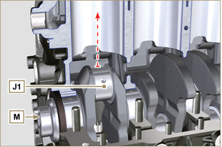  Fig 9.18
- Lubricate the piston skirt and rings Z .  - Check that the half-bearing U1 is mounted correctly and lubricate it thoroughly.  - Using the piston ring compression pliers, insert the piston inside the cylinder W1 by around 10mm (height T2 ).  Important  - Make sure you are at the stage described in Point 1 .  - Piston Z must be assembled with notch K1 on the side of the skirt facing oil spray nozzles G .  - Rotate the piston Z by 10° counter-clockwise with respect to its correct assembly position (Fig. 9.20 - height T3 ).  NOTE: Doing this prevents the impact between the connecting rod F2 and the sprayer G . | 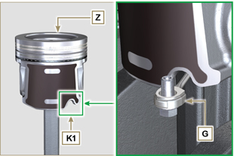  Fig 9.19  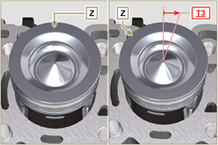  Fig 9.20  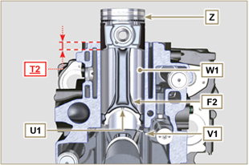  Fig 9.21  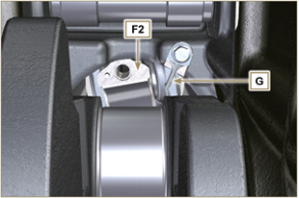  Fig 9.22
Important  - Leave the ring compressor assembled on the piston.  - Push piston Z downwards without introducing the segments in the cylinder, rotate piston Z by 10° in a clockwise direction (value T3 – correct assembly position). | 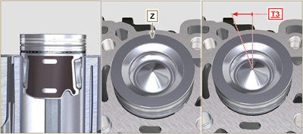  Fig 9.23

- Push the piston Z downwards by centering the crankpin J1 with the connecting rod F2 .  - Rotate the crankshaft M by moving the crankpin J1 to a BDC position of the affected cylinder.  - Push the piston Z downwards by centering the crankpin J1 with the connecting rod F2 .  - Turn the crankcase on support to assemble the con rod capp F1 .  - Check that the half-bearing U1 is mounted correctly on the connecting rod cap F1 .  Important  - Check that the break levels of connecting rod cap F1 coincide perfectly onto connecting rod F2 before screwing on and tightening capscrews E1 .  - Couple the connecting rod cap F1 to the connecting rod F2 using the marks made at disassembly ( Par. 7.15.2 and 7.15.5 ).  - Apply "Molyslip AS COMPOUND 40" on the threads and under the head of capscrew E1 and manually tighten them until their stop.  Important  - Failure to adhere to the assembly procedures may compromise the functionality of the engine, and also cause damage to persons and property.  - Tighten the screws E1 , alternately, strictly following the tightening torques indicated ( Tab. 9.3 ).  - Repeat the operations from 1 to 14 for each cylinder.  - Check that the connecting rods have axial play and the crankshaft M rotates smoothly.  NOTE: After the check carried out at point 16, position the shaft M with the first cylinder to TDC. | 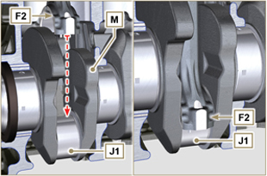  Fig 9.24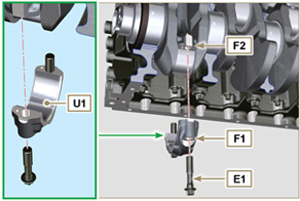  Fig 9.25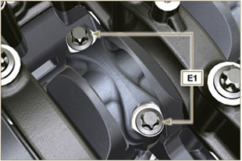  Fig 9.26
Tab 9.3
CYCLE | SCREWS | TORQUE
1 | E1 | 28 Nm
2 | E1 | 30°
3 | E1 | 30°

NOTE : Click by side to play the procedure. | https://www.youtube.com/embed/V4aXYc_0x8U?showinfo=0&rel=0

Oil sump unit assembly
9.4.1 Oil drain pipe  Important  - It is mandatory to replace the gasket D after each assembly.  - Always replace capscrews B with new ones or alternatively apply Loctite 2701 .  - Secure the hose A on the crankcase C with the screws B inserting the gasket D (tightening torque 10 Nm ). | 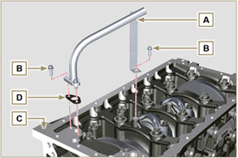  Fig 9.27
9.4.2 Oil suction pipe  Important  - It is mandatory to replace the gasket F after each assembly.  - Always replace capscrews B with new ones or alternatively apply Loctite 2701 .  - Secure the hose E on the crankcase C with the screws B (tightening torque 10 Nm ) fitting the gasket F . | 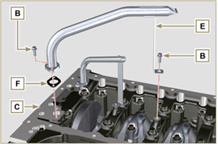  Fig 9.28
9.4.3 Oil Sump  - Ensure that the contact surfaces G of the oil sump H and the crankcase C are completely clean.  - Apply a bead of approx. 2.5 mm of sealant ( Loctite 5660 ) on the surface G of the crankcase C .  Note : alternatively apply Loctite 5699 . | 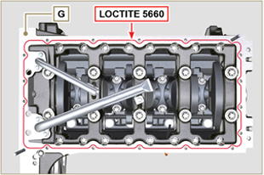  Fig 9.29
- Position the oil sump H on the crankcase C in line with the fastening holes (use the aid of tool ST_18 ). | 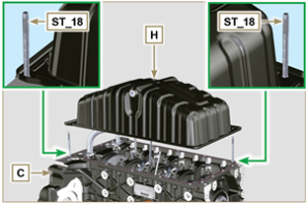  Fig 9.30
Important  - Tighten the screws L , strictly following the sequence and tightening torque indicated.  - Secure oil sump H by means of capscrews L .  - After tightening of the screw n° 10 , loosen screw n°1 and re-tighten it to the torque value specified in step 4 . | 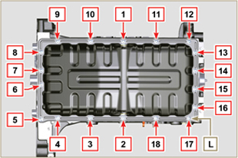  Fig 9.31

Cylinder head unit assembly
9.5.1 Valve stem gasket  Important  - Carry out the checks described in Par. 8.6.4 before proceeding with the following operations.  - Always replace gasket A with every assembly.  - Lubricate the oil seals A on the inside.  - Fit the oil seals A on the valve guides B using the tool ST_08 . | 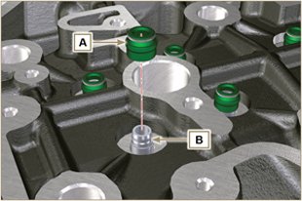  Fig 9.32
9.5.2 Electronic injector sleeves ( )  - Insert the seals C in the seats of the sleeve D .  - Insert the seal E with the convex side facing upward at the base of the sleeve D .  - Lubricate the gaskets C .  - Insert and carefully screw the sleeve D into the seat of the head F .  NOTE: The sleeve D must not protrude above the surface of the head G .  - Clamp the sleeve D (tightening torque at 30 Nm ). | 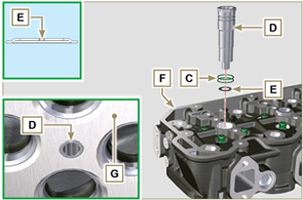  Fig 9.33
9.5.3 Electronic injectors projection  - Perform the operations of point 1 and 2 Par. 6.1.4.  - Perform the operations of point 3 and 4 Par. 6.1.5.  - Check using ST_03 tool (Fig. 9.35) , the projection of the injector, which must range between 1.68 ÷ 2.42 mm.  NOTE : if the value detected does not correspond, replace gasket Q with a different thickness. | 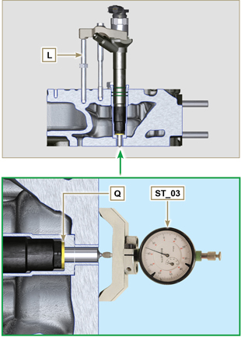  Fig 9.34 - Fig. 9.35
9.5.4 Valves  - Pre-lubricate and insert the valves X into the head F taking care to fit them in the original positions as per the reference marks made in Par. 7.12.4.1 .  - Position the spring Y on the seat of the head F .  - Position the disk S on the spring Y centering the valve X .  - Mount the tool ST_07 on the head F fixing it on one of the holes for securing the rocker arm cover.  NOTE: Change the fixing hole according to the position of the valves to be fitted.  - Position the tool ST_07 on the valve as shown in the Fig. 9.37 .  - Push the lever of the tool ST_07 downwards, in order to lower the valve disks S in the direction of the arrow AK , and insert the valve cotters AJ inside the disk S .  - Check that the valve cotters AJ are properly mounted on the valve seats X and release the tool ST_07 .  NOTE: repeat all the steps for the relevant valves and remove the tool ST_07 . | 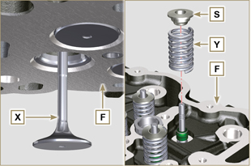  Fig 9.36
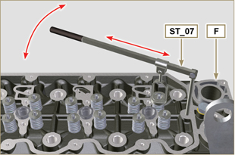
Fig 9.37
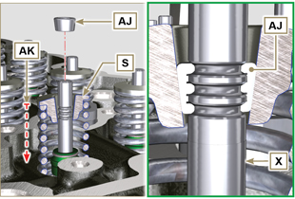
Fig 9.38
9.5.5 Cylinder head  - Fix the eyebolts AW with the screws AX onto the head F (tightening torque of 80 Nm ).  - Position the piston P at the TDC.  - Position the tool ST_03 on the crankcase surface of the head and measure the piston protrusion P from head level K in 4 diametrically opposed points R. Repeat the operation for all pistons P and take note of the highest average value, determining valu e S (Tab. 9.4) .  Tab. 9.42  S (mm) Hole number  0.030 - 0.126 1  0.127 - 0.250 2  0.251 - 0.375 3  - Based on the value detected at point 3 , select the relevant gasket T as shown in the Tab. 9.4 (Fig. 9.41 detail U ).  - Check that the crankcase surface K and the gasket T are completely free of dirt and grit.  Important  - The head gasket must be replaced for each assembly.  - Position the gasket T on the surface K with reference to the centering bushings J . | 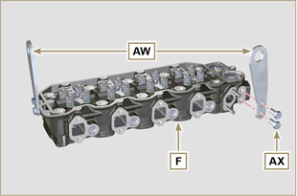  Fig 9.39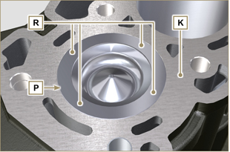  Fig 9.40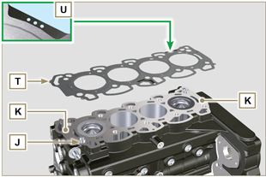  Fig 9.41
- Check that the surface head W is free from impurities.  - Position the head F on the crankcase Z with reference to the centering bushings J .  Important  - The fastening bolts V must be replaced every time they are assembled.  Modified component, see service letter 710009.  - Failure to adhere to the bolt fixing procedures may compromise the functionality of the engine, and also may cause damage to persons and property.  - Tighten capscrews V observing the cycles, tightening, and subsequent rotation as indicated in Tab. 9.5 .  - Secure the head F by tightening the screws V strictly following the sequence indicated in the Fig. 9.43 and the tightening torque and pauses between cycles indicated in the Tab. 9.5 . | 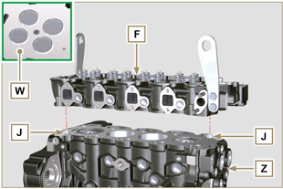  Fig 9.42
Tab. 9.5  CYCLE TORQUE PAUSE  1 75 Nm 3min  2 90° 3min  3 90° 3min  4 90° --- | 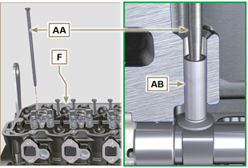  Fig 9.44
9.5.6 Rods and valve bridges  - Insert the rocker control rods AA into the niches of the head F .  Important  - Properly centre the rods AA into the spherical housing of the camshaft tappets AB .  - Mount the valve bridge AC on to the pairs of discharge and suction valves. | 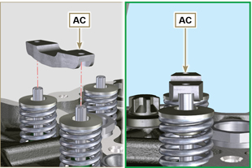  Fig 9.45
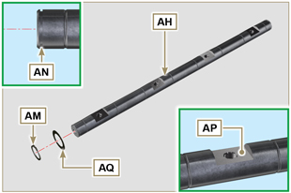
Fig 9.46
9.5.7 Rocker arms  Important  - The discharge rocker arm AT is shorter than the suction arm AR .  - Fit the lock ring AM into the seat AN of the rocker arm pin AH .  - Position the pin AH with the screw support surface AP facing upwards and insert the 2 shoulder rings AQ .  - Insert in sequence the suction rocker arm AR , the holder AS and the discharge rocker arm AT in the pin AH .  - Insert the spring AU in the pin AH .  - Repeat points 3, 4 for all the rocker arms.  NOTE: Support AV , which contains taper pin BV , must be assembled in correspondence with cylinder n° 3 .  - Insert 2 shoulder rings AQ and the lock ring AN to lock all the components inserted in the pin AH .  NOTE : The spring AU ensures that the supports AS and AV are kept in place. | 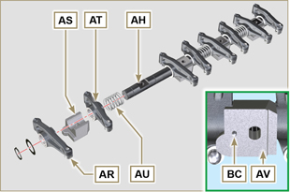  Fig 9.47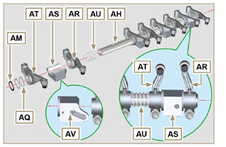  Fig 9.58
9.5.8 Rocker arm pin assembly  Important  - Position the rocker arm pin assembly BB on a level to align all the support surfaces.  - Check that the pistons are positioned half way between the TDC and BDC. As seen from A ⇒ ( Par. 1.4 ) turn the crankshaft anticlockwise by 90°, complying with TDC of the 1st cylinder , positioning taper pin BP of the crankshaft as shown in Fig. 9.48 .  - If the engine is painted or protected with clear paint, replace the fastening screws BE .  - Position rocker arm shaft unit BB on cylinder head F , complying with the taper pin BC reference with hole BF of cylinder head F .  - Check the correct positioning of all the rocker arms and the u-bolt control valves (detail BD ).  House the tappet in the seat of the rocker arms control rod.  - Secure the rocker arm pin BB tightening the screws BE (tightening torque to 40 Nm ). Adhere to the screw tightening sequence BE as shown in Fig. 9.50 . | 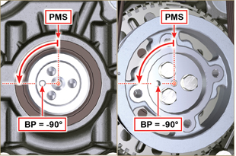  Fig 9.48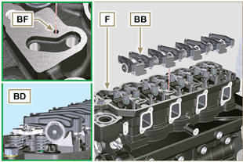  Fig 9.49
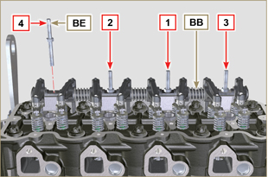
Fig 9.50
9.5.9 Assembly Rocker arm cover  Important  - Replace gasket BF, BL and BM with each assembly ( ST_11 - ST_12 apply Loctite 480 to the seats of cap BN before assembling the gaskets).  - Observe the order of tightening illustrated in Fig. 9.52 .  - Position tool ST_17 onto the head in correspondence with the two fastening holes 9 and 10 .  - With vaseline lubricate the gaskets BL in the upper part, and the gaskets BM in the lower part.  - Position gasket BF and the rocker arm cover BN on cylinder head F using tool ST_17 as a guide.  - Attach the rocker arm cover BN on the head F with the screw BG (tightening torque to 10 Nm ). | 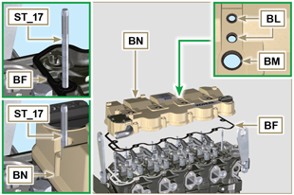  Fig 9.51
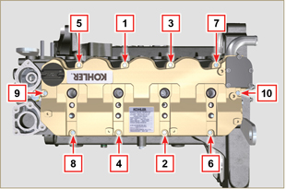
Fig 9.52

Intake manifold assembly
9.6.1 Internal half-manifold  Important  - Check that the contact surfaces between the semi-collector C and the head D are free from impurities.  - Insert the special tool ST_18 into indicated point.  - Position gasket B and manifold C on cylinder head D .  - Secure the semi-collector C with the screws A on the head D (tightening torque of 25 Nm ). | 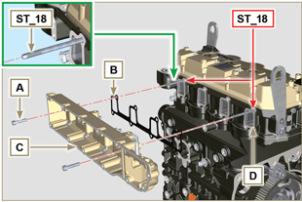  Fig 9.53
9.6.2 External half-manifold  Important  - Check that the contact surfaces between the two semi collectors C and D are free from impurities.  - Insert the special tool ST_18 into indicated point.  - Position gasket N , panel P and semi-manifold M onto semi-manifold C .  - Fit the semi-collector M on the semi-collector C with the screws L (tightening torque of 22 Nm - ST_05 ). | 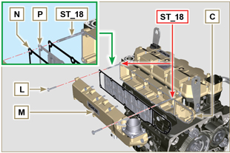  Fig 9.54

Fuel system assembly
Important

- Do NOT mount new or different injectors without the required tool ( Chap. 13 ).
- Remove the protective caps from all the components of the fuel circuit just before assembly just before assembly ( Par. 2.9.8 ).
9.7.1 High-pressure injection pump  - Check that the surface A is free from impurities ( Fig. 9.56 ).  Important  - Always replace gasket B with every assembly.  - The seal gasket B can only be fitted in one direction ( Fig. 9.55 ).  - Always replace capscrews C with new ones or alternatively apply Loctite 2701 ( Fig. 9.55 ).  - Fit the new gasket B on the injection pump D ( Fig. 9.56 ).  - Fix the pump D into the housing A1 together with the gasket B by the screws C ( Fig. 9. 56 - tightening torque at 25 Nm ).  - Check the correct fitting of the key E on the shaft F of the injection pump D ( Fig. 9.57 ).  - Place the gear G on the shaft F of the pump D respecting the reference to the key E and the reference H of the gear L ( Fig. 9.57 ).  - Tighten the nut M (tightening torque at 140 Nm ). | 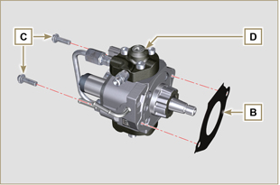  Fig 9.55
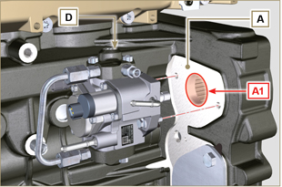
Fig 9.56
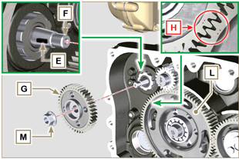
Fig 9.57
9.7.2 Fuel filter  - Secure the fuel filter holder N with the screws P on the crankcase Q (tightening torque of 25 Nm ).  NOTE : For the assembly of the fuel cartridge, refer to operations 4 and 5 of Par. 6.9.2 . | 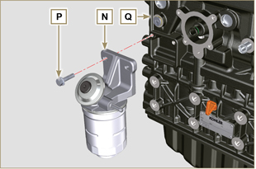  Fig 9.58
9.7.3 Electronic injectors  Importante  - Always replace and lubricate the gaskets R of the electronic injectors S with fuel, every time they are assembled.  - Pay attention when repositioning the electronic injectors, using the marks as described in Par. 7.10.5 .  - If a new (or different) electronic injector is fitted on the engine, you are required to prepare tool ST_01 .  - If the engine is painted or protected with clear paint, clean the paint off the diesel injector S near to the part in contact with the gasket AB .  - Assemble gasket T onto electronic injector S .  - Insert the electronic injectors S inside the rocker arm cover U being extra careful not to damage gasket AB and direct it as indicated in Fig. 9.59. | 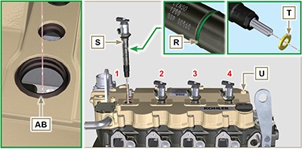  Fig 9.59
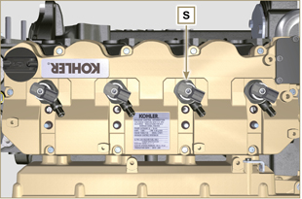
Fig 9.60
9.7.4 Common Rail  - Secure the rail W on the intake manifold X with the screws V (tightening torque at 25 Nm ). | 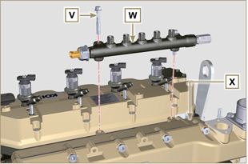  Fig 9.61
9.7.5 High pressure fuel pipes  Important  - Always replace the pipes Y and tube Z after each assembly.  - Position the pipes Y on the Common Rail W and on the electronic injectors S , adjust the position of electronic injectors S via the fitting inlets with the pipes Y .  Important  - Tighten the nuts J and K manually, without clamping them.  - If the engine is painted or protected with clear paint, replace the fastening screws B1 .  - Position the injector fastening brackets A1 and the screws B1 , inserting the washer C1 .  Important  - Replace the pipes Y ( Fig. 9.62 ) if the screws B1 do not rotate freely.  - Tighten all the nuts K (tightening torque at 30 Nm ).  - Tighten the nuts J (tightening torque at 25 Nm ).  - Make sure that the mounting brackets A1 are positioned correctly on electroinjectors S and on fixing screws of the rocker arm assembly D1 .  - Tighten the fixing screws B1 of the injector mounting bracket (tightening torque of 20 Nm ).  - Position the pipe Z screwing the nuts J and K .  Important  - Screw the nuts J and K manually without tightening them.  - Tighten the nut K (tightening torque of 30 Nm ).  - Tighten the nut J (tightening torque of 25 Nm ).  - Fasten the clamp E1 with the screw F1 (tightening torque of 10 Nm ). | 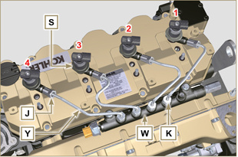  Fig 9.62
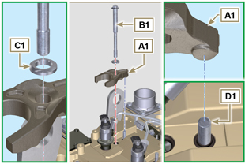
Fig 9.63
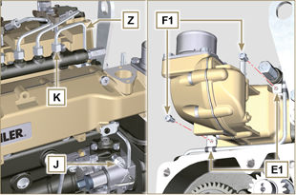
Fig 9.64
9.7.6 Fuel flow pipes  - Insert the pipes G1 on the fitting coming out of the filter holder N and on the fuel inlet fitting of the injection pump D . | 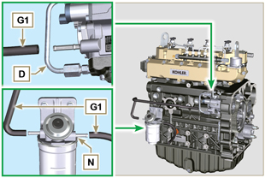  Fig 9.65
9.7.7 Fuel return pipes  - Check the gaskets H1 on the fittings J1 .  NOTE : Do not disconnect the pipes from the distributor K1 .  - Position the return pipes and fitting the distributor K1 with the screw L1 on the intake manifold X ( Fig. 9.67 - tightening torque of 10 Nm ).  - Mount the fittings J1 ( Fig. 9.67 ) on the injectors S and lock them with the clips M1 .  - Insert the pipe N1 on the fitting P1 .  - Fit the gaskets Q1 and the fitting R1 on the screw S1 .  - Tighten capscrews S1 on Common Rail W (tightening torque 15 Nm ) with the opening of union R1 facing upwards. | 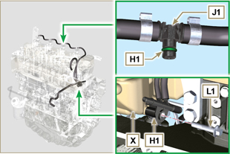  Fig 9.66
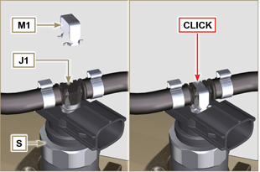
Fig 9.67
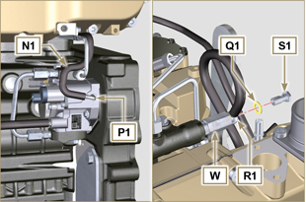
Fig 9.68

Assembly lubrication circuit
9.8.1 Assembly oil mist separator unit  Important  - Always carefully inspect the condition of the pipes, and replace them if there is any doubt regarding the integrity of their seal.  - Secure the plate A using the screws B (tightening torque of 10 Nm - ST_05 ).  - Assemble clamps C onto tube D .  - Secure tube D by means of fastening clamp C with capscrews E , inserting clamp F.  - Fit hose G onto union H .  - Secure tube J by means of capscrew K , inserting gasket L .  - Secure the clamp M .  - Perform the operations of Par. 6.7.2 . | 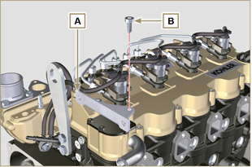  Fig 9.69
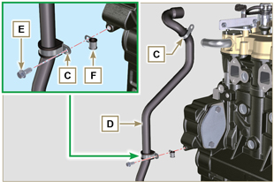
Fig 9.70
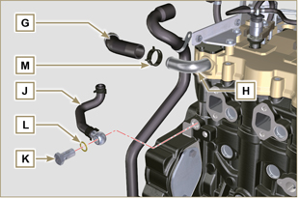
Fig 9.71
9. 8 .2 Oil Cooler and oil filter Unit Assembly

- Perform the operations of Par. 6.8.3 .

NOTE :To replace the oil cartridge, refer to operations of Par. 6.8.2 .

9. 8 .3 Oil pressure relief valve  - Lubricate the piston N and fully insert it in the seat P .  - Insert the spring Q in the piston N .  - Insert disk R onto spring Q .  - Insert cotter pin S in the provided seat of oil pump T to lock components N, Q and R . | 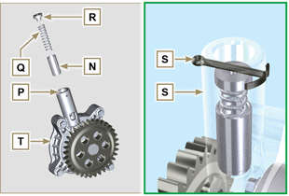  Fig 9.72
9. 8 .4 Oil pump  NOTE: Carry out the checks described in Par. 8.7 before proceeding with the following operations.  - Check that all contact surfaces between T, V are free of impurities – scratches - dents.  - When assembling, do not use any type of gasket between T and V .  - Thoroughly lubricate the seat of the rotors on oil pump T .  - Make sure the external rotor is assembled correctly with Ref. U visible, as shown in the picture (or refer to Par. 2.10.2 ).  - Fasten the oil pump cover T on the crankcase V with the screws X (tightening torque 10 Nm ). | 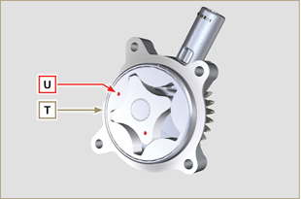  Fig 9.73
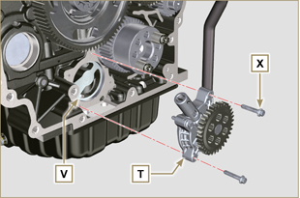
Fig 9.74

Flange unit assembly
9.9.1 Bell housing  Danger  - Bell A is very heavy; pay special attention during assembly operations to avoid dropping and causing serious risks to the operator.  Important  - Failure to adhere to the assembly procedures may compromise the functionality of the engine, and also cause damage to persons and property.  - Always replace and lubricate gasket C with oil with each assembly (gasket C is to be mounted after the operation in point 5 ( ST_47 ) ).  - To assemble components P, Q, R, S , and T , proceed with the operations described in Par. 11.2.2 - 11.3.2 - 11.4.2 - 11.5.2 .  - Apply a bead of approx. 2.5 mm of sealant ( Loctite 5188 ) on the surface B of the bell A .  - Ensure that bearing J is correctly assembled on camshaft K .  - Assemble bell A onto crankcase D , complying with reference taper pins E ( ST_45 ) .  - Apply the screws F by hand without tightening them.  - Tighten the screws F following the tightening sequence indicated (tightening torque 75 Nm ). | 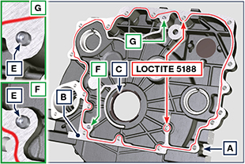  Fig 9.75  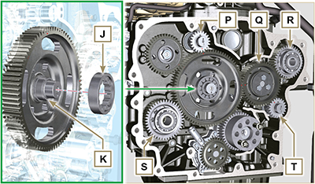  Fig 9.76A  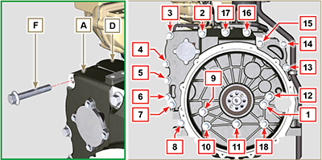  Fig 9.76B

9.9.2 Flywheel  Danger  - Flywheel F is very heavy; pay special attention during assembly operations to avoid dropping and causing serious risks to the operator.  - Loosen capscrews G and remove tool ST_41 .  - Position flywheel H onto crankshaft L by means of tool ST_43 - ST_46 .  - Apply " Molyslip AS COMPOUND 40 " on the threads and under the head of capscrews G and manually tighten them until their stop.  - Secure flywheel H with capscrews G (tightening torque 60 Nm ).  - Once again, tighten capscrews G (2 cycles with tightening torque 130 Nm ). | 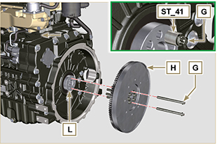  Fig 9.77

Exhaust manifold assembly
Important  - Replace the metal gaskets A, B every time they are assembled.  - In the event of mounting the studs C , fix ( 25 Nm tightening torque) with Loctite 2701 on the thread.  - Gasket B must be assembled with the wording " TOP " visible and facing upwards.  - Check that the contact surfaces D are free from impurities.  - Insert the gasket B on the studs C .  - Position manifold E onto cylinder head G by manually tightening capscrews F , inserting:  - gaskets A between cylinder head G and manifold E ;  - spacers H between capscrews F and manifold E .  - Secure manifold E onto cylinder head G by means of capscrews F (tightening torque 25 Nm ).  - Clamp the nuts L ( 25 Nm tightening torque). | 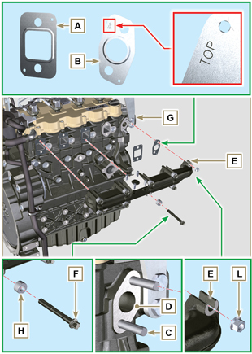  Fig 9.78

Crankshaft pulley assembly
- Perform the operations from point 1 to 7 of Par. 6.6.2 .

Turbocharger Assembly
Importante  - Before proceeding, perform the operation described in Par. 2.18 .  - Ensure that tube C is not clogged.  - Always replace the gaskets A, B, Q at each assembly.  - Remove the plastic or foam caps from the turbo compressor before assembling.  - Check that the contact surfaces D are free from impurities deformations or cracks, otherwise replace the damaged component.  - Position the turbo-compressor E on the bolts F on the manifold G .  - Fasten the turbo-compressor E with the nuts H (tightening torque of 25 Nm ).  - Fasten the pipe L with the screws M to the turbo-compressor E .  - Fasten the pipe G with the screws N on the crankcase P .  Importante  - Always replace the gasket Q after each assembly.  - Before assembly of the tube R , perform the operation described in Par. 2.18.2 - Point 2 .  - Ensure that tube R is not clogged.  - Fasten the pipe R with the fittings S on the turbo-compressor E and on the crankcase P (tightening torque of 15 Nm ).  Insert the gaskets Q between:  - S and R; - E and R;  - P and R. | 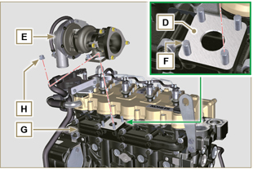  Fig 9.79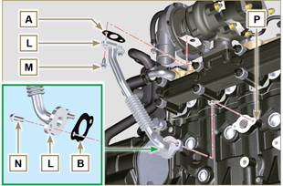  Fig 9.80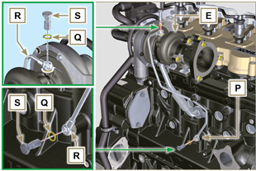  Fig 9.81

Electric component assembly
9.13.1 Sensors and switches

9.13.1.1 T-MAP Sensor  - Fasten the sensor A with the screws B on the manifold C (tightening torque of 10 Nm - ST_06 ). | 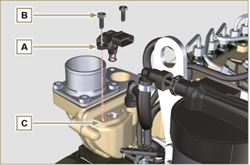  Fig 9.82
9.13.1.2 Coolant temperature sensor  - Secure the sensor D onto the head E (tightening torque of 20 Nm ). | 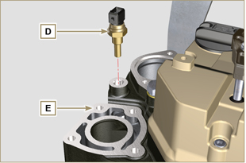  Fig 9.83
9.13.1.3 Oil Pressure Switch  - Clamp the oil pressure switch F on the crankcase G (tightening torque at 35 Nm ). | 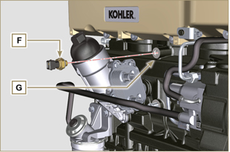  Fig 9.84
9.13.1.4 Camshaft phase sensor disassembly  - Measure the distance between the coupling surface P1 to gear teeth G1 (X1).  - Measure the distance between the coupling surface P1 and the sensor surface S7 (Y1).  - The difference between the 2 measurements determines the air gap value (Z1). The value (Z1) permitted must be a MIN of 0.2 mm and a MAX of 1.2 mm. Insert one spacers K2 based on the value (Z1) detected.  NOTE : The calibrated spacers K1 have a thickness of 0.2mm.  - Insert the shim K1 on the sensor S10.  - Secure phase sensor S10 onto crankcase L using capscrew R2 (tightening torque 10 Nm). | 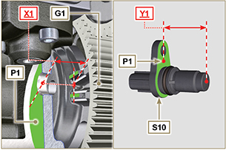  Fig 9.85
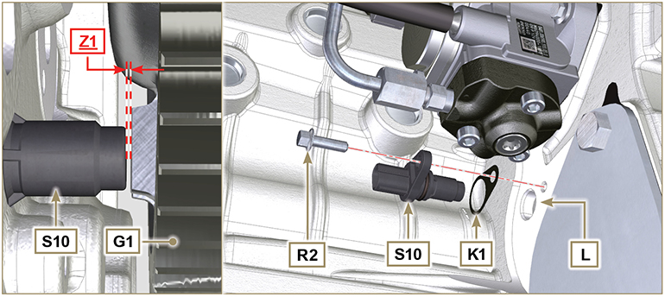
Fig 9.85A
9.13.1.5 Speed sensor  - Measure the distance from the coupling surface J to the external diameter of the phonic wheel ( X2 ).  - Measure the distance between the coupling surface J and the sensor surface H ( Y2 ).  - The difference between the 2 measurements determines the air gap value ( Z2 ).  The value ( Z2 ) permitted must be a MIN of 0.2 mm and a MAX of 1.2 mm .  Insert one or two spacers K based on the value ( Z2 ) detected.  NOTE : The calibrated spacers K have a thickness of 0.2mm.  - Secure the bracket M with the screws N inserting the washer S (tightening torque at 10 Nm ).  - Insert the shim K on the sensor H .  - Clamp the sensor H on the bracket M with the screw R (tightening torque at 10 Nm - ST_06 ). | 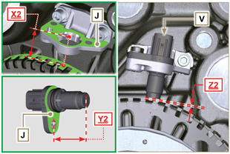  Fig 9.86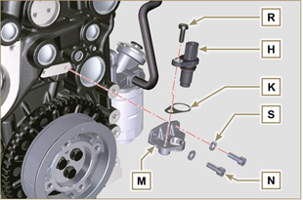  Fig 9.87
9.13.1.6 Fuel filter water detection sensor  - Lubricate and insert the gasket V on the fitting W .  - Tighten the sensor W onto the cartridge Z (tightening torque of 5 Nm ). | 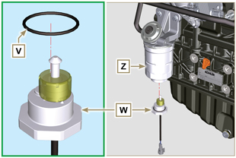  Fig 9.88
9.13.2 EGR valve  Important  - Check that the contact surfaces between flange B and the head D are free from impurities.  - Always replace the gasket A after each assembly.  - Position gasket A onto cylinder head D .  - Secure the flange B with the screws C on the head D (tightening torque of 10 Nm ).  - Perform the operations of Par. 6.4.2 . | 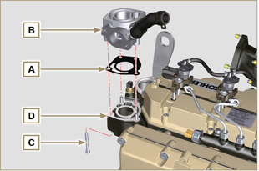  Fig 9.89
9.13.3 Alternator  - Insert the washer E onto the screw F .  - Insert the screw F onto the alternator G .  - Secure the bracket H and the alternator G using the screws L1, F onto the crankcase L .  9.13.4 Starter Motor  - Perform the operations to point 10 of Par. 6.6.2 . | 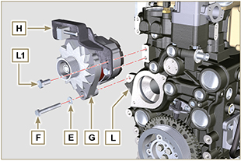  Fig 9.90
9.13.5 Electric cabling  - Position the cable holder N together with the cabling P on the rocker cap Q .  - Screw the wiring holder N on the rocker cap Q with the screws R (tightening torque of 10 Nm - ST_06 ).  - Mount the connectors C1 on the electronic injectors S1 .  Warning  - Slightly move wiring support N to check that there is no voltage in the electrical wire of connector C1 in correspondence with the outlet hole N1 . | 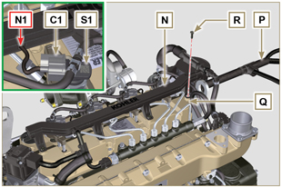  Fig 9.91
- Fit the connector C2 on the sensor S2 . | 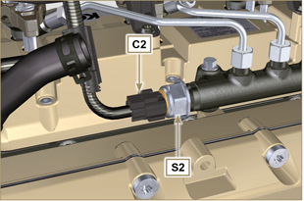  Fig 9.92
- Fit the connector C3 on the sensor S3 . | 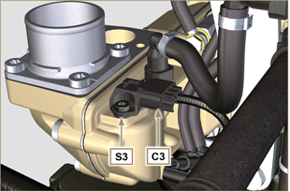  Fig 9.93
- Insert the connector C4 on the fuel intake valve S4 .  - Insert the connector C5 on fuel temperature sensor S5 . | 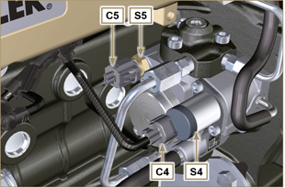  Fig 9.94
- Fit the connector C6 on the sensor S6 . | 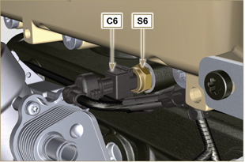  Fig 9.95
- Fit the connector C7 on the sensor S7 .  - Insert the clamp P1 onto the crankcase M .  - Fasten the clamp P2 with the screw T onto the crankcase M (tightening torque of 10 Nm ). | 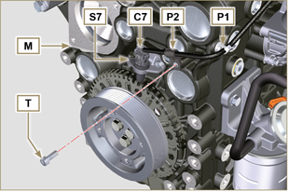  Fig 9.96
- Fit the connector C8 on the valve S8 .  - Fit the connector C9 on the sensor S9 . | 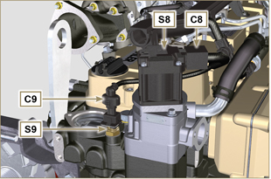  Fig 9.97
- Secure cable X on motor V by means of nut J .  - Secure cable Y on alternator W by means of nut K . | 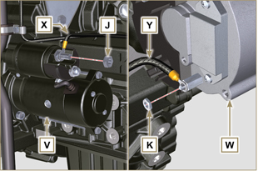  Fig 9.98

Coolant circuit assembly
9.14.1 Thermostatic valve  Important  - Always replace the gasket A after each assembly.  - Check the condition of the seal gasket A and fit it on the thermostatic valve B .  - Position the thermostatic valve B in the seat on the head C (detail D ).  - Secure the cover E with the screws F on the head C (tightening torque of 10 Nm ). | 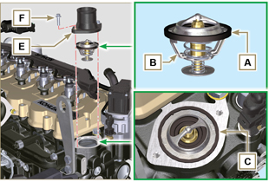  Fig 9.99
9.14.2 Coolant pump  Important  - Always replace the gasket L every time it is assembled.  - Secure the flange G with the screws H interposing the gasket L onto the crankcase M (tightening torque of 25 Nm ).  - Perform the operations of Par. 6.5.2 . | 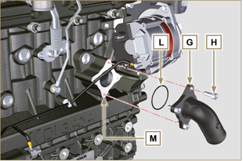  Fig 9.100
9.14.3 Oil Cooler hoses  - Secure hose N on Oil Cooler P and on crankcase M by means of clamps Q .  - Position and secure hose R by means of clamp S on Oil Cooler P and on crankcase M .  - Secure clamps T on manifold U by means of capscrews V in points X (tightening torque 10 Nm - ST_06 ). | 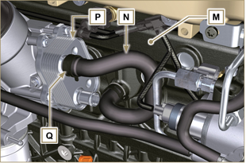  Fig 9.101
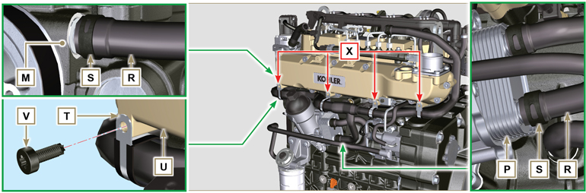
Fig 9.102

EGR Circuit Assembly
9.15.1 EGR Cooler  - Insert the fitting A1 of EGR Cooler B in the sleeve C of the EGR valve unit.  - Position EGR Cooler B on the intake manifold D with the screws E ( ST_05 ).  - Secure the fitting A1 with the clamp F1 to the sleeve C .  - Secure hose G onto union A2 of EGR Cooler B by means of clamp F2 . | 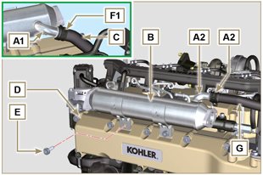  Fig 9.103
- Fasten the pipe H with the screws L on the EGR valve unit M inserting the gasket N (tightening torque of 22 Nm - ST_05 ).  - Fasten the pipe H with the screws P on EGR Cooler B inserting the gasket Q (tightening torque of 25 Nm ). | 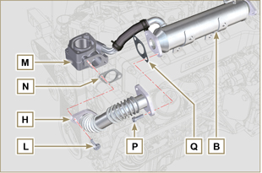  Fig 9.104
- Fasten the pipe J on the intake manifold D with the screws R (tightening torque of 22 Nm - ST_05 ) inserting the gasket S .  - Fasten the pipe J on the EGR Cooler B with the screws T (tightening torque of 25 Nm ) inserting the gasket U .  - Fit the EGR Cooler B on the intake manifold D with the screws E (tightening torque of 22 Nm - ST_05 - Fig. 9.103 ). | 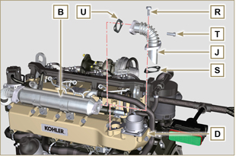  Fig 9.105

Tightening torques and the use of sealants
Tab. 9.4 - *Alternatively to the capscrew replacements, with "Dri-loc"
BASE CONFIGURATION

SHORT BLOCK
Component | Thread (mm) | Torque (Nm) | Sealer
Oil sprays fastening capscrew | M6x1 | 10
Lower crankcase fastening capscrew | M14x1.25 | 3 Torque cycles
1st Cycle |  | 60
2nd Cycle |  | +45°
3rd Cycle |  | +45°
Lower crankcase fastening capscrew | M10x1.25 | 30
Connecting rod screw | M11x1 | 3 Torque cycles
1st Cycle |  | 28
2nd Cycle |  | +30°
3rd Cycle |  | +30°
Coolant drain hole closing cap | M16x1.5 | 50
Main oil delivery line closing plate | M6x1 | 15
Intermediate idle gear cap fastening screw | M8x1 | 25
OIL SUMP ASSEMBLY
Component | Thread (mm) | Torque (Nm) | Sealer
Oil suction hose fastening capscrew | M6x1 | 10 | Loctite 2701*
Oil return pipe fastening screw | M6x1 | 10 | Loctite 2701*
Oil sump fastening capscrew | M8x1 | 25
Oil drain cap | M18x1.5 | 30
FLANGE ASSEMBLY (1st PTO)
Component | Thread (mm) | Torque (Nm) | Sealer
Flange bell fastening capscrew | M12x1,75 | 75
Flywheel fastening capscrew | M12x1,25 | 3 Torque cycles
1st Cycle |  | 60
2nd Cycle |  | 130
3rd Cycle |  | 130
ENGINE CYLINDER HEAD ASSEMBLY
Component | Thread (mm) | Torque (Nm) | Sealer
Air bleeding cap (Rev. 00) | M6x1 | 6
Air bleeding cap (Rev. 01) | M14x1,5 | 50
Lifting brace fastening capscrew | M8x1.25 | 80
Injector manifold | M12x1 | 30
Cylinder head fastening capscrew | M12x1.25 | 4 Torque cycles
1 ^{st} Cycle |  | 75
2 ^{nd} Cycle |  | +90°
3 ^{rd} Cycle |  | +90°
4 ^{th} Cycle |  | +90°
Rocker arm gudgeon fastening capscrew | M8x1,25 | 40
Rocker arm cover fastening capscrew | M6x1 | 10
INJECTION SYSTEM
Component | Thread (mm) | Torque (Nm) | Sealer
Fuel filter fastening capscrew | M8x1.25 | 25
Fuel cartridge fastening | ... | 17
Common rail fastening capscrew | M8x1.25 | 25
Electronic injector brace fastening capscrew | M8x1.25 | 20
Distributor fastening capscrew | M8x1.25 | 25
Waste line fastening drilled capscrew on common rail | M10x1 | 30
Injector side injection tube nuts | M12x1.5 | 25
Injection pump side injection tubes nuts | M12x1.5 | 25
Common Rail side injection tubes nuts | M14x1.5 | 30
Injection pump fastening capscrew | M8x1.25 | 25 | Loctite 2701*
Gear fastening nut on high-pressure fuel injection pump | M14X1.5 | 140
Screw for cover over injection pump shaft nut (on bell housing) | M6x1 | 10
INTAKE MANIFOLD
Component | Thread (mm) | Torque (Nm) | Sealer
Internal semi-manifold fastening capscrew (on cylinder head) | M8x1.25 | 25
External semi-manifold fastening capscrew | TG8 | 22
Intake flange fastening capscrew | TG8 | 22
EXHAUST MANIFOLD
Component | Thread (mm) | Torque (Nm) | Sealer
Exhaust manifold fastening screw | M10x1.5 | 50
Exhaust manifold fastening nut | M10x1.5 | 50
Exhaust manifold fastening stud | M10x1.5 | 2 Torque Cycles
1 ^{st} Cycle |  | 40
2 ^{nd} Cycle |  | 80
LUBRICATION CIRCUIT
Component | Thread (mm) | Torque (Nm) | Sealer
Oil vapour separator support plate fastening capscrew | TG8 | 22
Oil vapour separator support fastening capscrew (on crankcase) | M6x1 | 12
Oil steam separator return tube drilled fastening screw (on cranckase) | M16x1.5
Oil filter fastening union | M20x1.5 | 15 | Loctite 2701*
Oil cooler fastening capscrew | M6x1 | 10
Cartridge-holder cover | ... | 25
Oil pump fastening screw | M6x1 | 10
CRANKSHAFT AND TARGET WHEEL PULLEY ASSEMBLY (2nd PTO)
Component | Thread (mm) | Torque (Nm) | Sealer
Phonic wheel fastening capscrew (on crankshaft pulley) | M6x1 | 10
Crankshaft pulley fastening capscrew | M12x1.75 | 100 | Molyslip
COOLANT CIRCUIT

Component | Thread (mm) | Torque (Nm) | Sealer
Coolant tube clamp fastening capscrew (Oil Cooler return) | TG8 | 22
Thermostatic valve cover fastening capscrew | M6x1 | 10
Coolant pump fastening capscrew | M8x1.25 | 25
Blower fastening capscrew | M8x1.25 | 25
TURBOCHARGER
Component | Thread (mm) | Torque (Nm) | Sealer
Oil return tube fastening capscrew | M6x1 | 10
Oil supply tube fastening capscrew | M10x1 | 15
Turbine fastening stud (on manifold) | M10x1.5 | 25
Exhaust flange fastening stud (on turbine) | M8x1.25 | 25
Turbine fastening stud | M10x1.5 | 30
Exhaust flange fastening nut (on turbine) | M8x1.25 | 25
ELECTRICAL COMPONENTS
Component | Thread (mm) | Torque (Nm) | Sealer
MAP sensor fastening capscrew | M6x1 | 10
Coolant temperature sensor | M12x1.5 | 20 max.
Oil pressure switch | M12x1.5 | 35
Phase sensor fastening capscrew | M6x1 | 10
Speed sensor fastening capscrew | M6x1 | 10
Sensor for water presence in fuel |  | 5
Alternator fastening capscrew | M10x1.5 | 45
Alternator fastening capscrew | M8x1.25 | 25
Alternator brace fastening capscrew | M12x1.75 | 75
Starter motor fastening capscrew | M10x1.5 | 45
Supply cable fastening nut (starter motor) | M10x1.5 | 15
EGR CIRCUIT
Component | Thread (mm) | Torque (Nm) | Sealer
Flange EGR valve fastening capscrew | M8x1.25 | 25
EGR valve fastening capscrew | M6x1 | 10
EGR Cooler tube fastening capscrew (on flange EGR valve) | TG8 | 22
EGR Cooler fastening capscrew | TG8 | 22
Tube fastening capscrew on EGR Cooler | M8x1.25 | 25
Tube fastening capscrew on intake manifold | TG8 | 22
* Alternatively to the capscrew replacements, with "Dri-loc"

OPTIONAL COMPONENTS (Chap. 11)
HEATER
Component | Thread (mm) | Torque (Nm) | Sealer
Flange intake with heater fastening capscrew | M8x1.25 | 25
IDLE GEAR (FOR 3 ^{rd} )
Component | Thread (mm) | Torque (Nm) | Sealer
Gear fastening capscrew | M8x1 | 25
* Alternatively to the capscrew replacements, with "Dri-loc"

Fluids filling information

Engine oil
Warning

- Before proceeding with operation, carefully read Par. 3.3.2 .

- Loosen the oil filler cap A .  - Add the type and amount of oil recommended ( Tab. 2.2 ).  - Remove the oil dipstick B and check that the level is up to but does not exceed the MAX .  Important  - Do not use the engine with the level of oil below MIN or above MAX  - If the oil level is not at MAX , insert more oil until the MAX level is reached as indicated on the dipstick.  - Re-tighten the cap A . | 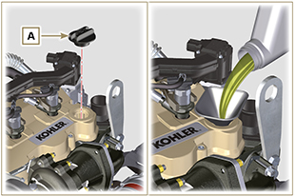  Fig 10.1
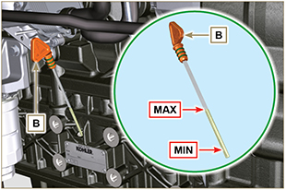
Fig 10.2
NOTE : Click by side to play the procedure. | https://www.youtube.com/embed/HWCzK41Br1U?showinfo=0&rel=0

Coolant
NOTE : Component not supplied by KOHLER .

Refer to the technical documentation of the vehicle.

Information about optional components

Heater (replacement)
Important

- Before proceeding with operation, read Par. 3.3.2 .
11.1.1 Disassembly  - Undo the screws A .  - Remove the flange C .  - Remove the heater E and the relevant gaskets F . | 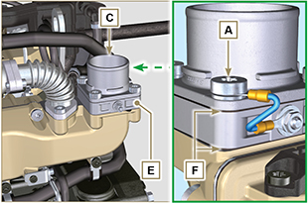  Fig 11.1
11.1.2 Assembly  Important  - Always replace gaskets F , with each assembly.  - In sequence, fit the manifold G with the gasket F , the new heater E , the second gasket F , the flange C , the washers H , the screws A and the cable B .  - Secure the flange C with the screws A (tightening torque at 22 Nm ). | 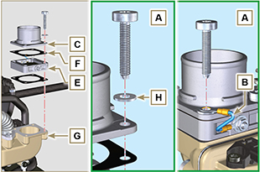  Fig 11.2

Idler gear (for 3rd / 4th PTO)
Important

- Before proceeding with operation, read Par. 3.3.2 .
11.2.1 Disassembly  - Perform the operations of point 7 of Par. 7.4.1 .  - Perform the operations from point 2 to 3 of Par. 6.6.1 .  - Perform the operations of point 3 of Par. 7.8.1 .  - Perform the operations of Par. 7.8.2 .  - Loosen capscrews A and remove plate B1 .  - Extract gear C .  - Remove gudgeon D together with plate B2 . | 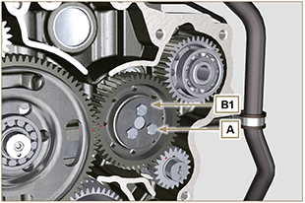  Fig 11.3
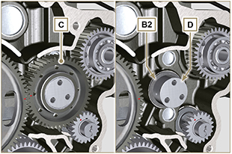
Fig 11.4
11.2.2 Assembly  Important  - Make sure that gudgeon D has no impurities inside.  - On capscrew A , assemble:  - plate B1  - gudgeon D  - gear C  - plate B2 . | Fig 11.5

- Position gear unit C1 onto crankcase E , complying with reference J1 , J2 with gear F .  - Secure unit C1 by means of capscrew A (tightening torque 25 Nm ).  NOTE: the reference J1 can have 2 different configurations for the gear C , Fig. 11.6b shows the correct position of the reference J1 for both configurations. | 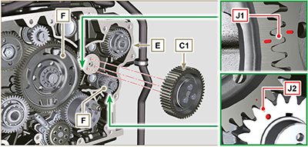  Fig 11.6  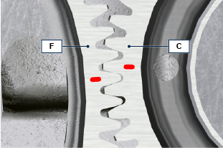  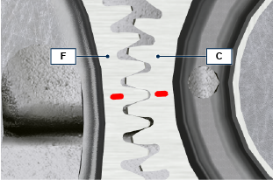  Fig 11.6b

3rd PTO (replacement)
Important

- Before proceeding with operation, read Par. 3.3.2 .
11.3.1 Disassembly  - Perform the operations of point 7 of Par. 7.4.1 .  - Perform the operations from point 2 to 3 of Par. 6.6.1 .  - Perform the operations of point 3 of Par. 7.8.1 .  - Perform the operations of Par. 7.8.2 .  - Extract gear A . | 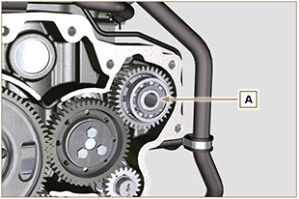  Fig 11.7
11.3.2 Assembly  - Insert gear A into the seat of crankcase B , fitting the shaft of pump C in gear A . | 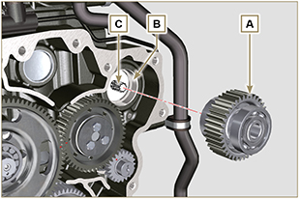  Fig 11.8

4th PTO (replacement)
Important

- Before proceeding with operation, read Par. 3.3.2 .
11.4.1 Disassembly  - Perform the operations of point 7 of Par. 7.4.1 .  - Perform the operations from point 2 to 3 of Par. 6.6.1 .  - Perform the operations of point 3 of Par. 7.8.1 .  - Perform the operations of Par. 7.8.2 .  - Extract gear A . | 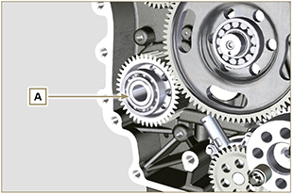  Fig 11.9
11.4.2 Assembly  - Insert gear A into the seat of crankcase B , fitting the shaft of pump C in gear A . | 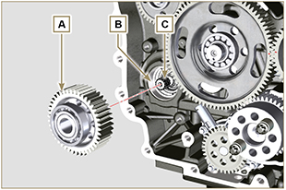  Fig 11.10

Balancer device (replacement)
Importante

- Before proceeding with operation, read Par. 3.3.2 .
11.5.1 Disassembly  - Perform the operations described in Par. 11.2.1 .  - Extract shaft A1 e A2. | 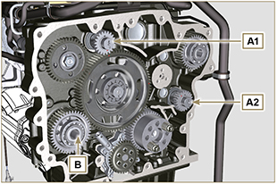  Fig 11.11
11.5.2 Assembly

- Lubricate gudgeon C of shaft A1 and A2 with oil.
- Insert shaft A1 into seat B1 of the crankcase, complying with reference D of gear E .
- Insert shaft A2 into seat B2 of the crankcase.
- Perform the operations described in Par. 11.2.2 .
NOTE: the shafts A1 and A2 are different and it is important not to invert the assembly position, the reference D is specific for the shaft A1 and is timed with the gear E , the reference J2 is specific for the shaft A2 and is timed with the idler gear F (see the Fig. 11.12b ).

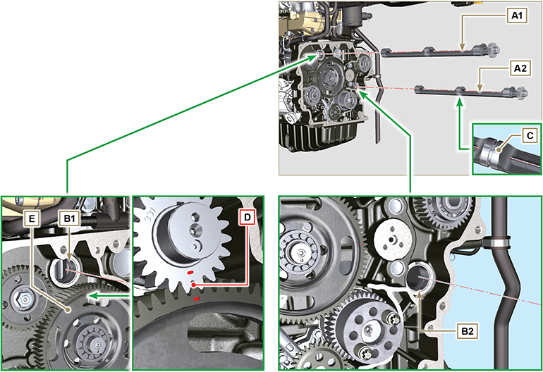
Fig 11.12

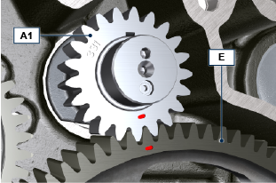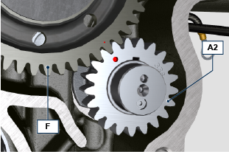
Fig 11.12b

ETB (replacement)
- Unscrew screws A and remove the ETB valve B with its gasket C .  Important  - Always replace the gasket C at each assembly. | 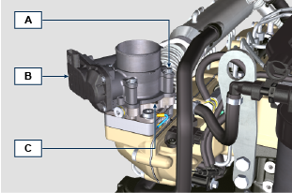  Fig. 11.13
- Fix the ETB valve B and its gasket C by means of screws A (tightening torque 10 Nm ) | 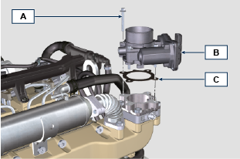  Fig. 11.14

EGR-T (replacement)
- Unscrew sensor A and its gasket B .  Important  - Before assembling the new sensor, see Par. 2.17.5  - Always replace the gasket B at each assembly. | 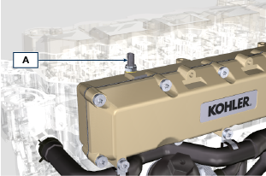  Fig. 11.15
- Fix sensor A and gasket B on their support C (tightening torque 20 Nm ). | 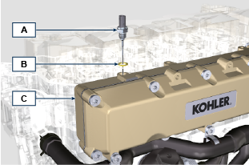  Fig. 11.16

EGTS (Black | Yellow - replacement)
- Unscrew sensors A .  Important  - Before assembling the new sensor, see Par. 2.17.6 | 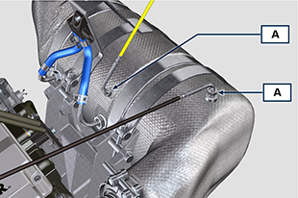  Fig. 11. 17
- Fix sensors A on the ATS B (tightening torque 30 Nm ). | 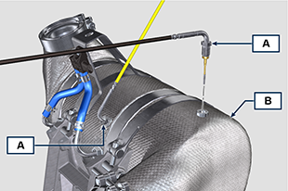  Fig. 11.18

DPF & DOC filter (replacement)
Danger
- Highly carcinogenic material!
- The dust contained inside the DPF is particularly fine and therefore classified as highly dangerous to living beings.
- Before proceeding to any operation, wear:
dust mask
gloves
goggles
- Do not allow any other operator who is not equipped with the above mentioned protective equipment to approach.
- Obtain a new replacement KIT for the DPF filter or a replacement KIT with regenerated DPF filter from your spare parts service.  Important  - Before disassembling/assembling any sensors, see Par. 2.17.5 and 2.17.6  - Always replace the seal P upon every assembly.  - During disassembly, do not expose the DPF to the surrounding environment for a long time and store it in a sealed bag as soon as possible.  - During disassembly operations, avoid using electric screwdrivers as vibrations could release the dust inside the DPF  - Do not try to clean the DPF  - Do not blow with compressed air  - Do not release the DPF or the dust contained in it in the environment  - Dispose of the DPF only in authorised centres  - Perform the operations indicated in point 1 of Par. 11.8 .  - Open the package of the DPF replacement KIT, taking care not to damage it.  - Unscrew screw A and loosen clamps B , then remove the Delta-P sensor D .  - Disconnect pipes C from their unions J and remove the Delta-P sensor D .  - Unscrew and remove unions J . | 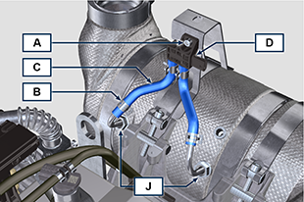  Fig. 11.19
- Loosen clamps E and remove manifold N . | 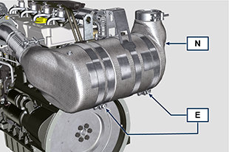  Fig. 11.20
- Loosen clamp G and remove the DPF filter H .  NOTE: do not remove clamp G .  - Inspect the DPF filter to detect any visible signs of oil contamination.  - Put the removed DPF filter in the plastic container supplied with the replacement KIT and send it to your spare parts service using the replacement KIT package.  NOTE : a residual value will be recognised depending on whether the used DPF is intact and recyclable or damaged and requiring a correct disposal. | 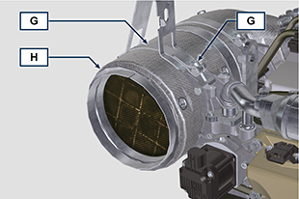  Fig. 11.21
- Loosen the clamps Q and S and remove the manifold with DOC M from the flexible hose R . | 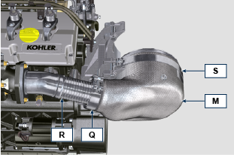  Fig. 11.22
- Fit the new manifold with the DOC filter M on the support T , inserting the flexible hose R inside the inlet of the manifold M . | 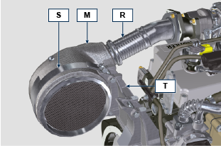  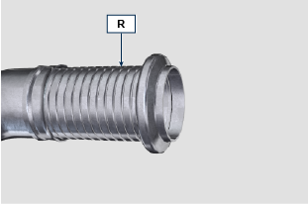  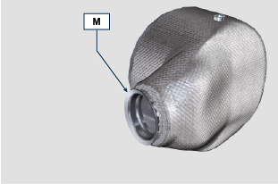  Fig. 11.23
Important  - Do not apply any tension during the assembly of components.  - Before fastening the manifold M , it must be oriented in the same position as the previously installed DOC filter.  - Tighten the clamp Q (tightening torque of 10 Nm ).  - Tighten the clamp S (tightening torque of 12 Nm ). | Fig. 11.24
- Insert the gasket P on the manifold with DOC filter M .  - Insert the new DPF filter H inside clamp G .  - Insert the DPF filter H on manifold M until reaching the gasket P . | 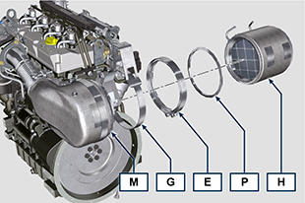  Fig. 11.25
Important  - Before fastening the DPF filter H , it must be oriented in the same position as the previous filter.  - Do not apply any tension during the assembly of components.  - Fasten the DPF filter H with clamp E (tightening torque 12 Nm ). | 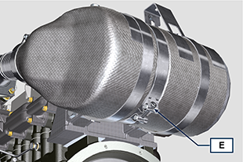  Fig. 11.26
- Insert gasket P on the DPF filter H .  - Insert manifold N on the DPF filter H until reaching the gasket P .  Important  - Before fastening manifold N , it must be oriented in the original position.  - Fasten manifold N with clamp E (tightening torque 12 Nm ). | 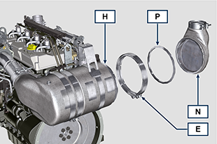  Fig. 11.27
- Position support K in contact with support K1 and fasten clamp G (tightening torque 12 Nm ). | 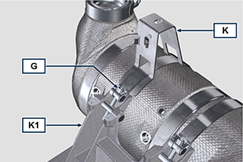  Fig. 11.28
- Screw unions J on the DPF filter H and position them about 20° away from the centre line (as in Fig. 11.30 ). | 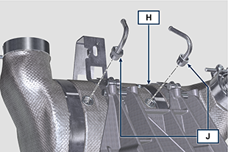  Fig. 11.29
- Fix unions J (tightening torque 60 Nm ). | 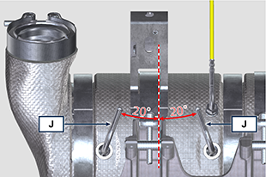  Fig. 11.30
- Fit pipes C on unions J and fasten them with clamps B .  - Fix the Delta-P sensor D on its support K by means of screw A (tightening torque 10 Nm ).  - Provide the machine owner with the warranty certificate of the new DPF filter KIT installed.  - Perform the " DPF replacement " procedure to reset the ASH & SOOT through the relevant KOHLER diagnostic tool interfaced with the ECU. | 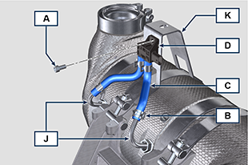  Fig. 11.31

Information on adjustments

'Waste Gate' opening valve regulation

Important

- Before proceeding with operation, read Par. 3.3.2 .
- Regulation must not be carried out with the engine running.
- During the procedure in point 5 , pay special attention not to bend rod H .

- Disconnect the hose A from the turbocharger.
- Connect a pressure reducer C to the network of compressed air.
- Position dial gauge D in such a way that feeler F rests onthe Waste Gate rod control valve extremity H (point E ).
- By using gradually the reduction gear C send the air to the Waste Gate actuator control L in order to move rod H forward by 1 mm (value M to check on dial gauge D). Pressure read on gauge B must be: 2500 mbar.
- If pressure is less or more than the indicated value, proceed as follows:
- Remove the retainer cotter pin (point E ) and disconnect rod H from the Waste Gate control lever.
- Tighten (to increase) / or loosen (to decrease) pressure of the ring nut of rod H until reaching the corrected calibration.
- Redo lock nut G .
- Reconnect rod H and assemble the cotter pin point E .

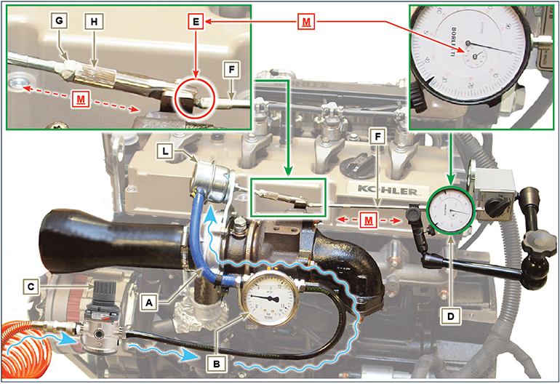
Fig 12.1

Air filter check
NOTE : Component not supplied by KOHLER .

Refer to the technical documentation of the vehicle.

Oil steam separator check
Important

- Before proceeding with operation, read Par. 3.3.2 .
- Loosen clamp B and remove hose C from hose A .  - Remove rapid fitting D from separator A .  - Start the engine at idle speed or without a load and check if air comes out from unions A1 and A2 .  NOTE: If what is described in Point 2 does not occur, proceed with cleaning or replacing oil separator A and accurately clean all connecting  hoses, and repeat the operation from Point 2. | 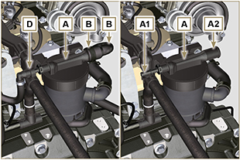  Fig 12.2

Rubber hoses and manifolds check
Important

- Before proceeding with operation, read Par. 3.3.2 .
The check is carried out by applying slight deflection or bending along the tube/hose and next to the hose clamps.  Components must be replaced if they have clear signs of cracks, tears, cuts, leaks, or do not retain a certain degree of elasticity.  - Check the condition of all rubber hoses A .  - Check whether there are any leakages of air, refrigerant, oil or fuel next to their connections.  NOTE : Refer to the technical documentation of the machine for components that are not shown in the figure. | 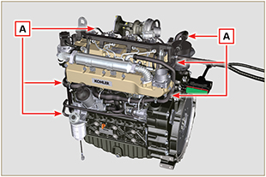  Fig 12.3

Oil leak check
Important

- Before proceeding with operation, read Par. 3.3.2 .
Check that there are no leakages next to area A .  - Start the engine at idle speed or without a load and check whether there are any leakages next to area A.  - It is anyhow necessary to also check the seals of all main components and their surface contact, such as:  - crankcase and gasket (side 1 ª PTO) - oil sump and exhaust caps  - cylinder head and its assembled components  - rocker arm cover  - Timing system carter and gasket (side 2 ª PTO) - oil dipstick housing or rod support tube.  NOTE: Perform the checks described in Points 1 and 2 periodically and during maintenance procedures.  It is also necessary to check for leakages on the components that are not listed.  If necessary, disassemble the components that have a leakage and investigate the possible cause.  The components must be replaced otherwise they do notguarantee their sealing. | 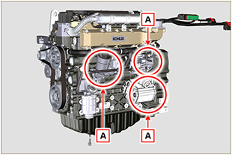  Fig 12.7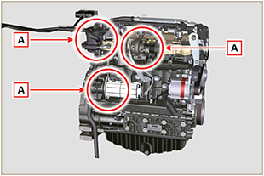  Fig 12.8

Oil pressure check
Important

- Before proceeding with operation, read Par. 3.3.2 .
- Replace the oil dipstick A with a thermocouple B (Fig. 12.6).  - Unscrew and remove the oil pressure switch C and screw on a 10 bar pressure gauge in its seat (Fig. 12.8) .  - Start the engine at idle speed and without a load, check the oil pressure value according to the oil temperature (Fig. 12.7 ).  NOTE : The graph in Fig. 12.7 illustrates the pressure line with speed of 1000 Rpm.  - If the pressure values are below the values indicated in Fig. 12.7 , check to identify the cause of the problem.  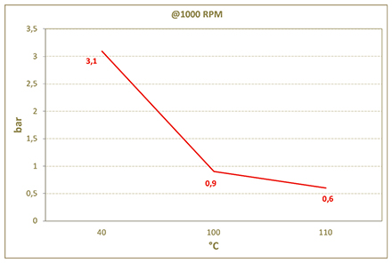  Fig. 12.7 | 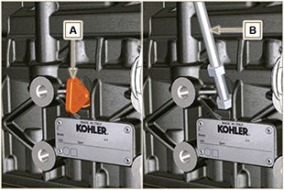  Fig. 12.6  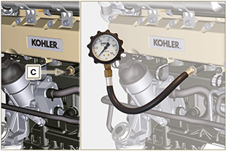  Fig. 12.8

Tools information

Information regarding specific tools

In Tab 13.1 - 13.2 - 13.3 there is a list of all the specific tools that are required and approved to carry out operations of disassembly - assembly - regulations - settings - repairs on engine series KDI

, correctly and safely.
Warning

- KOHLER declines all responsibility for any damage to the engine, persons, or things caused by the use of different types of tools to those indicated in Tab 13.1 - 13.2 - 13.3 , where referred to them in the manual.

Tab. 13.1
SPECIAL TOOLS FOR DISASSEMBLY AND ASSEMBLY
"ST" | Picture/Draw | DESCRIPTION | PART NUMBER
ST_03 | 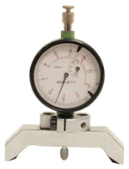 | Piston protrusion - electronic injectors cylinder head surface control tool | ED0014602980-S
ST_05 | 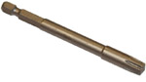 | Spanner for capscrews Six nicks SN 8 | ED0014603650-S
ST_06 | 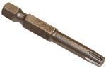 | Spanner for capscrews Six nicks SN 5 | ED0014603640-S
ST_07 | 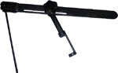 | Tool for disassembling / reassembling valves | ED0014603720-S
ST_08 | 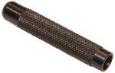 | Tool for gasket valve stem | ED0014603660-S
ST_11 | 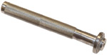 | Rocker arm cover gasket assembling tool (electronic injector seat) | ED0014603620-S
ST_12 | 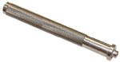 | Rocker arm cover gasket assembling tool (rocker arm capscrew gudgeon seat - electronic injector fastening capscrew brace seat) | ED0014603630-S
ST_13 | 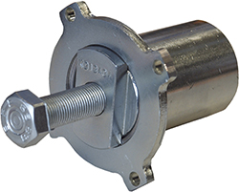 | High-pressure fuel injection pump puller gear | ED0014604050-S
ST_17 | 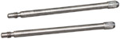 | Rocker arm cover mounting studs | ED0014603730-S
ST_18 | 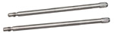 | Intake and oil sump manifold mounting studs | ED0014603740-S
ST_34 | 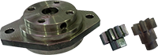 | Crankshaft blocking tool | ED0014604270-S
ST_43 | 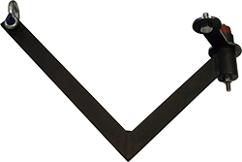 | Flywheel lifting tool | ED0014604030-S
ST_44 | 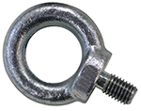 | Flange bell lifting tool | ED0014604010-S
ST_45 | 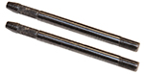 | Flange bell placing tool | ED0014604020-S
ST_46 |  | Flywheel placing tool | ED0014604040-S
ST_47 | 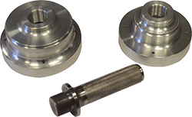 | Tool for sealing ring insertion flywheel side and pulley side | ED0014604340-S
Tab. 13.2
SPECIFIC EQUIPMENT TO PROTECT COMPONENTS OF THE INJECTION CIRCUIT
ST_40 | 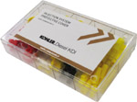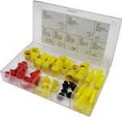 | Complete box with caps to close holes and unions for high-pressure injection circuit components. | ED0082051380-S
Tab. 13.3
SPECIAL TOOLS TO TEST THE ENGINE ON THE TEST BENCH - DIAGNOSTIC PROCEDURE
ST_01 |  | Complete instrument Kit for diagnostics  "POLAR XL" | ED0014603690-S
ST_49 |  | Complete instrument Kit for diagnostics  "DIAGBOX" | ED0014604210-S
ST_50 |  | Complete instrument Kit for engines bench test | ED0014604110-S

Information about failures

Possible causes and trouble shooting
IMMEDIATELY STOP THE ENGINE WHEN:
- Engine rpm increases and decreases suddenly without being able to control them;
- A sudden and unusual noise is heard;
- The colour of the exhaust fumes suddenly darkens or turns white;
- The oil pressure warning light or a Warning Lamp turns on during operation;
- The coolant temperature warning light turns on during operation.

Tab. 14.1 contains the possible causes of some failures, which may occur during operation.

Always perform these simple checks before removing or replacing any part.
Warning

- Do not carry out any checks or operations on the engine when it is running.

Tab. 14.1

Glossary

Glossary
A

ACACT: | "After Charge Air Cooler Temperature"
Air gap: | Distance to respect between a fixed component and one in movement.
Alternator: | A component that transforms mechanical energy into AC electrical energy.
Authorised workshop: | Kohler authorised service centre.
ATS: | "After Treatment System" - Post-treatment system, referred to the exhaust gases produced by the engine.

B

Balancer device: | A device that reduces vibrations caused by movement of the alternating weights (Crankshaft - Connecting rods - Pistons).
Base configuration: | Engine having components represented in Par. 1.4 - 1.5.
BDC: | Bottom Dead Centre; a moment in which the piston is at the start of its stroke.
Bore: | Internal diameter of the cylinder in combustion engines.

C

CAN: | "Controller Area Network" - also known as CAN-bus, is a data communication standard for ECUs.
Catalyst: | see " DOC "
Combustion: | Chemical reaction of a mixture composed of fuel and fuel (air) inside a combustion chamber.
Common Rail: | A high-pressure "Common Duct" that produces a constant supply of fuel directly to the injectors.
Crankshaft: | A component that transforms straight operation into rotary operation, and vice-versa.

D

DCU: | "Dosing Control Unit" - It is a control unit that checks the SCR system adjusting the AdBlue dosage inside the SCR catalytic converter according to the parameters detected by the different sensors.
DOC : | "Diesel Oxidation Catalyst" - Catalyst for diesel engines that reduces harmful exhaust gas emissions produced by the engine.
DPF : | "Diesel Particulate Filter" - A filter that captures particles of carbonaceous origin emitted by diesel engines.

E

EC: | "European Community".
ECS: | "Emission Control System"
ECU: | "Electronic Control Unit"; an electronic device in charge of electronically detecting and controlling other electronic control devices.
EGR Cooler: | Recirculated exhaust gas cooling; a system that is able to cool recirculated gas (EGR) from the exhaust. This enables the temperature to remain constant inside the intake manifold, thus improving combustion inside the cylinders and breaking down pollutants further.
EGR valve: | Electronically-controlled device that adjusts the entrance of exhaust gas recirculated inside the intake manifold.
EGR: | Exhaust Gas Recirculation, in internal combustion engines; a system that enables recirculation of combusted gas by means of taking it in once again, which enables it to break down a part of the pollutants present in the exhaust gas.
EGR-T: | "Exhaust Gas Recirculation Temperature" - temperature sensor for EGR
EGTS: | "Exhaust Gas Temperature Sensor"
Electronic :injector | An electronically activated component able to inject jets of atomised fuel inside the cylinders.
EPA: | "Environmental Protection Agency - The United States' authority that safeguards the environment" ; its duty is to govern and control polluting emissions.
ETB: | "Electronic Throttle Body" - This is controlled by the ECU upon request of the accelerator pedal, and its function is crucial for the correct regeneration of the ATS system.

F

Fig.: | Figure.
Functional units: | Component, or group of main components, able to carry out specific functions on the engine.

G

Galvanised: | Material that has undergone surface protection treatment.
Grinding (valves and seats): | Cleaning operation of the valves and seats carried out with an abrasive paste (refer to an authorised service station for this type of operation).

H

Heater: | A device that heats the intake air by means of an electrical resistor.
Heavy conditions: | Type of extreme condition referred to the work environment in which the engine is used (very dusty - dirty area, or in a contaminated environment due to various types of gas).

I

Idle speed operation: | Operation of a running engine with the vehicle stopped and on idle speed.
Intercooler: | Air-cooling element under pressure from the turbo situated between the turbine and intake manifold.

K

KDI: | "Kohler Direct Injection"

M

Maintenance - periodic: | A group of maintenance actions that have the sole objective to control and replace elements on their expiry, without modifying or improving the functions carried out by the system, neither increasing the value nor improving performance.
Max.: | "Maximum".
MCU: | Machine control unit
Methyl ester: | It is a mixture of products by means of a chemical conversion of oils and animal and/or vegetable fat, which is used to produce Biofuel.
Min: | "Minutes".
Min.: | "Minimum".
Model: | "Model", engine identification plate, which indicates the engine's model.

N

N/C: | Normally Closed, referred to switches (oil-pressure switch).

O

Oil Cooler: | Small radiator used to cool the oil.

P

Par.: | Paragraph.
Paraffin: | Fatty and solid substance that may form inside the diesel.
Pipe cleaner: | An instrument having a metal cylindrical body with bristles that jut outwards. It is similar to a brush and is used to clean areas that are not easily accessible manually (e.g. oil ducts inside an engine).
Poly-V: | "Poly-V", the name associated with a service belt, which derives from the profile of its section that is constructed with joined Vs.
Power operation: | Operation of the engine at high speeds.
PTO: | Power Take Off - a point provided to take advantage of alternative operation transmission.
Pump Learning: | Automatic procedure carried out by ECU (by means of a diagnostics instrument - ST_01) to discover the operating characteristics of the fuel feeding pump (should the injection pump or ECU be replaced).

Q

QR: | Quick Response (code) - QR Code, a two-dimensional matrix bar code composed of black modules placed inside a square-shaped structure.

R

Ref.: | Reference.
Rpm.: | Rounds per minute.

S

s/n: | "Serial number" (engine identification name plate) indicating the engine identification series/chassis number.
SCR-T | "SCR Temperature Sensor"
SCU: | Sensor Control Unit
Spec.: | "Specification", (engine identification name plate) indicating the engine version.
SCV: | Suction Control Valve - it is situated on the high-pressure injection pump and is directly controlled by the ECU adjusting the intake of fuel to send to the Common Rail.
STD: | (Standard), base configuration of a component, or a group of components.

T

Tab.: | Table.
Target wheel: | A wheel that is part of a device to control angular operation by means of teeth placed on the circumference, which enable to determine and transmit the speed and position of the crankshaft to a sensor.
TCR: | "Turbo Common Rail".
TDC: | Top Dead Centre; a moment in which the piston is at the end of its stroke.
Tightening torque: | A term indicated for installation of threaded components and which is determined by means of a unit of measurement Nm.
T-MAP: | "T-MAP" (sensor), measures the temperature and absolute pressure inside the intake collector.
Torque: | Force applied to an object that rotates on an idler shaft.
Trochoid: | Rounded toothed profile (also known as "lobes").
Turbocharger: | Device that compresses air intake by sending it to the intake manifold by means of a turbine.

U

Used oil: | Oil altered by operation or time, which is no longer compliant for correct lubrication of the components.

W

Warning Lamp: | A warning light (usually red) that indicates a serious anomaly during engine operation.
Waste-Gate valve: | A device, which is directly or automatically controlled, used to limit the pressure of exhaust gas inside the turbine.

SYMBOLS AND UNITS OF MEASUREMENT
SYMBOL | UNIT OF MEASUREMENT | DESCRIPTION | EXAMPLE
α | degree | Rotation/inclination angle | 1°
cm ² | square centimetre | Area | 1 cm ²
Ø | millimetre | Circumference | Ø 1 mm
Nm | newton-metre | Torque | 1 Nm
mm | millimetre | Length | 1 mm
µm | 1/1000 of a millimetre (micron) |  | 1 µm
H | hour | Time | 1 h
g/kW | grammes per kilowatt per hour | Specific consumption | 1 g/kWh
kg/h | kilogramme per hour | Max. flow rate | 1 kg/h
Lt./min. | litres per minute | Flow rate | 1 Lt./min.
Lt./h | litres per hour |  | 1 Lt./h
ppm | parts per million | Percentage | 1 ppm
N | newton | Force | 1 N
A | Ampere | Intensity of electrical current | 1 A
gr. | gramme | Weight | 1 gr.
kg | kilogramme |  | 1 kg
W | Watt | Power | 1 W.
kW | kiloWatt |  | 1 kW
pa | pascal | Pressure | 1 pa
KPa | Kilopascal |  | 1 KPa
bar | barometric pressure |  | 1 bar
mbar (1/1000 bar) | barometric pressure |  | 1 mbar
R | Resistance | Resistance to electrical current (referred to a component) | 1 Ω
Ω | ohm | Resistance of electrical current | 1 Ω
Rpm | revs per minute | Rotation of an axis | 1 Rpm
Ra | average roughness expressed in microns | Roughness | 1 Ra
°C | degree centigrade | Temperature | 1°C
V | Volt | Electrical voltage | 1 V
 | millimetre | Hex-head capscrew | 1 mm
cm ³ | cubic centimetre | Volume | 1 cm ³
Lt. | litre |  | 1 Lt.

