Glossary
Owner Manual KDW 502 | 702 | 1003 | 1404 - K-HEM 1003 (Rev. 00)

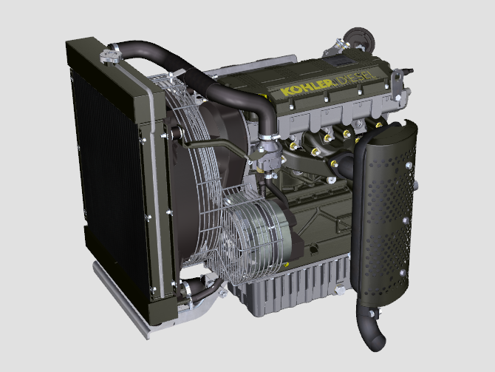

Registration of modifications to the document
Any modifications to this document must be registered by the drafting body, by completing the following table.

Released by | Code | Revision | Release Date | Revision date | Edited by | Endorsed
 | KDW 502-702-1003-1404 - K-HEM 1003

Translated from the original manual in Italian language
Data reported in this issue can be modified at any time by KOHLER.

Sommario
1. TITOLO 1 2
1.1. Asdfsdfsdf 2
1.2. Asdfsdfsdfggg 2

Glossary

Glossary
A | Alternator: | A component that transforms mechanical energy into AC electrical energy.
 | Authorised service station: | KOHLER authorised workshop.
 | Authorised workshop: | KOHLER authorised service centre.

B | Bore | Internal diameter of the cylinder in combustion engines.

C | Combustion: | Chemical reaction of a mixture composed of fuel and fuel (air) inside a combustion chamber.
 | Crankshaft: | A component that transforms straight operation into rotary operation, and vice-versa.

E | EC: | "European Community".

F | Fig.: | Figure.
 | Functional units: | Component, or group of main components, able to carry out specific functions on the engine.

G | Galvanised: | Material that has undergone surface protection treatment.

H | Heavy conditions: | Type of extreme condition referred to the work environment in which the engine is used (very dusty - dirty area, or in a contaminated environment due to various types of gas).

M | Maintenance - periodic | A group of maintenance actions that have the sole objective to control and replace elements on their expiry, without modifying or improving the functions carried out by the system, neither increasing the value nor improving performance.
 | MAX: | Maximum.
 | Methyl ester: | It is a mixture of products by means of a chemical conversion of oils and animal and/or vegetable fat, which is used to produce Biofuel.
 | Min.: | Minutes.
 | MIN: | Minimum.
 | Model: | Model, engine identification plate, which indicates the engine's model.

P | Par.: | Paragraph.
 | Paraffin.: | Fatty and solid substance that may form inside the diesel.
 | PTO: | Power Take Off - a point provided to take advantage of alternative operation transmission.

R | Ref.: | Reference.
 | Rpm: | Rounds per minute.

S | s/n: | Serial number (engine identification name plate) indicating the engine identification series/chassis number.
 | Spec.: | Specification, (engine identification name plate) indicating the engine version.
 | STD: | (Standard), base configuration of a component, or a group of components.

T | Tab.: | Table.
 | Thermostatic valve: | A valve that adjusts the flow of coolant liquid; it is able to operate by means of temperature variation.
 | Torque: | Force applied to an object that rotates on an idler shaft.

U | Used oil: | Oil altered by operation or time, which is no longer compliant for correct lubrication of the components.

W | Warning Lamp: | A warning light (usually red) that indicates a serious anomaly during engine operation.

15.1
SYMBOLS AND UNITS OF MEASUREMENT
SYMBOL | UNIT OF MEASUREMENT | DESCRIPTION | EXAMPLE
α | degree | Rotation/inclination angle | 1°
cm ² | square centimetre | Area | 1 cm ²
Ø | millimetre | Circumference | Ø 1 mm
Nm | newton-metre | Torque | 1 Nm
mm | millimetre | Length | 1 mm
µm | 1/1000 of a millimetre (micron) |  | 1 µm
H | hour | Time | 1 h
g/kW | grammes per kilowatt per hour | Specific consumption | 1 g/kWh
kg/h | kilogramme per hour | Max. flow rate | 1 kg/h
Lt./min. | litres per minute | Flow rate | 1 Lt./min.
Lt./h | litres per hour |  | 1 Lt./h
ppm | parts per million | Percentage | 1 ppm
N | newton | Force | 1 N
A | Ampere | Intensity of electrical current | 1 A
gr. | gramme | Weight | 1 gr.
kg | kilogramme |  | 1 kg
W | Watt | Power | 1 W.
kW | kiloWatt |  | 1 kW
pa | pascal | Pressure | 1 pa
KPa | Kilopascal |  | 1 KPa
bar | barometric pressure |  | 1 bar
mbar (1/1000 bar) | barometric pressure |  | 1 mbar
R | Resistance | Resistance to electrical current (referred to a component) | 1 Ω
Ω | ohm | Resistance of electrical current | 1 Ω
Rpm | revs per minute | Rotation of an axis | 1 Rpm
Ra | average roughness expressed in microns | Roughness | 1 Ra
°C | degree centigrade | Temperature | 1°C
V | Volt | Electrical voltage | 1 V
 | millimetre | Hex-head capscrew | 1 mm
cm ³ | cubic centimetre | Volume | 1 cm ³
Lt. | litre |  | 1 Lt.

