Technical information
KSD 1403 Workshop Manual (Rev. 00_DRAFT)

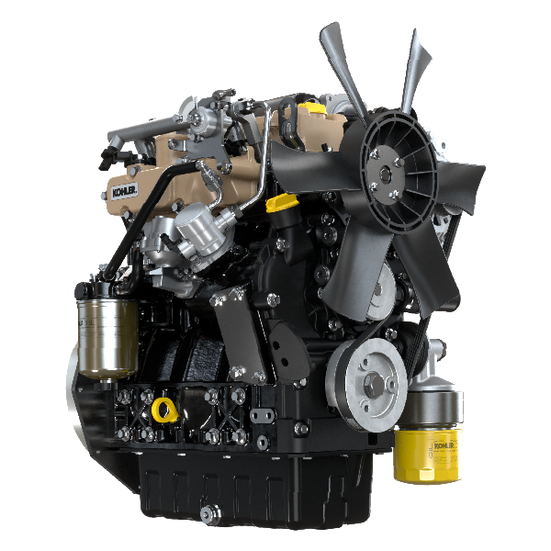

Registration of modifications to the document
Any modifications to this document must be registered by the drafting body, by completing the following table.

Released by | Code | Revision | Release Date | Revision date | Edited by | Endorsed
 | KSD1403-WS

Translated from the original manual in Italian language
Data reported in this issue can be modified at any time by KOHLER.

Sommario
1. TITOLO 1 2
1.1. Asdfsdfsdf 2
1.2. Asdfsdfsdfggg 2

Technical information

General description of the engine
- 4-stroke, in-line cylinders Diesel engine; - Liquid-cooling system;

- 2 valves per cylinder;

- Indirect injection.

Engine specifications (base version)
2.1
TECHNICAL DATA |  | UNIT OF MEASURE
Engine type |  |  | KSD 1403 NA | KSD 1403 TC | KSD 1403 TCA
Cylinders |  | n. | 3
Bore |  | mm | 81
Stroke |  | mm | 90
Displacement |  | cm ³ | 1391
MAX INCLINATION DURING OPERATION (even in combined) |  | α | 35° max
 |  | α | 45° max 1 min.
OIL CAPACITY (MAX level.) including oil filter | Compact Sump | lt. | 3.79
 | Deep Sump |  | 5.37
DRY WEIGHT |  | kg | 124 | 128 | 127

Engine dimensions (mm)

KSD 1403 NA
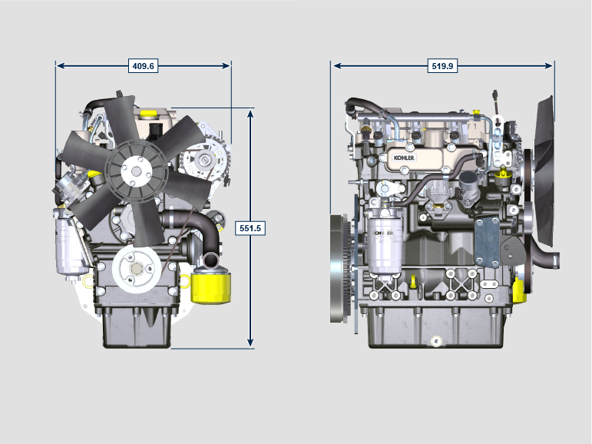
KSD 1403 TC
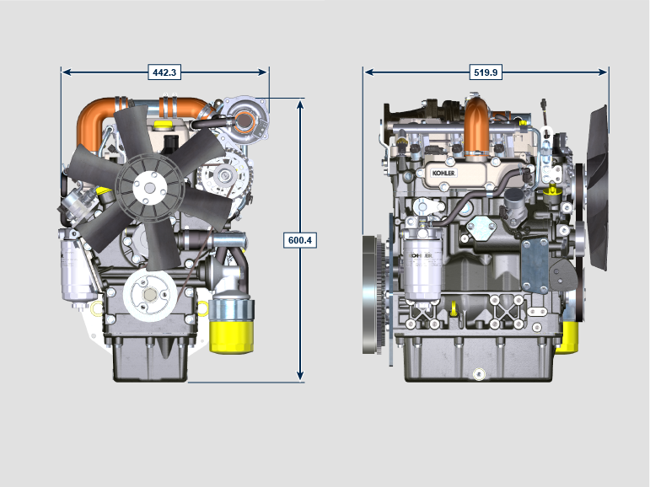
KSD 1403 TCA
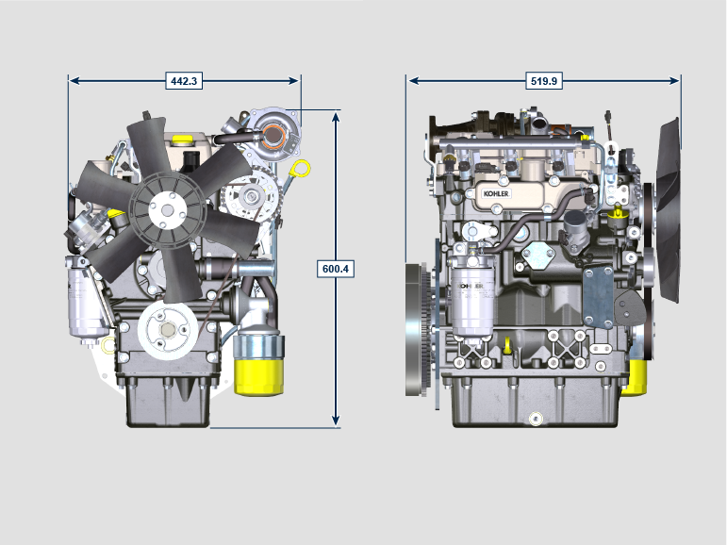

NOTE : Dimensions vary according to engine configuration.

Oil

Important

- The engine may be damaged if operated with improper oil level.
- Do not exceed the MAX level because a sudden increase in engine rpm could be caused by its combustion.
- Use only the approved oil to ensure adequate protection, efficiency and service life of the engine.
- The use of lubricants other than recommended may shorten the engine life.
- Viscosity must be appropriate to the ambient temperature to which the engine is to be exposed.

Danger

- Prolonged skin contact with the exhausted engine oil can cause cancer of the skin.
- If contact with oil cannot be avoided, thoroughly wash your hands with soap and water as soon as possible.
- For the exhausted oil disposal, refer to the Par. DISPOSAL and SCRAPPING .
2.4.1 SAE oil classification
- In the SAE classification, oils are identified according to viscosity without considering any other qualitative characteristic.
- The code is composed of two numbers, which indicate, and must correspond to, the ambient temperature in which the engine operates, the first number refers to the viscosity when cold, for use during winter (" W "), while the second number is for viscosity at high temperatures.

2.2
RECCMMENDED OIL
WITH SPECIFICATIONS | API | CI-4 or better
 | ACEA | E7 or better
VISCOSITY | SAE | 0w-40 (-40°C ÷ +50°C)  10w-40 (-25°C ÷ +50°C)

Fuel
Important  - Use of other types of fuel could damage the engine. Do not use dirty diesel fuel or mixtures of diesel fuel and water since this will cause serious engine faults. | Warning  - Clean fuel prevents the fuel injectors from clogging. Immediately clean up any spillage during refuelling.  - Never store diesel fuel in galvanized containers (i.e. coated with zinc). Diesel fuel and the galvanized coating react chemically to each other, producing flaking that quickly clogs filters or causes fuel pump and/or injector failure.  - Any failure resulting from the use of fuel other than Tab. 2.3, 2.4 will not be covered by warranty.
Cetane number of 40 minimum. Cetane number greater than 47 is preferred, especially for temperatures below –20 °C (–4 °F) or elevations above 1675 m (5500 ft.).

2.3
Certification --> | Stage 5 | Stage 3A  4 | Tier III  IV | no certification | Remarks :
Fuel Type --> | (EN 590 - DIN 51628) |  |  | (EN 590 - DIN 51628) | Do NOT USE vegetable oils as a biofuel not compliant with EN590 prescription.
 |  |  | Grade 1-D S15 |  | For ambient temperatures below 0°C (32°F) with no arctic fuel available (Grade 1-D S15, Grade 2-D S15, ASTM D 975) use the following additives to prevent possible engine damage with low engine load in cold weather:  - Power Service Diesel Fuel Supplement+Cetane Boost  Different additives are not allowed.  The use of approved additives has no impact on the engine maintenance schedule.  Do NOT USE vegetable oils as a biofuel not compliant with ASTM D975 Grade1 and Grade2 prescription.
 |  |  | Grade 2-D S15

2.4
FUEL ADDITIVES | Remarks
Fuel additives with biocide/algaecide functions only are allowed in case of storage of fuel in the tank for long periods (one year or more). | For suggested brands and types contact Kohler staff
These additives must be diluted in the fuel following the product prescribed percentages when filling the tank.
Additives with functions other than biocide / algaecide are not al-lowed.

Coolant recommendation
A mixture of 50% demineralized water and 50% low silicate ethylene glycol based coolant liquid must be used. Use a Long Life or Extended Life Heavy Duty OAT coolant free of: silicates, phosphates, borates, nitrites and amines.

The following ethylene-glycol based engine coolant for all models within KSD engine family may be used:

- OAT (Organic Acid Technology) Low Silicate: ASTM D-3306 D-6210
- HOAT (Hybrid Organic Acid Technology) Low Silicate: ASTM D-3306 D-6210

The above coolants in concentrated formulation must be mixed with distilled, deionized, or demineralized water. A pre-mixed formulation (40-60% or 50-50%) can be used directly when available.

Important
- Do not mix ethylene glycol and propylene glycol based coolants. Do not mix OAT and HOAT based coolant. OAT performance life can be drastically reduced if contaminated with nitrite-containing coolants.
- Never use automotive-type coolants. These coolants do not contain the correct additives to protect heavy – duty diesel engines.

OAT coolants are maintenance free up to 5 years or 4000hrs of operation , provided that the cooling system is topped up using the same type of coolant. Do not mix different coolant types. Test the coolant condition annually with coolant test strips.
HOAT are not all maintenance free and it is recommended to have SCA (Supplemental Coolant Additives) added at the first maintenance interval.

Battery recommendation
Battery not supplied by Kohler

2.6
RECOMMENDED BATTERIES
STANDARD OPERATING CONDITIONS AMBIENT TEMPERATURE > -15°C
BATTERY CAPACITY | BATTERY DISCHARGE CURRENT
70 Ah | SAE 650  EN 715

STANDARD OPERATING CONDITIONS AMBIENT TEMPERATURE < -15°C
BATTERY CAPACITY | BATTERY DISCHARGE CURRENT
100 Ah | SAE 850  EN 935

Fuel system
Important

- The high pressure supply injection system is highly susceptible to damage if the fuel is contaminated.
- It is crucial that all components of the injection circuit are thoroughly cleaned before the components are removed.
- Thoroughly wash and clean the engine before maintenance.
- Contamination in the fuel supply injection system may cause a reduction in effectiveness / operation of engine fault indication.
- If the engine is cleaned with high pressure washer, then the nozzle must be kept at a minimum distance of 200mm from the surface, and not directed at electrical components and connectors.

2.8.1 Supply system

NOTE : The representation of fuel tank is purely indicative. Component not necessarily supplied by KOHLER .
Con pompa alimentazione meccanica §  2.6a  POS. DESCRIPTION  1 Fuel tank  2 Fuel hose  3 Fuel feed pump  4 Fuel filter | 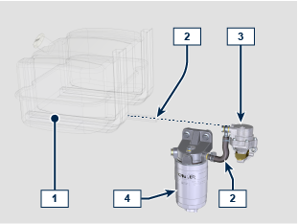
Con pompa alimentazione elettrica §  2.6b  POS. DESCRIPTION  1 Fuel tank  2 Fuel hose  3 Fuel Pre-filter  4 Electrical fuel feed pump  5 Fuel filter | 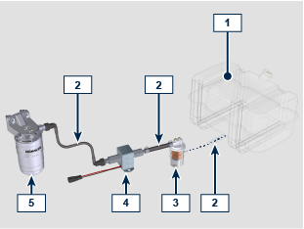
2.8.2 Injection  2.7  POS. DESCRIZIONE  1 Fuel filter  2 Fuel hose  3 Injection pump  4 High pressure fuel pipe  5 Common Rail  6 Electronic injector  7 Pre-chamber | 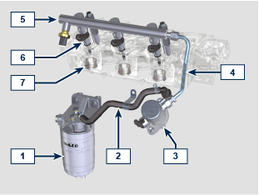
2.8.3 Fuel return circuit  The fuel return circuit is under low pressure.  NOTE : The representation of fuel tank is purely indicative. Component not necessarily supplied by KOHLER .  2.8 | TBD

2.8.4 Injection pump  Pressure into the injection pump must be positive in all operating conditions.  NOTE: In the event of leakage from the high pressure circuit do not intervene with the engine running, but turn it off and wait 5 - 10 minutes before checking the leak.  2.9  POS. DESCRIZIONE COMPONENTI  1 Inlet suction fuel  2 High pressure delivery  3 Gasket  4 Tappet  5 Fuel intake regulating valve connector | 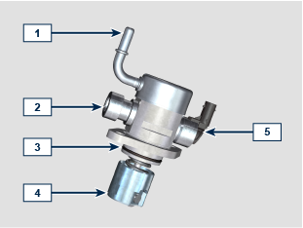
2.8.5 Common Rail  Fuel is injected under pressure into the Common Rail, from the high-pressure fuel injection pump.  - The internal volume of the Common Rail is optimised to obtain the best compromise in order to minimise pressure peaks due to the cyclical flow of the injection pump;  - Opening the electronic injectors;  - The high speed response of the system to the requests of the ECU control unit.  The pressure sensor measures the pressure of the fuel in the Common Rail. Pressure inside the Common Rail is regulated by the highpressure fuel injection pump by means of the fuel intake regulation valve.  Important  - Common Rail is NOT reparaible.  - It is NOT possible to perform any maintenance on the fuel pressure sensor, as it is an integral part of the Common Rail unit.  - Do NOT remove the pressure sensor from the Common Rail.  - If the pressure sensor is not working, replace the entire Common Rail unit.  2.10  POS. DESCRIZIONE COMPONENTI  1 Common Rail  2 Fuel pressure sensor  3 Electronic injector connections  4 Tube inlet union from fuel injection pump | 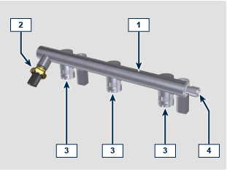

2.8.6 Electronic injector  The electronic injector is equipped with an integral solenoid valve which, when excited electronically, manages a valve controlled from inside the electronic injector to commence fuel injection.  The ECU output signal is digital.  Important  - The electronic injector is NOT repairable.  - Fuel containing impurities causes serious damage to the electronic injectors.  2.11  POS. COMPONENTS DESCRIPTION  1 Inlet fuel  2 Gasket  3 Connector for solenoid control  4 Gasket  5 Gasket | 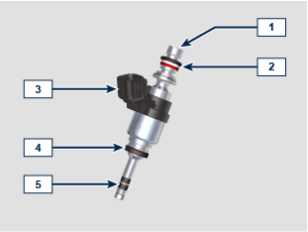

2.8.7 Fuel filter  The fuel filter is situated on the crankcase of the engine or it may be assembled on the frame of the vehicle.  2.12  POS. COMPONENTS DESCRIPTION  1 Fuel filter support cartridge  2 Air bleeding screw  3 Cartridge  4 Water draining device  5 Hole water drainage | 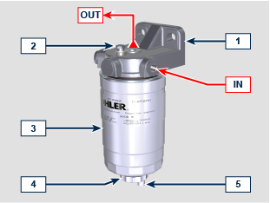

2.8.8 Guards for fuel injection circuit components  High-pressure injection circuit components are particularly sensitive to impurities.  To prevent impurities, even microscopic ones, from accessing the fuel input or output unions, you are required to close these accesses by means of specific caps as soon as the various tubes are disassembled and disconnected.  Disassembly of any component of the injection circuit must not occur in dusty environments.  Cap guards must remain closed in their housing (ST_xx) until the moment they are to be used.  Pay special attention when using the caps and avoid any contamination of dust or dirt of any kind.  Even after using the caps illustrated in this paragraph, all components of the injection circuit must be placed with care in environments that are free of any type of impurity.  Cap guards must be accurately washed after use and placed back in their housing (ST_xx).  Important  - It is highly recommended to have this page visible during disassembly operations of the components of the fuel injection circuit. | TBD

Lubrication circuit
2.9.1 Lubrication circuit diagram
The oil pump is driven by the crankshaft on the timing system side.

On the parts of the systems shown in green on In the parts in green, the oil is in intake, in the parts in red, the oil is under pressure and

in those in yellow the oil is returning towards the oil sump 2 (not under pressure).
2.13
COLOUR | DESCRIPTION
 | Oil in intake
 | Oil under pressure
 | Oil returning to the oil sump

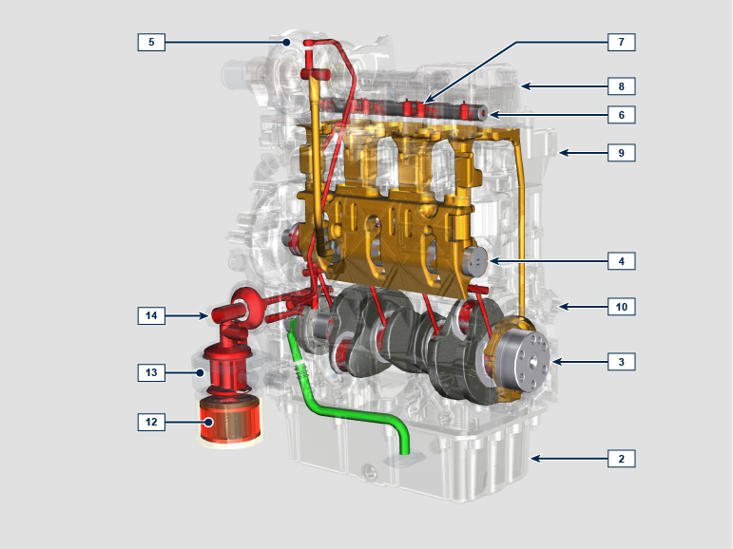
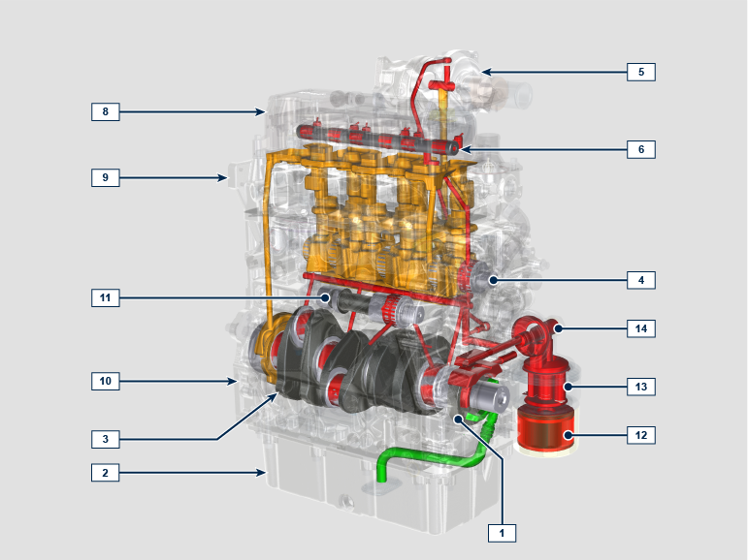
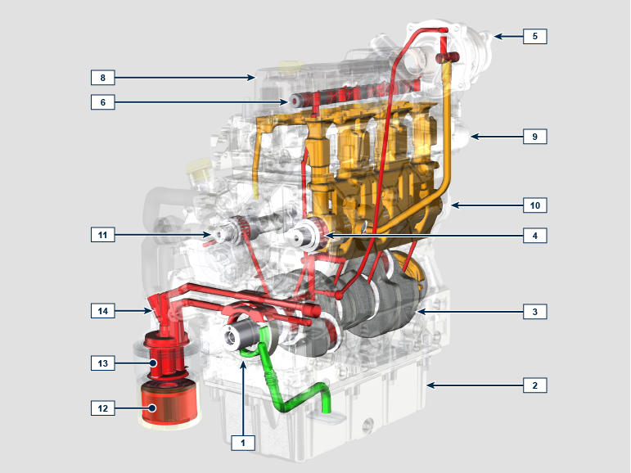
2.14
POS. | DESCRIPTION
1 | Oil pump rotors
2 | Oil sump
3 | Crankshaft
4 | Camshaft for engine valves control
5 | Turbocharger
6 | Rocker arm pin
7 | Hydraulic tappets
8 | Rocker arm cover
9 | Cylinder head
10 | Crankcase
11 | Camshaft for injection pump control
12 ⁽¹⁾ | Oil filter
13 ⁽¹⁾ | Oil Cooler
14 ⁽¹⁾ | Idle gear Housing

(1):
- STD Exhaust side
- Opional Intake side
2.9.2 Oil pump The oil pump rotors are trochoidal (with lobes) and are activated from the crankshaft by means of gears.  It is imperative to assemble the rotors with reference A visible by the operator.  2.15  POS. DESCRIPTION  1 Internal rotor  2 External rotor  3 Oil pump crankcase  4 Oil pump control key  5 Crankshaft | 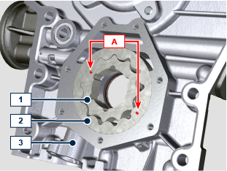  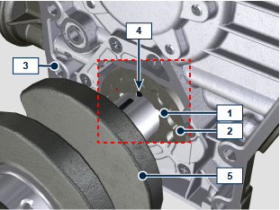

2.9.3 Oil filter and Oil Cooler

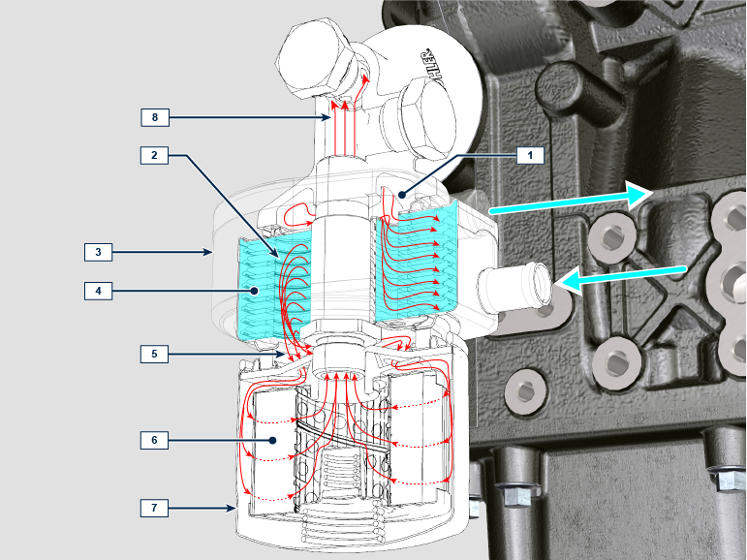

Tab 2.16
POS. | DESCRIPTION
1 | Oil arriving from the pump
2 | Oil cooling
3 | Oil Cooler
4 | Coolant
5 | Oil directly from the cartridge
6 | Oil filtering
7 | Oil filter cartridge
8 | Oil returning into the circuit

Cooling circuit
2.10.1 Cooling circuit diagram

2.17
POS. | DESCRIPTION
1 | Coolant pump
2 | Coolant intake
3 | Coolant, cylinder
4 | Coolant, cylinder head
5 | Coolant to radiator
6 | Coolant into radiator
7 | Thermostatic valve
8 | Coolant input into the Oil Cooler
9 | Coolant in the Oil Cooler
10 | Vent line
11 | Coolant output from the Oil Cooler

2.10.2 Water pump

2.18
POS. | DESCRIPTION
1 | Coolant pump control pulley
2 | Coolant intake fitting
3 | Coolant return hose from the Oil Cooler

2.10.3 Thermostatic valve
2.19
POS. | DESCRIPTION
1 | Cylinder head
2 | Coolant outlet cover
3 | Thermostatic valve
4 | Gaskets

Starting opening temperature of +80° ± 2°C.

Intake and exhaust circuit
2.11.1 Intake and exhaust circuit diagram

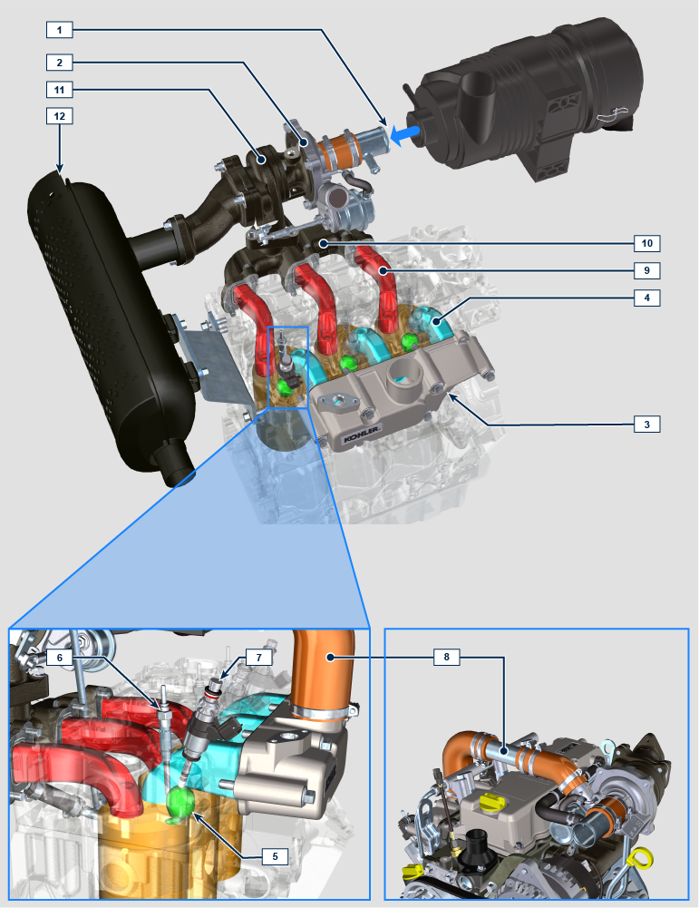

NOTE: the turbocharged is installed only for TC and TCA versions.
NA versions have the air filter intake line directly installed on the intake manifold.

Filtered air is sucked by the turbocharger, which compresses and sends it to the intercooler ( the Intercooler is installed only for TCA versions - as a consequence of compression, the air increases the temperature - the Intercooler cools it - this process enables better performance during combustion inside the cylinders). From the Intercooler, it is sent to the intake manifold and, via ducts in the cylinder head, enters the cylinders. Compressed air inside the cylinders and mixed with the fuel inside the prechamber transforms into Gas after combustion. The gas is expelled from the cylinders and sent to the exhaust manifold. The exhaust manifold sends the Gases to the turbocharger body (the expelled Gases activate the turbine), the Gases then proceed towards the muffler and definitely expelled.

2.20
POS. | DESCRIPTION
1 | Air in intake from air filter
2 | Air in compression
3 | Intake manifold
4 | Air in head intake
5 | Prechamber
6 | Electronic injector
7 | Glow plug
8 | Air to intake manifold hose (only for TC versions)
9 | Gas in head outlet
10 | Exhaust manifold
11 | The exhaust gases are activating the turbocharger
12 | Muffler

2.11.2 Air filter

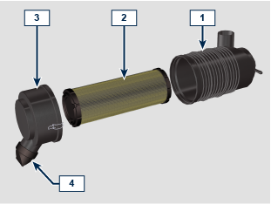

NOTE: Component not necessarily supplied by KOHLER .

Important

- The air filter is a dry type of filter with a paper filtering element; the filter cartridge 2 is replaceable (refer to Tab. XX and Tab.XX for procedure frequency on components).
- Filter suction must be positioned in a cool place.
- Should a hose be used, the length must not exceed XXX mm and is to be as straight as possible.
2.21
POS. | DESCRIPTION
1 | Filter support
2 | Air filter cartridge
3 | Filter cover
4 | Dust exhaust valve

Electric system
2.12.1 ECU input and output signals diagram

2.22
SENSORS/SWITCH (INPUT) |  | DEVICES (OUTPUT)
Power relay | ECU | Electronic injector 1
Engine revolutions sensor |  | Electronic injector 2
Engine phase sensor |  | Electronic injector 3
Coolant temperature sensor |  | Fuel flow control
Common Rail pressure sensor |  | Revolution indicator
Oil pressure switch |  | Glow plugs Relay
Fuel temperature sensor |  | Diagnosis indicator lights
T-MAP sensor |  | Electric fan control (1-2 speeds or variable speed)
Main accelerator pedal (double track) |  | CAN 1 (ISO15765 diagnostics)
Secondary accelerator pedal (optional) |  | CAN 2 (Vehicle SAE J1939)
Hydraulic oil pressure sensor (optional)
Fuel level sensor (optional)
Air filter clogging sensor (optional)
Water in fuel sensor

2.12.2 Control unit (ECU)
The ECU is a central processor, which monitors and controls engine operation.

The electronic control unit is responsible for engine management.

It is fitted on the frame of the vehicle, or in the cab (refer to the technical documentation of the vehicle).

Important

- The ECU must only be used with the configuration defined
by KOHLER , for each individual engine.
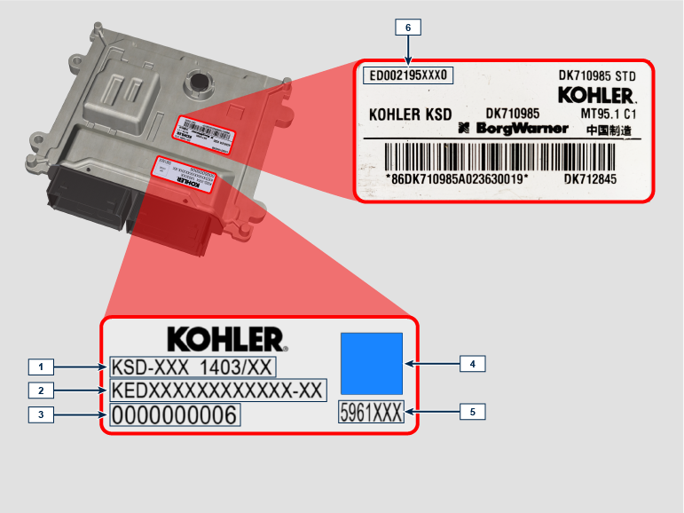

Tab. 2.23
ECU AND ENGINE IDENTIFICATION PLATES
POS. | DESCRIPTION
1 | Engine model
2 | Engine specifications
3 | Engine serial number
4 | Datamatrix
5 | Validation code
6 | ECU identification code

- Do NOT mount or replace the control unit with that of another engine.
- Although externally each ECU seems to be identical, internally they are specifically configured only for use on the engine that they are supplied with.
- To install a new control unit, is required to recharge on it's the original configuration relating to that specific engine .
- The control units are not interchangeable nor modifiable.
- Each control unit is accompanied by its adhesive identification plate.

2.12.4 Engine electrical wiring

Tab. 2.24  RIF. DESCRIZIONE  1 Vehicle interface connector  2 ECU Connector E  3 ECU Connector C  4 CANR  5 Ground  6 D+ Connector Alternator  7 Starter motor connector  8 Engine speed sensor connector  9 T-MAP sensor connector  10 Electronic Injector connector 1  11 Common Rail pressure sensor connector  12 Electronic Injector connector 2  13 Electronic Injector connector 3  14 Coolant temperature sensor connector  15 Fuel flow control  16 Engine phase sensor connector  17 Oil pressure switch connector  18 Diagnosis Connector  19 Doubble track accelerator connector | 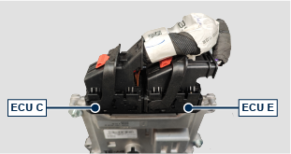
2.12.4.1 Wiring disconnection  All sensor connectors and electronic control devices are sealed.  The connectors must be disconnected by means of pressure on tabs A or unblock the retainers B . | 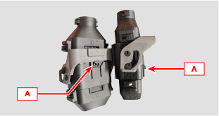
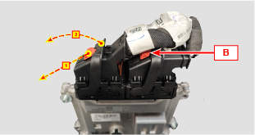 | 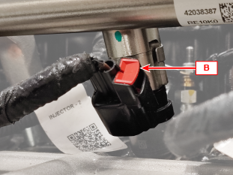
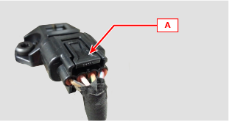 | 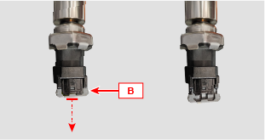
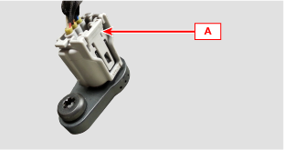 | 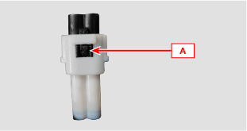
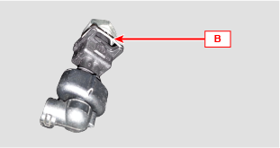

Sensors and switches
2.13.1 Revolution sensor on target wheel  Speed sensor A is situated on the crankcase.  The sensor detects the signal from the target wheel B situated on the flywheel. It sends it to the ECU as an analogical signal.  The sensor sends and analogue signal to the ECU.  The sensor produces a 5V square wave signal having a Hall effect while the flywheel in rotation detects its position and speed.  The data sent by this sensor enables the ECU to pilot fuel anticipation injection for each piston. | 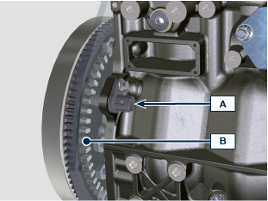
2.13.2 Camshaft sensor  Camshaft sensor C is situated on the timing system carter.  The purpose of the camshaft sensor C is to identify the position of the Camshaft control gear D with respect to the engine shaft and consequently the position of the pistons with respect to the T.D.C. The sensor produces a 5V square wave signal having a Hall effect while the camshaft in rotation detects the phases of the 4 strokes of the 1st cylinder. As a consequence, ECU by means of internal calculations, also recognises the phases of the other cylinders.  The data sent by this sensor enables the ECU to pilot fuel anticipation injection for each piston. | 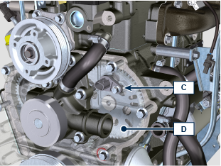
2.13.3 T-MAP sensor  The T-MAP F sensor is situated on the intake manifold. It detects the input pressure in the intake manifold by means of electrical voltage variation and the air temperature by means of an electrical resistor.  The sensor sends signals to the ECU, which determines the values and modifies the injection strokes.  Tab. 2.35 reports the electrical resistor values according to the intake air temperature.  NOTE : R indicates the pin where it is possible to measure electrical resistance.  Tab 2.25  °C (°F) R ( Ω )  -30 (-22) 23475 - 25945  0 (32) 5370 - 5935  25 (77) 1900 - 2100  50 (122) 772 - 854  100 (212) 177 - 195  120 (248) 107 - 119 | 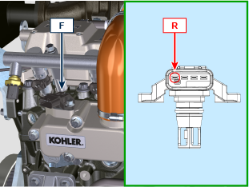
2.13.4 Common Rail pressure sensor  Fuel pressure sensor G assembled on the Common Rail, detects the fuel pressure inside it by means of electrical voltage variation.  Depending on the signal sent, ECU manages the fuel intake valve on the injection pump and, if necessary, modifies the injection strokes. | 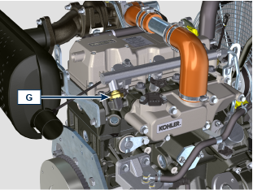
2.13.5 Oil pressure switch  Oil pressure switch N is assembled on the crankcase near to the injection pump.  It is a N/C sensor, calibrated at 0.6 bar ± 0.1 bar.  With oil low pressure the sensor closes the electrical circuit and the warning lamp in the panel board switches on. | 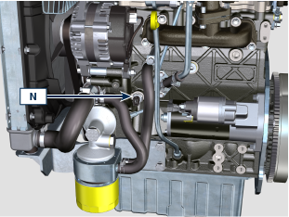
2.13.6 Coolant temperature sensor  The P coolant temperature sensor of the coolant circuit is applied to the cylinder head on the side of the thermostatic valve.  It is used by the ECU in order to obtain information regarding the coolant temperature.  2.26  CHARACTERISTICS  Temperature °C R min Ω R max Ω  -40 38720 49720  0 5669 6407  +140 77 98.8 | 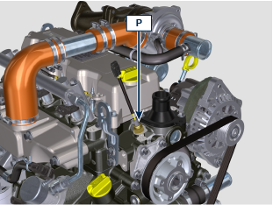
2.13.7 Air cleaner clogging switch  NOTE: Component not necessarily supplied by KOHLER.  The switch is assembled on the air cleaner. When the filter is clogged, it sends a signal to the panel. | 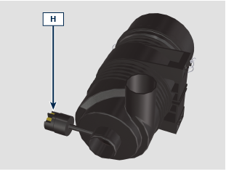

Electrical components
2.14.1 Alternator  Externally controlled by the crankshaft by means of a belt. | 12V-45A  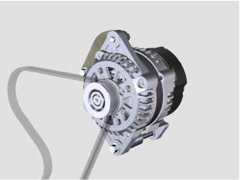
12V-80A
12V-100A
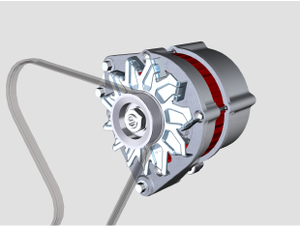
2.14.2 Starter Motor  - Type Bosch 12 V  - Potenza 3.2 kW  - Anticlockwise rotation (seen from timing system side) | 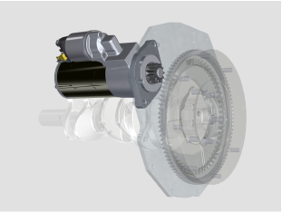
2.14.3 Glow plugs  Glow plugs A are located on the engine head, at low temperature the glow plugs will activate heating the prechamber B facilitating the fuel combustion sprayed by the injectors C . | 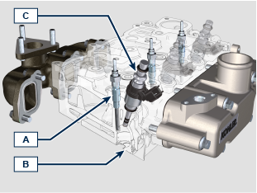
2.14.4 Electric fuel pump (optional)  NOTE: Component not necessarily supplied by KOHLER.  The electric pump is located before the fuel filter.  2.27  POS. Description  B Electrical connection  C Pump Prefilter  IN Ingoing fitting (IN) from tank  OUT Outgoing fitting (out) to fuel filter  A Value  Voltage 12 V  Delivery 60.56 L/h @ 0.41 bar | 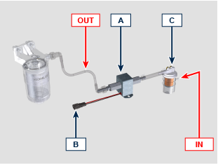

Timing system and tappets
The timing system is equipped with hydraulic tappets that automatically recover the operation of the rocker rods assembly.
No registration is therefore required.

2.15.1 Components identification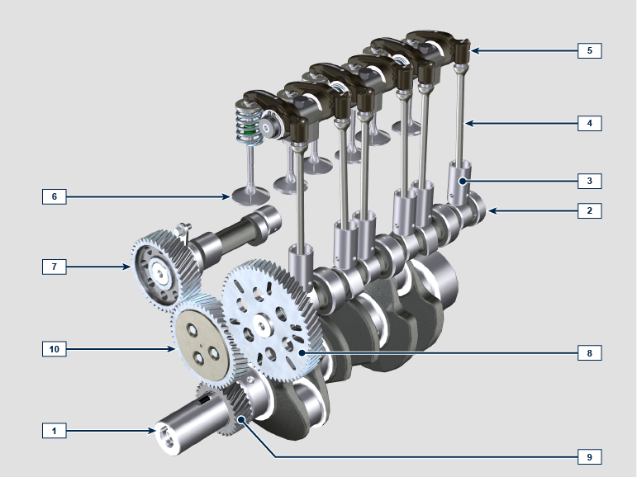

2.28  POS. DESCRIPTION  1 Crankshaft  2 Camshaft  3 Camshaft tappets  4 Rocker arm control rod  5 Rocker arms  6 Valves  7 Injection pump camshaft control gear  8 Engine valves camshaft control gear  9 Crankshaft gear  10 Idle gear  11 Valve tappet  12 Hydraulic tappets | 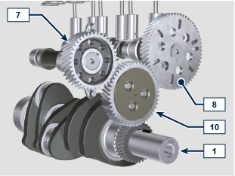  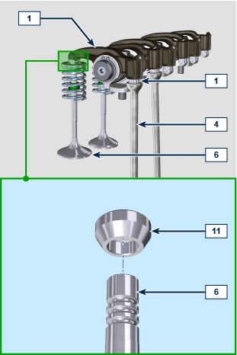
2.15.2 Rocker arm pin  2.29  POS. DESCRIPTION  1 Rocker arm pin  2 Rocker arm distancing spring  3 Rocker arm pin support  4 Exhaust rocker arm  5 Intake rocker arm | 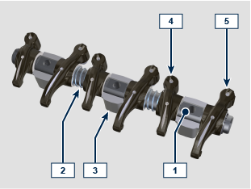
2.15.3 Rocker arms  2.30  POS. DESCRIPTION  1 Rocker arm body  2 Oil flow line  3 Hydraulic tappet oil refill line  4 Valve tappet  5 Hydraulic tappet | 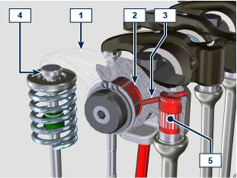
2.15.4 Hydraulic tappets  2.31  POS. DESCRIPTION  A Hydraulic tappets  B Hight pressure chamber  1 Hydraulic tappets oil refill pipe  2 Retaining ring  3 Piston  4 Unidirectional valve  5 Tappet body  6 Spring  2.15.4.1 Hydraulic tappet operation  The operating principle of the hydraulic tappet is based on the incompressibility of the liquids and on controlled leakage.  The oil under pressure enters the tappet chamber A , providing a constant supply of oil in the low-pressure chamber.  Through the non-return valve, 4 the oil can only access the high-pressure chamber B and exit via the clearance between the piston 3 and the tappet body 5 (controlled leakage).  The chamber B is filled when the rocker arm is on the base radius of the cam and the spring 6 keeps the piston 3 against the valve stem, thus eliminating any system play. Thanks to the spring extension, the tappet "extends", creating a small depression in the chamber B , making the non-return  valve 4 open, and allowing the oil in the chamber A to pass to chamber B , restoring the proper amount of oil required to eliminate any play in the valves. | 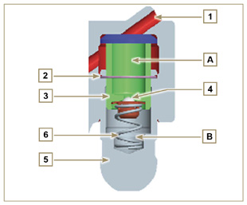

2.15.4.2 Difficult operating conditions
For proper operation on the hydraulic tappets it is essential that the low pressure chamber of the piston 3 is always full of oil.

In some conditions this may not occur (due to the fact that the oil leaks away when the engine is switched off, which can also partially drain the tappets). This situation will be the cause of clearances that will result in a characteristic noise similar toa ticking sound.
- When the engine is cold, the tappet filling time could be very long if the oil used is not suitable for the specific environmental conditions ( Tab. 2.2 )
- If the engine is very hot: at idle speed, oil pressure may be low, and small air bubbles could form in the circuit. Because of this, this compressing the tappet slightly and producing valve play which is responsible for the ticking sound. On account of this, the tappet compresses slightly giving rise to a valve clearance, thus generating a slight ticking sound, which however disappears rapidly ( MAX 10 seconds) once normal operating conditions have been restored.

Anyway the duration of ticking Anyway the duration of ticking sound must be MAX 30 seconds. If not, the problem is surely due to the poor quality of the oil, wear or impurities that, transported by the oil, can infiltrate between the ball valve and its seat inside the piston, compromising the operation of the tappet itself; In these cases, the only solution is to replace the oil or hydraulic tappets.

The prolonged persistence of the ticking sound or abnormal noise must be investigating in order to prevent any malfunctions; if necessary, replace the hydraulic tappets and engine oil.

Components handling
2.16.1 High-pressure fuel injection pump  - Only handle by means of the points marked by Y .  - It is forbidden to handle using the points marked by N . | 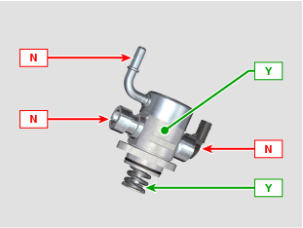
2.16.2 Electronic injector  - Only handle by means of the points marked by Y .  -It is forbidden to handle using the points marked by N . | 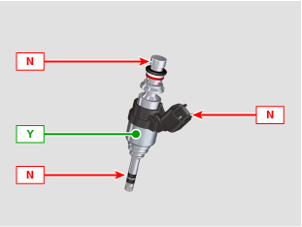
2.16.3 Common Rail  - Only handle by means of the points marked by Y .  - It is forbidden to handle using the points marked by N . | 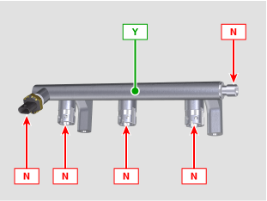  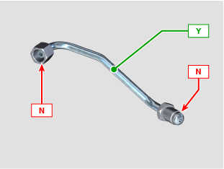
2.16.4 Turbocharger  - Only handle by means of the points marked by Y .  - It is forbidden to handle using the points marked by N .  Important  - Refer to Par. 2.18 . | 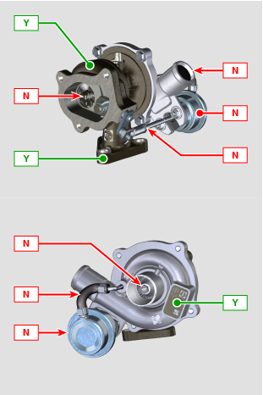

Turbocharger

2.17.1 What to do and what not to do  What to do:  - Before assembling the turbocharger, make sure that the protection caps are fitted on all openings of the turbo.  - Ensure pre-lubrication of the turbocharger.  - Periodically check that the joints are sealed against oil and air.  - Use lubricating oil according to the specifications described in Par. 2.4 .  - Check the engine oil level.  - Before switching it off after it has been used, make the engine run idle, or without a load, for approximately 1 minute.  - Ensure that controls and maintenance intervals of the engine are observed as specified in Chapt 4 .  - Make sure that the engine and equipment are used correctly so as not to compromise the life of the turbocharger. | What not to do:  - Do not store turbocharges in damp, wet places if they are not in their original packaging.  - Do not expose the turbocharger to dust and dirt if it is not in its original packaging.  - Do not lift of hold the turbocharger from the actuator rod if it is not in its original packaging.  - Do not apply additives to the lubricating oil and fuel, unless instructed to do so by Kohler.  - Do not increase engine speed, or apply loads, immediately after start-up.  - Do not intervene on the actuator settings A .  - Do not let the vehicle / engine run at idle speed for more than 20-30 minutes at a time.
2.17.2 Practical operating rules  Users can help to maximise the duration of their turbocharger by following the rules described below.  - Start-up Start the engine at idle speed, or without a load, for approximately one minute. Oil operating pressure is reached within a few seconds and enables the moving parts to warm up and be lubricated.  Immediately increasing the engine speed upon start-up means making the turbocharger run at high speed with suboptimal lubrication, which may compromise the life of the turbocharger.  - After maintenance or a new installation  Proceed with pre-lubrication by filling new oil into the oil supply duct B until filling it completely. Start the engine at idle speed, or without a load, for a few minutes in order to ensure that the oil and bearings system operate satisfactorily.  - Low temperature air or engine inactivity  If the engine has been inactive for some time, or the air temperature is very low, start the engine at idle speed or without a load for a few minutes.  - Engine shutdown  Before switching the engine off after intense activity, one must allow the turbocharger to cool down. One must therefore let the engine run at idle speed or without a load for at least 2 minutes, thus allowing the turbocharger to cool.  - Engine at idle speed  Avoid using the engine at idle speed or without a load for long periods (more than 20-30 minutes). When operating at idle speed or without a load, the turbocharger is at low pressure in the exhaust chamber C and air supply D ; this may cause oil leaks from seals E  to the extremity of the shaft. Even if this does not cause damage, it can cause blue smoke from the exhaust when the engine speed and load are increased. | 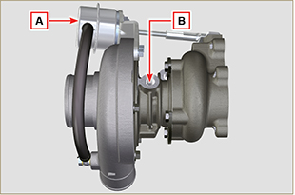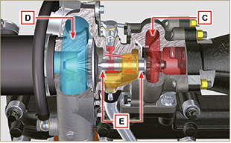
2.17.3 Before installing a new turbocharger  Important  - Do not lift the turbocharger with one hand from the box.  - Do not lift turbocharger from Comp hsg side.  - Lift the turbocharger with both hands from box.  - Make sure to use clean gloves.  - Handle the turbocharger as indicated in Par. 2.16. | 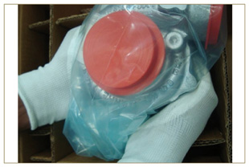
- Avoid lifting from the intake side G .  - Remove cap guard F and check that there is no excessive shaft axial and radial clearances. | 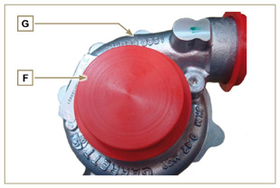
- Check for any signs of friction of the turbine on the turbocharger body.  - Check for any traces of oil leaks on the turbocharger body.  - After having check everything, reapply cap F on intake opening H of the turbocharger and do not remove it until assembly has been completed. | 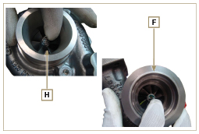
- Check the correct assembly of the capscrews and the presence of paint on them. | 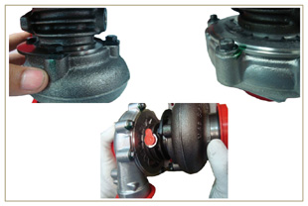
2.17.4 Installation instructions  - Remove the cap guards with care only when assembling.  Handle carefully avoiding erratic movements. | 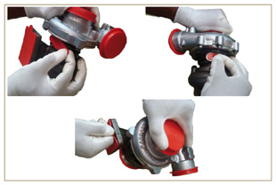
2.17.5 Replacement instructions

Always understand the cause of the breakage of the turbocharger before replacing it.

Correct the cause of the breakage before replacing it with a new turbocharger.

If in doubt, contact KOHLER service department.

Important

- Failure to comply with these instructions can cause damage to the turbocharger and void the warranty.
- Modifying the calibration of the turbocharger damages the turbocharger/engine.
- Always use the correct gaskets, and fit carefully to avoid blocking holes when mounting.
- Refer to the manual of the engine / vehicle, for: the correct type and quantity of oil, the correct tightening of components, instructions and installation.
- It is forbidden to use liquid gaskets or sealants, particularly for the oil inlet/outlet.
- Avoid dirt / debris while installing the turbocharger.
- Before mounting the turbocharger, check that the code of the component is correct for the type of engine, as mounting the wrong turbocharger can damage the turbo / engine and void the warranty.

