General Information
KSD 1403 owner manual (Rev. 00.1)

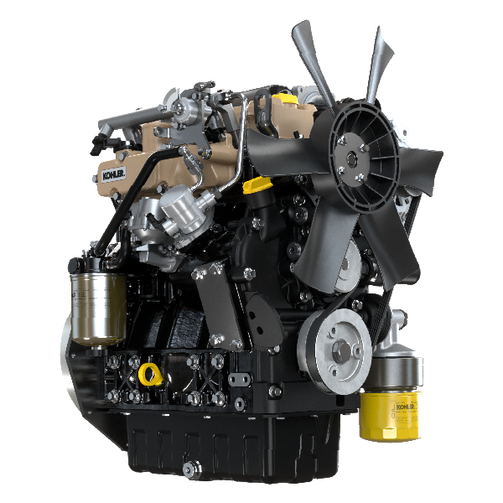

Registration of modifications to the document
Any modifications to this document must be registered by the drafting body, by completing the following table.

Released by | Code | Revision | Release Date | Revision date | Edited by | Endorsed
 | KSD1403

Translated from the original manual in Italian language
Data reported in this issue can be modified at any time by KOHLER.

Sommario
1. TITOLO 1 2
1.1. Asdfsdfsdf 2
1.2. Asdfsdfsdfggg 2

null

