Information about maintenance
KDI 2504 M Owner Manual (Rev. 16)

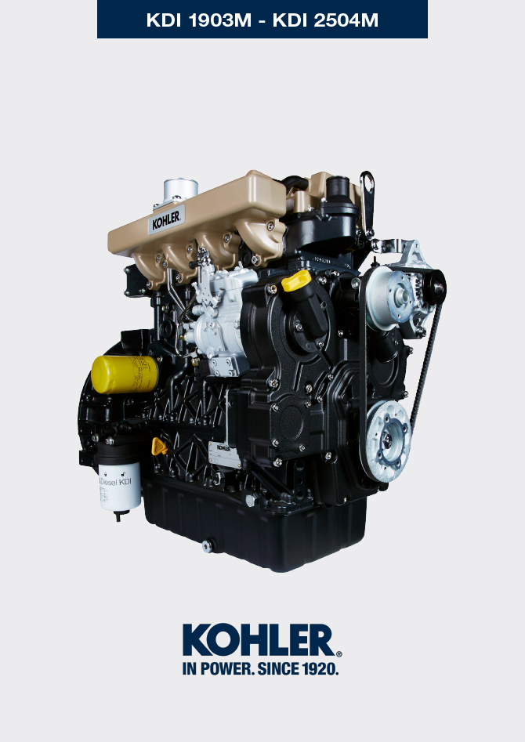

Registration of modifications to the document
Any modifications to this document must be registered by the drafting body, by completing the following table.

Released by | Code | Revision | Release Date | Revision date | Edited by | Endorsed
 | 2504M

Translated from the original manual in Italian language
Data reported in this issue can be modified at any time by KOHLER.

Sommario
1. TITOLO 1 2
1.1. Asdfsdfsdf 2
1.2. Asdfsdfsdfggg 2

null

