Technical information
Owner Manual KDW 502 | 702 | 1003 | 1404 - K-HEM 1003 (Rev. 00)

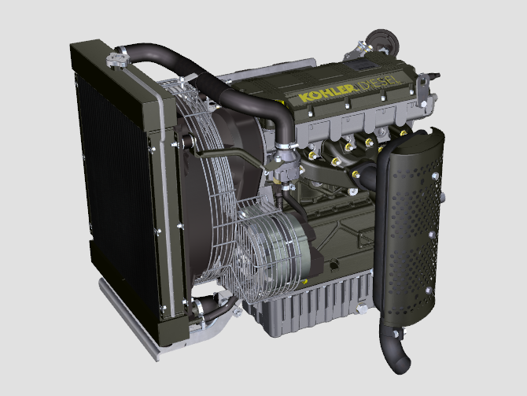

Registration of modifications to the document
Any modifications to this document must be registered by the drafting body, by completing the following table.

Released by | Code | Revision | Release Date | Revision date | Edited by | Endorsed
 | KDW 502-702-1003-1404 - K-HEM 1003

Translated from the original manual in Italian language
Data reported in this issue can be modified at any time by KOHLER.

Sommario
1. TITOLO 1 2
1.1. Asdfsdfsdf 2
1.2. Asdfsdfsdfggg 2

null

