Information about replacements
KDI 3404 TM Owner Manual (Rev. 10)

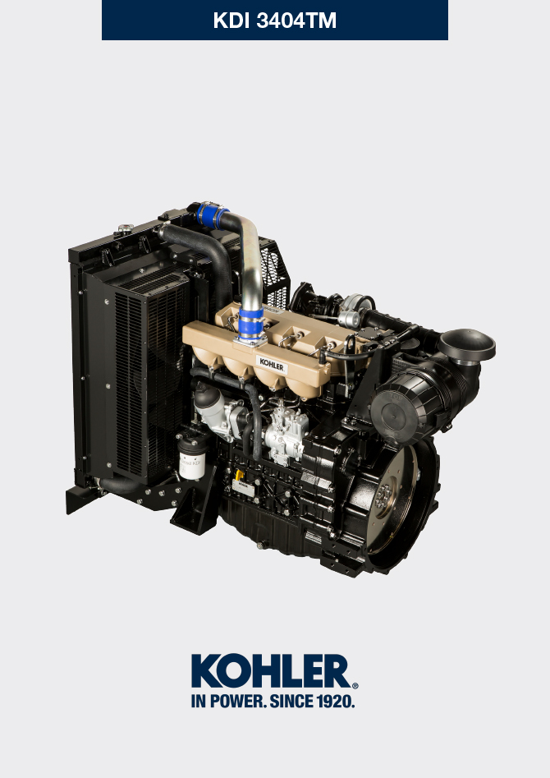

Registration of modifications to the document
Any modifications to this document must be registered by the drafting body, by completing the following table.

Released by | Code | Revision | Release Date | Revision date | Edited by | Endorsed
 | 3404TM

Translated from the original manual in Italian language
Data reported in this issue can be modified at any time by KOHLER.

Sommario
1. TITOLO 1 2
1.1. Asdfsdfsdf 2
1.2. Asdfsdfsdfggg 2

Information about replacements

Engine oil replacement
Danger  - Disconnect the negative wire (-) from the battery to avroid accidental engine stating.  Important  - Before proceeding with operation, read Par. 3.2.2  - Place engine on level sur face to ensure accurate measurement of oil level.  - Before proceeding, perform the operation described in Par. 6.2 - Point 1.  NOTE : Perform this operation with warm engine, to get a better fluidity of the oil and get a full discharge of oil and impurities contained in it.  - Loosen the oil filler cap A (Fig. 6.1) .  - Remove the oil dipstick B .  - Remove the oil drain plug D and the gasket E (the oil drain plug is on both sides of the oil sump).  - Drain oil in an appropriate container.  (For the exhausted oil disposal, refer to Par. 6.5 DISPOSAL and SCRAPPING ).  - Replace gasket E .  - Tighten the drain oil plug D (tightening torque at 50 Nm ).  - Perform the operation described in Par. 6.2 - point 2 to 5.  - Add the type and amount of oil recommended ( Tab. 2.1 and Tab. 2.2 ).  Important  - Do not exceed the MAX level on the dipstick.  - Fit and remove the oil dipstick B to check the level.  Pour in fluid until reaching the MAX level mark.  - Upon completion, reinstall the oil dipstick B completely.  - Tighten the cap A. | 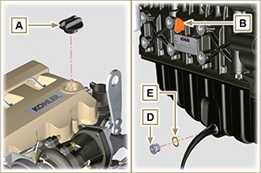  Fig. 6.1  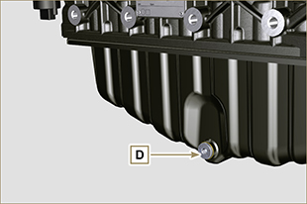  Fig. 6.2  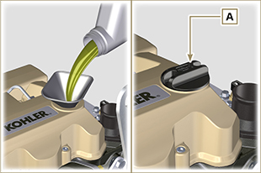  Fig. 6.3  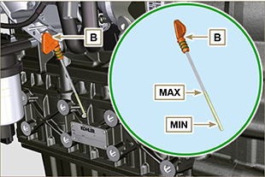  Fig. 6.4
NOTE: Click on the right to play the procedure. | https://www.youtube.com/embed/-KMhwZDDs9g?rel=0

Oil filter cartridge replacement
Important  - Before proceeding with operation, read Par. 3.2.2  Warning  - Electric/pneumatic screwdrivers are forbidden.  - In case of low use replace il 12 months.  - For disposal of oil filter cartridge and fuel filter refer to Par. 6.5 DISPOSAL and SCRAPPING .  - Unscrew cartridge holder cover A by performing three complete turns and wait 1 minute..  NOTE : this operation allows to oil contained in the support F to flow into the oil sump in the correct way.  - Unscrew cartridge holder cover A and check that the oil in the lub. oil filter support F has flowed towards the oil sump.  - Remove the cap A as well as the oil cartridge B from the oil filter support. | 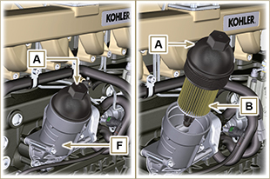  Fig 6.5
- Remove and replace the oil cartridge B with a new one.  Remove and replace the gaskets C, D and E with new ones. | 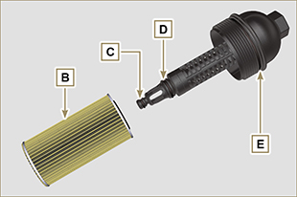  Fig 6.6
- Fit and tighten the cover A on the oil filter support F , tightening it with a torque wrench G (tightening torque of 25 Nm ). | 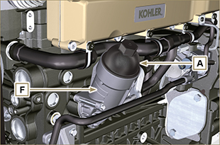  Fig 6.7
NOTE: Click on the right to play the procedure. | https://www.youtube.com/embed/lGMrGAceKXE?rel=0

Fuel filter cartridge replacement
Important

- Before proceeding with operation, read Par. 3.2.2

Warning

- In case of low use replace il 12 months.
- To replace the cartridge with Option B filter, it is necessary to use the ST_55 tool cod. ED0014604590-S .
- For disposal of oil filter cartridge and fuel filter refer to Par. 6.5 DISPOSAL and SCRAPPING

- Unscrew the filter cartridge A from the holder B .

Important

• Do not fill the new cartridge A with fuel.
Option A  - Rotate the filter A to take it to the unlocked position and remove it.  - Lubricate the gasket C .  - Assemble the filter A on the support B and rotate it until reaches the lock position. | 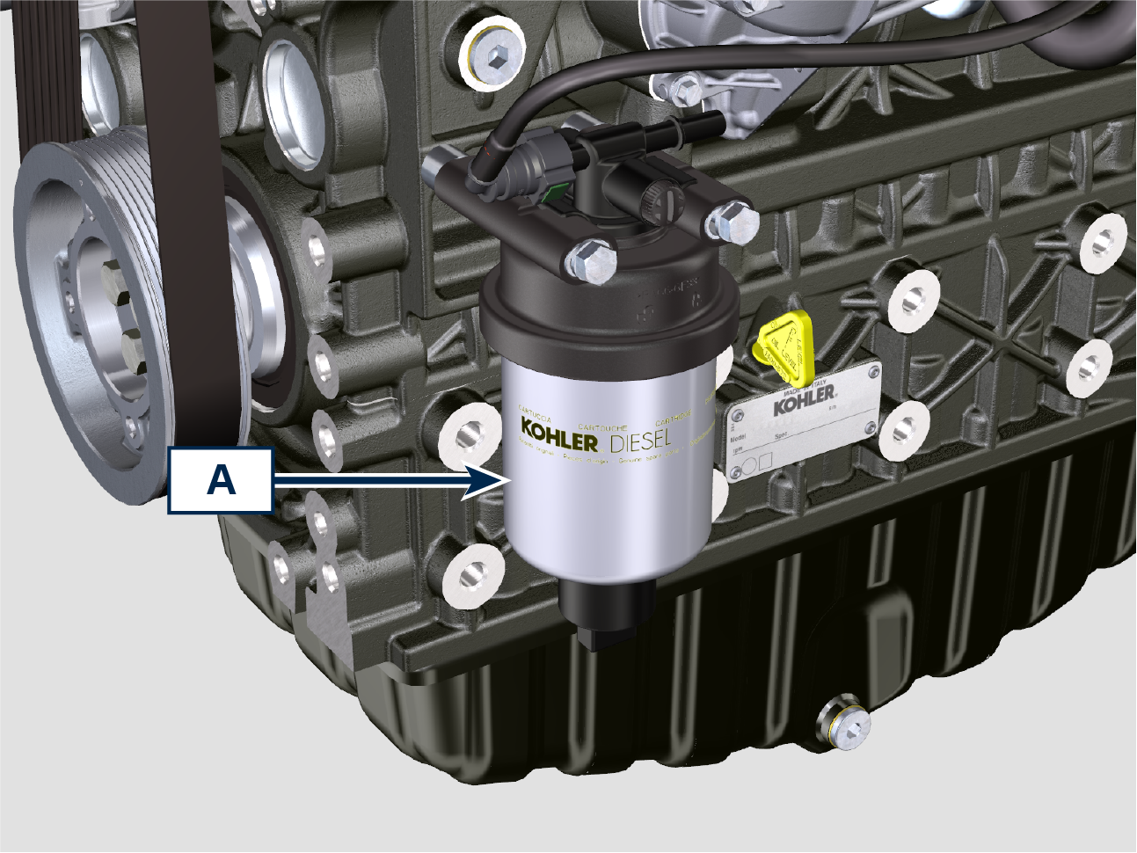  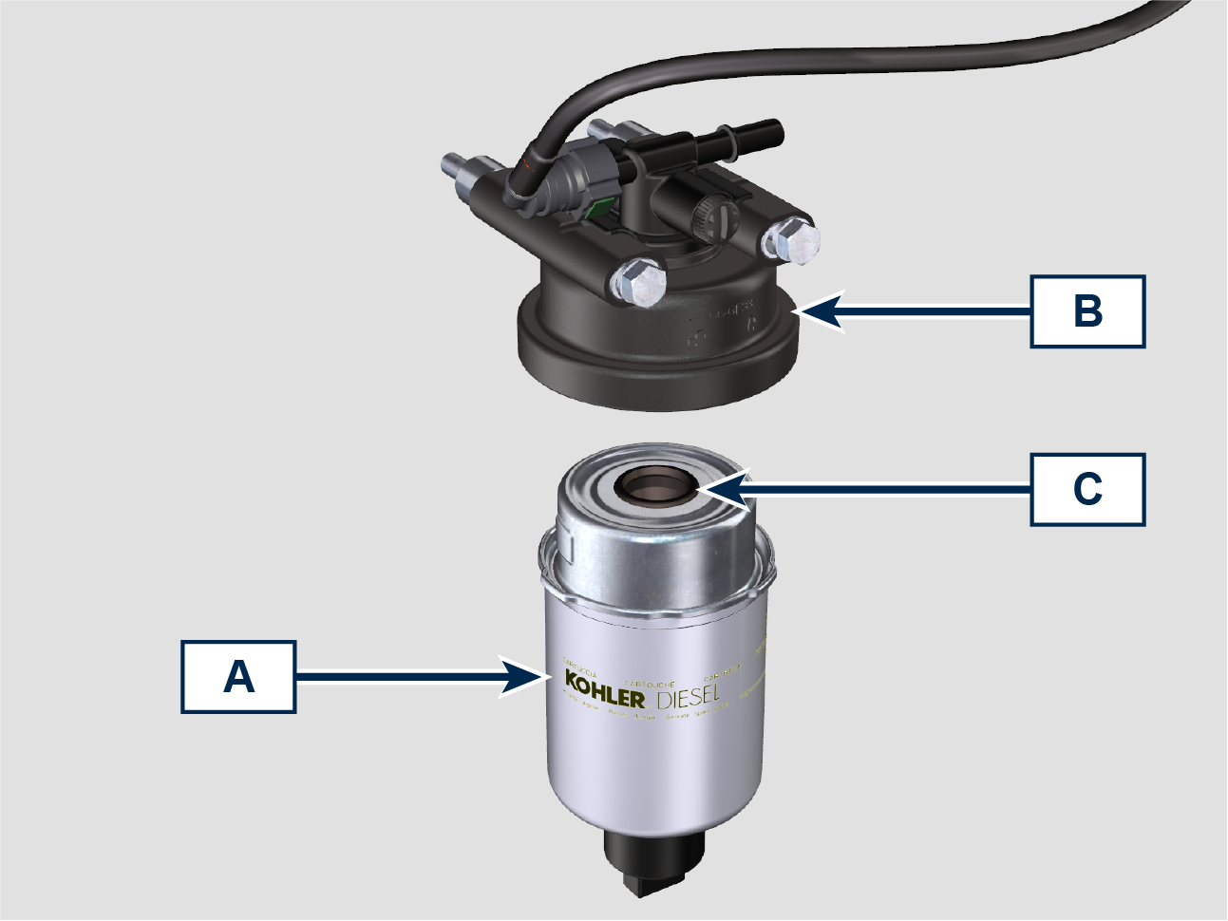  Fig 6.8
Option B  - Unscrew the ring nut H using the ST_55 tool and remove the cartridge A .  - Lubricate the gasket C of the new cartridge A .  - Insert the ring nut H on the new cartridge A and mount the new cartridge A on the support B .  - Tighten the ring nut H using the ST_55 tool (tightening torque 10 Nm ). | 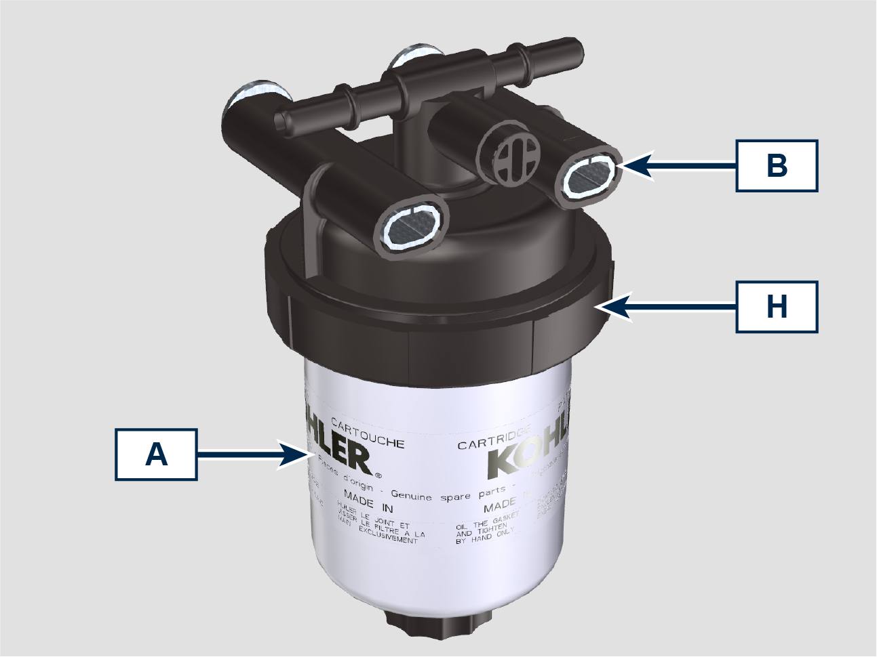  Fig 6.8a  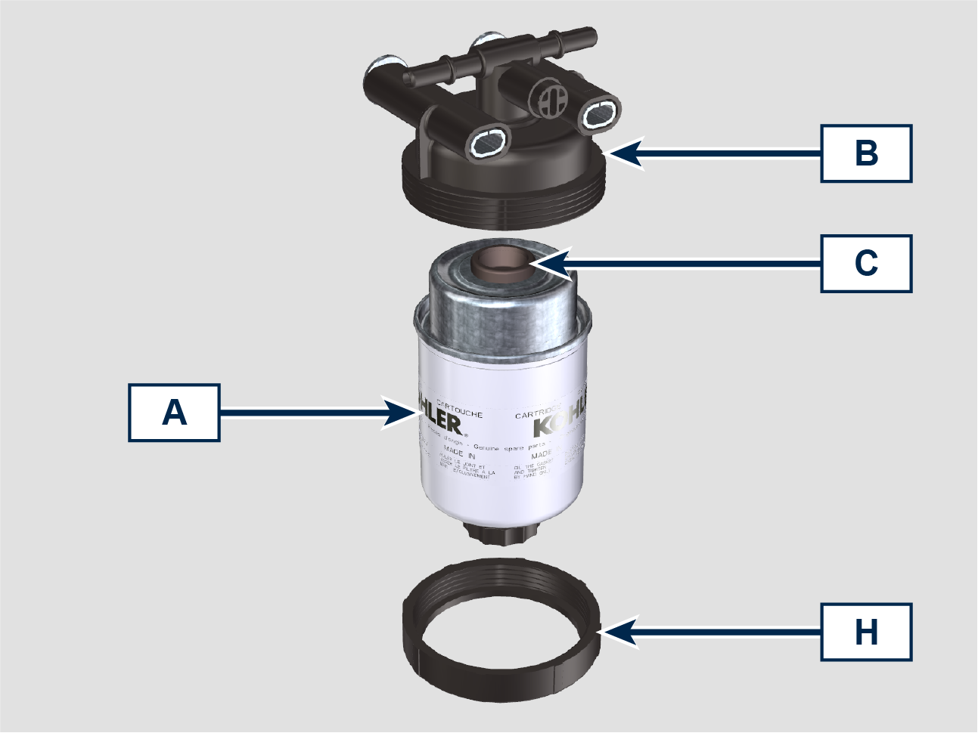  Fig 6.8b
- Turn the key on the control panel to the ON position.  The electric pump F sends fuel to the filter B and then the injection pump G .  - Loosen the air bleeding screw F on fuel filter bracket B and the screw E on the injection pump G .  - Procure a suitable container to collect the fuel.  - Loosen the air bleeding screw H on fuel filter bracket B .  The air inside the circuit and the filter will begin to escape from the screw H .  - Tighten the bleeding screw H and E (tightening torque of 1.5 Nm ) when the fuel begins to flow. | 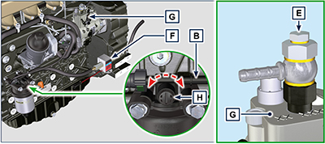  Fig 6.9

Air filter cartridge replacement
Important  - Before proceeding with operation, read Par. 3.2.2.  NOTE : Component not necessarily supplied by KOHLER .  - Release the two fastenings F of the cover A .  - Remove the cartridge B .  - Reinstall:  - the new cartridge B .  -the cover A checking the right tightness of fastenings F . | 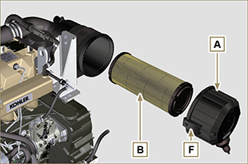  Fig. 6.11

Disposal and scrapping
- In case of scrapping, the engine shall be disposed of in appropriate locations, in conformity with the law in force.
- Before scrapping, it is necessary to separate the rubber or plastic parts from the rest of the components.
- The parts only composed of plastic material, aluminium and steel can be recycled if collected by the appropriate centers.
- Waste oil must properly be recycled and disposed of in the correct way to safeguard the environment. According to the laws in force, it is classified as hazardous waste, therefore it must be collected by the appropriate centers.

