Information about failures
KSD 1403 owner manual (Rev. 00.1)

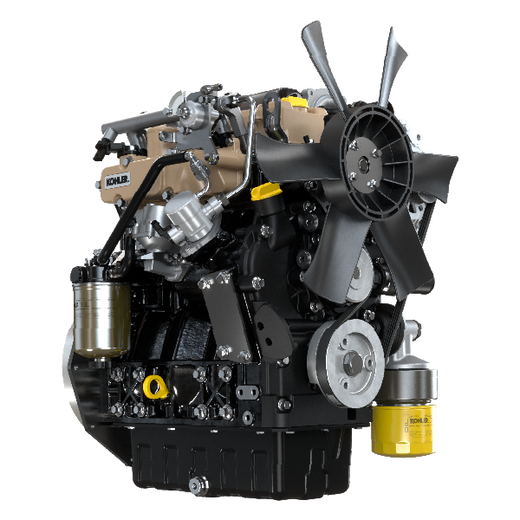

Registration of modifications to the document
Any modifications to this document must be registered by the drafting body, by completing the following table.

Released by | Code | Revision | Release Date | Revision date | Edited by | Endorsed
 | KSD1403

Translated from the original manual in Italian language
Data reported in this issue can be modified at any time by KOHLER.

Sommario
1. TITOLO 1 2
1.1. Asdfsdfsdf 2
1.2. Asdfsdfsdfggg 2

Information about failures

Useful information about failures
- This chapter contains information about the problems that may appear during engine operation with its causes and trouble shooting Tab. 5.2 .
- In some cases, you shall turn off the engine immediately to avoid further damage Tab. 5.1 .
5.1
THE ENGINE MUST BE IMMEDIATELY TURNED OFF WHEN
1 | Warning RED light turn on
2 | The oil pressure indicator light turns on while running
3 | The engine rpms suddenly increase and decrease
4 | A sudden and/or unusual noise is heard
5 | Colour the exhaust fumes suddenly darkens

5.2
TROUBLES | POSSIBLE CAUSE | SOLUTION
Warning YELLOW light turn on | Engine ECU has detect a malfunctions | Contact KOHLER authorised workshops
The engine does not start | Sulphated battery terminals corroded | Clean the battery terminals
 | Battery voltage too low | Recharge the battery or replace it
 | Low fuel level | Refuel
 | Frozen fuel | Contact KOHLER authorised workshops
 | Clogged fuel filter | Replace with a new filter
 | Air suction in fuel system | Contact KOHLER authorised workshops
 | Clogged air filter | Replace with a new filter
 | Clogged pipes | Contact KOHLER authorised workshops
 | Intake or exhaust system clogged | Replace with a new fuse; if the problem persists,  Contact KOHLER authorised workshops
 | Intake or exhaust system clogged | Contact KOHLER authorised workshops
Engine starts but stops | Inefficient electrical connections | Clean the electrical contacts; if the problem persists,  Contact KOHLER authorised workshops
 | Sulphated battery terminals | Clean the battery terminals
 | Clogged fuel filter | Replace with a new filter and clean the tank
 | Clogged fuel pipes | Contact KOHLER authorised workshops
Engine doesn't rev up | Safety protocol in starting | Wait some seconds
 | Throttle to MAX in starting | Release the throttle and wait some seconds
RPM instability at idle speed | Clogged fuel pipes | Contact KOHLER authorised workshops
Low RPM at idle speed | Clogged fuel pipes | Contact KOHLER authorised workshops
 | Poor quality fuel | Clean the tank and refuel with quality fuel
Blue smoke | High oil sump level | Replace the engine oil; if the problem persists,  Contact KOHLER authorised workshops
 | Clogged air filter | Replace with a new filter
Excessive fuel consumption | Clogged air filter | Replace with a new filter
 | High oil sump level | Replace the engine oil; if the problem persists,  Contact KOHLER authorised workshops
Engine lost its initial performance | Clogged air filter | Replace with a new filter
 | Clogged fuel pipes | Contact KOHLER authorised workshops
 | Cheap fuel | Clean the tank and refuel with quality fuel
 | High oil sump level | Replace the engine oil; if the problem persists,  Contact KOHLER authorised workshops
Slow acceleration | Clogged fuel filter | Replace the fuel filter
Engine jerking | Clogged fuel pipes | Contact KOHLER authorised workshops
Engine overheats | Insufficient coolant level | Fill up to the level
 | High oil sump level | Replace the engine oil; if the problem persists,  Contact KOHLER authorised workshops
 | Clogged radiator | Clean the radiator; if the problem persists, contact KOHLER authorised workshops
In the event that the solutions proposed in Tab. 5.2 do not eliminate the trouble, contact a KOHLER authorized workshop

