Storage information
KSD 1403 Workshop Manual (Rev. 00_DRAFT_01)

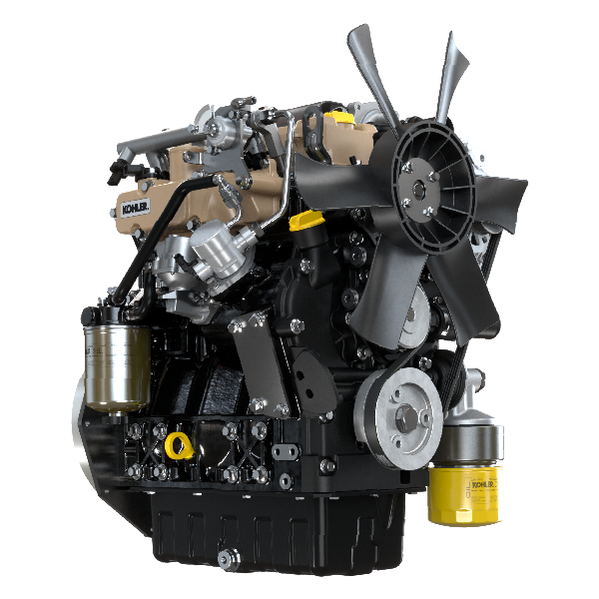

Registration of modifications to the document
Any modifications to this document must be registered by the drafting body, by completing the following table.

Released by | Code | Revision | Release Date | Revision date | Edited by | Endorsed
 | KSD1403-WS

Translated from the original manual in Italian language
Data reported in this issue can be modified at any time by KOHLER.

Sommario
1. TITOLO 1 2
1.1. Asdfsdfsdf 2
1.2. Asdfsdfsdfggg 2

Storage information

Product preservation
Important:
- If the engines are not to be used for 6 months, they must be protected by carrying out the operations described in Engine storage (up to 6 months) ( Par. 4.14 ).
- If the engine is still not in use after the first 6 months, it is necessary to carry out a further operation to extend the protection period (more than 6 months) ( Par. 4.15 ).
- If the engine is not to be used for an extended period, the protective treatment procedure must be repeated within 24 months of the previous one.

Engine storage (up to 6 months)
Before storing the engine check that:
- The environments are not humid or exposed to bad weather. Cover the engine with a proper protective sheet against dampness and atmospheric contaminants.
- The place is not near electric panel.
- Avoid storing the engine in direct contact with the ground.

Engine storage over 6 months
Follow the steps described in Par. 4.14 .
- Engine oil replacement ( Par. 4.6 ).
- Refuel with fuel additives for long storage.
- With expansion tank:
make sure that the coolant is up to the maximum level.
- Without expansion tank: Top liquid up until the pipes inside the radiator are covered by about 5 mm.

Do not overfill the radiator, but leave room for the fuel to expand.
- Start the engine and keep it idle at minimum speed for 2 minutes.
- Bring the engine to 3/4 of the maximum speed for 5÷10 minutes.
- Turn off the engine.
- Completely empty the fuel tank.
- Spray SAE 10W-40 on the exhaust and intake manifolds.
- Seal the exhaust and intake ducts to prevent foreign bodies from entering.
- When cleaning the engine, if using a pressure washer or steam cleaning device, avoid directing the nozzle on electrical components, cable connections and sealed rings (oil seals etc).
If cleaning engine with a pressure washer or steam cleaner, it is important to maintain a minimum distance of at least 200mm between the surface to be washed and the nozzle - avoiding absolutely electrical components such as alternators, starter motors and engine control units (ECU).
- Treat non-painted parts with protective products.

If the engine protection is performed according to the suggestions indicated no corrosion damage should occur.

Engine starting after storage
- Remove the protective sheet.
- Use a cloth soaked in degreasing product to remove the protective treatment from the external parts.
- Inject lubricating oil (no more than 2 cm ³ ) into the intake ducts.
- Refill the tank with fresh fuel.
- Make sure that the oil and the coolant are up to the MAX level.
- Start the engine and keep it idle at MIN speed for a two about minutes.
- Bring the engine to 75% of MAX rated speed for 5 to 10 minutes.
- Stop the engine while the oil is still hot, discharge the protective oil in a suitable container.

Warning

  - Over time, lubricants and filters lose their properties, so it is important consider whether they need replacing, also based on the criteria described in Par. 4.4 .

- Replace the filters (air, oil, fuel) with original spare parts.
- Pour new oil (Par. 4.6) up to the MAX level .
- Empty the cooling circuit completely and pour in the new coolant up to the MAX level ( Par. 4.7 ).

Unused machine
If the machine is not used for a certain amount of time, follow the operations below:

4.17.1 Operations for the engine
POINT | OPERATION
1 | Unused machine up to 2 months | - The place must be dry and fresh throughout the period in which the machine is not used.  - Consult the machine’s manual to disconnect the battery (before disconnecting the battery, wait for minimum 5 mins after turning off the engine).  - Make sure the engine is not exposed to direct sunlight.  - Make sure the engine is not near any heat sources.
 | Starting | - Before starting the engine, check Par. 4.4 for maintenance operations.  - Consult the machine’s manual to connect the battery and start the engine.
2 | Unused machine from 2 to 9 months | - Perform the operations related to unused machine described in point 1.  - Perform the operations described in Par. 4.11.  - Start the engine at least every 4 months as per operations described in point 1:  - Avoid sudden accelerations for the first few minutes.  - Bring the engine to the working temperature by pressing the accelerator 3/4 from MAX.  - Leave the engine running at minimum speed for a few minutes and turning off the engine.
 | - Starting | - Before starting the engine, check Par. 4.4 for maintenance operations.  - Consult the machine’s manual to connect the battery and start the engine.  - Avoid sudden accelerations for the first few minutes.
3 | Unused machine over 9 months | - Perform the operations related to unused machine described in point 1 and 2.
 | Starting | - Before starting the engine, check Par. 4.4 for maintenance operations.  - Check the quality of coolant from the relative testing strips.  - Consult the machine’s manual to connect the battery and start the engine.  - Avoid sudden accelerations for the first few minutes.

