Information for replacing the functional units
KDI 3404 TM Workshop Manual (Rev. 08.4)

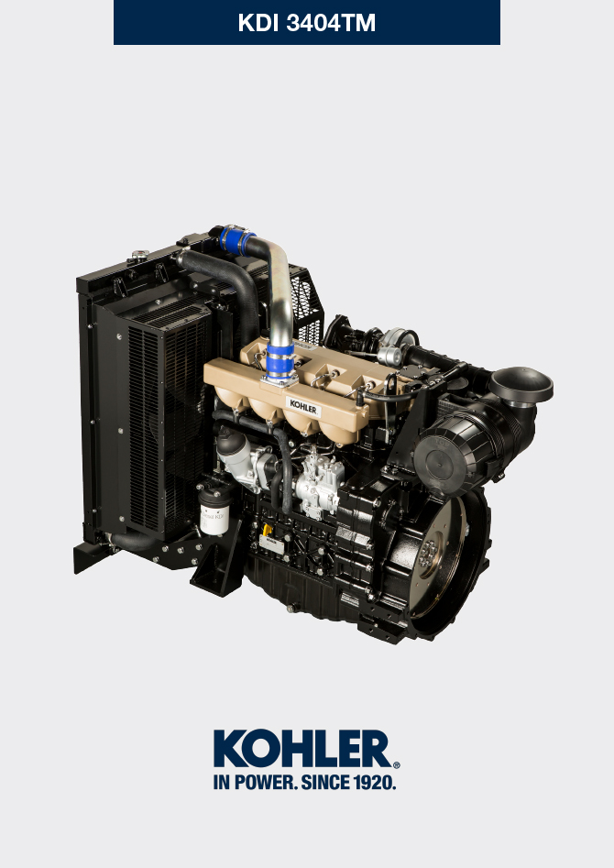

Registration of modifications to the document
Any modifications to this document must be registered by the drafting body, by completing the following table.

Released by | Code | Revision | Release Date | Revision date | Edited by | Endorsed
 | manoff

Translated from the original manual in Italian language
Data reported in this issue can be modified at any time by KOHLER.

Sommario
1. TITOLO 1 2
1.1. Asdfsdfsdf 2
1.2. Asdfsdfsdfggg 2

Information for replacing the functional units

Injector and injection pump replacement
Important  - Before proceeding with operation, carefully read Par. 3.3.2 .  - Replace the high pressure pipes after two disassemblies.  - Seal all injection component unions as illustrated in Par. 2.9.7 during disassembly.  - Always replace the gaskets after each disassembly.  - Handle the components as described in Par. 2.18 .  - Refer to Par. 1.3 for operating references when assembling and disassembling.  - When repaired, RSN-A injectors must be certified by a Stanadyne centre to check their correct operation - check the type of engine mounted injectors on the spare parts list ( RSN-A is specified in the description). | 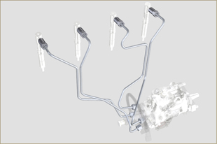  Fig 6.1
6.1.1 Injection fuel pipes disassembly (injection pump/injectors)  - Undo the screw s A .  - Undo the screws B .  - Remove quick fitting C .  - Undo the screws D and remove the manifold E . | 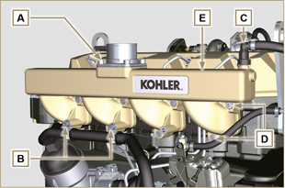  Fig 6.2
- Undo the screw H1 and remove the clamp H2 and remove rubber.  - Undo the nuts F .  - Undo the nuts G .  - Remove the tube H . | 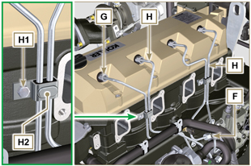  Fig 6.3
6.1.2 Rocker arms cover disassembly  - Undo the screw L .  - Undo the screw M.  - Undo the screws N and remove the rocker arm cap P . | 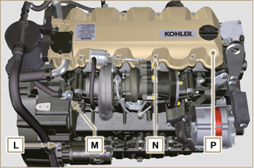  Fig 6.4
6.1.3 Fuel return pipes disassembly  - Undo the screws Q and remove hose R . | 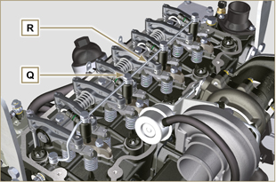  Fig 6.5
6.1.4 Injectors disassembly  - Undo the screw J and remove washer K and then bracket X .  - Remove the injector Z .  NOTE: Should you be unable to remove the electronic injector (acting only on point BC), use an open-ended spanner (Ø 11 mm), by applying small rotations to unblock the component.  - Seal all injection component unions as illustrated in Par. 2.9.7 .  - Ensure that gasket S has remained in the correct position ( Fig. 6.7 ). Otherwise, recover the gasket from inside the electronic injector V manifold. | 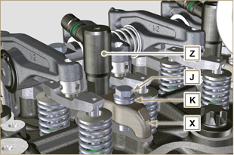  Fig 6.6  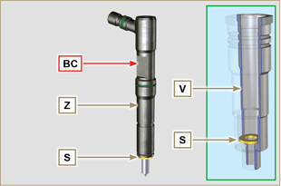  Fig 6.7
NOTE: Click on the right to play the procedure. | https://www.youtube.com/embed/mt-Dsw4A81A?rel=0
6.1.5 Injection pump disassembly  Importante  - Before proceeding with the disassembly, identify the pump code from its identifying name plate ( Pos. 12 - Tab. 2.12 ) and remove the cylinder injector 1 ( Par. 1.4 - 6.1.1 - 6.1.2 - 6.1.3 - 6.1.4 ).  - Alternatively, you can identify the pump from the online spare parts catalogue ( https://partners.lombardini.it/App/SparepartCatalogue/Default/Catalogue.aspx )  - Insert the tool ST_30 into the injector N°1 and fix it with the fixing brace X , capscrew J and washer K .  NOTE : Do not tighten the capscrew J . | 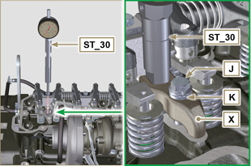  Fig 6.8
- Disassemble the starter motor.  - Mount the tool ST_34 in the seat of the starter motor Y and fit it with the two starter motor fixing screws.  - Rotate the crankshaft clockwise (Rif. A Par. 1.4 ) through the ST_34 tool bringing reference X upwards.  NOTE : When positioning reference X , make sure cylinder N° 1 is in compression phase (the valves on piston N° 1 must all be closed). | 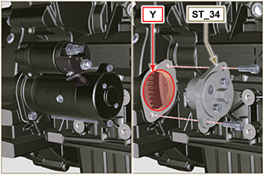  Fig 6.9

- With reference X pointed upwards, find the TDC through tool ST_30 , then bring the dial gauge indicator to 0. | 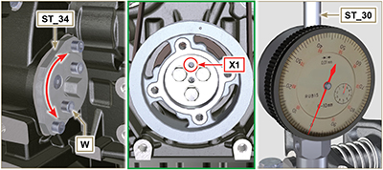  Fig 6.10
- By means of the identified pump code, refer to Tab. 6. 1 to know the advance degrees and the corresponding value to lower the piston.  - Having identified the value to lower the piston, rotate the crankshaft anti-clockwise by going beyond the value described in Tab. 6.1 , once again, rotate the crankshaft clockwise, stopping at the correct advance value by using tool ST_30 ( Rif. A Par. 1.4 ).  NOTE: The value indicated in Tab. 6.1 must be reached by rotating the shaft with the piston in compression phase. Use the ST_34 tool to totate the crankshaft. | Pump code Piston lowering (mm) Advance  ED0065905290-S 0,733 (0.562 - 0.927) 8° (± 1°)  ED0065905430-S 0,562 (0.413 - 0.733) 7° (± 1°)  ED0065905440-S 1,033 (0.828 - 1.261) 9,5° (± 1°)  ED0065905690-S 0,645 (0.485 - 0.828) 7.5° (± 1°)  Tab. 6.1
- Lock the ST_34 tool through J screws and ensure that the crankshaft does not rotate, which would alter the correct advance value. If this happens, repeat the instructions described in points 4 , 5 , 6 , 7 and 8 .  - Undo the screws A1 , remove the plate B1 . | 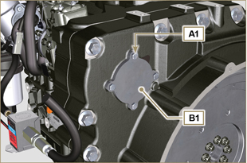  Fig 6.11
- Undo and remove the nut C1 fixing the injection pump control gear D1 .  Important  - After removing the nut C1 , ensure that the correct advance value has remained unchanged on ST_30 .  - Be careful that the nut C1 does not fall into the timing cover. | 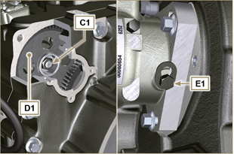  Fig 6.12
- Undo the capscrew E1 and shift the slotted plate F1 in the direction of arrow G1 .  - Tighten screw E1 to block the pump (tightening torque to 12 Nm ).  - Screw the tool ST_13 on the gear D1 . | 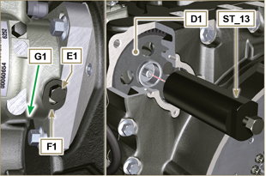  Fig 6.13
- Perform the operations of point 1 of Par. 5.2 .  - Remove quick fitting N1 .  - Undo the screws K1 and K2 and remove the Oil Cooler group L1 from the crankcase M1 .  - Loosen the screws J2 . | 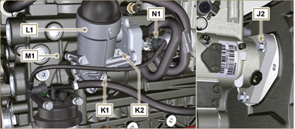  Fig 6.14
- Undo the screw P1 .  - Tighten the screw of tool ST_13 to disconnect the injection pump J1 from the high pressure pump control gear D1 .  - Svitare le viti J2 ed estrarre la pompa iniezione J1 .  - DO NOT remove the tool ST_13 . | 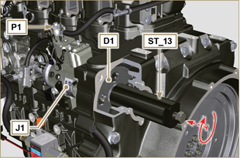  Fig 6.15
NOTE: Click on the right to play the procedure. | https://www.youtube.com/embed/lll9hIO0pXM?rel=0
6.1.6 Injection pump assembly  Important  - Before assembling the new pump J1 , make sure that plate F1 can move freely and that fastening capscrews E1 are not loose (the pump sold as a spare part is, upplied with the cylinder injection timing blocked N° 1 ).  - Ensure that the coupling surfaces on shaft Q1 and gear D1 are free from impurities and lubrication residues.  - Remove the guard cap only when the pipes are reconnected.  - Do not remove the tool ST_30 .  - Mount the injection pump J1 , inserting the shaft Q1 in the gear D1 .  Important  - Always change screws J2 with new ones or apply Loctite 2701 to the threads.  - Clamp the screws J2 on the crankcase M1 (tightening torque at 25 Nm ).  - Remove the tool ST_13 .  - Ensure that the correct advance value has remained unchanged, tighten nut C1 on shaft Q1 (as shown in Fig. 6.17, you are allowed to use a screwdriver to guide nut C1 onto shaft Q1 in order to prevent it from accidentally falling inside carter S1 - tightening torque at see service letter 710018 ). | 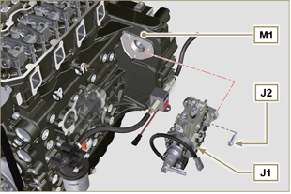  Fig 6.16  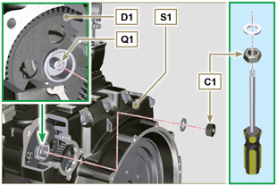  Fig 6.17
- Undo the capscrew E1 and shift the slotted plate F1 in the direction of arrow G2 .  - Tighten screw E1 (tightening torque to 5.5 Nm ). The injection pump is unlocked.  - Remove the tool ST_30 and ST_34 . | 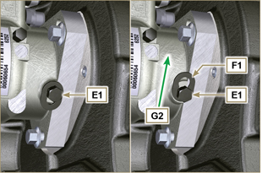  Fig 6.18
- Assemble Oil Cooler L1 onto crankcase M1 by means of capscrews K1 and K2 .  NOTE: Always replace the gasket R1 , R2 at each assembly. | 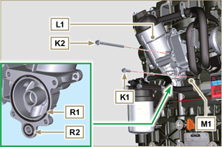  Fig 6.19
- Secure tube U1 by means of capscrew P1 , inserting gasket T1 .  - Fit quick coupling N1 onto pump J1 . | 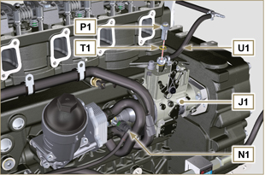  Fig 6.20
- Secure plate B1 by means of capscrews A1 , inserting gasket V1 onto carter S1 (tightening torque at 10 Nm ). | 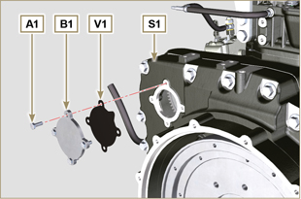  Fig 6.21
NOTE: Click on the right to play the procedure. | https://www.youtube.com/embed/xAUa9IQBmpU?rel=0
6.1.7 Injector assembly  Important  - To prevent damaging the injection system, the protection caps ( Par. 2.9.7 ) must be removed during assembly.  - Lubricate the gaskets U, T, S , and fit them on the injector Z . | 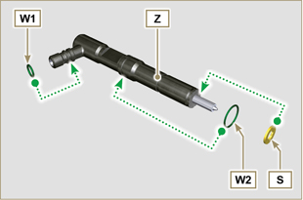  Fig 6.22
- Fit the injector Z in the sleeve V . | 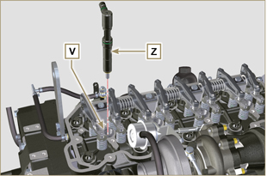  Fig 6.23
- Assemble the parts P, Q, R . and fit the parts so assembled on the injector Z . | 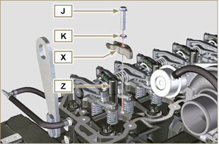  Fig 6.24
- Insert tool ST_52 on the injectors junctions Z (detail X2 ).  - Tighten the screw J (tightening torque to 20 Nm - Fig. 6.24 ). | 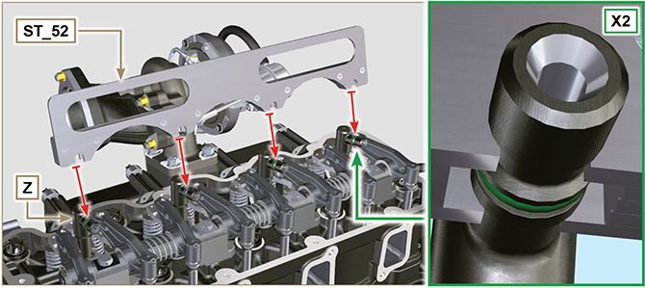  Fig 6.25
6.1.8 Assembly of the injector return pipes  - Position the tube N on the injectors Z and tighten screws M (tightening torque to 14 Nm ). | 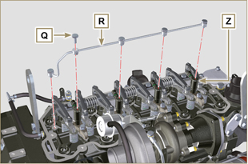  Fig 6.26
6.1.9 Assembly Rocker arm cover  Important  - The gasket Z1 between the rocker arm cover and the cylinder head must always be replaced every time it is disassembled.  - Position tool ST_17 onto the head in correspondence with the two fastening holes 9 and 10 .  - Position gasket Z1 and cap P on cylinder head A2 matching the holes of fastening capscrews N with the aid of the gudgeon guides ST_17 .  - Attach the rocker arm cover P on the head A2 with the screw N adhering to the tightening sequence shown in Fig. 6.28 (tightening torque to 10 Nm ).  - Secure the hose M2 with the screw L (tightening torque to 10 Nm ).  - Clamp the fitting M3 with the screw M (tightening torque to 25 Nm ) inserting the gasket B2 . | 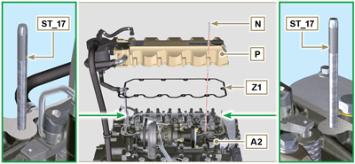  Fig 6.27  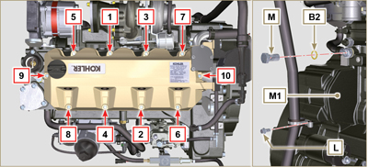  Fig 6.28
6.1.10 Installation of the fuel injector pipes (pump injector/injectors)  - Position pipes D on the injectors and on the injector pump.  Important  - Tighten the nuts F and G manually, without clamping them.  - Tighten the nuts F and G (tightening torque at 25 Nm ).  - Secure tubes H by means of clamps H2 , assembling:  - H3 rubber element;  - clamp H2 on element H3 ;  - secure clamp H2 by means of capscrew H4 and nut H5 (tightening torque at 10 Nm ).  - Secure manifold E onto cylinder head A2 by means of capscrews D , inserting gasket C2 .  - Secure suction line E2 onto manifold E by means of capscrews A , inserting gasket D2 .  - Fit quick coupling C onto manifold E .  - Fasten the pipe H6 on the manifold E with the screws B. | 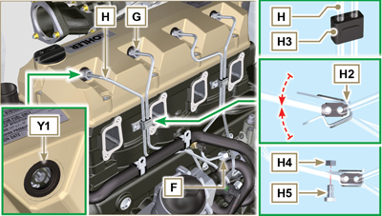  Fig 6.29
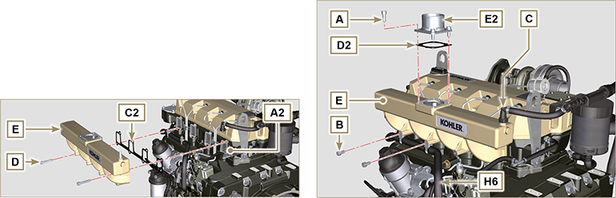
Fig. 6.30/6.31

Coolant pump replacement
6.2.1 Disassembly  NOTE: Perform the operations described in Par. 5.1 .  Important  - Before proceeding with operation, read Par. 3.3.2 .  - The coolant pump is not repairable.  - Loosen the screws A and B .  - Loosen capscrew C and disconnect voltage from belt D and remove belt D .  - Undo the screws E and remove the pulley F . | 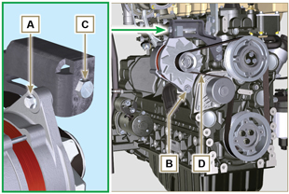  Fig 6.32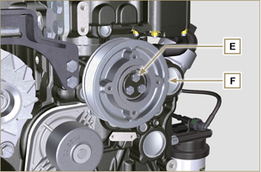  Fig 6.33
- Undo the screws G and remove the pump H with the relevant gasket. | 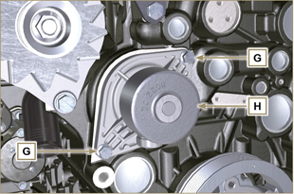  Fig 6.34
NOTE: Click by side to play the procedure. | https://www.youtube.com/embed/FdI56hBo_R0?rel=0
6.2.2 Assembly  Important  - Always replace the gaskets J , after each disassembly.  - Always replace the belt D after each assembly.  - To handling components refer to Par. 2.17  - Always replace the gaskets (where are provided) after each disassembly  - Fit the coolant pump G with the screws H interposing the new gasket J (tightening torque at 25 Nm ). | 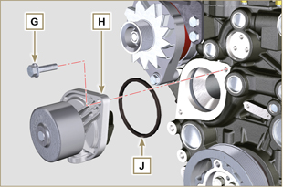  Fig 6.35
- By means of capscrews E , secure pulley F to crankcase K ( tightening torque at 25 Nm). | 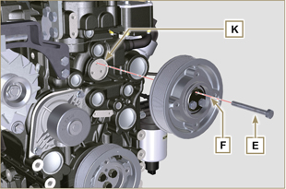  Fig 6.36
- Insert the belt D on the pulleys M .  - Tighten screw C and bring block L at 10 mm from bracket N (value C1 ).  - Fit the screw A (tightening torque at 25 Nm ).  - Fit the screw B (Fig. 6.32 - tightening torque at see service letter 710007 ).  - Start the engine and run it for some minutes, then turn off it, and let it cool down at ambient temperature. Check by the appropriate tool that at point P the tension value is between 135 and 178 Hz.  NOTE: If the poly-v belt tension results out of the above mentioned values, proceed with the replacement. | 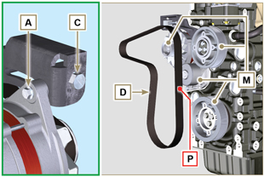  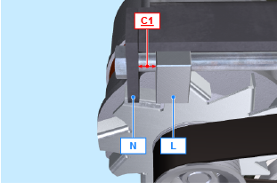  Fig 6.37
NOTE: Click by side to play the procedure. | https://www.youtube.com/embed/edCJrMN0G5M?rel=0

Oil vapour separator replacement
6.7.1 Disassembly  Important  - Before proceeding with operation, read Par. 3.3.2 .  - Remove quick fitting A .  - Release the clamps B and C .  - Remove hose D from breather body E . | 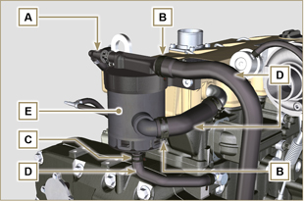  Fig 6.38
- Remove capscrews F and remove breather body E . | 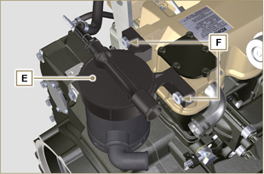  Fig 6.39
6.7.2 Assembly  - Secure breather body E by means of capscrews F (tightening torque at 22 Nm ).  - Fit hose D onto breather body E (Fig. 6.38) .  - Secure the clamps B and C (Fig. 6.38). | 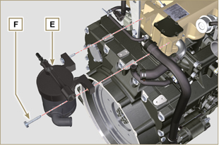  Fig 6.40

Oil cooler unit and oil filter replacement
6.4.1 Oil Cooler unit disassembly  Important  - Before proceeding with operation, read Par. 3.3.2 .  - Perform the operations described in Par 5.1 and Par 5.2 .  - Oil Cooler unit E is not repairable.  - Release the clamps A .  - Remove the manifolds B out of the Oil Cooler unit E . | 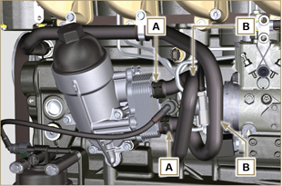  Fig 6.41
Warning  - Electric/pneumatic screwdrivers are forbidden.  - Use a suitable container to recover any residue oil.  - Unscrew cartridge holder cover H by performing three complete turns and wait 1 minute.  NOTE : this operation allows to oil contained in the support E to flow into the oil sump in the correct way.  - Unscrew cartridge holder cover H and check that the oil in the lub. oil filter support E has flowed towards the oil sump.  - Remove quick fitting N1 . | 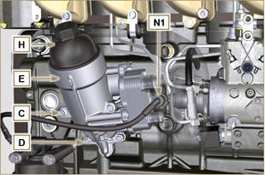  Fig 6.42
- Undo the screws C and D and remove the Oil Cooler unit E .  - Remove the gaskets F and G from the Oil Cooler unit E . | 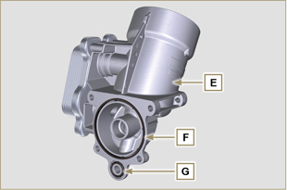  Fig 6.43
6.4.2 Oil filter cartridge replacement  - Remove gaskets L, M and N from element holder cover H .  - Remove cartridge P from element holder cover H . | 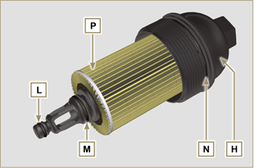  Fig 6.44
- Lubricate and insert gaskets L, M and N in the L1, M1 and N1 seats of element holder cover H .  - Insert element P into element holder cover H . | 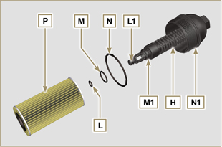  Fig 6.45
6.4.3 Oil Cooler unit assembly  Important  - In the event of assembly of union U on crankcase S , manual tightening torque with Loctite 2701 on the thread).  - Check that the surface Q on the support E and on the crankcase S are free from impurities.  - Lubricate and insert the gasket T on the fitting U .  - Lubricate and insert the gaskets on the support E :  F in seat F1 ;  G in seat G1 .  - Fit the support R with the screws C and D (tightening torque at 10 Nm ).  - Insert and tighten the cartridge support H on the filter support E (tightening torque at 25 Nm ).  - Fit the hoses B on the support E and secure the hoses B with the clamps A .  - Fit quick coupling N1 onto pump J1 . | 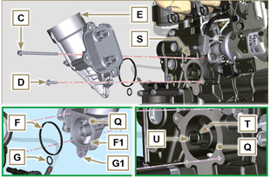  Fig 6.46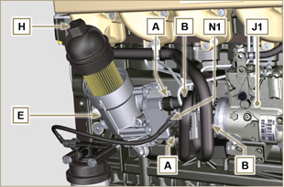  Fig 6.47

Fuel filter replacement
6.5.1 Disassembly  Important  - Before proceeding with operation, read Par. 3.3.2 .  Warning  - The fuel filter is not always mounted in the engine.  - When disassembling, use a suitable container to recover the fuel contained in the cartridge F .  - Remove quick fitting N1 .  - Release the clamps A and pull the pipes B out of the support H .  - Unscrew the cartridge F from the support H .  - Undo the screws C and remove the support H . | 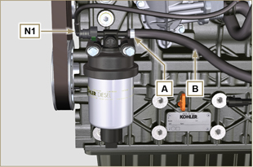  Fig 6.48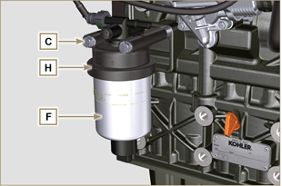  Fig 6.49
Warning  - Check that the fuel supply pump filter is present, and replace if necessary.  - Release the clamp D .  - Demount the hose E .  - Unscrew the filter G from the pump Q . | 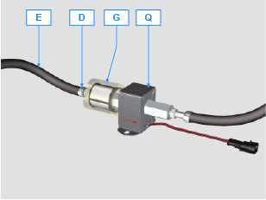
- Screw the new filter G onto the pump Q (tightening torque 20 Nm ).  - Connect the hose E to the filter G and fasten with the clamp D . | 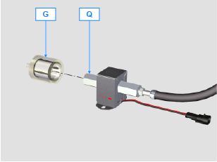
6.5.2 Assembly  - Secure fuel filter bracket H with capscrews C onto crankcase M , inserting spacer L between M and H and washer P between H and C (tightening torque at 25 Nm ).  - Fit the pipes B on the support H .  - Secure the pipes B with the clamps A . | 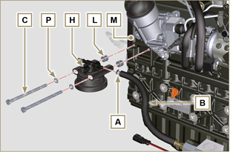  Fig 6.50
- Lubricate the gasket N with fuel.  - Tighten the cartridge F on the support H (tightening torque at 17 Nm ).  - Fit quick coupling N1 onto support H . | 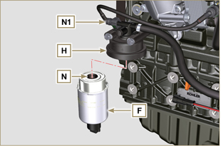  Fig 6.51

