Maintenance procedures
KSD 1403 Workshop Manual (Rev. 00_DRAFT_01)

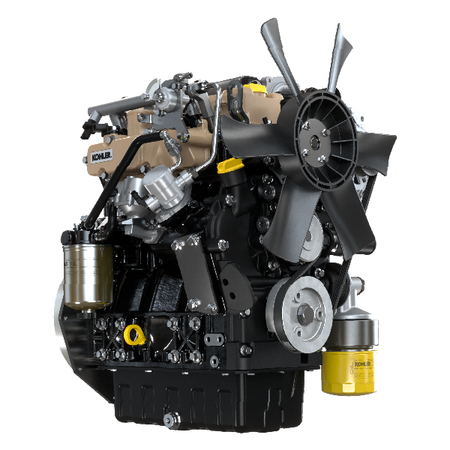

Registration of modifications to the document
Any modifications to this document must be registered by the drafting body, by completing the following table.

Released by | Code | Revision | Release Date | Revision date | Edited by | Endorsed
 | KSD1403-WS

Translated from the original manual in Italian language
Data reported in this issue can be modified at any time by KOHLER.

Sommario
1. TITOLO 1 2
1.1. Asdfsdfsdf 2
1.2. Asdfsdfsdfggg 2

Maintenance procedures

Cleaning and checking
Warning

- Inspections must be made when the engine is off and cold.
- Place engine on level sur face to ensure accurate measurement of oil level.

Danger

- For safety precautions see Chap. 3 .

The intervals of preventive maintenance in Tab. 4.1, Tab. 4.2, Tab. 4.3 and Tab. 4.4 refer to the engine operating under normal operating conditions with fuel and oil meeting the approved specifications.

x.x
CLEANING AND CHECKING
OPERATION DESCRIPTION | PERIOD (HOURS)
 | 100 | 500
Engine oil level ⁽⁸⁾
Coolant level ⁽⁸⁾ ⁽⁹⁾
Water presence in fuel filter
Alternator belt ⁽⁸⁾
Rubber hoses (intake air / coolant) - Fuel hose ⁽³⁾
Starter Motor ⁽¹⁾
Alternator ⁽¹⁾

(1) - In case of low use: 12 months. (2) - The period of time that must elapse before checking the filter element depends on the environment in which the engine operates. The air filter must be cleaned and replaced more frequently under very dusty conditions.

(3) - In case of low use: 36 months.
(4) - In case of low use: 5 years.
(6) - Contact authorized KOHLER workshops.
(7) - The replacement interval is only an indication, it strongly depends from environmental condition and hose status detected during regular visual inspection.
(8) - The first check must be done after 10 hours.
(9) - Test the coolant condition annually with coolant test strips.
(10) - It is recommended to have SCA (Supplemental Coolant Additives) added at the first maintenance interval.
Engine oil level  - Before checking oil engine needs to be level.  - Remove the oil dipstick B and check that the level is up to but does not exceed the MAX .  - If level is not at the MAX . level, add additional oil.  - Re-tighten the cap A, C . | 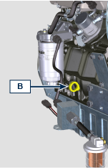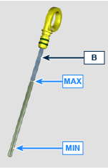  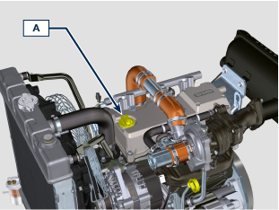  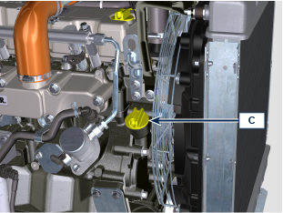  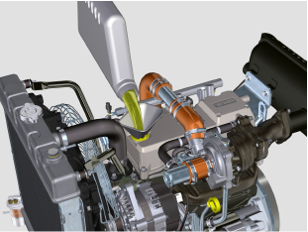
Coolant level  - Loosen the cap A .  - Top liquid up until the pipes inside the radiator are covered by about 5 mm.  - For engines equipped with expansion tank, pour in fluid until reaching the max level mark.  - Tighten the radiator cap A or the expansion tank ( C ) cap B . | 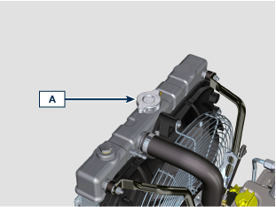  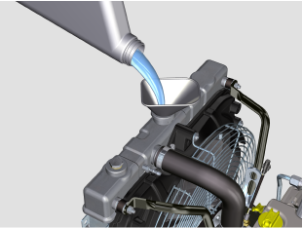  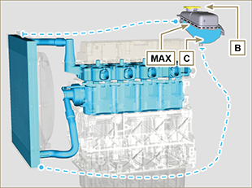
Water presence in fuel filter  Important  - Before proceeding with operation, read Par. 3.2.2 .  Danger  - For safety precautions see Chap. 3.  - Gently loosen the water drain plug A without removing it.  - Spill out the water if present.  - Re-tighten the water drain plug A as soon as the fuel spills. | 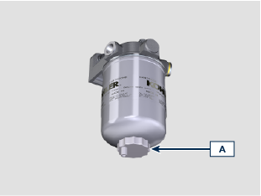
Check of the radiator heat - exchanger surface  Danger  - For safety precautions see Chap. 3 .  NOTE: Component not necessarily supplied by KOHLER .  Important  - Before proceeding with operation, read Par. 3.2.2 .  - Wear safety goggles when using compressed air.  - The radiator heat-exchange surface must be cleaned on both.  - Check the radiator heat-exchange surface A .  - Clean the surface with a brush soaked in special detergent if it is clogged. | 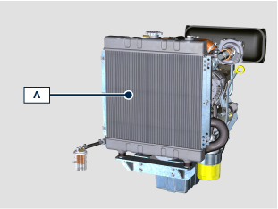
Alternator belt  Important  - Before proceeding with operation, read Par. 3.2.2 .  Danger  - For safety precautions see Chap. 3 .  NOTE : The belt is not adjustable.  - Check the belt A condition, if worn out or deteriorated, replace it.  NOTE : Make sure that the ribs of the belt A are inserted correctly into the grooves of the pulleys B . | 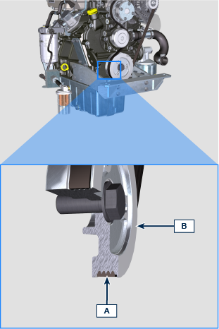
Rubber hoses (intake air / coolant / fuel)  Danger  - For safety precautions see Cap. 3.  The check is carried out by exerting a slight deflection or bending along the pipe and near the hose clamps. Components must be replaced if they have clear signs of cracks, tears, cuts, leaks and do not retain a certain degree of elasticity.  Important  - Before proceeding with operation, read Par. 3.2.2 .  - If hoses are damaged contact an authorized KOHLER workshop.  - For other pipes not illustrated refer to the technical documentation of the vehicle.  - Check the integrity of the pipes and hoses A . | 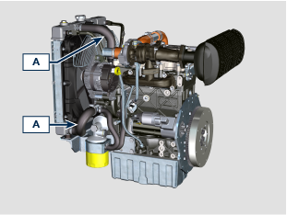  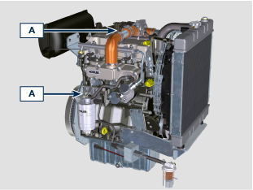
- Externally check the condition and clean motor A using compressed air. | 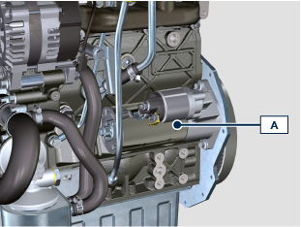
- Externally check the condition and clean the alternator A using compressed air. | 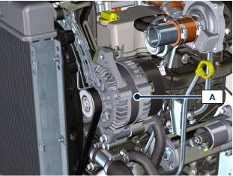

Replacement
- Periodic inspection and maintenance operations must be carried out as indicated in this manual and are the responsability of the user.
- Failure to comply with these service and maintenance intervals increases the risk of technical damage to the engine. Any non compliance makes the warranty become null and void.
- In order to prevent personal and property damage read carefully the instructions listed below before proceeding with any operation of the engine.

Warning

- Inspections must be made when the engine is off and cold.
- Place engine on level sur face to ensure accurate measurement of oil level.
- Before starting, to avoid spillages of oil make sure that: - the oil dipstick is inserted correctly;

- also check that:

oil drain plug and

oil filler cap are tightened firmly.

Important

- Before proceeding with operation, read Par. 3.2.2 .

Danger

- For safety precautions see Chap. 3 .

The intervals of preventive maintenance in Tab. 4.1, Tab. 4.2, Tab. 4.3 and Tab. 4.4 refer to the engine operating under normal operating conditions with fuel and oil meeting the approved specifications.

x.x
REPLACEMENT
OPERATION DESCRIPTION |  |  | PERIOD (HOURS)
 |  |  | 500 | 2000 | 4000
Air filter Cartridge ⁽² ⁾
Alternator belt ⁽ ³ ⁾
Rubber hoses (intake air / coolant) ⁽⁴ ⁾ ⁽⁶⁾ ⁽⁷⁾
Fuel line hose ⁽ ⁴ ⁾ ⁽⁶⁾ ⁽⁷⁾
Coolant |  | OAT ⁽ ⁴ ⁾ ⁽⁶⁾
 |  | HOAT ⁽ ⁴ ⁾ ⁽⁶⁾ ⁽¹⁰⁾

x.x
ENGINE OIL AND OIL FILTER CARTRIDGE REPLACEMENT
ENGINE VERSION |  | PERIOD (HOURS)
 |  | 500 | 1000
Compact Sump ⁽¹⁾
Deep Sump ⁽¹⁾

x.x
FUEL FILTER AND PREFILTER CARTRIDGE REPLACEMENT
ENGINE VERSION |  | PERIOD (HOURS)
 |  | 500 | 1000
STD Filtration ⁽¹⁾
High Filtration ⁽¹⁾

(1) - In case of low use: 12 months. (2) - The period of time that must elapse before checking the filter element depends on the environment in which the engine operates. The air filter must be cleaned and replaced more frequently under very dusty conditions.

(3) - In case of low use: 36 months.
(4) - In case of low use: 5 years.
(6) - Contact authorized KOHLER workshops.
(7) - The replacement interval is only an indication, it strongly depends from environmental condition and hose status detected during regular visual inspection.
(8) - The first check must be done after 10 hours.
(9) - Test the coolant condition annually with coolant test strips.
(10) - It is recommended to have SCA (Supplemental Coolant Additives) added at the first maintenance interval.
Engine oil and oil filter
NOTE : Perform this operation with warm engine, to get a better fluidity of the oil and get a full discharge of oil and impurities contained in it.

- Loosen the oil filler cap A or the oil filler cap C if the cap A is not accessible.
- Unscrew the oil filter F with appropriate wrench.  - Assembly and tighten the new oil filter cartridge F (torque to 20 Nm ). | 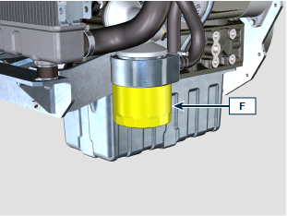  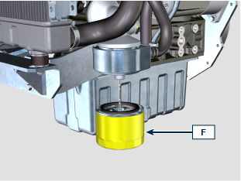
- Remove the oil dipstick B .  - Remove the oil drain plug D and the gasket E (the oil drain plug is on both sides of the oil sump).  - Drain oil in an appropriate container.  - Replace gasket E .  - Tighten the drain oil plug D (tightening torque at 40 Nm ). | 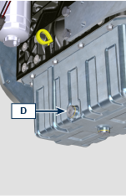  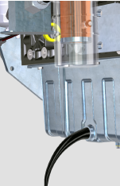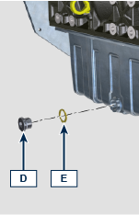
- Add the type of oil approved ( Tab. 2.2 ).
- Fit and remove the oil dipstick B to check the level.
- Pour in fluid until reaching the MAX level mark.
- Upon completion, reinstall the oil dipstick B completely.
- Tighten the cap A, C .
Fuel filter cartridge
Important  - Do not fill the new cartridge B with fuel.  - Procure a suitable container to collect the fuel.  - Loosen and remove cartridge B .  - Lubricate the gasket C .  - Tighten the new cartridge B onto support D (tighten manually). | 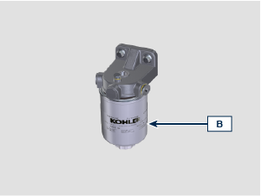  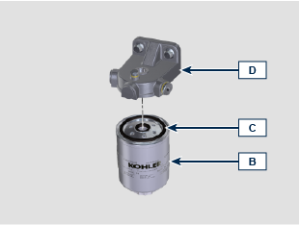
- Replace the prefilter H if present.  - Perform the operations described in Par. xx . | 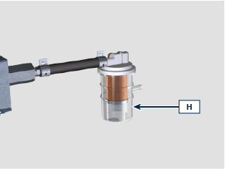
Air filter cartridge
Importante  - Before proceeding with operation, read Par. 3.2.2 .  NOTE : Components not necessarily supplied by KOHLER .  - Release the two fastenings F of the cover A .  - Remove the cartridge B .  - Clean the inside components A and D with a damp cloth.  - Reinstall:  - the new cartridge B .  -the cover A checking the right tightness of fastenings F . | 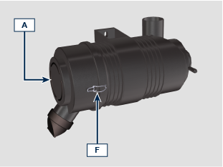  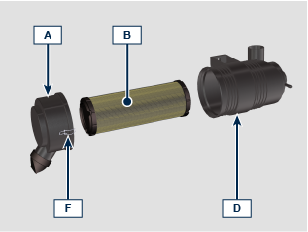
Alternator belt
- Remove the belt A using tool ST_57 .  - Install the new belt A using tool ST_57 . | 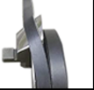  REMOVE  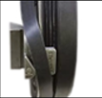  INTALL
Rubber hoses
- Undo the cap A carefully (circuit under pressure).  - Drain all the liquid inside the radiator via shut-off valve D into a suitable container. | 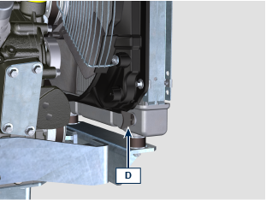
- Loosen the screws E and remove the fuel filter bracket G .  - Unscrew cap F , remove gasket H to allow all the system fluid contained inside the pipes in the engine crankcase to drain.  - Tighten the plug F (tightening torque at 35 Nm ).  - Fasten the fuel filter bracket G with screws E (tightening torque 25 Nm ). | 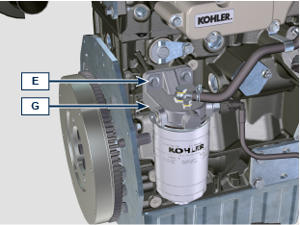  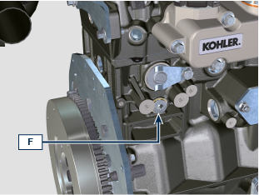  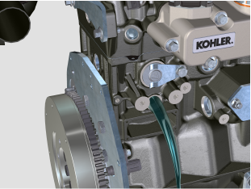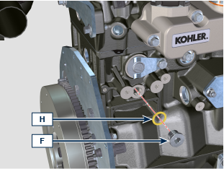  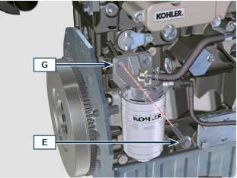
Replace the hoses B . | 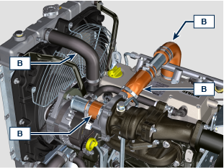  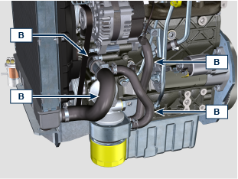
- Loosen the cap A and fill the radiator with coolant composed of: 50% ANTIFREEZE and 50% decalcified water.
- Top liquid up until the pipes inside the radiator are covered by about 5 mm. Do not overfill the radiator, but leave room for the coolant to expand.
- For engines equipped with expansion tank, pour in fluid until reaching the max level mark.
- Re-tighten the cap A .
- Keep it running at idle speed until the cooling liquid level goes down and becomes steady (the waiting times varies according to the ambient temperature).
- Stop the engine and allow it to cool.
- If there is an expansion tank ( C ) top liquid up to the mark MAX .
- Without expansion tank top liquid up until the pipes inside the radiator are covered by 5 mm. Do not overfill the radiator, but leave room for the coolant to expand.
- Tighten the radiator cap A or the expansion tank cap.
Fuel line hose
Replace the hoses B . | 