General information
KDI 2504 M Workshop manual (Rev. 09.6)

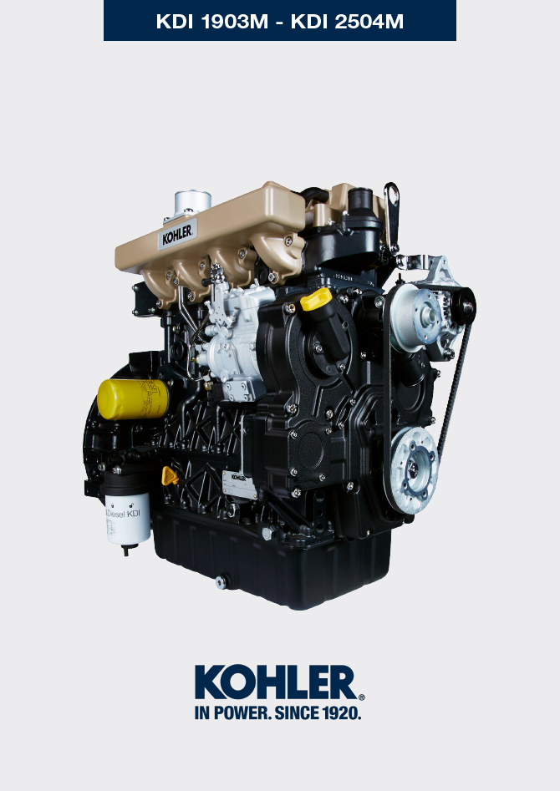

Registration of modifications to the document
Any modifications to this document must be registered by the drafting body, by completing the following table.

Released by | Code | Revision | Release Date | Revision date | Edited by | Endorsed
Technical Documentation | ED005302-961 | 9.6 | 04/2013 | 03/2023 | M. SILVESTRONE | V. MANINI

Translated from the original manual in Italian language
Data reported in this issue can be modified at any time by KOHLER.

Sommario
1. TITOLO 1 2
1.1. Asdfsdfsdf 2
1.2. Asdfsdfsdfggg 2

General information

Useful information
- This manual contains the instructions needed to carry out proper use and maintenance of the engine, therefore it must always be available, for future reference when required.
- The information, descriptions and illustrations contained in this manual reflect the basic configuration of the engines ( Par. 1.3 and Par. 1.4 ).
- However, the development of engines is continuous. Therefore, the information in this manual is subject to change without notice.
- KOHLER reserves the right to make, at any time, changes on the engines for technical or commercial reasons.
- These changes do not require KOHLER to intervene on the production marketed up to that time and nor to consider this manual as inappropriate.

The paragraphs, tables and figures are numbered by chapter and followed by the progressive paragraph, table and/or figure number.
Es: Par. 1.3 - chapter 1 paragraph 3 .
Tab. 2.4 - chapter 2 table 4 .
Fig. 4.5 - chapter 4 figure 5 .
NOTE: The paragraphs may contain sub-paragraphs.

- All technical terms, specific components and symbols ( Tab. 15.1 ) that are in the manual are listed and described inside the glossary, which can be consulted in ( Chap. 15 ).
- The references of the objects described in the text and in the figure are indicated by letters and numbers, which are always and only related to the paragraph you are reading unless there are specific references to other figures or paragraphs.
- Reference to values are indicated by letters or numbers ( underlined ).
- Any additional section that KOHLER will deem necessary to supply at a later stage must be kept with the manual and considered as an integral part of it.
- The information contained in this manual is the sole property of KOHLER , therefore no partial or total reproduction or replication is allowed without the express permission of KOHLER .

1.1.1 Useful Information - accident prevention - environmental impact

- Before proceeding repair - handling the engine , you should read Chap. 3 in its entirity, which contains important information regarding procedures to follow with regard to safety and the environment .

Manufacturer and engine identification
The engine identification name plate is situated in the lower part of the crankcase; it is visible from the intake or exhaust side.
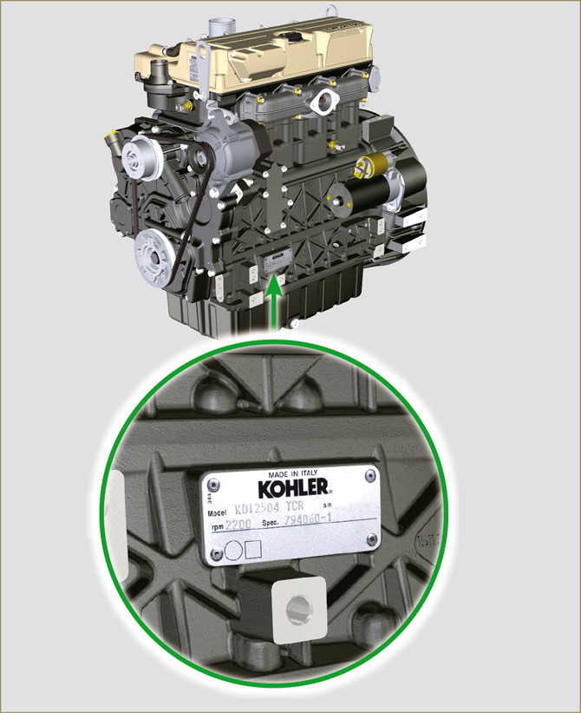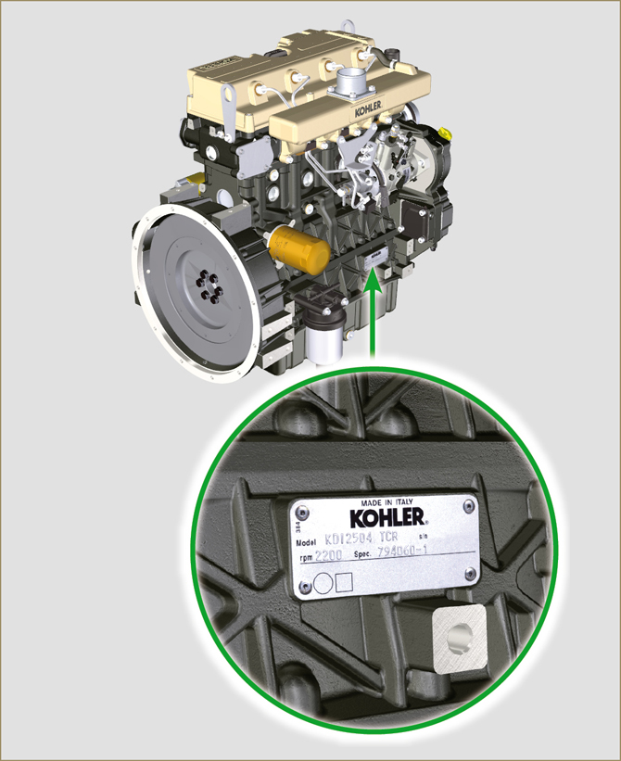
Fig 1.1 - Fig 1.2

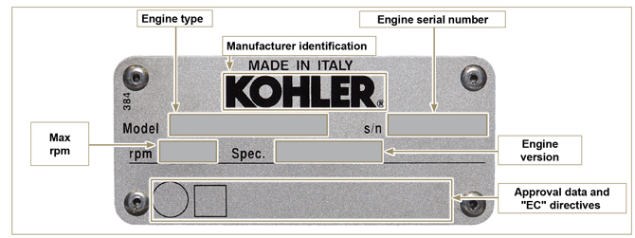
Fig 1.3

Identification of the main internal components of the engine and operating reference (BASE CONFIGURATION)
VIEW OF EXHAUST SIDE
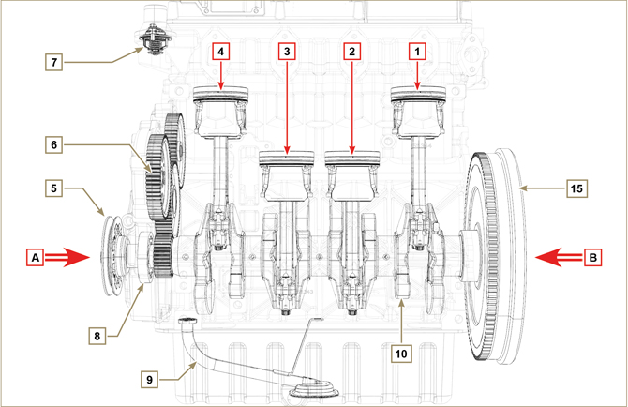
Fig 1.4

The following chapters contain operating references in order to clearly understand the engine. This paragraph illustrates these references that may be recognised by means of some main internal components.  Should you need to execute complex operations, always consult this paragraph.  NOTE : it is advisable to keep this page visible during disassembly and assembly operations. | Tab 1.1  REF. DESCRIPTION  A View of timing system side (2 ^{nd} PTO)  B View of flywheel side (1 ^{st} PTO)  C View of exhaust side  D View of intake side  1 Cylinder/Piston N. 1 (KDI 1903 - KDI 2504)  2 Cylinder/Piston N. 2 (KDI 1903 - KDI 2504)  3 Cylinder/Piston N. 3 (KDI 1903 - KDI 2504)  4 Cylinder/Piston N. 4 (KDI 2504)  POS. DESCRIPTION  5 Crankshaft pulley (2 ^{nd} PTO)  6 Gear timing system  7 Thermostatic valve  8 Oil pump  9 Oil suction hose  10 Crankshaft  11 Exhaust manifold  12 Intake manifold  13 Camshaft  14 Gears adaptor for 3 ª /4 ª PTO (optional)  15 Flywheel (1 ^{st} PTO)  16 Injector

VIEW OF FLYWHEEL SIDE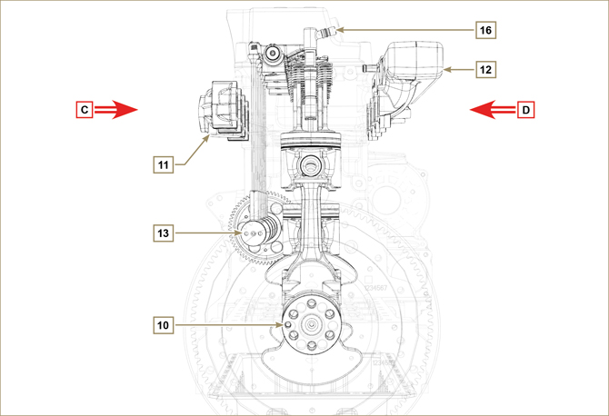
Fig 1.5

VIEW OF TIMING SYSTEM SIDE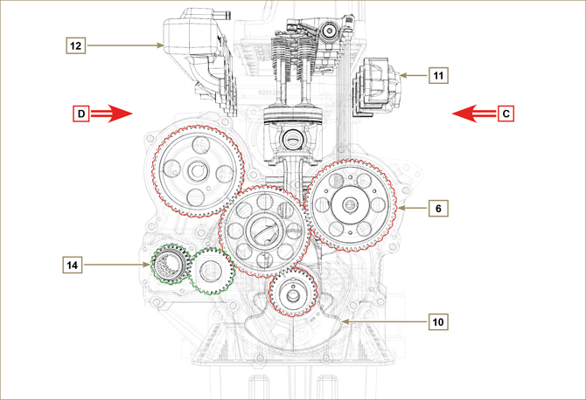
Fig 1.6

Identification of the external components of the engine (BASE CONFIGURATION)
VIEW OF TIMING SYSTEM SIDE - EXHAUST
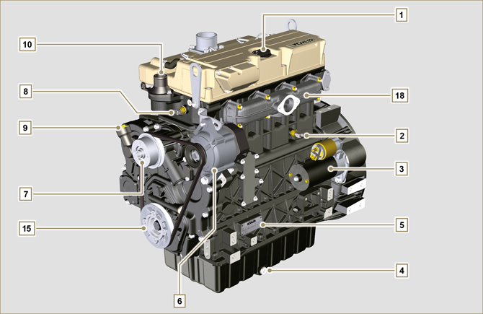
Fig 1.7

VIEW OF FLYWHEEL SIDE
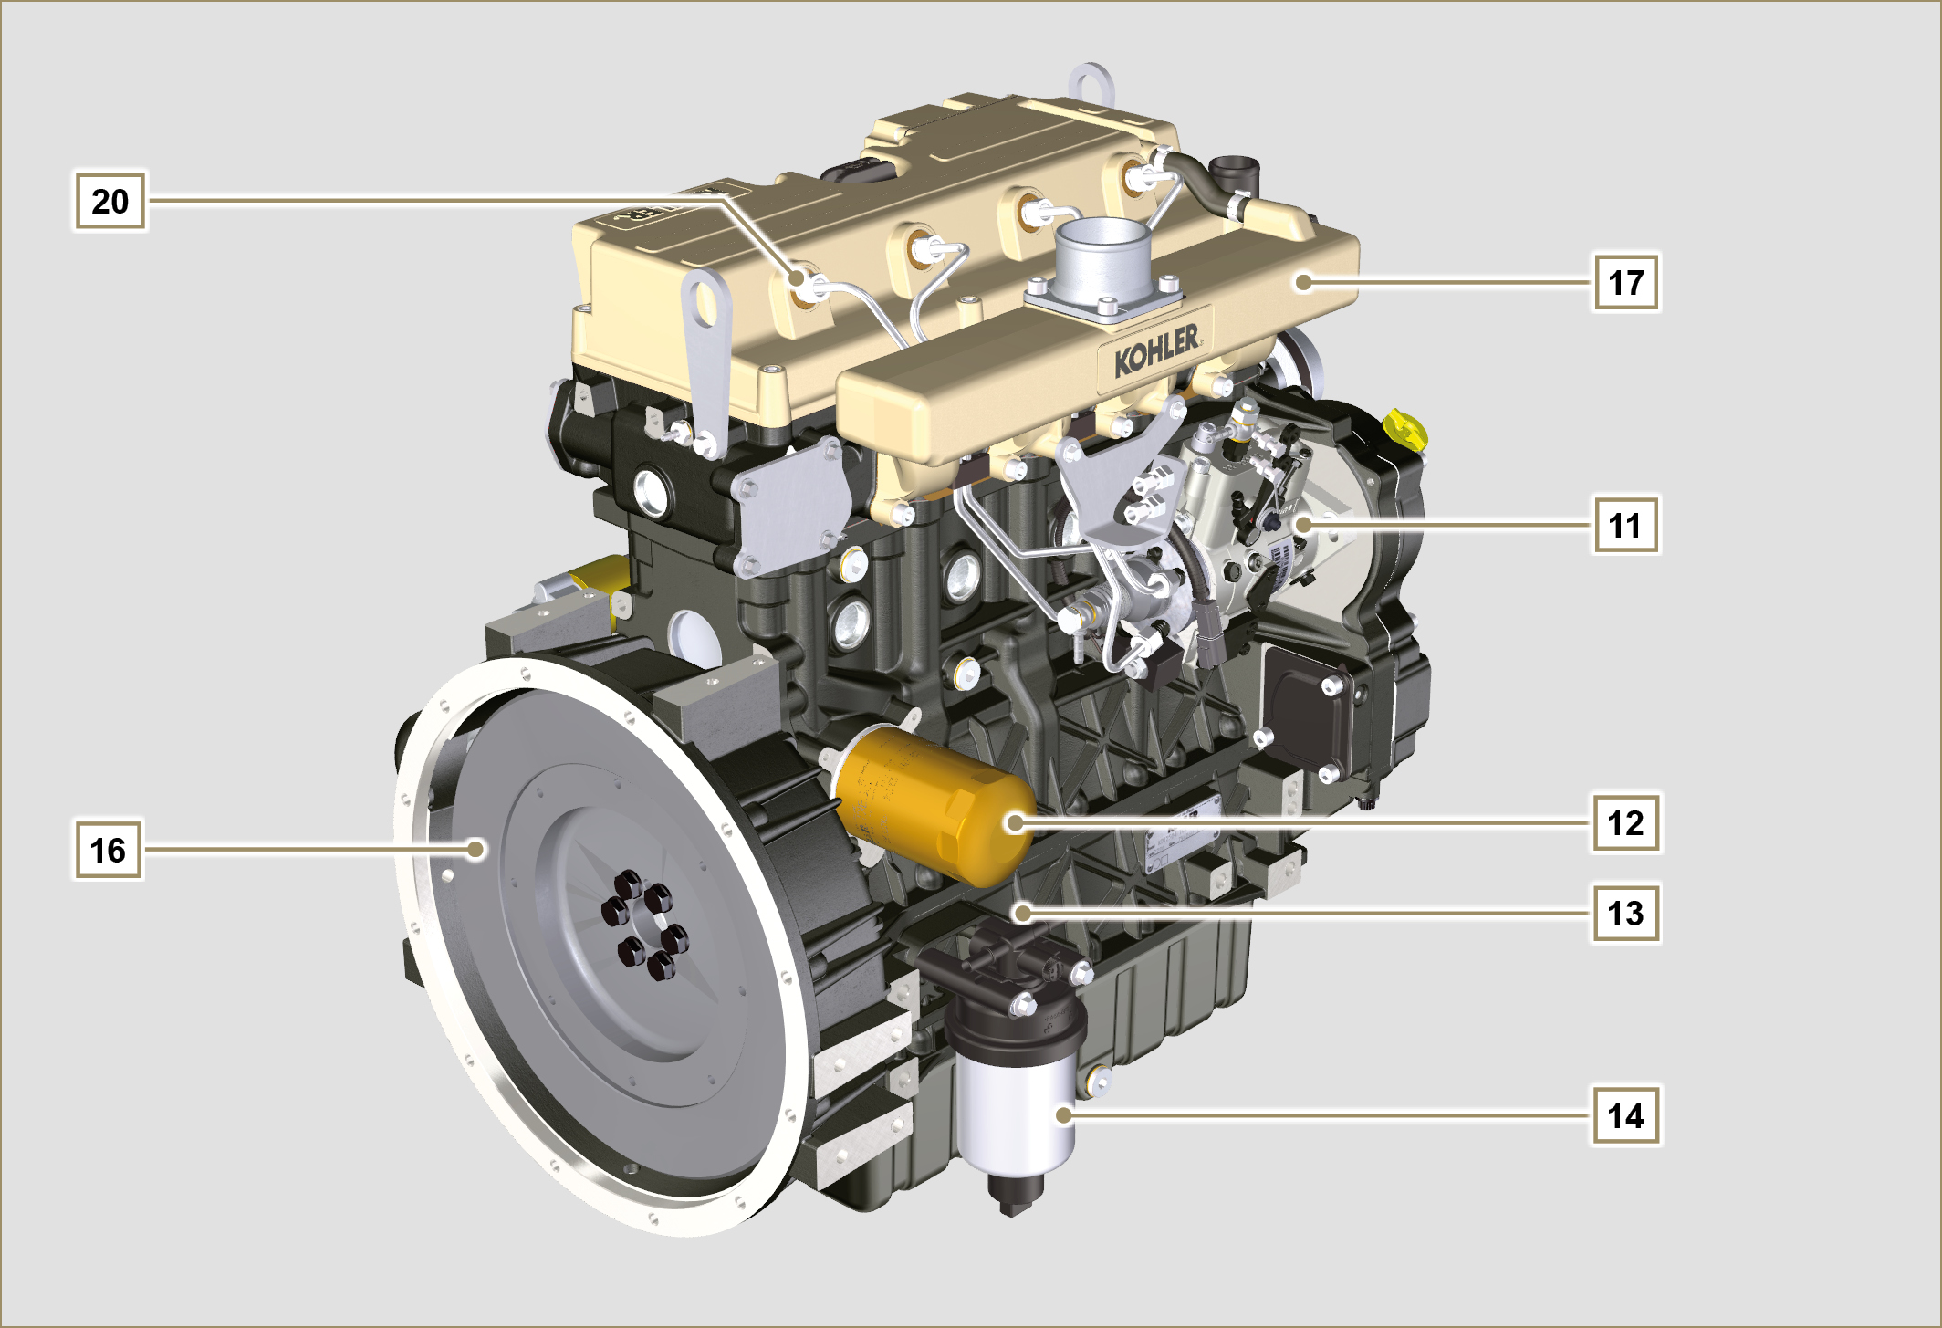
Fig 1.8

This paragraph illustrates all external components that are present in the base configuration of the engine.  For components present on engines that differ from those represented in these illustrations, refer to Chap. 11 . | NOTE: The illustrated components may differ from those illustrated; the illustration is only as an example.
Tab 1.2  POS. DESCRIPTION  1 Oil filler cap  2 Oil pressure switch  3 Starter motor  4 Oil drain plug  5 Engine identification name plate  6 Alternator  7 Coolant pump  8 Coolant temperature sensor  9 Oil filler cap side  10 Thermostatic valve  11 High-pressure fuel injection pump  12 Lub. oil filter  13 Oil dipstick  14 Fuel filter  15 Crankshaft pulley (2 ^{nd} PTO)  16 Flywheel (1 ^{st} PTO)  17 Intake manifold | POS. DESCRIPTION  18 Exhaust manifold  19 Flange bell  20 Injectors

UPPER VIEW
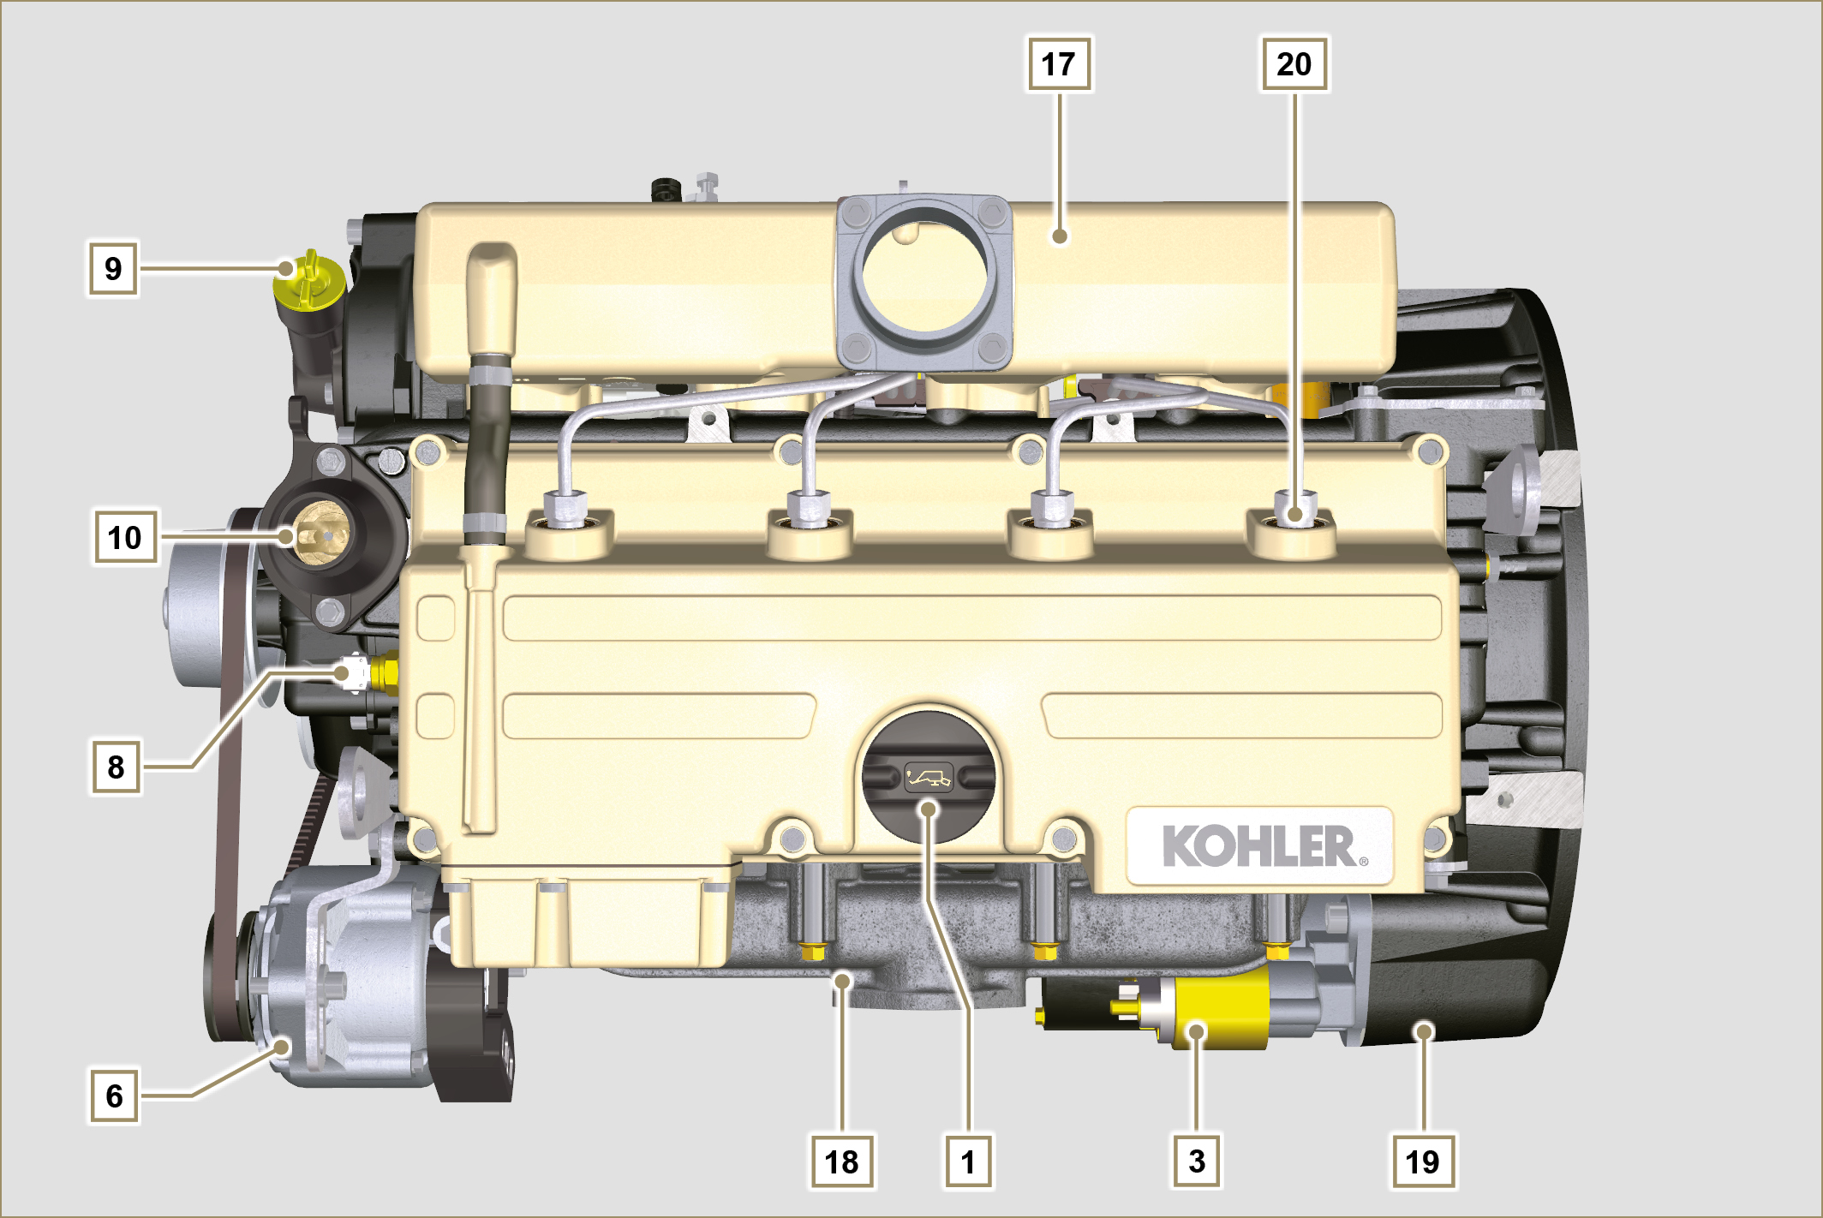
Fig 1.9

