Storage information
KDI 3404 TCR Workshop Manual (Rev. 10.4)

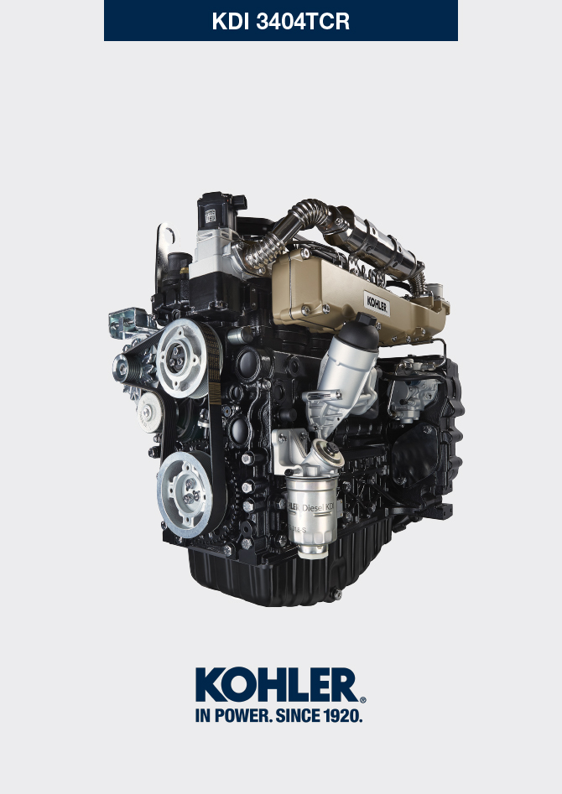

Registration of modifications to the document
Any modifications to this document must be registered by the drafting body, by completing the following table.

Released by | Code | Revision | Release Date | Revision date | Edited by | Endorsed
 | manoff

Translated from the original manual in Italian language
Data reported in this issue can be modified at any time by KOHLER.

Sommario
1. TITOLO 1 2
1.1. Asdfsdfsdf 2
1.2. Asdfsdfsdfggg 2

Storage information

Product preservation

Important

- If the engines are not to be used for 6 months, they must be protected by carrying out the operations described in Engine storage (up to 6 months) (Par. 4.2) .
- If the engine is still not in use after the first 6 months, it is necessary to carry out a further procedure to extend the protection period (more than 6 months) (Par. 4.3) .
- If the engine is not to be used for an extended period, the protective treatment procedure must be repeated within 24 months of the previous one.

Engine storage (up to 6 months)
Before storing the engine check that:
- The environments are not humid or exposed to bad weather. Cover the engine with a proper protective sheet against dampness and atmospheric contaminants.
- The place is not near electric panel.
- Avoid storing the engine in direct contact with the ground.

Engine storage (over 6 months)
Follow the steps described in Par. 4.2 .
- Pour protective oil in the carter up to the MAX level.
- Refuel with fuel additives for long storage.
- With expansion tank:
make sure that the coolant is up to the maximum level.
- Without expansion tank: Top liquid up until the pipes inside the radiator are covered by about 5 mm.

Do not overfill the radiator, but leave room for the fuel to expand.
- Start the engine and run it at idle speed for around 2 minutes.
- Bring the engine to 75% of maximum rated speed for 5 to 10 minutes.
- Turn off the engine.
- Empty out completely the fuel tank.
- Spray SAE 10W-40 on the exhaust and intake manifolds.
- Seal the exhaust and intake ducts to prevent foreign bodies from entering.
- When cleaning the engine, if using a pressure washer or steam cleaning device, avoid directing the nozzle on electrical components, cable connections and sealed rings (oil seals etc).
If cleaning engine with a pressure washer or steam cleaner, it is important to maintain a minimum distance of at least 200mm between the surface to be washed and the nozzle - avoiding absolutely electrical components such as alternators, starter motors and engine control units (ECU).
- Treat non-painted parts with protective products.
- Loosen the alternator belt Par. 6.5.1 point 1 and 2 .
If the engine protection is performed according to the suggestions indicated no corrosion damage will be found.

Engine starting after storage
- Remove the protective sheet.
- Use a cloth soaked in degreasing product to remove the protective treatment from the external parts.
- Inject lubricating oil (no more than 2 cm3) into the intake ducts.
- Adjust the alternator belt tension ( Par. 6.5.2 ) or replace if there are signs of deterioration.
- Refill the tank with fresh fuel.

Warning

- Over time, lubricants and filters lose their properties, so itis important to consider whether they need replacing, also based on the criteria described in Tab. 2.9 .

- Make sure that the oil and the coolant are up to the maximum level.
- Start the engine and run it at idle speed for around 2 minutes.
- Bring the engine to 75% of maximum rated speed for 5 to 10 minutes.
- Stop the engine and while the oil still hot, perform the operation in Par. 5.2 .
- Replace the filters (air, oil, fuel) with original spare parts.
- Perform the operations described in Par. 10.1 .
- Perform the operations described in Par. 5.1 and Par. 10.2 .

Unused machine
If the machine is not used for a certain amount of time, follow the operations below:

4.5.1 Operations for TCR versions

Tab 4.1
POINT | PERIOD | OPERATION
1 | up to 2 months | - The place must be dry and fresh throughout the period in which the machine is not used.  - Consult the machine’s manual to disconnect the battery (before disconnecting the battery, wait for minimum 5 mins after turning off the engine).  - Make sure the engine is not exposed to direct sunlight.  - Make sure the engine is not near any heat sources.
1a | Start-up after 2 months | - Before starting the engine, check Para. 2.8 for maintenance operations.  - Consult the machine’s manual to connect the battery and start the engine.
2 | Fino a 9 mesi | - Perform the operations described in point 1.  - Perform the operations described in Para. 12.4 and 12.5.  - Start the engine at least every 4 months as per operations described in point 1a:  - Avoid sudden accelerations for the first few minutes.  - Bring the engine to the working temperature by pressing the accelerator 3/4 from MAX.  - Leave the engine running at minimum speed for a few minutes and turning off the engine.
2a | Start-up after 9 months | - Before starting the engine, check Para. 2.8 for maintenance operations.  - Consult the machine’s manual to connect the battery and start the engine.  - Avoid sudden accelerations for the first few minutes.
3 | over 9 months | - Perform the operations described in point 1 and 2.
3a | Start-up after 9+ months | - Before starting the engine, check Para. 2.8 for maintenance operations.  - Check the quality of coolant from the relative testing strips.  - Consult the machine’s manual to connect the battery and start the engine.  - Avoid sudden accelerations for the first few minutes.

