Information for replacing the functional units
KDI 3404 TCR Workshop Manual (Rev. 10.4)

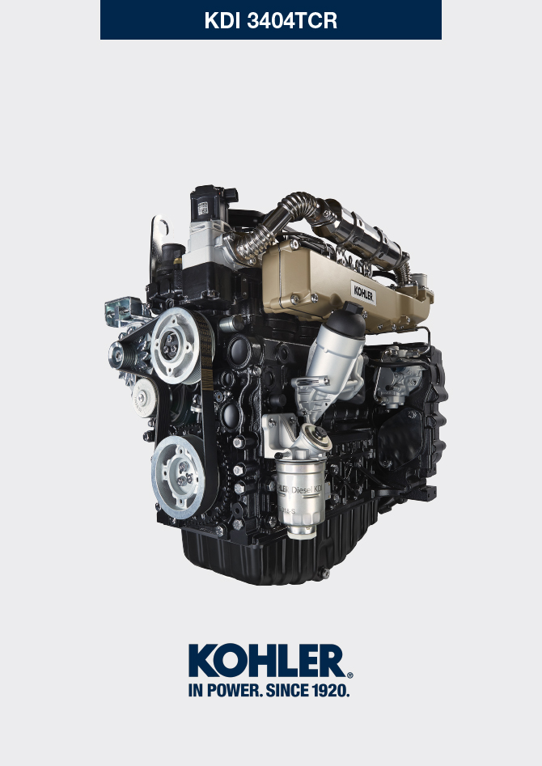

Registration of modifications to the document
Any modifications to this document must be registered by the drafting body, by completing the following table.

Released by | Code | Revision | Release Date | Revision date | Edited by | Endorsed
 | manoff

Translated from the original manual in Italian language
Data reported in this issue can be modified at any time by KOHLER.

Sommario
1. TITOLO 1 2
1.1. Asdfsdfsdf 2
1.2. Asdfsdfsdfggg 2

Information for replacing the functional units

Electronic injector replacement
Important  - Before proceeding with operation, read Par. 3.3.2 .  - In the event of the electronic injectors being disassembled (not necessarily replaced) their position with respect to individual cylinders must not be changed when re-assembled. Refer to the reference between each injector and respective cylinder number.  - Seal all injection component unions as illustrated in Par. 2.9.8 during disassembly.  - Handle the components as described in Par. 2.17 .  - Replace all seal gaskets after each assembly for all components on which they are provided.  - The high pressure pipes must be replaced every time they are disassembled.  - Before disassembling the electronic injectors, make sure the new high pressure pipes are available.  - If a new (or different) electronic injector is fitted on the engine, the new calibration data must be entered in the ECU through a specific instrument ( ST_01 ) .  - Electronic injectors are not repairable.  - This procedure may be performed on one or more electronic injectors.  NOTE: In the event of a leak upon replacement (oil - coolant - fuel - air), do not intervene with the engine running, but stop it and wait for 5/10 minutes before checking and solving the problem. | 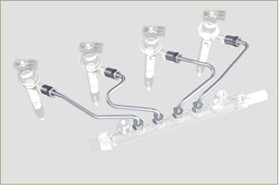  Fig 6.1
6.1.1 Fuel return pipes disassembly (Common Rail/electronic injectors)  - Disconnect the connector C . | 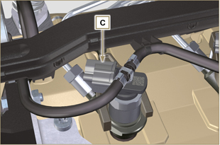  Fig 6.2
- Remove clips E from the electronic injector F .  - Disconnect the junction G from the electronic injector F .  Warning  - After removing the fittings, the clips E must automatically return to their initial position; otherwise they must be replaced.  - Seal all injection component unions as illustrated in Par. 2.9.8 . | 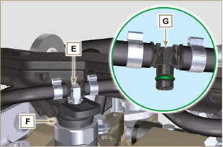  Fig 6.3
6.1.2 High pressure fuel pipes disassembly (Common Rail/electronic injectors)  Danger  - The fuel injection circuit is under high pressure, use safety protections as described in Par 3.4.3 .  - Ensure that the Common Rail is not under pressure by slowly and carefully unscrewing one of the nuts H .  - Undo the nut H on the Common Rail L and then the nut M on the electronic injector F and remove the pipe N .  Important  - In the event that the electronic injectors are disassembled (not necessarily replaced), mark them with the relevant cylinder number from which they originate so as not to confuse them during re-assembly.  - Seal all injection component unions as illustrated in Par. 2.9.8 . | 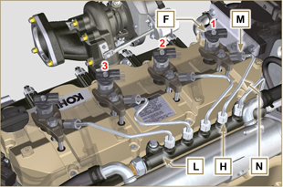  Fig 6.4
6.1.3 Electronic injectors disassembly  - Undo and remove the screw P with the washer R e and then the bracket Q .  Important  - Be careful not to damage the gaskets X .  - Replace rings X , if damaged.  2. Pull out the electronic injector F .  NOTE: Should you be unable to remove the electronic injector (acting only on point BC ), use an open-ended spanner (Ø 34 mm), by applying small rotations to unblock the component.  3. Seal all injection component unions as illustrated in Par. 2.9.8 .  4. Ensure that gasket S has remained in the correct position (Fig. 6.6) . Otherwise, recover the gasket from inside the electronic injector T manifold. | 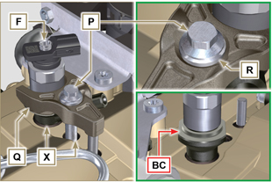  Fig 6.5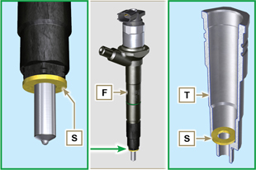  Fig 6.6
NOTE: Click by side to play the procedure. | https://www.youtube.com/embed/slELtJW2bFE?showinfo=0&rel=0
6.1.4 Electronic injector assembly  Important  - Always replace and lubricate the gaskets AA and S of the electronic injectors F with fuel, every time they are replaced.  - Reposition the electronic injectors (not replaced) by following the references made for disassembly, as indicated in Par. 6.1.2.  - If the engine is painted or protected with clear paint, clean the paint off the diesel injector F near to the part in contact with the gasket AB .  - Insert the gasket S on the electronic injectors F (Fig. 6.7) .  - Insert electronic injector F into manifold T , being extra careful not to damage gasket AB and direct it as indicated in Fig. 6.7 .  NOTE : to replace gaskets AB , follow the operations in Para. 7.12.1 and 9.5.9 . | 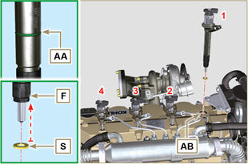  Fig 6.7
6.1.5 High pressure fuel pipes assembly  Important  - Always replace the pipes N after each assembly.  - If the engine is painted or protected with clear paint, replace the fastening screws P to ensure the gaskets are sealed properly.  - Position tube N in the Common Rail seat of the electronic injector; correct the position of the electronic injector by means of the entrance of the electronic injector unions F and Common Rail L .  - Apply the nuts H and M by hand without tightening them.  - Position the fastening brace of electronic injectors Q on capscrew surface AD , insert capscrews P in brace Q inserting washer R . | 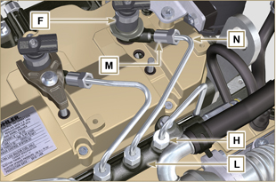  Fig 6.8
Important  - Ensure that brace S is perfectly positioned onto the electronic injector.  4. Tighten the fixing screws P of the electronic injector bracket (tightening torque at 20 Nm ).  5. Tighten the nut M (tightening torque at 25 Nm ).  6. Tighten the nut H (tightening torque at 30 Nm ).  Important  - Replace the pipes N (Fig. 6.8) if the screws P are stiff when tightened. | 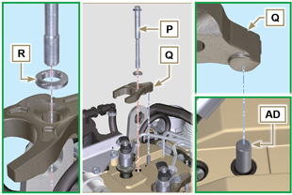  Fig 6.9
6.1.6 Fuel return pipes assembly  - Check the condition of the gaskets AE . | 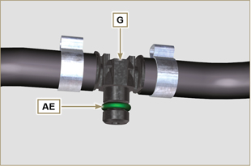  Fig 6.10

- Insert unions G onto electronic injectors F and block them with clips E .  - Mount the connectors C on the electronic injectors F .  Warning  - Slightly move the wiring support to check that there is no voltage in the electrical wire of connector C in correspondence with the outlet hole AF . | 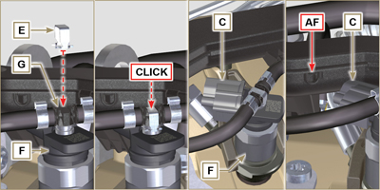  Fig 6.11
NOTE: Click by side to play the procedure. | https://www.youtube.com/embed/IVoumDwS7oY?showinfo=0&rel=0

High-pressure fuel injection pump replacement
Danger  - The fuel injection circuit undergoes high pressure, use safety protections as described in Par 3.4.3 .  - Ensure that the Common Rail is not under pressure by slowly and carefully unscrewing nut A .  Important  - Before proceeding with operation, read Par. 3.3.2 .  - Always replace the high pressure pipes after each disassembly.  - Before disassembling the injection pump, make sure the new high-pressure pipe is available.  - The injection pump is not repairable.  - Should the fuel feeding pump need to be replaced, after assembly, it is necessary to perform the Pump Learning procedure by means of instrument ST_01 . .  - Seal all injection component unions as illustrated in Par. 2.9.8  - To handling components refer to Par. 2.17  - Always replace the gaskets (where are provided) after each disassembly. | 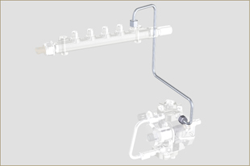  Fig 6.12
6.2.1 High-pressure fuel line disassembly (from the injection pump to the Common Rail).  - Undo the nut A . | 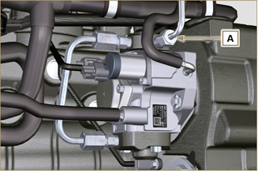  Fig 6.13
- Undo nut D from Common Rail E . | 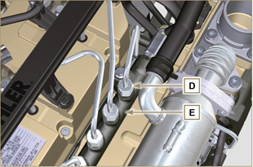  Fig 6.14
- Undo the nut B1 on the intake manifold C.  - Undo the nut B2 on the intake manifold C and remove the pipe F (Fig. 6.16) . | 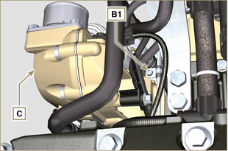  Fig 6.15
6.2.2 Timing system carter oil filling flange disassembly  - Remove starter motor ( Par. 6.6.1 point 2 ) and assemble special tool ST_34 ( Par. 6.6.1 point 3 ) .  - Undo the screws G ,remove the plate H . | 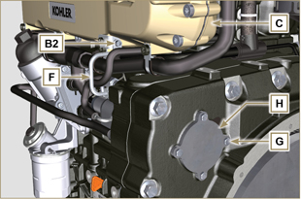  Fig 6.16
- Undo and remove nut L fixing the fuel feeding pump control gear M .  Important  - Be careful that the nut L does not fall into the timing cover.  - Tighten tool ST_13 on the gear M . | 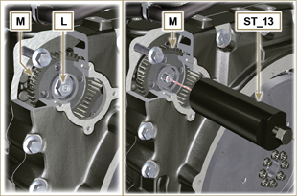  Fig 6.17
Important  - Do NOT use the cylinder connection pipe W as a handle, to prevent damage or fuel leaks.  - Before disassembling, care read Par. 2.17 .  - Seal all injection component unions as illustrated in Par. 2.9.8  - Disconnect tubes P and Q from fuel feeding pump R .  - Disconnect connectors S and T .  - Loosen and distance capscrews U .  - Redo the capscrew of tool ST_13 to disconnect injection  pump R from gear M .  - Undo capscrews U and extract injection pump R with the relevant gasket V .  Important  - Do NOT remove tool ST_13 in order to prevent gear M inside the distribution carter from falling. | 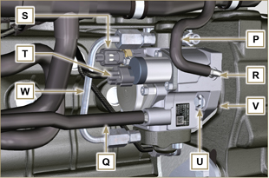  Fig 6.18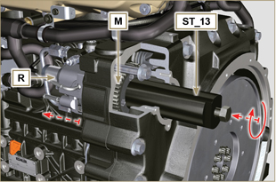  Fig 6.19
NOTE: Click by side to play the procedure. | https://www.youtube.com/embed/jPnRSYu0sKM?showinfo=0&rel=0
6.2.3 High-pressure fuel injection pump assembly  Important  - Before assembling, carefully read Par. 2.17  - Always replace the gasket V after each assembly. The gasket V can only be fitted in one direction.  - Do NOT use the cylinder connection pipe W as a handle, to prevent damage or fuel leaks.  - Remove the protection caps only when reconnecting the hoses. | 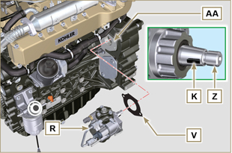  Fig 6.20
- Check that the contact surfaces AA are free from impurities.  - Make sure reference key K is properly inserted into the Z shaft seat.  - Assemble the new gasket V on injection pump R . Insert injection pump R in its housing on crankcase AA making key K coincide with key seat AH of gear M . | 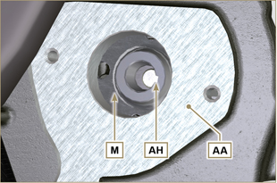  Fig 6.21
- Remove the tool ST_13 from the pump control gear ( Ref. M of Par. 6.2.3 ) if applicable.  Important  - Pay the utmost attention when executing the operation in point 5 so as to prevent nut L from falling inside the distribution carter.  - Fully tighten the nut L on the shaft Z of the injection pump.  Important  - Apply nut L by hand, but do not tighten.  - It is mandatory to replace the screws U or apply a few drops of Loctite 2701 . | 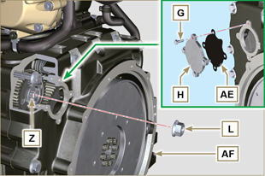  Fig 6.22
- Clamp the screws U on the crankcase AB (tightening torque at 25 Nm ).  - Clamp the nut L (Fig. 6.22) (tightening torque at 70 Nm ).  - Disassemble the special tool ST_34 and assemble the starter motor (tightening torque 45 Nm ).  NOTE: Always replace the gasket AE after each assembly.  - Position the gasket AE in the set on the plate H .  - Fix the plate H on the crankcase AF with the screws G (tightening torque at 10 Nm ). | 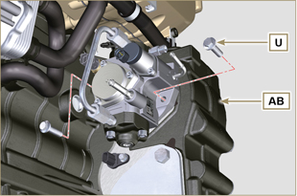  Fig 6.23
- Fit the connector T on the sensor J .  - Fit the connector S on the sensor Y .  - Remove the protection caps.  - Fit the pipe Q on the fitting AA .  - Fit the pipe P on the fitting AB . | 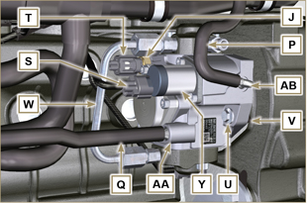  Fig 6.24
6.2.4 High-pressure line assembly (injection pump / Common Rail)  - Remove the protection cap.  - Position the pipe F .  - Manually tighten the nut A . | 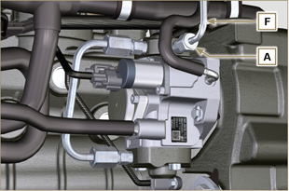  Fig 6.25
- Manually tighten the nut D . | 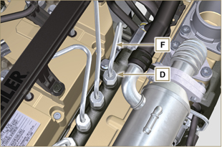  Fig 6.26
- Secure clamps F1 and F2 by means of capscrews B1 and B2 onto intake manifold C (tightening torque 10 Nm ).  - In order, tighten nut D (tightening torque 30 Nm ) and A (tightening torque 25 Nm ). | 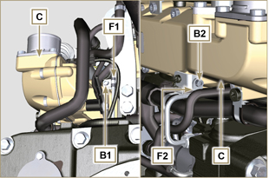  Fig 6.27
NOTE: Click by side to play the procedure. | https://www.youtube.com/embed/3ULD_PiHEaw?showinfo=0&rel=0

Unit EGR Cooler replacement
6.3.1 Disassembly  Important  - Before proceeding with operation, read Par. 3.3.2 .  - To handling components refer to Par. 2.17  - Always replace the gaskets (where are provided) after each disassembly.  NOTE: Perform the operations described in Par. 5.1 .  - Undo the screws B of pipe C .  - Release the clamps F and remove the hose M . | 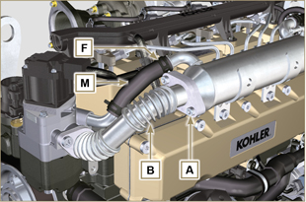  Fig 6.28
- Undo the screws C of pipe E .  - Release the clamp F and remove the hose G. | 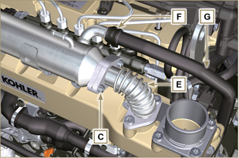  Fig 6.29
- Undo the screws H and remove the EGR Cooler L and the relevant metal gaskets ( ST_05 ).  - Should the passage ducts of the gas exhaust be clogged by soot or carbon, replace EGR Cooler L . | 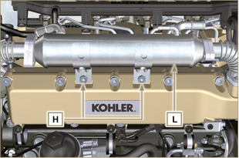  Fig 6.30
NOTE: Click by side to play the procedure. | https://www.youtube.com/embed/A8fU76g4nUQ?showinfo=0&rel=0
6.3.2 Assembly  - Fit the EGR Cooler L with the screws H on the intake manifold S (tightening torque at 22 Nm - ST_05 ). | 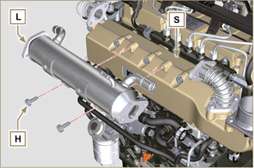  Fig 6.31
- Insert the gasket N between the hoses B-E and the EGR Cooler L . | 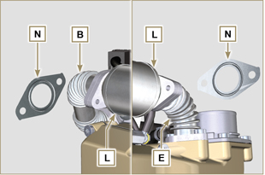  Fig 6.32
- Fit the screws A and C (tightening torque at 25 Nm ).  - Insert the hose M on the fitting V1 and G on V2 .  - Secure the clamps F .  NOTE: Perform the operations described in Par. 10.2 . | 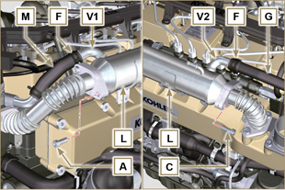  Fig 6.33
NOTE: Click by side to play the procedure. | https://www.youtube.com/embed/vTWVObqWIGE?showinfo=0&rel=0

EGR valve replacement
6.4.1 Disassembly  Important  - Before proceeding with operation, read Par. 3.3.2 .  NOTE: Perform the operations described in Par. 5.1 .  - Disconnect the connector A from the valve C .  - Undo the screws B and remove the EGR valve C with the relevant gasket. | 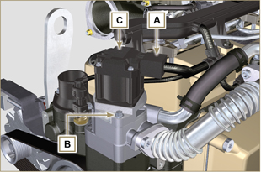  Fig 6.34
NOTE: Click by side to play the procedure. | https://www.youtube.com/embed/JZWXxa3UssY?showinfo=0&rel=0
6.4.2 Assembly  Important  - Always replace gasket D after each assembly.  - The EGR valve is not a serviceable item, and if faulty / worn out, should be replaced with a new one.  - Handle the components as described in Par. 2.17 .  - Mount the new gasket D on the valve C .  - Fit the valve C on the flange E with screws B (tightening torque at 10 Nm ). | 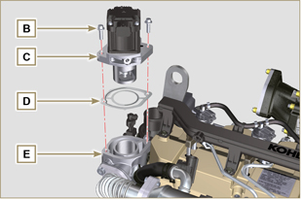  Fig 6.35
- Fit the connector A on the valve C .  NOTE: Perform the operations described in Par. 10.2 . | 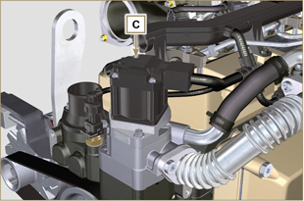  Fig 6.36
NOTE: Click by side to play the procedure. | https://www.youtube.com/embed/JZWXxa3UssY?showinfo=0&rel=0

Coolant pump and Poly-V belt replacement
6.5.1 Disassembly  NOTE: Perform the operations described in Par. 5.1 .  Important  - Before proceeding with operation, read Par. 3.3.2 .  - Loosen the screws A and B .  - Loosen capscrew C and disconnect voltage from belt D and remove belt D .  - Undo the screws E and remove the pulley F . | 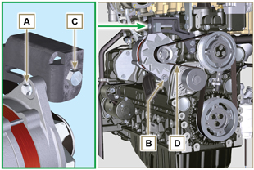  Fig 6.37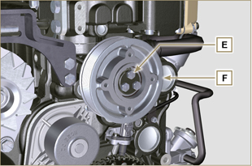  Fig 6.38
- Undo the screws G and remove the pump H with the relevant gasket. | 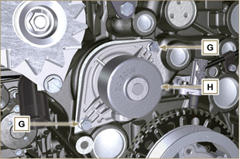  Fig 6.39
NOTE: Click by side to play the procedure. | https://www.youtube.com/embed/tgDL1w2AUd0?showinfo=0&rel=0
6.5.2 Assembly  Important  - Always replace the gaskets J , after each disassembly.  - Always replace the belt D after each assembly.  - To handling components refer to Par. 2.17  - Always replace the gaskets (where are provided) after each disassembly  - Fit the coolant pump G with the screws H interposing the new gasket J (tightening torque at 25 Nm ). | 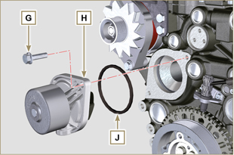  Fig 6.40
- By means of capscrews E , secure pulley F to crankcase K . | 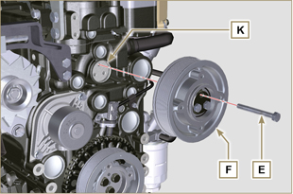  Fig 6.41
- Insert the belt D on the pulleys M .  - Tighten screw C and bring block L at 10 mm from bracket N (value C1 ).  - Fit the screw A (tightening torque at 25 Nm ).  - Fit the screw B (Fig. 6.37 - tightening torque at see service letter 710007 ).  - Start the engine and run it for some minutes, then turn off it, and let it cool down at ambient temperature. Check by the appropriate tool that at point p the tension value is between 135 and 178 Hz.  NOTE: If the poly-v belt tension results out of the above mentioned values, proceed with the replacement. | 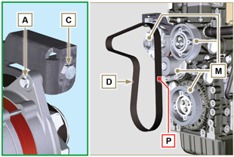  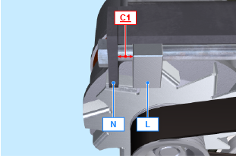  Fig 6.42
NOTE: Click by side to play the procedure. | https://www.youtube.com/embed/Zrhc5qTwPRM?showinfo=0&rel=0

Target wheel replacement
6.6.1 Disassembly  Important  - Before proceeding with operation, read Par. 3.3.2 .  - Remove the alternator belt following steps 1 and 2 ( Par. 6.5.1 ) .  - Undo the screws N and Remove starter motor A .  - Mount the tool ST_34 in the seat of the starter motor B and fit it with the two starter motor fixing screws. | 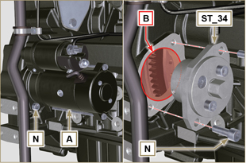  Fig 6.43
Important  - Pay the utmost attention when executing the operation in point 4 so as to prevent knocking speed sensor E .  - Undo the screws C and remove the pulley D . | 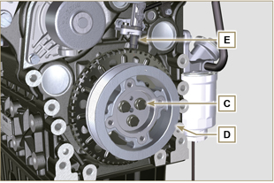  Fig 6.44
- Undo the screws F and remove the target wheel G . | 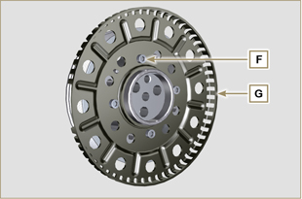  Fig 6.45
6.6.2 Assembly  - Check that the pin H is mounted properly on the pulley D .  - Position the phonic wheel G on the pulley D respecting the reference of the pin H .  - Fit the phonic wheel G with the screws F (tightening torque 10 Nm ). | 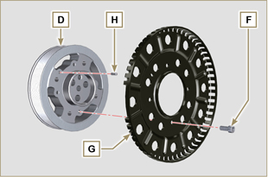  Fig 6.46
- Check that the pin L is mounted properly on the crankshaft M .  Important  - Pay the utmost attention when executing the operation in point 4 so as to prevent knocking speed sensor E .  - Position the pulley unit D on the crankshaft M respecting the reference with the pin L .  - Apply Molyslip grease onto the thread and under the head of capscrew C .  - Clamp the pulley unit D with the screw C (tightening torque at 100 Nm ).  - Perform the operations from point 3 to 7 of Par. 6.5.2. | 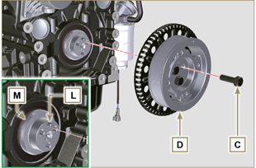  Fig 6.47
- Undo the screws N and remove special tool ST_34 .  - Secure motor A by means of capscrews N (tightening torque at 45 Nm ). | 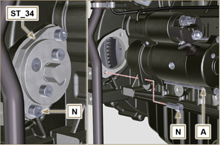  Fig 6.48

Oil vapour separator replacement
6.7.1 Disassembly  Important  - Before proceeding with operation, read Par. 3.3.2 .  - Remove quick fitting A .  - Release the clamps B and C .  - Remove hose D from breather body E . | 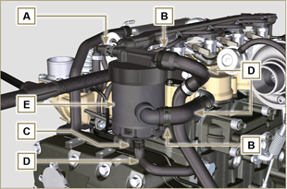  Fig 6.49
- Remove capscrews F and remove breather body E . | 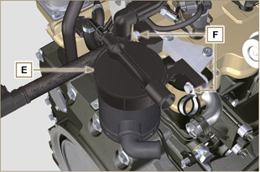  Fig 6.50
6.7.2 Assembly  Warning  - Always carefully inspect the condition of the tubes, and replace them if there is any doubt regarding their integrity.  - Always replace the gasket M after each assembly.  - Secure breather body E by means of capscrews F .  NOTE : Insert clamp G between capscrew F and breather body E .  - Fit hose D onto breather body E (Fig. 6.49) .  - Secure the clamps B and C (Fig. 6.49). | 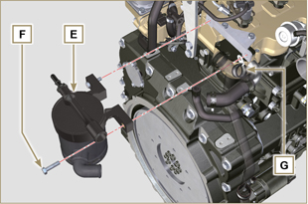  Fig 6.51

Oil cooler unit and oil filter replacement
6.8.1 Oil Cooler unit disassembly  Important  - Before proceeding with operation, read Par. 3.3.2 .  - Perform the operations described in Par 5.1 and Par 5.2 .  - Oil Cooler unit E is not repairable.  - Release the clamps A .  - Remove the manifolds B out of the Oil Cooler unit E . | 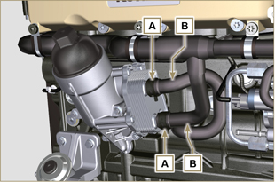  Fig 6.52
Warning  - Electric/pneumatic screwdrivers are forbidden.  - Use a suitable container to recover any residue oil.  - Unscrew cartridge holder cover H by performing three complete turns and wait 1 minute.  NOTE : this operation allows to oil contained in the support E to flow into the oil sump in the correct way.  - Unscrew cartridge holder cover H and check that the oil in the lub. oil filter support E has flowed towards the oil sump.  - Undo the screws C and D and remove the Oil Cooler unit E . | 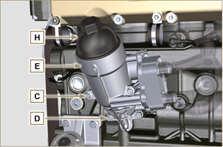  Fig 6.53
- Remove the gaskets F and G from the Oil Cooler unit E . | 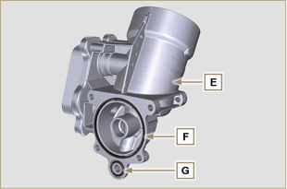  Fig 6.54
6.8.2 Oil filter cartridge replacement  - Remove gaskets L, M and N from element holder cover H .  - Remove cartridge P from element holder cover H . | 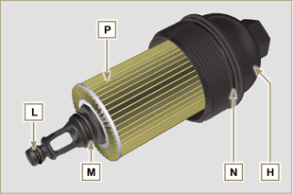  Fig 6.55
- Lubricate and insert gaskets L, M and N in the L1, M1 and N1 seats of element holder cover H .  - Insert element P into element holder cover H . | 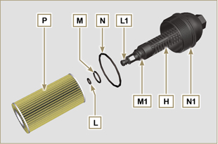  Fig 6.56
6.8.3 Oil Cooler unit assembly  Important  - In the event of assembly of union U on crankcase S , manual tightening torque with Loctite 2701 on the thread).  - Check that the surface Q on the support E and on the crankcase S are free from impurities.  - Lubricate and insert the gasket T on the fitting U .  - Lubricate and insert the gaskets on the support E :  F in seat F1 ;  G in seat G1 .  - Fit the support R with the screws C and D (tightening torque at 10 Nm ).  - Insert and tighten the cartridge support H on the filter support E (tightening torque at 25 Nm ).  - Fit the hoses B on the support E and secure the hoses B with the clamps A . | 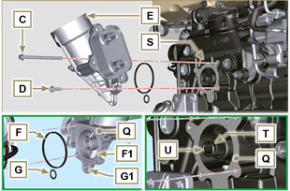  Fig 6.57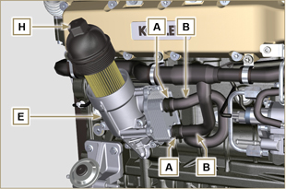  Fig 6.58

Fuel filter replacement
6.9.1 Disassembly  Important  - Before proceeding with operation, read Par. 3.3.2 .  Warning  - The fuel filter is not always mounted in the engine.  - When disassembling the sensor E , use a suitable container to recover the fuel contained in the cartridge F .  - Release the clamps A and pull the pipes B out of the support H .  - Unscrew the sensor E from the cartridge F .  - Unscrew the cartridge F from the support H .  - Undo the screws C and remove the support H . | 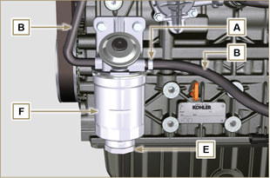  Fig 6.59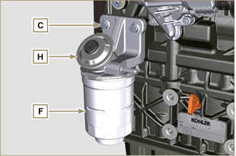  Fig 6.60
Warning  - Check that the fuel supply pump filter is present, and replace if necessary.  - Release the clamp D .  - Demount the hose E .  - Unscrew the filter G from the pump Q . | 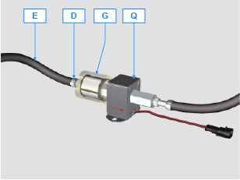
- Screw the new filter G onto the pump Q (tightening torque 20 Nm ).  - Connect the hose E to the filter G and fasten with the clamp D . | 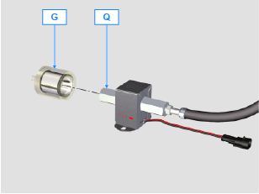
6.9.2 Assembly  - Secure the fuel filter support H with the screws C on the crankcase M (tightening torque at 25 Nm ).  - Fit the pipes B on the support H .  - Secure the pipes B with the clamps A . | 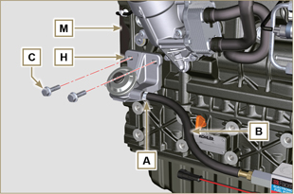  Fig 6.61
- Lubricate the gasket N with fuel.  - Tighten the cartridge F on the support H (tightening torque at 17 Nm ).  - Assemble gasket J onto sensor E and lubricate with fuel.  - Tighten the sensor E on the cartridge F (tightening torque at 5 Nm ). | 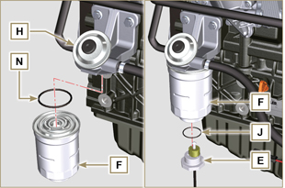  Fig 6.62

Replacement of SCV valve
Warning  - Before starting any replacement operations, make sure the work area is free from dust (part X of valve B is extremely sensitive to micro-dust).  - Pay the utmost attention to cleaning in order to prevent any type of contamination during replacement operations  - - Before proceeding with the replacement, clean the outer part of pump A thoroughly - Avoid any type of contact with part X of the valve during replacement.  - Lubricate part X of valve B with oil spray.  - Before starting any replacement operations, make sure that the key on the vehicle’s panel is OFF .  - Assemble the new valve in the same position as the previous one. | 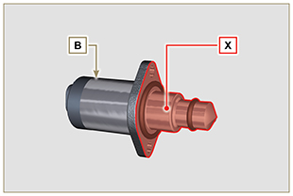  Fig. 6.60
6. 10 .1 Disassembly  1 - Disconnect connector C from valve B .  2 - Loosen screws D .  3 - Remove valve B from pump A . | 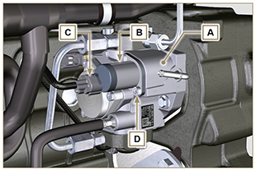  Fig. 6.61
6. 10 .2 Assembly  1 - Insert studs E supplied with valve B in the fastening holes of pump A and insert gasket F in the seat of pump A .  2 - Assemble valve B on pump A using studs E as positioning guides.  3 - Remove studs E and secure valve B with screws D (tightening torque of 6 Nm).  4 - Fasten valve B by means of screws D (tightening torque of 10 Nm). | 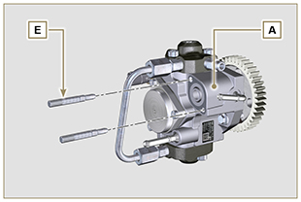  Fig. 6.62
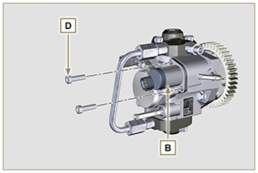  Fig. 6.63 | 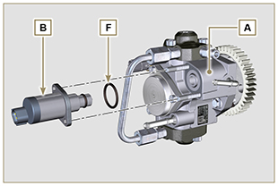  Fig. 6.64

