Information about optional components
KDI 3404 TCR Workshop Manual (Rev. 10.4)

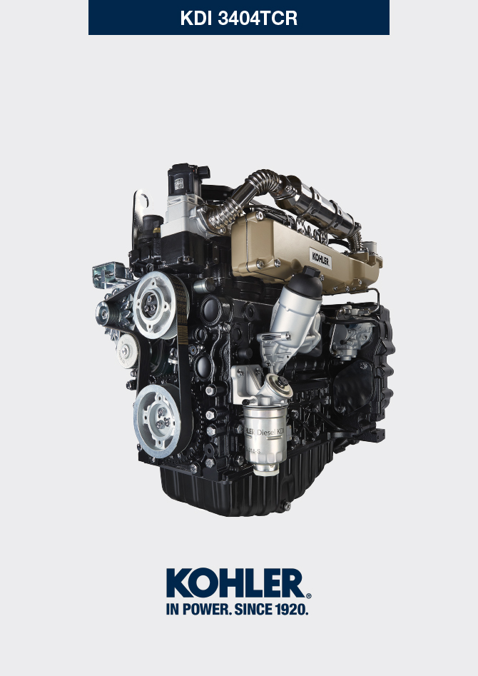

Registration of modifications to the document
Any modifications to this document must be registered by the drafting body, by completing the following table.

Released by | Code | Revision | Release Date | Revision date | Edited by | Endorsed
 | manoff

Translated from the original manual in Italian language
Data reported in this issue can be modified at any time by KOHLER.

Sommario
1. TITOLO 1 2
1.1. Asdfsdfsdf 2
1.2. Asdfsdfsdfggg 2

Information about optional components

Heater (replacement)
Important

- Before proceeding with operation, read Par. 3.3.2 .
11.1.1 Disassembly  - Undo the screws A .  - Remove the flange C .  - Remove the heater E and the relevant gaskets F . | 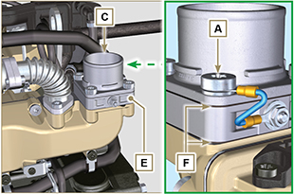  Fig 11.1
11.1.2 Assembly  Important  - Always replace gaskets F , with each assembly.  - In sequence, fit the manifold G with the gasket F , the new heater E , the second gasket F , the flange C , the washers H , the screws A and the cable B .  - Secure the flange C with the screws A (tightening torque at 22 Nm ). | 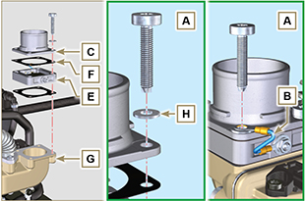  Fig 11.2

Idler gear (for 3rd / 4th PTO)
Important

- Before proceeding with operation, read Par. 3.3.2 .
11.2.1 Disassembly  - Perform the operations of point 7 of Par. 7.4.1 .  - Perform the operations from point 2 to 3 of Par. 6.6.1 .  - Perform the operations of point 3 of Par. 7.8.1 .  - Perform the operations of Par. 7.8.2 .  - Loosen capscrews A and remove plate B1 .  - Extract gear C .  - Remove gudgeon D together with plate B2 . | 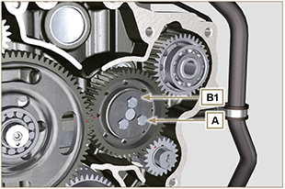  Fig 11.3
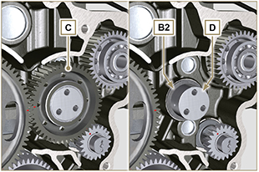
Fig 11.4
11.2.2 Assembly  Important  - Make sure that gudgeon D has no impurities inside.  - On capscrew A , assemble:  - plate B1  - gudgeon D  - gear C  - plate B2 . | Fig 11.5

- Position gear unit C1 onto crankcase E , complying with reference J1 , J2 with gear F .  - Secure unit C1 by means of capscrew A (tightening torque 25 Nm ).  NOTE: the reference J1 can have 2 different configurations for the gear C , Fig. 11.6b shows the correct position of the reference J1 for both configurations. | 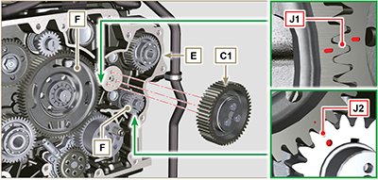  Fig 11.6  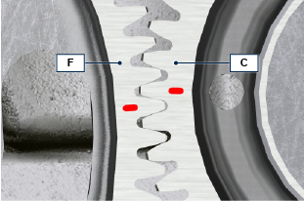  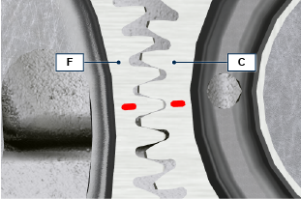  Fig 11.6b

3rd PTO (replacement)
Important

- Before proceeding with operation, read Par. 3.3.2 .
11.3.1 Disassembly  - Perform the operations of point 7 of Par. 7.4.1 .  - Perform the operations from point 2 to 3 of Par. 6.6.1 .  - Perform the operations of point 3 of Par. 7.8.1 .  - Perform the operations of Par. 7.8.2 .  - Extract gear A . | 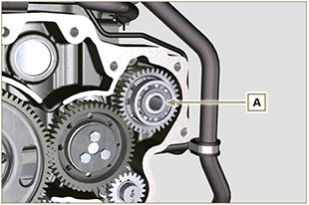  Fig 11.7
11.3.2 Assembly  - Insert gear A into the seat of crankcase B , fitting the shaft of pump C in gear A . | 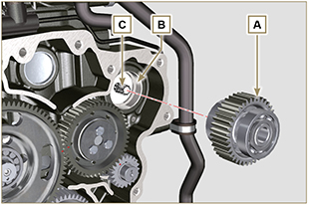  Fig 11.8

4th PTO (replacement)
Important

- Before proceeding with operation, read Par. 3.3.2 .
11.4.1 Disassembly  - Perform the operations of point 7 of Par. 7.4.1 .  - Perform the operations from point 2 to 3 of Par. 6.6.1 .  - Perform the operations of point 3 of Par. 7.8.1 .  - Perform the operations of Par. 7.8.2 .  - Extract gear A . | 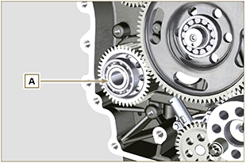  Fig 11.9
11.4.2 Assembly  - Insert gear A into the seat of crankcase B , fitting the shaft of pump C in gear A . | 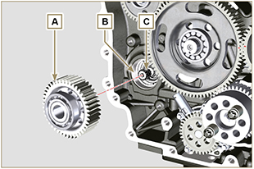  Fig 11.10

Balancer device (replacement)
Importante

- Before proceeding with operation, read Par. 3.3.2 .
11.5.1 Disassembly  - Perform the operations described in Par. 11.2.1 .  - Extract shaft A1 e A2. | 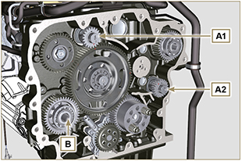  Fig 11.11
11.5.2 Assembly

- Lubricate gudgeon C of shaft A1 and A2 with oil.
- Insert shaft A1 into seat B1 of the crankcase, complying with reference D of gear E .
- Insert shaft A2 into seat B2 of the crankcase.
- Perform the operations described in Par. 11.2.2 .
NOTE: the shafts A1 and A2 are different and it is important not to invert the assembly position, the reference D is specific for the shaft A1 and is timed with the gear E , the reference J2 is specific for the shaft A2 and is timed with the idler gear F (see the Fig. 11.12b ).

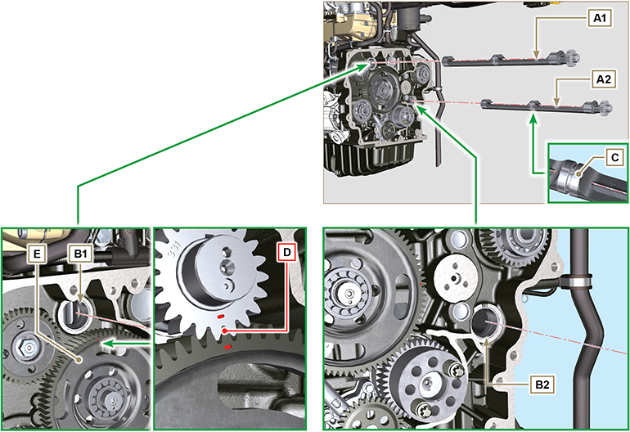
Fig 11.12

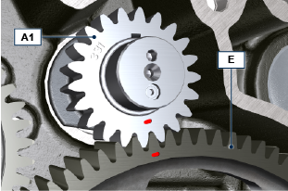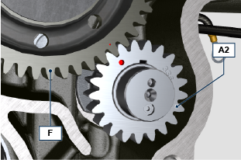
Fig 11.12b

ETB (replacement)
- Unscrew screws A and remove the ETB valve B with its gasket C .  Important  - Always replace the gasket C at each assembly. | 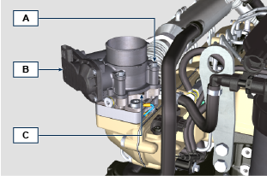  Fig. 11.13
- Fix the ETB valve B and its gasket C by means of screws A (tightening torque 10 Nm ) | 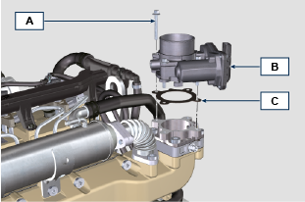  Fig. 11.14

EGR-T (replacement)
- Unscrew sensor A and its gasket B .  Important  - Before assembling the new sensor, see Par. 2.17.5  - Always replace the gasket B at each assembly. | 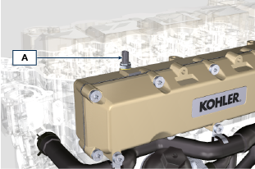  Fig. 11.15
- Fix sensor A and gasket B on their support C (tightening torque 20 Nm ). | 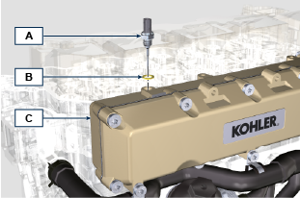  Fig. 11.16

EGTS (Black | Yellow - replacement)
- Unscrew sensors A .  Important  - Before assembling the new sensor, see Par. 2.17.6 | 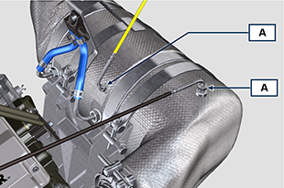  Fig. 11. 17
- Fix sensors A on the ATS B (tightening torque 30 Nm ). | 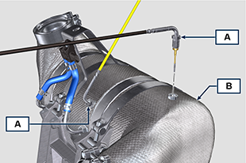  Fig. 11.18

DPF & DOC filter (replacement)
Danger
- Highly carcinogenic material!
- The dust contained inside the DPF is particularly fine and therefore classified as highly dangerous to living beings.
- Before proceeding to any operation, wear:
dust mask
gloves
goggles
- Do not allow any other operator who is not equipped with the above mentioned protective equipment to approach.
- Obtain a new replacement KIT for the DPF filter or a replacement KIT with regenerated DPF filter from your spare parts service.  Important  - Before disassembling/assembling any sensors, see Par. 2.17.5 and 2.17.6  - Always replace the seal P upon every assembly.  - During disassembly, do not expose the DPF to the surrounding environment for a long time and store it in a sealed bag as soon as possible.  - During disassembly operations, avoid using electric screwdrivers as vibrations could release the dust inside the DPF  - Do not try to clean the DPF  - Do not blow with compressed air  - Do not release the DPF or the dust contained in it in the environment  - Dispose of the DPF only in authorised centres  - Perform the operations indicated in point 1 of Par. 11.8 .  - Open the package of the DPF replacement KIT, taking care not to damage it.  - Unscrew screw A and loosen clamps B , then remove the Delta-P sensor D .  - Disconnect pipes C from their unions J and remove the Delta-P sensor D .  - Unscrew and remove unions J . | 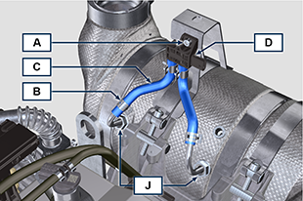  Fig. 11.19
- Loosen clamps E and remove manifold N . | 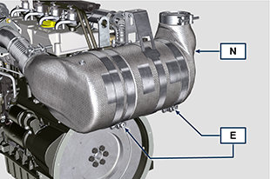  Fig. 11.20
- Loosen clamp G and remove the DPF filter H .  NOTE: do not remove clamp G .  - Inspect the DPF filter to detect any visible signs of oil contamination.  - Put the removed DPF filter in the plastic container supplied with the replacement KIT and send it to your spare parts service using the replacement KIT package.  NOTE : a residual value will be recognised depending on whether the used DPF is intact and recyclable or damaged and requiring a correct disposal. | 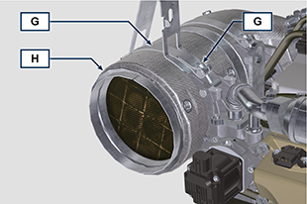  Fig. 11.21
- Loosen the clamps Q and S and remove the manifold with DOC M from the flexible hose R . | 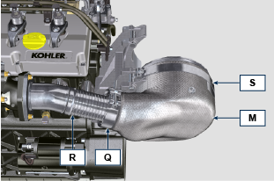  Fig. 11.22
- Fit the new manifold with the DOC filter M on the support T , inserting the flexible hose R inside the inlet of the manifold M . | 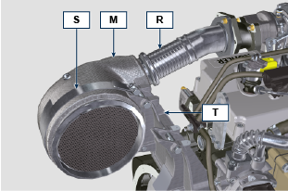  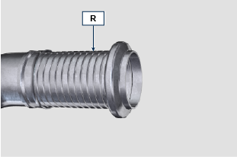  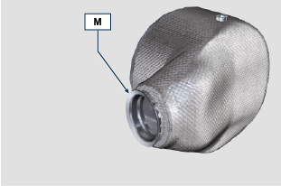  Fig. 11.23
Important  - Do not apply any tension during the assembly of components.  - Before fastening the manifold M , it must be oriented in the same position as the previously installed DOC filter.  - Tighten the clamp Q (tightening torque of 10 Nm ).  - Tighten the clamp S (tightening torque of 12 Nm ). | Fig. 11.24
- Insert the gasket P on the manifold with DOC filter M .  - Insert the new DPF filter H inside clamp G .  - Insert the DPF filter H on manifold M until reaching the gasket P . | 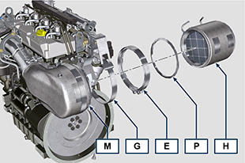  Fig. 11.25
Important  - Before fastening the DPF filter H , it must be oriented in the same position as the previous filter.  - Do not apply any tension during the assembly of components.  - Fasten the DPF filter H with clamp E (tightening torque 12 Nm ). | 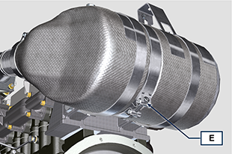  Fig. 11.26
- Insert gasket P on the DPF filter H .  - Insert manifold N on the DPF filter H until reaching the gasket P .  Important  - Before fastening manifold N , it must be oriented in the original position.  - Fasten manifold N with clamp E (tightening torque 12 Nm ). | 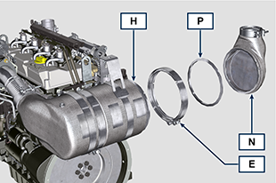  Fig. 11.27
- Position support K in contact with support K1 and fasten clamp G (tightening torque 12 Nm ). | 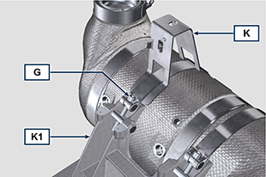  Fig. 11.28
- Screw unions J on the DPF filter H and position them about 20° away from the centre line (as in Fig. 11.30 ). | 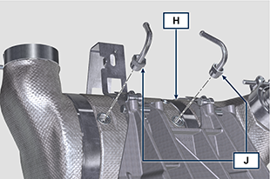  Fig. 11.29
- Fix unions J (tightening torque see service letter 710015 ). | 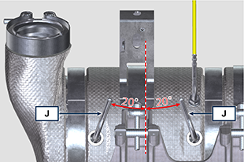  Fig. 11.30
- Fit pipes C on unions J and fasten them with clamps B .  - Fix the Delta-P sensor D on its support K by means of screw A (tightening torque 10 Nm ).  - Provide the machine owner with the warranty certificate of the new DPF filter KIT installed.  - Perform the " DPF replacement " procedure to reset the ASH & SOOT through the relevant KOHLER diagnostic tool interfaced with the ECU. | 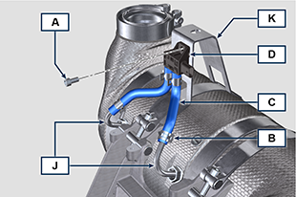  Fig. 11.31

