Fluids filling information
KDI 3404 TCR-SCR Workshop Manual (Rev. 10.4)

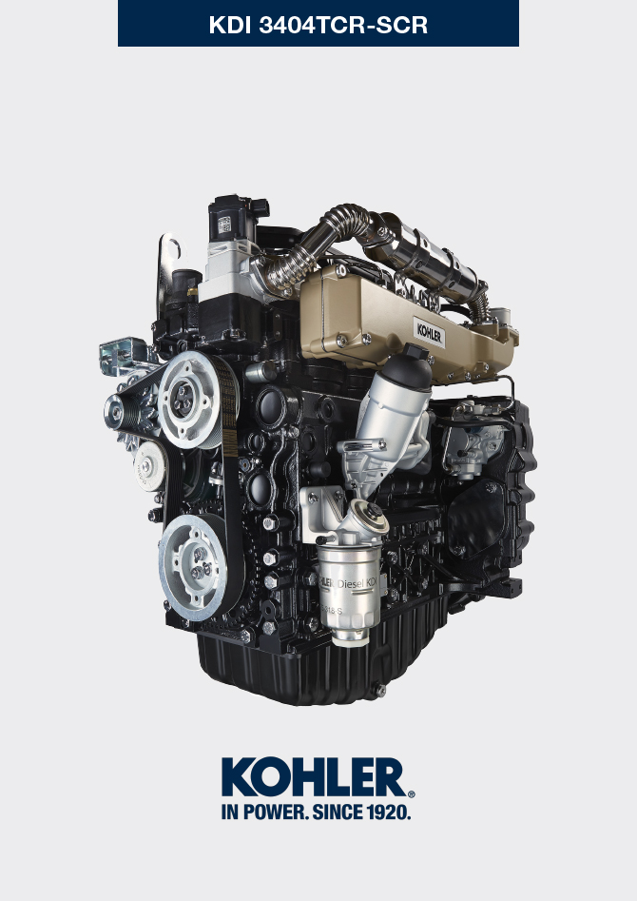

Registration of modifications to the document
Any modifications to this document must be registered by the drafting body, by completing the following table.

Released by | Code | Revision | Release Date | Revision date | Edited by | Endorsed
 | manoff

Translated from the original manual in Italian language
Data reported in this issue can be modified at any time by KOHLER.

Sommario
1. TITOLO 1 2
1.1. Asdfsdfsdf 2
1.2. Asdfsdfsdfggg 2

Fluids filling information

Engine oil
Warning

- Before proceeding with operation, carefully read Par. 3.3.2 .

- Loosen the oil filler cap A .  - Add the type and amount of oil recommended ( Tab. 2.2 ).  - Remove the oil dipstick B and check that the level is up to but does not exceed the MAX .  Important  - Do not use the engine with the level of oil below MIN or above MAX  - If the oil level is not at MAX , insert more oil until the MAX level is reached as indicated on the dipstick.  - Re-tighten the cap A . | 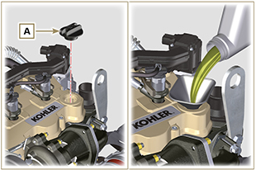  Fig 10.1
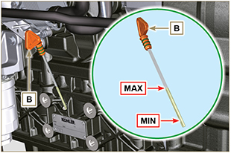
Fig 10.2
NOTE : Click by side to play the procedure. | https://www.youtube.com/embed/HWCzK41Br1U?showinfo=0&rel=0

Coolant
NOTE : Component not supplied by KOHLER .

Refer to the technical documentation of the vehicle.

