Information about optional components
KDI 3404 TCR-SCR Workshop Manual (Rev. 10.4)

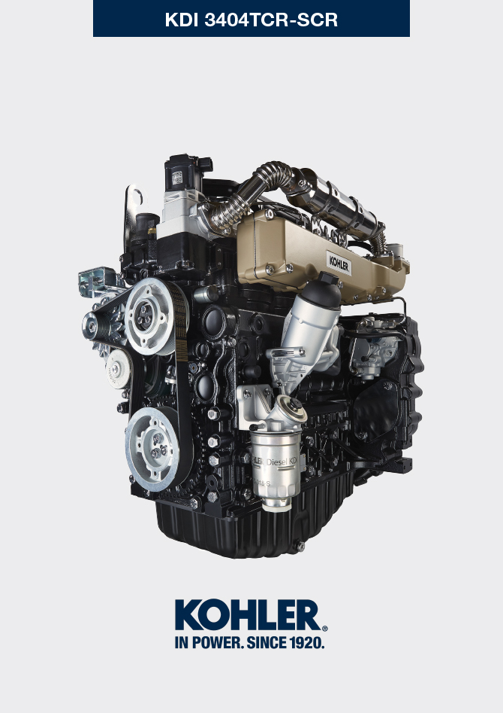

Registration of modifications to the document
Any modifications to this document must be registered by the drafting body, by completing the following table.

Released by | Code | Revision | Release Date | Revision date | Edited by | Endorsed
 | manoff

Translated from the original manual in Italian language
Data reported in this issue can be modified at any time by KOHLER.

Sommario
1. TITOLO 1 2
1.1. Asdfsdfsdf 2
1.2. Asdfsdfsdfggg 2

Information about optional components

Heater (replacement)
Important

- Before proceeding with operation, read Par. 3.3.2 .
11.1.1 Disassembly  - Undo the screws A .  - Remove the flange C .  - Remove the heater E and the relevant gaskets F . | 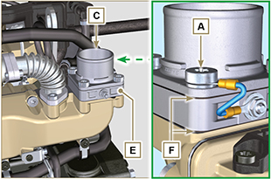  Fig 11.1
11.1.2 Assembly  Important  - Always replace gaskets F , with each assembly.  - In sequence, fit the manifold G with the gasket F , the new heater E , the second gasket F , the flange C , the washers H , the screws A and the cable B .  - Secure the flange C with the screws A (tightening torque at 22 Nm ). | 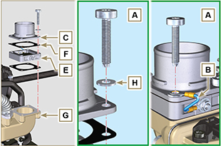  Fig 11.2

Idler gear (for 3rd / 4th PTO)
Important

- Before proceeding with operation, read Par. 3.3.2 .
11.2.1 Disassembly  - Perform the operations of point 7 of Par. 7.4.1 .  - Perform the operations from point 2 to 3 of Par. 6.6.1 .  - Perform the operations of point 3 of Par. 7.8.1 .  - Perform the operations of Par. 7.8.2 .  - Loosen capscrews A and remove plate B1 .  - Extract gear C .  - Remove gudgeon D together with plate B2 . | 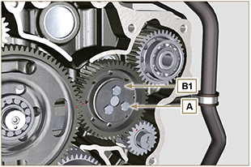  Fig 11.3
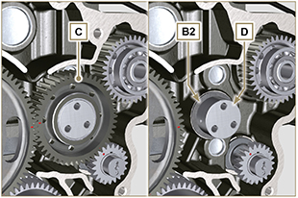
Fig 11.4
11.2.2 Assembly  Important  - Make sure that gudgeon D has no impurities inside.  - On capscrew A , assemble:  - plate B1  - gudgeon D  - gear C  - plate B2 . | Fig 11.5

- Position gear unit C1 onto crankcase E , complying with reference J1 , J2 with gear F .  - Secure unit C1 by means of capscrew A (tightening torque 25 Nm ).  NOTE: the reference J1 can have 2 different configurations for the gear C , Fig. 11.6b shows the correct position of the reference J1 for both configurations. | 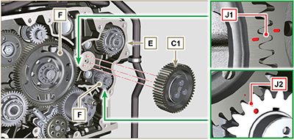  Fig 11.6  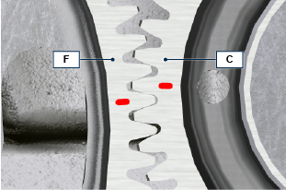  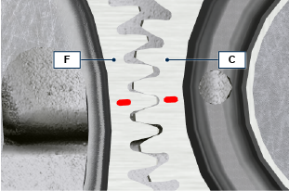  Fig 11.6b

3rd PTO (replacement)
Important

- Before proceeding with operation, read Par. 3.3.2 .
11.3.1 Disassembly  - Perform the operations of point 7 of Par. 7.4.1 .  - Perform the operations from point 2 to 3 of Par. 6.6.1 .  - Perform the operations of point 3 of Par. 7.8.1 .  - Perform the operations of Par. 7.8.2 .  - Extract gear A . | 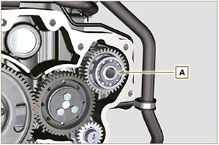  Fig 11.7
11.3.2 Assembly  - Insert gear A into the seat of crankcase B , fitting the shaft of pump C in gear A . | 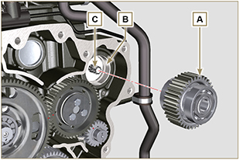  Fig 11.8

4th PTO (replacement)
Important

- Before proceeding with operation, read Par. 3.3.2 .
11.4.1 Disassembly  - Perform the operations of point 7 of Par. 7.4.1 .  - Perform the operations from point 2 to 3 of Par. 6.6.1 .  - Perform the operations of point 3 of Par. 7.8.1 .  - Perform the operations of Par. 7.8.2 .  - Extract gear A . | 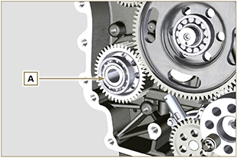  Fig 11.9
11.4.2 Assembly  - Insert gear A into the seat of crankcase B , fitting the shaft of pump C in gear A . | 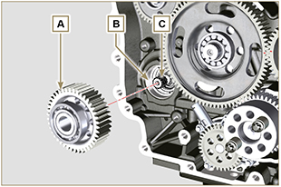  Fig 11.10

Balancer device (replacement)
Importante

- Before proceeding with operation, read Par. 3.3.2 .
11.5.1 Disassembly  - Perform the operations described in Par. 11.2.1 .  - Extract shaft A1 e A2. | 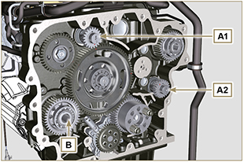  Fig 11.11
11.5.2 Assembly

- Lubricate gudgeon C of shaft A1 and A2 with oil.
- Insert shaft A1 into seat B1 of the crankcase, complying with reference D of gear E .
- Insert shaft A2 into seat B2 of the crankcase.
- Perform the operations described in Par. 11.2.2 .
NOTE: the shafts A1 and A2 are different and it is important not to invert the assembly position, the reference D is specific for the shaft A1 and is timed with the gear E , the reference J2 is specific for the shaft A2 and is timed with the idler gear F (see the Fig. 11.12b ).

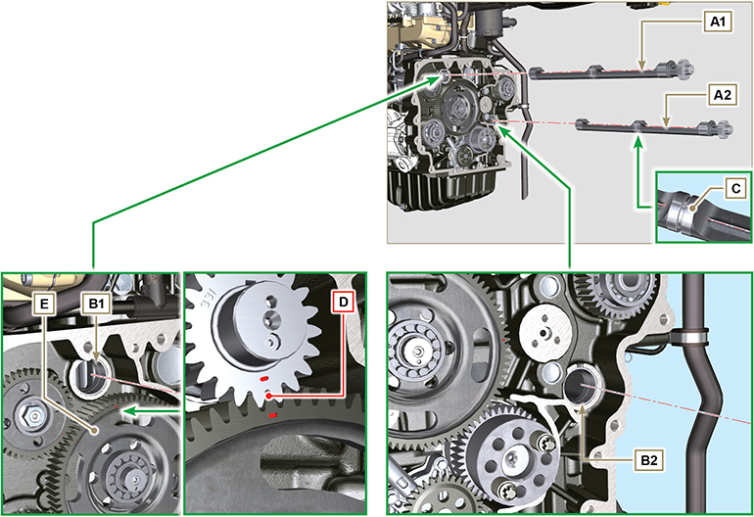
Fig 11.12

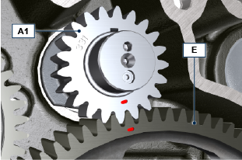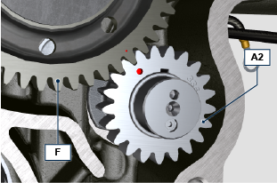
Fig 11.12b

ETB (replacement)
- Unscrew screws A and remove the ETB valve B with its gasket C .  Important  - Always replace the gasket C at each assembly. | 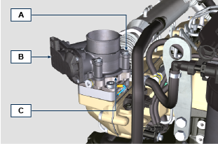  Fig. 11.13
- Fix the ETB valve B and its gasket C by means of screws A (tightening torque 10 Nm ) | 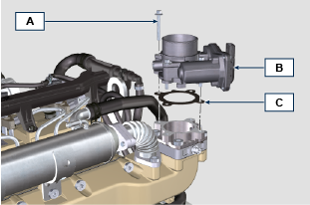  Fig. 11.14

